GOLDEN BULL AWARD 2026 · SINGAPORE CHAPTER
Winner Profile & Branding Materials
CE GLOBAL NETWORK INTERNATIONAL PTE LTD
Prestige Package · Outstanding Bull · Digital 50 · Inspirational Entrepreneur Awards

Submitted to | Golden Bull Award Organising Committee — attn. Mr Jason Ooi, Senior Project Manager
Award ceremony | 12 November 2026, Marina Bay Sands, Singapore
Materials due | 31 December 2026 (Winner Profile Write-Up and Company Advertisement)
Contents | 1. Company information  2. Profile write-up (1491 words; limit 2,000)  3. Company photos  4. Company advertisement — capital.asia  5. Rotating banner 728 × 90  6. Rotating banner 340 × 280

1. Company information
CEO / Director's name | DR SHEKINAIH SIEW SIN YAP
Designation | Founder and Managing Director
Chief Advisory & Support Officer | DR J AARON K DAVID — key management, jointly leads the company (co-founder of CE Global Network LLP)
Company name | CE GLOBAL NETWORK INTERNATIONAL PTE LTD (UEN 202605111K)
Company address | 27 Trevose Crescent, Dunearn Estate, Singapore 298042
Company website | https://www.ceglobalnetworkinternational.com
Email | shipping@ceglobalnetworkinternational.com
Chronology | Incorporated April 2026; operations commenced July 2026, carrying forward the freight business of CE Global Network LLP.  The freight business described in the write-up was built as CE Global Network LLP (launched at the start of COVID-19); no financial figures are disclosed in this submission. The Pte. Ltd.'s first financial reporting period ends on 31 December 2026.
Core business, products & services | Freight forwarding and logistics (SSIC 52292 — freight transport arrangement):  • Sea freight (FCL and LCL) and air freight  • Container haulage and transportation  • Warehousing and distribution  • Packing, unpacking and eCommerce logistics  • Customs clearance, handling and cargo insurance  • AI-assisted workflow and SOP advisory for SMEs (planned)

2. Profile write-up
1491 words · British English · names of the award recipients set in full capitals as registered with the organiser.
PROMISE DELIVERED
The cheapest quotation cannot tell you who will take responsibility when the plan changes. A Singapore freight company launched at the start of a pandemic, grew by referral without advertising, and built its name on one thing: it answers. Here is how it works, and the five questions it will teach you to ask before your next shipment.

Before a shipment becomes a problem
Picture it. The vessel has sailed. Someone spots the wrong consignee on the bill of lading. The supplier has been paid, the buyer is waiting on the other side of the world, and the clock on the free time has started.
The usual answer is an email, and a wait.
At CE Global Network International Pte. Ltd. the answer is a person. One contact, who already has the shipping instruction, the draft bill and the weight declaration on screen, because the team checks them against the source documents before anything is filed. The correction is requested the same day, with the right authority, through the right channel.
That is what "PROMISE DELIVERED" means here. Not a slogan. A habit.

Launched into a pandemic. Grew through it.
The freight business was launched at the very start of COVID-19, into closing borders, volatile rates, limited capacity and daily rule changes. It was the worst possible time to start a logistics company.
It grew anyway: every year for three years, and without an advertising campaign. Customers arrived by referral, stayed, and sent their friends. The published record describes it the same way: growth driven by referrals, client trust, service reliability and long-term relationships.
In April 2026 that business was carried into a new company, CE Global Network International Pte. Ltd., the company honoured here. The new company began operations in July 2026.
Ask the founder what made the difference and she will not talk about rates.
"TRUST IS A FORM OF CAPITAL. CLIENTS REMEMBER WHO ANSWERS THE TELEPHONE, WHO TELLS THE TRUTH AND WHO REMAINS PRESENT WHEN CONDITIONS ARE DIFFICULT."
— DR SHEKINAIH SIEW SIN YAP, Founder and Managing Director

Two leaders. One mission.
DR SHEKINAIH SIEW SIN YAP, Founder and Managing Director, writes the blueprint. She trained in accounting at Massey University, audited at Deloitte and spent six and a half years in financial control and corporate banking at UOB. She reads the numbers, the law, the contract and the cash flow before she says yes. She calls herself a steward, not an owner.
DR J AARON K DAVID, Chief Advisory and Support Officer, co-founded CE Global Network LLP with her. His responsibility is counsel: every major commitment, partnership and risk is weighed with him before it is signed. He is also co-author of the five-volume book series they publish together, and leads with her the teaching of the HEAVEN THRONE ROOM MINISTRY of Crowned Eagles Global.
In November 2025, JT Foxx introduced them on his Mega Success stage in Los Angeles as faith leaders who built a global freight enterprise, and called them "a blessing to this world". In October 2026 in Dubai, the Global Icons & Leadership Excellence Awards named her Global Icon for Spiritual Leadership & Divine Strategy and him Global Icon for Leadership & Transformation.
The division of labour is simple. She verifies. He counsels. Both serve.

Prayer first. Then the homework.
DR SHEKINAIH SIEW SIN YAP describes prayer as central to her decision-making. Every morning, before messages, meetings or money, she gives about an hour to it. She asks the GOD OF THE UNIVERSE what to pursue, what to wait for and what to leave alone, then tells her partner and her team what she heard.
Her professional responsibility does not stop there. Her published decision sequence has six steps, and only the first is prayer:
PRAY DEEPLY · DISCERN CAREFULLY · VERIFY RESPONSIBLY · STRUCTURE PROPERLY · EXECUTE COURAGEOUSLY · STEWARD FAITHFULLY.
Verification comes before signature. Stewardship comes after the money arrives. In her words, prayer does not replace due diligence; it tells you where due diligence must look more deeply.
You may not share her faith. You will recognise the discipline: clear payment terms, strict cargo-release controls, no undercutting, no shortcuts on documents. And one line she states without hedging:
"NOT EVERY PROFITABLE OPPORTUNITY IS A PURPOSEFUL OPPORTUNITY."

Five questions to ask before your next booking
The company's method can be borrowed by any shipper. A quotation is a starting point. Before you accept one, ask your forwarder:
- Who is responsible for each stage? Name the forwarder, the carrier, the haulier and any overseas agent. CE Global books directly with the shipping lines and chooses hauliers for their strength on each route.
- Who checks the documents, and against what? Shipping instructions, the draft bill of lading and the weight declaration should be checked against their source documents before filing, and someone should be authorised to correct them. A wrong consignee costs an amendment fee at best and a lost container at worst.
- Which charges are included? Ask for the exclusions, validity dates and free-time terms in writing. Demurrage, detention and re-export charges are where surprises hide.
- Who handles an exception? A named contact and an escalation route, not a ticket number. One contact. One set of records. One team that stands behind the shipment.
- What happens when the plan changes? Alternative sailings, amendments, release requirements and extra charges should be explained and approved before they are incurred.
A useful answer names a person, a process or a written term. Confidence alone is not enough. If you get five good answers, keep your forwarder. If you do not, keep reading.

A small team, powered by AI, guided by people
CE Global competes with forwarders many times its size. It does not try to out-hire them. It engineers.
Repetitive work was mapped step by step and moved onto AI-assisted workflows that the team uses every day: drafting shipping instructions, bookings and quotations; checking bill of lading drafts line by line; reconciling carrier invoices against agreed charges; tracking vessel schedules. Cloud accounting and a digital document trail sit underneath, so a shipment can be traced from first enquiry to final receipt.
AI drafts, checks and tracks. Experienced people decide. The two leaders choose what to automate and what must stay human, because acceleration without wisdom also accelerates mistakes.
"TECHNOLOGY IS A TOOL. IT IS NOT THE THRONE."
— DR SHEKINAIH SIEW SIN YAP

What the money is for
Profit was never the point. She has told of supporting a young man and his family with schooling, housing and food, then using her own savings to help set up a tuition centre so the family could earn a living. Business, in her view, becomes powerful when it does more than create revenue: when it creates employment, restores dignity and funds compassion.
"PROFIT IS NOT THE THRONE. PURPOSE IS."

When all else fails, contact DR SHEKINAIH
Every business owner knows the moment. The shipment is stuck. The bill is wrong. The plan has stopped working and nobody has an answer.
That is the moment these two leaders prepared for. They carried a freight business through a pandemic, rate shocks and port congestion, and into a new company. They bring a banker's discipline and a believer's calm.
You do not need a polished presentation. Start with the problem.
Request a shipment review. Email shipping@ceglobalnetworkinternational.com with your cargo, origin, destination and cargo-ready date. A real person replies.
Bring a breakthrough question. Email the HEAVEN THRONE ROOM MINISTRY at ceg@crownedeaglesglobal.org with your business, leadership or life question.
Explore their published work. Visit www.shekinaihsiewsinyap-jaaronkdavid.com for interviews, books, awards and event coverage.

The brand behind the promise
CE Global Network International Pte. Ltd. is the freight-forwarding and logistics arm of the Crowned Eagles Global group, led by DR SHEKINAIH SIEW SIN YAP and DR J AARON K DAVID. The group spans seven companies across Singapore and Malaysia, each with its own role.
The Crowned Eagles Global group — seven companies
Singapore
- CE Global Network International Pte. Ltd. — international freight forwarding and logistics (the company honoured here)
- CE Global Network LLP — the original freight business, launched at the start of COVID-19
- Crowned Eagles Global LLP — the founding entity of the group
- Crowned Eagles Global Group Holdings Pte. Ltd. — group holding company
- Crowned Eagles Global IP Holdings Pte. Ltd. — intellectual property, publishing and teaching
Malaysia
- CEG Malaysia Holdings Sdn. Bhd. — Malaysian holding company
- CEG Portfolio Abundant Sdn. Bhd. — portfolio and investments
Two marks carry the group: the CROWNED EAGLES GLOBAL crest and the CE GLOBAL NETWORK INTERNATIONAL PTE LTD shield. Wherever you see them together, the same promise applies: we answer, we tell the truth, and we deliver.
"WHEN EVERY HUMAN SOLUTION HAS FAILED, CONTACT THE GOD OF THE UNIVERSE … WHEN ALL ELSE FAILS, CONTACT US."
— DR SHEKINAIH SIEW SIN YAP, Founder and Managing Director, CE Global Network International Pte. Ltd.

3. Company photos
Cover photo — 2000 × 800 px, 72 dpi, .jpg — file: GBA2026_Cover_2000x800.jpg
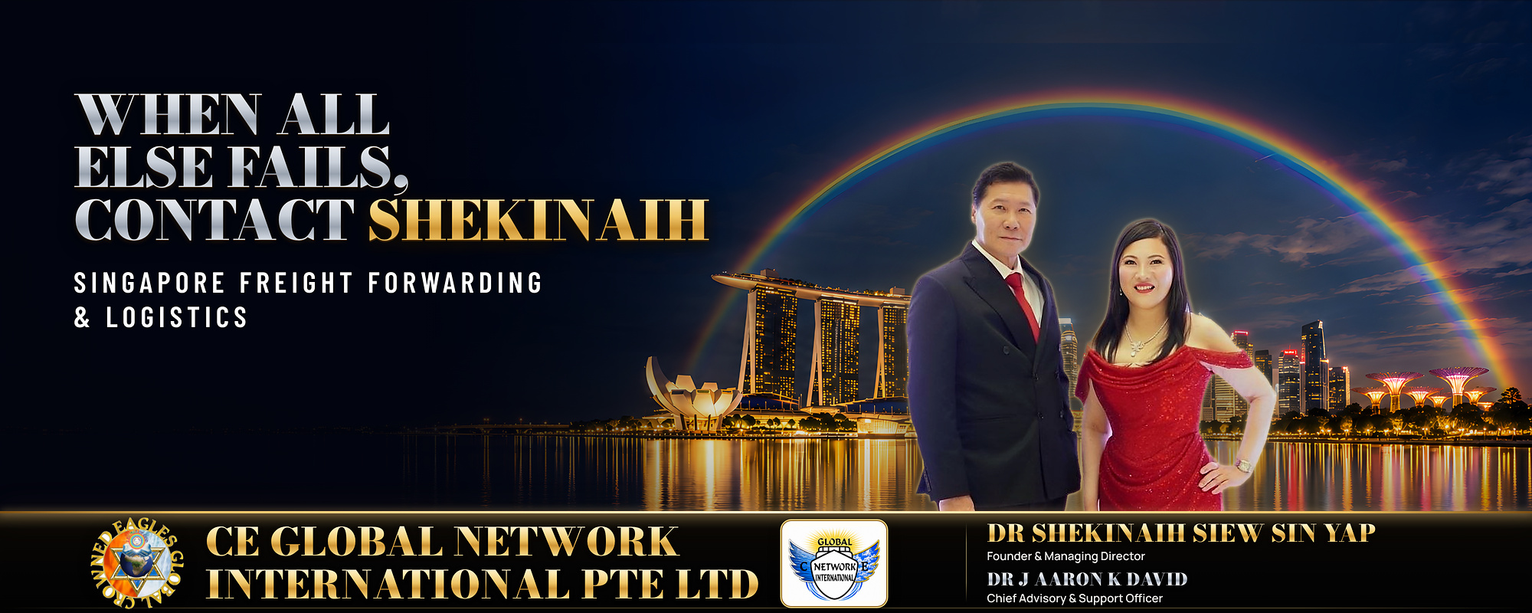
Cover photo. DR J AARON K DAVID, Chief Advisory & Support Officer, and DR SHEKINAIH SIEW SIN YAP, Founder and Managing Director, CE Global Network International — Promise Delivered.
Company photos — 10 to 30 photos, 1000 px wide, 72 dpi, .jpg. Supplied as a separate folder; captions follow the format Subject · Activity · Place.

4. Company advertisement — capital.asia
1000 × 500 px, 72 dpi, .jpg — file: GBA2026_Advertisement_1000x500.jpg
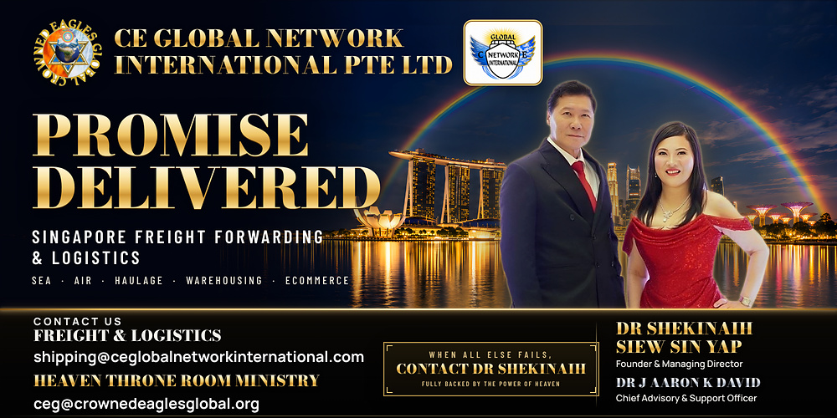

5. Rotating rectangular banner — goldenbullaward.com & capital.asia
728 × 90 px, RGB, 72 dpi — files supplied separately: GBA2026_Banner_728x90_V10_Boss_Sequence.gif (animated, 15 s loop; @2x and 2912×360 MP4 versions also available) and the static final frame. Shown here: the final frame of the V10 sequence.


6. Rotating rectangular banner — capital.asia
340 × 280 px, RGB, 72 dpi — files supplied separately: GBA2026_Banner_340x280_V9_Boss_Sequence.gif (animated, 16 s loop; @2x and 1360×1120 MP4 versions also available) and the static final frame. Shown here: the final frame of the approved V9C sequence.
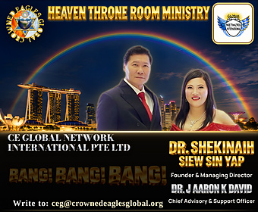

Company boilerplate
CE Global Network International Pte. Ltd. is a Singapore freight forwarder and logistics provider offering sea and air freight, container haulage, warehousing and distribution, and packing, unpacking and eCommerce logistics, with customs clearance and cargo insurance in scope. Incorporated in April 2026 and operating from July 2026, the company carries forward the freight business of CE Global Network LLP and runs an AI-assisted operating model that coordinates the journey of each shipment through one Singapore-based team. It is led by Founder and Managing Director DR SHEKINAIH SIEW SIN YAP and Chief Advisory & Support Officer DR J AARON K DAVID. Web: www.ceglobalnetworkinternational.com

