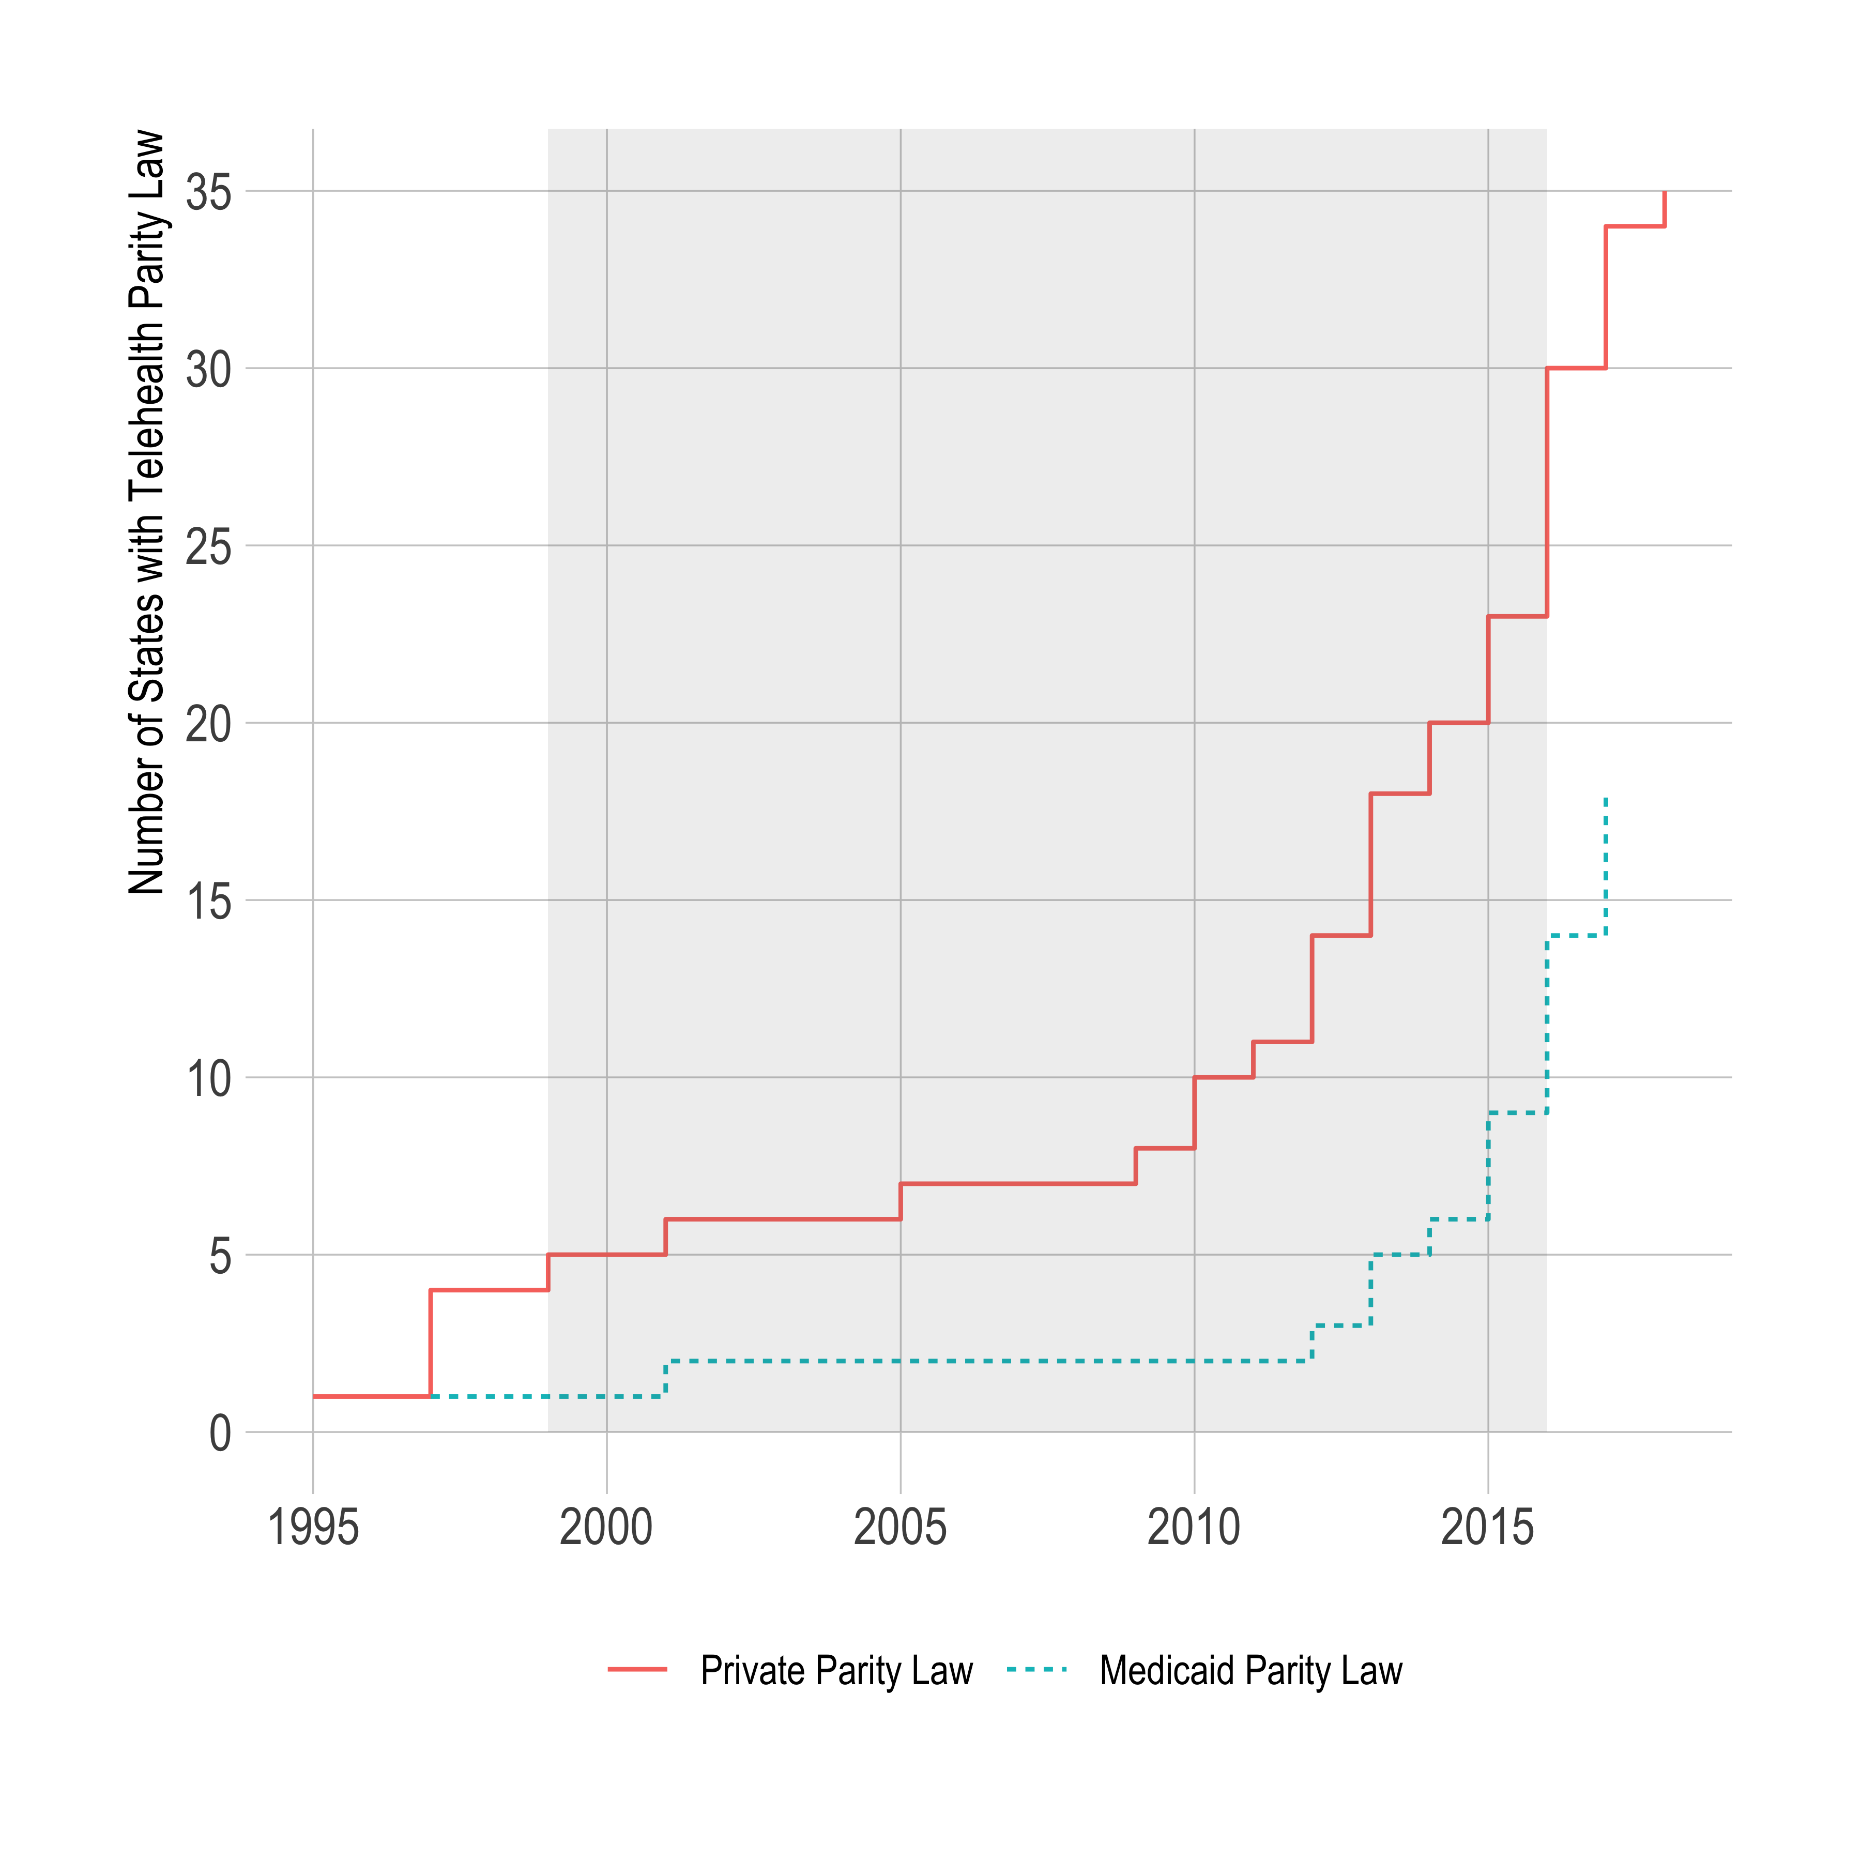

Figure 1. Number of States with Telehealth Parity Law Over Time (1995–2018). Note: Shaded area indicates the period in which mortality data was used for main analysis.