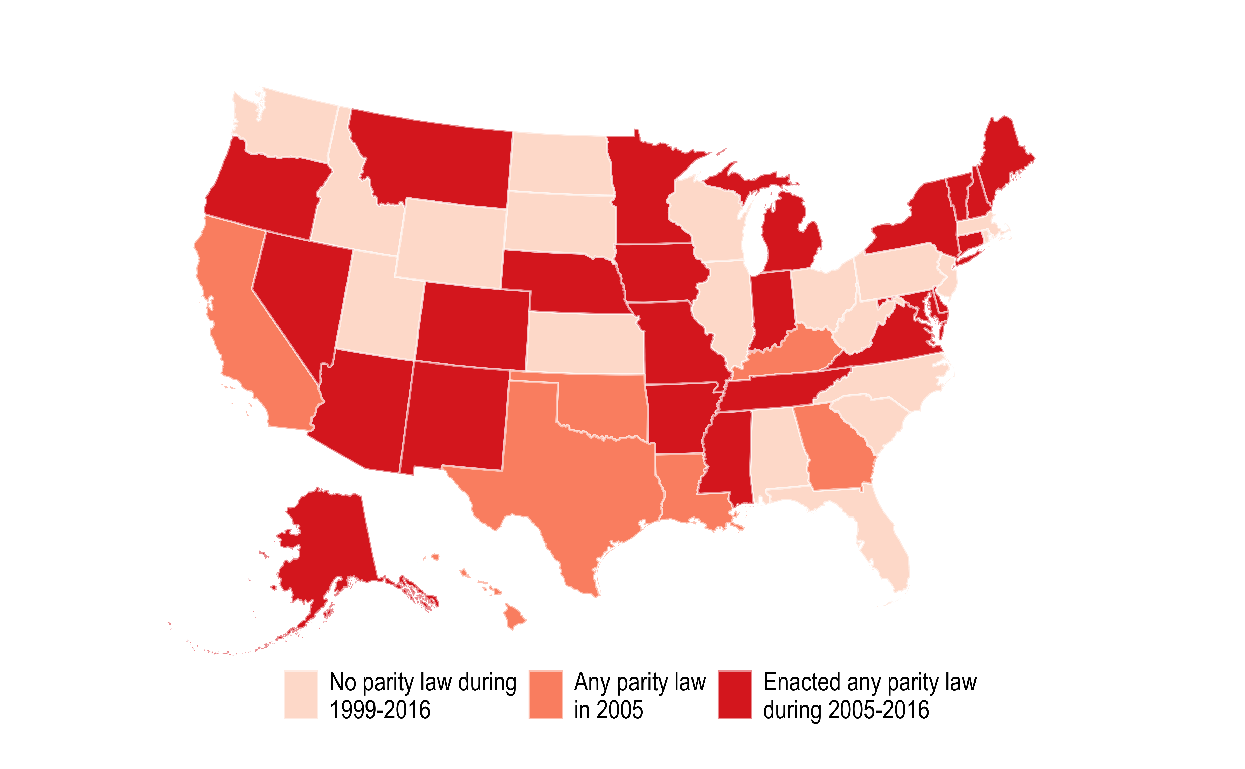

Figure 2. Changes in States Telehealth Parity Law (1999–2016). Note: We do not consider in the classification states that passed any parity law after 2016.