**Junho Choi**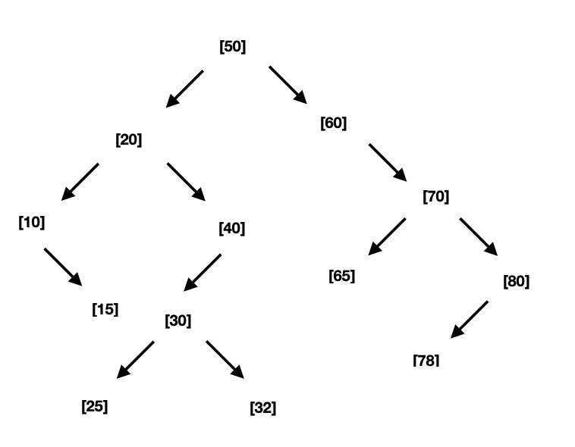

**3053290873**

1a

1b

Pre-Order : 50 20 10 15 40 30 25 32 60 70 65 80 78

In-Order : 10 15 20 25 30 32 40 50 60 65 70 78 80

Post-Order : 15 10 25 32 30 40 20 65 78 80 70 60 50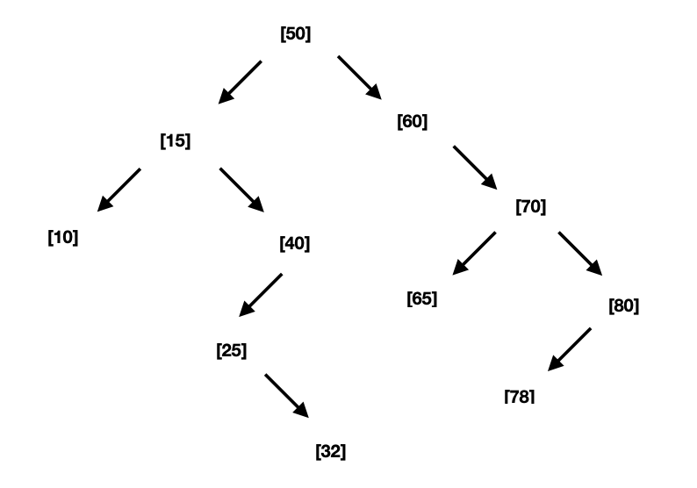

1c

2a

struct Node{

Node(int val):

_parent(nullptr), _left(nullptr), _right(nullptr), _val(val){}

Node* _parent, *_left, *_right;

int _val;

};

2b

Node* insertNode(Node* curNode, int val){

if curNode is nullptr :

return a new Node with val

if val is less than curNode’s val

set child pointer equal to insertNode(curNode’s _left Node, val)

set curNode’s left pointer to child pointer

set child pointer’s parent pointer to curNode

else if val is greater than curNode’s val

set child pointer equal to insertNode(curNode’s _right Node, val)

set curNode’s left pointer to child pointer

set child pointer’s parent pointer to curNode

return a pointer to curNode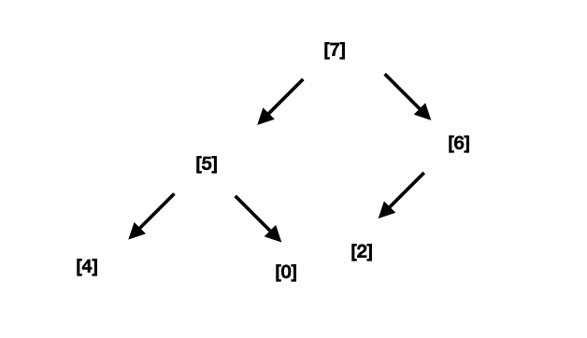

}

3a

3b {7, 5, 6, 4, 0, 2}

3c {6, 5, 2, 4, 0}

4a O(C + S)  
4b O(log C + S)  
4c O(log C + log S)

4d O(log S)

4e O(1)  
4f O(log C + S)

4g O(S log S) (with mergesort)

4h O(C log S)