CODE ESCAPE:
THE MISSING KID
Game Overview, Gameplay Guide, Features, and Technical Documentation
An educational programming adventure
Supports UN Sustainable Development Goal 4: Quality Education
Capstone Project Documentation
[Add team name, school and course here]
Document date: 13 October 2026 | Game status: in development

Project Status Summary
CODE ESCAPE: THE MISSING KID is still in development. The core game can be played from the main menu to the ending, but several parts are unfinished or still being checked. This document describes the game as it exists in the project files on 13 October 2026.
Item | Current situation
Game engine | Unity 6 (version 6000.5.10f1), PC game
Programming languages | Python, PHP and SQL (the player picks one)
Question bank | 48 questions: 16 for each language
Game locations | 6 (Home, Maple Street, Warehouse 7, Riverside Tech Facility, Old Station, SENTINEL Control Room)
Programming locks per playthrough | 9 (these must be solved to finish)
Dodge-or-code hazards | 28 across the six locations
Clue entries | 14 (8 main story clues and 6 optional hidden clues)
Saving | Local save on the computer is working. Cloud save (Unity Cloud Save) is in progress.
Not built yet (Planned) | Login and registration, and an administrator question editor

How to read the status labels: Implemented means the feature is built and was used during testing. In Progress means it exists but is unfinished, or has not been fully checked. Planned means it is not built yet.

Table of Contents
Project Status Summary 2
1. Introduction 5
2. Game Objectives 5
Main purpose 5
The player's mission 5
How programming challenges connect to gameplay 6
Educational goals 6
SDG 4: Quality Education 6
3. Story and Background 6
4. How the Game Works 7
5. Controls and Player Movement 8
Alex's movement and animations 8
6. Programming Languages and Lessons 9
How answers work 9
Question types used 9
When the answer is correct or incorrect 10
Python 10
PHP 10
SQL 10
Beginner ideas in plain language 10
7. Obstacles and the Dodge-or-Code Mechanic 10
Hazards the player can dodge 11
What happens when Alex is caught 11
8. Level Selection and Game Locations 12
What each card shows 12
How levels unlock and how the player moves between them 13
The locations 14
9. Game Features 15
10. Score, Clues, and Progress 16
Scoring rules 16
Rank on the results screen 16
Clues 16
Achievements 16
How progress is saved 16
11. Game Scenes 17
12. User Interface 17
Main menu 17
Language selection 18
Level selection 18
Gameplay screen (HUD) 18
Challenge window 18
Pause menu 18
Settings 19
Results screen 19
13. Technical Overview 19
14. How to Play 20
15. Educational Benefits 20
16. Current Limitations and Future Improvements 20
Confirmed from the project files 20
Not yet verified 21
Planned improvements 21
17. Conclusion 21

If the list above is empty or out of date, right-click it in Word and choose Update Field.

1. Introduction
CODE ESCAPE: THE MISSING KID is a 2D side-view adventure game for PC. The player controls a character named Alex and explores locations to find a missing younger sibling, Sam.
It is an educational game. To move forward, the player must solve short programming puzzles written in Python, PHP or SQL. The puzzles are built for beginners and are mixed into the story, so the player learns by playing instead of reading a lesson.
What a player can learn:
- How to read small pieces of code and say what they will do.
- Basic ideas such as variables, conditions (if / else), loops, lists or arrays, and functions.
- For SQL, how to ask a table of data a question using SELECT, WHERE, ORDER BY, COUNT and GROUP BY.
- How to spot mistakes in code and think logically when an answer is wrong.
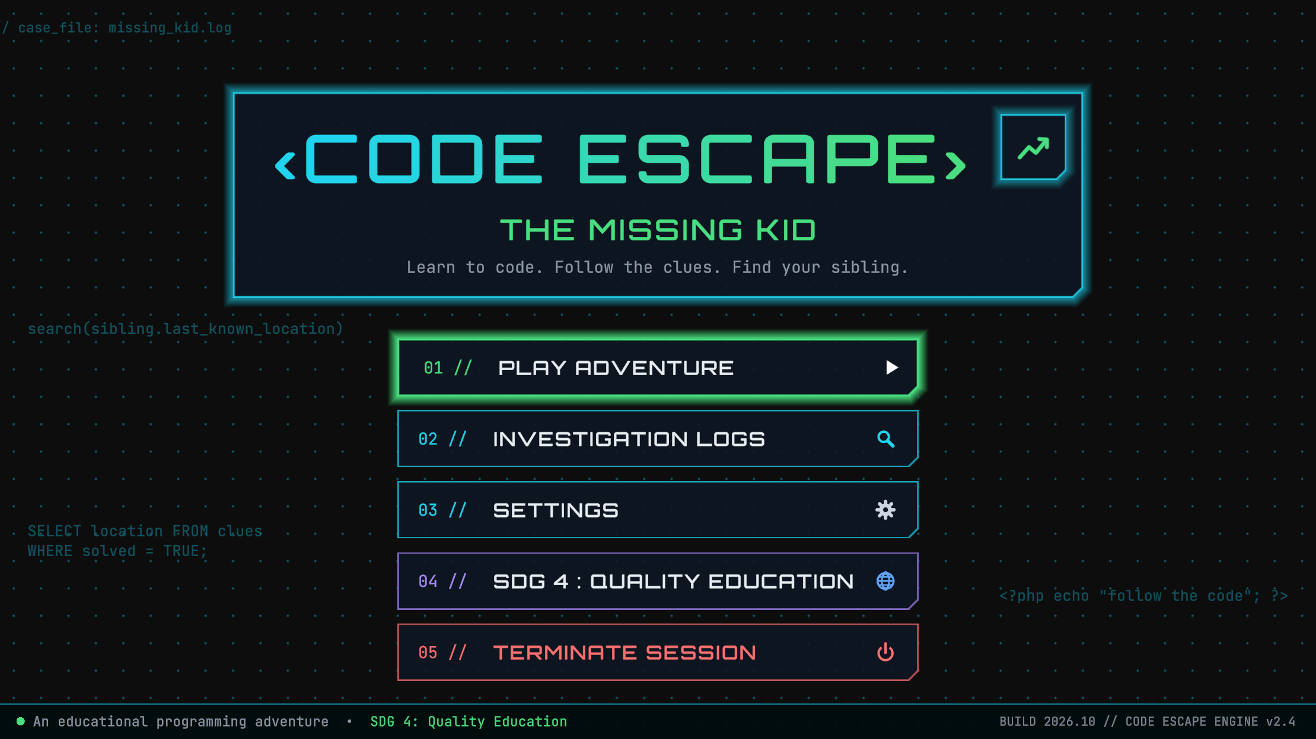
Figure 1: The main menu of CODE ESCAPE: THE MISSING KID.

2. Game Objectives

Main purpose
The main purpose is to help beginners practise programming logic in a way that feels like an adventure and not like a test.

The player's mission
Alex comes home and finds that Sam is missing. The player follows a trail of clues through six locations and finally reaches Sam. A computer system called SENTINEL has locked the way forward, and it only opens for someone who can solve its code puzzles.

How programming challenges connect to gameplay
- Locked doors, gates and keypads in the story are opened by solving a programming question.
- Hazards such as patrol robots and laser gates catch Alex if the player is careless. When Alex is caught, a question must be solved to escape. This is the "dodge-or-code" idea.
- Solving a challenge gives points, and some give a clue that moves the story forward.

Educational goals
- Practise reading and understanding simple code.
- Learn through trial and error. A wrong answer shows an explanation, and the player may try again.
- Build problem-solving and decision-making habits by choosing when to dodge and when to solve.
- Let the learner choose between three common beginner languages.

SDG 4: Quality Education
The game states on its main menu that it supports the United Nations Sustainable Development Goal 4, which is about inclusive and good-quality education. The game supports this goal by offering free-to-try, beginner-level programming practice in an engaging form. The game has not yet been tested with real students, so no learning results are claimed in this document.

3. Story and Background
This section only uses story details that appear in the game's dialogue and objectives.
It is a Tuesday afternoon, around 4:10 PM. Alex steps off the school bus on Maple Street and goes home. Sam is not there. Sam's bag and shoes are gone, and Sam was supposed to be home an hour earlier. Alex decides to "think like a detective".
Through a small window in the hallway door, Alex sees the old family computer running. It shows a message: "VISITOR DETECTED. CHECKPOINT 1 IS LOCKED. SOLVE THE CODE TO CONTINUE." Alex realises someone has set up a trail of code puzzles and decides to follow it.
How the story moves forward, location by location:
- Home: Alex cracks the keypad, finds the first clue ("Follow the code") and learns where to look next.
- Maple Street: Alex investigates the neighbourhood and opens a gate with a code lock.
- Warehouse 7: Alex finds small footprints that match Sam's size, passes another checkpoint, and finds a message hidden in the code that points to the old Riverside Tech facility.
- Riverside Tech Facility: Alex gets through the security doors and searches the control room.
- Old Station: Alex cracks the station's code lock and reads SENTINEL's route display, which says Sam is safe.
- SENTINEL Control Room: Alex unlocks the final security system and finds Sam.
In the ending, Sam explains that they wanted to finish a game called "Code Quest" and became a little scared. SENTINEL announces that all locks are solved and the visitor is released. Alex and Sam walk home together.

4. How the Game Works
The steps below follow the order of the scenes and scripts in the project.
- Open the main menu. The title screen offers Play Adventure, Investigation Logs, Settings, SDG 4: Quality Education and Terminate Session (exit).
- Choose Play Adventure. If a saved level is in progress, the game asks whether to Continue it or Select Level. Otherwise it goes straight to language selection.
- Choose a programming language. The player picks Python, PHP or SQL. Every puzzle in the playthrough then uses that language. Each language keeps its own progress.
- Pick a location on the level map. The map shows six location cards. Level 1 is open at the start and the next one opens after each is cleared.
- Watch the introduction. Starting Level 1 for the first time plays a short story introduction before the Home level.
- Explore the level. The player walks and jumps through the location, following the objective shown on the screen. Short story scenes and conversations play at key moments.
- Avoid hazards. Robots, lasers, cameras and similar hazards move in fixed patterns. Good timing avoids them.
- Solve programming challenges. A challenge opens either at a locked door or gate (the player presses E) or immediately when a hazard catches Alex.
- Collect clues. Clues are found by solving locks, by pressing E on story objects, and in hidden spots. They are saved in the Clue Journal.
- Leave the level. When the required challenges of the level are solved, the exit works and the next location unlocks. The game returns to the level map.
- Reach the ending. After the last location, the ending story plays, followed by the results screen.
Verification note: Each step above is supported by the project's scripts and scenes. A complete start-to-finish playthrough of all six locations in all three languages still needs to be done by the team and has not been confirmed in this document.

5. Controls and Player Movement
Action | Key or button
Move left / right | A and D, or the Left and Right arrow keys
Jump | W, the Up arrow key, or Space
Interact (open a lock, read a clue, use an exit, talk to Sam) | E
Continue a conversation | Space, Enter or E
Pause the game / go back one step in the pause menu | Esc
Skip a cutscene | Esc, then Y to confirm (N or Esc cancels)
Close a door or gate challenge without solving it | Esc (not allowed when a hazard has caught Alex)
Use menus | Mouse click. The level map also supports the arrow keys, A / D, Enter and Esc.

The controls are shown at the bottom of the gameplay screen so players can check them at any time.

Alex's movement and animations
Alex moves left and right at a steady speed and can jump. Gravity pulls Alex back down. Alex turns to face the direction of movement.
Alex has three sets of animation:
- Idle: a gentle breathing animation when standing still.
- Running: plays while Alex moves along the ground.
- Jumping: plays when Alex leaves the ground and while in the air.
The game checks whether Alex is on the ground and whether Alex is moving, and switches animations automatically.
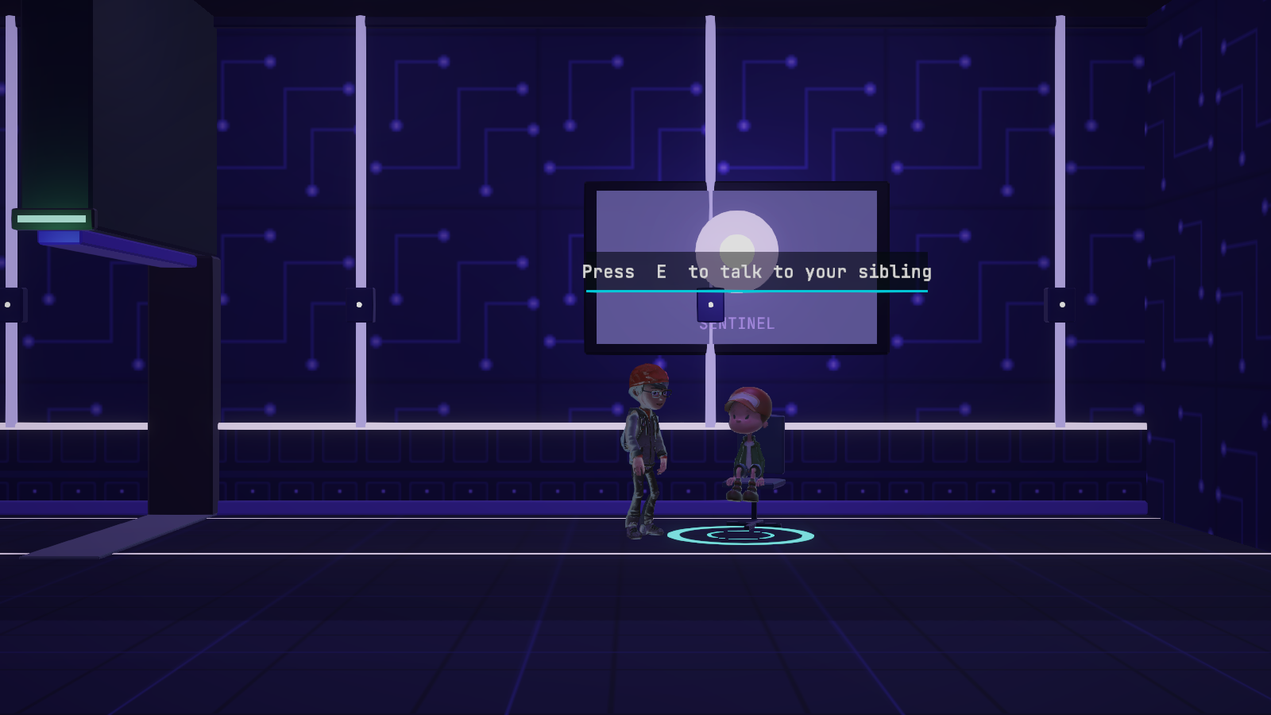
Figure 2: Alex (left) reaches Sam in the SENTINEL Control Room. The prompt shows the E key interaction.

6. Programming Languages and Lessons
The game has 48 questions in total, 16 for each language. The player chooses one language at the start, and all challenges then use that language.

How answers work
- Most questions (43 of 48) are multiple choice. The player clicks an option (A to D) and presses Submit.
- A few questions (5 of 48) ask the player to type a short answer.
- The game compares the answer with the correct answer stored in the project. It never runs the code the player types.

Question types used
Type | What the player does | Count
Predict the output | Read a short piece of code and say what it prints or returns | 21
Fill in the missing code | Choose or type the missing word or symbol | 8
Choose the correct code | Pick the version of the code that does the job | 7
Multiple choice | Answer a simple concept question | 6
Fix the incorrect code | Find the mistake in a short piece of code | 6

When the answer is correct or incorrect
- Correct: The game plays a success sound and shows a short explanation. For a locked door or gate, the player earns points and the lock opens. For a hazard, Alex is released.
- Incorrect: The game shows an explanation of the correct idea and a Retry button. There is no points penalty for a wrong answer.
- Hint: If a question has a hint, the player can open it. The first time a hint is used on a question, 25 points are deducted.

Python
Python is described in the game as "readable and beginner-friendly". The 16 questions cover: variables, data types, arithmetic, comparisons, boolean logic (true / false), if / else, loops, lists, functions, and a mixed review.

PHP
PHP is described as "the language of the web". The 16 questions cover: variables, strings, numbers, operators, boolean logic, if / else, loops, arrays, functions, and a mixed review.

SQL
SQL is described as "ask questions to data". The 16 questions cover: SELECT, WHERE, AND / OR, ORDER BY, COUNT, GROUP BY, INSERT, UPDATE, DELETE, and a mixed review. All SQL examples use made-up data in the game; the game does not connect to a real database.

Beginner ideas in plain language
Idea | What it means
Variable | A named box that holds a value, such as a number or a word.
Condition (if / else) | A choice: if something is true do one thing, otherwise do another.
Loop | A way to repeat an action several times without writing it again.
List / array | A group of values kept together in order.
Function | A named set of steps that can be used again whenever it is needed.
Boolean | A value that can only be true or false.
SELECT / WHERE | SQL words that mean "show me this data" and "only the rows that match".

Example of a question the player may see (Python, Easy): the code sets lasers = 3, then lasers = lasers + 2, then print(lasers). The player must choose what is printed. The correct answer is 5, because the second line adds 2 to the value that was already stored.

7. Obstacles and the Dodge-or-Code Mechanic
The game has two kinds of challenge. They look different and behave differently.
 | Locked doors, gates and keypads | Hazards (dodge-or-code)
How it starts | The player stands next to it and presses E. | Automatically, when a hazard touches or sees Alex.
Can the player close it? | Yes, with Esc, and try again later. | No. The challenge must be solved to escape.
Points | +100 for the first correct answer to a question. | None.
Result of a correct answer | The lock opens. A clue may be given. | Alex is freed and moved to a safe spot.
Needed to finish the level? | Yes (9 locks in a playthrough). | No, hazards only slow the player.

Hazards the player can dodge
There are 28 hazards across the six locations. Each repeats the same pattern, so a careful player can learn the timing.
Hazard | How to avoid it
Robot vacuum, delivery bot, security bot | They roll back and forth. Jump over them or time your crossing.
Laser gate | It switches on and off. A blinking amber warning appears before it turns on. Cross while it is off.
Laser tripwire | A beam across the floor. Jump over it.
Alarm floor | A floor panel that switches on and off with a warning blink. Cross while it is off.
Security camera | Its red view cone sweeps from side to side. Move through when the cone has swung away.
Drone | It flies back and forth and its searchlight turns on and off. Pass while the light is off.
Sliding door | It opens and closes on a timer with a warning blink. Walk through while it is open.
Swinging hook | A hook swinging like a pendulum. Pass when it swings away.

What happens when Alex is caught
- Alex stops moving and the game pauses.
- A window opens with the red banner "CAUGHT! SOLVE THE CODE TO ESCAPE!", a question, answer choices and a Submit button.
- A wrong answer shows an explanation and a Retry button. Alex stays caught.
- A correct answer frees Alex, who is moved to a safe spot nearby. A short grace period of about two seconds stops Alex being caught again straight away.
- The game then continues normally.
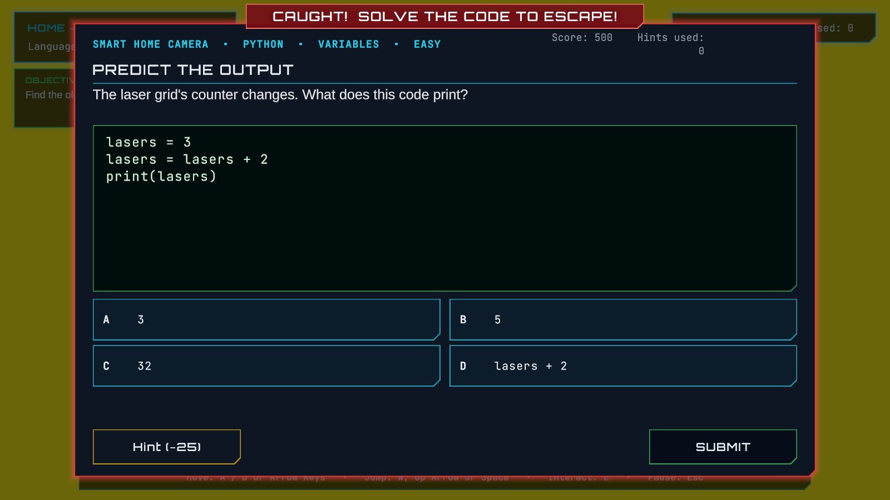
Figure 3: The "caught" challenge window after a hazard (here the Smart Home Camera) catches Alex.
Example: in Sam's room at Home there is a laser tripwire. If Alex jumps over it, nothing happens. If Alex walks into it, the challenge window opens and the player must answer a question to continue.

8. Level Selection and Game Locations
After choosing a language, the player sees a map titled "SELECT YOUR LOCATION". It shows six picture cards joined by a dotted route over a drawn town map.

What each card shows
- A picture of the location (the same picture style as the level itself).
- A small level number, the location name and a one-line description.
- A status: NEXT UP / IN PROGRESS, CLEARED (green frame and check mark) or LOCKED (dimmed with a padlock).
- A highlight and a small lift when the mouse or keyboard selects the card.
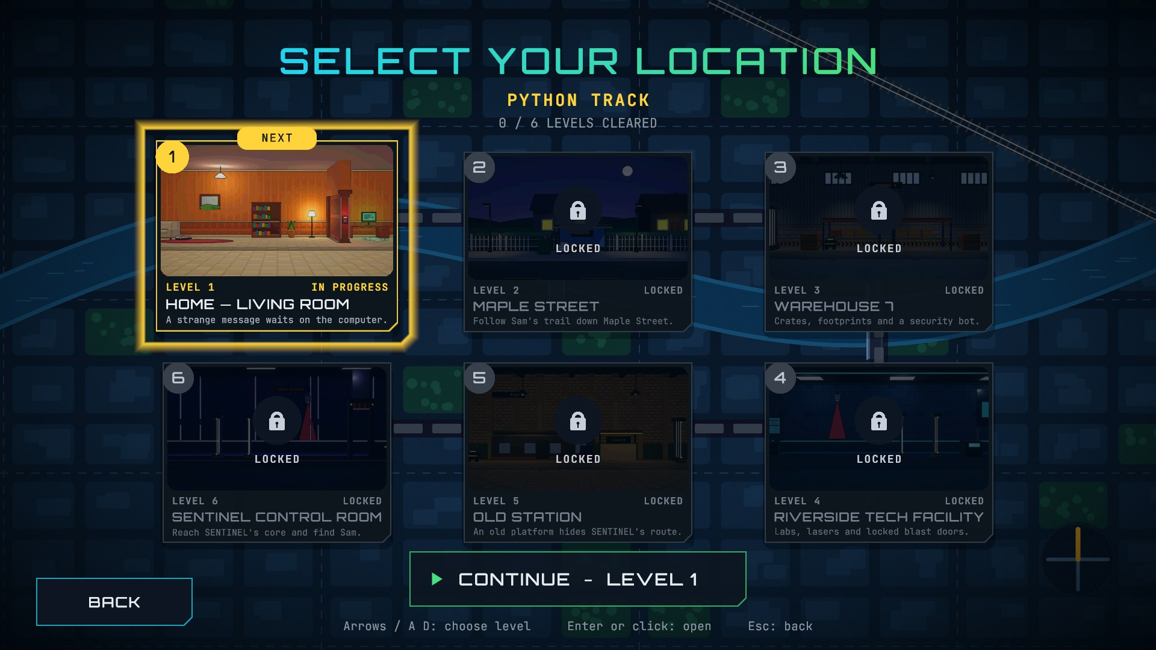
Figure 4: The level selection map at the start. Level 1 is open and Levels 2 to 6 are locked.
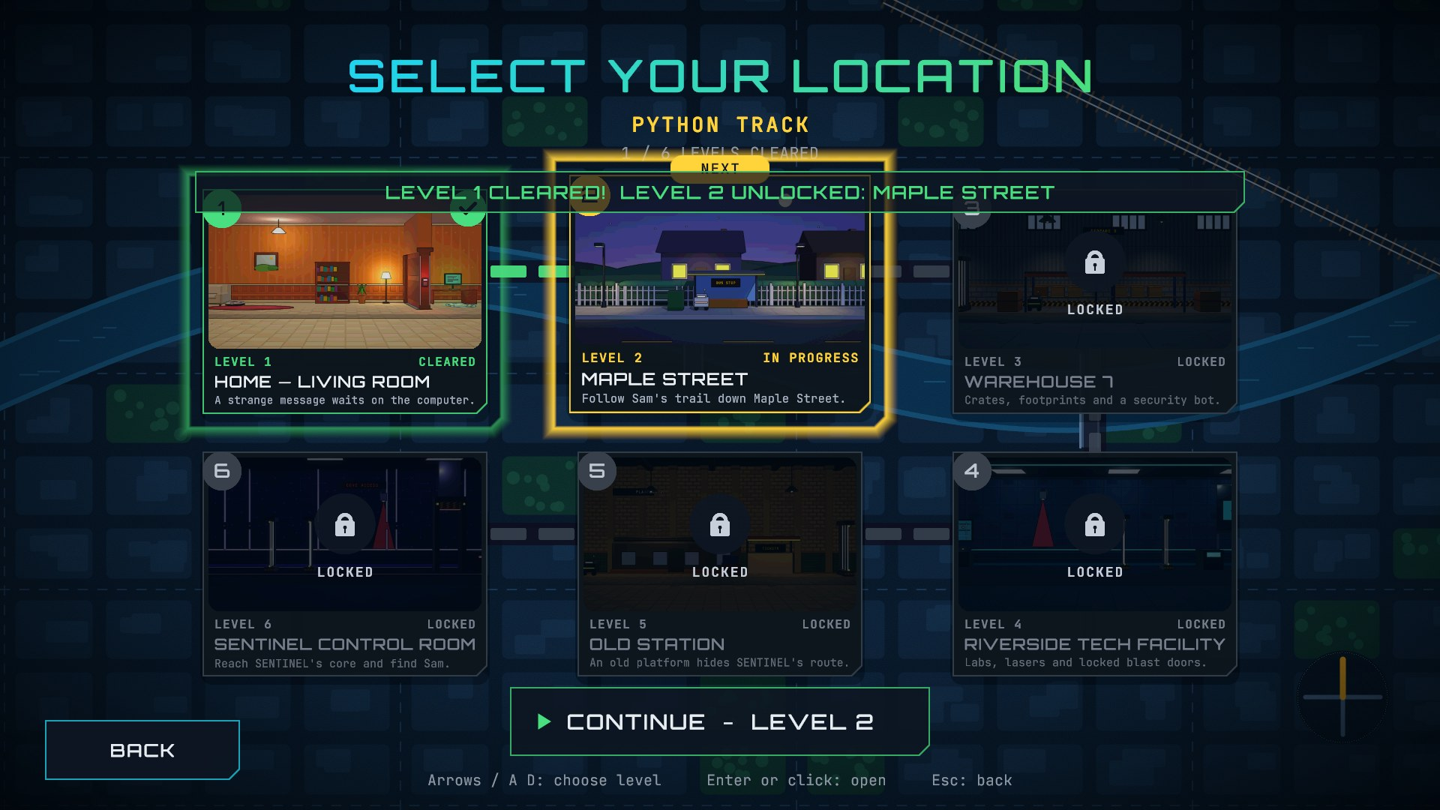
Figure 5: After clearing Level 1. Level 1 shows a check mark and Level 2 is unlocked. The "cleared / unlocked" message banner has since been moved into the gap between the two rows of cards.

How levels unlock and how the player moves between them
- Level 1 is always open. Each other level opens when the level before it is cleared.
- A level is cleared when the player uses its exit after solving all its required locks.
- Clicking a card opens a panel: Play / Continue / Restart for an open level, Replay and Skip to Next Level for a cleared level, and only an explanation for a locked level.
- Skip to Next Level is only offered for a level that is already cleared. It never marks a level as cleared.
- Each language keeps its own map progress.

The locations
Picture | Location (scene) | Purpose in the story | Locks to solve
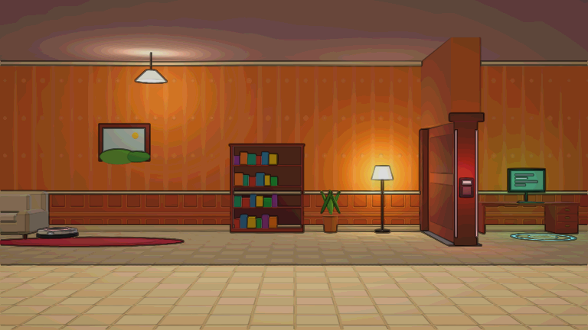 | Level 1: Home, Living Room (03_Home) | A strange message waits on the family computer. Alex cracks the hallway keypad and finds the first clue. | 1
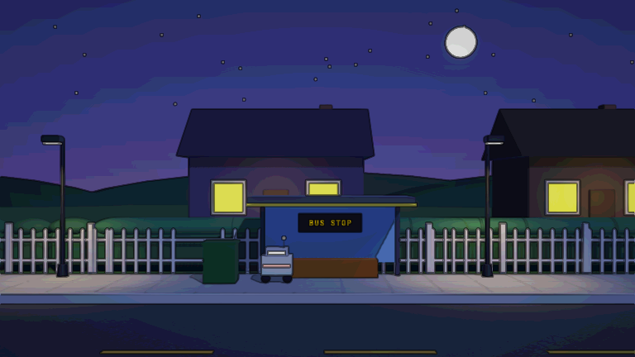 | Level 2: Maple Street (04_Neighborhood) | Follow Sam's trail down the street and open the gate's code lock. | 1
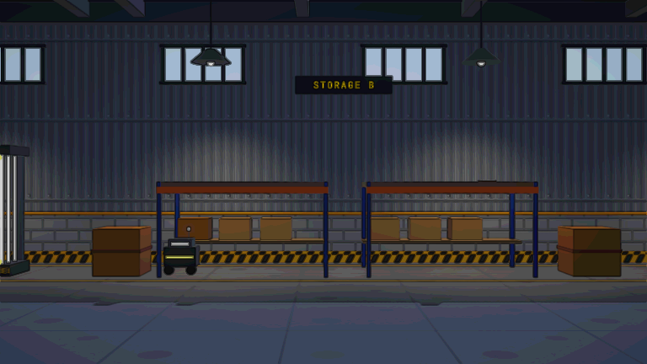 | Level 3: Warehouse 7 (05_Warehouse) | Crates, footprints and a security bot. Find the hidden message about Riverside Tech. | 1
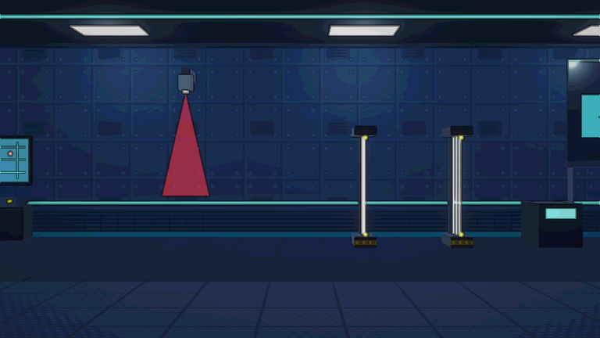 | Level 4: Riverside Tech Facility (06_Facility) | Labs, lasers and locked blast doors. Search the control room. | 2
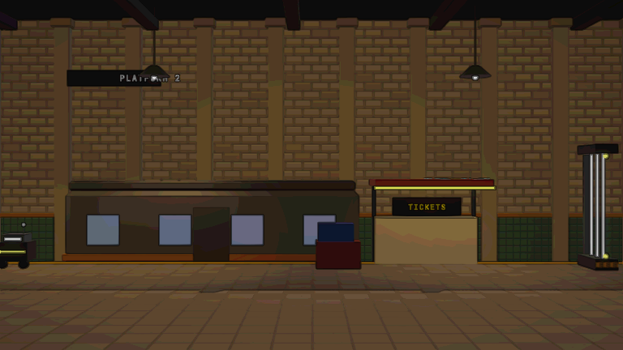 | Level 5: Old Station (07_Station) | An old platform hides SENTINEL's route. Crack the station lock and read the route display. | 1
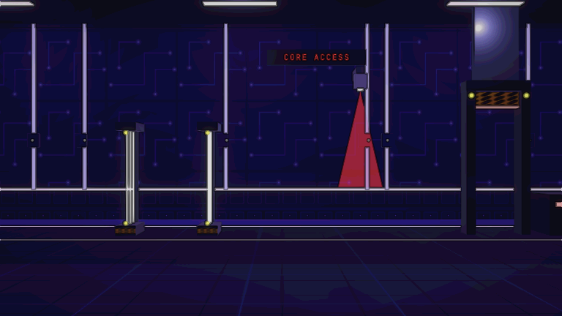 | Level 6: SENTINEL Control Room (08_FinalArea) | Unlock SENTINEL's final security system and find Sam. | 3

Each location was enlarged to about twice its original length and contains hazards, optional hidden clues and raised routes (platforms the player can jump onto).

9. Game Features
Feature | What It Does | Status
Main menu | Play Adventure, Investigation Logs, Settings, SDG 4 information, and exit | Implemented
Language selection | Choose Python, PHP or SQL; each keeps its own progress | Implemented
Story and cutscenes | Introduction, story scenes with dialogue, and an ending; scenes can be skipped | Implemented
Alex's movement and animations | Walking, jumping, idle, running and jumping animations | Implemented
Obstacles and collision detection | 28 hazards that catch Alex and open a challenge | Implemented
Programming challenge window | Shows the question, code, answer choices or typed answer, and an explanation | Implemented
Hint system | Optional hint for a 25-point cost, charged once per question | Implemented
Clue collection and journal | 14 clue entries, viewable from the pause menu and Investigation Logs | Implemented
Score system | +100 per solved lock question, -25 per hint, never below zero | Implemented
Level progression | Required locks must be solved before the exit works; the next level unlocks | Implemented
Level selection map | Picture cards, route, locked / next / cleared states, replay and skip | Implemented
Local save | Progress, language and settings saved on the computer; Continue button | Implemented
Pause menu and settings | Resume, Clue Journal, Restart Level, Settings, Main Menu; volume, fullscreen, resolution, Reset Progress | Implemented
Ending and results screen | Language, score, hints, clues, challenges, time, rank and Play Again | Implemented
Cloud save (Unity Cloud Save) | Anonymous sign-in and online copy of progress, with a save-status indicator and 5 achievements | In Progress
Level content balance and polish | Difficulty, timing of hazards and level length are still being tuned | In Progress
Login and registration | Sign in with a named account so progress belongs to a student | Planned
Administrator question editor | Lets an administrator edit questions | Planned

10. Score, Clues, and Progress

Scoring rules
- +100 points the first time a lock question is solved correctly.
- -25 points the first time a hint is used on a question.
- A wrong answer costs nothing.
- Hazard challenges give no points. They only free Alex.
- The score never goes below zero.

Rank on the results screen
The rank compares the final score with the best possible score (100 points for each of the 9 locks):
Score compared with the best possible | Rank
90% or more | MASTER CODER
70% to 89% | SKILLED DETECTIVE
40% to 69% | JUNIOR DETECTIVE
Under 40% | ROOKIE

Clues
- There are 14 clue entries. Eight belong to the main story and six are optional hidden clues placed in the expanded levels.
- Clues come from solving locks, from pressing E on story objects, and from hidden spots that need climbing or careful exploring.
- A pop-up announces each new clue. The Clue Journal lists them and can be opened from the pause menu or from Investigation Logs.
- A clue can only be collected once.

Achievements
The cloud save also records five achievements: First Challenge Solved, First Level Cleared, Five Challenges Solved, Halfway Through the Case, and Case Closed.

How progress is saved
- On the computer (working): The game stores progress, the chosen language and settings in the computer's own storage (Unity PlayerPrefs, as text). It saves when clues, challenges, story steps and levels change. The Continue button uses this save. A finished story clears the save. Reset Progress (in Settings on the main menu) deletes it.
- Online (in progress): The project includes Unity Cloud Save with anonymous sign-in. The code copies progress to the cloud in the background and shows a save-status indicator. It has not yet been verified in this document that this works on every computer, so it is marked In Progress.
- Not available yet: Because sign-in is anonymous, progress belongs to the device. There is no login yet, so progress cannot be tied to a named student.

11. Game Scenes
A scene is one screen or location of the game. The numbers in the names set the usual order.
Scene name | In plain language | When it appears
00_MainMenu | Main menu | When the game opens and after quitting a level
01_LanguageSelect | Choose your language | After Play Adventure, or when starting a new playthrough
01b_LevelMap | Level selection map | After choosing a language and after clearing a level
02_Intro | Story introduction | When Level 1 is started for the first time
03_Home | Level 1: Home, living room | Level 1
04_Neighborhood | Level 2: Maple Street | Level 2
05_Warehouse | Level 3: Warehouse 7 | Level 3
06_Facility | Level 4: Riverside Tech Facility | Level 4
07_Station | Level 5: Old Station | Level 5
08_FinalArea | Level 6: SENTINEL Control Room | Level 6, the last level
09_Ending | Ending story | After the last level is cleared
10_Results | Results screen | After the ending
SampleScene | A default Unity example scene | Not part of the game flow (needs checking whether it can be removed)

12. User Interface

Main menu
Five numbered buttons: Play Adventure, Investigation Logs (the clue list), Settings, SDG 4: Quality Education, and Terminate Session (exit). Play Adventure may first ask Continue or Select Level.

Language selection
Three cards for Python, PHP and SQL, each with a short description. A note says the choice stays the same for the whole playthrough. Esc or Back returns to the main menu.
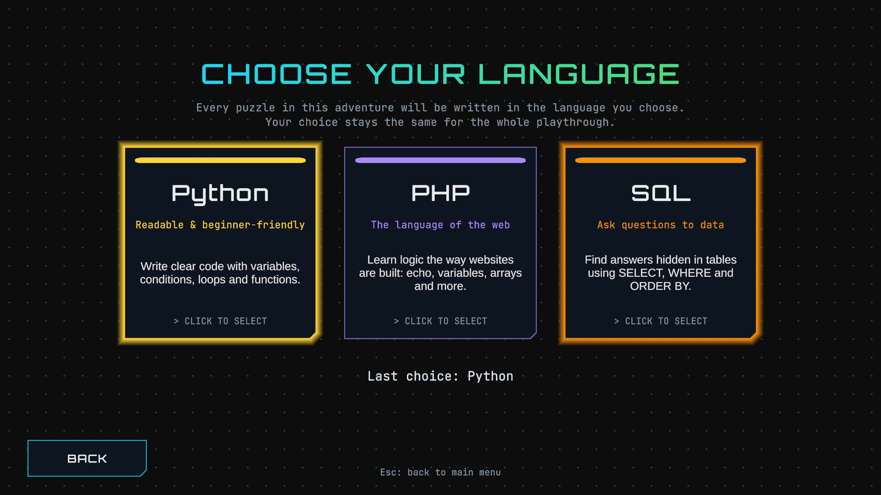
Figure 6: The language selection screen.

Level selection
Described in section 8. The screen also has a Play / Continue button under the cards, a Back button, and a hint line showing the keyboard controls.

Gameplay screen (HUD)
- Top left: current location and selected language.
- Top right: score and hints used.
- Objective box: what to do next, for example "Find the first clue."
- Clue counter, and a controls reminder along the bottom.

Challenge window
Shows the topic and difficulty, the type of question, the question text, a code box, the answer options or a text box, a Hint button and a Submit button. After answering, it shows the result, an explanation and Retry or Continue. When caught by a hazard, the window has a red banner and no Close button.

Pause menu
Press Esc to open it. Buttons: Resume, Clue Journal, Restart Level, Settings and Main Menu.
[SCREENSHOT TO CAPTURE] The pause menu over a current level (press Esc in any level).

Settings
Music volume, sound-effects volume, fullscreen on / off, screen resolution, Apply and Back. On the main menu only, there is also a Reset Progress button.
[SCREENSHOT TO CAPTURE] The Settings screen as it looks now.

Results screen
Shows language, score, hints used, clues collected, challenges completed, time played, completion status ("CASE SOLVED"), and the rank. Buttons: Return to Main Menu and Play Again.
[SCREENSHOT TO CAPTURE] The Results screen at the end of a playthrough.

13. Technical Overview
Topic | Explanation
Game engine | Unity 6 (6000.5.10f1) with the Universal Render Pipeline for graphics. C# is the programming language used to make the game.
Look of the game | Gameplay is 2D (left and right, with jumping). The levels and characters are 3D-looking models seen from the side, which gives depth.
How scenes are organised | Each menu, level and screen is its own Unity scene. A shared "GameSystems" object stays alive between scenes and holds the managers for language, score, clues, story, levels, audio and saving.
Player movement | A Player Controller script reads the keyboard through Unity's Input System, moves Alex using 2D physics, and tells the animation system whether Alex is running or jumping.
Questions | Each question is a stored data item with the text, code, choices, correct answer, hint and explanation. A Challenge Manager picks the question for the chosen language, shows it, checks the answer and updates the score.
Level progression | A Level Manager lists the six levels and which locks each one needs. A Level Progress Manager remembers which levels are cleared for each language and decides what is locked.
Saving | Local save: JSON text kept in PlayerPrefs on the computer. Cloud save: Unity Cloud Save through the Cloud Progress Service (in progress).
External services and packages | Unity Cloud Save and Unity Authentication (anonymous sign-in); Unity Input System; TextMesh Pro for text; Universal Render Pipeline; Unity 2D animation tools.
Safety | The game never runs code typed by the player and does not connect to a real database. This document contains no passwords, keys or tokens.

14. How to Play
- Start the game and click Play Adventure on the main menu.
- Choose a language: Python, PHP or SQL. Pick the one you want to practise.
- Click the first card on the map (Home) and choose Play Level.
- Watch the story and press Space, Enter or E to move through the conversation.
- Look at the Objective box on the screen. It tells you what to do next.
- Walk with A and D (or the arrow keys) and jump with W, Up or Space.
- Press E next to glowing objects, doors and keypads to inspect them or open a challenge.
- Answer the question. Pick an option and press Submit. If you are stuck, use the Hint (it costs 25 points). If you are wrong, read the explanation and try again.
- Watch out for hazards. Learn their pattern and time your movement. If one catches you, solve the question to get free.
- Collect clues and look for hidden ones on high shelves, roofs and ledges.
- Use the exit when the objective says so. You return to the map and the next location opens.
- Keep going until you reach Sam. Press Esc at any time to pause, read your clues or leave.

15. Educational Benefits
- Practice: players meet the same beginner ideas several times in different forms, such as predicting output, filling in code and fixing mistakes.
- Logical thinking: the player must follow code step by step to decide what it does.
- Decision-making: the player chooses whether to dodge a hazard, risk a hint or answer a question.
- Learning through trial and error: wrong answers can be retried, with an explanation that shows the reason.
- Choice: three languages let learners try web scripting (PHP), general programming (Python) or data queries (SQL).
Important: these benefits describe how the game is designed. The game has not been tested in a classroom or studied for learning results, so this document makes no claim that it improves test scores.

16. Current Limitations and Future Improvements

Confirmed from the project files
- The cloud save step may stop the game from starting without an internet connection. The code includes a screen that waits for Cloud Save and offers Retry. This needs to be checked.
- Progress is tied to the device, because sign-in is anonymous.
- The 48 questions have not yet been reviewed by a teacher or checked against an official curriculum.
- Only a small part of the question bank is used per playthrough: 9 locks plus whichever hazards the player is caught by.
- SampleScene is an unused default Unity scene.
- The game has not been tested with students.

Not yet verified
- A full start-to-finish playthrough in all three languages.
- Keyboard-only navigation of every menu.
- Behaviour on different screen sizes beyond the level map.
- Whether the cloud save restores progress correctly on a second computer.

Planned improvements
- Login and registration so progress belongs to a named student.
- An administrator question editor so teachers can change questions.
- Teacher review of all questions, with a reference for each.
- Classroom testing and feedback.

17. Conclusion
CODE ESCAPE: THE MISSING KID turns beginner programming practice into a story. The player follows clues through six locations, dodges hazards, and answers Python, PHP or SQL puzzles to open locks and escape. A score, a rank and a clue journal give feedback along the way.
The main game is built and playable: menus, language choice, story, movement, obstacles, challenges, level map, saving on the computer, and the ending with results. Cloud saving is in progress, and login and the administrator editor are planned. The game is still in development, and its educational value has not yet been tested with students.
Appendix: How this document was prepared
The facts in this document were taken from the project's scripts, scenes, prefabs and data files (questions, clues, dialogue and cutscenes). Screenshots are real captures of the game. Items that could not be confirmed are marked as needing a check. The Unity editor connection was not available when this document was written, so no new screenshots were captured; the placeholders mark the ones to add.

