**Homework 14**

**Due: Wednesday, December 13th at 1:30PM**

**PART I: Conceptual Questions**

1. What do Judd and colleagues recommend in terms of reporting “simple” and “main” effects? What is their justification? Does Jaccard (2003) agree or disagree with this perspective?
2. A researcher is studying population density maps. She presents different maps to participants to indicate how many people live in each region of a made-up country. She predicts that presenting the map on a white background rather than a black background will predict higher estimates of the country’s population. She also examines whether a map that has borders (versus no boarders) leads to higher estimates of the country’s population than a map that does not have borders.  
   Please refer to the following table, representing participants’ group means for estimated population density (1 = 1,000,000 people):

|  |  |  |  |
| --- | --- | --- | --- |
|  |  | **Borders** | |
|  |  | **Has Boarders** | **No Boarders** |
| **Background** | **White** | 5 | 7 |
| **Black** | 4 | 5 |

* 1. What is(are) the simple effect(s) for background?
  2. What is(are) the simple effect(s) for boarders?
  3. What is(are) the main effect(s) for background?
  4. What is(are) the main effect(s) for boarders?
  5. What is(are) the grand mean(s) for the present study?

**PART II: ANCOVA**

Instructional gestures can influence children’s comprehension and learning. One potential reason is that seeing gesturing encourages children to gesture themselves. The current study examined the role of gesture for learning shape patterns in a sample of 60 four- to six-year-old children patterning skills.

Children received a lesson from a researcher on shape patterning (see figure below) with or without gesture. Then, children solved nine patterning problems on their own. The nine patterning problems consisted of three completion, extension, and abstraction items. After solving each item, children were asked to explain their solutions. During each child’s explanation, the researcher noted whether the child produced gestures themselves. The researcher hypothesized that the effect of gesture is moderated by whether children gesture themselves, even after controlling for age. Note that while the stimuli below are real, the research questions and data were made up for this assignment.

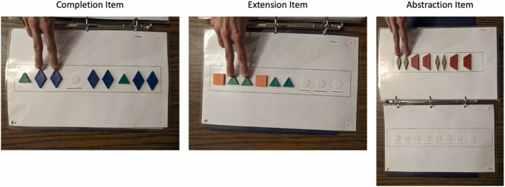

Figure 1. Examples of various patterning problems and the kinds of gestures children saw.

**Codebook for “gestureproduction.csv”**

|  |  |  |
| --- | --- | --- |
| **Name** | **Description** | **Values** |
| **Child_ID** | ID of participant | 1-60 |
| **Age** | Age in months | 48-72 |
| **Condition** | Gesture manipulation | without_gesture or with_gesture |
| **Produced_Gesture** | Whether the participant ever produced gestures during explanations | 0 = did not produce  1 = did produce |
| **Performance** | Percent correct on nine patterning problems | 0-100 |

**Answer the following questions (all in your R Markdown file):**

1. Read the data into R, convert names to snake case. Examine univariate and bivariate statistics (i.e., generate a correlation matrix between age, condition, produced_gesture, and performance). Note any significant correlations.
2. Center condition, produced_gesture, and age. Then, fit a new model that regresses performance on condition_c, produced_gesture_c, their interaction, and age_c (covariate).
3. According to Yzerbyt et al. (2004), why is this not the correct analysis in this situation? Hint: think about the IVs.
4. Create a new model that Yzerbyt and colleagues (and we) would consider the be the correct way to analyze these data. Interpret each of the regression coefficients from this model individually.
5. Make a publication-quality bar plot displaying these results, *using the adjusted means* when controlling for age. (Note: this means you should not plot the raw data)

**PART III: Polynomial Regression**

A sociologist wants to know whether the percentage of a state’s population living in a metropolitan area can predict per capita state and local public expenditure. Put simply, do cities cost the state more money? The researcher acquired data from forty-eight states (excluding Hawaii and Alaska because she does not have enough funding to travel out of the continental U.S.). Data include how much public money (in dollars) is spent on each individual on average for the year of 1960 (“Ex”) and the percentage of population living in metropolitan areas in each state (“MET”).

**Codebook for “population.csv”**

|  |  |  |  |
| --- | --- | --- | --- |
| **Column** | **Variable** | **Description** | **Values** |
| 1 | Ex | Per capita state and local public expenditures ($) | 183-454 |
| 2 | MET | Metro population, i.e., percentage of population living in standard metropolitan areas | 0-86.5 |

**Answer the following questions (all in your R Markdown file):**

1. Read the data into R, convert names to snake case, and remove the column labeled grp.
2. Examine a quick and dirty scatterplot with percentage of population living in metropolitan on the x-axis and public expenditures on the y-axis. At a glance, does the distribution of datapoints resemble a linear or quadratic trend?
3. The researcher does not have an *a priori* prediction about the shape of the relationship between percentage of population living in metropolitan areas and public expenditures. Run a model in which the relation is assumed to be linear and a model in which the relation is assumed to be quadratic. Do not center your predictors yet. Based on the results, which model should she choose?
4. Regardless of the model you chose, fit a new model with linear and quadratic trends for mean-centered metro population. Compare this model (parameter estimates, SE, overall model R2) to a model with only a linear predictor for metro population. Do any values change, and if so, why?
5. Make a figure in which the quadratic model is depicted. The figure should be publication quality with uncentered met (metro population).
6. What is the optimum proportion of metropolitan residents that would yield the lowest per capita public expenditure?
7. Write up a summary of the results.
8. In hours, how long did this assignment take you?