Comprehensive Assignment 2

Psychology 610

Due Date: Wednesday, November 15th, 1:30pm

**Academic misconduct:** You are allowed and encouraged to refer to prior lab scripts, homework assignments, books/articles, and the internet. However, you may not consult with other students (e.g., via Slack), and this includes more advanced students in your program. You cannot give help or receive help. You CAN email the TAs to ask questions, but we will not be as instructive as we would be for a regular assignment.

**Submitting your assignment, 2 points:** Use RMarkdown as you do for homework assignments and submit your files anonymously. Submit an .Rmd and .pdf file. Use the last 4 digits of your student ID number in the format ####_comp_hw_02.Rmd, where #### represents the last 4 digits your ID. Include no identifying information in your files!

The number of points each question is worth appears in the parentheses next to the question, for a total of 100 points. Four points are awarded for the correct file submission and naming. To obtain these 4 points, you must submit both an RMarkdown and PDF file.

**Formatting your assignment, 2 points:** Label your answers in RMarkdown according to the sections and question numbers given here (e.g., with a Conceptual Questions section and a Data Analysis section). Use RMarkdown heading level 1 (#) for section headings (e.g., “Experimental design,” “Reading questions”, etc.). Use RMarkdown heading level 2 (##) for question numbers. Use RMarkdown heading level 3 (###) if there are question letters. Always start your answer on a new line following any question number, so your response is not formatted like a heading.

Please do not repeat the question prompt next to the question number in your RMarkdown script; the number is plenty for us. Repeating the question adds more clutter we must sort through for grading and could cause knitting errors.

Remember to create a chunk in your RMarkdown file that is specifically for loading in any packages needed to complete this assignment, as well as sourcing in functions 610710_functions.R.

Follow the course style guide and norms for naming variables and models.

**Part A: Conceptual Questions, 16 points**

A1. Judd, McClelland, and Ryan (2017) declare that it is unethical to include outliers in analyses without reporting or removing them. In your own words, what are the ethical grounds the authors use to support this claim? Why should we care as statisticians and practitioners of science? (2 pts)

A2. You find yourself in the middle of testing the conditions of a mediation model when suddenly R stops working and you must continue by hand. Before R stopped working, you had successfully calculated the size of the effect for the b path (.367), the a path (.988), and the c path (3.65). Moreover, you found that all three of these pathways were significant -- paths a and b were just *barely* significant. Calculate the indirect effect and the direct effect. (2 pts)

A3. The next day (when R was working again) you calculated the size of the effect for the direct and indirect effect using R. Your linear model testing the direct effect revealed that it was significant. Your bootstrapping method estimated a 95% percent confidence interval around the indirect effect ranging from -3.65 to .01. Based on this information, can you conclude that the data are consistent with the hypothesized mediation model? Why or why not? (2 pts)

A4. Why is the Sobel test problematic? What is the advantage of the non-parametric bootstrapping method over the Sobel test? (2 pts)

A5. Judd, Yzerbyt, and Muller (2014) claim that the term “direct effect” in mediation analysis can be misleading. In your own words, explain why. (1 pt)

A6. For the following statements about mediation say true or false.

1. Mediation analysis can determine causality between the independent variable (IV) and the dependent variable (DV). (1 pt)
2. Once the indirect effect is significant, it is impossible to have a non-significant total effect. (1 pt)

A7. A researcher compares a model with five predictors to a model with three predictors. Why is this comparison not very useful in most cases? (1 pt)

A8. For the following statements about multicollinearity say true or false.

1. Having a correlation of .9 between your predictor and your outcome variable leads to multicollinearity. (1 pt)
2. Multicollinearity is only a problem if it involves a focal predictor. (1 pt)

A9. For the following statements about case analysis say true or false.

1. Hat values represent leverage on one predictor: your focal predictor. (1 pt)
2. I have three predictors and 120 participants. I will have 120 Cook’s D values across ALL parameters and 120 dfbetas PER parameter. (1 pt)

**Part B: Data Analysis 1, 40 points**

For Part B of the assignment, you will analyze data from the Trends in International Mathematics and Science Study (TIMSS). TIMSS is a well-established international assessment of mathematics and science at the fourth and eighth grades. The study is led by the International Association for the Evaluation of Educational Achievement at Boston College’s Lynch School of Education and Human Development. It is administered every four years, and as of 2019, approximately 60 countries use TIMSS trend data for monitoring the effectiveness of their educational systems in a global context. In 2019, the study was administered to children electronically. The results were made publicly available online (see link below). For this assignment, we will focus on fourth-grade level mathematics.

Many jobs require a basic understanding of mathematics, and this will become increasingly so in the future. Mathematics helps us manage a host of daily tasks and is essential in developing the technology we depend on, such as computers, smartphones, and television.

The TIMSS assesses various aspects that are crucial for effective mathematics learning. These aspects include content-related, cognitive, and contextual dimensions.

Content-related dimensions include areas such as number, measurement, geometry, and data. Cognitive dimensions consist of “knowing” (which contributes to 40% of the total assessment), “applying” (also contributing to 40% of the total assessment), and “reasoning” (which accounts for 20% of the total assessment). Contextual dimensions go beyond just academic content and evaluate the context in which learning occurs. These dimensions include measurements examining students’ experiences in schools and the home (e.g., having adequate resources), as well as their attitudes towards learning (e.g., confidence in math and/or liking math).

In the following data analyses, you will develop and test research questions with a subset of data from the TIMSS. In the dataset, *each row represents a country*, and the scores are national average scores. The data are from fourth graders.

Mullis, I. V. S., Martin, M. O., Foy, P., Kelly, D. L., & Fishbein, B. (2020). *TIMSS 2019 International Results in Mathematics and Science.* Retrieved from Boston College, TIMSS & PIRLS International Study Center website: [https://timssandpirls.bc.edu/timss2019/international-results/](https://timss2019.org/reports)

Codebook:

|  |  |  |
| --- | --- | --- |
| Column | Variable | Description |
| 1 | Country | Country that participated in the TIMSS |
| 2 | Overall Math Score | TIMSS assessment across all content-related dimensions |
| 3 | Math Knowing | TIMSS assessment that covers the facts, concepts, and procedures students need to know |
| 4 | Math Applying | TIMSS assessment that focuses on ability of students to apply knowledge and conceptual understanding to solve problems |
| 5 | Math Reasoning | TIMSS assessment that encompasses unfamiliar situations, complex contexts, and multistep problems |
| 6 | Students Conf Matha | Students' confidence in mathematics (greater score indicates higher confidence in mathematics) |
| 7 | Students Like Matha | Students' liking of mathematics (greater score indicates higher liking of mathematics) |
| 8 | School Resourcesa | Available mathematics resources likely to positively affect instruction (textbooks, classrooms, etc.; greater score indicates more resources) |
| 9 | Home Resourcesa | Available home resources for mathematics learning (books, internet access, etc.; greater score indicates more resources) |
| 10 | Global Region | The global region which a country resides in |
| 11 | GNI Per Capitab | Gross national income (= average income) earned by a country's residents in 2019 (in USD) |
| 12 | Percent Girls | Percentage of girls who took assessment |

aResponses were scaled so that the scores of the combined distribution of all TIMSS 2019 fourth-grade countries had a mean of 10.

bObtained from <https://data.worldbank.org/indicator/NY.GNP.PCAP.CD>.

B1. Read the description of this study and familiarize yourself with the codebook. Identify three possible research questions you could address with this dataset. (1 pt)

B2. Is the study causal or correlational? Describe in 1-2 sentences how you know. (1 pt)

B3. Read in the data (timss.csv) and convert variables to snake case. Get descriptives statistics for all variables. Are there any missing values? (2 pt)

B4. Consider the research question: Do attitudes about mathematics relate to performance on the TIMSS math assessment on the cognitive dimensions? Generate a correlation matrix with Math Knowing, Math Applying, Math Reasoning, Students Conf Math, and Students Like Math. (1 pt)

B5. In the US, girls are disproportionately affected by stereotype threat in math. We want to know whether a favorable attitude about math (liking math) predicts overall performance on the TIMSS math content assessment controlling for the percentage of girls who participated in the study. What is the focal predictor? What is the covariate? List the compact and augmented model. (4 pts)

B6. Fit the appropriate linear model from B5 with uncentered predictors. Interpret b0, b1, and b2. (4 pts)

B7. Obtain ηp2 and ΔR2 for the two predictors in the model from B8. (2 pts)

B8. Now, consider the research question: Does gross national income, school resources, and home resources relate to each of the three cognitive dimensions of the TIMSS assessment? Generate a 6x6 correlation matrix. (1 pt)

B9. List and describe (direction and strength) significant correlations between gross national income, school resources, and home resources with ONLY the *math knowing* dimension. (3 pts)

B10. Now, consider the research question: Does gross national income per capita predict overall performance on the TIMSS content-related assessment controlling for school resources and home resources? What is the focal predictor? What are the covariates? List the compact and augmented model. (5 pts)

B11. Center the three predictors (for easier interpretation of the intercept) and fit the appropriate linear model. Interpret b0, b1, b2, and b3. (5 pts)

B12. By considering all the information you have up to this point, do you think there may be an issue with multicollinearity in this model? In general, what happens to standard errors when multicollinearity occurs? (2 pts)

B13. Directly test the multicollinearity of each predictor in the model from B13. What is the variance inflation factor for each variable and do any exceed the conventional cut off? (3 pts)

B14. Generate the following publication-quality plot: (6 pts)

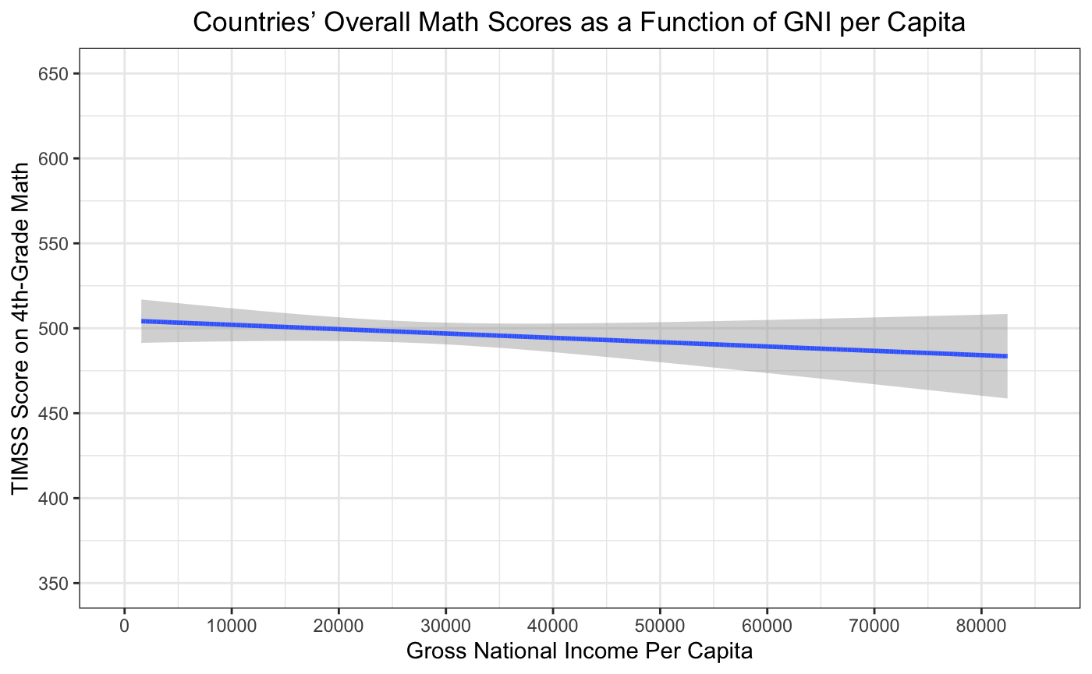

Note: This is a scatterplot in which countries’ overall math scores are shown as a function of GNI. Plotted are the model predictions from a model in which overall math score was regressed on GNI, school resources, and home resources.

B15. Extra Credit: Use ggplot2 to create a scatter plot with overall math score on the y-axis and gross national income per capita on the x-axis. Include six datapoints that represent the average math score and average GNI for each global region. Make each datapoint a different color. Label your x- and y-axes. (5 pts)

*Assignment continued onto next page…*

**Part C: Data Analysis 2, 40 points**

For Part C of the assignment, we will narrow from a global perspective to a local one. You will analyze a subset of data collected on Zoom from a math intervention study. Participants were a convenience sample recruited from the Madison, WI area.

Integer arithmetic skills (e.g., addition with positive and negative numbers) are important for more advanced mathematical performance and learning. This study investigated factors associated with fluency in integer addition in children in fifth through seventh grade (*N* = 62, *M*age = 11.44 years). The researchers examined demographic, attitudinal, and cognitive factors, which included age, grade, gender, mathematics anxiety, understanding of the Additive Inverse principle (i.e., the sum of any number and its inverse is 0), and use of mathematically precise language (“negative” rather than “minus” on a related task).

Codebook:

|  |  |  |
| --- | --- | --- |
| Column | Variable | Description |
| 1 | SubID | Subject ID |
| 2 | Age Months | Age of participant in months |
| 3 | Grade Level | Grade of participant (1 = fifth grade, 2 = sixth grade, 3 = seventh grade) |
| 4 | Gender | Gender of participant (0 = female, 1 = male, 2 = non-binary) |
| 5 | Integer Fluency | Total correct out of 26 problems (e.g., 2 + (-6) = ?) on a two-minute integer addition task |
| 6-14 | MA 1 to MA 9 | A scale of how anxious children are in nine different scenarios (e.g., “Finding out you’re going to have a surprise math quiz when you start your math lesson”) |
| 15 | Additive Inverse | Total amount of times (out of 4) participants described the additive inverse principle while verbally explaining their solutions to problems such as 8 + (-8) = 0 |
| 16 | Precise Language | Total amount of times (out of 4) participants used precise mathematical language while verbally explaining their solutions to problems such as 8 + (-8) = 0 |

C1. Read in the data (integer_fluency.csv) and convert variables to snake case. Get descriptives statistics for all variables. Are there any missing data? (1 pt)

C2. Check the reliability of the math anxiety scale. None of the items are reverse coded. What is Cronbach’s alpha of this scale? Do you consider this scale reliable? Why? (2 pts)

C3. Create a composite math anxiety score across the nine items. Label the new variable: math_anxiety_total. (1 pt)

C4. Because only one participant identified as non-binary and the following research questions are examining differences between male and female participants, remove the one non-binary participant from the dataset. Note: Future studies should recruit samples with a wider variety of gender identities to examine the different kinds of experiences children have in education depending on their gender expression!!!!! (1 pt)

C5. Consider the research question: Does math anxiety relate to children’s fluency with integers controlling for other theoretically relevant factors? Fit a linear model predicting integer fluency from age, grade, gender, math anxiety total, additive inverse understanding, and precise language. Do not center your predictors. Note the statistically significant predictor(s) and interpret their coefficient(s). (3 pts)

C6. Now, consider this research question: Is the effect of gender on integer fluency mediated by math anxiety? Fit the appropriate models to test conditions 1-3 of mediation. (3 pts)

C7. By only looking at these models so far, do we have evidence of mediation? Why or why not? (1 pts)

C8. Let’s consider an exploratory hypothesis: We hypothesize that as children get older, they acquire more sophisticated language skills. Specifically, we predict that the effect of age on integer fluency is mediated by acquisition of more precise mathematical language. Fit the appropriate models to test conditions 1-3 of mediation. (3 pts)

C9. Test the indirect effect of age on integer fluency through precise language. Set the seed to 123. Is the indirect effect significant? (2 pts)

C10. Write-up the results of the mediation analysis from C8-C9 using APA style. Assume that the reader has already seen the description of the study purpose and design provided at the beginning of the assignment. (3 pts)

C11. Now, you will add a (fake) variable to your dataframe. Pretend we had participants complete the Backwards Digit Span Task which measures working memory. Participants receive a score 1-9 with a higher value indicating higher working memory capacity. Merge the dataframe from C1-C10 with working_memory.csv. To be consistent, if they are in your new dataframe, remove the same participant as you did in C4. (2 pt)

C12. Consider one more additional exploratory hypothesis: We hypothesize working memory predicts integer fluency controlling for age. Fit a linear model predicting integer fluency from working memory and age. Do not center your predictors. (1 pt)

C13. You suspect there may be outliers present in the model from C12. First, identify which participant(s) have high leverage. Note: the modelCaseAnalysis function will give you row numbers not sub_id; you can just report row numbers. For each participant(s), report the variable(s) on which the participant is extreme (i.e., why it has a large hat value). (2 pts)

C14. Next, test for regression outliers. For the participant(s) you determine to be a regression outlier, report why the participant(s) is a regression outlier. (2 pts)

C15. Now examine and report the Cook’s D scores of the participants. Are the participants who have extreme Cook’s D scores surprising to you or not? (2 pts)

C16. Produce the influence plot for this model. Which participants have high influence as identified in this plot? (2 pts)

C17. If you had to give the researchers advice about whether to remove any of the participants, what would you say? (2 pts)

C18. Remove the influential participants and rerun the model from C12 with uncentered predictors. Interpret b0, b1, and b2. How did the SE for each predictor change? (5 pts)

C19. Before you knit your file, paste this line of code in the chunk where you load your packages right before the packages: knitr::opts_chunk$set(warning = FALSE, echo = TRUE) AND ensure {r} at the beginning of the chunk includes {r setup, include=FALSE} (2 pts)

C20. How many hours did you spend working on this assignment? If you worked on it over multiple days, please report ONLY the total time you spent *actively* working on the assignment.

!!!! Amazing work on CA2 !!!!