Optimal Covariate Selection Approaches for Experimental Research: A Simulation Study

Abstract
Covariates can reduce Type II errors in experimental research, but optimal covariate selection can be challenging and may reduce statistical validity if done incorrectly. Consequently, researchers often adopt two extremes - including no or all covariates in their primary analysis. However, data-driven approaches for covariate selection may represent an effective advantageous alternative.
In this simulation study, we evaluated nine covariate selection approaches that include the two traditional approaches (no covariates, all covariates) and seven data-driven approaches that use screening models to identify optimal covariates. We compared these approaches on their Type I and Type II errors rates and evidence of parameter estimate bias within 40,000 simulated datasets across 540 research contexts varying in effect size, sample size, number of covariates, and covariate-outcome relationships. Simulation results confirm the benefits of using covariates generally, the risks of p-hacking, and the incremental increase in statical power associated with several data-driven covariate selection approaches.

Introduction
Research in Psychology often uses experimental manipulations to establish causal relationships between a focal independent variable (IV) and a psychological outcome. For example, participants may be randomly assigned to receive a moderate dose of alcohol or placebo to evaluate alcohol’s effect on response to a laboratory stressor (Bradford et al., 2013; Hefner et al., 2013). A valid test of the effect of such an IV requires adequate statistical power (Cohen, 1988). By definition, low statistical power is associated with a high probability of a Type II error. Furthermore, significant effects detected by low-powered studies may not replicate (due to low positive predictive value) and estimates of their effect size may be positively biased (due to publication bias; Button et al., 2013). For all these reasons, methods to reduce Type II errors when testing IV effects are critically important for a robust scientific literature (Cohen, 1962).
The use of covariates that are measured at baseline (i.e., prior to random assignment/manipulation of the focal IV) has been shown to reduce Type II errors by accounting for unexplained variance in the outcome that would otherwise be treated as noise in the analysis (Hernández et al., 2004; Thompson et al., 2015). For example, in the previously described test of alcohol’s effect on stress response, baseline measures of trait anxiety and fearfulness could be included as covariates. These measures would not be systematically correlated with the IV because they are collected prior to random assignment. They would also be expected to correlate with laboratory stress response based on prior research. Given this, the addition of these measures as covariates in the analysis could reduce variance in stress response that is unrelated to the manipulation and lower the probability of a Type II error for the IV effect.
However, selection of optimal covariates to reduce Type II errors is not straightforward. Historically, researchers often iterated over a large set of available covariates and included only those covariates that increased the effect size (and decreased the p-value) for the test of their focal IV. Today, we recognize that this approach, known as p-hacking (Simonsohn et al., 2014), seriously undermines the statistical validity of the analyses by substantially increasing the probability of Type I errors (Ioannidis, 2005; Schelchter & Forsythe, 1985; Simmons et al., 2011). Statistically valid analyses require both low probability of Type II errors and control of Type I errors at the specified value of alpha (e.g., 0.05).
Given that p-hacking compromises statistical validity, we are left with questions about appropriate covariate selection approaches. Traditionally, researchers have relied on two somewhat extreme strategies for selecting covariates. At one end, the researcher could avoid the use of covariates altogether with no risk to Type I error control. But this decision would increase the probability of Type II errors due to lower statistical power. At the other extreme, the researcher could include all available covariates that are reasonably believed to account for unexplained variance in the outcome in the statistical analysis. This decision, if made a priori, would also not be expected to inflate the Type I error rate. However, this approach may not yield optimal Type II error rate and statistical power because a subset of these covariates may not manifest strong, or any, relationships with the outcome if they have not been previously well-established as robust predictors. Furthermore, available covariates are often correlated with each other (e.g., trait anxiety and fearfulness from the previous example), which reduces their potential benefit in reducing noise relative to their cost to degrees of freedom.
Given these possibly sub-optimal options, it may be that a data-driven approach to covariate selection could improve statistical validity relative to the traditional all or no covariate approaches. An optimal data-driven covariate selection method may be able to select the covariates that provide the greatest reduction in Type II error rate (e.g., covariates highly correlated with the outcome (Kahan et al., 2014)) with the lowest cost to degrees of freedom (e.g., by including only covariates that contribute to unique reductions in variance). Of course, statistically valid data-driven approaches must also not meaningfully inflate the Type I error rate.
In this study, we use simulation methods to evaluate two traditional (“no covariates” and “all covariates”) and seven data-driven approaches to select an optimal set of covariates when testing the effect of a focal manipulated IV. For each data-driven approach, we use covariate “screening models” to determine which covariates to include in the subsequent primary analysis that tests the focal IV. These data-driven approaches include a “p-hacking approach and six additional approaches that vary by the modeling approach (i.e., separate linear models vs. simultaneous linear model vs. LASSO; Tibshirani, 1996) for the screening model and whether $X$ was included in the screening model. For all of the approaches we quantify the probability of Type I and Type II errors across a variety of research contexts that vary by sample size, number of available covariates, strength of covariate effects, effect size for the IV and other relevant context characteristics. We use results from these simulations to provide clear and accessible guidance about how best to select an optimal set of covariates to decrease Type II error rate while controlling Type I error rate when testing the effect of a manipulated IV in various research contexts.

Research Transparency Statement

General Disclosures
Conflicts of interest: All authors declare they have no conflicts of interest. Funding: This research received no funding. Artificial intelligence: No artificial intelligence assisted technologies were used in this research or the creation of this article. Ethics: This research did not require ethics approval because no human participants involved.

Study 1 Disclosures
Preregistration: No aspects of this study were preregistered. Materials: Not applicable. Data: All primary data are publicly available https://osf.io/zh5gn/. Analysis scripts: All analysis scripts are publicly available https://osf.io/zh5gn/.

Methods

Covariate Selection Approaches
As described earlier, we evaluated two traditional and seven data-driven approaches to select covariates to use in a primary analysis that tested the effect of a focal dichotomous IV (notated as $X$). A summary of these nine approaches is presented in Table 1.
The two traditional selection approaches did not use the data to screen and select covariates. Instead, the “no covariates” and “all covariates” approach used none and all of the available covariates, respectively, in the specific research context in the primary analysis of $X$.
For the seven data-driven approaches, we selected covariates for the primary analysis of $X$ by fitting preliminary covariate screening models. For the p-hacking approach, separate screening models were used for each covariate and covariates were selected to be included in the primary analysis if the effect of $X$ became descriptively larger in the screening model that included that covariate. This approach replicates the real-world practice of p-hacking where researchers aim to increase the effect size of a focal variable to match a pre-existing hypothesis. For the remaining six data-driven approaches, covariates were selected to be included in the analysis based on the size or statistical test of the covariate rather than X in the screening model.
The screening models for these remaining six data-driven approaches (excluding p-hacking) differed across two dimensions. First, we considered three modeling approaches for the screening models: linear models that screened each covariate separately in its own model (“separate lm” approach), linear models that screened all covariates simultaneously in a single model (“simultaneous lm” approach), and LASSO (Tibshirani, 1996) models that screened all covariates simultaneously in a single model (“simultaneous LASSO” approach). Across these three approaches, we also either exclude or include $X$ in the screening models (notated as w/o or with $X$). For the simultaneous LASSO with $X$ approach, we set the regularization penalty (lambda) for $X$ was to 0 to ensure it was always retained in the screening model.
For the linear models (separate lm w/o $X$, separate lm with $X$, simultaneous lm w/o $X$, and simultaneous lm with $X$), a covariate was selected to be included in the primary analysis if the p-value for that covariate was less than 0.05 in the screening model that evaluated it. Importantly, the size and p-value for $X$ were not used for covariate selection. For the LASSO models (simultaneous LASSO w/o $X$ and simultaneous LASSO with $X$), covariates were selected to be included in the primary analysis if they were retained in the screening model (i.e., did not have their parameter estimate set to 0).
Table 1
The nine covariate selection models and their definition for covariate selection.
Method | Screening Models | Covariate Selection Criteria
No covariates | No screening models | No covariates used
All covariates | No screening models | All covariates used
p-hacking | Y ~ X + C₁  Y ~ X + C₂  ⋮  Y ~ X +C_{k} | Covariates that increase the effect of X are included in the final model
Separate lm w/o X | Y ~ C₁  Y ~ C₂  ⋮  Y ~ C_{k} | Significant covariates (p < .05) are included in the final model
Separate lm with X | Y ~ X + C₁  Y ~ X + C₂  ⋮  Y ~ X + C_{k} | Significant covariates (p < .05) when controlling for X are included in the final model
Simultaneous lm w/o X | Y ~ C₁ + C₂ + … + C_{k} | Significant covariates (p < .05) when controlling for all other covariates are included in the final model
Simultaneous lm with X | Y ~ X + C₁ + C₂ + … + C_{k} | Significant covariates (p < .05) when controlling for X and all other covariates are retained in the final model
Simultaneous LASSO w/o X | Y ~ C₁ + C₂ + … + C_{k} with λ penalty applied to all covariates | Covariates with non-zero coefficients are included in the model
Simultaneous LASSO with X | Y ~ X + C₁ + C₂ + … + C_{k} with λ penalty applied to all covariates | Covariates with non-zero coefficients are included in the model
Note. Screening models represent symbolic linear models where Y is the outcome, X is the focal independent variable, C is a covariate, and k is the number of covariates.

Research Contexts
We manipulated several characteristics designed to mimic a range of research contexts that researchers in psychology might encounter in their studies. We crossed all levels of each characteristic to create a total of 540 unique research contexts to allow results from our simulations to generalize across the diversity of contexts within which psychology studies are situated. A summary of these characteristics is presented in Table 2. They include:
- The population parameter for the focal IV ($β_{X}$). We selected values that represent null ($β_{X}=0$), small ($β_{X}=0.2$) and medium ($β_{X}=0.5$) effect sizes for the IV. Given that the standard deviation of the outcome variable was set to 1 in all simulations, these parameter values correspond to null, small, and medium Cohen’s d effect sizes (Cohen, 1988).
- The sample size ($N$). We chose values for the number of observations that pertain to common sample sizes in experimental research in psychology: 50, 100, 150, 200, 300, and 400 observations.
- The number of covariates available ($N_{cov}$). We selected a wide range of possible scenarios: 4, 8, 12, 16, or 20 available covariates.
- The percentage of covariates with non-zero correlations with the outcome ($\%_{cov}$). We simulated research contexts where 25%, 50% or 75% of the available covariates had non-zero correlations with the outcome in the population. This allowed us to model situations where the researcher has an exploratory vs. more well-established set of covariates at their disposal.
- The magnitude of the correlation between the covariates and $Y$ ($r_{cov-Y}$). All non-zero covariates (see characteristic 4) were given a moderate or large relationship to the outcome $Y$ (i.e., $r_{cov-Y}$ = 0.3 or 0.5, respectively). Given that these covariates are all correlated with the outcome, it is expected that they would typically also be correlated with each other. Therefore, we assigned a moderate 0.3 correlation among each of these non-zero covariates.
Table 2
Research context variables and values
Research Context Variable | Values
The population parameter for the focal IV | 0, 0.2, 0.5
The sample size | 50, 100, 150, 200, 300, 400
The number of covariates available | 4, 8, 12, 16, 20
The percentage of covariates with non-zero correlations with the outcome | 0.25, 0.50, 0.75
The magnitude of the correlation between the covariates and Y | 0.3, 0.5

Data Analytic Plan
All data analyses were done in R using the Tidyverse ecosystem (Kuhn & Wickham, 2020) and the RStudio IDE (RStudio Team, 2020). Simulations were run using high-throughput computing resources provided by the University of Wisconsin-Madison Center for High Throughput Computing (Center for High Throughput Computing, 2006).
We simulated 40,000 datasets within each research context. For each simulated dataset, we generated scores for a dichotomous focal IV ($X$), varying numbers of quantitative covariates ($C$), and a quantitative outcome ($Y$). To generate these datasets, we first created $N$ scores for a set of multivariate normal distributed covariates and $Y$, with their variances = 1 and the number of covariates, and the covariances among the covariates and with $Y$ dictated with the research context (see points 3-5 above). Consistent with the manipulation of the IV following measurement of the baseline covariates, the effect of $X$ was ($β_{X}*X$) was then added into $Y$.
Below, we display an exemplar covariance matrix and subsequent R code to generate a single simulated dataset for a research context with a small population effect size for the IV ($β_{X}=0.2$), a sample size of 100, and four covariates, where 50% of the covariates have a 0.50 correlation with the outcome and 0.30 correlations with each other.
This is the relevant covariance matrix (sigma).
Y C1 C2 C3 C4
Y 1.0 0.5 0.5 0.0 0.0
C1 0.5 1.0 0.3 0.0 0.0
C2 0.5 0.3 1.0 0.0 0.0
C3 0.0 0.0 0.0 1.0 0.0
C4 0.0 0.0 0.0 0.0 1.0
The covariance matrix can then be used to generate a multivariate normal dataset of $Y$ and $C_{1}...C_{4}$ for 100 observations where all variables have a mean of 0. Following this, the effect of the IV ($X$) can be added into $Y$.
df <- MASS::mvrnorm(n = 100, mu = c(0, 0, 0, 0, 0), Sigma = sigma)
x <- rep(c(-.5, .5), each = 50)
df[, 1] <- df[, 1]+ .2 * x
Line 1
Generate $Y$ and all covariates using a multivariate normal distribution with all means of 0 and variances/covariances from sigma displayed above.
Line 2
Create a dichotomous focal IV ($X$).
Line 3
Add in $X$ effect on $Y$.
For each simulated dataset in each research context, we used each of the 9 covariate selection approaches to determine which covariates to use in the primary analysis to test the effect of $X$ on $Y$. For example, if the selection approach selected covariates 1 and 4, the primary analysis would be $lm(Y∼X+C_{1}+C_{4},\text{data}=\text{df})$. From each primary analysis, we saved the research context characteristics, the covariate selection approach used, and the parameter estimate for $X$, p-value for its statistical test against 0, and the conclusion (reject or fail to reject) using alpha = 0.05.
We provided descriptive statistics and sampling distributions (from the 40,000 simulations) of the parameter estimate for $X$ across research contexts for each covariate selection approach, separately by true effect size for $X$ (0, 0.2, and 0.5). For research contexts where the population parameter for $X$ was 0 (i.e., $X$ has no effect on $Y$), we assessed and reported the Type I error rates associated with each covariate selection approach by research context characteristics. For research contexts where the population parameter for $X$ was 0.2 or 0.5 (i.e., $X$ has an effect on $Y$), we assessed and reported the Type II error rate for each covariate selection method by research context characteristics. An interactive shiny dashboard of mean error rates for all combinations of research context variables is accessible through our OSF page (https://osf.io/zh5gn/).

Results

Parameter Estimates
When the assumptions of the linear model are met, parameter estimates are unbiased (i.e. the mean of the parameter estimate’s sampling distribution equals the value of the population parameter) and their sampling distributions follow the t-distribution. To evaluate the impact of the covariate selection approaches on the parameter estimate (i.e., $b_{X}$), Table 3 shows the mean parameter estimate from our primary analysis for each covariate screening approach across research contexts (with 40,000 sample parameter estimates per context), separately by population effect size ($β_{X}=0$, $β_{X}=0.2$, $β_{X}=0.5$).
Table 3
Mean estimates of effect size by method and population parameter.
Method | No effect ($β_{X}=0$) | $$β_{X}=0.2$$ | $$β_{X}=0.5$$
Traditional Selection
No covariates | 0.000 | 0.200 | 0.500
All covariates | 0.000 | 0.200 | 0.500
Data-driven Selection
p-hacking | 0.100 | 0.300 | 0.600
Separate lm w/o X | 0.000 | 0.198 | 0.495
Separate lm with X | 0.000 | 0.200 | 0.500
Simultaneous lm w/o X | 0.000 | 0.192 | 0.479
Simultaneous lm with X | 0.000 | 0.200 | 0.500
Simultaneous LASSO w/o X | 0.000 | 0.200 | 0.500
Simultaneous LASSO with X | 0.000 | 0.195 | 0.487

We also display the associated sampling distributions for these parameter estimates for each approach and population effect size in Figure 1.
Figure 1
Sampling distributions for population parameter estimates displayed separately by selection method and population parameter. Selection methods that do not control for X are displayed as dashed lines.
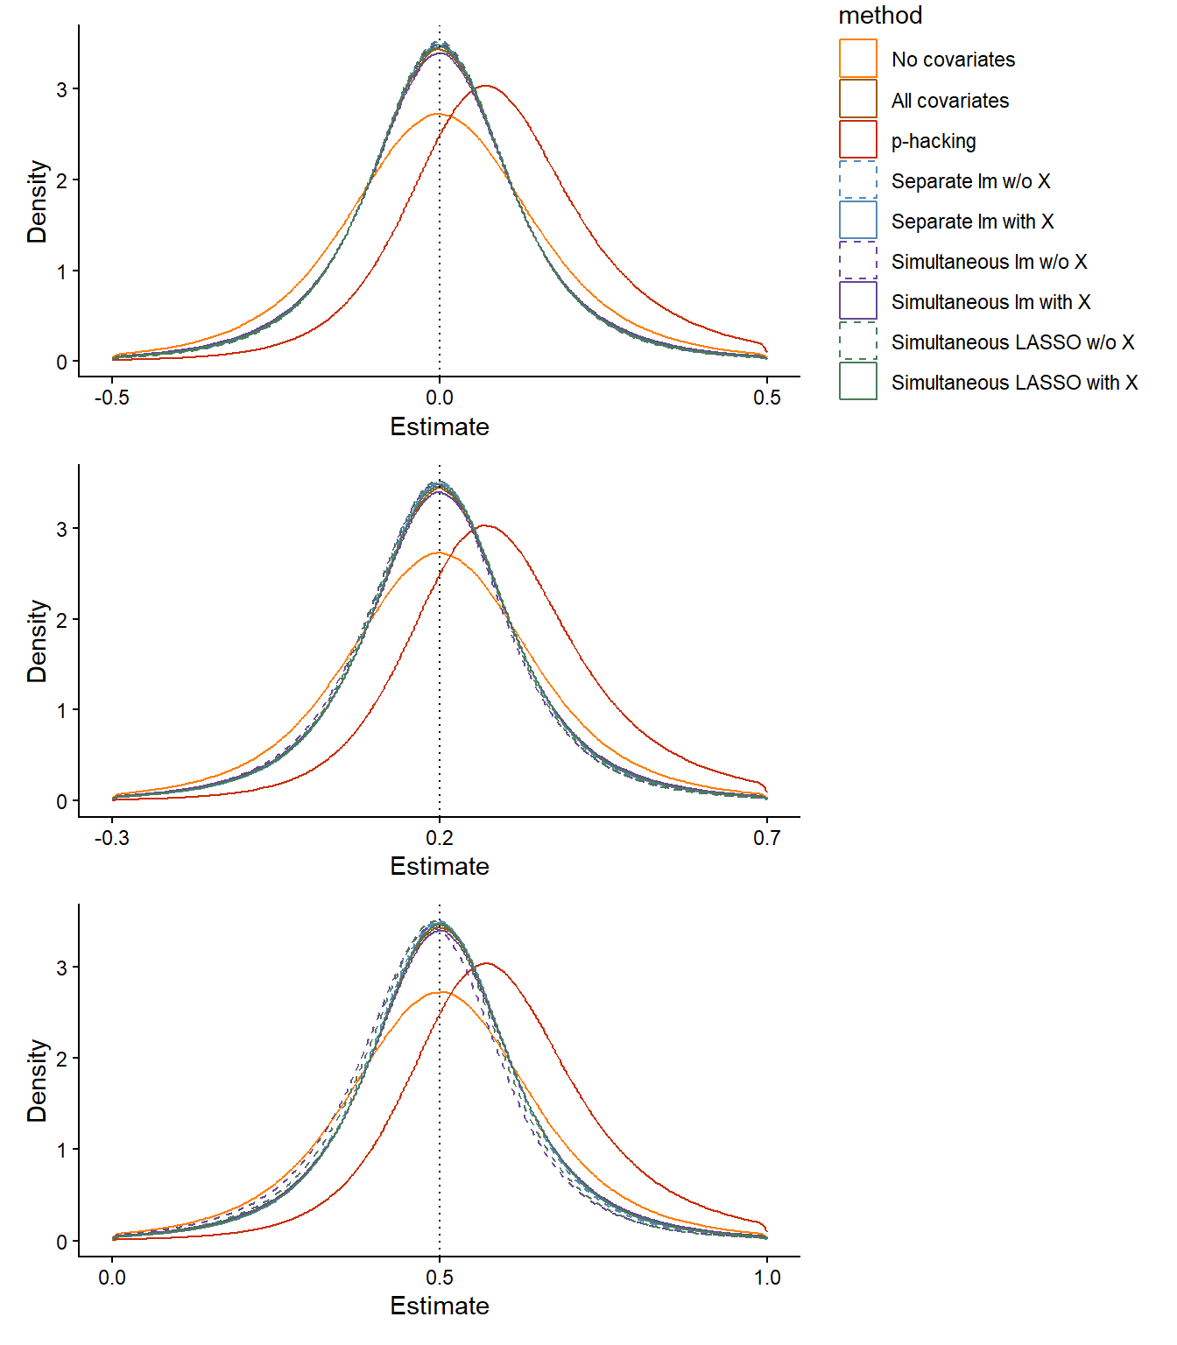
First, we considered contexts where the population effect size was 0 ($β_{X}$ = 0). In these contexts, all approaches, except for the p-hacking approach, yielded unbiased estimates. The p-hacking approach yielded substantial optimistic (over-estimation) bias in the magnitude of the parameter estimates as seen in both the mean $b_{X}$ and the rightward shift of the sampling distribution. This distortion results from this approach selecting covariates that magnify the positive effect of $X$ in any specific sample (even when the effect is due to chance), producing a distribution that does not accurately reflect the true population parameter.
Next, we considered contexts where there was a non-zero population effect for $X$. In these contexts, p-hacking unsurprisingly continued to yield positively biased estimates for the same reasons mentioned above. Of course, the traditional approaches (no covariates, all covariates) produced unbiased $b_{X}$ because the linear model in the primary analysis that tested the effect of $X$ was used without any prior screening of covariates in separate analyses. The remaining data-driven approaches that included $X$ also yielded unbiased $b_{X}$ because the covariates were selected only based on their unique (partial) relationship with $Y$ after removing any modest correlation between the covariates and $X$ due to sampling error (remember that any correlation between $X$ and a covariate in a specific sample is due to noise in that sample because covariates are measured prior to IV manipulation). Given this, when selected covariates were included in the primary analysis, they did not systematically increase or decrease $b_{X}$.
In contrast, when the screening model did not include $X$, covariates that are positively correlated with $X$ in the sample (due to noise) are selected at a slightly higher rate because this spurious correlation further increased their positive correlation with $Y$ (given that $β_{X}$ was also positive). When these covariates are subsequently included in the primary analysis of $X$, they systematically remove some of the true causal effect $X$ on $Y$ and result in a pessimistic (under-estimation) bias in the estimate of $β_{X}$.

Type I Error
Given our use of simulated datasets, we were able to set the true population parameter for $X$ to be zero (i.e., $β_{X}=0$). Therefore, any significant result was a Type I error. Figure 2 shows the average Type I error rate across all research contexts for each approach. The p-hacking approach for selecting covariates, unsurprisingly led to a highly inflated mean Type I error rate across contexts, consistent with the extant research published in the last several years on the connection between researcher degrees of freedom and false positives (Baker, 2016; Fanelli, 2010; Ioannidis, 2005; Simmons et al., 2011). The other approaches were at or near the expected error rate of alpha = .05 across the relatively broad range of research context characteristics we considered. Specifically, the two traditional selection approaches and the data-driven selection approaches that did not include $X$ in the screening model displayed mean Type I error rates of exactly .05. The data-driven approaches that did include $X$ in the screening model (excluding p-hacking) displayed slightly increased (<= .06) mean Type I error rates across contexts.
Figure 2
Type I Error by Method. Average type I error rate across all research contexts is displayed for each method separately by color. Traditional selection methods are on the left, data-driven selection methods are on the right. Striped shading indicates data-driven selection methods that do not control for X.
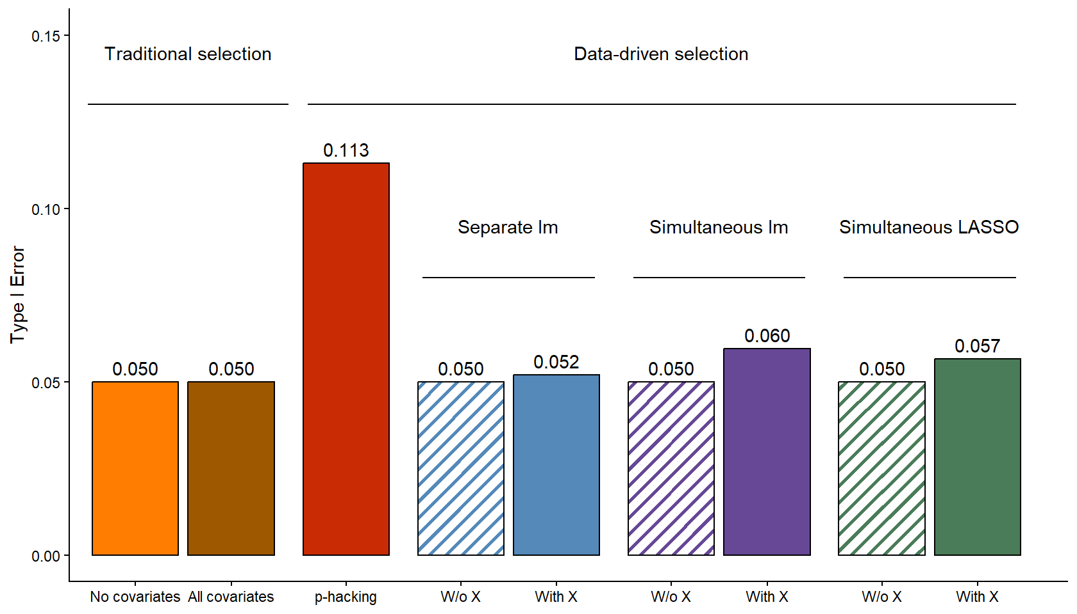

We next assessed how Type I error rates varied by specific dimensions of our research contexts and noted several patterns (Figure 3). First, the magnitude of Type I error rate inflation for the p-hacking approach substantially increased with increasing number of available covariates, larger correlations between the covariates and $Y$ (i.e., $r_{cov-Y}$ = 0.5), higher percentage of available covariates with non-zero correlations with $Y$, and smaller sample sizes. The Type I error rate for p-hacking reached 0.298 in the worst case context (see Shiny dashboard for error rates in all contexts).
In contrast, to the p-hacking approach, the Type I error rates remained constant at 0.05 across all research context dimensions for the traditional approaches and the data-driven approaches that did not include $X$. Among the other data-driven approaches that did include $X$, small increases in Type I error rates were observed as the sample size decreased and the number of available covariates increased. However, Type I error rate inflation remained modest for these approaches even at the extremes of these two dimensions (up to 0.074 at $N$=50 and up to 0.066 with 20 covariates in the simultaneous linear model approach). And in the worst case context at the intersection of all dimensions, error rates for these screening approaches that included $X$ only reached 0.072 for separate linear models, 0.096 with a simultaneous linear model and 0.089 with a simultaneous LASSO. Neither the magnitude $r_{cov-Y}$ nor the percentage of available covariates with non-zero correlations with $Y$ appeared to have any systematic impact on the Type I error rates for the data-driven approaches that included $X$.
Figure 3
Type I error by method and research context. Plots are paneled by aspects of the research context: number of observations, number of covariates, percentage of good covariates (i.e., covariates with non-zero correlations with Y), and Y-covariate correlation strength. Methods are displayed separately by color. Data-driven selection methods that do not control for X are depicted as dashed lines.
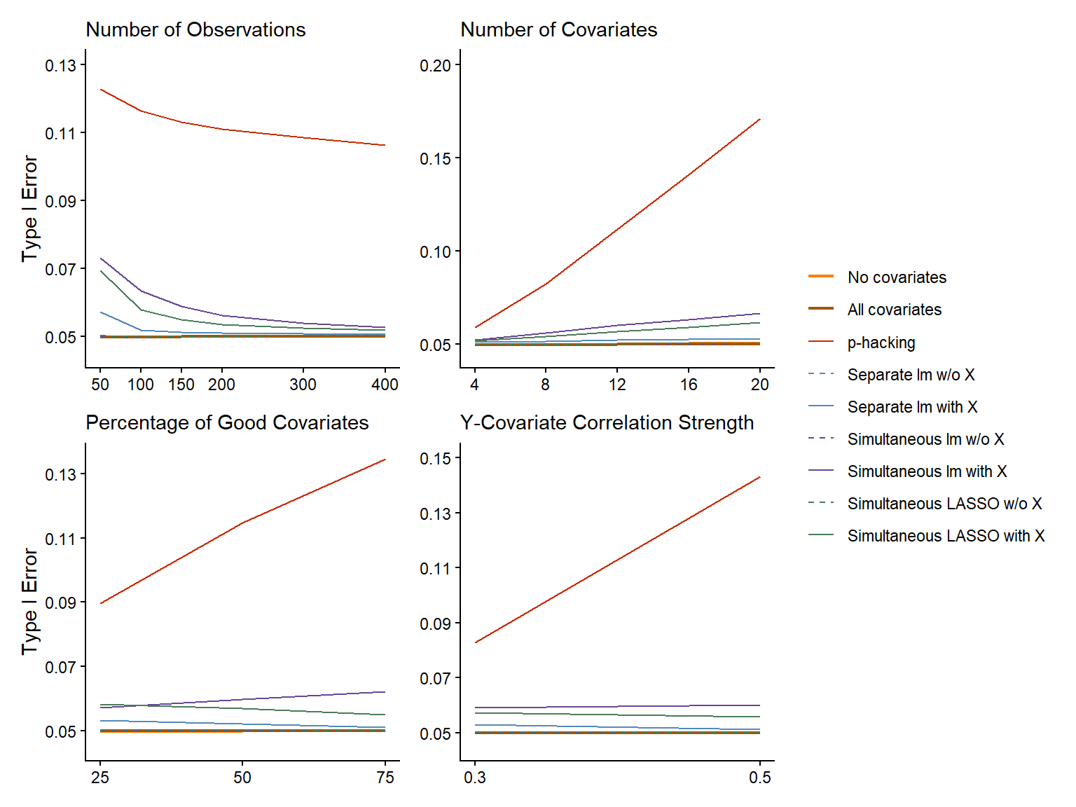

Type II Error
We simulated datasets with two possible non-zero population parameters for the effect of $X$ on $Y$ ($β_{X}=0.2$, $β_{X}=0.5$). Given that we set the pooled standard deviation of $Y$ to equal 1, these represented contexts where $X$ had a small (Cohen’s d = 0.2) or moderate (Cohen’s d = 0.5) effect on $Y$. In these simulations, non-significant effects for $X$ were, by definition, Type II errors. Given the substantial problems with Type I error rate inflation noted above, we do not consider the p-hacking approach to be viable and therefore did not evaluate Type II error rates for this approach.
Figure 4 shows the mean Type II error rate across all research contexts for each approach. The traditional no covariates approach displayed the highest average Type II error (0.449), which reinforces the value of using covariates to increase statistical power to detect true effects. Among the approaches that used covariates, the data-driven approaches generally produced modestly lower average Type II error rates than the traditional all covariates approach. Furthermore, the data-driven approaches that included $X$ displayed modestly lower mean Type II error rates than the comparable approaches that did not include $X$ in the screening model.
Figure 4
Type II Error by Method. Average type II error rate across all research settings is displayed for each method separately by color. Traditional selection methods are on the left, data-driven selection methods are on the right. Striped shading indicates data-driven selection methods that do not control for X.
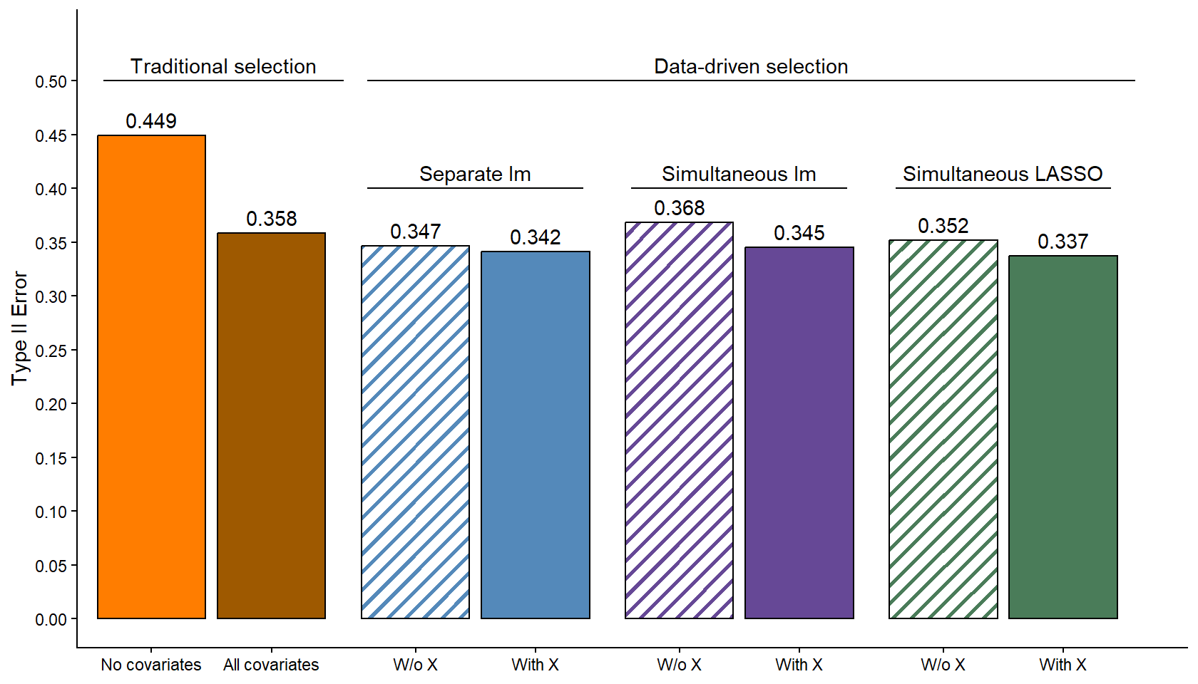

We next assessed how Type II error rates varied by specific dimensions of our research contexts and noted several patterns (Figure 5). First, it is clear that the no covariates approach was always associated with the highest Type II error rates across all values of all dimensions of the research contexts. Second, the traditional all covariates approach tended to under-perform (i.e., higher Type II error rates) relative to the data-driven approaches when the sample size was low, the number of available covariates was high, or the percentage of available covariates with non-zero correlations with $Y$ was low. Similarly, the data-driven approaches that did not include $X$ tended to under-perform relative to the matched approaches that did include $X$ in these same contexts (low $N$, high number of covariates, low percentage of available covariates with non-zero correlations with $Y$).
Figure 5
Type II error by method and research context. Plots are paneled by aspects of the research context: number of observations, number of covariates, percentage of good covariates covariates (i.e., covariates with non-zero correlations with Y), and Y-covariate correlation strength, and population parameter for X. Methods are displayed separately by color. Data-driven selection methods that do not control for X are depicted as dashed lines.
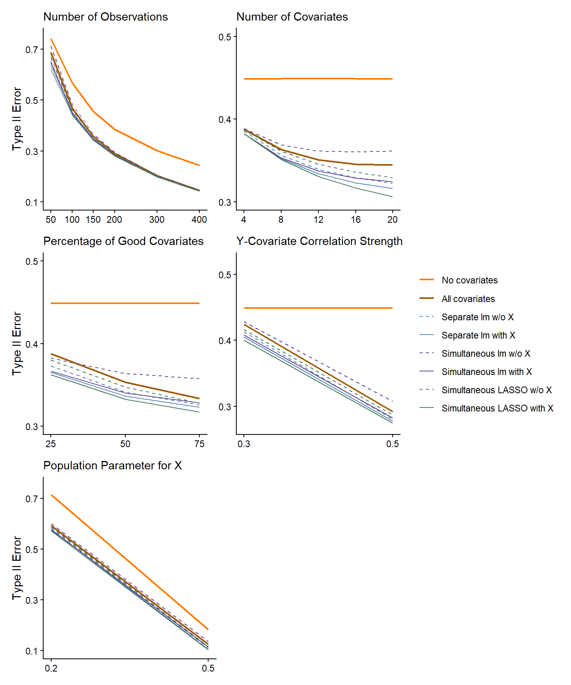

Discussion
Our findings reinforce Simmons and colleagues (Simmons et al., 2011) warning that p-hacking can severely inflate Type I error rate. We observed average Type I rates of 0.113, consistent with Simmons et al. However, our simulations further suggest that this estimate may meaningfully underestimate the potential magnitude of the p-hacking problem in common research contexts. In some research contexts, Type I error rates reached up to 0.298 (range: 0.051-0.298). Additionally, p-hacking produced substantially biased parameter estimates, indicating that even when true effects exist, the estimated effect sizes are likely to be overly optimistic.
When no covariates were used, the primary analysis of $X$ had a mean Type I error rate of 0.05 and provided an unbiased estimate of $β_{X}$ as expected given this traditional use of a linear model with its assumptions met. However, decisions regarding statistical validity must also consider an approach’s Type II error rate and the no covariates approach had a meaningfully higher Type II error rate compared to the other approaches. This should not be surprising. The use of covariates that are correlated with the outcome and uncorrelated with $X$ will account for additional variance in the outcome, thus increasing power (and decreasing Type II error rate). Of course, the relative cost to not use covariates is higher when more covariates are available and a higher percentage of them (e.g., 75%) have strong relationships with $Y$ (e.g., $r_{cov-Y}$ = 0.5). In addition, the costs of ignoring available covariates are higher when the effect size for $X$ is smaller but also when the sample size is larger (such that the proportional reduction of degrees of freedom is smaller when covariate are added). We hope these results motivate increased use of covariates in experimental research.
Next, we acknowledge that the all covariates approach is a reasonable option in many research contexts. Like the no covariates approach, it had a mean Type I error rate of 0.05 and yielded an unbiased estimate of $β_{X}$. Yet across almost all research contexts, the Type II error rate for the all covariates approach was lower than the no covariates approach, confirming its superiority. Furthermore, the mean Type II error rate (aggregated across all research contexts) for the all covariates approach was only 0.015 - 0.020 higher than some of the best performing data-driven selection approaches. And, of course, it is easier to implement because it eliminates the need for screening models altogether.
Nonetheless, the data-driven covariate selection approaches are not difficult to implement (see examples of R code for each method shared on OSF) and it may never be wise to give up any reduction in Type II error rate, even if modest. Moreover, the relative benefits of the best data-driven approaches are more substantial in some specific research contexts (e.g., small $N$, large number of more exploratory covariates available). In the best case example, the Type II error rate was 0.203 lower for the simultaneous LASSO with $X$ approach than the all covariates approach!
There are several issues to consider when comparing among the several top data-driven approaches. The approach with the lowest mean Type II error rate (0.337) was the simultaneous LASSO with $X$. This approach also provided an unbiased estimate of $β_{X}$. However, it had a slightly inflated Type I error rate (0.057) and the implementation of LASSO may be less familiar to some researchers (but see example code on OSF to implement it). Screening with separate lm with $X$ may feel easier and/or more familiar to some researchers. When compared to the LASSO with $X$ approach, separate lm with $X$ also yielded an unbiased estimate of $β_{X}$ and a better Type I error rate (0.052), but with slightly worse Type II error rate (0.341). Finally, if perfect control of Type I error rate at the nominal alpha is desired, screening with separate lm w/o $X$ may be preferred. However, this approach introduced modest pessimistic bias into the estimate of $β_{X}$, and further increased mean Type II error rate (0.347) than these other two approaches.
There are several additional considerations worth noting when evaluating a covariate selection method. First, although some of the data-driven approaches (that include $X$) introduced slight inflation of mean Type I error rate, this increase is likely no greater than what occurs with common modest violations of model assumptions (e.g., some heterogeneity in variance of residuals across $\hat{Y}$). Similarly, although some data-driven approaches (that do not include $X$) introduced slight bias into the estimate of $β_{X}$, this bias is also likely no greater than what is typical when the assumption of no measurement error in model predictors is routinely violated.
Second, we use these simulation results to strongly advocate for the use of covariates in experimental research that tests the effects of IVs. However, given that we are now providing researchers with yet another researcher degree of freedom (choice of covariate selection approach), it is critical that this decision be pre-registered to avoid undermining the statistical validity (and your peers’ confidence) in the reported results. And of course, if the all covariates approach is used, the specific covariates that will be used should also be pre-registered.
Finally, this simulation study evaluated the benefits of using covariates in experimental research where covariates are measured at baseline and therefore uncorrelated with the subsequently manipulated IV. In such instances, covariates are a powerful yet simple tool to increase statistical power without adding any complexity to the interpretation of the effect of the IV. However, in some areas of Psychology (e.g., clinical), covariates are routinely used for a different goal - to control for baseline differences across groups when participants were not randomly assigned to groups. In these instances, covariates should be selected using other approaches not considered in this paper (e.g., based on theory and/or putative causal structure among $X$ and covariates). Furthermore, researchers should carefully consider if the interpretative complexity introduced by this alternative use of correlated covariates is warranted and meets their goals (Miller & Chapman, 2001).
We believe our paper provides strong evidence of the clear benefits of using baseline covariates. In our opinion, we believe that either the simultaneous LASSO with $X$ or the separate lm with $X$ are the best choices when considering both Type I/II error rates and parameter estimate bias. However, we also hope that we have clarified the relative costs and benefits across all of these approaches to allow researchers to make informed decisions based on their own priorities and research context.

References
Baker, M. (2016). 1,500 scientists lift the lid on reproducibility. Nature, 533(7604), 452–454. https://doi.org/10.1038/533452a
Bradford, D. E., Shapiro, B. L., & Curtin, J. J. (2013). How bad could it be? Alcohol dampens stress responses to threat of uncertain intensity. Psychological Science, 24(12), 2541–2549. https://doi.org/10.1177/0956797613499923
Button, K. S., Ioannidis, J. P. A., Mokrysz, C., Nosek, B. A., Flint, J., Robinson, E. S. J., & Munafò, M. R. (2013). Power failure: Why small sample size undermines the reliability of neuroscience. Nature Reviews Neuroscience, 14(5), 365–376. https://doi.org/10.1038/nrn3475
Center for High Throughput Computing. (2006). Center for high throughput computing. Center for High Throughput Computing. https://doi.org/10.21231/GNT1-HW21
Cohen, J. (1962). The statistical power of abnormal-social psychological research: A review. The Journal of Abnormal and Social Psychology, 65(3), 145–153. https://doi.org/10.1037/h0045186
Cohen, J. (1988). Statistical Power Analysis for the Behavioral Sciences (2 edition). Routledge.
Fanelli, D. (2010). “Positive” Results Increase Down the Hierarchy of the Sciences. PLOS ONE, 5(4), e10068. https://doi.org/10.1371/journal.pone.0010068
Hefner, K. R., Moberg, C. A., Hachiya, L. Y., & Curtin, J. J. (2013). Alcohol stress response dampening during imminent versus distal, uncertain threat. Journal of Abnormal Psychology, 122(3), 756–769. https://doi.org/10.1037/a0033407
Hernández, A. V., Steyerberg, E. W., & Habbema, J. D. F. (2004). Covariate adjustment in randomized controlled trials with dichotomous outcomes increases statistical power and reduces sample size requirements. Journal of Clinical Epidemiology, 57(5), 454–460. https://doi.org/10.1016/j.jclinepi.2003.09.014
Ioannidis, J. P. A. (2005). Why most published research findings are false. PLoS Medicine, 2(8), e124. https://doi.org/10.1371/journal.pmed.0020124
Kahan, B. C., Jairath, V., Doré, C. J., & Morris, T. P. (2014). The risks and rewards of covariate adjustment in randomized trials: An assessment of 12 outcomes from 8 studies. Trials, 15, 139. https://doi.org/10.1186/1745-6215-15-139
Kuhn, M., & Wickham, H. (2020). Tidymodels: A collection of packages for modeling and machine learning using tidyverse principles.
Miller, G. A., & Chapman, J. P. (2001). Misunderstanding analysis of covariance. Journal of Abnormal Psychology, 110(1), 40–48.
RStudio Team. (2020). RStudio: Integrated Development for R. RStudio, Inc.
Schelchter, M. D., & Forsythe, A. B. (1985). Post-hoc selection of covariates in randomized experiments. Communications in Statistics - Theory and Methods, 14(3), 679–699. https://doi.org/10.1080/03610928508828942
Simmons, J. P., Nelson, L. D., & Simonsohn, U. (2011). False-positive psychology: Undisclosed flexibility in data collection and analysis allows presenting anything as significant. Psychological Science, 22(11), 1359–1366. https://doi.org/10.1177/0956797611417632
Simonsohn, U., Nelson, L. D., & Simmons, J. P. (2014). P-curve: A key to the file-drawer. Journal of Experimental Psychology: General, 143(2), 534–547. https://doi.org/10.1037/a0033242
Thompson, D. D., Lingsma, H. F., Whiteley, W. N., Murray, G. D., & Steyerberg, E. W. (2015). Covariate adjustment had similar benefits in small and large randomized controlled trials. Journal of Clinical Epidemiology, 68(9), 1068–1075. https://doi.org/10.1016/j.jclinepi.2014.11.001
Tibshirani, R. (1996). Regression Shrinkage and Selection Via the Lasso. Journal of the Royal Statistical Society: Series B (Methodological), 58(1), 267–288. https://doi.org/10.1111/j.2517-6161.1996.tb02080.x

