A Super Cool Study - Take 2

Josephine Student

John J. Curtin

2024-04-08

Abstract

This study found some pretty cool results that have both high impact and important clinical implications. For example …

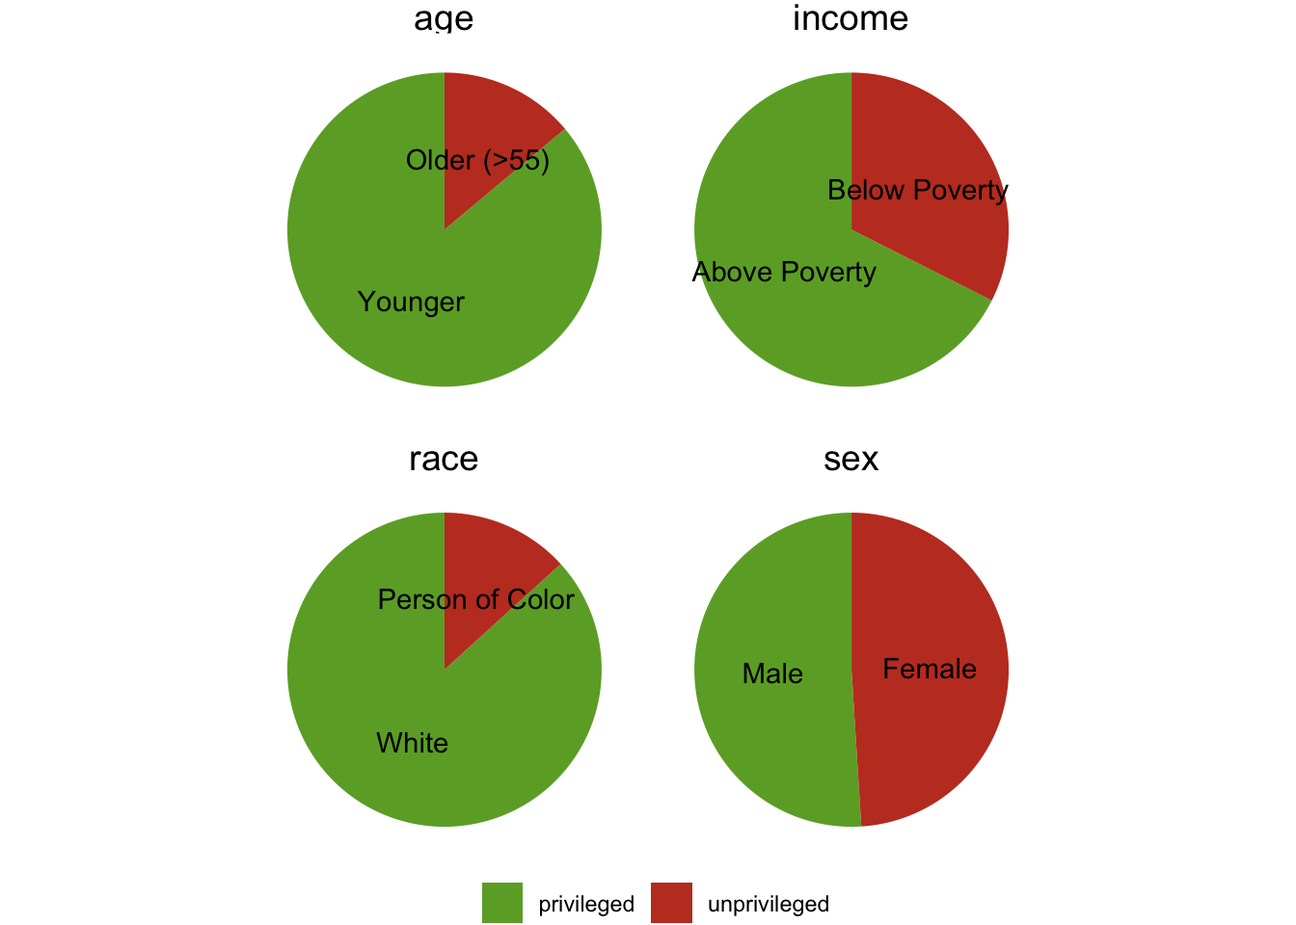

Source: [Create Demographics Summary](https://jjcurtin.github.io/study_fairema/notebooks/demographics-preview.html#cell-pie_chart)

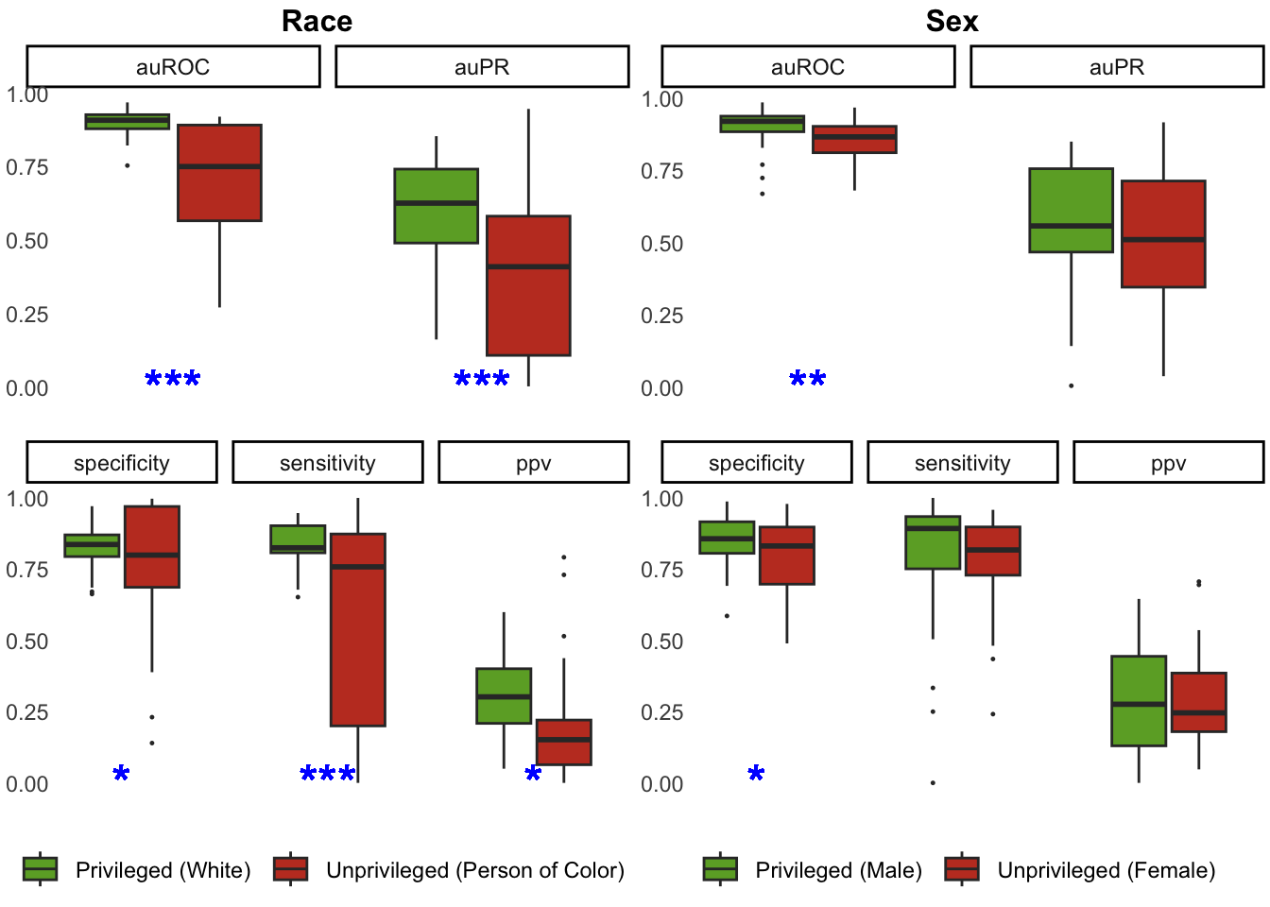

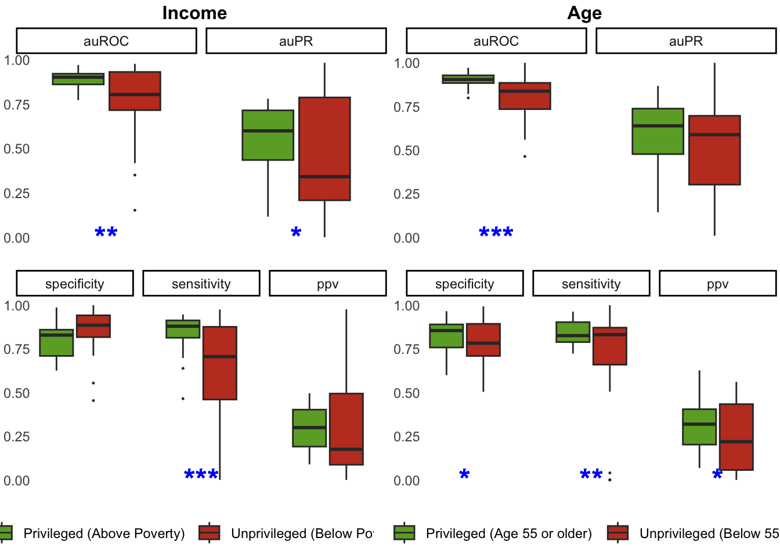

Source: [Agregated metrics plot](https://jjcurtin.github.io/study_fairema/notebooks/aggregated_plot-preview.html#cell-bar_plot)