Leveraging Text Messages to Predict Near Real-Time Alcohol Lapse in AUD Patients
Coco Yu
John J. Curtin
2024-10-17

Specific Aims

Background
According to National Survey on Drug Use and Health (NSDUH), 29.5 million people age 12 and older had alcohol use disorder (AUD) in the past year. However, only 2.2 million (less than 10%) in this age group received alcohol treatment (National Institute on Alcohol Abuse and Alcoholism 2023a, 2023b). Provider availability in rural areas, fear of stigma, and economic hardship all contribute to racial, gender and age disparities in treatment seeking (Abraham et al. 2020; DiBartolo and Jarosinski 2017; Young et al. 2018; Kaufmann et al. 2014; Schuler et al. 2015; Verissimo and Grella 2017). The emergence of digital therapeutics (DTx) has provided new opportunities to address such health disparity in underprivileged groups with its higher accessibility, acceptability and at least modest efficacy (Beukenhorst et al. 2022; N. Jacobson et al. 2023; James R. McKay et al. 2022; Perski and Short 2021). The broad goal of this program of research is to improve the effectiveness of DTx, by adding personal sensing capabilities and algorithms that allow DTx to have more refined capacities in anticipating lapses and personalizing interventions and supports to meet individuals’ momentary needs (Bae et al. 2018; Lee et al. 2023; Carreiro et al. 2018)
Machine learning models leveraging ecological momentary assessment (EMA) measures have performed relatively well to predict goal-inconsistent alcohol use (e.g., lapses), yet this methodology is associated with several limitations. As it actively relies on self-reports, it places some measurement burden on users. This is particularly problematic as AUD is a chronic disease that requires constant risk monitoring. Reducing sampling rates and number of survey items might reduce this burden but at the cost of impairing prediction precision and temporal specificity. Further, selection of EMA items is based on a top-down, theory-driven approach that may be limited by historical biases in the research literature (e.g., over-representation of white, males). Given this, we might miss important constructs that predict lapses among individuals from groups that have been less well-studied.
Passive sensing using text message monitoring provides an opportunity to address the above issues while still retaining some benefits of EMA. As text sensing is both passive and continuous, it simultaneously lowers measurement burden while maintaining a high sampling frequency. Research has found that users report more willingness to use passive sensing measures (vs. active) for as long as one year (Wyant et al. 2023). Some feature engineering techniques allow researchers to mine underlying constructs of texts. They are unconstrained and are thus less susceptible to knowledge gaps. They are also less biased towards previous research samples (i.e., White males). In the meantime, passive sensing methods can still attain some benefits of EMA measures. EMA measures encompass robust predictors that are supported by decades of research. Some feature engineering methods in text analysis can still seize benefits of this theory-driven approach by feeding algorithms with well-established risk factors. For example, sentiment analysis can reveal emotional tones, resembling subjective feelings measures in EMA.
Machine learning algorithms that use features from text messaging as inputs can be informative of both who may lapse and why that lapse may occur. Language analysis can identify heavy drinkers and risky drinking behaviors. Indeed, natural language processing (NLP) techniques on electronic health records and clinical notes have demonstrated moderate performance in predicting alcohol misuse, risky alcohol use and alcohol use status (Afshar et al. 2019; Vydiswaran et al. 2024; To et al. 2020; Topaz et al. 2019; Alzoubi et al. 2018). Some NLP methods can also potentially derive interpretable features that might optimize DTx design to customize recommended treatment at the moment. For example, LIWC (see Section Customized Dictionary) might deepen our understanding of psycholinguistic risk factors (Tausczik and Pennebaker 2010). Sentimental analysis weighing emotional tone might have implications for emotion-focused therapy. Some NLP techniques generate features empirically and make them less interpretable. Topic modeling examines hidden semantic patterns and identifies clusters of topics from text. Depending on the derived clusters, they might reveal cautionary topics that trigger alcohol use. Other NLP methods such as word embeddings might be less interpretable.

Current Study
In the current study, we will use several classic and/or emerging NLP feature engineering techniques applied to participants text messages over a period of three months. We will use features from these techniques as inputs to models that predict alcohol lapses. We will evaluate both model performance and interpretability of each distinct method. Followings are the more specific aims:
Aim 1: Train and evaluate performance of machine learning models using language features derived from different NLP techniques to predict alcohol lapses. We will use various feature engineering methods such as topic modeling, sentiment analysis, bag of words, word embeddings and customized dictionary. For each distinct feature set derived from these natural language processing techniques, we will train machine learning models using several contemporary statistical algoritms (e.g.. glmnet, random forest (RF), XGBoost). We will evaluate and statistically compare the model performance, quantified as area under the receiver operating characteristic curve (auROC), across models that differ by feature engineering technique.
Aim 2: Identify important features and evaluate their interpretability with respect to recommending interventions. Model interpretation is key to providing treatment recommendations and uncovering potential causes of lapses. We will use contemporary approaches to quantify feature importance (e.g., SHAP) of features within each of the NLP techniques used.
Aim 3: Examine model fairness in historically underprivileged subgroup populations. It is also important to note that if embedded algorithms perform relatively worse for marginalized groups, their use can exacerbate rather than alleviate treatment disparities. As such, model performance between privileged vs. unprivileged groups should be carefully examined. We will evaluate model performance in demographic subgroups that face excessive barriers accessing alcohol treatments or medications, including females, racial minorities, individuals living under poverty, and older population.

Significance
AUD remains a prevalent, lasting and costly problem in the United States over the past few years. According to 2022 NSDUH (National Institute on Alcohol Abuse and Alcoholism 2023a, 2023b), an estimate of 29.5 million (10.5% of the population) individuals aged 12 or older had AUD in 2022, which is consistent with the estimates for 2021. AUD problems have also brought huge economic burdens to the U.S., where excessive alcohol use has cost $223.5 billion in 2006 and $249 billion in 2010 (Sacks et al. 2015).
Despite the high prevalence of AUD, limited number of individuals receive alcohol treatments. Only a small portion (7.6%) of individuals aged 12 or older with AUD acquired alcohol use treatment in the past year (National Institute on Alcohol Abuse and Alcoholism 2023a, 2023b). This low treatment acquisition rate is even more pronounced for individuals from disadvantaged groups. Disparities in treatment-seeking behavior based on race, gender, and age are evident (Abraham et al. 2020; DiBartolo and Jarosinski 2017; Young et al. 2018; Kaufmann et al. 2014; Schuler et al. 2015; Verissimo and Grella 2017). Only 6.6% of Black or African-American people, 3.8% of people of two or more races, and 4.8% of Hispanic or Latino people with past-year AUD received treatments (National Institute on Alcohol Abuse and Alcoholism 2023a, 2023b). Women are less likely to obtain treatments compared to men, even if they have equivalent level of perceived need for help (Gilbert et al. 2019).
Several obstacles hinder people’s utilization of treatment options. Previous studies have identified that AUD patients face financial barriers (Kaufmann et al. 2014; Schuler et al. 2015), lack of knowledge or awareness (Williams et al. 2018; Probst et al. 2015; May, Nielsen, and Bilberg 2019), social stigma (Sedarous and Flemming 2023; Finn, Mejldal, and Nielsen 2023; Wallhed Finn, Bakshi, and Andréasson 2014; May, Nielsen, and Bilberg 2019), and geographical barriers (Gregory et al. 2022) for accessing care. Individuals with disadvantaged demographic background suffer from even heightened barriers to treatment resources. Women with high severity of alcohol use face larger fear of stigma compared to their male counterparts (Finn, Mejldal, and Nielsen 2023).

DTx and smart DTx
DTx is an emerging tool that may partially address extant challenges AUD patients face for treatment and continuing care. DTx are evidence-based health software that deliver assessments, interventions, and other supports to patients to prevent, treat, or manage a disease or disorder. Available evidence suggests they are generally effective for mental health conditions including AUD and demonstrate clear clinical advantages (Philippe et al. 2022; Lecomte et al. 2020; Gustafson et al. 2014). Further, DTx may provide better access for hard-to-reach populations, including those from socially marginalized group who encounter increased barriers to access treatment. They can benefit patients from rural areas with low provider availability as they are accessible remotely via mobile phones (Bucci et al. 2019; N. Jacobson et al. 2023). DTx also have potentials to relieve barriers to seek professional help resulting from stigma concerns as they can facilitate anonymity and shorten the need for in-person interactions. They are of lower costs compared to in person care and have the capacity to be scalable.
The concept of “smart” DTx is emerging in recent years allowing us to expand the benefits of DTx. Smart DTx comprises two key components. First, they rely on personal sensing methods to collect data. Ideally, sensing should be 1) feasible and place low burden on users; 2) longitudinal; and 3) with high temporal granularity. Exemplary measures include EMA, which actively prompts users to complete surveys and can encompass desired questions on moods, social relationships, stressful events, etc. More passive sensing approaches include the measurement of geolocation, phone call logs and text messages collection. GPS tracking, phone logs sharing and SMS message sharing continuously and passively gather information. Combined with self-reports, smart DTx are capable of acquiring contextual information such as levels of support user can obtain from their frequently visited places and frequently contacted people.
Second, the rich dataset extracted from personal sensing can be incorporated into machine learning algorithms. The goal of such models is to identify who are at heightened risk for alcohol lapses, when they will lapse, and why they are at increased risk. Through the embedded algorithms, smart DTx can achieve two tasks: 1) continuous AUD relapse risk-monitoring; and 2) individualized, just-in-time treatment recommendations when needed. Notably, these functions are very important given the dynamic nature of alcohol relapse. AUD is a chronic, dynamic and temporally varying disease where patients face constant challenges of relapsing after abstinence (Scott, Foss, and Dennis 2005; Andersson, Wenaas, and Nordfjærn 2019; Witkiewitz and Marlatt 2007).
To develop such algorithms, we must first identify a clinically relevant outcome to predict. This outcome should be clearly and precisely defined across individuals, easy to measure, and with high temporal precision. Relapse, which usually refers to the return of a symptomatic behavior, is hard to quantify due to its multidimensional nature and temporal coarseness (Miller 1996). One potential conceptualization of alcohol relapse is linked to problems of use. Nonetheless, negative consequences are multifaceted and can therefore be burdensome to collect. It is also unclear what the onset of problems are. Another possible outcome is quantity of alcohol use. However, this measure is not temporally precise because there will be a time lag between onset of drinking and the last drink completed. Levels of drinking might also mean differently for individuals with different AUD severity, which makes it hardly generalizable across individuals. Alternatively, in this study, we utilize lapse (i.e., a single episode of alcohol use) as our primary outcome variable. Lapses are easy to define, have a clear onset, and are also clinically meaningful. They can serve as an early warning sign of failure to sustain a desired behavioral change (Chung and Maisto 2006; Marlatt and Donovan 2005). Research has also shown that initial lapse and frequent lapses are the associated with enhanced risk of relapse (Witkiewitz and Marlatt 2004; Högström Brandt et al. 1999).
Next we need to determine what inputs to use for our prediction model. The features should be easy to measure and feasible. The widespread availability of smartphones has rendered constant data collection with DTx attainable. Data collection procedure should not be unduly burdensome to users to ensure that sensing is sustainable. Previous research has established satisfying acceptability of active self-report measures such as EMA and even more willingness to use passive sensing measures (Wyant et al. 2024). The features should also be well-validated. For example, GPS tracking has high accuracy in locating individuals and is temporally precise. Text sensing captures precisely the interactions between users and other individuals via SMS.
Desirable features should meaningfully predict lapse risks. More specifically, they should be capable of detecting increased lapse risks in a timely manner. These predictions allow windows for subsequent just-in-time intervention to prevent lapses targeting a specific person. Notably, in the current work, we will emphasize on estimating probabilities of lapsing instead of precise anticipation of lapse occurrence. Under this approach, we can avoid finding a threshold to yield class labels (lapse vs. no lapses).
We can derive top-performing features both from a theory-driven approach and a empirically-driven approach. A theory-driven approach involves integrating domain-specific knowledge of known risks for alcohol lapses from a relapse prevention model into the algorithms. Such features are pre-specified and might involve affect state, social interactions, and alcohol-related factors. For instance, the majority of an inpatient teen sample reported initial relapse to alcohol when offered alcohol, when in negative state, and when in interpersonal conflicts (Brown, Vik, and Creamer 1989). Other commonly found risk factors include alcohol craving (J. R. McKay 1999; Korlakunta, Chary, and Reddy 2012-07/2012-12), negative affect state (J. R. McKay 1999), cognitive factors (J. R. McKay 1999), and interpersonal problem (J. R. McKay 1999). Contrarily, a empirically-driven approach starts with collecting data from various sources and then extracts relevant features. The features generated from this method are completely dependent on data. Notably, it is possible to yield features align with known risk factors but not guaranteed.
Features should also have temporal granularity given the dynamic nature of alcohol relapse risks. Smart DTx algorithms with good temporal precision should consistently collect data on situated, risk-relevant predictors while retaining low burden on users. Exemplary features with good temporal precision might involve the proximal factors depicted in the relapse prevention model (Witkiewitz and Marlatt 2007; James R. McKay et al. 2006; Feingold, Capaldi, and Owen 2015). Proximal factors (e.g., drinking partner, drinking behavior) are situated and can be fluctuating over time. They usually occurs before an episode of alcohol use (Chih et al. 2014). They can be elusive to therapists’ attention due to infrequent visits, highlighting importance of sustained monitoring to prevent lapses.
Useful risk prediction algorithms are capable of identifying unrecognized risk factors for lapses. The bottom-up approach does not pre-specify indexes when building models. This method is therefore less susceptible to our knowledge gaps and might even discover previously unfound underlying processes contributing to alcohol lapses. We might even expect less differential performance under the bottom up approach across privileged vs. unprivileged groups because the features are not drawn from past research dominated by White males with AUD and are thus potentially unbiased towards privileged groups.
Smart DTx algorithms should also incorporate features that are interpretable and can map on to current interventions. Exemplary features that are highly interpretable include those derived from the top-down, theory-driven approach. These features are easy to interpret and closely align with established therapies. For example, features related to social relationship might have important implications for family or marital counseling. Affect state features might be informative of emotion-focused therapy. In addition to selecting interpretable features during data training, computational methods can also be used to enhance model interpretability by analyzing feature importance. For instance, we can examine global feature importance to determine which features contribute the most to predict lapses across individuals. Further, examining local feature importance (i.e., features influencing a single observation) in these models might also be helpful for model interpretation. They have benefits of identifying the factors that contribute to lapse risk for any specific person and moment in time.
Importantly, the selected features should also predict well among individuals from disadvantaged groups. One of the key benefits of DTx is that they partially address barriers utilizing professional help by providing 24/7/365, affordable, personalized support. They are particularly beneficial to marginalized groups who have low rates of utilizing treatment options due to these treatment barriers. However, they might exacerbate health inequity if embedded algorithms perform relatively worse for less privileged groups. One possible explanation of differential performance across subgroups might stem from the features we feed the algorithms. For example, features derived from a theory-driven approach might be biased towards advantaged groups because they depend on decades of research on White males. The biased features therefore might favor better prediction performance for advantaged groups because they are more robust in predicting their relapse risks. Notably, the differential performance between different groups might also be owing to the under-representation of unprivileged groups in the dataset besides feature selection. The algorithms might sacrifice some prediction accuracy for the minority groups if they are severely underrepresented in the data to ensure overall model performance. As such, it is important to recruit a diverse sample to complete model training. Some statistical resampling strategy might also be used to increase the representation of marginalized groups in the dataset.

Recent progress in smart DTx
Recent DTx work has yielded satisfactory performance in predicting lapses with EMA measures. Our group developed an XGBoost machine learning model using self-reported craving, affect, efficacy, risky situations, stressful events, pleasant events to predict alcohol lapses in the next hour, day, or week (Wyant et al. 2024). The surveys were collected up to four times daily for three months. The model achieved exceptional performance when predicting lapses for new individuals, with a mean auROC score of .89, .90 and .93 for the hour-, day-, and week-level model respectively. Global feature importance demonstrated that past alcohol use and future self-efficacy consistently contributed greatly across all models to predict lapses.
Nonetheless, relying on EMA measures for model building is associated with several limitations. First, constantly completing surveys makes it burdensome for real-world DTx use. Although most EMA relevant mental health research demonstrated modest compliance rates, their time windows last from two weeks to three months (Porras-Segovia et al. 2020; Czyz, King, and Nahum-Shani 2018; van Genugten et al. 2020; Mackesy-Amiti and Boodram 2018; Hung et al. 2016). The study length is insufficient for real-world DTx use. As extended period of time of app use is anticipated, users’ perceived burden of answering surveys is presumably larger (Mogk et al. 2023). Although minimizing the number of items in the surveys and the frequency of prompting users to complete the surveys might help mitigate the associated burden, it can inevitably reduce the prediction precision and temporal precision of algorithms.
Second, decisions regarding what constructs to assess and what items to include to assess these constructs are limited by theory and past data. Including risk factors solely drawn from decades of research on White, male-dominant samples might even exacerbate health disparities when applied to DTx. Further, our current understanding of alcohol relapse precursors is not comprehensive, especially for proximal factors. For example, Marlatt’s proposed taxonomy characterizes high-risk situational precursors to alcohol relapse such as social pressure and positive/negative emotional state (Marlatt 1996). Nonetheless, replication studies have found this theoretical framework to be somewhat unreliable and have low predictive validity of post-treatment outcomes (Lowman et al. 1996; Stout, Longabaugh, and Rubin 1996; Kadden 1996). A review study also suggests that current proximal factors are not well-understood in past research due to methodological constraints and a death of “near real-time” data (James R. McKay et al. 2006).

Incorporating SMS in smart DTx
Text sensing technology, which is both feasible and sustainable, represents new opportunities in DTx that might address limitations of the current active reporting approach. Since AUD is a chronic condition requiring ongoing risk monitoring over an extended period, DTx can benefit from SMS sensing because it places a low burden on users and allows for continuous data collecti138on. Studies collecting passive data have demonstrated high acceptability from participants and higher compliance rates compared to active measures (Wyant et al. 2023; Beukenhorst et al. 2022). Further, risk monitoring using SMS sensing is temporally sensitive to fluctuating risks. Analyzing text messages can detect potential triggers in time without actively prompting users to reflect on their feelings at the moment or report their environment.
With the burgeoning of NLP techniques, language analysis is well-equipped with diverse feature engineering tools to have good predictability with temporal specificity for alcohol lapses in new individuals. Some top-down methods might have good performance because they allow researchers to mine previously established robust construct of alcohol lapse precursors. For example, a bag-of-words approach using customized dictionary might allow researchers to mine alcohol-related content from messages such as alcohol cravings. Sentiment analysis can also enable researchers to assess individuals’ affect state. Further, some NLP methods follow a bottom-up approach. They might identify new alcohol lapse precursors and are less susceptible to limitations in past research. For example, topic modeling techniques such as Latent Dirichlet Analysis (LDA) and Latent Semantic Analysis (LSA) can examine patterns in SMS messages and identify clusters of topics from the data. Word embeddings approach transforms words into vectors with high dimension space.
NLP also offers avenues for model interpretation to yield valuable insights into treatment recommendations. Although some feature engineering techniques (e.g., word embeddings) might reveal arbitrary features that is incomprehensible, some can still mine features that can be potentially interpretable (e.g., topic clustering). Assessing their feature importance helps us understand how features contribute to the models (i.e., which features are robust in predicting lapses). For example, global feature importance can identify robust predictors across individuals in predicting lapses. Local feature importance provides insights on what contributes to a lapse for a specific person at a specific time. They can be useful in personalized, just-in-time treatment recommendations.

Current Study
In this study, we will utilize different NLP techniques to predict lapses from SMS message content. More specifically, we will compare across different feature engineering methods encompassing topic modeling, sentiment analysis, bag-of-words, word embeddings, and customized dictionary. We will evaluate model performance from three aspects: 1) overall model prediction performance in detecting lapses; 2) model interpretability; and 3) performance between advantaged groups vs. disadvantaged groups with regards to race, gender, income and age.

Approach

Overview
This study will analyze data collected from 2017-2019 from a larger grant funded by National Institute of Alcohol Abuse and Alcoholism (R01 AA024391). In this proposal, we focus on methods and measures that are relevant to this study. Additional details on broader methods and the full set of measures collected are discribed elsewhere (see https://osf.io/w5h9y/ and (Wyant et al. 2024; Wyant et al. 2023)).

Participants
Individuals in early recovery from AUD were recruited from Madison and surrounding area via social media platforms (e.g., Facebook), referrals from clinics, and television and radio advertisements. After initial phone screen, interested individuals came in-person to complete a more in-depth screening to determine their eligibility. We documented their demographic information. Inclusion criteria include that participants: 1) must be at least aged 18 or older; 2) must meet criteria for AUD with at least moderate severity (>four DSM-5 criteria); 3) must be abstinent from alcohol for at least one week and fewer than two months at time of intake; 4) must be able to read and write in English; 5) must be willing to use smartphone and their smartphone is compatible with our study technology. Participants were excluded if they have a lifetime history of severe and persistent mental illness. One hundred sixty-nine participants were eligible and enrolled in the study. After excluding participants who discontinued before the first follow-up session and those with low compliance rates and too few messages (<100 messages), we have a final sample size of 138 participants.

Procedures
The study lasted up to three months with five in-person visits (see Figure 1). Participants completed an in-person screening visit to determine their eligibility, obtain their informed consent, and collect their demographic information and self-report measures. They then completed an intake session one week later and three follow-up visits afterwards spaced at one-month intervals. During each of the follow-up visits, a research assistant downloaded participants’ SMS messages from their phone, verified reports of lapses and queried participants about any additional unreported laspes. Additional self-reported measures were obtained (see https://osf.io/w5h9y/).
Throughout the course of the study, participants were expected to complete four daily EMAs that asked about their alcohol cravings, risky situations, stressful/pleasant events, etc (Wyant et al. 2024). Notably, in the first item in the EMA survey, participants also reported their past alcohol use. Answer to this item will be used as the predicted outcome (see Section Alcohol Lapses).

_{Source: Article Notebook}
Figure 1: Flowchart of in-person visits. We obtained participant demographics and alcohol use history from the screening session. SMS messages were downloaded from participant phones at each of the follow-up visit.

Measures

Individual Characteristics
We collected participants’ individual characteristics including their demographics and their past drinking history during the screening session (see Table 1).
Participant self-reported measures
Log Type | Measure
Demographics | Age
 | Sex
 | Race
 | Ethnicity
 | Highest Education
 | Employment Status
 | Total Personal Gross Income
 | Marital Status
 | Family Member
Alcohol Use | Alcohol Use History
 | DSM-5 Checklist for AUD
 | Young Adult Alcohol Problems Test
 | WHO-The Alcohol, Smoking and Substance Involvement Screening Test

Alcohol Lapses
Participants were prompted up to four times daily to report their recent alcohol use. In the first item of each daily EMA survey, dates and times of any unreported past alcohol use were obtained. Reports of past alcohol use are used as a dichotomous outcome variable (Lapse vs. No Lapse). We will predict alcohol lapses in the next 24-hour window (i.e., next day lapse prediction). Every outcome window will start from 4 a.m. everyday and end 24 hours later.

SMS Messages
At each of the follow-up visits, a research assistant downloaded the participants’ SMS message logs from their phone. These logs included the message type (incoming vs. outgoing), date and time sent/received, text body, contact name, whether the participants read the text or not, etc. Images and voice texts were excluded from analysis. Both group messages and one-on-one messages were obtained from participants’ phones. We included only messages from/to important contacts and in group chats.
For each individual lapse window, we have predictor sets that differ in prediction window length and their analytic unit. We define text prediction windows to be 3-day and 1-week preceding the lapse window. We analyzed the two prediction windows both individually and combined (i.e., three configurations in total).

Feature Engineering
Text messages will serve as the only raw source for all feature engineering. The document sets will go through a generic pre-processing step that involves removal of all emojis. Our decision to remove all emojis was due to loss of emoji data in the ios devices during back up. This study used the LIWC dictionary (Pennebaker et al. 2015) and computed scores by counting frequency of words that belong to each category. We did not remove any stop words. LIWC aligns with the current alcohol relapse risk factor literature in that it examines psychometric properties including cognitive state and social processes (Brown, Vik, and Creamer 1989; J. R. McKay 1999, 1999).
We adopted two configurations for analytic units – individual messages and concatenated messages. In the first configuration method, we ran individual messages within the defined prediction window through LIWC. We then normalized LIWC feature scores based on the square root of word counts instead of raw word counts. This normalizatio method was chosen due to the relatively short message length for individual messages. We further obtained the median and 95% percentile of normalized LIWC scores for all messages related to each lapse label.
In the other analytic unit configuration, we first concatenated all messages associated with each lapse label altogether. We then obtained LIWC results for the concatenated messages. We further adopted three configurations for normalization methods – normalized on raw word count, normalized on the square root of word count, and combination of these two.

Candidate Machine Learning Algorithms
Note that our candidate machine learning algorithms already differ on three configurations: 1) prediction window length (see Section SMS Messages); 2) analytic units (see Section Feature Engineering); and 3) normalization methods (see Section Feature Engineering). We further consider a range of candidate statistical algorithms that vary with regard to their model complexity, model assumptions, and training speed. Candidate algorithms that will be used include glmnet (penalized, parametric linear model), random forest (RF), and XGBoost.

Model Training and Performance Evaluation
We performed grouped, nested cross-validations to perform hyperparameter tuning and select the best model configuration. The dataset was be participant-grouped so that each individual will be assigned to either held-in or held-out set to avoid bias of predicting participants’ lapses using their own data. The nested cross-validation method uses two nested loops to divide folds. In the inner loop, held-out folds are used as a validation set for model selection. In the outer loop, held-out folds are utilized as a test set for model evaluation. More specifically, we will use one repeat of 10-fold cross-validation in the inner loop for model selection and 3 repeats of 10-fold cross-validation in outer loop for model evaluation.
The primary performance metrics to select the best model configuration and evaluate the model performance on the test sets will be auROC. auROC computes the area under the ROC curve which demonstrates the trade-off between sensitivity and specificity across all possible thresholds. Values between .70 and .80 are considered fair, values between .80 and .90 are considered good, and values above .90 are considered excellent. We will report the median auROCs for the 30 held-out folds. The model with the highest auROC among the ones differing on those eight configurations (see Section SMS Messages) and statistical methods (see Section Candidate Machine Learning Algorithms) will be selected as the best model for each natural language processing technique.

Feature Importance
We also calculated SHAP values to interpret the results. SHAP is a game theory based method to explain how each feature influences the model output (Lundberg and Lee 2017). It assigns importance to each feature, where a positive feature importance positively affects the model output. This methodology can be applied to any machine learning algorithm and can increase model transparency and interpretability. Local Shapley values explain factors that contribute to a single observation, and global Shapley values represent feature importance across all observations. To compute global Shapley values, we average the absolute value of all local Shapley values.

Model Comparison and Algorithmic Bias
We further performed a Bayesian hierarchical generalized linear model to estimate the posterior probability (i.e., the likelihood of achieving the results given out data) distributions of the auROCs. We will regress the 30 auROCs from the held-out test set as a function of feature engineering technique (a total of 10 comparisons for the five NLP methods). The two random intercepts in the models include the repeat and the fold within repeat. We will report the 95% CIs for our models’ auROCs and determine if they include .5 (chance performance). We will also report the 95% CI for the differences in performance with regard to Bayesian comparison. If this CI does not include 0, we can conclude that the feature engineering technique yields better model performance than the other.
A subset of individual characteristic measures will be used to evaluate model fairness on subgroups. We compared model performance among each sex, racial, age and income subgruops because the populations face increased barriers obtaining AUD treatments. Stigma among older populations and wome, and economic hardship in racial minority groups can all contribute to low treatment-seeking and alcohol treatment completion (DiBartolo and Jarosinski 2017; J. O. Jacobson, Robinson, and Bluthenthal 2007; May, Nielsen, and Bilberg 2019). Participants younger than 55 years old were considered as a privileged group. We adopted half of median income in Madison area in 2017 as cut-off to assign participants to income groups.
We performed a Bayesian hierarchical generalized linear model that regresses the auROCs from the 30 held-out test set as a function of group membership (privileged group vs. unprivileged group in each of above individual characteristics). We reported the 95% CI for model performance differences and examine if they include 0.

Results

Demographics
The final sample includes 138 participants. 73 (53%) participants are females, 17 (12%) are non-White minorities, 39 (28%) earned less than half of the median income in Madison in Year 2017, and 13 (9%) aged 55 or older.
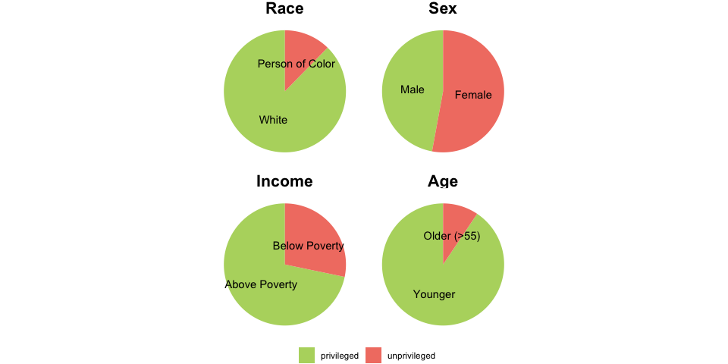
Figure 2: Demographic Distribution
Source: EDA on Subject Demographics

Sample Distribution
The final total number of lapse labels in the dataset is 11562. On average, each participant has 83.78 labels (sd = 11.35, median = 88.00, range = 30.00 - 90.00).
The total number of messages in the dataset is 313492. On average, each subject has 2271.68 messages (sd = 2536.60, range = 100.00 - 15884.00). The average message length across all participants is 10.42 words (sd = 14.30, median = 7.00, range = 1.00 - 1266.00). On average, each participant has a mean message length of 10.87 (sd = 3.97, range = 5.25 - 38.91).
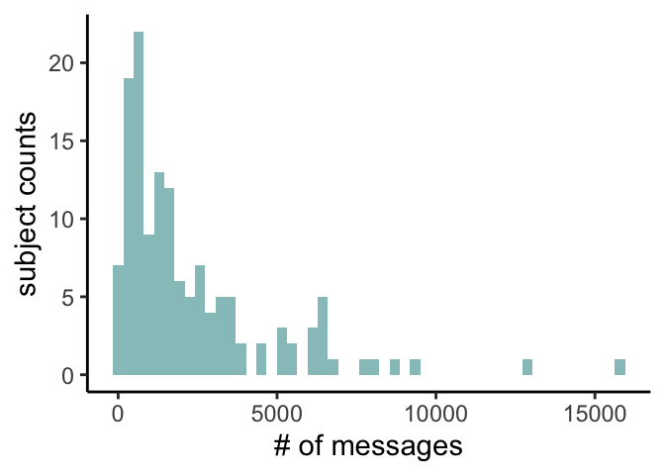  Figure 3: Distribution of Message Counts  _{Source: EDA on Raw Messages} | 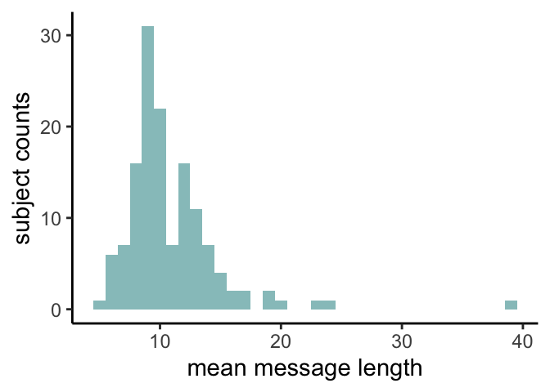  Figure 4: Distribution of Mean Message Length  _{Source: EDA on Raw Messages}
On average, each lapse label has 79.21 messages (sd = 112.13, median = 40.00, range = 1.00 - 1414.00) during the 3-day prediction window. 11.92% of labels have no associated messages in the previous 3 days. Each participant has an averaged 79.48 messages as predictors per label (sd = 87.12, median = 50.12, range = 2.97 - 529.45). On average, each participant’s data missingness is 12.28% (sd = 19.42%, median = 1.14%, range = 0.00% - 77.27%).
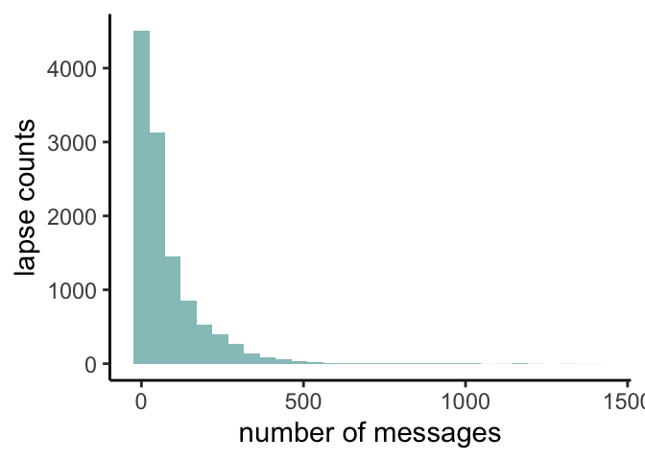
Figure 5: Distribution of Message Counts in the 3-Day Prediction Window
_{Source: EDA on Raw Messages}
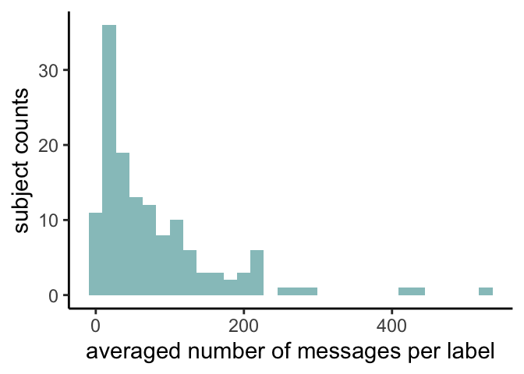  Figure 6: Distribution of Message Counts by Subject in the 3-Day Prediction Window  _{Source: EDA on Raw Messages} | 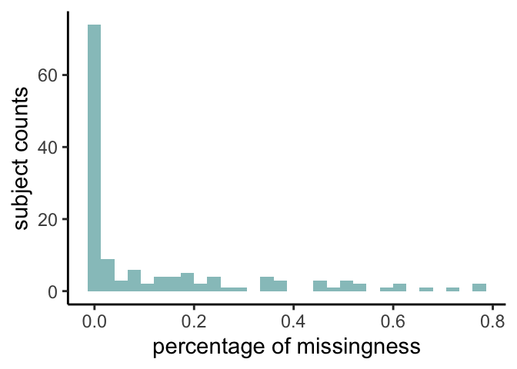  Figure 7: Distribution of Missingness by Subject in the 3-Day Prediction Window  _{Source: EDA on Raw Messages}
On average, each lapse label has 180.42 messages (sd = 241.30, median = 96.00, range = 1.00 - 2866.00) during the 1-week prediction window. 7.83% of labels have no associated messages in the previous week. Each participant has an averaged 181.23 messages as predictors per label (sd = 199.32, median = 113.47, range = 6.75 - 1200.76). On average, each participant’s data missingness is 8.14% (sd = 16.23%, median = 0.00%, range = 0.00% - 72.73%).
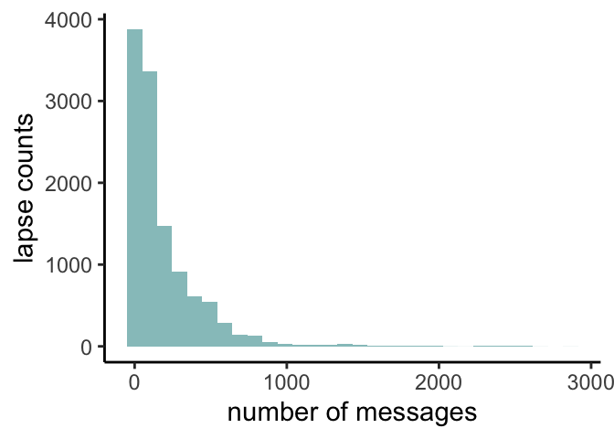
Figure 8: Distribution of Message Counts in the 1-Week Prediction Window
_{Source: EDA on Raw Messages}
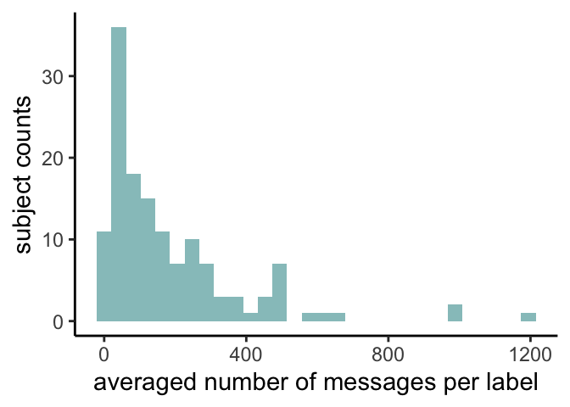  Figure 9: Distribution of Message Counts by Subject in the 1-Week Prediction Window  _{Source: EDA on Raw Messages} | 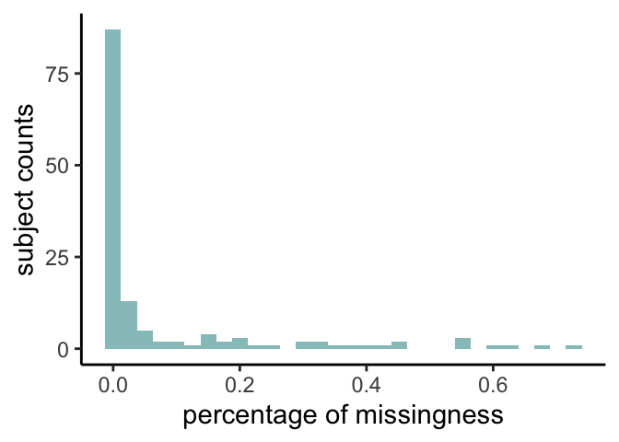  Figure 10: Distribution of Missingness by Subject in the 1-Week Prediction Window  _{Source: EDA on Raw Messages}

LIWC Features
We obtained LIWC scores from XXX linguistic categories.

Model Evaluation

Model Fairness

Discussions

References
Abraham, Amanda J., Christina M. Andrews, Samantha J. Harris, and Peter D. Friedmann. 2020. “Availability of Medications for the Treatment of Alcohol and Opioid Use Disorder in the USA.” Neurotherapeutics 17 (1): 55–69. https://doi.org/10.1007/s13311-019-00814-4.
Afshar, Majid, Andrew Phillips, Niranjan Karnik, Jeanne Mueller, Daniel To, Richard Gonzalez, Ron Price, Richard Cooper, Cara Joyce, and Dmitriy Dligach. 2019. “Natural Language Processing and Machine Learning to Identify Alcohol Misuse from the Electronic Health Record in Trauma Patients: Development and Internal Validation.” Journal of the American Medical Informatics Association 26 (3): 254–61. https://doi.org/10.1093/jamia/ocy166.
Alzoubi, Hadeel, Naeem Ramzan, Raid Alzubi, and Ehsan Mesbahi. 2018. “An Automated System for Identifying Alcohol Use Status from Clinical Text.” In 2018 International Conference on Computing, Electronics & Communications Engineering (iCCECE), 41–46. https://doi.org/10.1109/iCCECOME.2018.8658578.
Andersson, Helle Wessel, Merethe Wenaas, and Trond Nordfjærn. 2019. “Relapse After Inpatient Substance Use Treatment: A Prospective Cohort Study Among Users of Illicit Substances.” Addictive Behaviors 90 (March): 222–28. https://doi.org/10.1016/j.addbeh.2018.11.008.
Bae, Sangwon, Tammy Chung, Denzil Ferreira, Anind K. Dey, and Brian Suffoletto. 2018. “Mobile Phone Sensors and Supervised Machine Learning to Identify Alcohol Use Events in Young Adults: Implications for Just-in-Time Adaptive Interventions.” Addictive Behaviors, Ambulatory Assessment of Addictive Disorders, 83 (August): 42–47. https://doi.org/10.1016/j.addbeh.2017.11.039.
Beukenhorst, Anna L, Katherine M. Burke, Zoe Scheier, Timothy M. Miller, Sabrina Paganoni, Mackenzie Keegan, Ella Collins, et al. 2022. “Using Smartphones to Reduce Research Burden in a Neurodegenerative Population and Assessing Participant Adherence: A Randomized Clinical Trial and Two Observational Studies.” JMIR Mhealth and Uhealth 10 (2): e31877. https://doi.org/10.2196/31877.
Brown, Sandra A., Peter W. Vik, and Vicki A. Creamer. 1989. “Characteristics of Relapse Following Adolescent Substance Abuse Treatment.” Addictive Behaviors 14 (3): 291–300. https://doi.org/10.1016/0306-4603(89)90060-9.
Bucci, Sandra, Natalie Berry, Rohan Morris, Katherine Berry, Gillian Haddock, Shôn Lewis, and Dawn Edge. 2019. “‘They Are Not Hard-to-Reach Clients. We Have Just Got Hard-to-Reach Services.’ Staff Views of Digital Health Tools in Specialist Mental Health Services.” Frontiers in Psychiatry 10 (May). https://doi.org/10.3389/fpsyt.2019.00344.
Carreiro, Stephanie, Peter R. Chai, Jennifer Carey, Jeffrey Lai, David Smelson, and Edward W. Boyer. 2018. “mHealth for the Detection and Intervention in Adolescent and Young Adult Substance Use Disorder.” Current Addiction Reports 5 (2): 110–19. https://doi.org/10.1007/s40429-018-0192-0.
Chih, Ming-Yuan, Timothy Patton, Fiona M. McTavish, Andrew J. Isham, Chris L. Judkins-Fisher, Amy K. Atwood, and David H. Gustafson. 2014. “Predictive Modeling of Addiction Lapses in a Mobile Health Application.” Journal of Substance Abuse Treatment 46 (1): 29–35. https://doi.org/10.1016/j.jsat.2013.08.004.
Chung, Tammy, and Stephen A. Maisto. 2006. “Relapse to Alcohol and Other Drug Use in Treated Adolescents: Review and Reconsideration of Relapse as a Change Point in Clinical Course.” Clinical Psychology Review, Relapse in the addictive behaviors, 26 (2): 149–61. https://doi.org/10.1016/j.cpr.2005.11.004.
Czyz, E. K., C. A. King, and I. Nahum-Shani. 2018. “Ecological Assessment of Daily Suicidal Thoughts and Attempts Among Suicidal Teens After Psychiatric Hospitalization: Lessons about Feasibility and Acceptability.” Psychiatry Research 267 (September): 566–74. https://doi.org/10.1016/j.psychres.2018.06.031.
DiBartolo, Mary C., and Judith M. Jarosinski. 2017. “Alcohol Use Disorder in Older Adults: Challenges in Assessment and Treatment.” Issues in Mental Health Nursing 38 (1): 25–32. https://doi.org/10.1080/01612840.2016.1257076.
Feingold, Alan, Deborah M. Capaldi, and Lee D. Owen. 2015. “Proximal Vs. Distal Predictors of Alcohol Use Disorders and Treatment Utilization in at-Risk Men in Early Middle Age.” Comprehensive Psychiatry 61 (August): 64–71. https://doi.org/10.1016/j.comppsych.2015.05.010.
Finn, Sara Wallhed, Anna Mejldal, and Anette Søgaard Nielsen. 2023. “Perceived Barriers to Seeking Treatment for Alcohol Use Disorders Among the General Danish Population – a Cross Sectional Study on the Role of Severity of Alcohol Use and Gender.” Archives of Public Health 81 (1): 65. https://doi.org/10.1186/s13690-023-01085-4.
Gilbert, Paul A., George Pro, Sarah E. Zemore, Nina Mulia, and Grant Brown. 2019. “Gender Differences in Use of Alcohol Treatment Services and Reasons for Non-Use in a National Sample.” Alcoholism, Clinical and Experimental Research 43 (4): 722–31. https://doi.org/10.1111/acer.13965.
Gregory, Caroline, Yelena Chorny, Shelley L. McLeod, and Rohit Mohindra. 2022. “First-Line Medications for the Outpatient Treatment of Alcohol Use Disorder: A Systematic Review of Perceived Barriers.” Journal of Addiction Medicine, February. https://doi.org/10.1097/ADM.0000000000000918.
Gustafson, David H., Fiona M. McTavish, Ming-Yuan Chih, Amy K. Atwood, Roberta A. Johnson, Michael G. Boyle, Michael S. Levy, et al. 2014. “A Smartphone Application to Support Recovery from Alcoholism: A Randomized Controlled Trial.” JAMA Psychiatry 71 (5): 566–72. https://doi.org/10.1001/jamapsychiatry.2013.4642.
Högström Brandt, A. M., D. Thorburn, A. J. Hiltunen, and S. Borg. 1999. “Prediction of Single Episodes of Drinking During the Treatment of Alcohol-Dependent Patients.” Alcohol (Fayetteville, N.Y.) 18 (1): 35–42. https://doi.org/10.1016/s0741-8329(98)00065-2.
Hung, Shan, Min-Shan Li, Yen-Lin Chen, Jung-Hsien Chiang, Ying-Yeh Chen, and Galen Chin-Lun Hung. 2016. “Smartphone-Based Ecological Momentary Assessment for Chinese Patients with Depression: An Exploratory Study in Taiwan.” Asian Journal of Psychiatry 23 (October): 131–36. https://doi.org/10.1016/j.ajp.2016.08.003.
Jacobson, Jerry O., Paul L. Robinson, and Ricky N. Bluthenthal. 2007. “Racial Disparities in Completion Rates from Publicly Funded Alcohol Treatment: Economic Resources Explain More Than Demographics and Addiction Severity.” Health Services Research 42 (2): 773–94. https://doi.org/10.1111/j.1475-6773.2006.00612.x.
Jacobson, Nicholas, Rachel Quist, Camilla Lee, and Lisa Marsch. 2023. “Using Digital Therapeutics to Target Gaps and Failures in Traditional Mental Health and Addiction Treatments.” In, 5–18. https://doi.org/10.1016/B978-0-323-90045-4.00005-8.
Kadden, Ronald M. 1996. “Is Marlatt’s Relapse Taxonomy Reliable or Valid?” Addiction 91 (12s1): 139–46. https://doi.org/10.1046/j.1360-0443.91.12s1.4.x.
Kaufmann, Christopher N., Lian-Yu Chen, Rosa M. Crum, and Ramin Mojtabai. 2014. “Treatment Seeking and Barriers to Treatment for Alcohol Use in Persons with Alcohol Use Disorders and Comorbid Mood or Anxiety Disorders.” Social Psychiatry and Psychiatric Epidemiology 49 (9): 1489–99. https://doi.org/10.1007/s00127-013-0740-9.
Korlakunta, Anupama, Swaroopa R. S. Chary, and Pavan Kumar CM Reddy. 2012-07/2012-12. “Reasons for Relapse in Patients with Alcohol Dependence.” Archives of Mental Health 13 (2): 108.
Lecomte, Tania, Stéphane Potvin, Marc Corbière, Stéphane Guay, Crystal Samson, Briana Cloutier, Audrey Francoeur, Antoine Pennou, and Yasser Khazaal. 2020. “Mobile Apps for Mental Health Issues: Meta-Review of Meta-Analyses.” JMIR mHealth and uHealth 8 (5): e17458. https://doi.org/10.2196/17458.
Lee, Uichin, Gyuwon Jung, Eun-Yeol Ma, Jin San Kim, Heepyung Kim, Jumabek Alikhanov, Youngtae Noh, and Heeyoung Kim. 2023. “Toward Data-Driven Digital Therapeutics Analytics: Literature Review and Research Directions.” IEEE/CAA Journal of Automatica Sinica 10 (1): 42–66. https://doi.org/10.1109/JAS.2023.123015.
Lowman, Cherry, John Allen, Robert L. Stout, and The Relapse Research Group. 1996. “Replication and Extension of Marlatt’s Taxonomy of Relapse Precipitants: Overview of Procedures and Results.” Addiction 91 (12s1): 51–72. https://doi.org/10.1046/j.1360-0443.91.12s1.16.x.
Lundberg, Scott M., and Su-In Lee. 2017. “A Unified Approach to Interpreting Model Predictions.” In Proceedings of the 31st International Conference on Neural Information Processing Systems, 4768–77. NIPS’17. Red Hook, NY, USA: Curran Associates Inc.
Mackesy-Amiti, Mary E., and Basmattee Boodram. 2018. “Feasibility of Ecological Momentary Assessment to Study Mood and Risk Behavior Among Young People Who Inject Drugs.” Drug and Alcohol Dependence 187 (June): 227–35. https://doi.org/10.1016/j.drugalcdep.2018.03.016.
Marlatt, G. Alan. 1996. “Taxonomy of High-Risk Situations for Alcohol Relapse: Evolution and Development of a.” Addiction 91 (12s1): 37–50. https://doi.org/10.1046/j.1360-0443.91.12s1.15.x.
Marlatt, G. Alan, and Dennis M. Donovan, eds. 2005. Relapse Prevention: Maintenance Strategies in the Treatment of Addictive Behaviors, 2nd Ed. Relapse Prevention: Maintenance Strategies in the Treatment of Addictive Behaviors, 2nd Ed. New York, NY, US: The Guilford Press.
May, Camilla, Anette Søgaard Nielsen, and Randi Bilberg. 2019. “Barriers to Treatment for Alcohol Dependence.” Journal of Drug and Alcohol Research 8 (236083). https://doi.org/10.4303/jdar/236083.
McKay, J R. 1999. “Studies of Factors in Relapse to Alcohol, Drug and Nicotine Use: A Critical Review of Methodologies and Findings.” Journal of Studies on Alcohol 60 (4): 566–76. https://doi.org/10.15288/jsa.1999.60.566.
McKay, James R., Teresa R. Franklin, Nicholas Patapis, and Kevin G. Lynch. 2006. “Conceptual, Methodological, and Analytical Issues in the Study of Relapse.” Clinical Psychology Review 26 (2): 109–27. https://doi.org/10.1016/j.cpr.2005.11.002.
McKay, James R., David H. Gustafson, Megan Ivey, Klaren Pe-Romashko, Brenda Curtis, Tyrone Thomas, David W. Oslin, Daniel Polsky, Andrew Quanbeck, and Kevin G. Lynch. 2022. “Efficacy and Comparative Effectiveness of Telephone and Smartphone Remote Continuing Care Interventions for Alcohol Use Disorder: A Randomized Controlled Trial.” Addiction 117 (5): 1326–37. https://doi.org/10.1111/add.15771.
Miller, William R. 1996. “What Is a Relapse? Fifty Ways to Leave the Wagon.” Addiction 91 (12s1): 15–28. https://doi.org/10.1046/j.1360-0443.91.12s1.6.x.
Mogk, Jessica M., Theresa E. Matson, Ryan M. Caldeiro, Angela M. Garza Mcwethy, Tara Beatty, Brandie C. Sevey, Clarissa W. Hsu, and Joseph E. Glass. 2023. “Implementation and Workflow Strategies for Integrating Digital Therapeutics for Alcohol Use Disorders into Primary Care: A Qualitative Study.” Addiction Science & Clinical Practice 18 (1). https://doi.org/10.1186/s13722-023-00387-w.
National Institute on Alcohol Abuse and Alcoholism. 2023a. “Alcohol Treatment in the United States National Institute on Alcohol Abuse and Alcoholism (NIAAA).” https://www.niaaa.nih.gov/alcohols-effects-health/alcohol-topics/alcohol-facts-and-statistics/alcohol-treatment-united-states.
———. 2023b. “Alcohol Use Disorder (AUD) in the United States: Age Groups and Demographic Characteristics National Institute on Alcohol Abuse and Alcoholism (NIAAA).” https://www.niaaa.nih.gov/alcohols-effects-health/alcohol-topics/alcohol-facts-and-statistics/alcohol-use-disorder-aud-united-states-age-groups-and-demographic-characteristics.
Pennebaker, James W., Ryan L. Boyd, Kayla Jordan, and Kate Blackburn. 2015. “The Development and Psychometric Properties of LIWC2015,” September.
Perski, Olga, and Camille E. Short. 2021. “Acceptability of Digital Health Interventions: Embracing the Complexity.” Translational Behavioral Medicine 11 (7): 1473–80. https://doi.org/10.1093/tbm/ibab048.
Philippe, Tristan J., Naureen Sikder, Anna Jackson, Maya E. Koblanski, Eric Liow, Andreas Pilarinos, and Krisztina Vasarhelyi. 2022. “Digital Health Interventions for Delivery of Mental Health Care: Systematic and Comprehensive Meta-Review.” JMIR Mental Health 9 (5): e35159. https://doi.org/10.2196/35159.
Porras-Segovia, Alejandro, Rosa María Molina-Madueño, Sofian Berrouiguet, Jorge López-Castroman, Maria Luisa Barrigón, María Sandra Pérez-Rodríguez, José Heliodoro Marco, et al. 2020. “Smartphone-Based Ecological Momentary Assessment (EMA) in Psychiatric Patients and Student Controls: A Real-World Feasibility Study.” Journal of Affective Disorders 274 (September): 733–41. https://doi.org/10.1016/j.jad.2020.05.067.
Probst, Charlotte, Jakob Manthey, Alicia Martinez, and Jürgen Rehm. 2015. “Alcohol Use Disorder Severity and Reported Reasons Not to Seek Treatment: A Cross-Sectional Study in European Primary Care Practices.” Substance Abuse Treatment, Prevention, and Policy 10 (1): 32. https://doi.org/10.1186/s13011-015-0028-z.
Sacks, Jeffrey J., Katherine R. Gonzales, Ellen E. Bouchery, Laura E. Tomedi, and Robert D. Brewer. 2015. “2010 National and State Costs of Excessive Alcohol Consumption.” American Journal of Preventive Medicine 49 (5): e73–79. https://doi.org/10.1016/j.amepre.2015.05.031.
Schuler, Megan S., Savitha Puttaiah, Ramin Mojtabai, and Rosa M. Crum. 2015. “Perceived Barriers to Treatment for Alcohol Problems: A Latent Class Analysis.” Psychiatric Services 66 (11): 1221–28. https://doi.org/10.1176/appi.ps.201400160.
Scott, Christy K., Mark A. Foss, and Michael L. Dennis. 2005. “Pathways in the Relapse–Treatment–Recovery Cycle over 3 Years.” Journal of Substance Abuse Treatment 28 Suppl 1: S63–72. https://doi.org/10.1016/j.jsat.2004.09.006.
Sedarous, Mary, and Jennifer A. Flemming. 2023. “Culture, Stigma, and Inequities Creating Barriers in Alcohol Use Disorder Management in Alcohol-Associated Liver Disease.” Clinical Liver Disease 21 (5): 130. https://doi.org/10.1097/CLD.0000000000000026.
Stout, Robert L., Richard Longabaugh, and Amy Rubin. 1996. “Predictive Validity of Marlatt’s Relapse Taxonomy Versus a More General Relapse Code.” Addiction 91 (12s1): 99–110. https://doi.org/10.1046/j.1360-0443.91.12s1.20.x.
Tausczik, Yla R., and James W. Pennebaker. 2010. “The Psychological Meaning of Words: LIWC and Computerized Text Analysis Methods.” Journal of Language and Social Psychology 29 (1): 24–54. https://doi.org/10.1177/0261927X09351676.
To, Daniel, Brihat Sharma, Niranjan Karnik, Cara Joyce, Dmitriy Dligach, and Majid Afshar. 2020. “Validation of an Alcohol Misuse Classifier in Hospitalized Patients.” Alcohol 84 (May): 49–55. https://doi.org/10.1016/j.alcohol.2019.09.008.
Topaz, Maxim, Ludmila Murga, Ofrit Bar-Bachar, Kenrick Cato, and Sarah Collins. 2019. “Extracting Alcohol and Substance Abuse Status from Clinical Notes: The Added Value of Nursing Data.” In MEDINFO 2019: Health and Wellbeing e-Networks for All, 1056–60. IOS Press. https://doi.org/10.3233/SHTI190386.
van Genugten, Claire R., Josien Schuurmans, Femke Lamers, Harriëtte Riese, Brenda W. J. H. Penninx, Robert A. Schoevers, Heleen M. Riper, and Johannes H. Smit. 2020. “Experienced Burden of and Adherence to Smartphone-Based Ecological Momentary Assessment in Persons with Affective Disorders.” Journal of Clinical Medicine 9 (2): 322. https://doi.org/10.3390/jcm9020322.
Verissimo, Angie Denisse Otiniano, and Christine E. Grella. 2017. “Influence of Gender and Race/Ethnicity on Perceived Barriers to Help-Seeking for Alcohol or Drug Problems.” Journal of Substance Abuse Treatment 75 (April): 54–61. https://doi.org/10.1016/j.jsat.2016.12.013.
Vydiswaran, V. G. Vinod, Asher Strayhorn, Katherine Weber, Haley Stevens, Jessica Mellinger, G. Scott Winder, and Anne C. Fernandez. 2024. “Automated-Detection of Risky Alcohol Use Prior to Surgery Using Natural Language Processing.” Alcohol: Clinical and Experimental Research 48 (1): 153–63. https://doi.org/10.1111/acer.15222.
Wallhed Finn, Sara, Ann-Sofie Bakshi, and Sven Andréasson. 2014. “Alcohol Consumption, Dependence, and Treatment Barriers: Perceptions Among Nontreatment Seekers with Alcohol Dependence.” Substance Use & Misuse 49 (6): 762–69. https://doi.org/10.3109/10826084.2014.891616.
Williams, Emily C., Carol E. Achtmeyer, Jessica P. Young, Douglas Berger, Geoffrey Curran, Katharine A. Bradley, Julie Richards, et al. 2018. “Barriers to and Facilitators of Alcohol Use Disorder Pharmacotherapy in Primary Care: A Qualitative Study in Five VA Clinics.” Journal of General Internal Medicine 33 (3): 258–67. https://doi.org/10.1007/s11606-017-4202-z.
Witkiewitz, Katie, and G. Alan Marlatt. 2004. “Relapse Prevention for Alcohol and Drug Problems: That Was Zen, This Is Tao.” The American Psychologist 59 (4): 224–35. https://doi.org/10.1037/0003-066X.59.4.224.
———. 2007. “Modeling the Complexity of Post-Treatment Drinking: It’s a Rocky Road to Relapse.” Clinical Psychology Review, New Approaches to the Study of Change in Cognitive Behavioral Therapies, 27 (6): 724–38. https://doi.org/10.1016/j.cpr.2007.01.002.
Wyant, Kendra, Hannah Moshontz, Stephanie B. Ward, Gaylen E. Fronk, and John J. Curtin. 2023. “Acceptability of Personal Sensing Among People With Alcohol Use Disorder: Observational Study.” JMIR mHealth and uHealth 11 (August): e41833. https://doi.org/10.2196/41833.
Wyant, Kendra, Sarah J. Sant’Ana, Gaylen E. Fronk, and John J. Curtin. 2024. “Machine Learning Models for Temporally Precise Lapse Prediction in Alcohol Use Disorder.” Journal of Psychopathology and Clinical Science 133 (7): 527–40. https://doi.org/10.1037/abn0000901.
Young, Jessica P., Carol E. Achtmeyer, Kara M. Bensley, Eric J. Hawkins, and Emily C. Williams. 2018. “Differences in Perceptions of and Practices Regarding Treatment of Alcohol Use Disorders Among VA Primary Care Providers in Urban and Rural Clinics.” The Journal of Rural Health 34 (4): 359–68. https://doi.org/10.1111/jrh.12293.

