Contextualized opioid lapse risk prediction using daily surveys and geolocation data in a national sample
Kendra Wyant
Claire E. Punturieri
John J. Curtin
2026-09-18
Abstract
Enter abstract here.
_{Source: Article Notebook}

Introduction

Opioid Use Disorder Treatment
About 4.5 million adults in the United States met criteria for opioid use disorder (OUD) in 2024 (Substance Abuse and Mental Health Services Administration, n.d.). OUD is associated with increased rates of mortality and morbidity, including infectious disease, psychiatric comorbidity, and disability (Hser et al., 2017). The societal burden of untreated OUD is substantial. The combined economic costs of lost productivity, health care expenditures, criminal justice involvement, loss of life, and reduced quality of life have been estimated to exceed $1 trillion USD (Florence et al., 2021).
Medications for OUD (MOUD), including methadone and buprenorphine, are effective at reducing opioid use, craving, and overdose risk (Ma et al., 2019). They are also associated with improvements in mental health and social functioning, particularly when maintained over extended periods. However, recovery also requires individuals to effectively navigate daily challenges, such as stress, negative emotions, interpersonal conflict, and exposure to opioid-related cues. Behavioral interventions that teach coping and relapse prevention skills can help individuals identify and respond to these high-risk situations and are an important complement to medication treatment (Marlatt & Donovan, 2007; K. A. Witkiewitz & Marlatt, 2007; K. Witkiewitz & Marlatt, 2004). However, despite strong evidence for MOUD and behavioral interventions, the majority of individuals with OUD do not receive treatment (Dowell et al., 2024; Novak et al., 2019).
These low rates of treatment initiation are concerning; however, initiation alone is insufficient to achieve sustained recovery. OUD is considered to be a chronic health condition (Dennis & Scott, 2007; McLellan et al., 2000) and, as such, requires long-term support. Yet among the minority of individuals who do initiate treatment, engagement is often brief and episodic with many individuals terminating treatment early (Gryczynski et al., 2014). Lapses back to substance use and relapse (i.e., a full return to problematic use) are common, particularly in the absence of continued treatment engagement and recovery support. Importantly, relapse rates for OUD are comparable to symptom recurrence rates in other chronic conditions (e.g., type I diabetes, hypertension, asthma) when medication adherence and follow-up care are inconsistent. Thus, the recurrence of symptoms is not unique to OUD but instead reflects the challenges of managing any chronic condition without adequate continuing care.
As in other healthcare domains, disparities in both access to treatment and positive treatment outcomes are observed among certain subgroups of individuals. Women, low-income individuals, rural residents, and older adults may more frequently experience barriers to treatment, including limited service availability, mobility or transportation challenges, psychiatric and medical comorbities, and social constraints (e.g., childcare responsibilities or living alone without support) (Greenfield et al., 2007; Kilaru et al., 2020; Lister et al., 2020; McHugh et al., 2018; Parlier-Ahmad et al., 2021; Sigmon, 2014; Wood et al., 2019). Minoritized groups, such as racial, ethnic, and sexual and gender minorities may experience additional minority stress, stigma, discrimination, and isolation leading to higher rates of OUD and negative consequences from opioid use and overall poorer treatment outcomes (Freitag et al., 2021; Guerrero et al., 2013; Kilaru et al., 2020; Pinedo, 2019; Saloner & Lê Cook, 2013; Schmidt et al., 2007).

The Complexity of Lapses
While lapses are considered a natural part of recovery from substance use disorders, opioid lapses are particularly high-risk events. Reduced opioid tolerance (e.g., following a period of abstinence) and the increasing prevalence of fentanyl and other synthetic opioids in the drug supply substantially increase the likelihood of fatal overdose (Skolnick et al., 2024; Strang et al., 2003). Identifying vulnerable periods of high lapse risk and contextualizing that risk (i.e., why risk is high) could enable individuals to take targeted, proactive action to prevent lapse (e.g., using behavioral interventions learned in treatment for a specific risk context).
However, lapse risk is highly heterogeneous. Risk factors differ across individuals and within individuals over time. Intrapersonal factors, such as self‑efficacy (i.e., confidence in one’s ability to maintain abstinence), craving, motivation, emotional states, and coping‑related or substance‑use behaviors (Marlatt & Donovan, 2007; K. A. Witkiewitz & Marlatt, 2007; K. Witkiewitz & Marlatt, 2004), interact with one another and with interpersonal and environmental contexts to influence lapse risk (Stanton, 2005; K. Witkiewitz & Marlatt, 2004). For example, cravings are typically short-lived urges that can be successfully managed in recovery-supportive environments (e.g., when supportive people are available or opioids are not readily accessible). However, when cravings occur in environments where opioids are easily available, the likelihood of lapse may increase. Given the complex, interactive, and dynamic nature of lapse risk, identifying the most salient risk factors at any given moment can be difficult.

Using Technology to Support Lapse Prevention
An algorithm‑guided recovery monitoring and support system could help address this challenge by automating the delivery of risk-relevant feedback (e.g., communicating current lapse risk and the factors contributing to that risk). Advances in smartphone sensing methods offer a powerful way to collect densely sampled risk-relevant data (Mohr et al., 2017). These data can be used as inputs into machine learning models to generate temporally precise predictions of lapse risk (Heinz et al., 2025; Wyant et al., 2024). Methods from interpretable machine learning can be used to understand the most important features contributing to a prediction for a given individual at a given moment in time (Lundberg & Lee, 2017).
Daily self-report surveys can reliably collect proximal risk factors for lapse, such as recent craving, abstinence self-efficacy, risky situations, and substance use behaviors. Research suggests that individuals can adhere to self-report sensing methods while using substances (Jones et al., 2019; Wyant et al., 2023). However, it is less clear to what extent people in recovery from illicit substance use disorders can, or are willing to, report risk information accurately enough to develop prediction models. People with OUD may experience greater instability in their day-to-day lives (e.g., stigma or legal consequences may make access to healthcare, stable housing, or supportive relationships more difficult). This instability could make it difficult to recall and report recent behaviors and events promptly or accurately. It may also skew baseline perceptions of what constitutes a risky or stressful experience.
Supplementing self-report data with passively sensed geolocation data could make up for imprecise reports of risk factors or be used for lapse prediction during periods of non-adherence to self-report surveys. Moreover, geolocation data could provide a complementary and distinct set of intervenable features. For example, geolocation data may provide insight into time spent in risky locations or changes in routine. These features may become even more powerful when combined with contextual information from public sources (e.g., census data, alcohol outlet density) or from self-report (e.g., self-evaluated riskiness of specific locations). Geolocation data have been demonstrated to contain sufficient signal for predicting craving (Epstein et al., 2020), a putative precursor to opioid lapse, and therefore present as a promising sensing method for predicting lapse risk.
Importantly, a monitoring system that performs fairly (i.e., the accuracy of the predictions and clinical benefit of the system is similar for everyone; Rajkomar et al. (2018)) could help mitigate pervasive discrepancies in the negative outcomes from OUD across certain subgroups. Because the system is automated, it could be implemented at relatively low‑cost and high scalability. Stigma‑related barriers may be reduced through delivery via a smartphone app that individuals can choose to use privately (e.g., without the awareness of family members or medical providers). Similarly, individuals living in geographically underserved areas or experiencing mobility constraints could independently monitor their risk from home.

The Current Study
In the current study, we developed a machine learning model that predicts next-day opioid lapse risk using daily self-report and geolocation sensing data. We recruited a national sample of participants across the United States with varying diversity in regard to race and ethnicity, income, gender, sexual orientation, and geographic location. To ensure that the study sample closely reflected the intended clinical population for our model, we recruited participants who were in early recovery from OUD and receiving MOUD. Participants provided sensing data and opioid lapse reports for up to one year, a duration that exceeds previously published substance use prediction studies. This enabled us to evaluate how our model performed as individuals progressed through different stages of recovery. We explicitly evaluated model performance across demographic subgroups to assess algorithmic fairness and we identified the most important predictors using two complementary descriptive approaches, providing insight into important clinical targets for opioid lapse prevention.

Methods

Transparency and Openness
We adhere to research transparency principles that are crucial for robust and replicable science. First, we published this study’s protocol as a registered report (International Registered Report Identifier [IRRID]: DERR1-10.2196/29563) during the initial enrollment of pilot participants (Moshontz et al., 2021). Second, we followed the Transparent Reporting of a multivariable prediction model for Individual Prognosis Or Diagnosis extension for Artificial Intelligence (TRIPOD+AI) guidelines (Collins et al., 2024). A TRIPOD+AI checklist is available in the supplement. Finally, our features, labels, questionnaires, and other study materials are publicly available on our OSF page (https://osf.io/zvm7s/overview) and our annotated analysis scripts and results are publicly available on our study website (https://jjcurtin.github.io/study_risk2/).

Participants
We recruited participants in early recovery from OUD from across the United States. We recruited through national digital advertising and collaborations with treatment providers at MOUD clinics. Our recruitment strategy was designed to create a diverse sample with respect to demographics (gender, age, race, and ethnicity), and geographic location (urban and rural). We required participants:
- were age 18 or older,
- could read, write, and speak in English,
- were enrolled in and adherent with an MOUD program for at least 1 month but no longer than 12 months or enrolled in or recently completed a day treatment program, and
- had an Android smartphone with an active data plan.
We did not exclude participants for comorbid substance use or other psychiatric disorders.

Procedure
Participants completed three video or phone visits over approximately 12 months. During the enrollment visit, study staff obtained written informed consent and collected demographic information. Participants were shown how to download the Smart Technology for Addiction Recovery (STAR) study app, provided a set of video tutorials to learn how to use the app, and instructed to complete the intake survey within the app. The STAR app was developed by the UW Madison Center for Health Enhancement Systems Studies and used for all data collection. Within the app participants could control their data sharing options, monitor completed study tasks, receive reminder notifications about tasks, message staff, and access STAR’s suite of resources and tools for people in recovery from AUD (Gustafson et al., 2014). Enrolled participants met with study staff one week later to troubleshoot technical issues. At the end of the study enrollment period participants met briefly with study staff for a debriefing session. While on study, participants were expected to complete daily surveys, monthly surveys, and share geolocation sensing data. Other sensing data streams (i.e., daily video check-ins, cellular communications, and app usage data) were collected as part of the parent grant’s aims (NIDA R01 DA047315). All procedures were approved by the University of Wisconsin-Madison Institutional Review Board (Study #2019-0656).
Participants were compensated $40 for completing the enrollment visit and watching the STAR video tutorials and $10 for the two follow-up phone visits. Participants were compensated $10 per month for the monthly survey, up to $15 per month for the daily surveys, and $5 per month for sharing geolocation data. Participants were also paid $50 per month to offset the cost of maintaining a cellphone data plan.

Measures

Individual Differences
We collected self-report information about demographics (age, gender, sexual orientation, race, ethnicity, education, employment, and income). Zip codes from participants’ reported home addresses were linked to Rural–Urban Commuting Area (RUCA) codes to characterize the rural–urban status of their residences (Economic Research Service US Department of Agriculture, n.d.). These variables were collected to characterize our sample. They were also included as features in our model to allow for potential interactions with the sensing features and control for demographic differences on lapse risk. Demographic variables with some evidence for influencing OUD treatment access and clinical outcomes and/or carrying general societal stigma (gender, race/ethnicity, income, sexual orientation, and geographic location) were used to perform subgroup analyses for evaluating model fairness (Greenfield et al., 2007; Kilaru et al., 2020; Lofaro et al., 2025; Martin et al., 2022; Olfson et al., 2022; Pinedo, 2019; Xin et al., 2023).
We collected information about OUD history to characterize OUD severity and recovery stability across our sample. These measures included self-reported Diagnostic and Statistical Manual of Mental Disorders, Fifth Edition OUD symptoms (American Psychiatric Association, 2022), past month opioid use, past month residential treatment for OUD, past month receipt of psychiatric medication, preferred opioid, preferred route of administration, and lifetime history of overdose. Additional trait and state measures were collected as part of the aims of the parent grant. A complete list of all measures can be found in our registered report (Moshontz et al., 2021).

Daily Survey
Participants completed a brief (1-2 minute) 16-item daily survey each day on study through the STAR app. The daily survey became available in the app at 5:00 AM CST each morning and remained available for 24 hours. Participants could enable push notifications for reminder prompts to complete the survey. Participants reported opioid lapses on the first daily survey item. If participants responded “yes” to the question “Have you used any opioids for non-medical reasons that you have not yet reported?”, they were prompted to select the day(s) and time(s) of the lapse(s). Times were reported in 6-hour increments (12:00am–5:59am, 6:00am–11:59am, 12:00pm–5:59pm, 6:00pm–11:59pm). These reports served as the primary outcome for the lapse risk prediction model. On the remaining 15 items, participants reported any other drugs that they had used in the past 24 hours, whether they took their MOUD as prescribed in the past 24 hours, and rated the maximum intensity of recent (i.e., in the past 24 hours) experiences of pain, craving, risky situations, stressful events, and pleasant events. Participants also rated their sleep and how depressed, angry, anxious, relaxed, and happy they have felt in the past 24 hours. Lastly, participants responded to 2 future-facing items that asked about participants’ motivation and confidence to continue to avoid using opioids for non-medical reasons over the next week. The full daily survey is available in the supplement.

Geolocation Sensing
The STAR app passively recorded participants’ time-stamped geolocations (i.e., latitude and longitude) every 1.5-15 minutes, depending on their movement. We augmented the geolocation data with self-reported subjective context. On each monthly survey participants were asked 6 questions about frequently visited locations from the previous month (i.e., locations that the participant spent more than 3 minutes at 2 or more times in a month). Participants were asked to describe the type of place, what they typically do there, the general frequency of pleasant and unpleasant experiences at the location, and the extent to which spending time there helps or harms their recovery. The full set of location questions is available in the supplement.

Data Analytic Strategy
Data preprocessing, modeling, and Bayesian analyses were done in R using the tidymodels ecosystem (Goodrich et al., 2023; Kuhn, 2022; Kuhn & Wickham, 2020). Models were trained and evaluated using high-throughput computing resources provided by the University of Wisconsin Center for High Throughput Computing (Center for High Throughput Computing, 2006).

Feature Engineering
Features were calculated using only data collected before the start of each prediction window to ensure our models were making true future predictions. We calculated a total of 297 features from three data sources:
- The prediction window day. We created one-hot encoded features for day of the week for the start of the prediction window.
- Demographic individual differences. For demographics, we created ordinal features for age, education, and income based on predefined response ranges (see Table 1 for ranges), an ordinal feature for RUCA code associated with home address (range 1-10), and one-hot encoded features for gender (male, not male), race and ethnicity (non-Hispanic White, Hispanic and/or not White), orientation (heterosexual, not heterosexual), and employment (employed, not employed/looking for work, not employed/not looking or able to work).
- Dynamic daily survey and geolocation sensing data. For both sets of sensing features we calculated two types of features: raw and difference features. Raw features represent the feature value calculated within a given feature scoring epoch (e.g., the maximum urge rating reported on the daily survey during the 168 hours immediately preceding the start of the prediction window). Difference features capture participant-level changes from their baseline scores. Specifically, we subtracted each participant’s mean score for each feature using all available data prior to the prediction window from the associated raw feature (e.g., the participant’s average urge rating across all prior daily surveys subtracted from the maximum urge rating in the preceding 168 hours).
- For the daily survey, we calculated raw and difference features for the most recent and the min, max, and median responses in the 168 hours preceeding the start of the prediciton window for the 13 5-point Likert scale items (items 4-16; pain, urge, risky situation, stressful event, pleasant event, sleep, depressed, angry, anxious, relaxed, happy, abstinence motivation, and abstinence confidence). We also calculated raw and difference rate features based on counts of previous opioid lapses, other drug use, missed MOUD doses (items 1-3), and completed daily surveys in 24 and 168-hour feature scoring epochs (e.g., counts of opioid lapses within the 168 hours preceding the start of a prediction window divided by 168).
- We used two feature scoring epochs (24 and 168 hours before the start of the prediction window) to create proximal and distal geolocation features. Raw geolocation points were cross-checked against known locations with reported subjective context. We used a threshold of 50 meters for matching context to geolocation points. We calculated raw and difference features for sum duration of time out of the home in the evenings (i.e., not at their home between the hours of 7:00pm-4:00am). We calculated raw and difference features for sum duration of time spent at locations according to what they indicated they do at the location (spend time with friends, socialize with new people, religious activities, relax, spend time with family, volunteer, receive mental health care, receive physical health care, receive MOUD treatment, drink alcohol, take classes, work), how pleasant and unpleasant their experiences typically are at the location (Always, Most of the time, Sometimes, Rarely, Never), and how helpful and harmful the location is to their recovery (Extremely, Considerably, Moderately, Mildly, Not at all). We also calculated a raw and difference feature of location variance (i.e., the extent to which a participant’s location changes over a feature scoring epoch).
All features (sets 1-3 above) were included in our full model. We also fit three models with varying combinations of ablated sensing data type from set 3. Specifically, these models ablated daily survey features, ablated geolocation features, and ablated daily survey and geolocation features combined to assess the incremental predictive value of these features.
Other feature engineering steps performed during cross-validation included imputing missing values (median imputation for numeric features and mode imputation for nominal features), dummy coding nominal features, normalizing features to have a mean of zero and standard deviation of 1, bringing outlying values (|z-score| > 5) to the fence, and removing zero and near-zero variance features as determined from held-in data. We selected coarse median/mode methods for handling missing data due to the low rates of missing values and computational costs associated with more advanced forms of imputation (e.g., KNN imputation, multiple imputation). A sample feature engineering script (i.e., tidymodels recipe) containing all feature engineering steps is available on our OSF study page.

Lapse Labels
Prediction windows started at 6:00am in participants’ local timezones and ended at 5:59am the next day. This window start time was selected to more closely approximate a typical wake-sleep cycle as opposed to a midnight-to-midnight calendar day. For each participant the first prediction window began at 6:00am on their second day of participation and rolled forward day-by-day until their participation ended (i.e., the last prediction window ended at 5:59am on the day of their last recorded daily survey). Responses from the first daily survey item were used to label each prediction window as lapse or no lapse. For example, if a participant reported a lapse on December 12 from 12:00am-5:59am the prediction window spanning 6:00am on December 11 through 5:59am on December 12 was labeled as a lapse.

Cross-Validation
We used nested cross-validation for selection and evaluation of the final candidate model configurations. We used 1 repeat of 5-fold cross-validation on the inner loop for model selection and 6 repeats of 5-fold cross-validation on the outer loop for evaluation. Participants were grouped so that all of their data were always in the held-in or held-out fold to avoid bias introduced when predicting a participant’s data from their own data. Folds were stratified so that all folds contained comparable proportions of individuals who lapsed at least once while on study.

Model Configurations
We initially considered three statistical algorithms that differed in terms of assumptions and bias-variance tradeoff: elastic net, random forest, and XGBoost. Preliminary analyses using simple 6x5 cross-validation suggested that XGBoost was superior (see Table S1 in the supplement for initial performance estimates by algorithm). Additionally, we planned to use the Shapley additive explanations (SHAP) method for calculating feature importance which is optimized for XGBoost. Therefore we only considered XGBoost for the final nested cross-validation analyses. Final candidate model configurations differed across sensible values for key hyperparameters. All model configurations were fit for the full model and the three feature ablation models (ablated daily survey features, ablated geolocation features, and ablated daily survey and geolocation features combined).

Model Evaluation
We evaluated the best full model’s probability predictions across three domains: discrimination, calibration, and overall performance. We followed best practices for reporting performance metrics and using visualizations to characterize model performance across these domains (Van Calster et al., 2025).

auROC and Model Comparisons
Our performance metric for model selection and evaluation was area under the receiver operating characteristic curve (auROC). auROC is an aggregate measure of discrimination across all possible decision thresholds. Specifically, it represents the probability that the model will assign a higher predicted probability to a randomly selected positive case (lapse) compared to a randomly selected negative case (no lapse).
We used a Bayesian hierarchical generalized linear model to estimate the posterior distribution and 95% credible intervals (CI) for auROC for the 30 held-out test sets (i.e., held-out data in the outer loop of the nested cross-validation procedure) for our best full and ablated models. We used weakly informative, data-dependent priors to regularize and reduce overfitting. Priors were set as follows: residual standard deviation ~ normal(location=0, scale=exp(2)), intercept (after centering predictors) ~ normal(location=2.3, scale=1.3), the two coefficients for window width contrasts ~ normal (location=0, scale=2.69), and covariance ~ decov(regularization=1, concentration=1, shape=1, scale=1). We set two random intercepts to account for our resampling method: one for the repeat, and another for the fold nested within the repeat. We specified three model contrasts that compared the full model to each of the three ablated models (full vs. ablated daily survey features, full vs. ablated geolocation features, full vs. ablated daily survey and geolocation features combined). auROCs were transformed using the logit function and regressed as a function of model contrast. From the Bayesian model we obtained the posterior distribution for auROC for the full and ablated models. We reported the median posterior probability for auROC and 95% CIs for each model. We then conducted four Bayesian model comparisons to determine the probability that the full model differed systematically in performance compared to the three ablated models.
We performed five dichotomous subgroup analyses to assess the fairness of our model’s predictions. Using the same 30 held-out test sets and the same modeling procedure as above, we calculated the median posterior probability and 95% CI for auROC for each model separately by gender (not male vs. male), race/ethnicity (Hispanic and/or non-White vs. non-Hispanic White), income (less than $25,000 vs. more than $25,000), sexual orientation (heterosexual vs. not heterosexual), and geographic location (rural vs. urban). We conducted Bayesian group comparisons to assess the likelihood that each model performs differently by group.

Calibration and Overall Performance
To further evaluate the accuracy of the full model’s predictions, we used our inner resampling procedure (1 repeat of 5-fold cross validation) on the full data set to select and fit a single best model configuration. The final configuration selected represents the most reliable and robust configuration for deployment.
Calibration is an indicator of how well a model’s predicted probabilities match the true observed outcomes (Dormann, 2020). For example, a well-calibrated model that assigns a 30% lapse risk prediction should observe lapses in approximately 30% of such cases. We provided a calibration plot of the raw predicted probabilities reported Brier scores to characterize overall performance. Brier scores are the mean squared difference between the predicted probabilities and observed outcome and range from 0 (perfect accuracy) to 1 (perfect inaccuracy). We also provided histograms of risk probability distributions by true lapse outcome.

Feature Importance
Feature importance values provide insight into the features that have the most influence on the model’s predictions. For every prediction, we can extract feature importance values providing actionable insight into intervenable targets for lapse risk (i.e., for a specific individual at a specific moment). We used the same single 5-fold cross-validation procedure (see Calibration and Overall Performance section) to calculate raw Shapley values for each observation in held-out data (Lundberg & Lee, 2017).
The magnitude of the raw Shapley value indicates how much the feature score for that observation adjusted the prediction (in log-odds units) relative to the mean prediction across all observations. Positive Shapley values indicate that the feature score increased the prediction for that observation and negative values indicate that the feature score decreased the prediction. In other words, higher Shapley values suggest the feature increased lapse risk and lower values suggest the feature decreased lapse risk. Shapley values are inherently additive. For any observation, Shapley values can be summed to create a total adjustment score for the predicted value. We created feature categories by collapsing features that differed only by feature scoring epoch and calculation into a single feature category (e.g., Raw features for most recent urge rating, and min, max, and mean urge rating in the 168 hours preceding the start of the prediction window were combined to form a “Urge, Raw” feature category). Raw and difference features were not combined as their relationship to risk were not uniform. We plotted individual Shapley values and feature categories as partial dependence plots to illustrate these feature-risk relationships.
Feature importance values can also be aggregated across all participants and all observations to provide a relative rank ordering of the most important features. We calculated overall feature importance in two ways. First, we used a traditional approach in which we calculated the mean absolute Shapley value for each feature category across all observations. This approach summarizes overall feature importance by averaging the magnitude of each feature’s contribution. However, it can be skewed toward features that exhibit infrequent but very large Shapley values, potentially overstating the importance of features that are strongly associated with the outcome, but only come up in a small subset of observations. The second way we calculated feature importance was by calculating the proportion of observations in which each feature category had the highest Shapley value. This approach summarizes how frequently a feature category is influential across observations (i.e., considering both magnitude and prevalence). We provided a plot of the relative ranking of feature categories by their overall feature importance using these two methods.

Results

Participants
We enrolled 330 participants across 47 states in the United States from April 2021 through December 2024. To be considered enrolled in the study, participants were required to be eligible, consent, and complete the first personalized monthly survey where geolocation context were provided. Of these 330, 14 were excluded for not providing at least 28 days of EMA data with acceptable adherence, 7 participants were excluded due to evidence of careless responding on daily surveys, and 13 participants were excluded due to having insufficient context data for geolocation points (fewer than two contextualized locations). Our final analysis sample consisted of 296 participants. Participant demographic and OUD characteristics of our final sample is presented in Table 1.
Table 1: Demographic and Clinical Characteristics
 | N | %
Age
22-25 | 7 | 2.4
26-35 | 105 | 35.5
36-45 | 107 | 36.1
46-55 | 60 | 20.3
56-65 | 13 | 4.4
Over 65 | 4 | 1.4
Gender
Man | 158 | 53.4
Woman | 131 | 44.3
Non-binary | 4 | 1.4
Not listed above | 2 | 0.7
Orientation
Straight, that is, not gay or lesbian | 237 | 80.1
Lesbian or gay | 17 | 5.7
Bisexual | 35 | 11.8
Not sure | 1 | 0.3
Not listed above | 4 | 1.4
Race and Ethnicity (select all that apply)
American Indian/Alaskan Native | 17 | 5.7
Asian | 3 | 1.0
Black/African American | 43 | 14.5
Native Hawaiian/Other Pacific Islander | 3 | 1.0
White/Caucasian | 235 | 79.4
Hispanic, Latino, or Spanish origin | 26 | 8.8
Not listed above | 5 | 1.7
Geographic Location
rural | 57 | 19.3
urban | 239 | 80.7
Education
8th grade or less | 5 | 1.7
Some high school, but did not graduate | 25 | 8.4
High school graduate or GED | 92 | 31.1
Some college or 2-year degree | 130 | 43.9
4-year college graduate | 30 | 10.1
More than 4-year or advanced degree | 12 | 4.1
Employment
Disabled, not able to work | 34 | 11.5
Employed, working 1-39 hours per week | 69 | 23.3
Employed, working 40 or more hours per week | 54 | 18.2
Not employed, NOT looking for work | 32 | 10.8
Not employed, looking for work | 102 | 34.5
Retired | 3 | 1.0
Household Income
Less than $25,000 | 164 | 55.4
$25,000 - $34,999 | 42 | 14.2
$35,000 - $49,999 | 38 | 12.8
$50,000 - $74,999 | 29 | 9.8
$75,000 - $99,999 | 13 | 4.4
$100,000 - $149,999 | 3 | 1.0
$150,000 - $199,999 | 4 | 1.4
$200,000 or more | 1 | 0.3
Self-reported DSM-5 OUD Symptom Count
Under threshold (0-1) | 5 | 1.7
Mild (2-3) | 0 | 0.0
Moderate (4-5) | 5 | 1.7
Severe (6+) | 284 | 95.9
Past Month Opioid Use
No | 201 | 67.9
Yes | 93 | 31.4
Past Month Detox or Residential Treatment
No | 189 | 63.9
Yes | 106 | 35.8
Past Month Psychiatric Medication
No | 151 | 51.0
Yes | 144 | 48.6
Preferred Opioid
Fentanyl | 50 | 16.9
Heroin | 122 | 41.2
Prescription opioid not for opioid treatment | 93 | 31.4
Medication for opioid treatment | 28 | 9.5
Preferred Route of Administration
Injection | 104 | 35.1
Oral | 56 | 18.9
Smoke | 48 | 16.2
Sniff or snort | 83 | 28.0
Other | 3 | 1.0
Lifetime History of Overdose
Never | 119 | 40.2
1 time | 41 | 13.9
2-3 times | 69 | 23.3
4-5 times | 26 | 8.8
More than 5 times | 39 | 13.2
Note:
N = 296

Source: Make All Tables for Main Manuscript

Adherence, Features, and Labels
Mean days on study across participants was 278.32 days (range 30-392 days). 77.7% of participants (230/296) remained on study for at least six months. Daily survey adherence was high. On average participants completed 77.8% of the daily survey prompts (range 40-100%). Participants provided, on average, 263.50 daily geolocation points (range 2.17-871.34).
The average percentage of missing values across daily survey features was low (mean=0.71%, range 0-1.10%). The average percentage of missing values across geolocation features was higher compared to daily survey features (mean=12.0%, range 0-15.6%). Across participants we generated a total of 82,156 day-level labels. Thirty-six percent of participants (106/296) reported an opioid lapse while on study (mean=4.93, range 0-117). This resulted in 1.8% of the labels positive for lapse (1,458/82,156 labels). Data were stratified across whether someone lapsed on study to ensure our imbalanced outcome was evenly split (and roughly equivalent to the sample prevalance) across cross-validation folds.

auROC and Model Comparisons
The median posterior probability for the best full model was 0.94, with narrow 95% CI ([0.93, 0.95]). Model performance appeared relatively consistent irrespective to a participant’s time in recovery (1-18+ months; a plot of auROC by month in recovery is available in Figure S1 in the supplement). To evaluate the incremental predictive value of our dynamic sensing features, we compared the performance of our full model to the performance of three ablated models: 0.63 (ablated daily survey features), 0.94 (ablated geolocation features), and 0.55 (ablated daily survey and geolocation features). There was strong evidence that the full model’s performance was better compared to models that ablated the daily survey features and the daily survey and geolocation features combined (probabilities = 1.00). There was no evidence that the full model performed better than a model with geolocation features ablated (probability = 0.34). The median difference in auROC, 95% Bayesian CI, and posterior probability that that the auROC difference was greater than 0 for all ablation contrasts are presented in Table 2.
Table 2: Median difference in auROC, 95% Bayesian credible interval (CI), and posterior probability that that the auROC difference was larger than 0 for all ablated model contrasts.
Contrast | Median auROC Difference | Bayesian CI | Probability
full vs. ablated daily survey | 0.314 | [0.29, 0.338] | 1.000
full vs. ablated geolocation | -0.002 | [-0.009, 0.005] | 0.342
full vs. ablated daily survey and geolocation | 0.389 | [0.363, 0.414] | 1.000
Median auROC differences greater than 0 indicate the full model, on average, performed better than the ablated model (i.e., full vs. ablated daily survey, full vs. ablated geolocation, full vs. ablated daily survey and geolocation). Bayesian CI represents the range of values where there is a 95% probability that the true auROC difference lies within that range. Probability indicates the posterior probability that this difference is greater than 0 (i.e., the full model is performing better).

Source: Make All Tables for Main Manuscript
Our fairness subgroup comparisons for the full model revealed strong evidence that performance differed by gender, income, race and ethnicity, sexual orientation, and geographic location (probabilities > 0.96). Notably, our model performed better for individuals with an annual income of less than $25,000 compared to individuals with an annual income greater than $25,000, thus favoring the disadvantaged group. While differences in performance estimates exist, this model is likely still clinically meaningful across subgroups, as all subgroups yielded median auROCs between 0.92 - 0.95 (Figure 1). A table of fairness subgroup comparisons is available in Table S2 in the supplement.
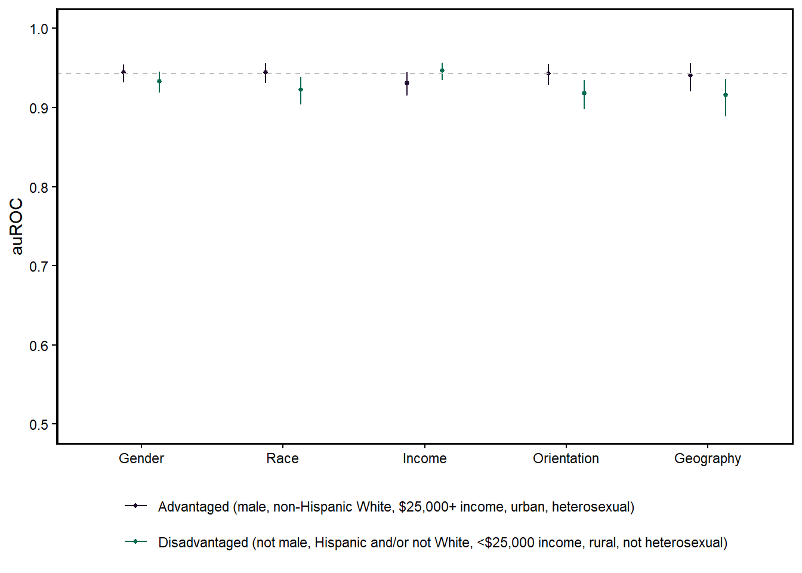
Figure 1: Posterior probabilities for area under the receiver operating curve (auROC) by demographic subgroup. auROC ranges from .5 (chance performance) to 1 (perfect performance). Subgroups advantaged in access to substance use treatment and outcomes (male, non-Hispanic White, greater than $25,000 annual income, urban location, and heterosexual) are depicted in dark purple. Subgroups disadvantaged in access to substance use treatment and outcomes (not male, Hispanic and/or not White, less than $25,000 annual income, rural location, and not heterosexual) are depicted in green. Overall model performance across groups is depicted as the dashed grey line.
_{Source: Make Figures}

Calibration and Overall Performance
The best full model configuration selected with 1 repeat of 5-fold cross-validation used an xgboost statistical algorithm. This model produced well-calibrated predicted probability scores (brier score = 0.014; Figure 2). Histograms of risk probability distributions by true lapse outcome are presented in Figure 2.
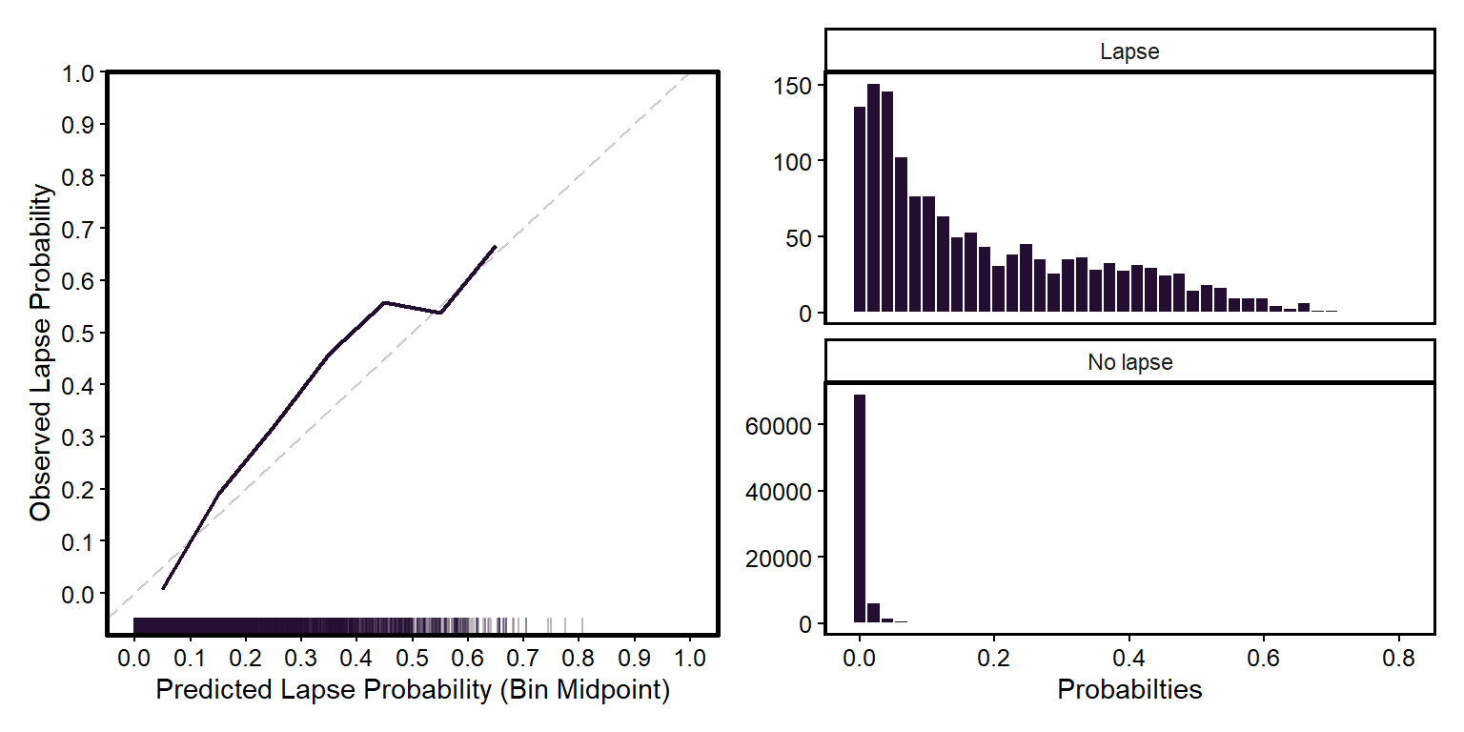
Figure 2: The left panel presents a calibration plot of raw risk probabilities. Predicted probabilities (x-axis) are binned into deciles. Observed lapse probability (y-axis) represents the proportion of actual lapses observed in each bin. The dashed diagonal represents perfect calibration. Points below the line indicate overestimation and points above the line indicate underestimation. The rug plots along the x-axis depicts the observation frequency in each bin for the raw probabilities. The right panel presents histograms of raw risk probability distributions separately by true lapse outcome.
_{Source: Make Figures}

Feature Importance
Individual Shapley values were aggregated across all participants and all observations to provide a relative rank ordering of the most important features. A traditional mean absolute Shapley value approach revealed the most important feature category (i.e., largest magnitude of change in log-odds) was differences in past opioid use. This feature category was over two-fold times more important than the next most important feature category, raw urge ratings. Figure 3 displays the top 20 (out of 88) feature categories, as defined by the 20 largest absolute mean Shapley values. All possible feature categories are provided in Figure S2 in the supplement.
We used a second approach where we calculated the proportion of observations in which each feature category had the highest Shapley value (i.e., largest magnitude and prevalence). This approach revealed the most important feature category to be raw urge ratings, followed by raw abstinence confidence ratings. Differences in past opioid use was the third most important feature category, suggesting that while it has a strong relationship with lapse risk, it is not as prevalent across observations as other feature categories. Notably, in this approach several additional comparably important feature categories emerged, including differences in past stimulant use and differences in time spent in pleasant, unpleasant, helpful, and harmful locations.
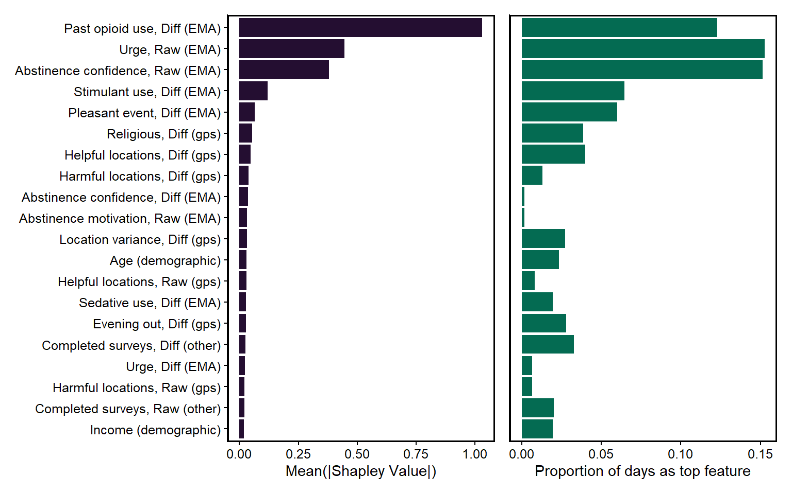
Figure 3: Feature importance plots. The plots display magnitude of feature importance for the top 20 features, determined by the mean absolute Shapley value (left). Feature importance on the right depicts importance by the proportion of days (or observations) that each feature was most important (highest absolute Shapley value).
_{Source: Make Figures}
To understand how each feature category influenced lapse risk predictions, we plotted Shapley-value–based partial dependence plots for the top 20 feature categories (Figure 4; plots for all feature categories are provided in Figure S3 in the supplement). In these plots, positive Shapley values indicate that a feature category increased the predicted probability of lapse (i.e., higher lapse risk), whereas negative Shapley values indicate that the feature category decreased the predicted probability (i.e., lower lapse risk). For raw features, lower values represent lower levels of the corresponding feature (e.g., lower urge intensity, lower abstinence confidence, higher abstinent motivation, and less time spent in pleasant, unpleasant, or helpful locations), while higher values represent higher levels (e.g., higher urge intensity, higher abstinence confidence, lower abstinent motivation, and greater time spent in pleasant, unpleasant, or helpful locations). For difference features, values are interpreted relative to the individual’s baseline. Negative values indicate that the score is below the individual’s typical level (e.g., less substance use, less time in pleasant, unpleasant, or helpful locations, less time at places where religious activities are performed, less location variance, and lower urges or abstinence confidence). A value of zero indicates no deviation from baseline. Positive values indicate that the score is above the individual’s typical level (e.g., more substance use, more time in pleasant, unpleasant, or helpful locations, more time at places where religious activities are performed, more location variance, and higher urges or abstinence confidence). For demographic features, values correspond to ordered categories. For example, lower values indicate younger age and lower income, and higher values indicate older age and higher income.
Differences in past opioid use showed lowered lapse risk probability for participants with no change from baseline (i.e., a feature score of 0). This value can only be achieved by having no lapses (i.e., 0 lapses in the feature scoring epoch - 0 lapses on average over all time on study). In contrast, positive differences in use (i.e., increased use over the past 24 and 168 hour feature scoring epochs compared to baseline use) notably increased lapse risk. Participants with negative differences in use (i.e., reduced use over the past 24 and 168 hour feature scoring epochs compared to baseline use) had lower risk than those with increased use. However, their risk remained elevated relative to individuals whose use did not deviate from baseline.
Raw urge and abstinence confidence ratings had linear relationships to lapse risk, with higher urge ratings increasing lapse risk probability and higher abstinence confidence decreasing lapse risk probability.
Differences in stimulant use showed highest lapse risk probability when there were negative differences in use (i.e., decreased recent stimulant use compared to baseline). While, there was only a modest increase in lapse risk when positive differences in stimulant use were observed, compared to individuals who did not use any stimulants while on study, the raw stimulant use feature category showed a clear linear relationship of stimulant use with lapse risk (see Figure S3 in the Supplement).
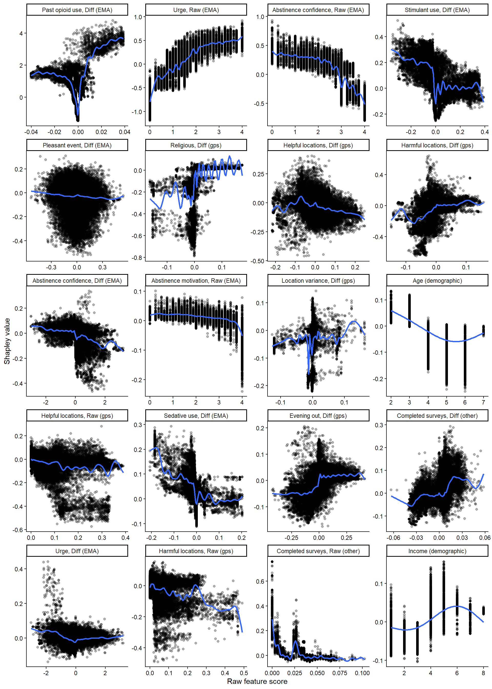
Figure 4: Shapley-feature value partial dependence plots. The plots display the relationship between the Shapley value and mean raw feature value for the top 20 important features. The blue lines represent the estimated smooth functions from generalized additive models.
_{Source: Make Figures}

Discussion

Performance
Our full model demonstrated that it is possible to predict future next-day lapses back to opioid use with high accuracy using smartphone sensing data (auROC = 0.94). Model predictions were well-calibrated, with estimated probabilities closely aligning with observed lapse rates. This is encouraging in that the lapse probabilities themselves may provide clinically valuable and intuitive insight into lapse risk for individuals to use for self-monitoring during OUD recovery.
Our full model performed comparably for predicting lapses in the first month of recovery up to 18+ months in recovery. This suggests that our model includes a set of features that accurately represents relationships between risk factors and lapse among individuals in early and later recovery. Of course, in the context of chronic disease management, even 18 months may not be a long enough trajectory to conclude whether our model generalizes to individuals in later stages of sustained recovery.
Fairness discrepancies in the full model’s performance were minimal. In all subgroups, our model had a median auROC above 0.90, which is generally considered to be a benchmark of outstanding performance (Mandrekar, 2010). Nevertheless, differences of 0.01 - 0.03 (favoring the advantaged group) were present in gender, race and ethnicity, sexual orientation, and geographic location comparisons. Despite our efforts to recruit a diverse sample, many of these group comparisons remained imbalanced (e.g., 19-29% of participants in the disadvantaged groups for race and ethnicity, sexual orientation, and geographic location). Our model may perform better for these groups with greater representation in the training data.
Future research should also purposefully recruit participants across a wider age range. Older adults (65+ years) are less likely to receive substance use disorder treatment and often report lower levels of social interaction and support than younger adults (Choi et al., 2014; Kilaru et al., 2020). They may also be less comfortable with, or less able to provide, smartphone sensing data at the level of adherence needed for accurate prediction. We did not explicitly evaluate model fairness for this subgroup due to limited representation in our sample. We encourage future research to examine model performance for older adults to ensure generalizability.
In addition to representation, it may be that additional risk factors not currently measured could further improve the fairness performance of our models. For example, incorporating lapse risk factors that may be more salient for women (e.g., interpersonal relationship problems, hormonal changes (McHugh et al., 2018; Walitzer & Dearing, 2006)) and other underrepresented groups may help reduce performance disparities by adding features more salient for predicting lapse for certain subgroups.

Sensing Methods
Ablation model comparisons revealed that daily surveys alone captured nearly all of this predictive signal (auROC = 0.94). To our knowledge, no other published substance use prediction study has collected daily survey data from participants continuously over the course of one year. Survey adherence rates in our sample were comparable to those observed in other clinical populations, suggesting that self‑report surveys are a feasible and risk-relevant sensing method for long‑term monitoring in this population.
When daily surveys were ablated from the model, predictive performance dropped substantially (auROC = 0.63). Although this performance remained above chance and exceeded that of a demographics‑only model (with both geolocation and daily surveys ablated; auROC = 0.55), it indicates that geolocation features captured only modest predictive signal. Moreover, given that ablating geolocation features did not result in any drop in performance, this signal likely overlaps with information already captured with the daily surveys.
It is possible that the relatively low predictive value of geolocation sensing in this study was due to methodological limitations. Although geolocation data can, in principle, be collected continuously moment‑by‑moment, in practice these data are difficult to collect reliably. In our study, geolocation features had substantially higher rates of missingness compared to daily surveys. Consequently, approximately 12% of geolocation features were imputed using median values derived from other individuals in the training dataset. Median values are by definition near the center of the feature distribution. These values are common and have limited influence on model predictions (i.e., low leverage). This was a purposeful decision in our design to ensure that missing data would not systematically influence predictions in either direction. However, this conservative approach likely contributed to reduced predictive performance of geolocation features, as imputations that minimize influence also limit the ability of those features to contribute risk‑relevant signal. Lastly, these median imputations are also not person-specific and as a result may not accurately represent typical values for the individual whose data are being imputed. As geolocation sensing methods become more robust and missingness is reduced, these features may become more powerful for lapse prediction.
We could also imagine augmenting our method for contextualizing geolocation data with other publicly available data. A limitation of our geolocation sensing method was that we relied on known locations with self-reported context. While this method provides meaningful contextual information, it is limited in its ability to capture the full range of locations participants visit without substantially increasing participant burden. Passive methods for contextualizing location could address this limitation by providing risk-relevant contextual information across all locations. For example, latitude and longitude coordinates could be contextualized using publicly available datasets, such as alcohol outlet density, area deprivation index, and Narcotics Annonymous meeting times and locations. Increasing the number of locations would allow for potentially more variance in feature distributions within and between individuals.
There is also a question as to whether geolocation sensing is as feasible for rural populations as it is for urban populations. Modern GPS often uses cell towers and Wi-Fi networks to improve speed and accuracy. In rural areas, where such infrastructure is sparse, devices rely more heavily on satellite-only positioning, which can be slower to initialize and less reliable under suboptimal signal conditions (Groves, 2013). Even in the best conditions where GPS points are accurate and stored locally on an individuals phone, the data must still be transmitted over an internet-connected app (at least daily) to be used as reliable features in the model. Therefore, in future work we plan to explicitly assess differences in geolocation adherence (e.g., the percentage of days with available geolocation data) as well as differences in the strength of geolocation feature importance between these groups.
If geolocation sensing proves to be less accurate or reliable for rural populations, this could foreshadow additional design challenges associated with using a web-based app for recovery monitoring. For example, unstable internet connectivity may necessitate storing in-app recovery recommendations locally so that individuals can access them at moments of need. Even EMA, when administered once per day, could pose challenges if completed surveys cannot be reliably transmitted over cellular data. We highlight these potential limitations as areas warranting close examination in future work. Nevertheless, we remain optimistic about the potential of geolocation sensing, given that our models generally performed comparably across rural and urban groups.
To summarize, if the goal is prediction, geolocation sensing features are not necessary as they do not offer any unique incremental predictive value. However, if the goal is to have a more nuanced understanding of lapse risk across a more diverse array of risk features than geolocation is helpful. Adding geolocation features did not hurt model performance, and more data sources provides more opportunities for identifying intervenable targets specific to a person and moment in time.

Feature Importance
When using a standard mean absolute Shapley value approach to estimate average feature importance across observations, the most important feature was prior opioid use. This finding is consistent with the relapse‑prevention literature, which identifies lapse as an important precursor to relapse, and prior prediction research demonstrating that lapses predict future lapses (Wyant et al., 2024). Notably, this feature had a mean absolute Shapley value that was over two-fold times higher than the next most important feature. However, when considering this model in the context of a recovery monitoring support system that provides daily insight into lapse risk, this finding may be misleading. Fewer than 2% of day-level observations contained a lapse, and the majority of participants did not lapse at all. Among those who did lapse, many only lapsed one time. Given that past use does not become a risk factor until after it has occurred, in most cases other features may represent more clinically meaningful targets for intervention.
A more informative approach to characterize feature importance is to consider the proportion of observations in which a given feature had the highest Shapley value. This approach considers both the magnitude of a feature’s effect (in terms of log-odds change in the prediction) and its prevalence across observations. Using this approach, urge ratings and abstinence confidence emerged as the features most frequently influencing lapse risk predictions. This suggests that individuals may benefit more often from recovery recommendations focused on reducing urges (e.g., urge surfing) and increasing abstinence confidence (e.g., reflecting on recent successes). Additionally, this approach showed that while some features have low average importance (across all individuals and observations), they can be highly important on certain days for certain individuals (e.g., evenings out).
Across both feature importance approaches, geolocation features emerged among the top subset of features. Specifically, time spent in pleasant, unpleasant, helpful, or harmful locations and time spent at locations where religious activities are performed were among the top ten features. These findings suggest that although geolocation features may not provide unique signal for prediction, it may be worthwhile to still include them in the model to expand opportunities for intervention and provide precision-oriented recovery support.
Shapley-feature value partial dependence plots demonstrated the direction of the relationship of these top feature categories with lapse risk. The direction of these relationships was consistent with the extant literature on the precursors to lapse and relapse (Marlatt & Donovan, 2007; K. A. Witkiewitz & Marlatt, 2007; K. Witkiewitz & Marlatt, 2004). More frequent opioid use, high intensity urges, low abstinence confidence, and less time spent in helpful locations all increased lapse risk. However, our use of raw and difference features allowed us to discover nuance in these relationships. For example, while the use of non-opioid illicit substances generally has a positive relationship with lapse risk, recent decreases in use (i.e., in the past day or week) appears to present a vulnerable period of time where individuals are at high risk for lapsing back to opioids. We saw this pattern with both stimulant and sedative use. This suggests that it is important to consider not just the presence or absence of substance use behaviors, but also how these behaviors differ from a person’s typical use pattern. Recent decreases in the use of one substance may trigger cognitive and physiological processes resembling those linked to opioid use, reactivating a negative reinforcement cycle of using opioids for relief from distressing states.
We observed a similar pattern with urge ratings. Higher urges clearly increased lapse risk; however, recent decreases in urges were also associated with increased lapse risk. At first, this finding appeared contradictory. However, individuals with extremely negative urge difference values must, on average, often experience high-intensity urges in order to produce a change of this magnitude (e.g., a downward two-point shift on a five-point scale). Thus, it is possible that when these individuals suddenly experience a reduction in urge intensity, they may develop a false sense of security, leading to a lowered guard, overconfidence, or increased exposure to triggers.
Unexpectedly, a recent decrease in time spent at locations where religious activities are performed appeared to lower lapse risk. This feature category was relatively sparse in our data. In fact, the raw feature category was not retained in the final model due to having less than 5% variance (i.e., non-zero values). As a result, it may be that this pattern represented only a handful of participants’ relationship to religion and these locations may not generalize more broadly. Nevertheless, this feature did emerge as the 7th most important feature category, making it a worthwhile area to explore in future studies.

Additional Limitations and Future Directions
Other characteristics of our sample may limit the generalizability of our findings. One obvious limitation is the research context in which participants provided these data. Participants were modestly compensated for completing daily surveys and providing geolocation data, which may have influenced their willingness to provide these data. In fact, it would not be surprising if compensation did play at least a minor role in these findings, given the support for contingency management in promoting both treatment adherence and abstinence (Bolívar et al., 2021). However, participants received no additional direct benefit beyond financial compensation. In real-world implementations, individuals may be more motivated to share data if doing so enables personalized recovery support as providing ongoing compensation, regardless of proven benefits seen in clinical practice, would likely be prohibitive at-scale.
Second, we implemented daily survey compliance thresholds to exclude participants and adjust study end dates. This criterion was important because we generated our lapse labels from the daily survey data and thus we required consistent collection of this data stream for accurate observation labels. As a result, our estimates of adherence and model performance may be slightly optimistic. Still, even with this criterion, nearly 78% of participants remained in the study for at least six months, suggesting that long-term monitoring with daily surveys is feasible for a substantial proportion of individuals in this population.
A third limitation is that our sample was restricted to individuals with a goal of abstinence. Accordingly, our models were trained to predict goal-inconsistent use (i.e., lapse), which may limit their applicability to individuals with alternative recovery goals. Although we see no inherent reason these models could not be adapted for individuals pursuing moderation or harm reduction, this remains an empirical question. For individuals who do not aim to abstain, the definition of goal-inconsistent use is less straightforward and may vary considerably from person to person. Future studies could improve generalizability by allowing individuals to self-define goal-inconsistent use (e.g., mixing opioids with other substances or using larger amounts than planned) and train models in samples with diverse recovery goals.
Lastly, there may be value in exploring alternative modeling approaches that better leverage the temporal structure and individual-level nature of these data. For example, hierarchical models that start with population-based information (i.e., priors) and are updated with person-specific information as the individual provides data may be the most promising approach for effective use of time-varying information to model how an individual’s lapse risk evolves over time. Our lab has begun to develop these models and found preliminary evidence to suggest that they may modestly outperform traditional machine learning models for predicting alcohol lapses (Pulick et al., 2025) (but also see Leenaerts et al. (2024)).

Conclusion
In conclusion, it is possible to predict future lapses back to opioid use using smartphone sensing data. Daily surveys and geolocation sensing provide a diverse array of important risk factors for lapse. Daily recovery recommendations can be mapped onto these factors to deliver support that is personalized to both the person and the moment. Our machine learning model, trained on a national clinical sample of individuals with OUD, is a promising step toward future real-world implementation and evaluation.

References
American Psychiatric Association. (2022). Diagnostic and statistical manual of mental disorders : DSM-5-TR. 5th edition, text revision. Washington, DC : American Psychiatric Association Publishing, 2022.
Bolívar, H. A., Klemperer, E. M., Coleman, S. R. M., DeSarno, M., Skelly, J. M., & Higgins, S. T. (2021). Contingency Management for Patients Receiving Medication for Opioid Use Disorder: A Systematic Review and Meta-analysis. JAMA Psychiatry, 78(10), 1092–1102. https://doi.org/10.1001/jamapsychiatry.2021.1969
Center for High Throughput Computing. (2006). Center for high throughput computing. Center for High Throughput Computing. https://doi.org/10.21231/GNT1-HW21
Choi, N. G., DiNitto, D. M., & Marti, C. N. (2014). Treatment use, perceived need, and barriers to seeking treatment for substance abuse and mental health problems among older adults compared to younger adults. Drug and Alcohol Dependence, 145, 113–120. https://doi.org/10.1016/j.drugalcdep.2014.10.004
Collins, G. S., Moons, K. G. M., Dhiman, P., Riley, R. D., Beam, A. L., Van Calster, B., Ghassemi, M., Liu, X., Reitsma, J. B., Van Smeden, M., Boulesteix, A.-L., Camaradou, J. C., Celi, L. A., Denaxas, S., Denniston, A. K., Glocker, B., Golub, R. M., Harvey, H., Heinze, G., … Logullo, P. (2024). TRIPOD+AI statement: Updated guidance for reporting clinical prediction models that use regression or machine learning methods. BMJ, 385, e078378. https://doi.org/10.1136/bmj-2023-078378
Dennis, M., & Scott, C. K. (2007). Managing Addiction as a Chronic Condition. Addiction Science & Clinical Practice, 4(1), 45–55.
Dormann, C. (2020). Calibration of probability predictions from machine-learning and statistical models. Global Ecology and Biogeography, 29, 760–765. https://doi.org/10.1111/geb.13070
Dowell, D., Brown, S., Gyawali, S., Hoenig, J., Ko, J., Mikosz, C., Ussery, E., Baldwin, G., Jones, C. M., Olsen, Y., Tomoyasu, N., Han, B., Compton, W. M., & Volkow, N. D. (2024). Treatment for Opioid Use Disorder: Population Estimates - United States, 2022. MMWR. Morbidity and Mortality Weekly Report, 73(25), 567–574. https://doi.org/10.15585/mmwr.mm7325a1
Economic Research Service US Department of Agriculture. (n.d.). Rural-Urban Commuting Area Codes - Users’ Guide. https://www.ers.usda.gov/data-products/rural-urban-commuting-area-codes/users-guide.
Epstein, D. H., Tyburski, M., Kowalczyk, W. J., Burgess-Hull, A. J., Phillips, K. A., Curtis, B. L., & Preston, K. L. (2020). Prediction of stress and drug craving ninety minutes in the future with passively collected GPS data. Npj Digital Medicine, 3(1), 26. https://doi.org/10/ghqvcw
Florence, C., Luo, F., & Rice, K. (2021). The economic burden of opioid use disorder and fatal opioid overdose in the United States, 2017. Drug and Alcohol Dependence, 218, 108350. https://doi.org/10.1016/j.drugalcdep.2020.108350
Freitag, T. M., Chen-Sankey, J. C., Duarte, D. A., Ramsey, M. W., & Choi, K. (2021). Variations in Substance Use and Disorders Among Sexual Minorities by Race/Ethnicity. Substance Use & Misuse, 56(7), 921–928. https://doi.org/10.1080/10826084.2021.1899225
Goodrich, B., Gabry, J., Ali, I., & Brilleman, S. (2023). Rstanarm: Bayesian Applied Regression Modeling via Stan.
Greenfield, S. F., Brooks, A. J., Gordon, S. M., Green, C. A., Kropp, F., McHugh, R. K., Lincoln, M., Hien, D., & Miele, G. M. (2007). Substance abuse treatment entry, retention, and outcome in women: A review of the literature. Drug and Alcohol Dependence, 86(1), 1–21. https://doi.org/10.1016/j.drugalcdep.2006.05.012
Groves, P. (2013). Principles of GNSS, Inertial, and Multisensor Integrated Navigation Systems, Second Edition.
Gryczynski, J., Mitchell, S. G., Jaffe, J. H., O’Grady, K. E., Olsen, Y. K., & Schwartz, R. P. (2014). Leaving Buprenorphine Treatment: Patients’ Reasons for Cessation of Care. Journal of Substance Abuse Treatment, 46(3), 356–361. https://doi.org/10.1016/j.jsat.2013.10.004
Guerrero, E. G., Marsh, J. C., Khachikian, T., Amaro, H., & Vega, W. A. (2013). Disparities in Latino substance use, service use, and treatment: Implications for culturally and evidence-based interventions under health care reform. Drug and Alcohol Dependence, 133(3), 805–813. https://doi.org/10.1016/j.drugalcdep.2013.07.027
Gustafson, D. H., McTavish, F. M., Chih, M.-Y., Atwood, A. K., Johnson, R. A., Boyle, M. G., Levy, M. S., Driscoll, H., Chisholm, S. M., Dillenburg, L., Isham, A., & Shah, D. (2014). A smartphone application to support recovery from alcoholism: A randomized clinical trial. JAMA Psychiatry, 71(5), 566–572. https://doi.org/10.1001/jamapsychiatry.2013.4642
Health Resources and Services Administration. (n.d.). How We Define Rural. https://www.hrsa.gov/rural-health/about-us/what-is-rural.
Heinz, M. V., Price, G. D., Singh, A., Bhattacharya, S., Chen, C.-H., Asyyed, A., Does, M. B., Hassanpour, S., Hichborn, E., Kotz, D., Lambert-Harris, C. A., Li, Z., McLeman, B., Mishra, V., Stanger, C., Subramaniam, G., Wu, W., Campbell, C. I., Marsch, L. A., & Jacobson, N. C. (2025). A longitudinal observational study with ecological momentary assessment and deep learning to predict non-prescribed opioid use, treatment retention, and medication nonadherence among persons receiving medication treatment for opioid use disorder. Journal of Substance Use & Addiction Treatment, 173. https://doi.org/10.1016/j.josat.2025.209685
Hser, Y.-I., Mooney, L. J., Saxon, A. J., Miotto, K., Bell, D. S., Zhu, Y., Liang, D., & Huang, D. (2017). High Mortality Among Patients With Opioid Use Disorder in a Large Healthcare System. Journal of Addiction Medicine, 11(4), 315. https://doi.org/10.1097/ADM.0000000000000312
Jones, A., Remmerswaal, D., Verveer, I., Robinson, E., Franken, I. H. A., Wen, C. K. F., & Field, M. (2019). Compliance with ecological momentary assessment protocols in substance users: A meta-analysis. Addiction (Abingdon, England), 114(4), 609–619. https://doi.org/10/gfsjzg
Kilaru, A. S., Xiong, A., Lowenstein, M., Meisel, Z. F., Perrone, J., Khatri, U., Mitra, N., & Delgado, M. K. (2020). Incidence of Treatment for Opioid Use Disorder Following Nonfatal Overdose in Commercially Insured Patients. JAMA Network Open, 3(5), e205852. https://doi.org/10.1001/jamanetworkopen.2020.5852
Kuhn, M. (2022). Tidyposterior: Bayesian Analysis to Compare Models using Resampling Statistics.
Kuhn, M., & Wickham, H. (2020). Tidymodels: A collection of packages for modeling and machine learning using tidyverse principles.
Leenaerts, N., Soyster, P., Ceccarini, J., Sunaert, S., Fisher, A., & Vrieze, E. (2024). Person-specific and pooled prediction models for binge eating, alcohol use and binge drinking in bulimia nervosa and alcohol use disorder. Psychological Medicine, 54(10), 2758–2773. https://doi.org/10.1017/S0033291724000862
Lister, J. J., Weaver, A., Ellis, J. D., Himle, J. A., & Ledgerwood, D. M. (2020). A systematic review of rural-specific barriers to medication treatment for opioid use disorder in the United States. The American Journal of Drug and Alcohol Abuse, 46(3), 273–288. https://doi.org/10.1080/00952990.2019.1694536
Lofaro, R. J., Bohler, R. M., Spurgeon, R., & Mase, W. A. (2025). Rural and urban differences in treatment on demand for substance use treatment involving medications for opioid use disorder. The Journal of Rural Health, 41(3), e70076. https://doi.org/10.1111/jrh.70076
Lundberg, S. M., & Lee, S.-I. (2017). A unified approach to interpreting model predictions. Proceedings of the 31st International Conference on Neural Information Processing Systems, NIPS’17, 4768–4777.
Ma, J., Bao, Y.-P., Wang, R.-J., Su, M.-F., Liu, M.-X., Li, J.-Q., Degenhardt, L., Farrell, M., Blow, F. C., Ilgen, M., Shi, J., & Lu, L. (2019). Effects of medication-assisted treatment on mortality among opioids users: A systematic review and meta-analysis. Molecular Psychiatry, 24(12), 1868–1883. https://doi.org/10.1038/s41380-018-0094-5
Mandrekar, J. N. (2010). Receiver operating characteristic curve in diagnostic test assessment. Journal of Thoracic Oncology: Official Publication of the International Association for the Study of Lung Cancer, 5(9), 1315–1316. https://doi.org/10.1097/JTO.0b013e3181ec173d
Marlatt, G. A., & Donovan, D. M. (Eds.). (2007). Relapse Prevention, Second Edition: Maintenance Strategies in the Treatment of Addictive Behaviors (2nd edition). The Guilford Press.
Martin, C. E., Parlier-Ahmad, A. B., Beck, L., Scialli, A., & Terplan, M. (2022). Need for and Receipt of Substance Use Disorder Treatment Among Adults, by Gender, in the United States. Public Health Reports®, 137(5), 955–963. https://doi.org/10.1177/00333549211041554
McHugh, R. K., Votaw, V. R., Sugarman, D. E., & Greenfield, S. F. (2018). Sex and gender differences in substance use disorders. Clinical Psychology Review, 66, 12–23. https://doi.org/10.1016/j.cpr.2017.10.012
McLellan, A. T., Lewis, D. C., O’Brien, C. P., & Kleber, H. D. (2000). Drug dependence, a chronic medical illness: Implications for treatment, insurance, and outcomes evaluation. JAMA, 284(13), 1689–1695. https://doi.org/10.1001/jama.284.13.1689
Mohr, D. C., Zhang, M., & Schueller, S. M. (2017). Personal Sensing: Understanding Mental Health Using Ubiquitous Sensors and Machine Learning. Annual Review of Clinical Psychology, 13(1), 23–47. https://doi.org/10.1146/annurev-clinpsy-032816-044949
Moshontz, H., Colmenares, A. J., Fronk, G. E., Sant’Ana, S. J., Wyant, K., Wanta, S. E., Maus, A., Jr, D. H. G., Shah, D., & Curtin, J. J. (2021). Prospective Prediction of Lapses in Opioid Use Disorder: Protocol for a Personal Sensing Study. JMIR Research Protocols, 10(12), e29563. https://doi.org/10.2196/29563
Novak, P., Feder, K. A., Ali, M. M., & Chen, J. (2019). Behavioral health treatment utilization among individuals with co-occurring opioid use disorder and mental illness: Evidence from a national survey. Journal of Substance Abuse Treatment, 98, 47–52. https://doi.org/10.1016/j.jsat.2018.12.006
Olfson, M., Mauro, C., Wall, M. M., Choi, C. J., Barry, C. L., & Mojtabai, R. (2022). Healthcare coverage and service access for low-income adults with substance use disorders. Journal of Substance Abuse Treatment, 137, 108710. https://doi.org/10.1016/j.jsat.2021.108710
Parlier-Ahmad, A. B., Martin, C. E., Radic, M., & Svikis, D. S. (2021). An exploratory study of sex and gender differences in demographic, psychosocial, clinical, and substance use treatment characteristics of patients in outpatient opioid use disorder treatment with buprenorphine. Translational Issues in Psychological Science, 7(2), 141–153. https://doi.org/10.1037/tps0000250
Pinedo, M. (2019). A current re-examination of racial/ethnic disparities in the use of substance abuse treatment: Do disparities persist? Drug and Alcohol Dependence, 202, 162–167. https://doi.org/10.1016/j.drugalcdep.2019.05.017
Pulick, E., Curtin, J., & Mintz, Y. (2025). Idiographic Lapse Prediction With State Space Modeling: Algorithm Development and Validation Study. JMIR Formative Research, 9(1), e73265. https://doi.org/10.2196/73265
Rajkomar, A., Hardt, M., Howell, M. D., Corrado, G., & Chin, M. H. (2018). Ensuring Fairness in Machine Learning to Advance Health Equity. Annals of Internal Medicine, 169(12), 866. https://doi.org/10.7326/M18-1990
Saloner, B., & Lê Cook, B. (2013). Blacks and Hispanics are less likely than whites to complete addiction treatment, largely due to socioeconomic factors. Health Affairs, 32(1), 135–145. https://doi.org/10.1377/hlthaff.2011.0983
Schmidt, L. A., Ye, Y., Greenfield, T. K., & Bond, J. (2007). Ethnic disparities in clinical severity and services for alcohol problems: Results from the National Alcohol Survey. Alcoholism, Clinical and Experimental Research, 31(1), 48–56. https://doi.org/10.1111/j.1530-0277.2006.00263.x
Sigmon, S. C. (2014). Access to treatment for opioid dependence in rural America: Challenges and future directions. JAMA Psychiatry, 71(4), 359–360. https://doi.org/10.1001/jamapsychiatry.2013.4450
Skolnick, P., Paavola, J., & Heidbreder, C. (2024). Synthetic opioids have disrupted conventional wisdom for treating opioid overdose. Drug and Alcohol Dependence Reports, 12, 100268. https://doi.org/10.1016/j.dadr.2024.100268
Stanton, M. (2005). Relapse Prevention Needs More Emphasis on Interpersonal Factors. American Psychologist, 60(4), 340–341. https://doi.org/10.1037/0003-066X.60.4.340
Strang, J., McCambridge, J., Best, D., Beswick, T., Bearn, J., Rees, S., & Gossop, M. (2003). Loss of tolerance and overdose mortality after inpatient opiate detoxification: Follow up study. BMJ, 326(7396), 959–960. https://doi.org/10.1136/bmj.326.7396.959
Substance Abuse and Mental Health Services Administration. (n.d.). 2024 NSDUH Detailed Tables CBHSQ Data. https://www.samhsa.gov/data/report/2024-nsduh-detailed-tables.
Van Calster, B., Collins, G. S., Vickers, A. J., Wynants, L., Kerr, K. F., Barreñada, L., Varoquaux, G., Singh, K., Moons, K. G., Hernandez-Boussard, T., Timmerman, D., McLernon, D. J., Van Smeden, M., & Steyerberg, E. W. (2025). Evaluation of performance measures in predictive artificial intelligence models to support medical decisions: Overview and guidance. The Lancet Digital Health, 100916. https://doi.org/10.1016/j.landig.2025.100916
Walitzer, K. S., & Dearing, R. L. (2006). Gender differences in alcohol and substance use relapse. Clinical Psychology Review, 26(2), 128–148. https://doi.org/10.1016/j.cpr.2005.11.003
Witkiewitz, K. A., & Marlatt, G. A. (Eds.). (2007). Therapist’s Guide to Evidence-Based Relapse Prevention (1st edition). Academic Press.
Witkiewitz, K., & Marlatt, G. A. (2004). Relapse prevention for alcohol and drug problems: That was zen, this is tao. American Psychologist, 59(4), 224–235. https://doi.org/10.1037/0003-066X.59.4.224
Wood, P., Opie, C., Tucci, J., Franklin, R., & Anderson, K. (2019). “A lot of people call it liquid handcuffs” – barriers and enablers to opioid replacement therapy in a rural area. Journal of Substance Use, 24(2), 150–155. https://doi.org/10.1080/14659891.2018.1523968
Wyant, K., Moshontz, H., Ward, S. B., Fronk, G. E., & Curtin, J. J. (2023). Acceptability of Personal Sensing Among People With Alcohol Use Disorder: Observational Study. JMIR mHealth and uHealth, 11(1), e41833. https://doi.org/10.2196/41833
Wyant, K., Sant’Ana, S. J. K., Fronk, G., & Curtin, J. J. (2024). Machine learning models for temporally precise lapse prediction in alcohol use disorder. Psychopathology and Clinical Science. https://doi.org/10.31234/osf.io/cgsf7
Xin, Y., Schwarting, C. M., Wasef, M. R., & Davis, A. K. (2023). Exploring the intersectionality of stigma and substance use help-seeking behaviours among lesbian, gay, bisexual, transgender, queer, questioning or otherwise gender or sexuality minority (LGBTQ+) individuals in the United States: A scoping review. Global Public Health, 18(1), 2277854. https://doi.org/10.1080/17441692.2023.2277854

$0.25 per survey plus an additional $3.70 for completing at least 12 surveys in the first half of the month and an additional $3.70 for completing at least 12 surveys in the second half of the month (total range of $14.40 - $15.15)
Participants were also compensated for providing other sensing data as part of the parent grant’s aims, including $10 per month for sharing cellular communication logs and text message content and up to $10 per month for the daily video check-in.
We followed guidelines from the United States Health Resources and Services Administration and define urban as an area where the primary commuting flow is within a metropolitan core of 50,000 or more people (RUCA code = 1) and rural as anything not urban (RUCA codes 2-10). (Health Resources and Services Administration, n.d.)
405 participants consented to participate in the study and provided at least one daily survey; however, 75 participants dropped out prior to completing the first personalized monthly survey and were therefore not considered fully enrolled in the study.
If adherence fell below 33% (roughly 9 surveys in a 28-day period) for a prolonged period of time, participant study end dates were changed to match the start of this adherence drop.

