CMSC-4180-Assignment 1
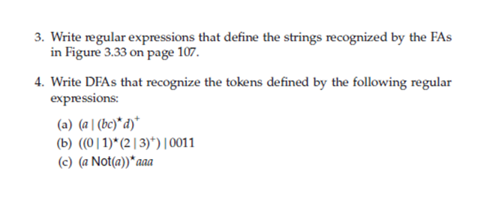
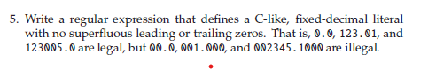
Question 3.)
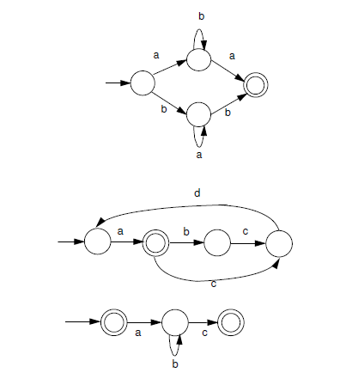
    - Top figure: (a(b)*a | b(a)*b)
    - Middle figure: a ((bcda)* | (cda)*)
    - Bottom figure: (λ | a(b)*c)

Question 4.)
a.
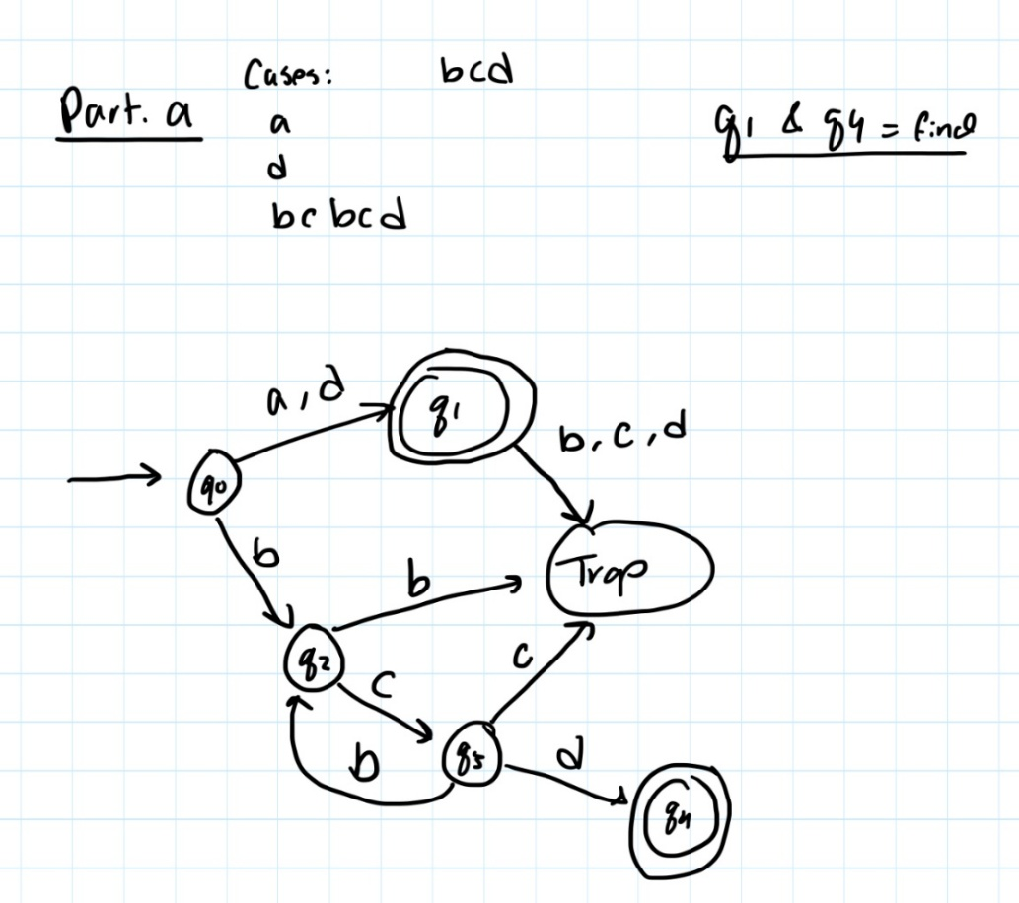
b.
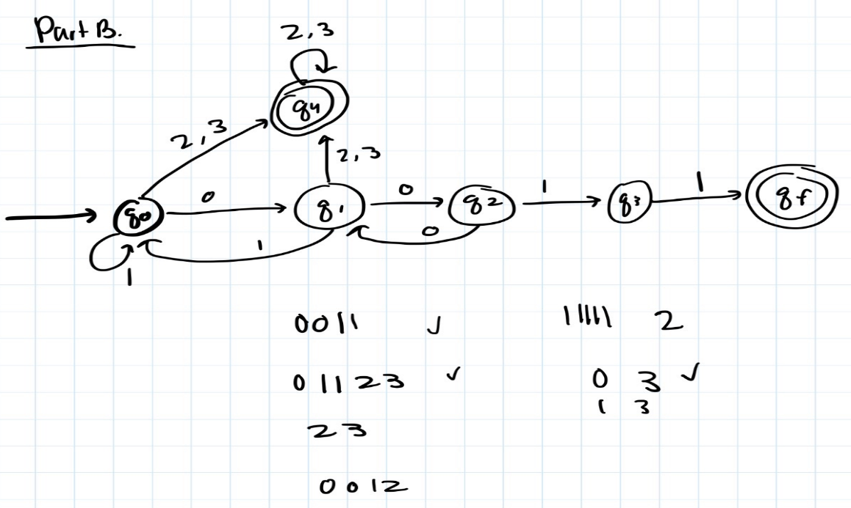

c.
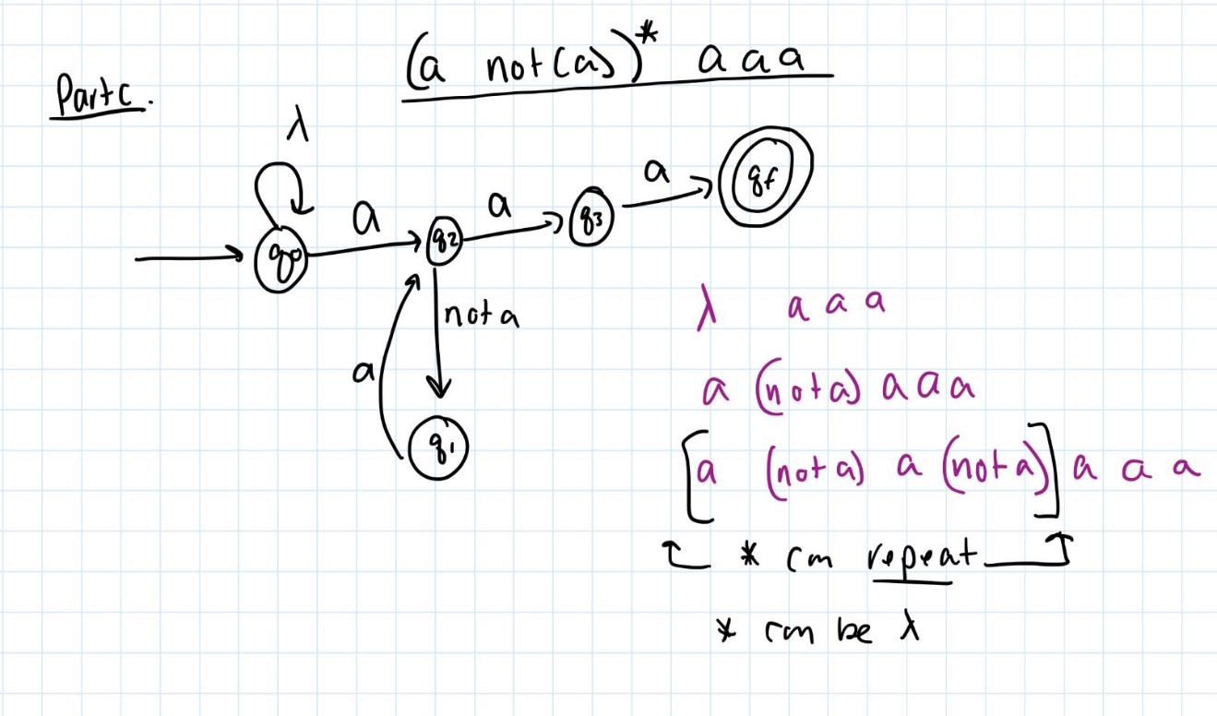

Question 5.)

D = (1|…|9)
Z = (0|…|9)
( 0 | D (Z)* ) "." ( 0 | (Z)* D )

