CMSC-4180-Assignment 3
Chapter 8: Problem 1
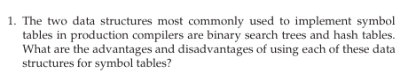
Binary Search Trees are data structures that use the efficentcy of linked datastructures for insertion. These Bionary Search Trees allow each name of the structure to be used as a stack of currently actuive scopes that declare the name. Advantages can be seen since their design is simple leading to both useablity and populatity. Average case performance makes them an optimal choice for implementing symbol tables. However, they do have a trade off on overall performance. Maintaining O(log n ) can be inconsistent since programmers do not choose identifier names at random. These searches can then degrade to O(n) lookup time with inefficient ordering if unbalanced.
Hash tables are another popluar method. This method can handle large datasets with excellent performance. Hashing, collision-handling, insertion, and retriveal can all be performed in constant time. Similar to the Binary Search Tree, the Hash table also has disadvantages. Hash collision, memory inefficiencies, and no specifc ordering within the table are a few.
Chapter 9: Problem 2
