Vulcan Activity Tracker
The Athletic Activity Tracker for PennWest California Students.

Specifications Document
Team Members:
Margo Bonal
John Gerega
Luke Ruffing

Professor:
Dr. Weifeng Chen

Course: Software Engineering Project I
School: Pennsylvania Western University

Instructor Comments/Evaluation

Table of Contents
Abstract 3
Description of the Document 5
Purpose and Use 5
Intended Audience 5
System Description 5
Overview 5
Environment and Constraints: 6
End User Profile 6
User Interaction 6
Hardware Constraints 6
Software Constraints 7
Time Constraints 7
Cost Constraints 8
Other Concerns 8
Acceptance Test Criteria 9
Testers 9
Criteria for User Acceptance 10
System Modeling 11
Functional: Use Cases & Scenarios 11
Entity: Class Diagrams 13
Dynamic: Statechart 16
States 17
Events 18
Transitions 18
Dataflow Diagrams Components 19
Tools Needed 20
List of Resources 21
Appendix I: Glossary of Terms 22
Appendix III: Workflow Authentication 25
Appendix IV: Writing Center report 27

Abstract
This project, the Vulcan Activity Tracker, is an activity tracker that can be accessed by students attending Pennsylvania Western University’s California branch. The activity tracker will allow students to track any physical activity they participate in, which may include running, sports, walking, lifting, and many more. Strava (2025), running and fitness app, is the initial inspiration for this project, however, campus life will be modeled as the environment. This project will use a Docker container, a database, and a Python backend, built alongside a CSS/Vanilla HTML frontend. All these components will be used to track user data, such as login information and the activities the user has completed. The Docker container will be used to keep the frontend, backend, and database in one place. This will also ensure that the app runs consistently across multiple platforms. The database will store all the users and their data. Functions to retrieve, create, and delete data will be written in the Python programming language. The user will be able to add activities manually and view other users’ activities. This document will cover all necessary details for the user and the development team regarding the functionality of the final product.

Description of the Document

Purpose and Use
The purpose of this document is to define the scope and specific requirements for the project. These requirements include the product’s functionality and system requirements. The developers and clients will use this document to state the terms of their arrangement. The client has the right to dispute the contents of this document, so the product properly reflects their desired requirements. After acceptance of the terms stated in this document, it shall be known that this document becomes a binding contract.

Intended Audience
This document’s intended audience includes the clients and product developers. The product developers have created this document to make an outline of their finished product. By doing so, it helps the client to know exactly what product, functionality, and the cost that will be associated with this project. It also assists the development team to know which direction they are headed in and states their priorities for the project. Any uncertainty in this document needs to be addressed as this serves as a binding contract.

System Description

Overview
The Vulcan Activity Tracker is a software application, accessed via a web application. The main function of the activity tracker is to manually track exercise activities. A user can track exercise activities ranging from multiple sports. These could include running, lifting, biking, swimming, any organized sport, and many other activities. A user will also be able to join their sports team, recreational club team, or create a group with friends. With recreational clubs and teams there will be a person to admit users into the organization. Users can view activities from everyone on campus. A leaderboard for each activity will also be accessible to all users in order to inspire some friendly competition.

Environment and Constraints:

End User Profile
The most common end users of the Vulcan Activity Tracker are PennWest students, most likely ones involved in sports or recreational clubs. Users should be familiar with using web applications to interact with the website. With a basic understanding of navigating web applications, any student will be able to add an activity, view their statistics, view other students’ activities, and view the leaderboards.

User Interaction
The user interaction will be through the software application that runs the web application. Once the user logs in or creates a new account with Pennsylvania Western credentials, they will be redirected to the home page with all recent student activities. The user can then find the buttons to redirect them to the leaderboard section, group section, and the section to actually add an activity. In the leaderboard section, users will be able to filter based on activity type and by group, meaning they can see the leaderboard of only their group or organization.

Hardware Constraints
The following are hardware constraints of the Vulcan Activity Tracker. A user will need the following:
- A desktop computer system (with mouse & keyboard), laptop computer, or mobile device with internet access and WIFI capabilities.
- Internet network components of router, modem, ethernet.
- Mobile device data plan from ISP.
- Current Windows version 11
- External fitness tracker i.e. smart watch for collecting activity tracking data.

Software Constraints
Software constraints for the Vulcan Activity Tracker will include components that directly impact both development and useability. A current updated operating system is important for proper functioning. Mobile devices must also be updated for optimal use. To ensure multiple users can interact with the site at one without system throttling, internet speed will need to be tested. Antivirus software applications will need to be tested and monitored to see if they slow operations by any means.

Time Constraints
The time constraints for this project are designed for Senior Project course requirements. Fall 2025 semester is allocated for documentation of team chosen project. This will make up fifteen-week timeline. The following fifteen-week term will be dedicated to development and design. Several hours per week will be allotted to team meetings, development, testing, and advisory check-in meetings. A goal will be set to have the project adequately finished in sufficient time before due date and end presentation to ensure testing time. All declared and documented features will be anticipated to be completed and functioning at the end of proposed timeline.

Cost Constraints
Cost constraints will be related to software toolsets and subscriptions. Development tools will need to be evaluated and considered with cost analysis. Since most toolsets and libraries will be open-sourced, the primary cost constraint for the Vulcan Activity Tracker will be web application hosting service. Most services only allot certain time periods for free hosting, or certain qualities of service. The best hosting application will be decided through team decisions.

Other Concerns
The end-user will need to have access to Wi-Fi or a Data Plan to utilize the website. If a student is out of range of cellular service, for example, hiking, access to the Vulcan Activity Tracker will be impacted. Users must also have valid Pennsylvania Western University credentials. Limitations need to prevent non-PennWest students from using the application. The sharing of student credentials is unintended and improper use case. A final but significant concern is the uploading of malicious content to data entry fields. Since the Vulcan Activity tracker is primarily a web-based application, cybersecurity attacks such as internet virus infection, data injection, and DDoS are of concern. The developers of the Vulcan Activity Tracker are held non-responsible for user data corruption and cybersecurity attacks; however, software precautions will be implemented to protect the CIA Cybersecurity Triad: Confidentiality, Integrity, and Accessibility. The Fortinet (2025) article, CIA Triad, provided helpful information for team security modeling. “Applying the CIA triad can help strengthen an organization’s overall security strategy. It protects sensitive data from exposure, ensures information isn’t tampered with, and keeps systems available when users need them. Together, these three pillars reduce risk, support compliance, and build a robust IT environment. (Fortinet, 2025)”

Acceptance Test Criteria

Testers
The Vulcan Activity Tracker will be thoroughly tested to ensure proper functionality and quality assurance. Primary testing will be carried out by Senior Project development team. All members will perform individual testing along with team testing on hardware/software accessibility, application use, feature operations, and mobile device access. Each member will exhaust their testing abilities and resources. Testing will be performed throughout the project’s development. Additional testers will be brought in to explore application use and provide external opinions to ensure that useability is of primary importance for campus students.
The following people will serve as testers for the Vulcan Activity tracker:
Developers:
- Margo Bonal
- John Gerega
- Luke Ruffing
Professor:
- Dr. W. Chen
External Testers (PennWest Student outside of CS Major):
- Oumer Abdulkadir
- Bilal Ghasfan

Criteria for User Acceptance
Proper criteria for successful user acceptance of the Vulcan Activity Tracker will be reached when a user can access the platform and perform all features with no errors. A user should be able to log into the user portal to access fitness data, leaderboards, activity routes, and group activities. The following criteria are represented in the following points established by the Senior Project development team as application success.
- PennWest secure Student Log In
- Access platform
- Navigate pages: User Profile, Activity Page, Leaderboard Page
- Students can log athletic activities, with input of workout statistics and data
- Students can choose or add custom activity environments
- Past activity history can be viewed and sorted.
- Students can make activity groups for friends or clubs
- Students can view leaderboard features to see highest participation and stats
- Friendly social interaction between users will be achieved
Integration of Separate Parts and Installation
The Vulcan Activity Tracker is designed for easy accessibility. Since it will be a web-based application, the user is not required to install or download software. This encourages more users to participate since laptop storage constraints can discourage use, especially students storing many homework assignments. For access to the Vulcan Activity Tracker, a PennWest student user will need to access the application through the web browser on either a computer or mobile device and enter their student email address credentials for valid entry.

System Modeling

Functional: Use Cases & Scenarios
Upon entering the correct PennWest credentials, the user can choose between 7 options shown in the diagram below.
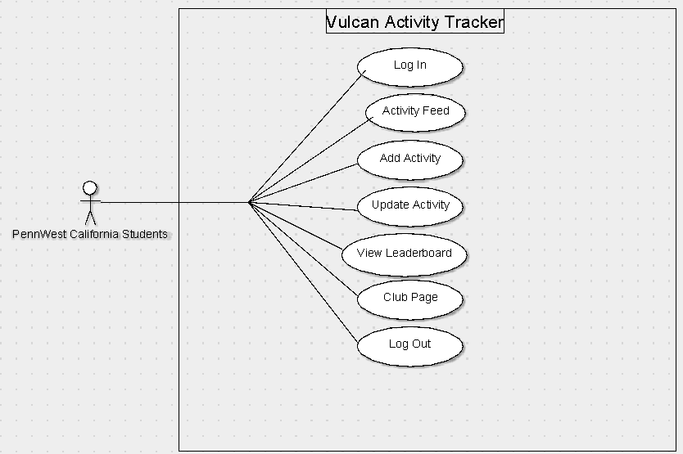

Figure 1 displays a simple Use Case Diagram of what the user would see once they have successfully logged in. They will be redirected to the activity page once logged in, but will have a menu bar with multiple options that they can click on and redirect to. The activity feed will display all users' recent activities around campus. The View Leaderboard section will take the user to the leaderboard, which the user can then filter by activity, club/team, or by group if they want a more specified leaderboard. The Add Activity page will let the user manually enter an activity they have recently completed. The user will need to enter the activity type, duration, mileage (if applicable), date completed, route completed on, and detailed specifications based on the activity type. An example of detailed specifications would be an average mile time if a user completed a run. The detailed section will be optional, as not every student will have access to that kind of information. The Club/Organization page will allow the user to see more details about their group, club, organization, or team activity which they are a part of. Clubs, Organizations, and Teams will have an Admin who will oversee who is allowed into their group on the application. Groups can be made between friends and will be open to anybody. The User Profile page will display the user’s activities only, as well as an overview of their statistics based on their logged activities. The Log Out button will redirect the user to the original login page.
Run Scenario
- User logs in with correct PennWest credentials
- User is redirected to Activity Feed, but clicks on the Add Activity button to track their most recent run
- User enters required details for a run, which includes the distance, time, and whether it was an indoor or outdoor run
  - Outdoor runs will have routes that can be taken around campus available to choose from
- The User then names the run and hits submit in order to upload it into the database
- The User goes to view their own profile to make sure the run was uploaded and is visible on their profile.
- The User clicks on the Leaderboard Section of the app and is redirected to a general leaderboard.
- The User then filters the leaderboard to running to see if their most recent activity affected their standings
- User clicks Log Out

Entity: Class Diagrams
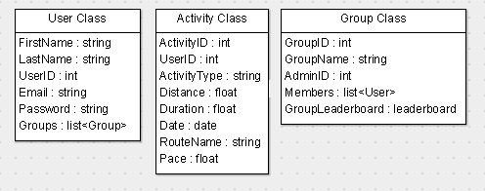
Figure 2: Class Diagrams

Class name / description / type

User Class: The User Class holds the data needed for each user. It will hold the first name, last name, email and password that the user used to sign up, after sign up each user will be given a User ID which is an integer used to link the user to their activities and groups.

Activity Class: The Activity Class holds the data needed for each activity. As soon as the create activity button is pushed an activity object will be created giving the object a unique activity ID and storing the ID of the user creating the activity. Once created, the activity will ask for the input of activity type, distance, duration, date, route name (Optional), and Pace (Optional). Once all the needed data is added to the activity it will be stored in the database.

Group Class: The Group Class holds the data needed to create and manage each group. Once a group is created by a user the group object will receive a unique group ID. The user will then input an appropriate group name and become the group’s administrator. Each group object will also hold the Admin ID (ID of user that created the group), a list of the members, and a group leaderboard that tracks group performance.

Attributes
User Class Attributes:
Attribute | Type | Description
FirstName | string | The user’s first name.
LastName | string | The user’s last name.
UserID | int | A unique number that is used to identify each user.
Email | string | The email address the user used to register.
Password | string | The password the user used to register.
Groups | list<Group> | A list of groups the user is a member of.

Activity Class Attributes:
Attribute | Type | Description
ActivityID | int | A unique number that is used to identify each activity.
UserID | int | The ID of the user who created the activity.
ActivityType | string | The type of activity that was performed.
Distance | float | The total distance covered during the activity.
Duration | float | The total time spent completing the activity.
Date | date | The date on which the activity occurred.
RouteName | string | An optional field that hold the name of the route taken.
Pace | float | An optional field for recording the user’s pace.

Group Class Attributes:
Attribute | Type | Description
GroupID | int | A unique number that is used to identify the group.
GroupName | string | The name of the group.
AdminID | int | The ID of the user who created and manages the group.
Member | list<User> | A list of all users who are members of the group.
GroupLeaderboard | leaderboard | A leaderboard that displays the performance of all users in the group.

Dynamic: Statechart
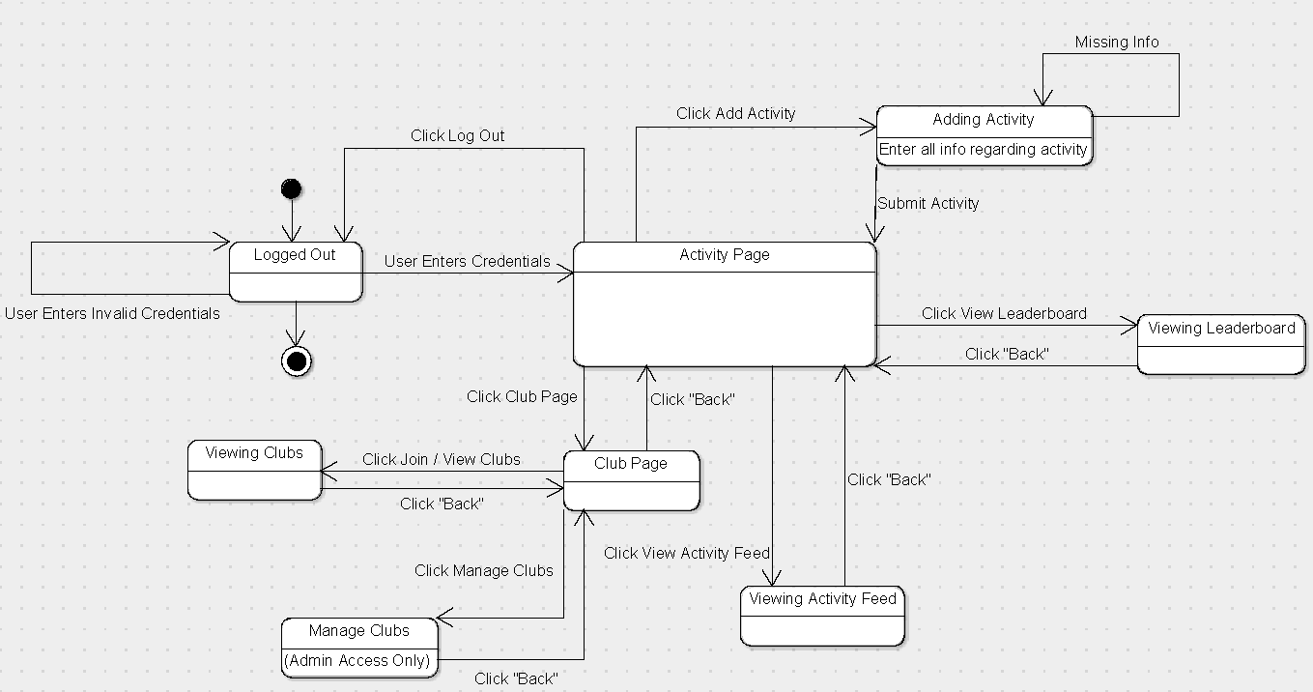
Figure 3: User State Diagram
Figure 3 shows the User State Diagram, which models how a user can navigate the Vulcan Activity Tracker. The user starts in the logged-out state, after the user enters valid credentials, they are put into the activity page. From the activity page the user can navigate between adding activities, viewing leaderboards, viewing activity feed, and viewing/joining clubs, users are also able to manage a club if they are an admin of the club.
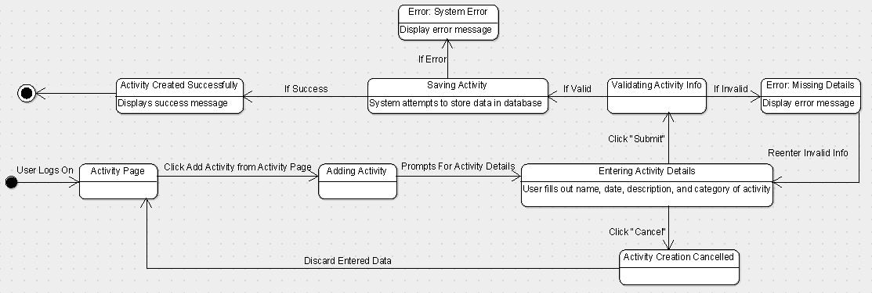
Figure 4: Add Activity State Diagram

States
- The user logs in with PennWest Credentials and is redirected to the Activity Page
- Once logged in, the user has 5 options
  - State 1: Add an Activity by adding all required information
  - State 2: View Leaderboard, filtering as desired
  - State 3: View Activity Feed, seeing all recent activities completed by students on campus
  - State 4: Club Page, if part of a club, organization, team, or group, this page will show the data for everyone part of the organization. If user is an admin they can go in and edit club details.
  - State 5: Log Out, which will take user back to the log in page

Events
There are many user-driven events that trigger the transition between states in the Vulcan Activity Tracker:
- Click “Log In”
- Click “Add Activity”
- Click “View Leaderboard”
- Click “View Activity Feed”
- Click “Club Page”
- Click “Join/View Clubs”
- Click “Manage Clubs”
- Click “Back”
- Click “Log Out”

Transitions
- Once the user is logged in, they have a series of options they may choose. The initial state is the activity feed page, which will be considered the home page. The user can loop through as many times as they want through Activity feed, Add Activity, View Leaderboard, and Club Page. The only way the user may exit the program is by logging out.

Dataflow Diagrams Components
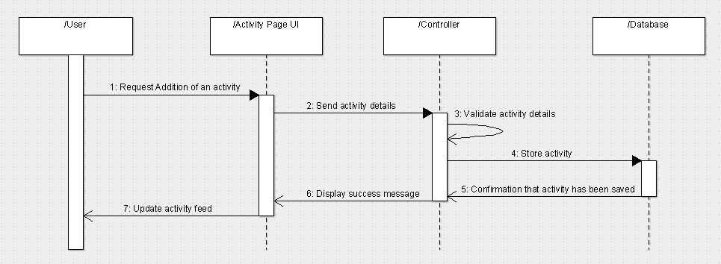
Figure 5: Add Activity Sequence Diagram

The sequence diagram above illustrates the process flow of adding a new activity in the Vulcan Activity Tracker. The sequence starts with the user requesting the addition of a new activity, this happens when the user clicks “Add Activity” in the activity page. The activity page UI collects the activity details from the user and then sends them to the controller, which is responsible for validating the details provided by the user. After the data has been validated by the controller it is sent to the database to store the new activity record. After the database has successfully stored the record, confirmation is sent back to the controller, the controller then sends a confirmation message to the activity page UI. Finally, the activity page UI displays a success message to the user, and the user’s activity feed is updated with the new activity.

Tools Needed

Tools for the development of The Vulcan Activity Tracker will include both software and hardware components. For software development, Visual Studio Code, GitHub, Git, Docker, SQL Database, Python libraries, Flask Server logic, a hosting service, frontend programming language, and schema framework will be used. These software components are crucial to the building of The Vulcan Activity Tracker’s web-application. A QR-code generator will be needed to package mobile access link and display onto site. However, since the Vulcan Activity Tracker is designed with the user in mind, in Production Phase, there are no required hardware components needed to build. The user needs UpToDate operating system and a device (mobile or computer) to access.

List of Resources
Docker. (2025) What is Docker?
https://docs.docker.com/get-started/docker-overview/
Fortinet. (2025) CIA Triad.
https://www.fortinet.com/resources/cyberglossary/cia-triad
Jeremiah, O. (2024, Aug 18th). Python Backend Development: A Complete Guide for Beginners.
https://www.datacamp.com/tutorial/python-backend-development
SolarWinds. (2025). What is a Database Query?
https://www.solarwinds.com/resources/it-glossary/database-query
Strava, Inc. (2025, Sept 11). Strava (Version 428.0.1) [Website and Mobile App].
https://www.strava.com
Yasae, K. (2024, Nov 25th). What is web application (web apps) and its benefits?
https://www.techtarget.com/searchsoftwarequality/definition/Web-application-Web-app

Appendix I: Glossary of Terms
Activity Feed – component that show past and current activities participated in. Allow the sorting by date, or data statistic.
Admin – a user with full access privileges to an application with no limitation. Privileges may be view, read, write, execute for data modification.
API (Application Programming Interface) - Short for Application Programming Interface, a connection between computers or computer programs that offer services to other pieces of software.
Database – a structured set of data held in a computer, especially one that is accessible in various ways.
Database Query – A database query is the logic that is used to access, retrieve, delete, manipulate information from the database container. It is a specific format that allows for table injections.
Docker Container – Docker is an application that aids in developing, shipping, and running applications. It consolidated database logic into one place, allowing you to run your database and application together instead of building separate. Allows for easy and fast management. “Docker provides the ability to package and run an application in a loosely isolated environment called a container (2025, Docker).”
Entity Class Diagram – shows the structure of data classes in a system. Represents the relationship between data, the actions performed, and methods used. This diagram is mainly mor systematic modeling for object-oriented software projects.
Frontend (CSS/HTML) – the frontend of an application is the part that users interact with. This is what is loaded when the application is opened. Frontends are usually written in Vanilla HTML and CSS programming languages. This allows for formatting, styling, and coloring of the site.
Git – A distributed version control software system that can manage versions of source code or data. It is often used to control source code by programmers who are developing software collaboratively.
GitHub – A proprietary developer platform that allows developers to create, store, manage, and share their code. It uses Git to provide distributed version control and GitHub itself provides access control, bug tracking, software feature requests, task management, continuous integration, and wikis for every project.
Leaderboard – a social interactive feature that stores overall highest activity data.
Python Backend – refers to the server side or behind the scenes logic that drives/powers a web application. It is built in the python programming language. The python server handles logic, data processing, and database communication. This communication is done through series of API calls.
Server – A computer that provides information to other computers called “clients” on a computer network. Servers can provide various functionalities, often called “services,” such as sharing data or resources among multiple clients of performing computations for a client.
State Chart Diagram – shows the relation of how objects and systems change over time while responding to certain events. This diagram represents behavior, phases, and event driven systems.
Use Case Diagram – the use case diagram is used to illustrate how users interact with a system or application.
Web Application – “A program that is stored on a remote server and delivered over the internet through a browser interface (2025, TechTarget)”. This differs from a website because websites are primarily static web pages connected for reading information, whereas web applications are powered by servers and databases to provide user functionality.
Appendix II: Team Details
This specifications document was developed through the collaboration of all team members. The document was made with the combined efforts of the entire team over the course of the project timeline. While each member contributed across various parts of the document, the primary contributors for each section are listed below:
- Margo Bonal:
    - Title Page, table of contents, Hardware/software/time /cost/other constraints, acceptance test criteria, tester, user acceptance, integration and installation, appendix II, III, IV, glossary, reference list
- John Gerega:
    - Title Page, Abstract, Description of document- purpose, intended audience, system description, end user, user interaction
- Luke Ruffing:
    - System modeling, functional use case scenario, entity class diagram, class descriptions, dataflow diagrams
The rest of the major sections of the document were completed collaboratively with all members participating equally in discussions, decision making, and writing. This collaborative approach taken to completing the document allowed the group to refine ideas and reach a consensus before making any big decisions.
In addition to the writing of each section, all team members took part in proof reading and formatting ensuring the creation of a clear, concise and well-organized document. Together the team worked to check for proper grammar, proper citation, and adherence to all formatting guidelines.

Appendix III: Workflow Authentication

I, Margo Bonal, confirm that all work I have contributed to this document has been to the best of my knowledge, completed with integrity and in accordance with the objectives and collaborative standards established by the team. I attest that I will maintain these standards in all future contributions to this project.

Signature:  Date: 11/14/25
I, John Gerega confirm that all work I have contributed to this document has been to the best of my knowledge completed with integrity and in accordance with the objectives and collaborative standards established by the team. I attest that I will maintain these standards in all future contributions to this project.

Signature:  Date: 11/14/25
I, Luke Ruffing, confirm that all work I have contributed to this document has been to the best of my knowledge completed with integrity and in accordance with the objectives and collaborative standards established by the team. I attest that I will maintain these standards in all future contributions to this project.

Signature: Date: 11/14/25

Appendix IV: Writing Center report
The following notes related to your 11/12/2025 2:00 PM EST appointment with Chayse Lizon have been shared with you:
Your and your group came in for a review of your paper overall and in comparison to the rubric and the example papers provided. Content wise I think that you did good in making sure that every single one of the sections was hit and I didn't notice anything content or grammar wise that particularly stood out. While most of the paper follows the formatting rules, for the figure numbers it should be altered into being times new roman and 12 point. Also, I suggest that you make the figure title closer to the figures present. Another thing that was observed was that some sections should be indented (there is one that says Figure 3 that probably should be). You should read through the paper aloud on your own to verify if there is anything that sounds incorrect or should be further explained. Make sure for your resources page that the citations are in the proper format and have all the details necessary, and as we discussed you will need to put them in alphabetical order. When you refer to these sources in the paper and you do in-text citations make sure that they are before the periods and not inside of quotation marks. Delete any extra spacing above titles and make sure all your titles are centered, consistency is key. Another thing that stood out was the bullet points seemed to be over a significant amount so you should try and move those over if possible. I meant to point it out, but if your quote wasn't italicized then do not italicize it in the paper. If you have any following questions, please feel free to email me at liz58193@pennwest.edu

