`
Vulcan Activity Tracker
User Manual

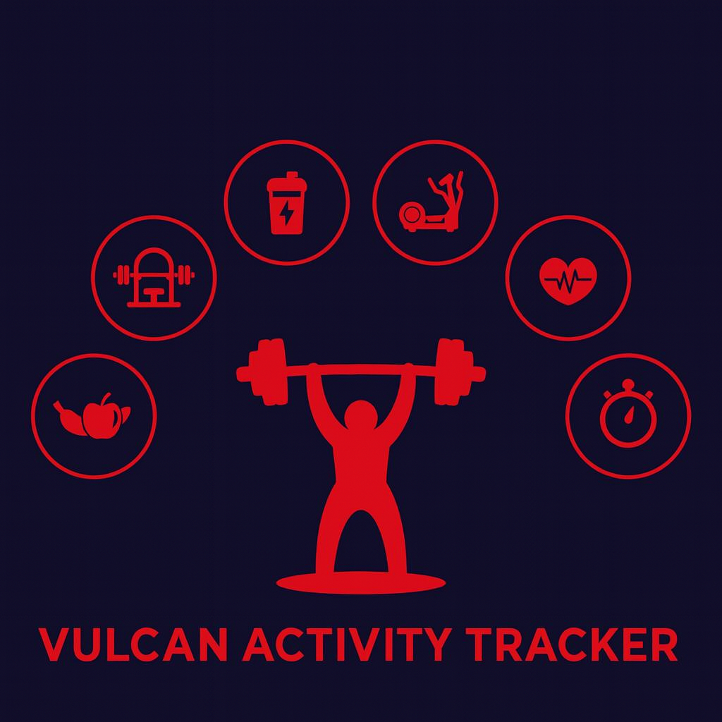

Week 11
Team Members:
Margo Bonal
John Gerega
Luke Ruffing

Professor: Dr. Weifeng Chen

Course: CMSC-4920-Senior Project II
School: Pennsylvania Western University

Instructor Comments/Evaluation

Table of Contents

Section 1: 0
Project Title: Vulcan Activity Tracker 1
Project Overview: 1
Motivation: 1
Comparison: 2
Community or Social Implications 2
System Block Diagram 3
Project Implementation Details 4
Difference from Design Document 4
Challenges During Implementation: 7
Software Engineering Principles: 8
Section 2: 0
User Manual Description: 1
User Instructions: 1
Welcome Page: 2
Account creation: 2
Login: 2
Dashboard: 2
Training Page: 4
Maps Page: 6
Clubs Page: 7
Teams Page: 7
Leaderboard: 7
Challenges: 8
Settings: 8
Section 3: 0
Developer Instructions: 1
Step 1: 1
Step 2: 1
Step 3: 3
Step 4: 4
Team Contact Information: 6
List of References 7
Table of Index / Glossary 8
Appendix I: Writing Center report 9
Appendix II: Team Details 10
Appendix III: Workflow Authentication 11
Appendix III: Code listing 12

Section 1:
Project Overview

Project Title: Vulcan Activity Tracker

Project Overview:
The Vulcan Activity Tracker is a fitness app designed for logging and sharing athletic activities with friends. It incorporates social interaction and personal goal tracking for campus students. Our digital athletic logbook offers several features for planning routes, monitoring progress, and competing, for running, cycling, swimming, and many other sports. Our app is designed to push Vulcan athletes to train at their highest performance, while encouraging healthy habits for casual users. Encrypted account creation and login portal ensures that student data is secure, demonstrating our upmost priority of user safety. Modern user-friendly dashboards allow easy use. Activity history can be stored and viewed at any time with dynamic searching. Clubs can be created and managed. Challenges can be created by users and are available to platform users. These can be anywhere from daily step goals, summer training plans, or weightlifting PRs. Full customization makes the Vulcan Activity Tracker flexible for each student’s needs! Leaderboard features additionally allow platform users to interact with each other in friendly competition. Earning a spot on the weekly leaderboard novitiates users to get outside or into the gym! The Vulcan Activity Tracker is free and available for all students with valid PennWest California credentials, regardless of if they are actively on an official campus team, intramural club, or individual.

Motivation:
Accessibility and usability were the founding principles and motivation for the Vulcan Activity Tracker, ensuring that individuals of all abilities can easily track, understand, and improve their daily activities without unnecessary complexity. The Vulcan Activity Tracker is intended to serve as an athletic activity management system specifically for PennWest California students. Students serve as the intended audience; however, campus faculty such as coaches and professors can access as well. Allowing students with strict budgets to have access to fitness tracking while eliminating hefty subscription that locks these valuable features, motivated our development team to produce this senior project deliverable. We experienced this paywall issue firsthand with fitness tracker applications such as Strava (2026) and aspired to solve this problem.

Comparison:
The question arises, there are many current athletic activity trackers available, what makes The Vulcan Activity Tracker different? Apps on the market right now are activity specific, alienating both uncommon and unpopular exercises from using the app features. For example, Nike Run Club App (2025), Runna (2025), and Strava (2025) are directed towards running athletes and users only. Whereas, Strong (2025) and Hevy (2025) are designed for weightlifting activities. While many other activity trackers may provide exclusive features and smart watch connectivity, they are costly and detrimental to a student’s overall budget. In one combined platform, the Vulcan Activity Tracker aspires to meet student organization needs, social interaction, and exercise goal planning in a free accessible way.

Community or Social Implications
The purpose of the Vulcan Activity Tracker is to bring together the PennWest student population into one athletic app that allows for the tracking of all campus sports, cycling, weightlifting, calisthenics, swimming, running, climbing, equestrian sports, and general exercise categories. Building a community base on campus not only helps students feel motivated by others but also allows students to have a break from academic stress by participating in fun activities with others that share similar interests.

System Block Diagram
The Vulcan Activity Tracker consists of 2 main software components, Client (Frontend) and Server (Backend) Sides. Client Side will be user interface that is accessible by internet hosting. Server-Side drives functionality of the application that will be designed to handle data propagation and database storage. The UI prepares and sends fitness activity data to the Backend Server. The Server then cleans the data and prepares it for database entry. When received by database handling logic, the fitness activity data is then sent into and stored by the MSSQL database. Below, this modular process is depicted in the system block diagram.
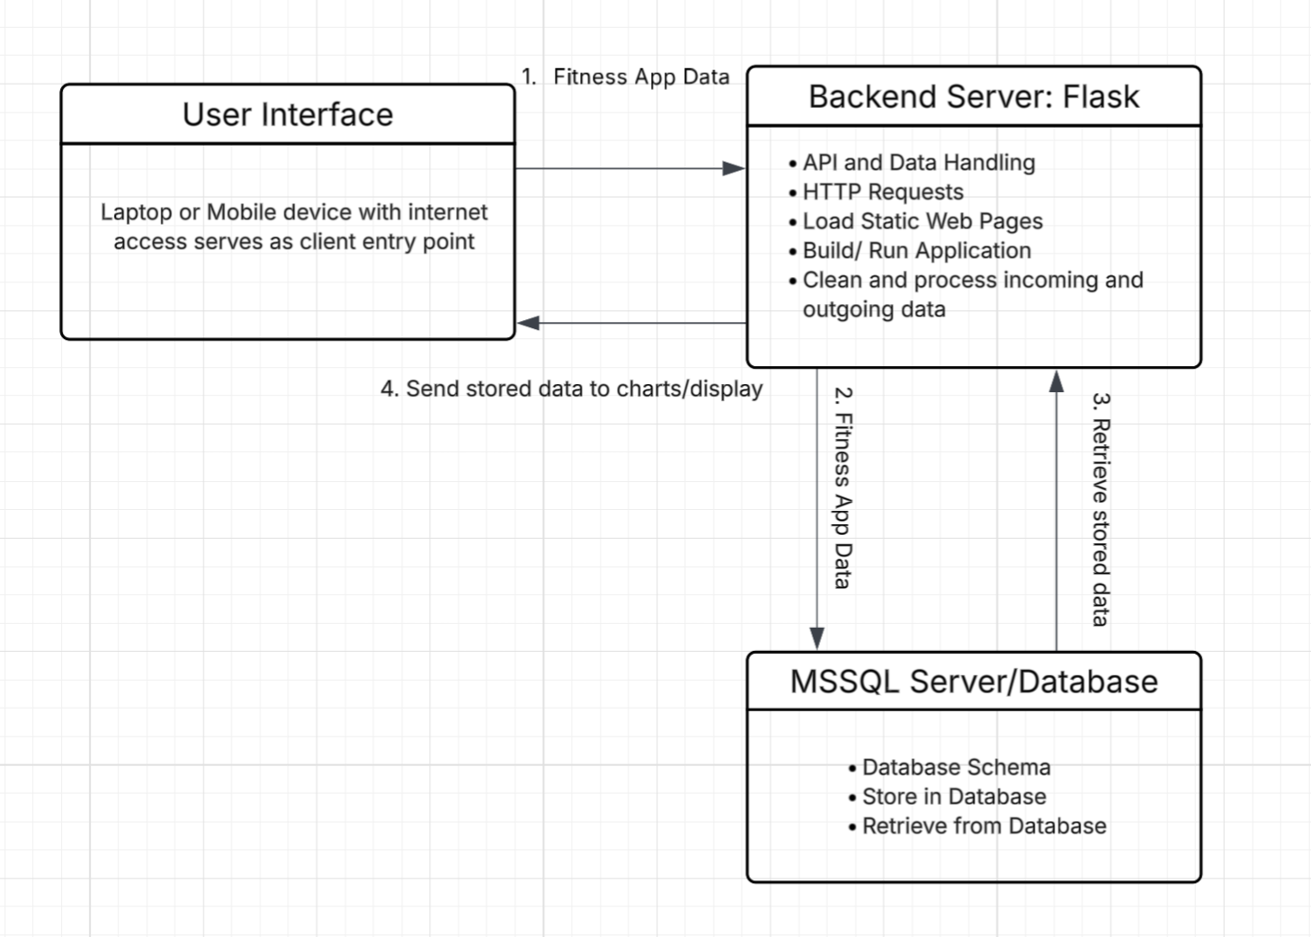
Figure 0: System Block Diagram

Project Implementation Details

Difference from Design Document
During the initial stage of this project, our development team drafted a Design Document to set overall goals for the Vulcan Activity Tracker. Within this design document, modular setup, server details, and client user-facing features, and data-flow processes were discussed. To provide project verification, the user manual will now compare initial stage and post-delivery maintenance versions to ensure consistency.
Module Cohesion was originally defined as the following:
- The Login & Authentication Module: This module focuses solely on validating the login credentials of users.
- The Activity Management Module: This module handles only the creation, validation, removal, and retrieval of activities.
- The Group Management Module: This module handles only the management of club/group memberships and roles.
- The Leaderboard Module: This module focuses only on processing and displaying the rankings within different parts of the Vulcan Activity Tracker.
- The Database Module: This module solely manages the storage and retrieval of data items into and out of the database.
Module Coupling was originally defined as the following:
- The Login & Authentication Module: This module interacts with the Database Module to verify the user’s login credentials.
- The Activity Management Module: This module interacts with the Database Module to store and retrieve activity data.
- The Group Management Module: This module interacts with the Database Module to store and retrieve group data.
- The Leaderboard Module: This module interacts with the Database Module to store and retrieve leaderboard data.
- The Database Module: This module interacts with all the previous modules to send data back and forth to the database server.
Both Module cohesion and coupling were achieved following the design document roadmap. Modularization kept development organized. Database schema was created based on these components. However, the modularization differs since our team had initially proposed a smaller scale then resulted. The Vulcan Activity Tracker’s database architecture became quite involved, handling both encrypted user data and recuring site information. Class and objects were also followed from the design document.
Physical file storage remained a system vulnerability and was out of scope for the Vulcan Activity Tracker. All data was stored in the SQL database. This avoided vulnerabilities of locally or session stored data. Additionally, avoided complex logic of file validation of uploading or downloading files to or from the system. SQL Server access provided timely data lookup and table propagation for both login and application features.
Real time requirements were correctly projected in the Design document. WIFI connection was for internet access without cellular data service provider or for device access without SIM connectivity. Efficiency was also reached as it was noted as a concern for platform response time. This can be seen in loading static interface pages into the server, reducing rendering time. The concern of potential losses of internet connection having negative effects on the completion of data storage remains a problem.
The proposed PDL Outline in the Design Document was successfully achieved, however, the Vulcan Activity Tracker was expanded with many components that were not initially specified.
Original Outline:
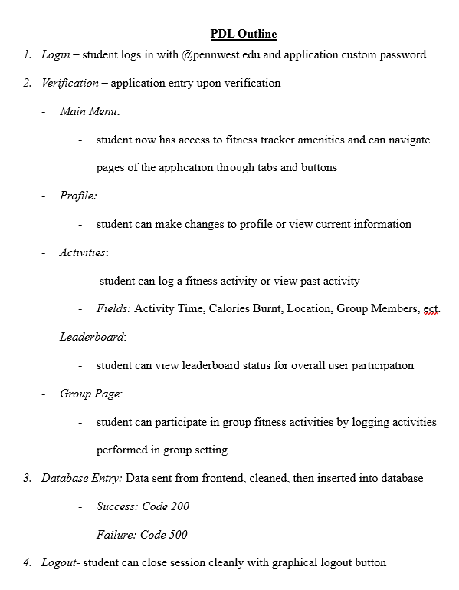
Figure 1: Original drafted PDL Outline
Difference: Addition of Settings, Challenges, Teams, Dashboard, Inbox, Welcome pages, along with resulting server configuration and schema architecture.
Programing language and database management systems were kept consistent throughout this project. Python was originally projected in the design document and was maintained throughout. Same consistency with Microsoft SQL Server database systems. All software tools were achieved through Open-Source services. However, features that were not initially proposed in the design document are Map viewer APIs and Weather forecast APIs. These two features were research and outsourced since creating our own weas outside the scope of this project. These APIs were Map API Leaflet (2025) and OpenWeather (2026).
Finally, the projected Implementation timeline was followed and met. January through April were reserved for primary development time. April through May was set for project validation, revisions, testing, and final product presentation. The design document served as a contractual agreement for a defined timeline and now in post-delivery maintenance it can be confirmed.

Challenges During Implementation:
Over the course of the semester, the development of the Vulcan Activity Tracker faced several technical and logistical challenges that tested the team’s problem-solving abilities. A major challenge arose with database compatibility. The team discovered that MSSQL Server 2022 (version 17) was incompatible with ARM 64 architecture, as it was designed for Intel processors. Potential solutions, including the use of virtual machines or acquiring Intel-based laptops, proved to be financially and logistically unfeasible given the project’s time and resource constraints.
An issue encountered was with the leaderboard functionality. While the table successfully extracted sport-specific data, it failed to rank users correctly. Initially, the leaderboard simply reflected the order of entries in the database rather than actual totals, which undermined the intended competitive functionality and required a reassessment of the ranking logic.
The activity tracking table also presented complications due to timing issues. When users submitted activity forms, the updates were not immediately reflected in the viewing table, requiring manual page refreshes. This behavior broke the user’s perception of a seamless, real-time experience. Investigation revealed that asynchronous JavaScript functions were not paired correctly with await statements, and logic errors occasionally prevented the data from being retrieved in time.
Other functional issues included radio buttons, which were initially implemented but lacked the necessary logic to operate correctly. Additionally, email functionality became a challenge when attempting to implement verification and password recovery features. Although a frontend page was successfully created and the Resend email service integrated, backend errors prevented complete functionality, requiring ongoing debugging and further refinement.
Feature design decisions also created challenges. The team debated whether users should be able to add badge images to challenges, which led to broader questions about supporting profile picture uploads. Finally, the development of the Teams page proved particularly difficult. Verification of user roles, whether coach or team member, was not functioning, preventing access to the page and hindering backend integration. Moreover, the database currently contains empty tables for teams and members, making it impossible to fully test or display content.
Overall, these challenges highlighted the complexity of coordinating multiple systems, technologies, and features within a single project. Despite the obstacles, our team developed creative solutions, gained valuable troubleshooting experience, and identified key areas for improvement in future iterations of the application.

Software Engineering Principles:
During the Fall 2025 and Spring 2026 senior semesters, our development team used foundational software engineering principles to guide project initialization through completion. Agile Software Development Lifecycle was the method that met both team and project requirements. The Agile lifecycle allows for changes during development, while using documentation as a guide. We identified that Linear development would not allow for the Vulcan Activity Tracker to grow and shift during the process. Additionally, Agile uses incremental development, increased adaptability, and fast component creation when dealing with short timelines. The final feature of Agile that aided in our project’s development was the method of splitting tasks between team members accelerated project development.
However, the documentation stages of the Waterfall software development lifecycle were implemented to record requirements and goals. These stages are requirements, analysis, design, implementation, post-delivery maintenance and retirement. Four technical documents were prepared, drafted, and revised to certify the Vulcan Activity Tracker’s creation. These documents were the initial Proposal, Requirements, Design, and Specifications. A Gantt Chart was used in correspondence to align team schedule along with semester milestones and due dates. All these documents additionally serve as binding contractual agreements between team developers and projected goals.
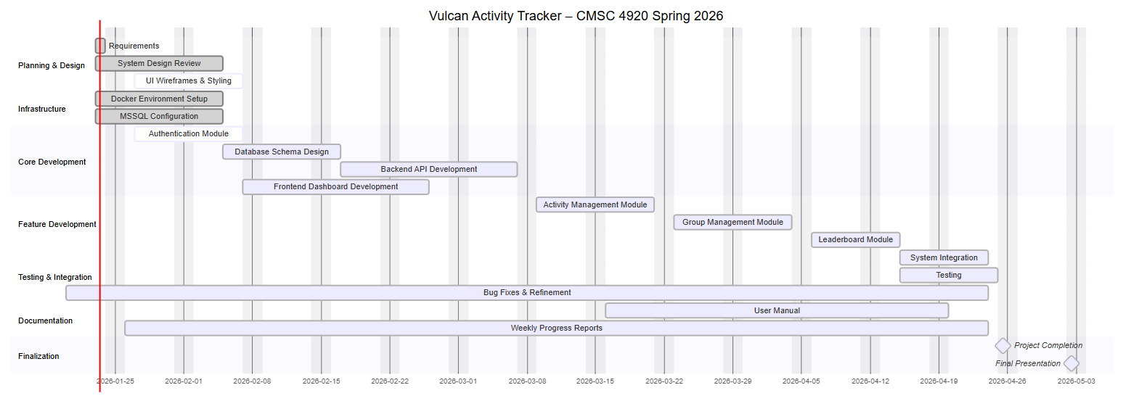
Figure 2: Gantt Chart

Section 2:
User’s Manual

User Manual Description:
This document serves the purpose of a user manual for The Vulcan Activity Tracker Senior project 2026. Prepared by the development team; this user manual represents both instructions for developers and users. User case will demonstrate where Pennsylvania student users can find and access the platform. Additionally, instructions to interact with platform features will be included. On the software side, a step-by-step guide will allow developers to build and access the platform locally on their machine.

User Instructions:
These instructions are intended for Pennsylvania Western University California campus student users. Below are step by step instructions for finding the Vulcan Activity Tracker online by domain, account registration, and feature description. The overall goal of this document is to teach users to fully manage and interact with their app accounts. Additionally, this user manual will enable users to understand how their information is viewed (public or private) and what can be either shared or hidden from other users. Our goal as the development team when creating this project was to make sure that all students could use our app regardless of qualifications or specific sport. The Vulcan Activity Tracker provides important daily habit tracking that is otherwise blocked by a paywall in other similar applications. Below, users can find all information needed to fully enjoy the Vulcan Activity Trackers features. While there is a designated developer section of this document, developers are encouraged to read the user instructions to understand user interface components.

Welcome Page:
Visit: https://vulcanactivitytracker.onrender.com

The welcome page demonstrates features and overall information of the Vulcan Activity Tracker. Training environments are displayed on the welcome page, however, more information can be found within the application once an account is created. By navigating to Log In, users can create an account to enter the app and access fitness tracking features.
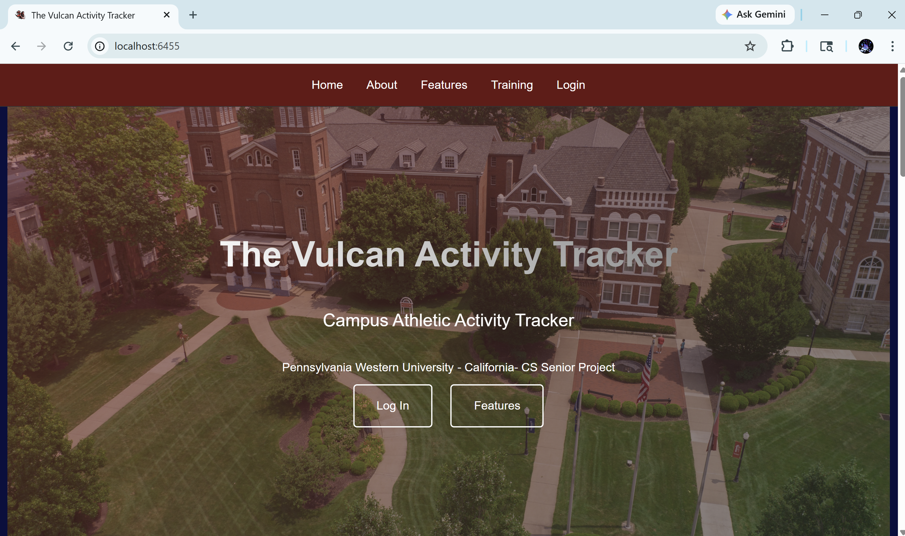
Figure 3: App Welcome Page

Account creation:
Users can create an account by navigating to the Create Account page. By entering a valid Pennwest.edu email address, a username, and password, Students can successfully make an account. Password requirements are displayed on form to show length, special character and uppercase requirements.
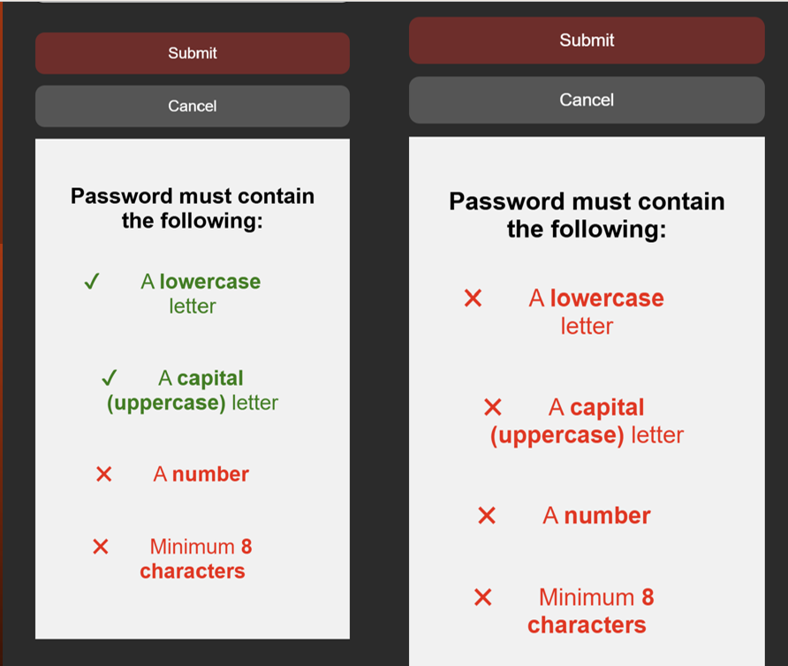
Figure 4 : Password Requirements

Login:
Only after account is successfully created can a student enter the Vulcan Activity Tracker. To login, students must enter their unique username and password.

Dashboard:
The following diagram displays the Vulcan Activity Tracker’s main dashboard. Here, users can view top ten activity overview. Users can view what challenges they are participating in. Joined clubs can be seen from the dashboard as well. Users can browse a list of available friends and follow their friends to keep updated on what activities and clubs they are in. Main profile card keeps count of quick stats of clubs joined, logged activities, and account followers. Each activity shows a like count as well. Friends can only view each other’s public activities, providing an option for users to set certain activities to private. While accounts remain public, this feature enables users to participate in the way they feel comfortable. The Vulcan Activity Tracker promotes positivity, therefore, there is not a dislike button.
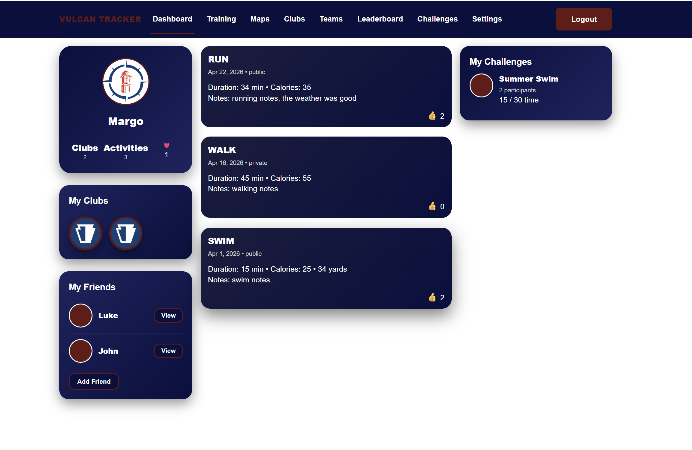
Figure 5: Dashboard
Additionally, the friends feature can be accessed through the dashboard. By clicking View next to a friend’s profile, the Friend Portal will pop up. Since the friends feature acts as an overlay, users can feel like they are still within their own dashboard rather than moving to an external feature. Public information is displayed here.
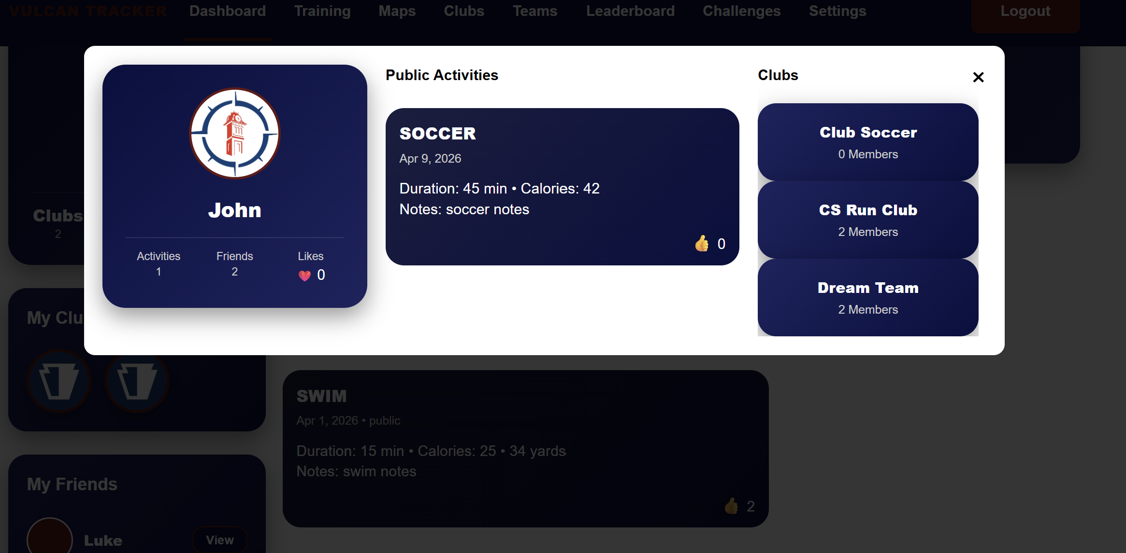
Figure 6: Friends Feature Modal
From the dashboard, each page is accessible for users to navigate to visit from the top navigation bar. This bar stays visible no matter what page is being viewed. This enables users to have easy access to each feature.

Training Page:
The next feature of the Vulcan Activity Tracker is the training page. This page serves as a hub for all athletic and fitness activities. Here, workout data can be entered by category/activity type. Appropriate metric fields are accessible upon selection. In the figure below, the activity form defaults to fields that are common between all sports. Date, duration, Calories, and Accessibility. However, once a user selects a sport from the Activity Selection dropdown menu, the activity form will be customized with sport specific fields. This dynamic method allows users to enter specific details on the activity they participated in.
Figure 5 shows the activity Selection dropdown menu with several activity types for all athletes. When an activity is selected, the display badge at the top of form will reflect what type has been selected. This allows users to be reminded of selected activity type when filling in the form. The activity form can also be cleared at any time during data entry process, resulting in empty form so users can start form over if a mistake was made or no longer want the information.
Additionally, in figure 5, activity history can be searched for easy viewing. The search bar filters by name, date, calories, public, private, notes. Each of these filters can be used as a keyword; however, users should note that the search bar is case sensitive.
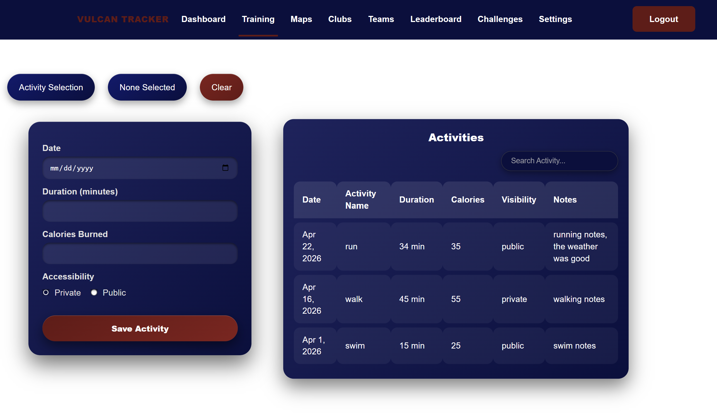
Figure 7: Training Page
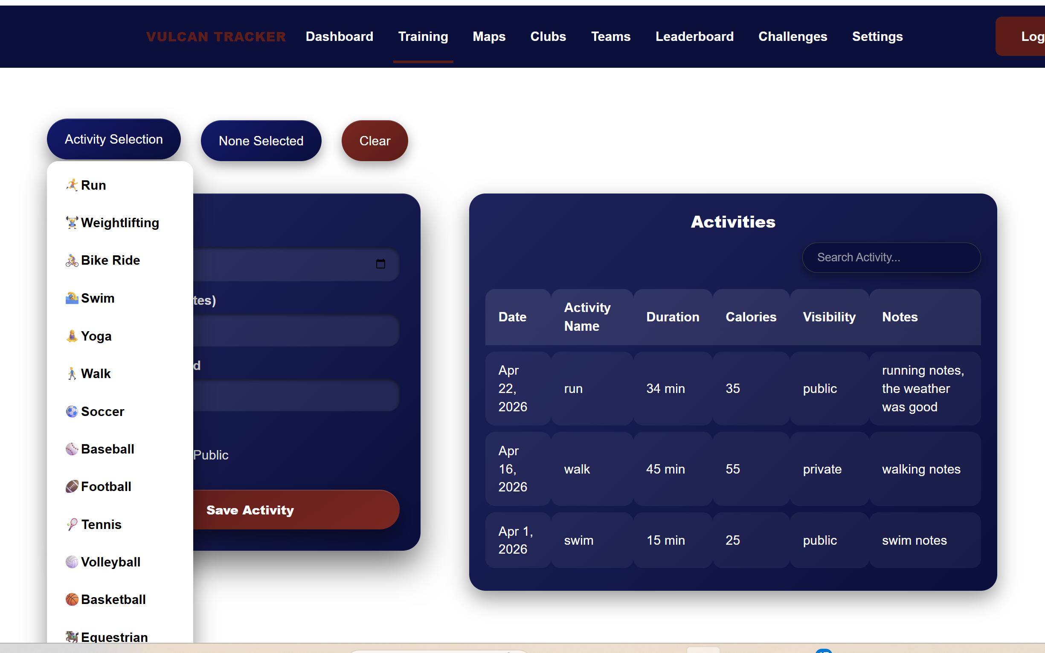 | 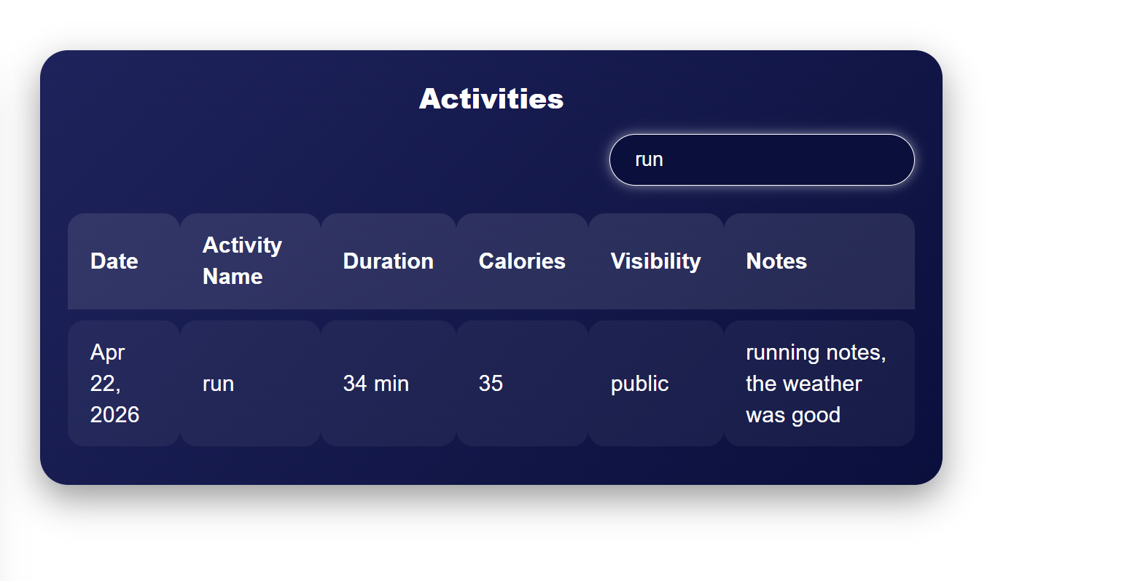
Figure 8: Activity Selection and Search bar

Maps Page:
The third page of the Vulcan Activity Tracker holds many customizable features for users to interact with! Users can create their very own new running, walking, or cycling routes. By clicking Start Route, users can draw on the map, placing pins and map markers as they go. When the new route has been completed, enter a name for the route and click End Route. This signals the route to be stored in the users account for viewing again. A marker always will remain in the center of campus to aid in relocating when map is zoomed out.
Routes can be viewed by clicking on routes stored under My Routes. They will be redrawn on the map for viewing in red. Routes can be deleted when hovered on and distance in miles can be seen. Vulcan Routes holds official campus running routes that are available in the California campus gym. Clicking on these routes displays them on the map in blue.
The final feature of the Maps page is a live weather forecast. This provides weekly weather forecast view. Recommendations are made in yellow based on optimal athletic conditions, i.e. days with lowest chance of rain, wind, snow, etc...
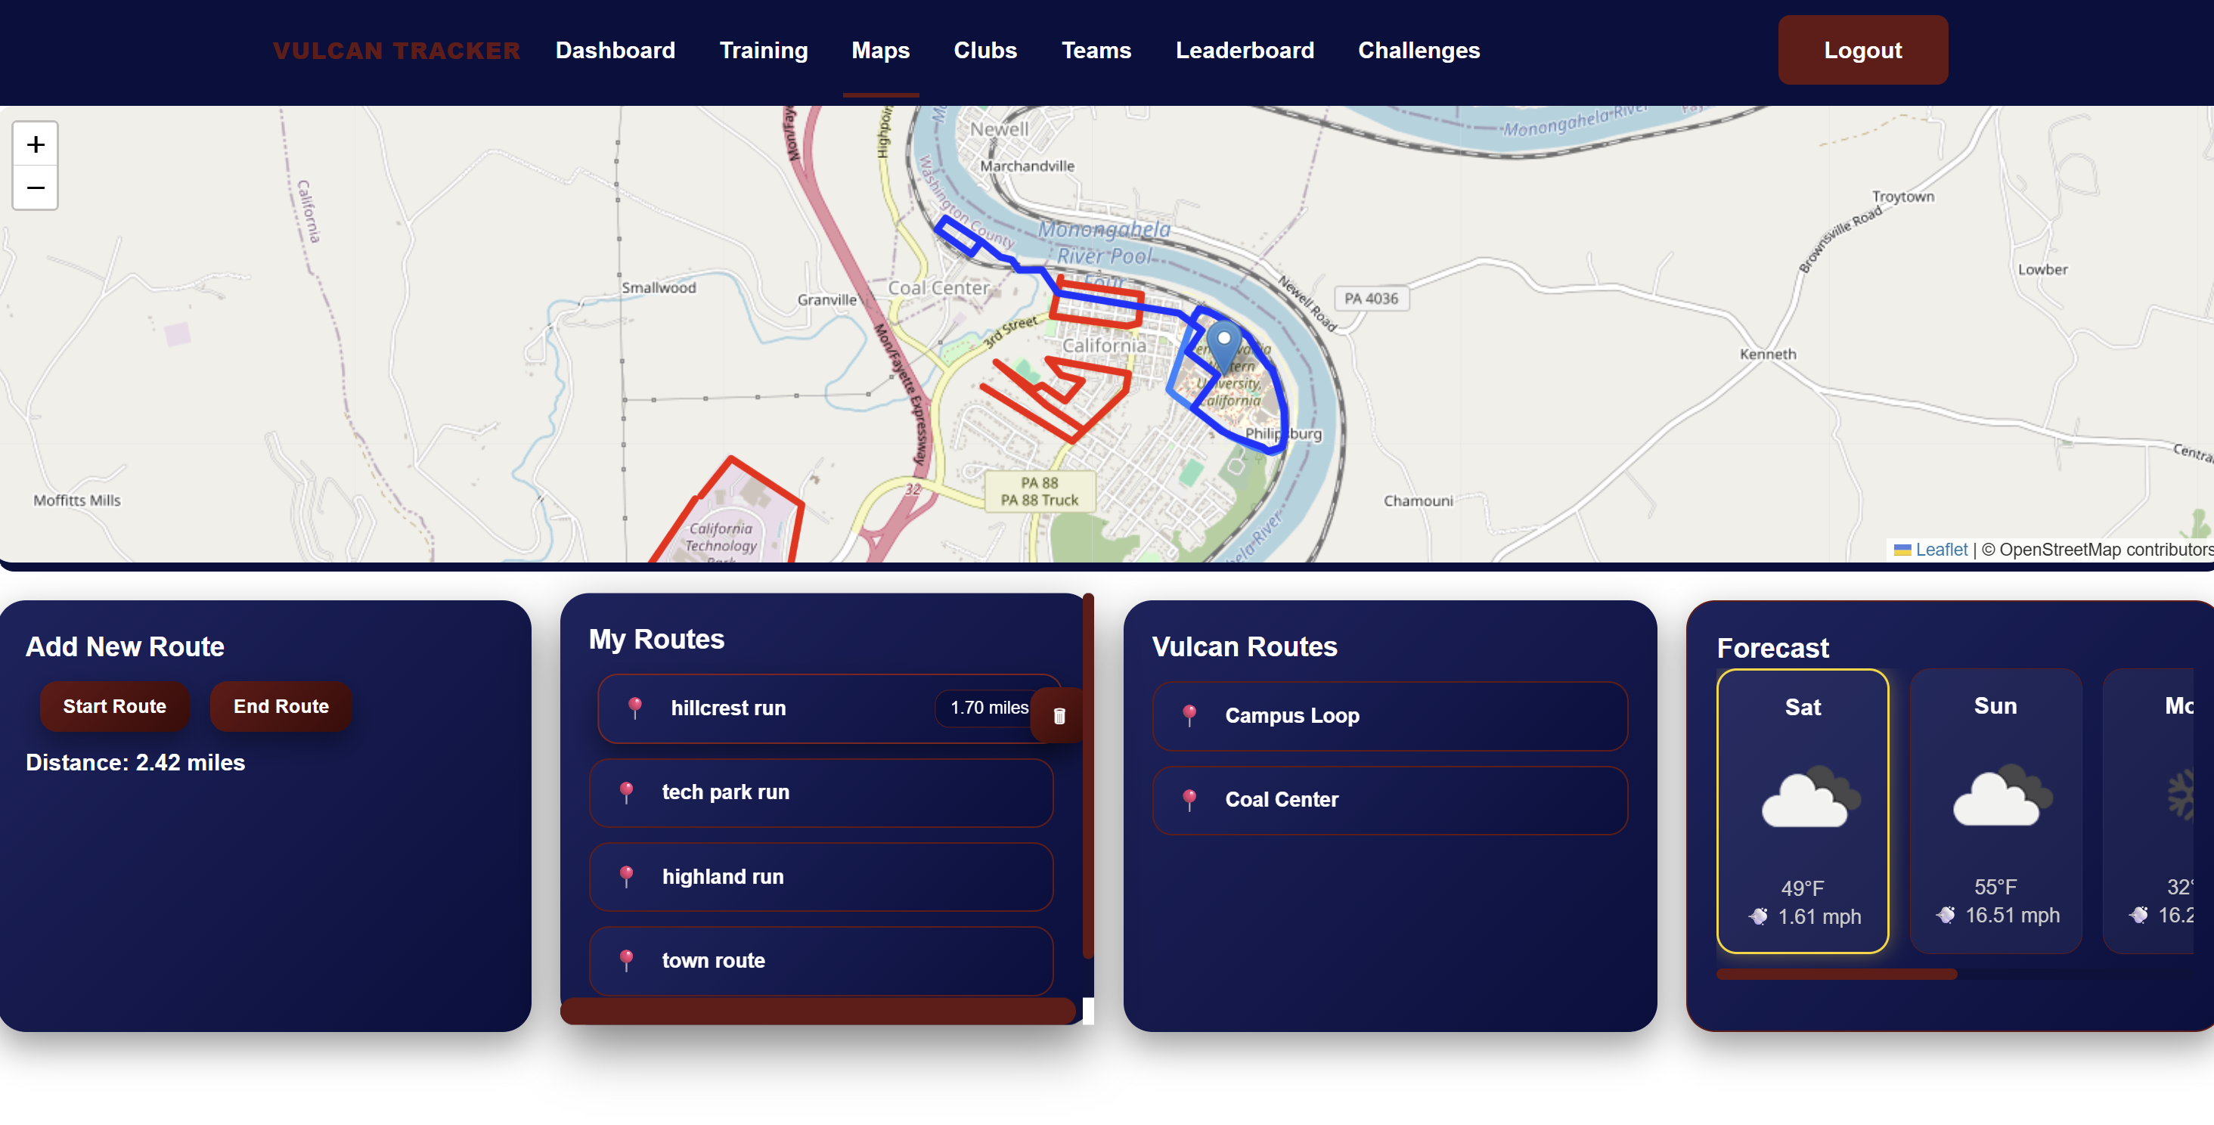
Figure 9: Maps View and Route Builder

Clubs Page:
The clubs page of the Vulcan Activity Tracker allows users to join clubs that can be made for recreational groups, campus wide organizations, or even club sports teams. This page is a hub that users can navigate to discover clubs, join clubs, create clubs, and interact with clubs. After navigating to the clubs page the user is presented with the create a club button and two primary sections: My Clubs and Available Clubs
My Clubs displays all the clubs that the current user is a member of or the owner of. In this section a user can quickly access their clubs without having to search through a long list. The club cards in the my clubs scetion have two buttons, view which brings the user to the clubs details page and leave/delete which removes the user from the club if they are a member and deletes the club if they are the owner.
Available Clubs displays all the clubs that have been created by other users. Each club has a card that shows the clubs name, description, number of members and if the club is public or private. In this section a user can scroll through the different clubs to find one that intrests them. Like the club cards in the my clubs section there is two buttons, view which brings the user to the clubs details page and join/request to join which will display just join if the club is public and will add the user to the club. If the club is a private club it will display request to join, and when clicked will send a request to join to the owner of the clubs inbox.
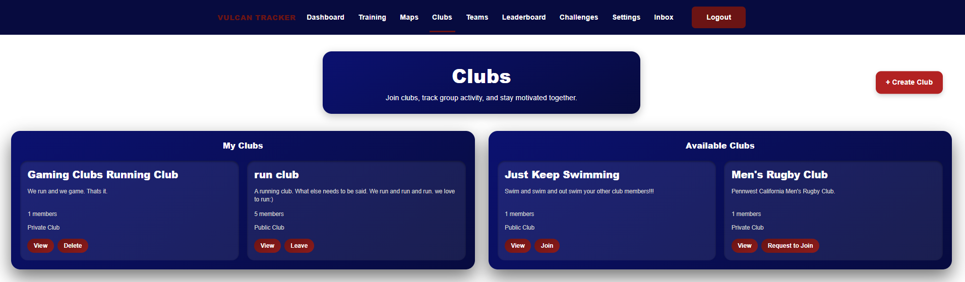
Figure 10: Clubs Page
On each clubs card there is a view button which navigates users to a clubs details page. Each clubs details page is unique, showing the clubs name, description, club leaderboard, members recent activities, and member list. Along with that there is also a small card that contains the clubs info such as: member count, sport type, and privacy.
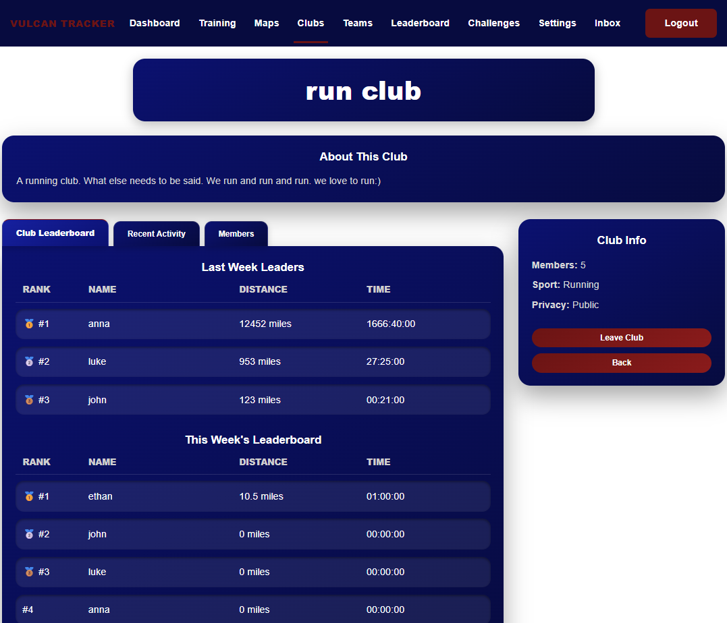
Figure 11: Clubs Details Page

Teams Page:
The teams page feature enables users who are a part of one of the university’s NCAA sports teams. This feature is limited to those who are part of these teams: coaches and players. A regular user cannot access a team-specific page unless they are invited by the coach. Coaches can invite usernames, create announcements, and create events like practices or games. The user will receive the invite in their inbox and can decide to accept or deny the invitation to the team. Once a user is invited and has joined the team, they can view announcements and events but cannot create them. A mini leaderboard is also in the teams page, containing only those who are on the roster of that specific team.
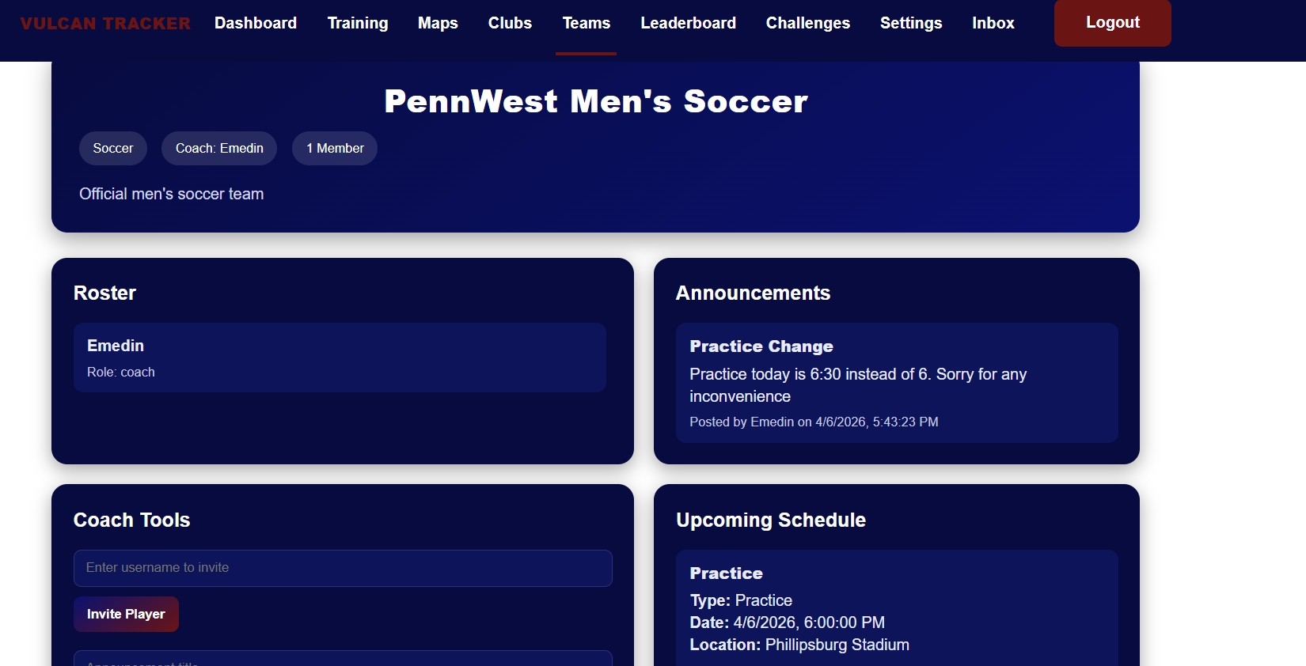
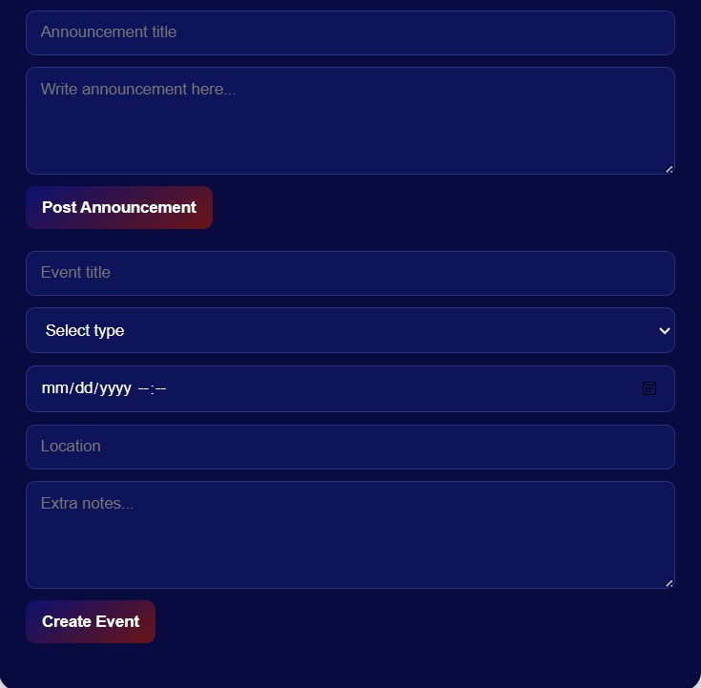
Figure 12a (top) and 12b (bottom): Coaches team page view
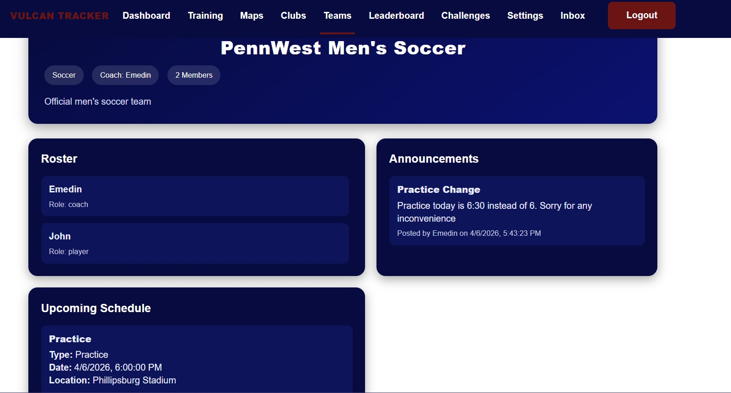
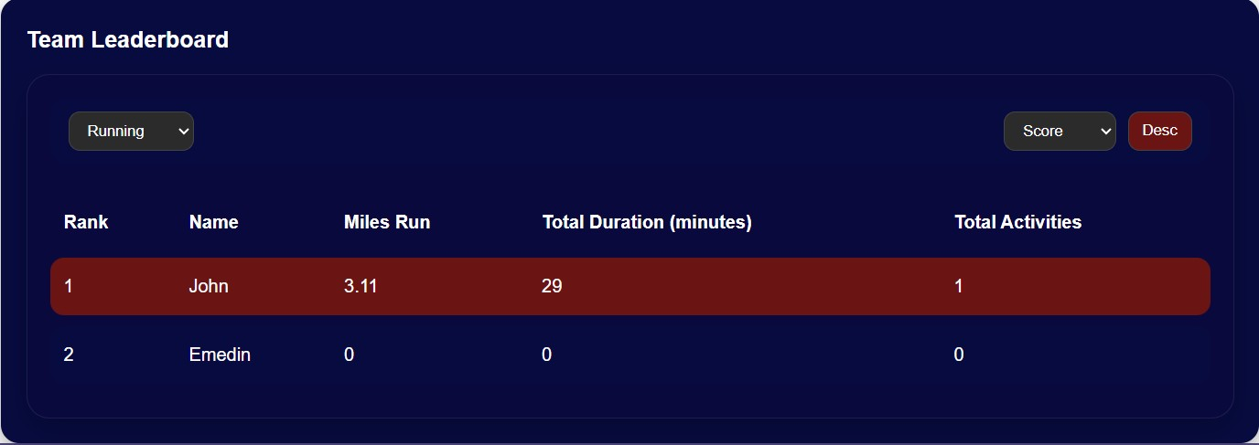
Figure 12c (Top) and 12d (bottom): User view of the team page

Leaderboard:
The leaderboard feature enables users to participate with each other in friendly competition. This feature allows users to filter between sport type, score, duration, distance. The leaderboard can also be seen in ascending or descending order. Top 3 winners will be ranked by gold, silver, and bronze medals. The Vulcan Activity Tracker leaderboard is updated automatically based on user accounts. Users should check back periodically to see updated statistics for the sports they participate in.
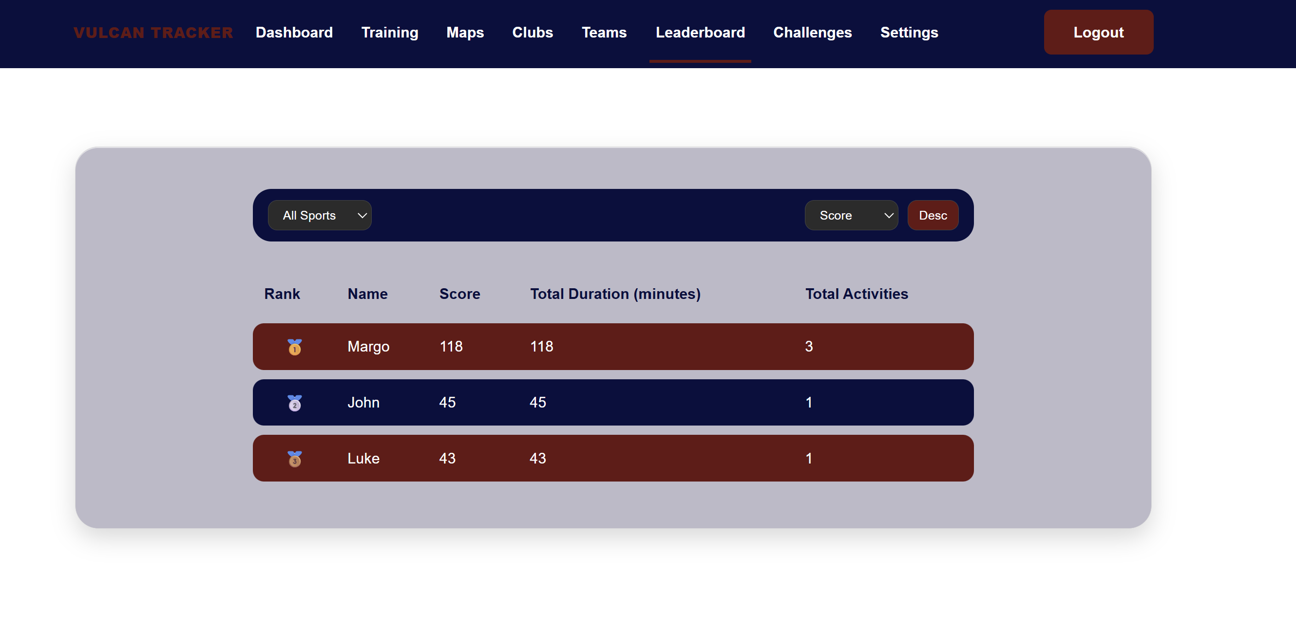
Figure 13: Vulcan Leaderboard

Challenges:
The challenges page enables Vulcan student users to create fun athletic competitions. These can be private were a user records data and challenges themselves or they can be set to public were all Vulcan Activity Tracker can participate. A challenge can be created by clicking Create Challenge and filling out challenge entry form. After completing and clicking submit, the challenge is then active and stored for future use.
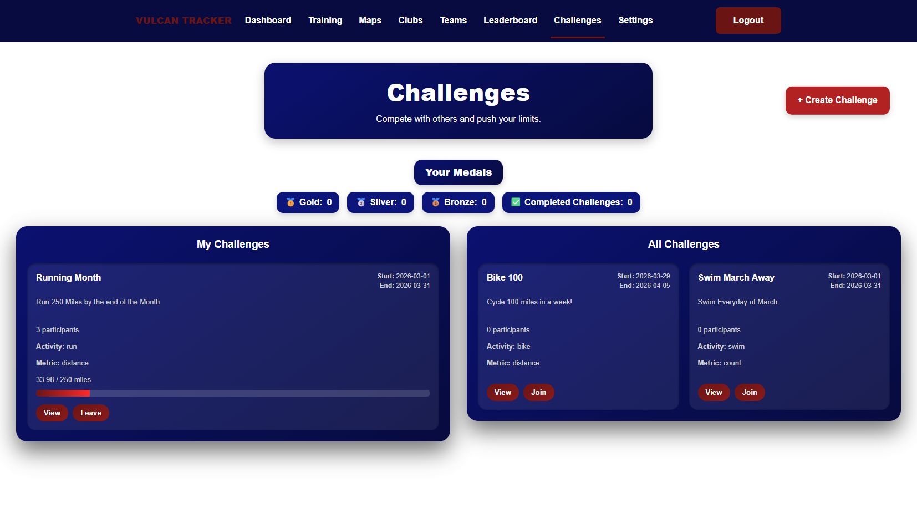
Figure 14: Challenge Page
Within the challenge feature, users can select view challenge or leave challenge. When view is selected, an overview of that challenge, participants, and mini leaderboard can be seen. Top 3 ranks on the leader board are signaled with gold, silver, and bronze medals. Progress bars demonstrate how far along in the challenge users are, while start and end dates are represented at the top of each. The left-hand side shows challenges user created or have joined, whereas the right-hand side shows challenges that are available to join made by other users. Students should be aware that if they join another uses challenge, their data will be public to others.
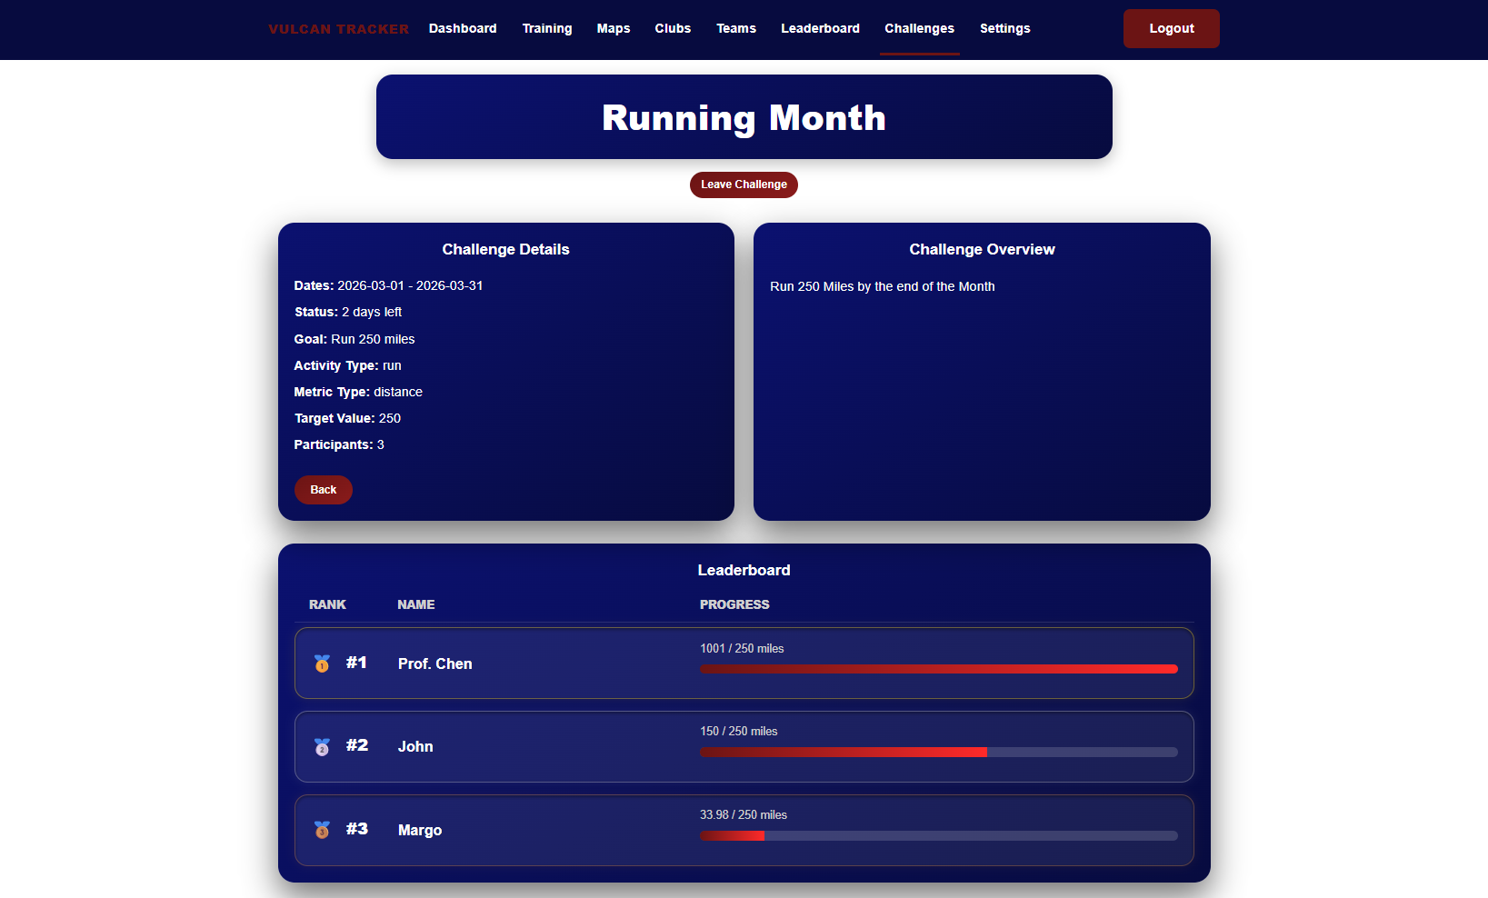
Figure 15: Challenge View and leaderboard

Settings:
On the settings page users can view quick information regarding their account. This information is currently logged in username, email associated with the account, and if their status is active. Quick Stats tab shows overall activity number, clubs joined, and challenge goals set. Username can be changed in the settings feature. However, users must log out after they change username to allow platform to reset. Accounts can be deleted from setting as well.
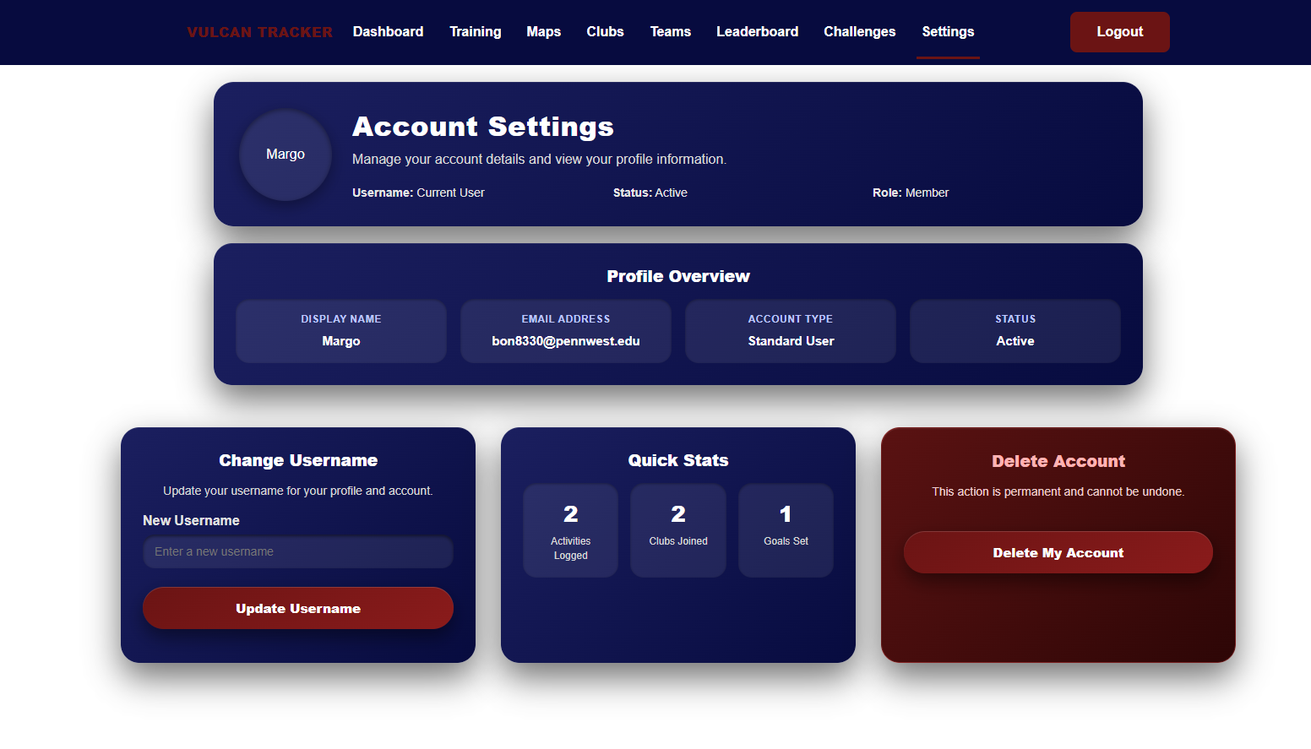
Figure 16: Setting page Features

Inbox:
The user inbox is designed for users to accept/decline invites from coaches or club administrators. Users will see a red dot next to their inbox when they have an unread invite that they still need to view. Once they go to their inbox, the invites will be marked as read. The user then has the option to accept or decline invites. If they accept, the club/team is updated to include their name in their roster, and the invite is cleared from the inbox. If they decline, the invite clears from the inbox with no updates.

Section 3:
Developer Manual

Developer Instructions:
The following developer technical instructions are for Windows 10/11 operating systems. To build and run the Vulcan Activity Tracker codebase locally from developers’ machine (laptop or PC). Source code solution will be submitted upon senior project deadline. This will include a ZIP folder of the project code base, named Vulcan Activity Tracker.

Step 1:
The first step will be to download the Vulcan Activity Tracker folder from D2l. Move the folder to a location on computer where it is easliy accessible and isolated from other software that may interact or cuase disturbance. Our development team recommend either the Documents folder or an empty OneDrive Folder. Once the file is place, unzip the folder or extract the file contents. The files are then prepared for the next step.
If in any case the ZIP file is unecessible, the folder can be found online at our group GitHub repository: https://github.com/jjdeuce06/VulcanActivityTracker
Here, the Vulcan Activity Tracker can be downloaded manually, or can be cloned/ssh directly into code editor.

Step 2:
Developers must prepare their computer to build the Vulcan Activity Tracker codebase. Since containerized, Docker, an external containerization software must be installed. Navigate to the site: https://www.docker.com/ and procede to download Docker Desktop. Select your proper operating system, in this case Windows.
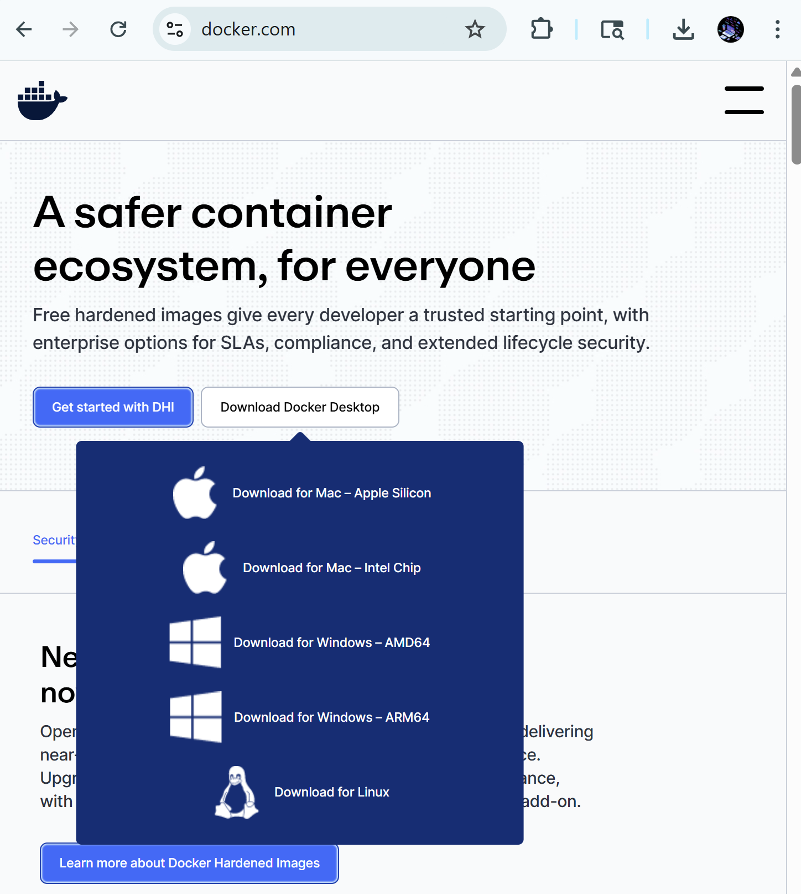Figure 10: Docker Desktop Download
Procede through the installation process. Docker Installation Wizard will provide additional steps to ensure properly installed. After installation, the developer will be prompted to restart computer. When system is rebooted, Docker Desktop will be ready to use. Installation success can be verified in terminal with command: docker --version with expected output as Docker version 24.0.x followed by a build number.

Step 3:
Now navigate back to the folder where the Vulcan Activity Tracker is stored. In either a code editor like Visual Studio Code, or right from the command prompt. The app can only be run if the environment is in the Source Code File. Move through files in the terminal with cd command along with folder name, i.e. cd SourceCode/
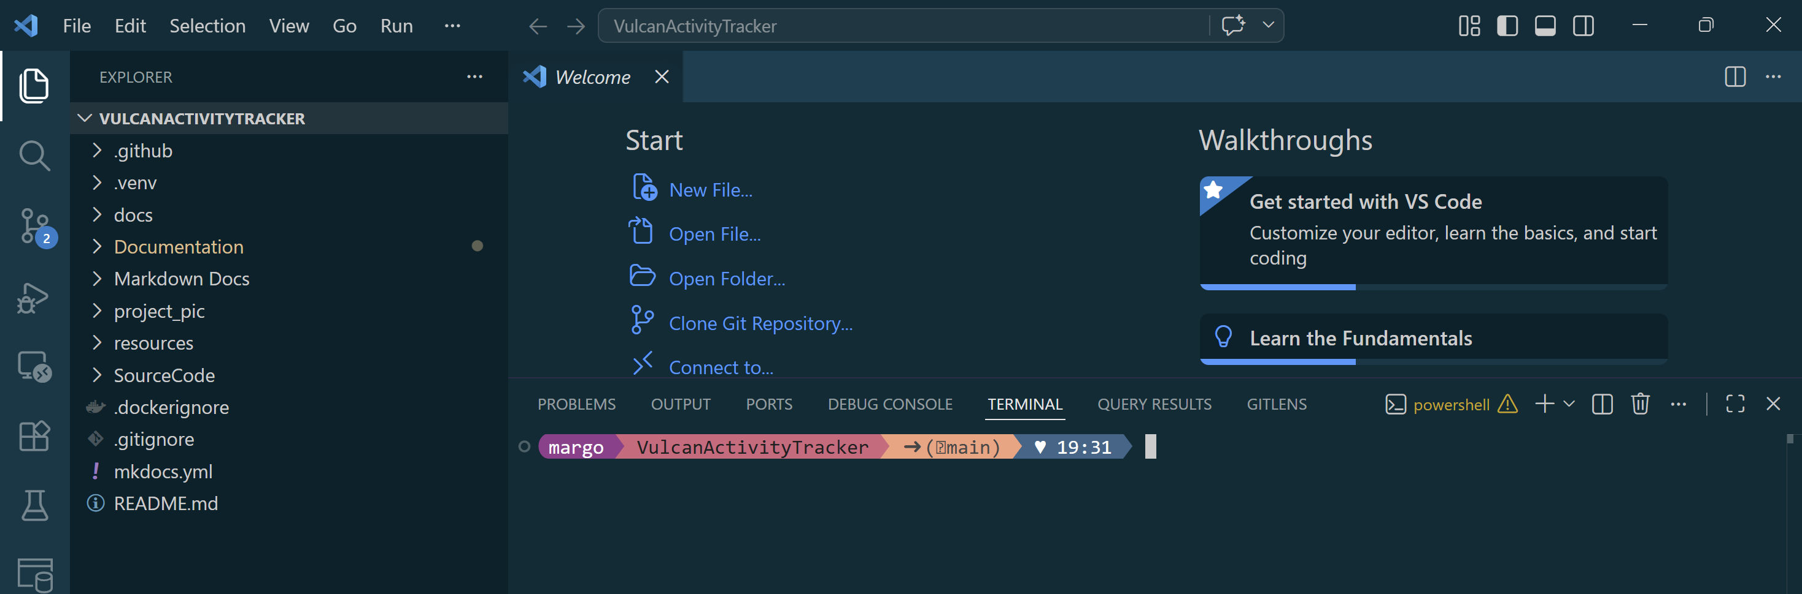
Figure 11: Vulcan Activity Tracker Open in code editor
Within the source code file, all files to properly build the project will be accessible.
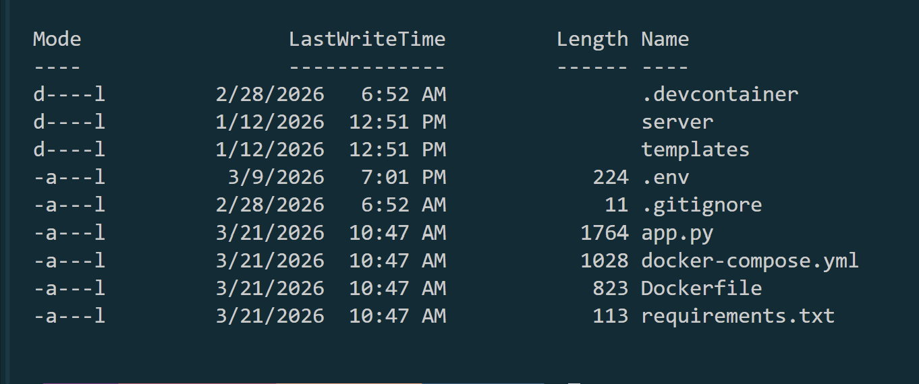
Figure 12: Source code folder contents

Step 4:
The fourth developer technical step will be to run the docker container. Since our application is structured with group collaboration in mind, containerization allows the app itself to download and install all dependencies to function. In the SourceCode Directory in the terminal, enter the command docker compose up --build
This will initiate the docker container to build the database, app server, and online website. Docker will move through the requirements.txt file automatically and build all resources and dependencies that the app needs. Once the app is built, the terminal will show messages that the database tables have been initialized and are prepared for platform use. Navigate in the browser to localhost:6455 to view the app built locally. 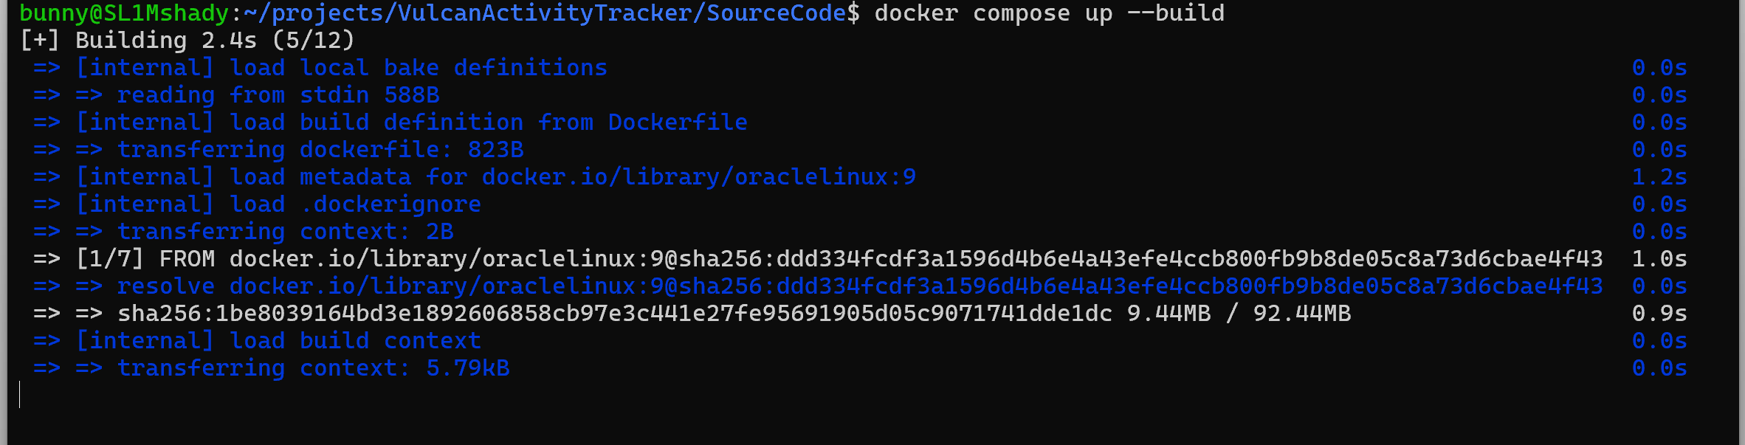
Figure 13: Docker initializing build
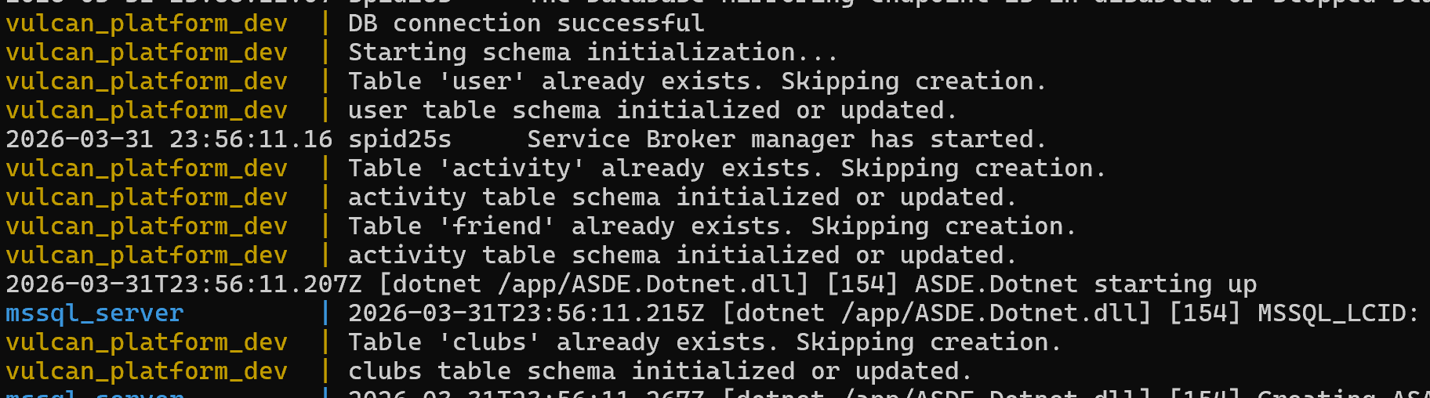
Figure 14: Database tables built, signals app is ready to access
Figure 15: App is accessed by localhost:6455 in browser
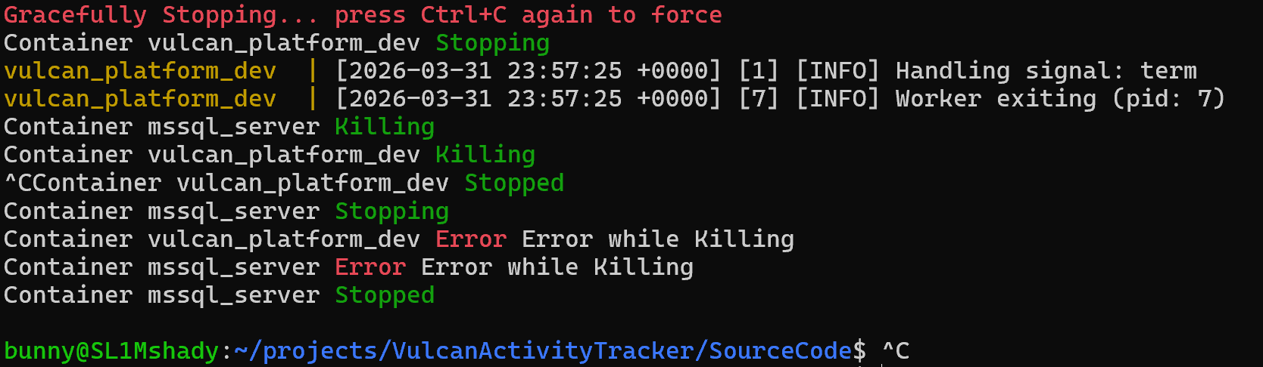
Figure 16: App is stopped locally by Ctrl-C key combination
This concludes the developer instructions portion of this document. Please reach out to development team with any questions or errors during local building process.

Team Contact Information:

Developer | Email
Margo Bonal | bon8330@pennwest.edu
John Gerega | ger9822@pennwest.edu
Luke Ruffing | RUF96565@pennwest.edu

List of References
Agafonkin, V. (2025, Aug 16th). Leaflet.
https://leafletjs.com/

Hevy Studios S.L. (2025). Hevy – Gym Log Workout Tracker (Version 2.4.7) [Mobile app].
https://www.hevyapp.com/
Lucidchart Software Inc. (2025). Lucidchart [Website and Software Application]
https://www.lucidchart.com
Nike, Inc. (2025). Nike Run Club: Running Coach (Version 7.70.0 for iOS) [Mobile app].
https://www.nike.com/nrc-app
OpenStreetMap. (2025). OpenStreetMap.
https://www.openstreetmap.org/copyright
The Run Buddy Ltd. (2022). Runna: Running Training Plans (Version 8.5.0) [Mobile app].
https://www.runna.com/?gad_source=1&gad_campaignid=22530268929&gbraid=0AAAAABfUKAUcs2aA7jayQhjZYrJnvDftf&gclid=CjwKCAjwuePGBhBZEiwAIGCVS1dtaMKRlGDzWrJsTvy5TKab0O_LodHzXuZie-qwF0uvQrYvfe_-CRoC89MQAvD_BwE
STRONG FITNESS PTE. LTD. (2025). Strong Workout Tracker Gym Log (Version 6.2.1) [Mobile app].
https://www.strong.app/
Strava, Inc. (2025, Sept 11). Strava (Version 428.0.1) [Website and Mobile App].
https://www.strava.com

Table of Index / Glossary

Appendix I: Writing Center report

Appendix II: Team Details
This User Manual document was developed through the collaboration of all team members. The document was made with the combined efforts of the entire team over the course of the project timeline. While each member contributed across various parts of the document, the primary contributors for each section are listed below:
- Margo Bonal:
    - Title Page, table of contents, team details, authentication, developer instructions, user instructions, project overview, screenshots, SWE Principles, comparison, motivation,
- John Gerega:
    - Teams page
- Luke Ruffing:
The rest of the major sections of the document were completed collaboratively with all members participating equally in discussions, decision making, and writing. This collaborative approach taken to completing the document allowed the group to refine ideas and reach a consensus before making any big decisions.
In addition to the writing of each section, all team members took part in proof reading and formatting ensuring the creation of a clear, concise and well-organized document. Together the team worked to check for proper grammar, proper citation, and adherence to all formatting guidelines.

Appendix III: Workflow Authentication
I, Margo Bonal, confirm that all work I have contributed to this document has been to the best of my knowledge, completed with integrity and in accordance with the objectives and collaborative standards established by the team. I attest that I will maintain these standards in all future contributions to this project.
Signature:  Date: 4/26/26
I, John Gerega confirm that all work I have contributed to this document has been to the best of my knowledge completed with integrity and in accordance with the objectives and collaborative standards established by the team. I attest that I will maintain these standards in all future contributions to this project.

Signature:  Date: 4/26/26
I, Luke Ruffing, confirm that all work I have contributed to this document has been to the best of my knowledge completed with integrity and in accordance with the objectives and collaborative standards established by the team. I attest that I will maintain these standards in all future contributions to this project.

Signature: Date: 4/26/26

Appendix III: Code listing

