
Brief “how-to” for the LOFAR Navigator”

"how-to" to install the LOFAR-Navigator (as standalone)
- Create “Standard project” with the PVSS Project Administrator, name it “Navigator” (see this picture)
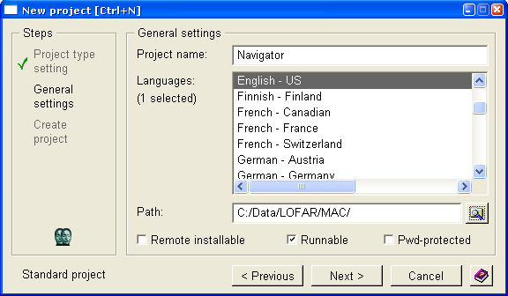
Note: The picture above shows the second step of the “New project” wizard.
Note: Keep the default selections.
Note: Choose a path without (!) any white spaces or special characters and exclusive the “Project name”.
Note: Creation of a PVSS project takes a number of minutes. So you have time to drink a cup of coffee.
- Check out the files from the LOFAR/MAC/NAV directory in CVS into the same directory (in our case: C:\Data\LOFAR\MAC\Navigator) as the just created PVSS project. At this way it is possible to check-in changed Navigator files directly. If you don’t want this you can check out the files to any other place and copy the content of the LOFAR/MAC/NAV dir to the PVSS project dir once and copy changed files back to the original place of the CVS files.
- Open a “Command Prompt”. Go to project path (in our case: C:\Data\LOFAR\MAC\Navigator) and enter the following command:
C:\Data\LOFAR\MAC\Navigator> @ bash prepareNavigator Navigator
Now you have a typical set of DP’s of the physical part of a Station. If you need more please contact Tilman Müller.
- Start now the project Navigator with the PVSS Administrator. But in this case DON’T LOG-IN DIRECTLY! First read point 5.
- Because this is now a standalone Navigator you have to create the so-called “ENABLED” DP’s. Otherwise you will never see a tree in the Navigator. This can be done by means of selecting the last row in the list of the Console for the Navigator and pressing the (green) button “Manager start”. 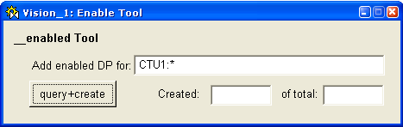
Default this panel opens with the query: “CTU1:*”. In a standalone Navigator normally only the PIC part of a LOFAR station is available. That’s way the query could be better: “CTU1:PIC_*”. After “query + create” for all DP’s, which matches this query, the so-called “ENABLED” DP’s will be created. The progress will be shown in the Created text field.
- Log now in as user ”root” (The first time the “User name” field is empty.)
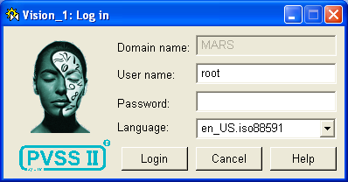
- Now the LOFAR Navigator is started. Click the “Configure system” button (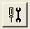). Generate for the user “root” a personal environment. Select username “root” in the Create environment area, and then use the “Create“ button. (See picture below).
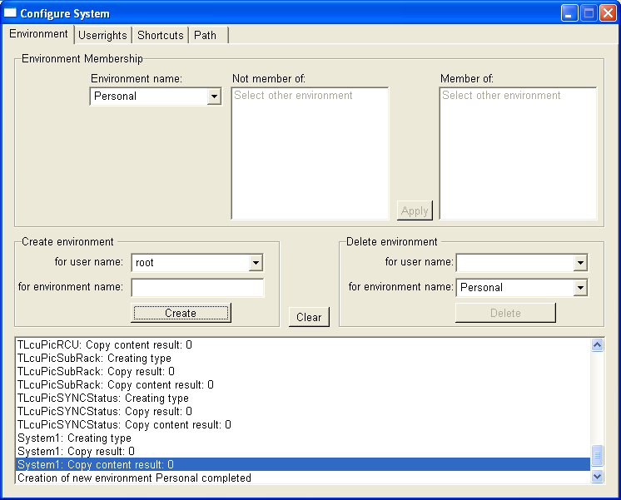
Close this popup en you will be able to browse through the tree and select one of the view tabs.
- The last version of gnuplot must be downloaded from http://www.gnuplot.info/. Install this package and configure in the "System configuration" of Windows the gnuplot path, this is the bin directory within the gnuplot directory.
- The last version of iview (image convertor) must be downloaded from http://www.irfanview.com/. Install this package and configure in the "System configuration" the picture converter path.
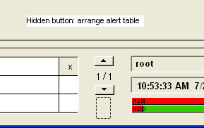
- There is a hidden button in the bottom of the screen (see picture), which arranges the column-width and visibility of the alert table at the bottom of the screen,.
- Log levels: There are several library functions present, which can be used for log levels in the program code. The datapoint "__loglevel" of type GCFLogLevel, handles the log level. These are the values and meanings, level en function call:
LOGLEVEL_FATAL = 50000; LOG_FATAL(<content>, ….);
LOGLEVEL_ERROR = 40000; LOG_ERROR(<content>, ….);
LOGLEVEL_WARN = 30000; LOG_WARN(<content>, ….);
LOGLEVEL_INFO = 20000; LOG_INFO(<content>, ….);
LOGLEVEL_DEBUG = 10000; LOG_DEBUG(<content>, ….);
LOGLEVEL_TRACE = 0; LOG_TRACE(<content>, ….);
- shield file
To be able to start PVSS project you need a license for the PVSS product. This is handled by a dongle in combination with a “shield” file. This shield file you can find on the PVSS CDROM with the study projects made by Arjan de Bruijn. It must be placed in the root of PVSS product installation directory. Default this is “c:\ETM\pvss2\3.0”.

