
Brief “how-to” for the LOFAR Navigator”

"how-to" to install the LOFAR-Navigator
(as standalone development machine)
Precondition: PVSSII 3.1 is installed on the same PC in the default directory: C:\ETM. And LOFAR root resides on C:\data.
If PVSS is not installed it has to be installed first. If version 3.0.1 is currently installed you can install a patch/SP2, which can be downloaded from the ftp site of ETM:
- ftp://ftp.pvss.com/partner/astron
- ftp://ftp.pvss.com/partner/download
username: astron, passwd: wre2hupr

- Create a “Distributed project” with the PVSS Project Administrator, name it “MCU001” (see the pictures below) 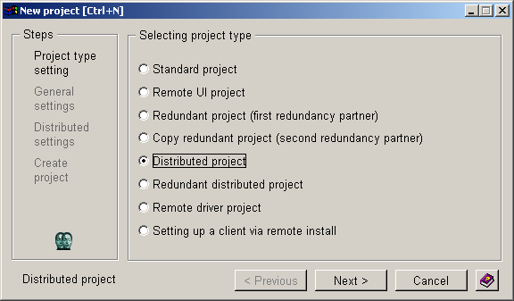
Press Next>
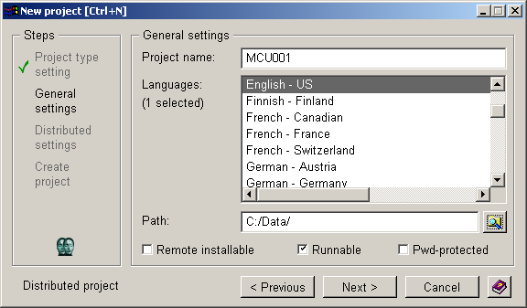

Note: Choose a path without (!) any white spaces or special characters and exclusive the “Project name”. Press Next>
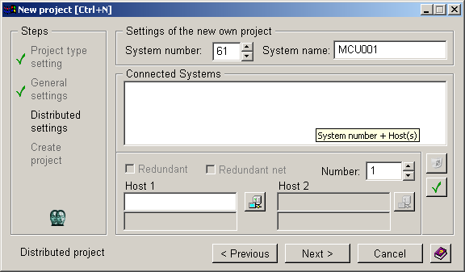
Press Next> Note: Creation of a PVSS project takes a number of minutes.
So you have time to drink a cup of coffee.
- Create a “Distributed project” with the PVSS Project Administrator,
name it “CS010” (see the pictures below)

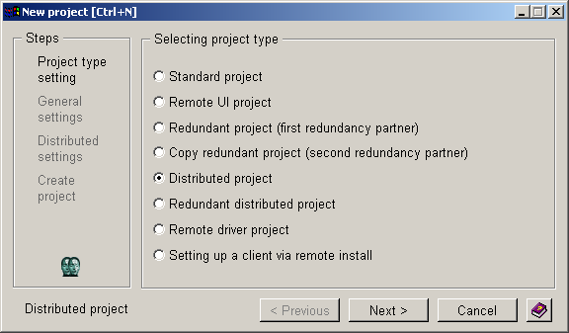
Press Next>
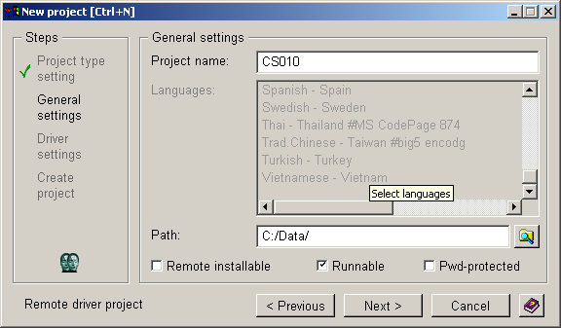
Press next>
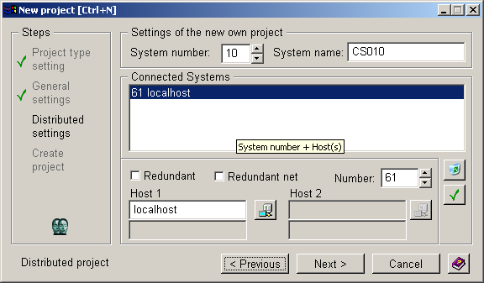
Press Next>

- Create a “Remote UI project” with the PVSS Project Administrator, name it “Navigator” (see the pictures below) 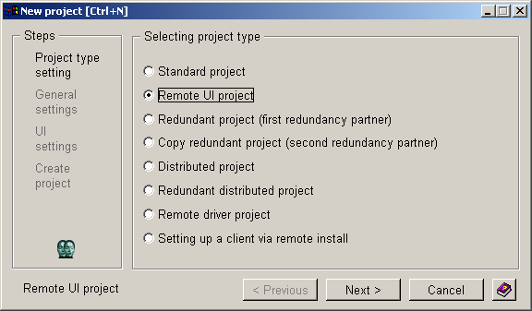
Press Next> 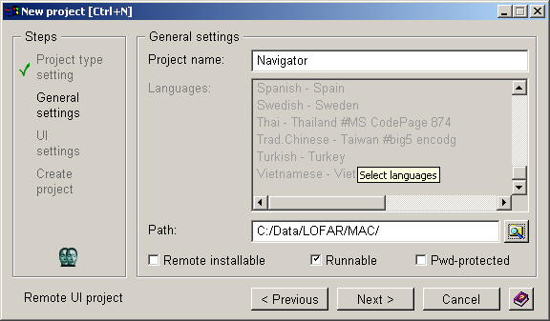
Press Next>
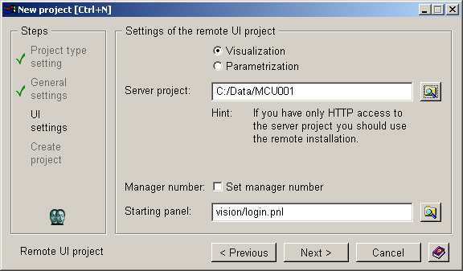
Press Next>
Ignore the Error Msg and press OK 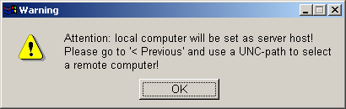

- Check out the files from the LOFAR/MAC/Navigator directory in CVS into the same directory (in our case: C:\Data\LOFAR\MAC\Navigator) as the just created PVSS project. At this way it is possible to check-in changed Navigator files directly (for example by using TurtoiseCVS). If you don’t want this you can check out the files to any other place and copy the content of the LOFAR/MAC/Navigator dir to the PVSS project dir once and copy changed files back to the original place of the CVS files.

- If you are on an Windows machine make sure that you have prepared the .dpl files on a linux machine. These files can be created in the LOFAR/MAC/Deployment/data/PVSS directory by running the command:
.create_db_files –o Observation_10
.create_db_files –o Observation_10 –s CS010
.create_db_files
.create_db_files –s CS101
Set the structure from unix to dos with the command: unix2dos *.dpl

FTP the created files :
CS010ObsDatapoints.dpl
CS010ObsDatapointtypes.dpl
CS010PermDatapoints.dpl
MainObsDatapoints.dpl
MainObsDatapointtypes.dpl
MainPermDatapoints.dpl
to the Navigator directory.\
!!NOTE: If you are installing with another version then 3.0, Make sure that you
Alter the config.* files in the LOFAR/MAC/Navigator/config/ directory FIRST
To point to this version in stead of 3.0!!

- Setting up the MainCU database: Copy c:\Data\LOFAR\MAC\Navigator\prepareMainCU C:\Data\MCU001 Open a “Command Prompt”. Go to project path (in our case: C:\Data\MCU001) and enter the following command:
C:\Data\MCU001> @ bash prepareMainCU MCU001
Now you have a typical set of DP’s of the physical part of a MainCU

- Setting up the Station database: Copy c:\Data\LOFAR\MAC\Navigator\prepareStation to C:\Data\CS010 Open a “Command Prompt”. Go to project path (in our case: C:\Data\CS010\) and enter the following command:
C:\Data\CS010> @ bash prepareStation CS010
Now you have a typical set of DP’s of the physical part of a Station

- Setting up the Navigator : Open a “Command Prompt”. Go to project path (in our case: C:\Data\LOFAR\MAC\Navigator) and enter the following command:
C:\Data\LOFAR\MAC\Navigator> @ bash prepareNavigator Navigator

- Start the MCU001 and CS010 projects with the PVSS administrator.

- Because this is now a standalone Navigator you have to create the so-called “ENABLED” DP’s. Otherwise you will never see a tree in the Navigator. This can be done by means of selecting the last row in the list of the Console for the MCU001 and pressing the (green) button “Manager start”. 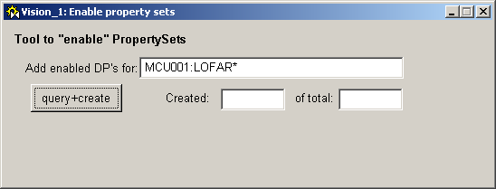
Default this panel opens with the query: “[NAME]:LOFAR*”. After “query + create” for all DP’s, which matches this query, the so-called “ENABLED” DP’s will be created. The progress will be shown in the Created text field. When this is finished the window can be closed.

- Do the same for the CS010 Project.

- shield file
To be able to start PVSS project you need a license for the PVSS product. This is handled by a dongle in combination with a “shield” file. This shield file you can find on the PVSS CDROM with the study projects made by Arjan de Bruijn on this location: 2005-07-01 PVSS and Navigator documents.It must be placed in the root of PVSS product installation directory. Default this is “c:\ETM\pvss2\3.0”

- Start now the project Navigator with the PVSS Administrator. But in this case DON’T LOG-IN DIRECTLY! Always check whether the system name of the Navigator is now MCU001: and/or CS010:. This can be done by means of the PARA tool.
You can find the paratool in the Graphical Editor screen on the toolbar. It looks like two small blue windows connected to small yellow one.
This will present you with a list of datapoints.If you open one of the datapoints to the left (station for example) you can click on until you are represented with a list of attributes (for example common, lock or state) if you click on one of those you get a DPE shown in the window right, here you can see the system name:
MCU001:LOFAR_PermSW_Core_CS010.

- Log now in as user ”root” (The first time the “User name” field is empty.)
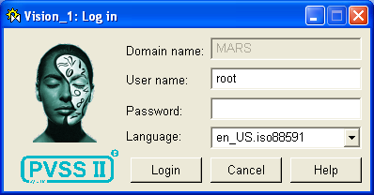
- Now the LOFAR Navigator is started. Click the “Configure system” button (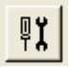). Generate for the user “root” a personal environment. Select username “root” in the Create environment area, and then use the “Create“ button. (See picture below).
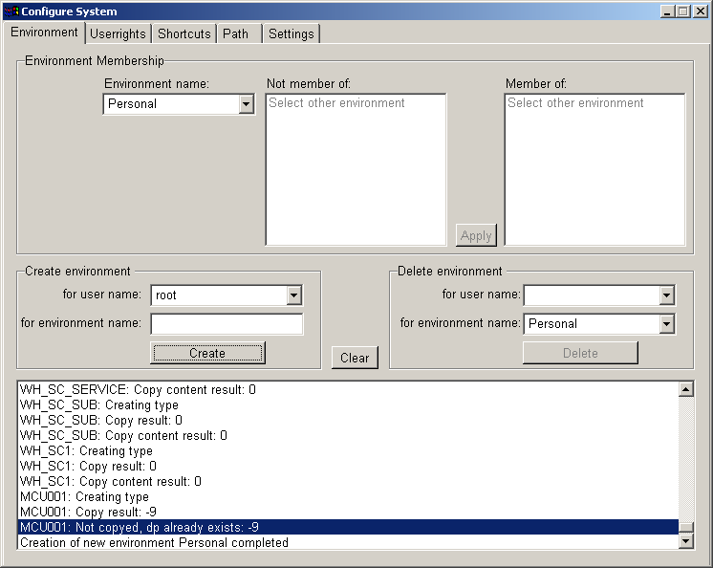
In the same popup you must select the trees you want to enable. This can be done under the Settings tab. There might be some trees placed there (CCU1:PIC, CCU1:PAC and CCU1:LOFAR) These are just examples and wont work. You can remove those from the list. After that insert the new trees: MCU001:LOFAR and CS*:LOFAR(see picture below) 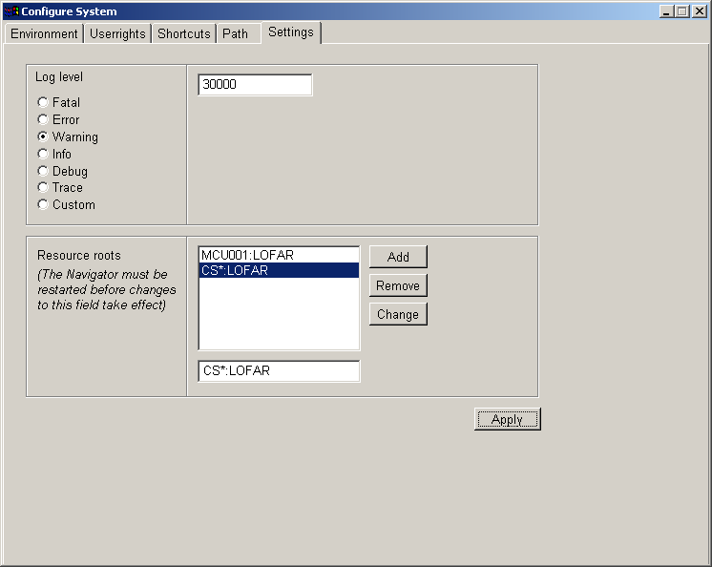. Press apply and close the popup.Now the Userrights in the same console should be altered to read (see picture below) 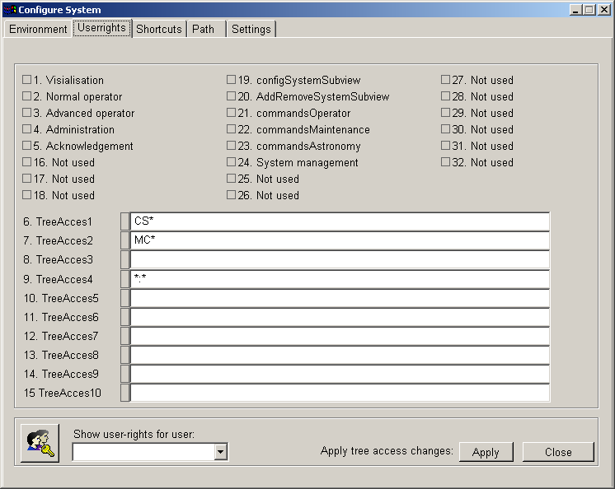
Press Apply if you changed anything .The navigator needs to be restarted to make
this working. (press the x right on the screen) after restart you should be able to
browse through the tree.
Note: The output of the Create action can also be different to the output in the
screen dump above. Mainly the output contains than the following results: “-9” in
combination with the message: “Not copyed, dp already exists: -9”. This is normal
behavior.

- The last version of gnuplot must be downloaded from http://www.gnuplot.info/. Install this package and configure in the "System configuration" of Windows the gnuplot path, this is the bin directory within the gnuplot directory.

- The last version of iview (image convertor) must be downloaded from http://www.irfanview.com/. Install this package and configure in the "System configuration" the picture converter path.

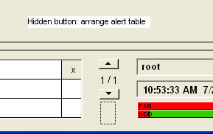
- There is a hidden button in the bottom of the screen (see picture), which arranges the column-width and visibility of the alert table at the bottom of the screen. In most case you will see no changes in the alert table.

- Log levels: There are several library functions present, which can be used for log levels in the program code. The datapoint "__loglevel" of type GCFLogLevel, handles the log level. These are the values and meanings, level en function call:
LOGLEVEL_FATAL = 50000; LOG_FATAL(<content>, ….);
LOGLEVEL_ERROR = 40000; LOG_ERROR(<content>, ….);
LOGLEVEL_WARN = 30000; LOG_WARN(<content>, ….);
LOGLEVEL_INFO = 20000; LOG_INFO(<content>, ….);
LOGLEVEL_DEBUG = 10000; LOG_DEBUG(<content>, ….);
LOGLEVEL_TRACE = 0; LOG_TRACE(<content>, ….);

"how-to" configure subviews for the LOFAR-Navigator

The Navigator supports several types of views. For each view, subviews can be defined in the Config tab of the selected view. All config tabs have the following controls:

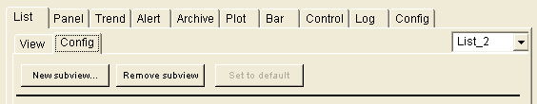

The New subview… button adds a new subview to the list of subviews. To configure the new subview, it has to be selected using the drop-down listbox.
The Remove subview button removes the current subview.
The Set to default button makes the current subview the default subview.

Note that subviews-configurations are always linked to the type of the currently selected node in the treeview. For example: If a subview is configured for an RCU, then the subview and its configuration is used for all RCU’s in the tree.

List view configuration

The list view shows the properties of the selected datapoint. There are two types of list views: The standard list view and the Custom list view.
The Standard list view shows all elements of the current datapoint-type, with the actual value and unit. Only the actual value can be changed by the user in this view, by entering the new value in the column “New” and pushing the apply button.
In the Custom list-view a selection query can be defined and the found results, with a configured maximum amount, is displayed in the list, with the actual value and unit. Only the actual value can be changed by the user in this view.

The following picture shows the configuration options for the list view:
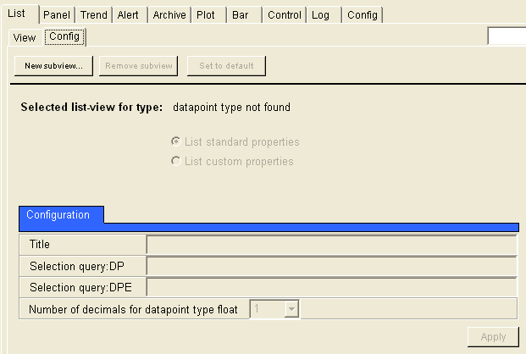

List standard properties / List custom properties | Choice between the default list (listing all properties of the selected node) and a custom list defined by the options below.
Title | Title of the list
Selection query:DP | Root datapoint for the query
Selection query:DPE | Property selection, wildcards are allowed
Number of decimals | Number of decimals for floating point values

Panel view configuration

The panel is a view where user can use (his own) dedicated panels. The panel file name is written into the subview configuration and use when the panel is opened. In the panel-config this panel name can be changed to any other panel.

User defined panels are stored in the nav_usr subdirectory. This directory is further divided in the following subdirectories:
CCU | Central Core panels
CS1 | CS1 Specific panels
CEP | Central Processing panels
MAC | Monitoring and Control panels
STS | Station panels
VIC | Virtual Instrument panels
WAN | Network infrastructure panel

The following picture shows the configuration options for the panel view:
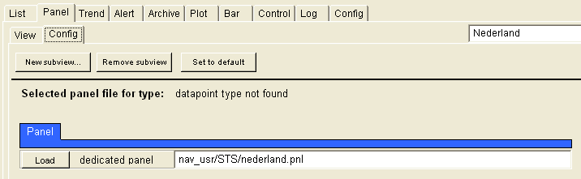

The Load button allows the operator to browse and select a panel.

Trend view configuration
The trend view allows the user to monitor property changes during a certain
period.The following picture shows the configuration options for the trend view:
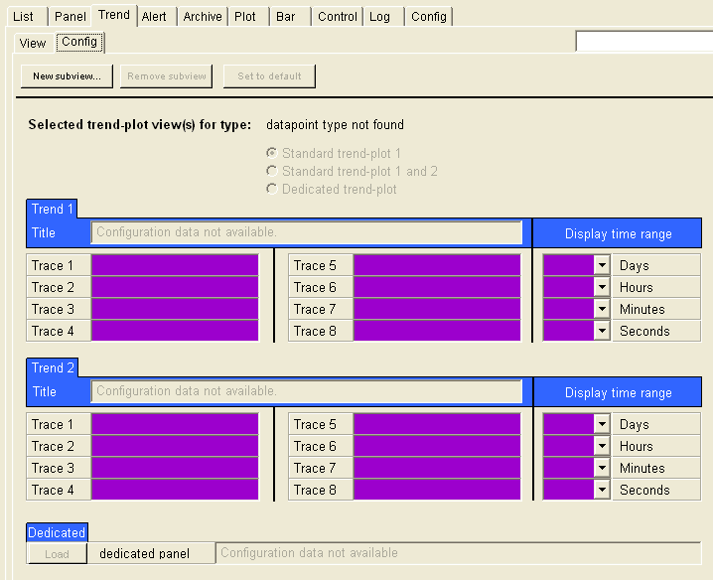

Standard trend-plot 1 / Standard trend-plot 1 and 2 /  Dedicated trend-plot | Choice between 1 standard trend-plot, 2 standard trend-plots and a custom defined trendplot
Title | Defines the title for the trend-plot in case a standard trend-plot is selected.
Trace 1 .. Trace 8 | Right-clicking these controls opens a context menu that allows the definition or removal of trend-plot traces
Time range | Defines the visible time-range in the trend-plot
Dedicated | Defines the dedicated trend-plot panel

Alert view configuration

The Alert view shows up to three tables with the alert-status of configured datapoints and an alert list with all alerts.
The following picture shows the configuration options for the alert view:
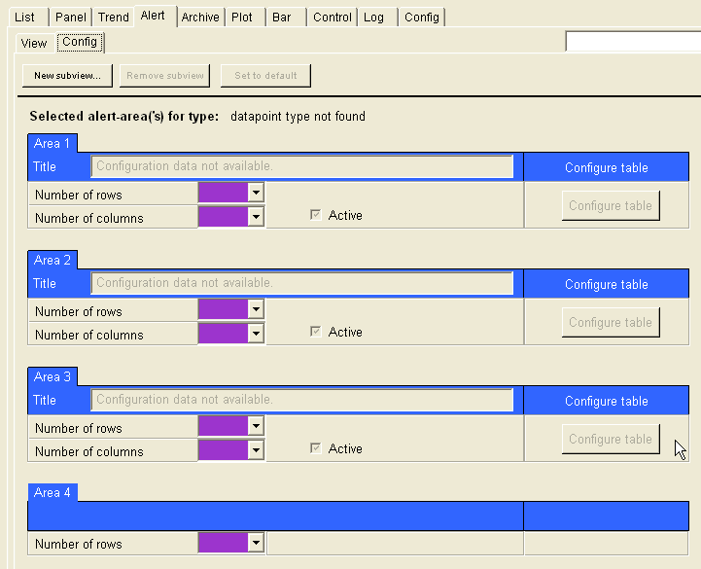

Title | Defines the title for the alert areas
Number of rows/columns | Defines the size of the alert areas
Configure table | Opens a dialog to configure the fields in the alert area

Archive view configuration

-

Plot view configuration

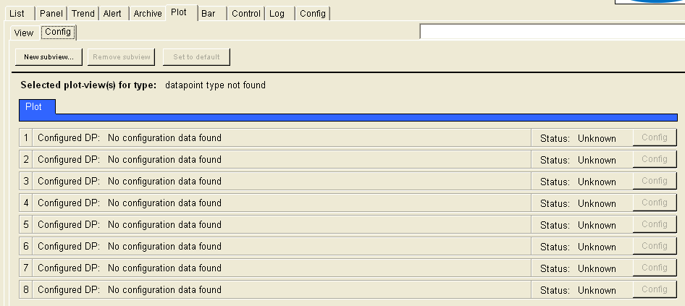

Eight plot-lines can be configured. The Config button opens a dialog in which each plot-line can be configured.

Bar view configuration

The bar view can show bar graphs of properties.
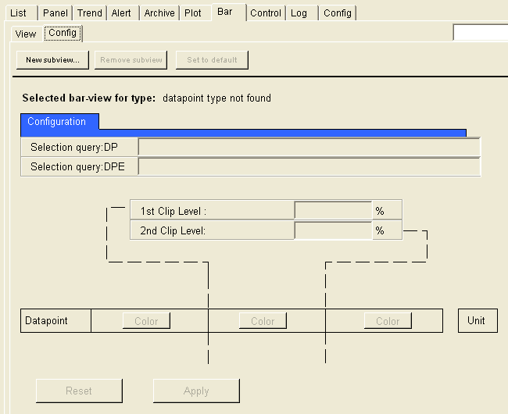

Control view configuration

The control view enables monitoring and controlling Lofar control applications. It has no configurable options.

Log view configuration

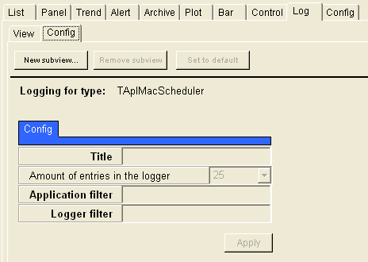

Config view configuration

The config view is not defined.

