CS1 Navigator Panels

CS1 Main panel
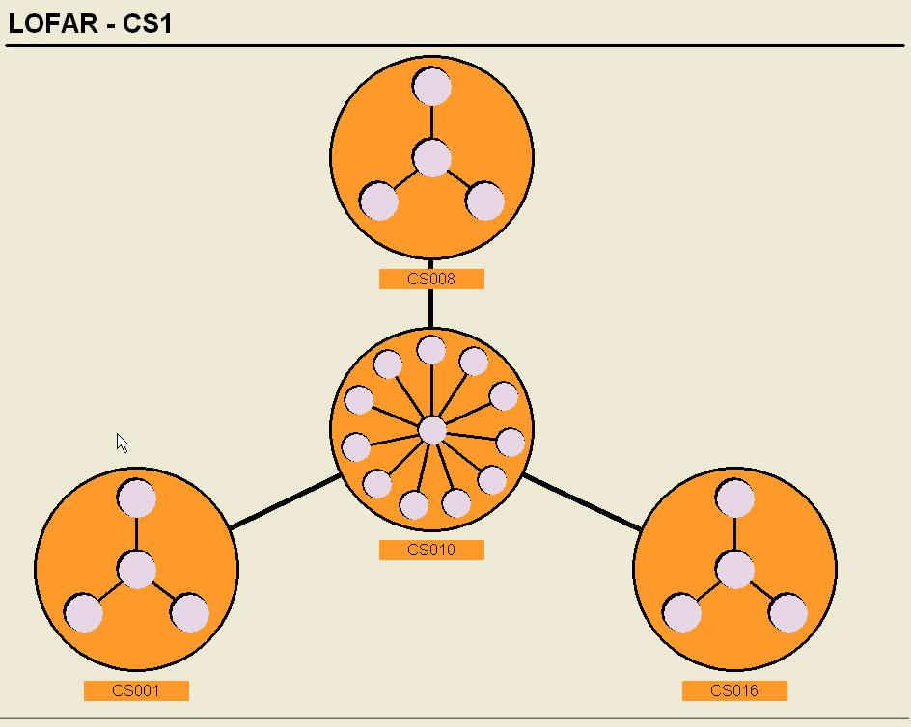

Description
Main panel of the CS1 release of LOFAR. It shows the 4 central stations. Clicking on a station takes you to the station hardware overview of that station.

Parameters (filled in by the Navigator framework)
$referenceDatapoint | Selected datapoint in the tree

Filename
panels/nav_usr/CS1/cs1-main.pnl

Station hardware
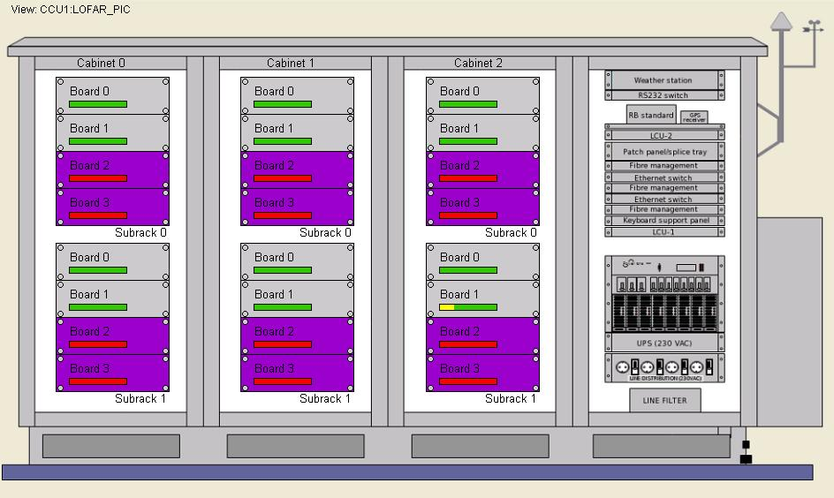

Description
Overview of the hardware of a station. The panel shows 3 cabinets, each with 2 subracks and each subrack with 4 boards. The bar in each board gives an indication of the status of the board. If it is all green, then the board has no errors. If it is partly yellow, then some parts of the board are not functioning. If the bar is all red, then one or more crucial parts of the board are not functioning correctly. Clicking on a board takes you to the hardware details panel of that board.

Parameters (filled in by the Navigator framework)
$datapoint | Selected datapoint in the tree
$referenceDatapoint | Selected datapoint if it is a reference to a different PVSS database
$configDatapoint | Selected datapoint in the tree

Filename
panels/nav_usr/CS1/Station-CS1.pnl

Station hardware details
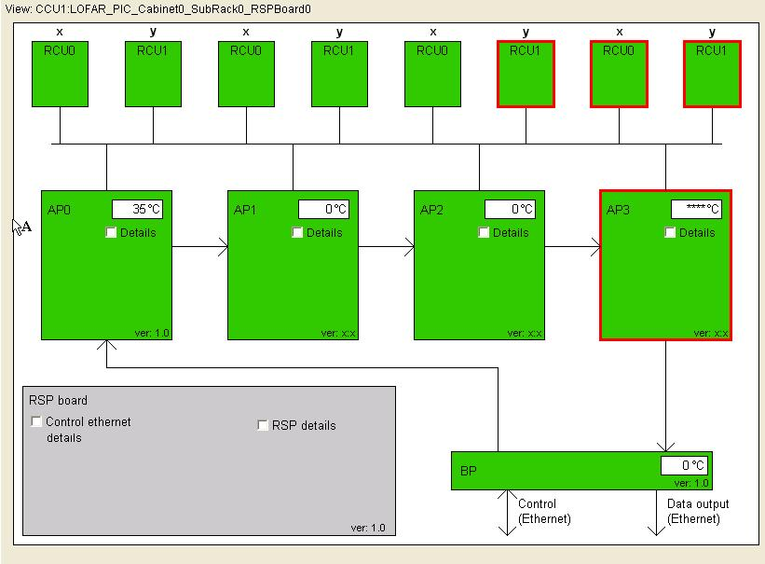

Description
Shows the hardware details of one RSP board. The green blocks represent the FGPA’s on the board and the connected RCU’s. If an FPGA or RCU is in error, then the block will turn red. System Health Management can determine the functionality of an RSP board and its components. If SHM suspects a component to be malfunctioning a red border apears around that component.

Parameters (filled in by the Navigator framework)
$datapoint | Selected datapoint in the tree
$referenceDatapoint | Selected datapoint if it is a reference to a different PVSS database (Navigator internal)

Filename
panels/nav_usr/CS1/Station_Subrack-CS1.pnl

CEP hardware view
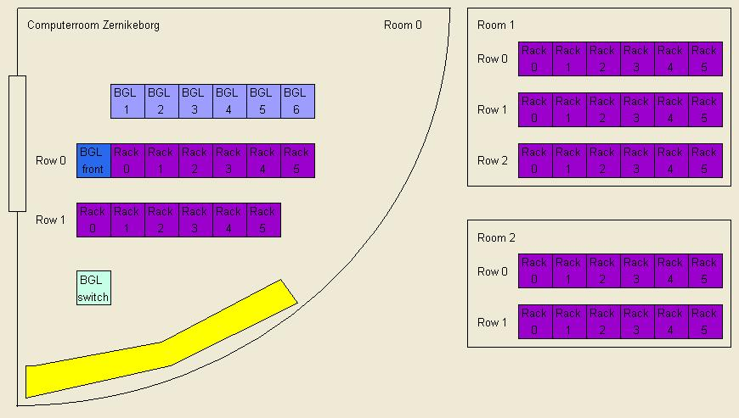

Description
This panel shows the status of the BlueGene nodes as well as the status of the nodes in the CEP clusters. It is a top view of the computerroom.

Parameters (filled in by the Navigator framework)
$datapoint | Selected datapoint in the tree

Filename
panels/nav_usr/CEP/CEP_fysical_view.pnl

CEP logical view
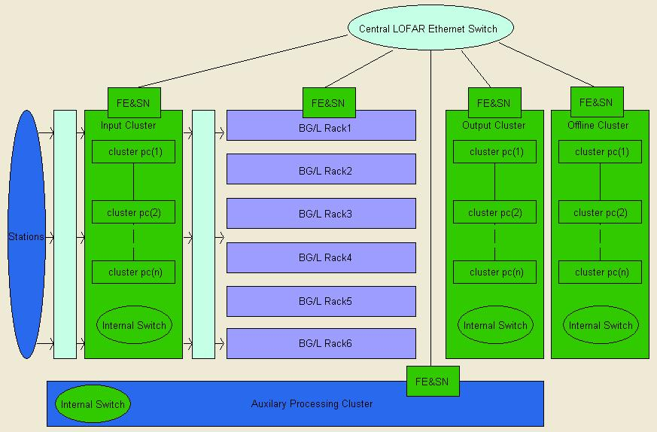

Description
This panel shows the status of the same nodes as the CEP physical view panel, but the information is represented in a logical way, grouped by type of cluster.

Parameters (filled in by the Navigator framework)
none

Filename
panels/nav_usr/CEP/CEP_logical_view.pnl

WAN hardware
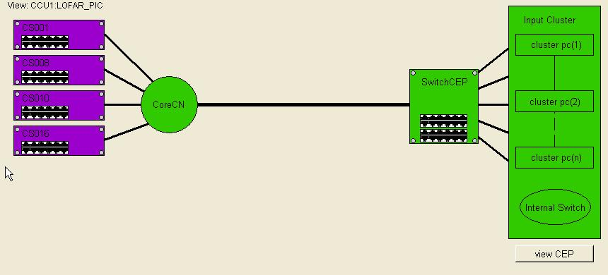

Description
This panel shows the topology of the CS1 WAN and the status of the nodes in the network.

Parameters (filled in by the Navigator framework)
$datapoint | Selected datapoint in the tree
$referenceDatapoint | Selected datapoint if it is a reference to a different PVSS database (Navigator internal)
$configDatapoint | Selected datapoint in the tree

Filename
panels/nav_usr/CS1/WAN-CS1.pnl

Software overview
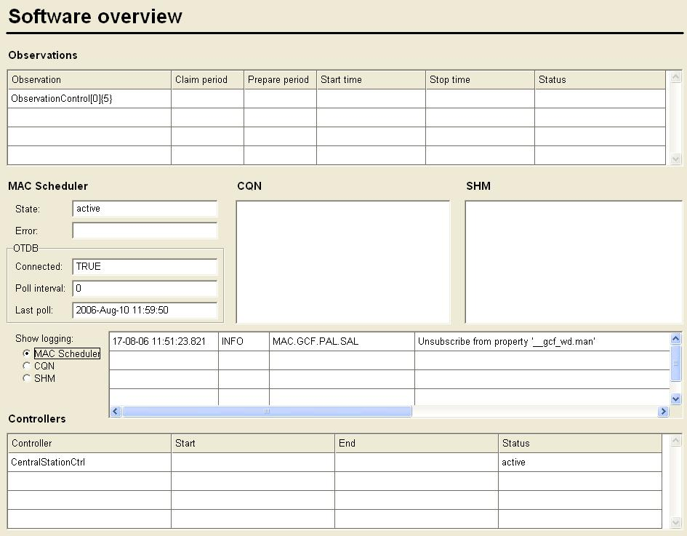

Description
Shows the status of scheduled observations and some key MAC processes.

Parameters (filled in by the Navigator framework)
none

Filename
panels/nav_usr/CS1/software-overview.pnl

Observation overview
Description
not implemented yet

Parameters (filled in by the Navigator framework)
$datapoint | Selected datapoint in the tree

Filename
panels/nav_usr/CS1/observation-overview.pnl

Observation details
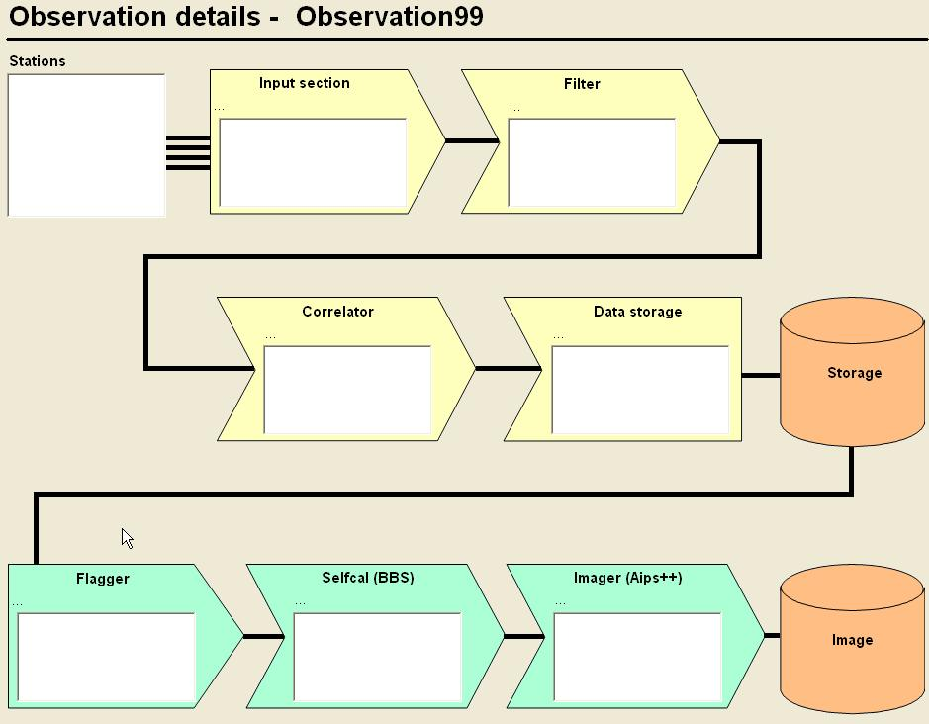

Description
Shows the status of the online and offline CEP processing of an observation.

Parameters (filled in by the Navigator framework)
$datapoint | Selected datapoint in the tree

Filename
panels/nav_usr/CS1/observation-details-imaging.pnl

Rings overview
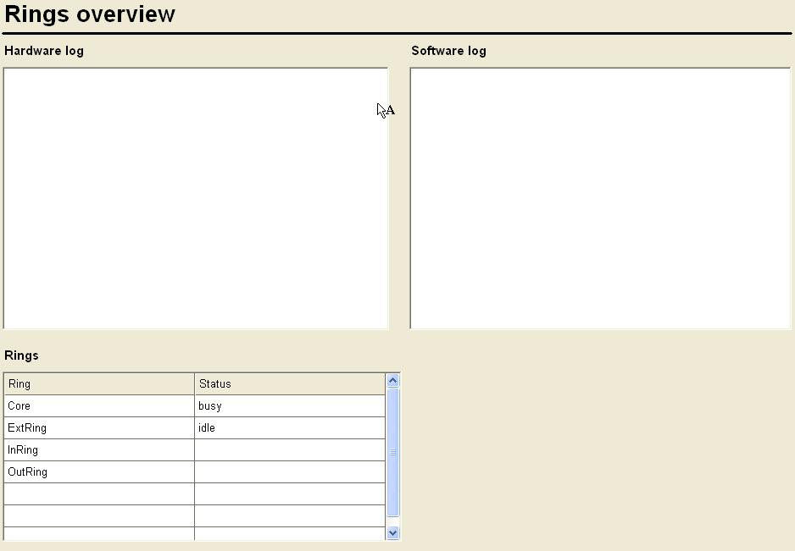

Description
This panel shows the Rings of LOFAR and their status. Clicking on a ring in the list will open a panel showing the details of the ring.

Parameters (filled in by the Navigator framework)
$datapoint | Selected datapoint in the tree

Filename
panels/nav_usr/CS1/rings-overview.pnl

Station controller overview
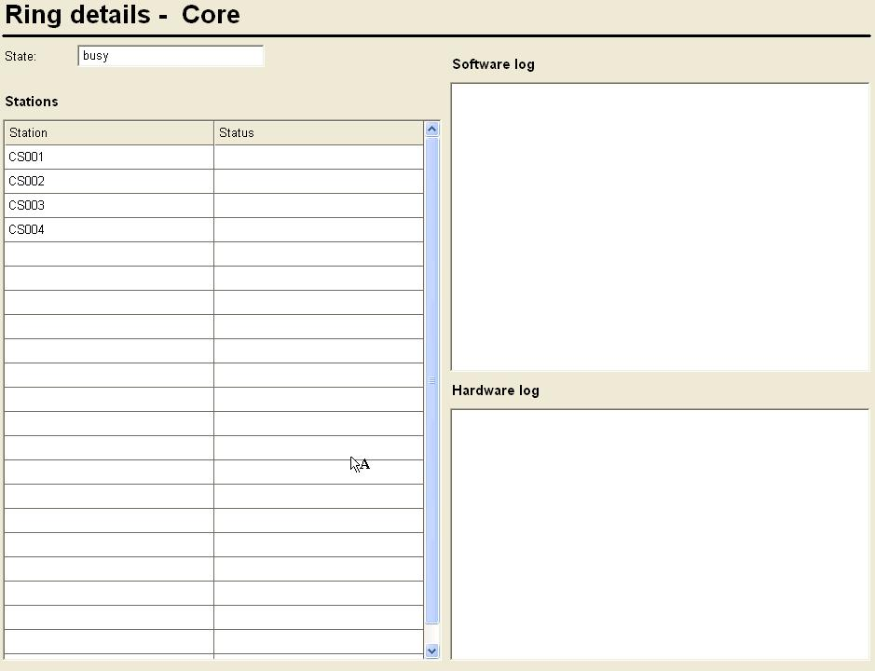

Description
This panel gives an overview of the stations in a ring. Clicking on a station in the list will open a panel showing all controllers running on that station.

Parameters (filled in by the Navigator framework)
$datapoint | Selected datapoint in the tree

Filename
panels/nav_usr/CS1/station-overview.pnl

Controller overview
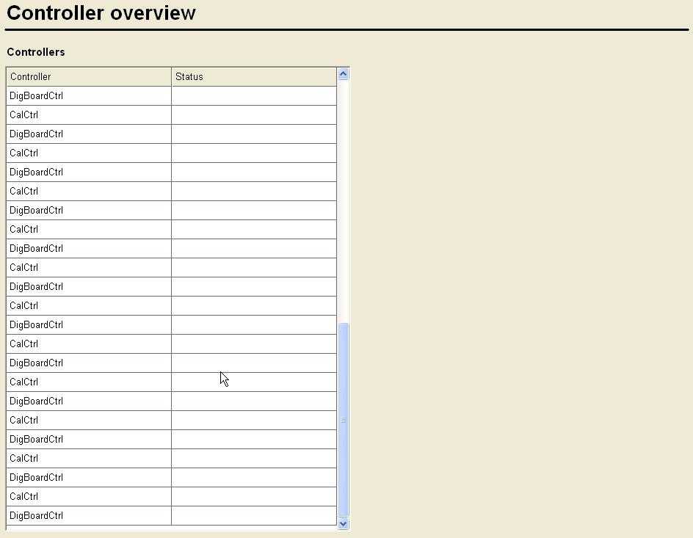

Description

Parameters (filled in by the Navigator framework)
$datapoint | Selected datapoint in the tree

Filename
panels/nav_usr/CS1/controller-overview.pnl

