Codechef-VIT Competitive Coding Answers
-Jacob Jean, 25BAI0077

1 - Chef and the ancient Jungle Monkeys

Logic:
- Splice word to delete last 2 characters
- add “oi” to root word

Code:
testCases = int(input())

for i in range(testCases):
singWord = input()
plurWord = singWord[:-2] + "oi" # Remove last 2 characters and add “oi”
print(plurWord)

Testcases:
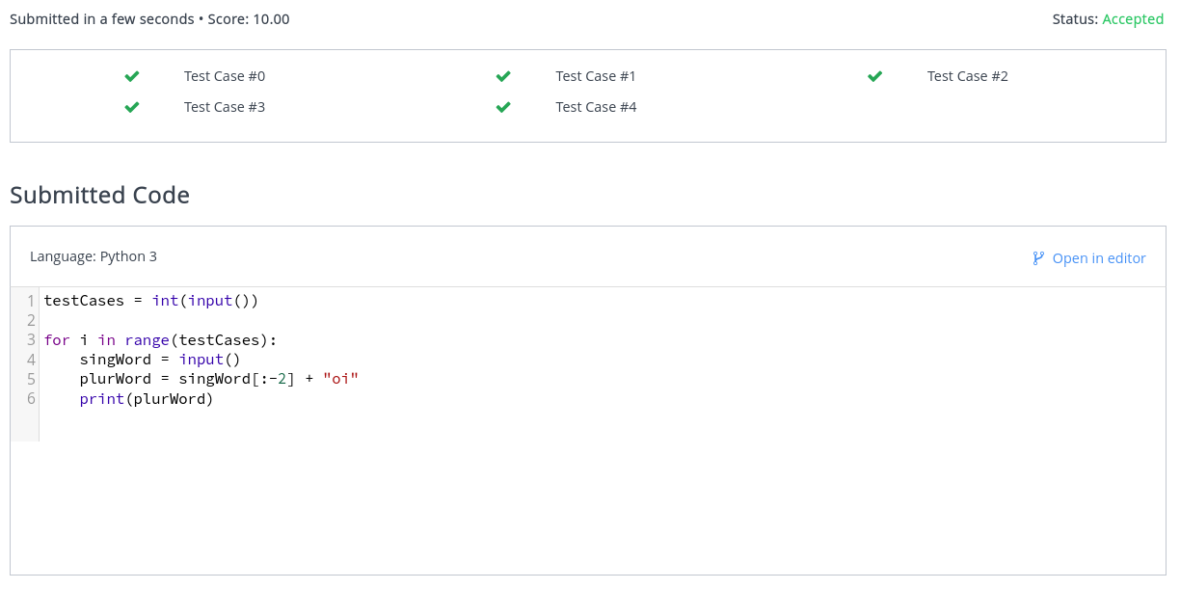

Output:
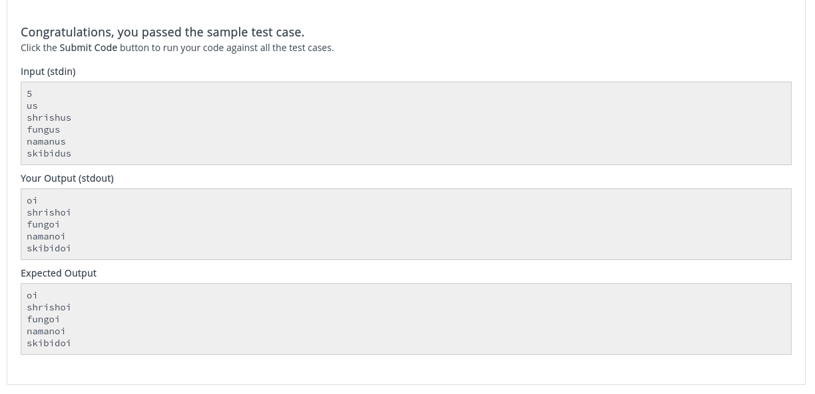

2 - A Spicy Stew

Logic:
- Spiciness formula cancels telescopically
- If given chilies are: a,b,c,d
- Final spiciness = 1 * (b/a) * (c/b) * (d/c) = last/first
- If spiciness equals 1 then last = first
- So we must be able to add chillies in such a way that the first and last have the same spiciness value
- Therefore there must be duplicates present
- If there are duplicates present, they are discarded by set(arr)
- Therefore len(arr) will not be equal to len(set(arr))

Code:
testCases = int(input())

for i in range(testCases):
chilliNum = int(input())
chilliSpiciness = list(map(int, input().split()))

if len(chilliSpiciness) != len(set(chilliSpiciness)): # Check for duplicates, True if present
print("YES")
else:
print("NO")

Testcases:
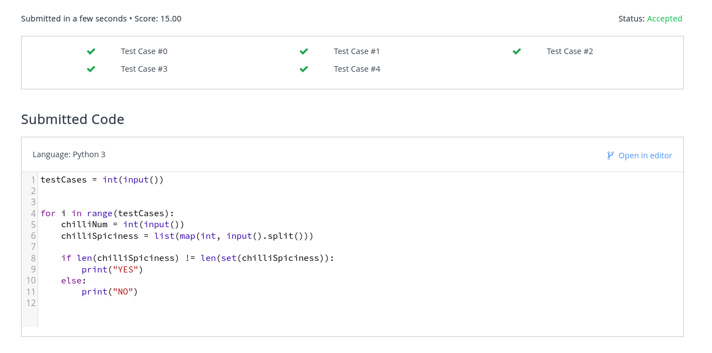

Output:
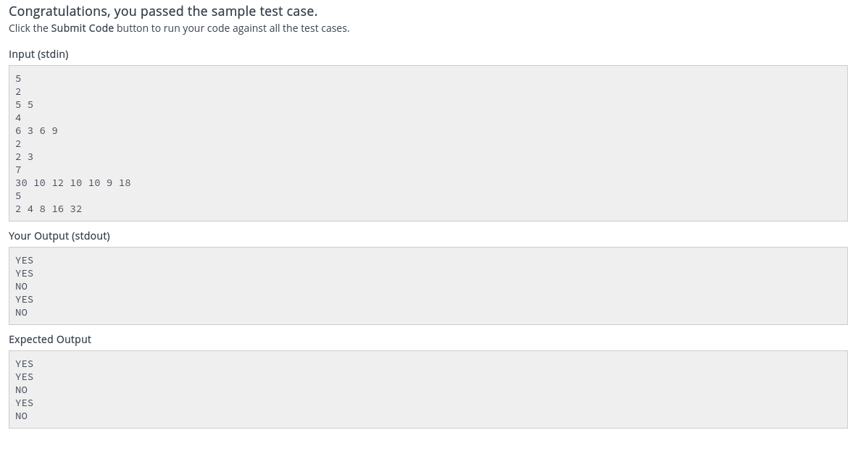

3 - A Fruitful Stroll

Logic:
- Sliding window with at most 2 distinct digits
- Maintain count of elements in window in dict
- Keep growing window to the right until 3rd element is seen
- Increase count
- When 3rd element is seen keep shrinking sliding window from left until only 2 distinct elements are in the window again
- If len(dict) > 2 => 3 distinct elements present in window, shrink window and reduce count of deleted element until len(dict) = 2 i.e only 2 distinct elements in window
- Update max
- Continue growing window to right

Code:
testCases = int(input())

for tc in range(testCases):
n = int(input())
trees = list(map(int, input().split()))

numFruitsMax = 0

left = 0
right = 0
count = {}

for right in range(n):
fruit = trees[right]
count[fruit] = count.get(fruit, 0) + 1 # Maintain count of fruits

while len(count) > 2: # If more than 2 fruits present, shrink window from left
left_fruit = trees[left]
count[left_fruit] -= 1
if count[left_fruit] == 0:
del count[left_fruit]
left+=1

numFruitsMax = max(numFruitsMax, right - left + 1) # Update max
print(numFruitsMax)

Testcases:
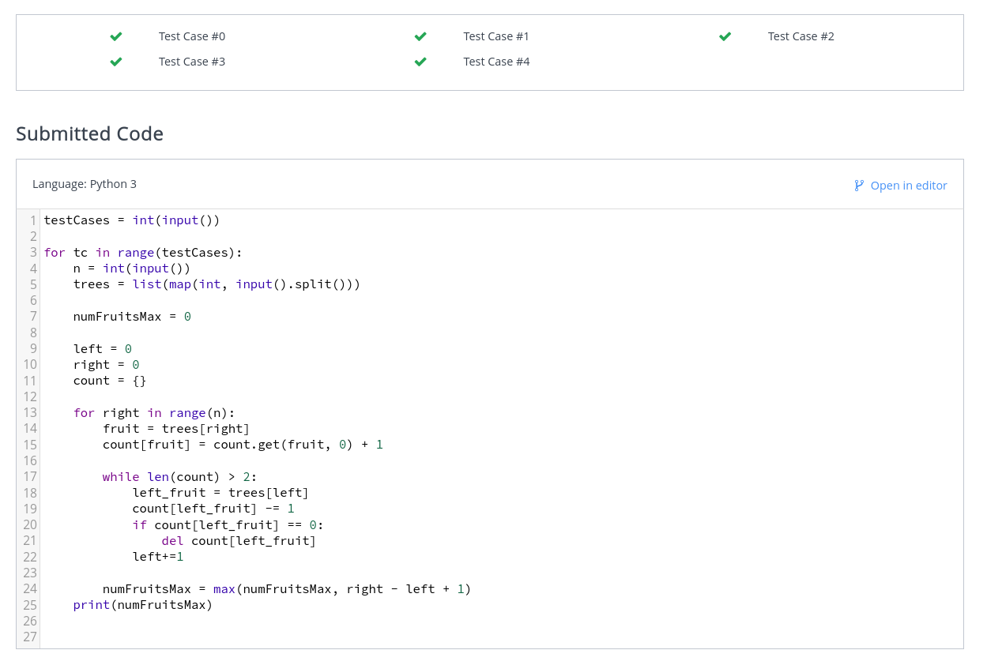

Output:
