- Classify the following as descriptive, diagnostic, or predictive dashboards.
Descriptive dashboards focus on what happened, like a dashboard showing monthly sales totals, student attendance rates, or website traffic counts. Diagnostic dashboards focus on why it happened, like a dashboard that compares performance across regions, highlights correlations (e.g., low engagement leading to poor grades), or shows drill-downs into the causes of a revenue decline. Predictive dashboards focus on what will happen, like a dashboard forecasting next quarter’s sales, predicting student dropout risk, or estimating customer churn probability using machine learning models.
- Design one dashboard example for each type.
Descriptive Dashboard – Sales Performance
Shows what happened using KPI cards (total revenue, total orders, average order value), a monthly revenue bar chart, and a channel-mix donut. All of the values are recorded facts, with no interpretation or forecast.
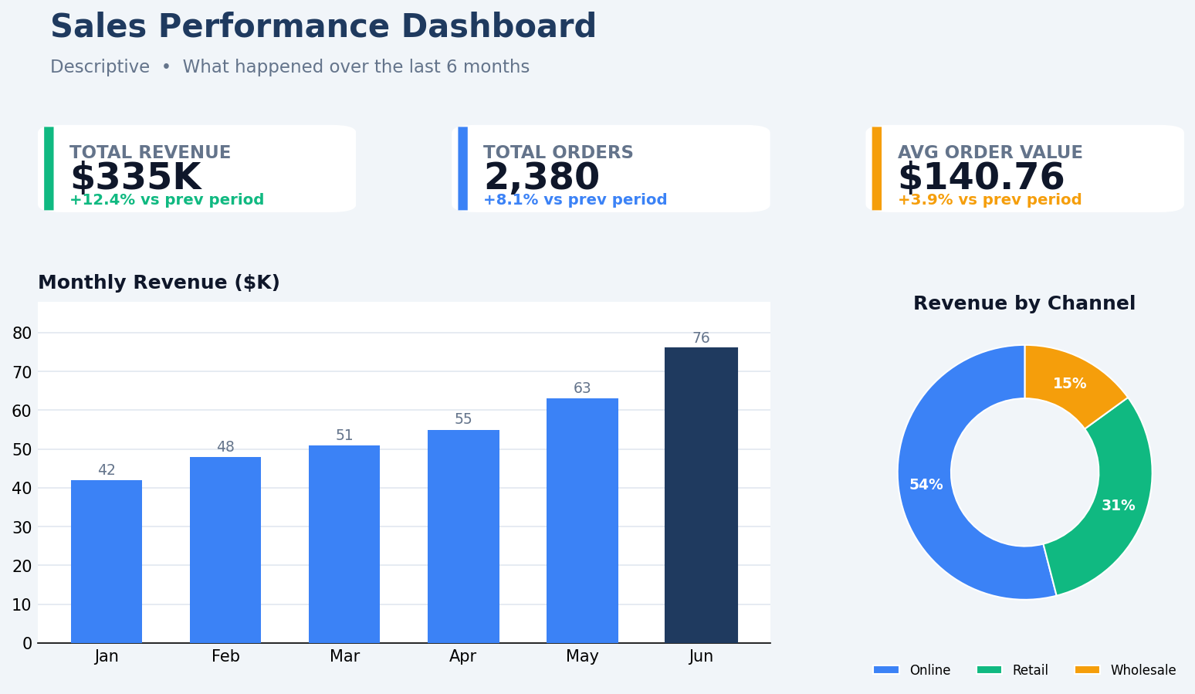

Diagnostic Dashboard – Regional Performance Analysis
Shows why it happened. The bars compare each region against its target, and the scatter plot links ad spend to sales. Together they reveal that the South region underperformed (‒30%) mainly because of unusually low ad spend.
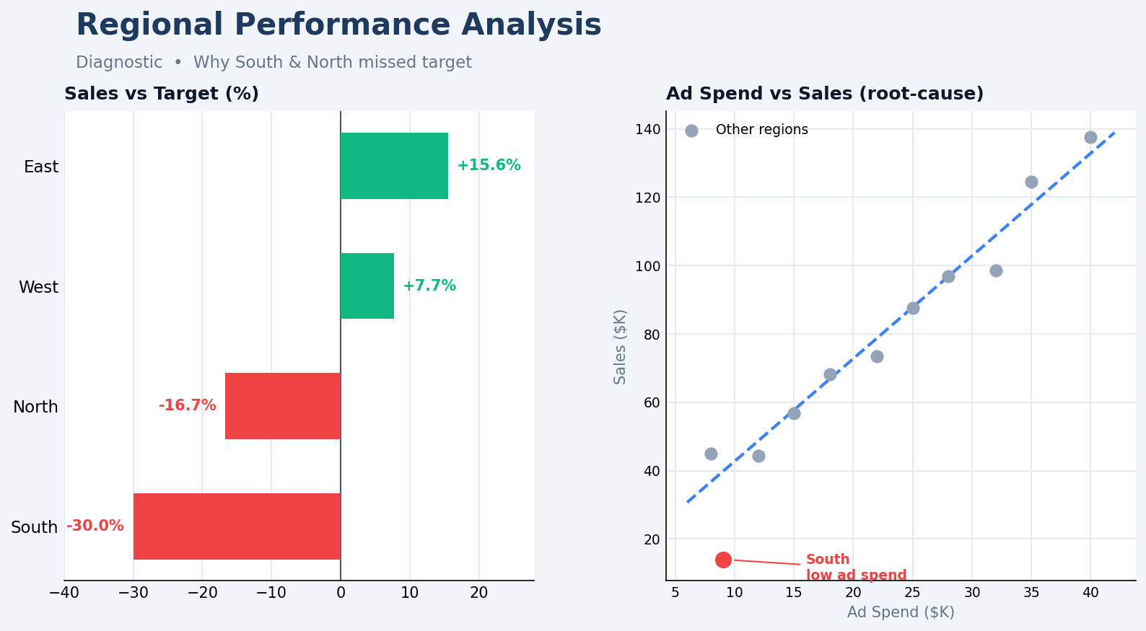

Predictive Dashboard – Sales & Revenue Forecast
Shows what will happen. Actual revenue (solid line) hands off to a model-generated forecast (dashed line) with an 88% confidence band. The KPI cards summarize the projected next-quarter revenue ($512K, +15.1%) and the model’s reliability.
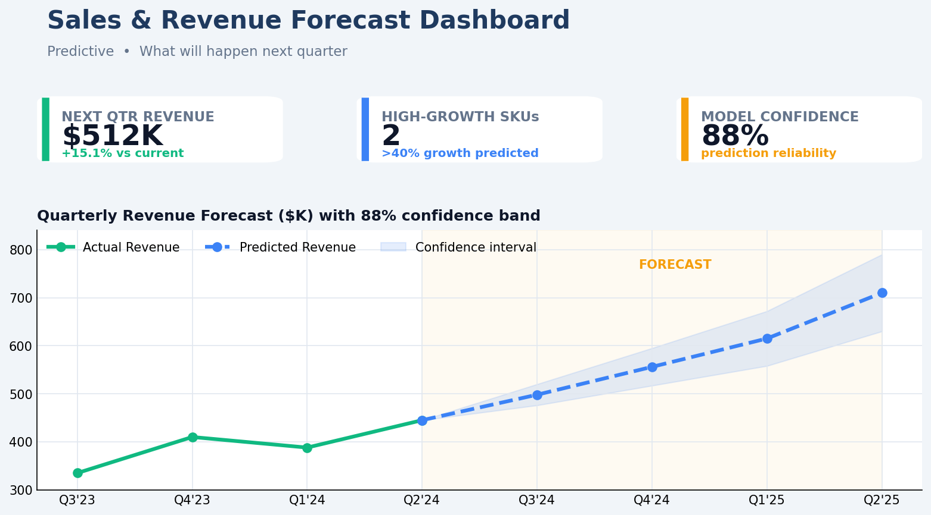
- Why is predictive analytics harder to implement than descriptive analytics?
Predictive analytics is harder because it has to estimate a value that has not happened yet, while descriptive analytics only summarizes data that already exists.

