 | SREE NARAYANA GURUKULAM  COLLEGE OF ENGINEERING  KADAYIRUPPU, KOLENCHERY 682311

---------------------------------------
LABORATORY RECORD
YEAR: 2022 TO 2023

NAME : JERIN JOY
SEMESTER : 3 ROLL NO : 17
BRANCH : COMPUTER APPLICATIONS

Certified that this is a Bonafide Record of Practical work done in partial fulfillment of the requirements for the award of the Degree in Master of Computer Applications of Sree Narayana Gurukulam College of Engineering.

Kadayiruppu
Date:

Head of the Department Course Instructor

Submitted for University Practical Examination

Reg. No: SNG21MCA-2019 on___________

External Examiner Internal Examiner

INDEX PAGE
NO | PROGRAM | DATE
COURSE OUTCOME 1
1 | LOGIN FORM | 30/08/22
2 | ACTIVITY LIFECYCLE | 03/09/22
3 | SIMPLE CALCULATOR | 10/09/22
4 | FORM VALIDATION | 20/09/22
COURSE OUTCOME 2
5 | INTENT AND SHARED PREFERENCES | 25/09/22
6 | GRID CALCULATOR | 30/09/22
7 | FACEBOOK PAGE | 05/10/22
8 | TOGGLE IMAGE | 20/10/22
COURSE OUTCOME 3
9 | INTENT | 30/10/22
10 | MENU | 10/11/22
COURSE OUTCOME 5
11 | DATABASE MANAGEMENT | 20/11/22

COURSE OUTCOME 1

PROGRAM NO : 1
DATE : 30/08/2022

LOGIN FORM

AIM: Design a Login Form with username and password using LinearLayout and toast valid credentials

XML CODE

<?xml version="1.0" encoding="utf-8"?>
<androidx.constraintlayout.widget.ConstraintLayout xmlns:android="http://schemas.android.com/apk/res/android"
xmlns:app="http://schemas.android.com/apk/res-auto"
xmlns:tools="http://schemas.android.com/tools"
android:layout_width="match_parent"
android:layout_height="match_parent"
tools:context=".MainActivity">

<TextView
android:id="@+id/textView"
android:layout_width="wrap_content"
android:layout_height="wrap_content"
android:text="Hello World!"
app:layout_constraintBottom_toBottomOf="parent"
app:layout_constraintEnd_toEndOf="parent"
app:layout_constraintStart_toStartOf="parent"
app:layout_constraintTop_toTopOf="parent" />

<LinearLayout
android:layout_width="405dp"
android:layout_height="727dp"
android:orientation="vertical"
tools:layout_editor_absoluteX="3dp"
tools:layout_editor_absoluteY="3dp"
tools:ignore="MissingConstraints">

<LinearLayout
android:layout_width="match_parent"
android:layout_height="71dp"
android:orientation="horizontal">

<TextView
android:id="@+id/t_user"
android:layout_width="wrap_content"
android:layout_height="wrap_content"
android:layout_weight="1"
android:text="USERNAME" />

<EditText
android:id="@+id/et_user"
android:layout_width="wrap_content"
android:layout_height="wrap_content"
android:layout_weight="1"
android:ems="10"
android:inputType="textPersonName" />
</LinearLayout>

<LinearLayout
android:layout_width="match_parent"
android:layout_height="124dp"
android:orientation="horizontal">

<TextView
android:id="@+id/t_pass"
android:layout_width="wrap_content"
android:layout_height="wrap_content"
android:layout_weight="1"
android:text="PASSWORD" />

<EditText
android:id="@+id/et_pass"
android:layout_width="wrap_content"
android:layout_height="wrap_content"
android:layout_weight="1"
android:ems="10"
android:inputType="textPersonName" />
</LinearLayout>

<Button
android:id="@+id/b_submit"
android:layout_width="match_parent"
android:layout_height="wrap_content"
android:onClick="click"
android:text="SUBMIT" />
</LinearLayout>

</androidx.constraintlayout.widget.ConstraintLayout>

JAVA CODE

package com.example.jrnprogram_1;
import androidx.appcompat.app.AppCompatActivity;
import android.os.Bundle;
import android.view.View;
import android.widget.Button;
import android.widget.EditText;
import android.widget.Toast;
public class MainActivity extends AppCompatActivity {
EditText uname,pass;
Button button;
@Override
protected void onCreate(Bundle savedInstanceState) {
super.onCreate(savedInstanceState);
setContentView(R.layout.activity_main);
uname=findViewById(R.id.et_user);
pass=findViewById(R.id.et_pass);
button=findViewById(R.id.b_submit);
}
public void click(View view) {
String s1=uname.getText().toString();
String s2=pass.getText().toString();
if(s1.equals("jerin") && s2.equals("joy"))
{
Toast.makeText(this,"Successfully", Toast.LENGTH_SHORT).show();
}
else
{
Toast.makeText(this,"Failed",Toast.LENGTH_SHORT).show();
}
}
}

OUTPUT

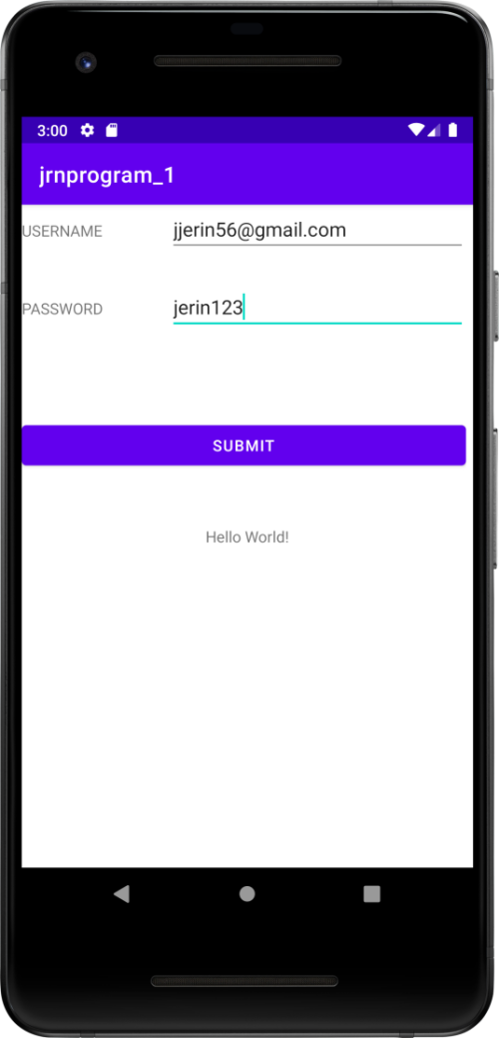

PROGRAM NO : 2
DATE : 03/09/2022

ACTIVITY LIFE CYCLE

AIM:Write a program that demonstrates Activity Lifecycle

XML CODE

<?xml version="1.0" encoding="utf-8"?>
<androidx.constraintlayout.widget.ConstraintLayout
xmlns:android="http://schemas.android.com/apk/res/android"
xmlns:tools="http://schemas.android.com/tools"
xmlns:app="http://schemas.android.com/apk/res-auto"
android:layout_width="match_parent"
android:layout_height="match_parent"
tools:context=".MainActivity">
<TextView
android:layout_width="wrap_content"
android:layout_height="wrap_content"
android:text="Hello World!"
app:layout_constraintBottom_toBottomOf="parent"
app:layout_constraintStart_toStartOf="parent"
app:layout_constraintEnd_toEndOf="parent"
app:layout_constraintTop_toTopOf="parent" />
</androidx.constraintlayout.widget.ConstraintLayout>
JAVA CODE

package com.example.jprogram_2;
import androidx.appcompat.app.AppCompatActivity;
import android.os.Bundle;
import android.widget.Toast;
public class MainActivity extends AppCompatActivity {
@Override
protected void onCreate(Bundle savedInstanceState)
{
super.onCreate(savedInstanceState);
setContentView(R.Layout.activity_main);
Toast.makeText(this,"onCreate",Toast.LENGTH_LONG).show();
}
@Override
protected void onStart()
{
super.onStart();
Toast.makeText(this,"onStart",Toast.LENGTH_SHORT).show();
}
@Override
protected void onResume()
{
super.onResume();
Toast.makeText(this,"onResume",Toast.LENGTH_SHORT).show();
}
@Override
protected void onPause()
{
super.onPause();
Toast.makeText(this,"onPause",Toast.LENGTH_SHORT).show();
}
@Override
protected void onStop()
{
super.onStop();
Toast.makeText(this,"onStop",Toast.LENGTH_SHORT).show();
}
@Override
protected void onDestroy()
{
super.onDestroy();
Toast.makeText(this,"onDestroy",Toast.LENGTH_SHORT).show();
}
@Override
protected void onRestart()
{
super.onRestart();
Toast.makeText(this,"onRestart",Toast.LENGTH_SHORT).show();
}
}

OUTPUT

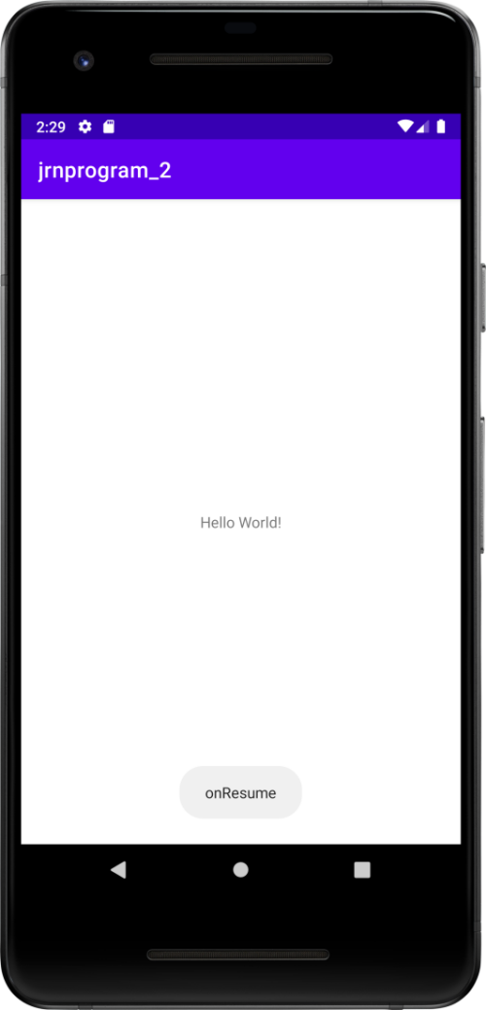

PROGRAM NO : 3
DATE : 10/09/2022

SIMPLE CALCULATOR

AIM:Implementing basic arithmetic operations of a simple calculator

XML CODE

<?xml version="1.0" encoding="utf-8"?>
<androidx.constraintlayout.widget.ConstraintLayout xmlns:android="http://schemas.android.com/apk/res/android"
xmlns:app="http://schemas.android.com/apk/res-auto"
xmlns:tools="http://schemas.android.com/tools"
android:layout_width="match_parent"
android:layout_height="match_parent"
tools:context=".MainActivity">
<TextView
android:layout_width="wrap_content"
android:layout_height="wrap_content"
android:text="Hello World!"
app:layout_constraintBottom_toBottomOf="parent"
app:layout_constraintEnd_toEndOf="parent"
app:layout_constraintStart_toStartOf="parent"
app:layout_constraintTop_toTopOf="parent" />
<LinearLayout
android:layout_width="407dp"
android:layout_height="731dp"
android:orientation="vertical"
tools:layout_editor_absoluteX="1dp"
tools:layout_editor_absoluteY="1dp">
<LinearLayout
android:layout_width="match_parent"
android:layout_height="82dp"
android:orientation="horizontal">
<TextView
android:id="@+id/t_num1"
android:layout_width="wrap_content"
android:layout_height="wrap_content"
android:layout_weight="1"
android:text="Enter Value A"
android:textSize="20sp" />
<EditText
android:id="@+id/et_num1"
android:layout_width="wrap_content"
android:layout_height="wrap_content"
android:layout_weight="1"
android:ems="10"
android:inputType="textPersonName" />
</LinearLayout>
<LinearLayout
android:layout_width="match_parent"
android:layout_height="64dp"
android:orientation="horizontal">
<TextView
android:id="@+id/t_num2"
android:layout_width="wrap_content"
android:layout_height="wrap_content"
android:layout_weight="1"
android:text="Enter Value B"
android:textSize="20sp" />
<EditText
android:id="@+id/et_num2"
android:layout_width="wrap_content"
android:layout_height="wrap_content"
android:layout_weight="1"
android:ems="10"
android:inputType="textPersonName" />
</LinearLayout>
<Button
android:id="@+id/b_submit"
android:layout_width="match_parent"
android:layout_height="wrap_content"
android:onClick="click"
android:text="SUBMIT" />
<LinearLayout
android:layout_width="match_parent"
android:layout_height="match_parent"
android:orientation="horizontal">
<TextView
android:id="@+id/t_result"
android:layout_width="136dp"
android:layout_height="wrap_content"
android:fontFamily="sans-serif-black"
android:text="RESULT"
android:textColorLink="#2196F3"
android:textSize="24sp" />
<EditText
android:id="@+id/et_result"
android:layout_width="258dp"
android:layout_height="69dp"
android:ems="10"
android:inputType="textPersonName" />
</LinearLayout>
</LinearLayout>
</androidx.constraintlayout.widget.ConstraintLayout>

JAVA CODE

package com.example.jrnprogram_3;
import androidx.appcompat.app.AppCompatActivity;
import android.os.Bundle;
import android.view.View;
import android.widget.Button;
import android.widget.EditText;
import android.widget.Toast;
public class MainActivity extends AppCompatActivity
{
EditText num_1,num_2,add;
Button button;
@Override
protected void onCreate(Bundle savedInstanceState)
{
super.onCreate(savedInstanceState);
setContentView(R.layout.activity_main);
num_1 = findViewById(R.id.et_num1);
num_2 = findViewById(R.id.et_num2);
button = findViewById(R.id.b_submit);
add = findViewById(R.id.et_result);
}
public void click(View view)
{
int A=Integer.parseInt(num_1.getText().toString());
int B=Integer.parseInt(num_2.getText().toString());
int result=A+B;
add.setText(result+"");
}
}

OUTPUT

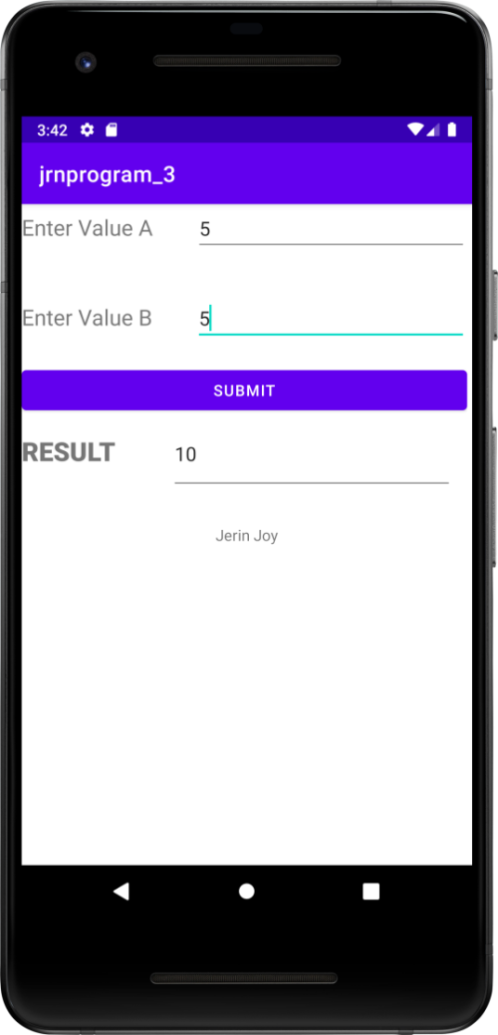

PROGRAM NO : 4
DATE : 20/09/2022

FORM VALIDATION

AIM:Implement validations on various UI controls

XML CODE

<?xml version="1.0" encoding="utf-8"?>
<androidx.constraintlayout.widget.ConstraintLayout xmlns:android="http://schemas.android.com/apk/res/android"
xmlns:app="http://schemas.android.com/apk/res-auto"
xmlns:tools="http://schemas.android.com/tools"
android:layout_width="match_parent"
android:layout_height="match_parent"
tools:context=".MainActivity">
<TextView
android:id="@+id/textView"
android:layout_width="wrap_content"
android:layout_height="wrap_content"
android:text="Hello World!"
app:layout_constraintBottom_toBottomOf="parent"
app:layout_constraintEnd_toEndOf="parent"
app:layout_constraintStart_toStartOf="parent"
app:layout_constraintTop_toTopOf="parent" />
<LinearLayout
android:id="@+id/pass"
android:layout_width="411dp"
android:layout_height="730dp"
android:background="#fafffa"
android:orientation="vertical"
android:textAlignment="center"
tools:layout_editor_absoluteX="0dp"
tools:layout_editor_absoluteY="-2dp">
<LinearLayout
android:layout_width="wrap_content"
android:layout_height="84dp"
android:orientation="vertical">
<TextView
android:id="@+id/textView2"
android:layout_width="408dp"
android:layout_height="match_parent"
android:background="#a5faa5"
android:text="Enter the Details of Registration"
android:textAlignment="center"
android:textColor="#151414"
android:textColorHighlight="#D51818"
android:textSize="26sp" />
</LinearLayout>
<LinearLayout
android:layout_width="match_parent"
android:layout_height="66dp"
android:orientation="horizontal">
<EditText
android:id="@+id/et_fname"
android:layout_width="192dp"
android:layout_height="58dp"
android:layout_weight="1"
android:ems="10"
android:hint="FIRST NAME"
android:inputType="textPersonName"
android:textSize="20sp" />
<EditText
android:id="@+id/et_lname"
android:layout_width="wrap_content"
android:layout_height="66dp"
android:layout_weight="1"
android:ems="10"
android:hint="LAST NAME"
android:inputType="textPersonName"
android:textSize="20sp" />
</LinearLayout>
<LinearLayout
android:layout_width="match_parent"
android:layout_height="65dp">
<RadioGroup
android:id="@+id/rg_gender"
android:orientation="horizontal"
android:layout_width="match_parent"
android:layout_height="wrap_content">
<RadioButton
android:id="@+id/r_male"
android:layout_width="wrap_content"
android:layout_height="wrap_content"
android:layout_weight="1"
android:text="MALE"
android:textColor="#121111"
android:textSize="20sp" />
<RadioButton
android:id="@+id/r_female"
android:layout_width="wrap_content"
android:layout_height="wrap_content"
android:layout_weight="1"
android:text="FEMALE"
android:textSize="20sp" />
<RadioButton
android:id="@+id/r_others"
android:layout_width="wrap_content"
android:layout_height="wrap_content"
android:layout_weight="1"
android:text="OTHERS"
android:textSize="20sp" />
</RadioGroup>
</LinearLayout>
<LinearLayout
android:layout_width="match_parent"
android:layout_height="67dp">
<EditText
android:id="@+id/et_dob"
android:layout_width="wrap_content"
android:layout_height="match_parent"
android:layout_weight="1"
android:ems="10"
android:hint="DATE OF BIRTH"
android:inputType="textPersonName"
android:textSize="20sp" />
<EditText
android:id="@+id/et_date"
android:layout_width="wrap_content"
android:layout_height="wrap_content"
android:layout_weight="1"
android:ems="10"
android:hint="dd/mm/yy"
android:inputType="date" />
</LinearLayout>
<LinearLayout
android:layout_width="match_parent"
android:layout_height="90dp"
android:orientation="vertical">
<EditText
android:id="@+id/et_mail"
android:layout_width="match_parent"
android:layout_height="wrap_content"
android:ems="10"
android:hint="Enter your E-Mail Id"
android:inputType="textPersonName"
android:textColor="#807D7D"
android:textSize="24sp" />
</LinearLayout>
<LinearLayout
android:layout_width="match_parent"
android:layout_height="wrap_content"
android:orientation="vertical">
<EditText
android:id="@+id/et_pass"
android:layout_width="match_parent"
android:layout_height="wrap_content"
android:ems="10"
android:hint="Enter Password"
android:inputType="textPassword"
android:textSize="24sp" />
</LinearLayout>
<LinearLayout
android:layout_width="match_parent"
android:layout_height="85dp"
android:orientation="vertical">
<CheckBox
android:id="@+id/checkBox"
android:layout_width="match_parent"
android:layout_height="75dp"
android:shadowColor="#AF1212"
android:text="Agree? Privacy Policy"
android:textColor="#F44336"
android:textSize="24sp" />
</LinearLayout>
<LinearLayout
android:layout_width="match_parent"
android:layout_height="76dp"
android:orientation="vertical">
<Button
android:id="@+id/b_register"
android:layout_width="183dp"
android:layout_height="67dp"
android:layout_gravity="center"
android:backgroundTint="#a5faa5"
android:onClick="submit"
android:text="REGISTER"
android:textAlignment="center"
android:textAllCaps="true"
android:textColor="#FA2B2B"
android:textSize="24sp" />
</LinearLayout>
</LinearLayout>
</androidx.constraintlayout.widget.ConstraintLayout>

JAVA CODE

package com.example.jrnregister;
import androidx.appcompat.app.AppCompatActivity;
import android.os.Bundle;
import android.provider.MediaStore;
import android.view.View;
import android.widget.Button;
import android.widget.CheckBox;
import android.widget.EditText;
import android.widget.RadioButton;
import android.widget.RadioGroup;
import android.widget.TextView;
import android.widget.Toast;
public class MainActivity extends AppCompatActivity {
EditText fname, lname, dob, mail, pass; //variables names to be used
Button button; // variables names to be used
Boolean isAllFieldsChecked;
RadioButton female, male, others;
RadioGroup gender;
CheckBox agree;
@Override
protected void onCreate(Bundle savedInstanceState) {
super.onCreate(savedInstanceState);
setContentView(R.layout.activity_main);
fname = findViewById(R.id.et_fname);
lname = findViewById(R.id.et_lname);
dob = findViewById(R.id.et_dob);
mail = findViewById(R.id.et_mail);
pass = findViewById(R.id.et_pass);
button = findViewById(R.id.b_register);
gender = findViewById(R.id.rg_gender);
male = findViewById(R.id.r_male);
female = findViewById(R.id.r_female);
others = findViewById(R.id.r_others);
agree = findViewById(R.id.checkBox);
}
public void submit(View view) {
isAllFieldsChecked = CheckAllFields();
if (isAllFieldsChecked) {
Toast.makeText(this, "Sucessfully", Toast.LENGTH_SHORT).show();
}
}
private Boolean CheckAllFields() {
if (fname.length() == 0) {
fname.setError("This field is required");
return false;
}
if (lname.length() == 0) {
lname.setError("This field is required");
return false;
}
if (dob.length() == 0) {
dob.setError("This field is required");
return false;
}
if(gender.getCheckedRadioButtonId()== -1) {
others.setError("Select Gender");
others.requestFocus();
return false;
}
if(!agree.isChecked())
{
agree.setError("Please agree");
agree.requestFocus();
return false;
}
if (mail.length() == 0) {
mail.setError(" Email is required");
return false;
}
else{
String smail=mail.getText().toString();
String checkmail="[a-zA-Z0-9._-]+@[a-z]+[.]+[a-z]+";
if(!smail.matches(checkmail))
{
mail.setError("Invalid Email");
return false;
}
}
if (pass.length() == 0) {
pass.setError("This field is required");
return false;
}
else if(pass.length()<8)
{
pass.setError("Password must be minimum 8 characters..");
return false;
}
return true;
}
}

OUTPUT

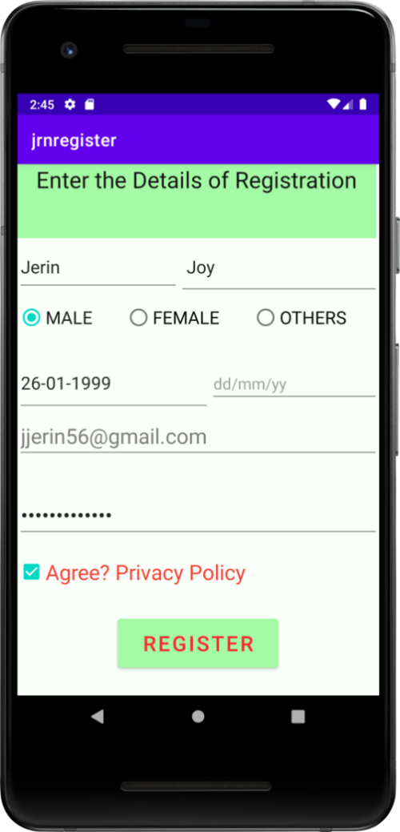

COURSE OUTCOME 2

PROGRAM NO : 5
DATE : 25/09/2022

INTENTS AND SHARED PREFERENCES

AIM: Design a registration activity and store registration details in local memory of phone
using Intents and SharedPreferences

XML CODE 1

<?xml version="1.0" encoding="utf-8"?>
<androidx.appcompat.widget.LinearLayoutCompat xmlns:android="http://schemas.android.com/apk/res/android"
xmlns:app="http://schemas.android.com/apk/res-auto"
xmlns:tools="http://schemas.android.com/tools"
android:layout_width="match_parent"
android:layout_height="match_parent"
tools:context=".MainActivity">
<LinearLayout
android:layout_width="match_parent"
android:layout_height="match_parent"
android:orientation="horizontal">
<LinearLayout
android:layout_width="match_parent"
android:layout_height="345dp"
android:orientation="vertical">
<TextView
android:id="@+id/textView3"
android:layout_width="match_parent"
android:layout_height="95dp"
android:text="\n...Enter the details..."
android:textAlignment="center"
android:textSize="24sp" />
<EditText
android:id="@+id/edt_name"
android:layout_width="match_parent"
android:layout_height="71dp"
android:ems="10"
android:hint="Name"
android:inputType="textPersonName" />
<EditText
android:id="@+id/edt_place"
android:layout_width="match_parent"
android:layout_height="64dp"
android:ems="10"
android:hint="Place"
android:inputType="textPersonName" />
<Button
android:id="@+id/button"
android:layout_width="match_parent"
android:layout_height="63dp"
android:onClick="show"
android:text="submit"
android:textSize="20sp" />
</LinearLayout>
</LinearLayout>
</androidx.appcompat.widget.LinearLayoutCompat>

JAVA CODE 1

package com.example.sharedpref;
import androidx.appcompat.app.AppCompatActivity;
import android.content.Intent;
import android.content.SharedPreferences;
import android.os.Bundle;
import android.view.View;
import android.widget.EditText;
public class MainActivity extends AppCompatActivity {
EditText edtname,edtplace;
SharedPreferences sp;
@Override
protected void onCreate(Bundle savedInstanceState) {
super.onCreate(savedInstanceState);
setContentView(R.layout.activity_main);
edtname=findViewById(R.id.edt_name);
edtplace=findViewById(R.id.edt_place);
sp = getSharedPreferences("SUBMIT",MODE_PRIVATE);
}
public void show(View view) {
Intent i = new Intent(MainActivity.this,MainActivity2.class);
SharedPreferences.Editor ed = sp.edit();
ed.putString("name",edtname.getText().toString());
ed.putString("place",edtplace.getText().toString());
ed.commit();
startActivity(i);
}
}

XML CODE 2

<?xml version="1.0" encoding="utf-8"?>
<androidx.appcompat.widget.LinearLayoutCompat xmlns:android="http://schemas.android.com/apk/res/android"
xmlns:app="http://schemas.android.com/apk/res-auto"
xmlns:tools="http://schemas.android.com/tools"
android:layout_width="match_parent"
android:layout_height="match_parent"
tools:context=".MainActivity2">
<LinearLayout
android:layout_width="match_parent"
android:layout_height="345dp"
android:orientation="vertical">
<TextView
android:id="@+id/txt1"
android:layout_width="match_parent"
android:layout_height="78dp"
android:background="#FDE8E8"
android:textSize="20sp" />
<TextView
android:id="@+id/txt2"
android:layout_width="match_parent"
android:layout_height="85dp"
android:background="#D4E8F8"
android:textSize="20sp" />
</LinearLayout>
</androidx.appcompat.widget.LinearLayoutCompat>

JAVA CODE 2

package com.example.sharedpref;
import androidx.appcompat.app.AppCompatActivity;
import android.content.SharedPreferences;
import android.os.Bundle;
import android.widget.TextView;
public class MainActivity2 extends AppCompatActivity {
TextView txt_1,txt_2;
SharedPreferences sp;
@Override
protected void onCreate(Bundle savedInstanceState) {
super.onCreate(savedInstanceState);
setContentView(R.layout.activity_main2);
txt_1 = findViewById(R.id.txt1);
txt_2 = findViewById(R.id.txt2);
sp = getSharedPreferences("SUBMIT",MODE_PRIVATE);
String s1 = sp.getString("name","Ganga");
String s2 = sp.getString("place","Kumbalam");
txt_1.setText("Name : "+s1+"");
txt_2.setText("Place : "+s2+"");
}
}

OUTPUT

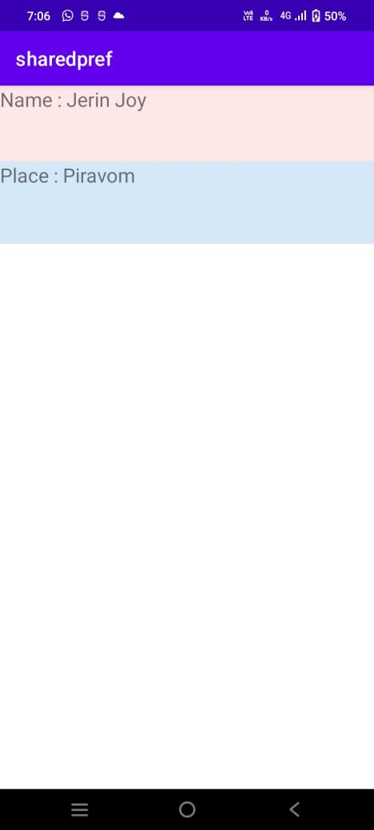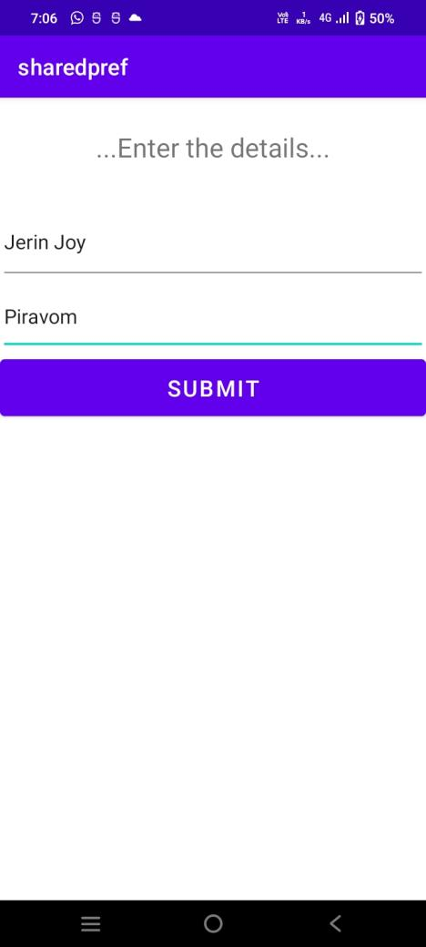

PROGRAM NO : 6
DATE : 30/09/2022

GRID CACULATOR

AIM:Design a simple Calculator using GridLayout and Cascaded LinearLayout

XML CODE

<?xml version="1.0" encoding="utf-8"?>
<LinearLayout xmlns:android="http://schemas.android.com/apk/res/android"
xmlns:app="http://schemas.android.com/apk/res-auto"
xmlns:tools="http://schemas.android.com/tools"
android:layout_width="match_parent"
android:layout_height="match_parent"
android:orientation="vertical"
tools:context=".MainActivity">
<LinearLayout
android:layout_width="411dp"
android:layout_height="143dp"
android:orientation="vertical"
tools:layout_editor_absoluteX="2dp"
tools:layout_editor_absoluteY="-2dp">
<EditText
android:id="@+id/et_display"
android:layout_width="match_parent"
android:layout_height="wrap_content"
android:ems="10"
android:hint="Enter Value"
android:inputType="textPersonName"
android:textSize="34sp" />
</LinearLayout>
<androidx.gridlayout.widget.GridLayout
android:layout_width="match_parent"
android:layout_height="match_parent"
android:layout_marginStart="39dp"
app:layout_constraintStart_toStartOf="parent"
tools:layout_editor_absoluteY="297dp">
<Button
android:id="@+id/b_7"
android:layout_width="75dp"
android:layout_height="78dp"
android:text="7"
android:textSize="34sp"
app:layout_column="0"
app:layout_row="0" />
<Button
android:id="@+id/b_total"
android:layout_width="82dp"
android:layout_height="87dp"
android:text="="
android:textSize="34sp"
app:layout_column="3"
app:layout_row="3" />
<Button
android:id="@+id/b_4"
android:layout_width="82dp"
android:layout_height="87dp"
android:text="4"
android:textSize="34sp"
app:layout_column="0"
app:layout_row="1" />
<Button
android:id="@+id/b_5"
android:layout_width="82dp"
android:layout_height="87dp"
android:text="5"
android:textSize="34sp"
app:layout_column="1"
app:layout_row="1" />
<Button
android:id="@+id/b_mul"
android:layout_width="82dp"
android:layout_height="87dp"
android:text="*"
android:textSize="34sp"
app:layout_column="3"
app:layout_row="0" />
<Button
android:id="@+id/b_9"
android:layout_width="82dp"
android:layout_height="87dp"
android:text="9"
android:textSize="34sp"
app:layout_column="2"
app:layout_row="0" />
<Button
android:id="@+id/b_8"
android:layout_width="82dp"
android:layout_height="87dp"
android:text="8"
android:textSize="34sp"
app:layout_column="1"
app:layout_row="0" />
<Button
android:id="@+id/b_6"
android:layout_width="82dp"
android:layout_height="87dp"
android:text="6"
android:textSize="34sp"
app:layout_column="2"
app:layout_row="1" />
<Button
android:id="@+id/b_sub"
android:layout_width="82dp"
android:layout_height="87dp"
android:text="-"
android:textSize="34sp"
app:layout_column="3"
app:layout_row="1" />
<Button
android:id="@+id/b_1"
android:layout_width="82dp"
android:layout_height="87dp"
android:text="1"
android:textSize="34sp"
app:layout_column="0"
app:layout_row="2" />
<Button
android:id="@+id/b_clear"
android:layout_width="82dp"
android:layout_height="87dp"
android:text="AC"
android:textSize="26sp"
app:layout_column="0"
app:layout_row="3" />
<Button
android:id="@+id/b_2"
android:layout_width="82dp"
android:layout_height="87dp"
android:text="2"
android:textSize="34sp"
app:layout_column="1"
app:layout_row="2" />
<Button
android:id="@+id/b_3"
android:layout_width="82dp"
android:layout_height="87dp"
android:text="3"
android:textSize="34sp"
app:layout_column="2"
app:layout_row="2" />
<Button
android:id="@+id/b_sum"
android:layout_width="82dp"
android:layout_height="87dp"
android:text="+"
android:textSize="34sp"
app:layout_column="3"
app:layout_row="2" />
<Button
android:id="@+id/b_div"
android:layout_width="82dp"
android:layout_height="87dp"
android:text="/"
android:textSize="34sp"
app:layout_column="2"
app:layout_row="3" />
<Button
android:id="@+id/b_0"
android:layout_width="82dp"
android:layout_height="87dp"
android:text="0"
android:textSize="34sp"
app:layout_column="1"
app:layout_row="3" />
</androidx.gridlayout.widget.GridLayout>
</LinearLayout>

JAVA CODE

package com.example.jrn_calculator;
import androidx.appcompat.app.AppCompatActivity;
import android.os.Bundle;
import android.view.View;
import android.widget.Button;
import android.widget.EditText;
import android.widget.TextView;
public class MainActivity extends AppCompatActivity implements View.OnClickListener {
EditText number;
double num1=0;
double num2=0;
String opt="";
Button b1,b2,b3,b4,b5,b6,b7,b8,b9,b0,mul,sum,sub,div,clear,total;
@Override
protected void onCreate(Bundle savedInstanceState) {
super.onCreate(savedInstanceState);
setContentView(R.layout.activity_main);
number = findViewById(R.id.et_display);
b1 = findViewById(R.id.b_1);
b2 = findViewById(R.id.b_2);
b3 = findViewById(R.id.b_3);
b4 = findViewById(R.id.b_4);
b5 = findViewById(R.id.b_5);
b6 = findViewById(R.id.b_6);
b7 = findViewById(R.id.b_7);
b8 = findViewById(R.id.b_8);
b9 = findViewById(R.id.b_9);
b0 = findViewById(R.id.b_0);
mul = findViewById(R.id.b_mul);
sum = findViewById(R.id.b_sum);
sub = findViewById(R.id.b_sub);
div = findViewById(R.id.b_div);
clear = findViewById(R.id.b_clear);
total = findViewById(R.id.b_total);
b1.setOnClickListener(this);
b2.setOnClickListener(this);
b3.setOnClickListener(this);
b4.setOnClickListener(this);
b5.setOnClickListener(this);
b6.setOnClickListener(this);
b7.setOnClickListener(this);
b8.setOnClickListener(this);
b9.setOnClickListener(this);
b0.setOnClickListener(this);
mul.setOnClickListener(this);
sum.setOnClickListener(this);
sub.setOnClickListener(this);
div.setOnClickListener(this);
clear.setOnClickListener(this);
total.setOnClickListener(this);
}
@Override
public void onClick(View view) {
Button b=(Button) view;
if(view==clear)
{
number.setText("");
}
else if(view==sub||view==sum||view==mul||view==div )
{
num1=Integer.parseInt(number.getText().toString());
opt=b.getText().toString();
number.setText("");
}
else if(view==total)
{
num2= Integer.parseInt(number.getText().toString());
if(opt.equals("+"))
{
number.setText(num1+num2+"");
}
else if(opt.equals("-"))
{
number.setText(num1-num2+"");
}
else if(opt.equals("*"))
{
number.setText(num1*num2+"");
}
else if(opt.equals("/"))
{
number.setText(num1/num2+"");
}
}
else
{
String s=number.getText().toString();
number.setText(s+b.getText().toString());
}
}
}

OUTPUT

PROGRAM NO : 7
DATE : 05/10/2022

FACEBOOK PAGE

AIM:Create a Facebook page using RelativeLayout; set properties using .xml file

XML CODE

<?xml version="1.0" encoding="utf-8"?>
<RelativeLayout xmlns:android="http://schemas.android.com/apk/res/android"
xmlns:app="http://schemas.android.com/apk/res-auto"
xmlns:tools="http://schemas.android.com/tools"
android:layout_width="match_parent"
android:layout_height="match_parent"
tools:context=".MainActivity">
<ImageView
android:id="@+id/image"
android:layout_width="match_parent"
android:layout_height="147dp"
android:layout_marginTop="70dp"
android:src="@drawable/facebook"/>
<EditText
android:id="@+id/name"
android:layout_width="360dp"
android:layout_height="60dp"
android:layout_alignBottom="@id/image"
android:layout_marginLeft="20dp"
android:layout_marginBottom="-100dp"
android:background="#deedfa"
android:ems="10"
android:hint="Username or email"
android:inputType="textPersonName"
android:minHeight="48dp" />
<EditText
android:id="@+id/pass"
android:layout_width="360dp"
android:layout_height="60dp"
android:layout_alignBottom="@id/name"
android:layout_marginLeft="20dp"
android:layout_marginBottom="-100dp"
android:background="#deedfa"
android:ems="10"
android:hint="Password"
android:inputType="textPersonName" />
<Button
android:id="@+id/login"
android:layout_width="360dp"
android:layout_height="60dp"
android:layout_alignBottom="@id/pass"
android:layout_marginLeft="20dp"
android:layout_marginBottom="-100dp"
android:backgroundTint="#167ad9"
android:text="LOGIN"
android:textColor="@color/white"
android:textSize="20sp" />
<TextView
android:id="@+id/signup"
android:layout_width="360dp"
android:layout_height="60dp"
android:layout_alignBottom="@id/login"
android:layout_marginLeft="20dp"
android:layout_marginBottom="-70dp"
android:text="Signup"
android:textAlignment="center"
android:textSize="20sp" />
</RelativeLayout>

JAVA CODE

package com.example.relative;
import androidx.appcompat.app.AppCompatActivity;
import android.os.Bundle;
public class MainActivity extends AppCompatActivity {
@Override
protected void onCreate(Bundle savedInstanceState) {
super.onCreate(savedInstanceState);
setContentView(R.layout.activity_main);
}
}

OUTPUT

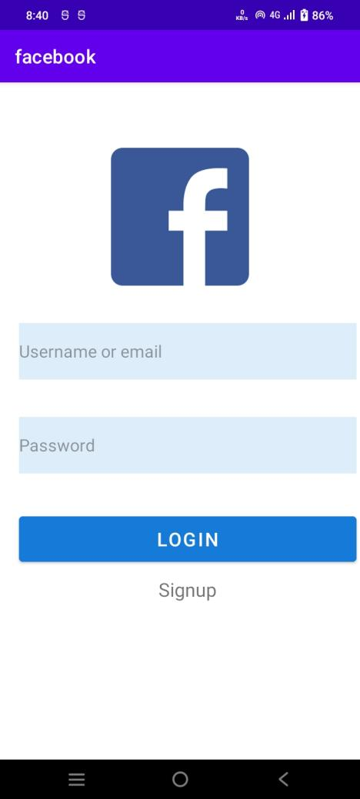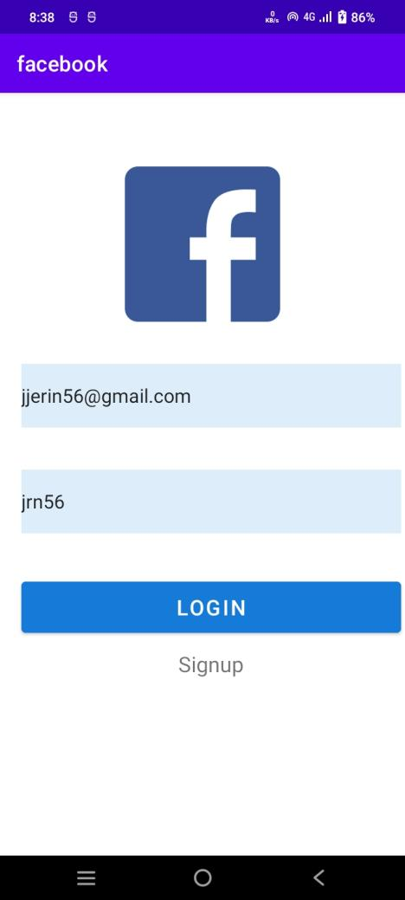

PROGRAM NO : 8
DATE : 20/10/2022

TOGGLE IMAGE

AIM:Develop an application that toggles image using FrameLayout

XML CODE

<?xml version="1.0" encoding="utf-8"?>
<FrameLayout
xmlns:android="http://schemas.android.com/apk/res/android"
xmlns:tools="http://schemas.android.com/tools"
xmlns:app="http://schemas.android.com/apk/res-auto"
android:layout_width="match_parent"
android:layout_height="match_parent"
tools:context=".MainActivity">
<LinearLayout
android:layout_width="match_parent"
android:layout_height="match_parent"
android:orientation="horizontal">
<LinearLayout
android:layout_width="match_parent"
android:layout_height="match_parent"
android:layout_weight="1"
android:orientation="vertical">
<TextView
android:id="@+id/textView"
android:layout_width="400dp"
android:layout_height="64dp"
android:text="Click on any one of the images"
android:textSize="24sp" />
<ImageView
android:id="@+id/img_1"
android:layout_width="match_parent"
android:layout_height="wrap_content"
app:srcCompat="@android:drawable/alert_dark_frame" />
<ImageView
android:id="@+id/img_2"
android:layout_width="match_parent"
android:layout_height="wrap_content"
app:srcCompat="@android:drawable/alert_light_frame" />
</LinearLayout>
</LinearLayout>
</FrameLayout>

JAVA CODE

package com.example.framelayout;
import androidx.appcompat.app.AppCompatActivity;
import android.os.Bundle;
import android.view.View;
import android.widget.ImageView;
public class MainActivity extends AppCompatActivity implements View.OnClickListener {
ImageView img1,img2;
@Override
protected void onCreate(Bundle savedInstanceState) {
super.onCreate(savedInstanceState);
setContentView(R.layout.activity_main);
img1 = (ImageView) findViewById(R.id.img_1);
img2 = (ImageView) findViewById(R.id.img_2);
img1.setOnClickListener(this);
img2.setOnClickListener(this);
}
@Override
public void onClick(View v) {
if (v==img1)
{
img1.setVisibility(View.GONE);
img2.setVisibility(View.VISIBLE);
}
else
{
img2.setVisibility(View.GONE);
img1.setVisibility(View.VISIBLE);
}
}
}

OUTPUT

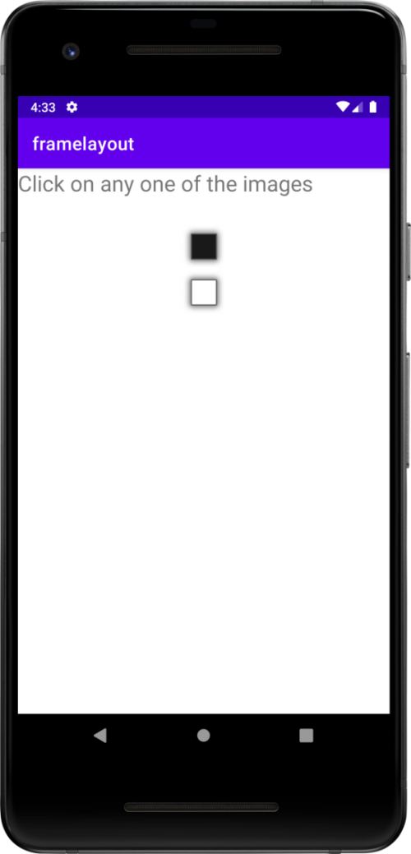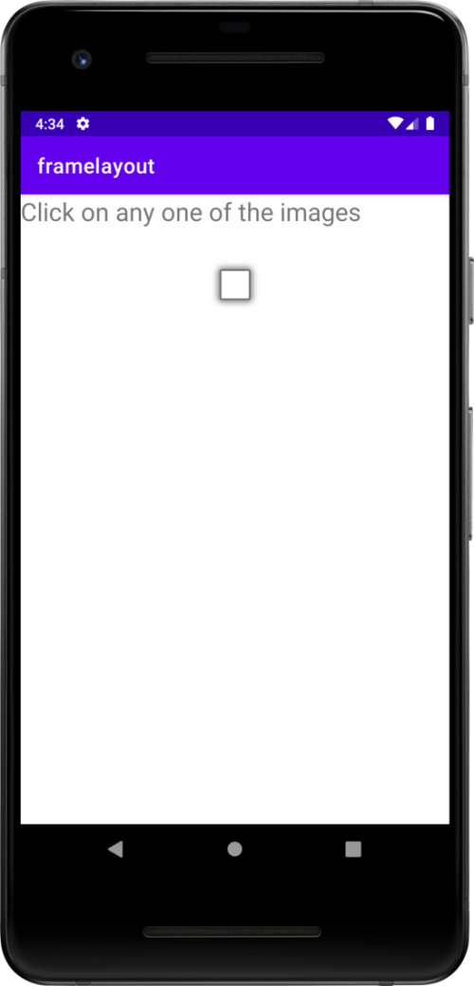

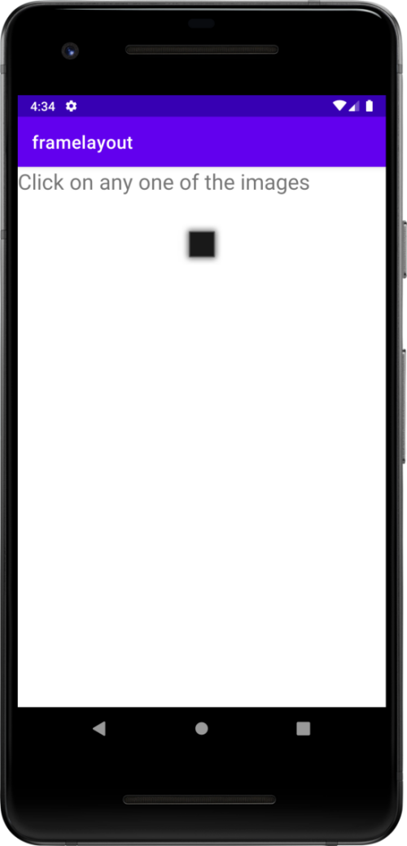

COURSE OUTCOME 3

PROGRAM NO : 9
DATE : 30/10/2022

INTENTS

AIM:Implement Intent to navigate between multiple activities

XML CODE 1

<?xml version="1.0" encoding="utf-8"?>
<androidx.constraintlayout.widget.ConstraintLayout xmlns:android="http://schemas.android.com/apk/res/android"
xmlns:app="http://schemas.android.com/apk/res-auto"
xmlns:tools="http://schemas.android.com/tools"
android:layout_width="match_parent"
android:layout_height="match_parent"
tools:context=".MainActivity">
<LinearLayout
android:layout_width="397dp"
android:layout_height="398dp"
android:layout_weight="1"
android:orientation="vertical"
tools:layout_editor_absoluteX="7dp"
tools:layout_editor_absoluteY="16dp">
<EditText
android:id="@+id/et_fname"
android:layout_width="344dp"
android:layout_height="wrap_content"
android:layout_weight="1"
android:ems="10"
android:hint="Enter your First Name"
android:inputType="textPersonName" />
<EditText
android:id="@+id/et_lname"
android:layout_width="321dp"
android:layout_height="61dp"
android:layout_weight="1"
android:ems="10"
android:hint="Enter your Last Name"
android:inputType="textPersonName" />
<Button
android:id="@+id/b_1"
android:layout_width="245dp"
android:layout_height="25dp"
android:layout_weight="1"
android:onClick="submit"
android:text="Button" />
<TextView
android:layout_width="wrap_content"
android:layout_height="wrap_content"
android:text="Hello World!" />
</LinearLayout>
</androidx.constraintlayout.widget.ConstraintLayout>

JAVA CODE 1

package com.example.jrnprogram_co2sample;
import androidx.appcompat.app.AppCompatActivity;
import android.content.Intent;
import android.os.Bundle;
import android.view.View;
import android.widget.Button;
import android.widget.EditText;
public class MainActivity extends AppCompatActivity {
EditText fname, lname;
Button submit;
@Override
protected void onCreate(Bundle savedInstanceState) {
super.onCreate(savedInstanceState);
setContentView(R.layout.activity_main);
fname = findViewById(R.id.et_fname);
lname =findViewById(R.id.et_lname);
}
public void submit(View view) {
Intent i =new Intent(MainActivity.this,MainActivity2.class);
String st1 =fname.getText().toString();
String st2 =lname.getText().toString();
// i.putExtra("Name",st);
Bundle b1 =new Bundle();
b1.putString("fname",st1);
b1.putString("lname",st2);
i.putExtras(b1);
startActivity(i);
}
}

XML CODE 2

<?xml version="1.0" encoding="utf-8"?>
<LinearLayout xmlns:android="http://schemas.android.com/apk/res/android"
xmlns:app="http://schemas.android.com/apk/res-auto"
xmlns:tools="http://schemas.android.com/tools"
android:layout_width="match_parent"
android:layout_height="match_parent"
android:orientation="vertical"
tools:context=".MainActivity2">
<LinearLayout
android:layout_width="410dp"
android:layout_height="72dp"
tools:layout_editor_absoluteX="1dp"
tools:layout_editor_absoluteY="1dp">
<TextView
android:id="@+id/textView1"
android:layout_width="wrap_content"
android:layout_height="wrap_content"
android:layout_weight="1"
android:text="First Name"
android:textSize="24sp" />
<EditText
android:id="@+id/et_name1"
android:layout_width="wrap_content"
android:layout_height="wrap_content"
android:layout_weight="1"
android:ems="10"
android:inputType="textPersonName" />
</LinearLayout>
<LinearLayout
android:layout_width="match_parent"
android:layout_height="match_parent"
android:layout_weight="1"
android:orientation="horizontal">
<TextView
android:id="@+id/textView"
android:layout_width="wrap_content"
android:layout_height="wrap_content"
android:layout_weight="1"
android:text="Last Name"
android:textSize="24sp" />
<EditText
android:id="@+id/et_name2"
android:layout_width="wrap_content"
android:layout_height="wrap_content"
android:layout_weight="1"
android:ems="10"
android:inputType="textPersonName" />
</LinearLayout>
</LinearLayout>

JAVA CODE 2

package com.example.jrnprogram_co2sample;
import androidx.appcompat.app.AppCompatActivity;
import android.os.Bundle;
import android.widget.EditText;
import android.widget.Toast;
public class MainActivity2 extends AppCompatActivity {
EditText name1,name2;
@Override
protected void onCreate(Bundle savedInstanceState) {
super.onCreate(savedInstanceState);
setContentView(R.layout.activity_main2);
name1=findViewById(R.id.et_name1);
name2=findViewById(R.id.et_name2);
//Intent i = getIntent();
//String st = i.getStringExtra("name");
Bundle b1=getIntent().getExtras();
String s1=b1.getString("fname");
String s2=b1.getString("lname");
name1.setText(s1+"");
name2.setText(s2+"");
Toast.makeText(this, "hello jerin", Toast.LENGTH_SHORT).show();
}
}

OUTPUT:

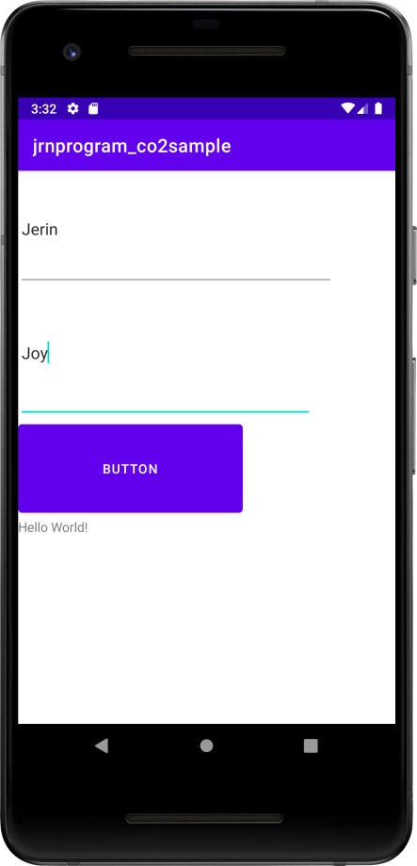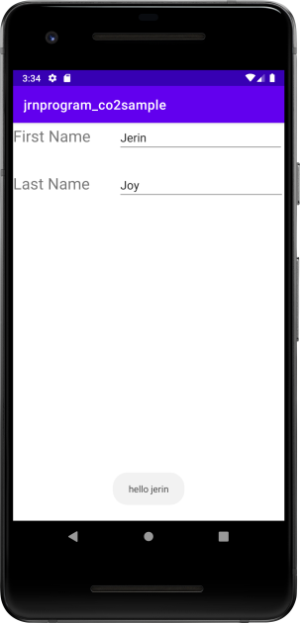

PROGRAM NO : 10
DATE : 10/11/2022

MENU

AIM:Implement Options Menu to navigate to activities

XMLCODE

<?xml version="1.0" encoding="utf-8"?>
<androidx.constraintlayout.widget.ConstraintLayout xmlns:android="http://schemas.android.com/apk/res/android"
xmlns:app="http://schemas.android.com/apk/res-auto"
xmlns:tools="http://schemas.android.com/tools"
android:layout_width="match_parent"
android:layout_height="match_parent"
tools:context=".MainActivity">
<TextView
android:id="@+id/textView"
android:layout_width="417dp"
android:layout_height="132dp"
android:fontFamily="@font/aguafina_script"
android:text="Welcome"
android:textAlignment="center"
android:textColor="#e86fe4"
android:textSize="96sp"
android:textStyle="bold"
tools:layout_editor_absoluteX="1dp"
tools:layout_editor_absoluteY="2dp" />
</androidx.constraintlayout.widget.ConstraintLayout>

JAVA CODE

package com.example.optionsmenu;
import androidx.annotation.NonNull;
import androidx.appcompat.app.AppCompatActivity;
import android.os.Bundle;
import android.view.Menu;
import android.view.MenuInflater;
import android.view.MenuItem;
import android.widget.Toast;
public class MainActivity extends AppCompatActivity {
@Override
protected void onCreate(Bundle savedInstanceState) {
super.onCreate(savedInstanceState);
setContentView(R.layout.activity_main);
}
@Override
public boolean onCreateOptionsMenu(Menu menu) {
MenuInflater inflater=getMenuInflater();
inflater.inflate(R.menu.samplemenu,menu);
return true;
}
@Override
public boolean onOptionsItemSelected(@NonNull MenuItem item) {
switch (item.getItemId()){
case R.id.icar:
Toast.makeText(this,"Welcome to site..have a look on the cars of your interest",Toast.LENGTH_LONG).show();
break;
case R.id.ibike:
Toast.makeText(this, "Welcome to site..have a look on the bikes of your interest", Toast.LENGTH_SHORT).show();
break;
case R.id.i2:
Toast.makeText(this, "Welcome to the page.Know more about institutions", Toast.LENGTH_SHORT).show();
break;
}
return true;
}
}

SAMPLEMENU.XML

<?xml version="1.0" encoding="utf-8"?>
<menu xmlns:app="http://schemas.android.com/apk/res-auto"
xmlns:android="http://schemas.android.com/apk/res/android">
<item
android:id="@+id/i1"
android:title="Vehicles">
<menu>
<item
android:id="@+id/ibike"
android:title="Bikes" />
<item
android:id="@+id/icar"
android:title="Cars" />
</menu>
</item>
<item
android:id="@+id/i2"
android:title="Institutions" />
</menu>

OUTPUT

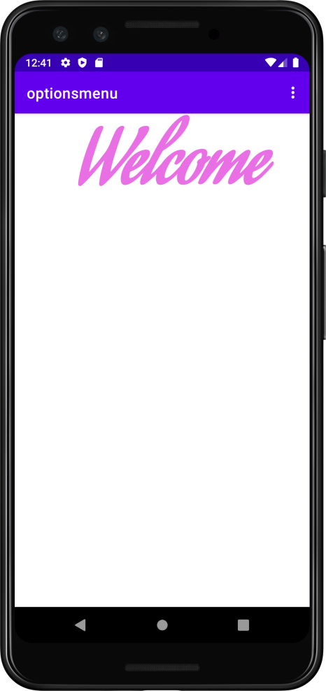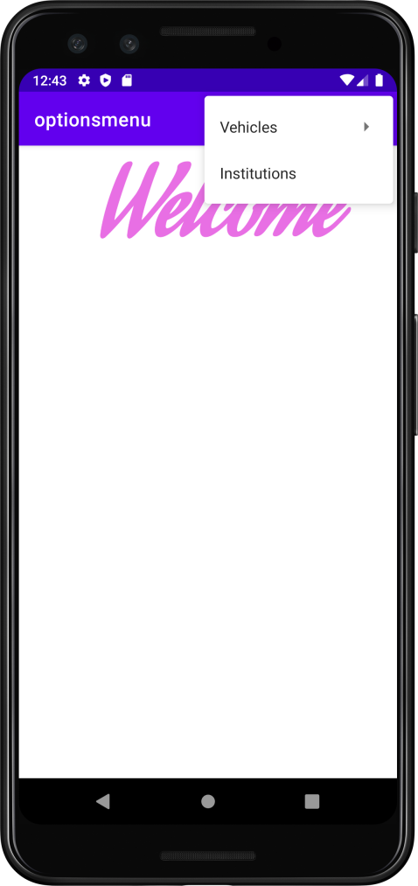

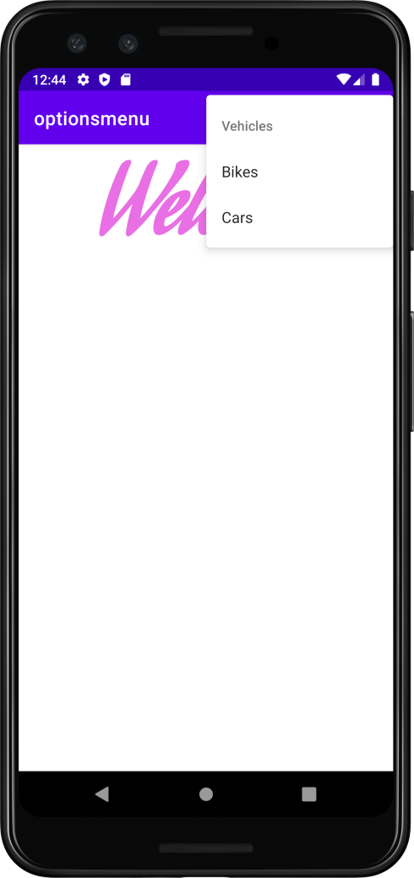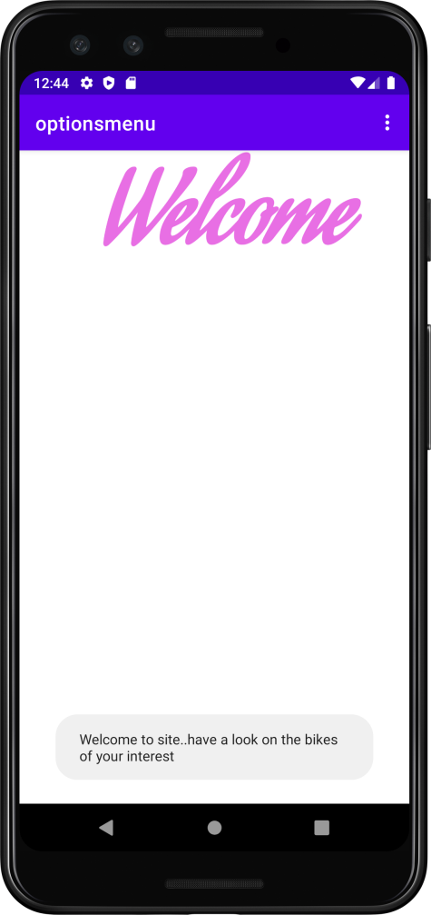

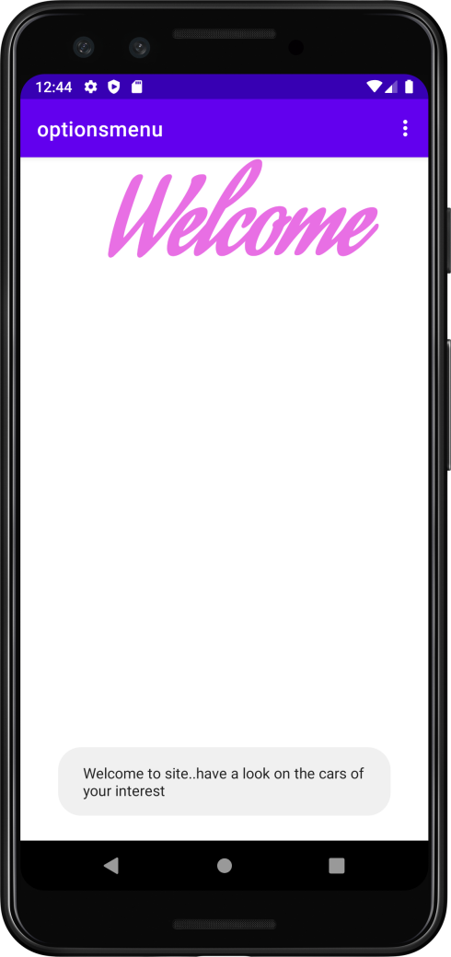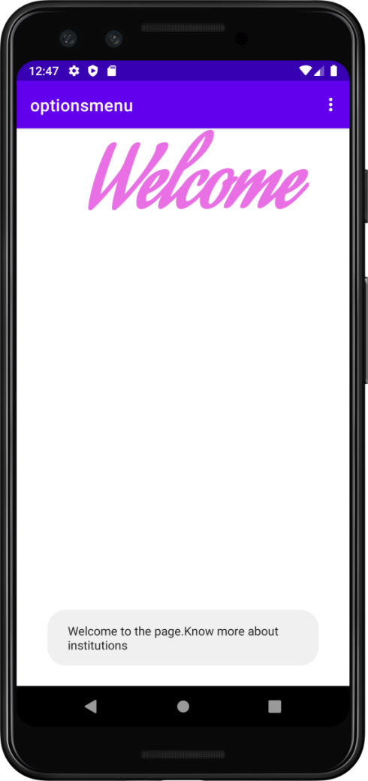

COURSE OUTCOME 5

PROGRAM NO : 11
DATE : 20/11/2022

DATABASE MANAGEMENT

AIM:Create database using SQLite and perform INSERT , SELECT , UPDATE and
DELETE on SQLite database

XML CODE

<?xml version="1.0" encoding="utf-8"?>
<androidx.constraintlayout.widget.ConstraintLayout xmlns:android="http://schemas.android.com/apk/res/android"
xmlns:app="http://schemas.android.com/apk/res-auto"
xmlns:tools="http://schemas.android.com/tools"
android:layout_width="match_parent"
android:layout_height="match_parent"
android:background="#fce8fa"
tools:context=".MainActivity">
<LinearLayout
android:layout_width="409dp"
android:layout_height="729dp"
android:orientation="vertical"
tools:layout_editor_absoluteX="1dp"
tools:layout_editor_absoluteY="1dp">
<TextView
android:id="@+id/textView"
android:layout_width="match_parent"
android:layout_height="42dp"
android:layout_marginTop="15dp"
android:layout_marginBottom="10dp"
android:background="#f7c1f1"
android:fontFamily="@font/alegreya_sc"
android:text="DATABASE MANAGEMENT"
android:textAlignment="center"
android:textColor="#4f0346"
android:textSize="26sp"
android:textStyle="bold" />
<EditText
android:id="@+id/e_id"
android:layout_width="match_parent"
android:layout_height="60dp"
android:ems="10"
android:hint="ID"
android:textColor="#501652"
android:textColorHint="#0b034f"
android:layout_marginBottom="10dp"
android:inputType="textPersonName" />
<EditText
android:id="@+id/e_name"
android:layout_width="420dp"
android:layout_height="60dp"
android:ems="10"
android:textColorHint="#0b034f"
android:textColor="#501652"
android:hint="Name"
android:layout_marginBottom="10dp"
android:inputType="textPersonName" />
<EditText
android:id="@+id/e_place"
android:layout_width="match_parent"
android:layout_height="60dp"
android:ems="10"
android:hint="Place"
android:textColorHint="#0b034f"
android:textColor="#501652"
android:layout_marginBottom="15dp"
android:inputType="textPersonName" />
<Button
android:id="@+id/b_insert"
android:layout_width="match_parent"
android:layout_height="wrap_content"
android:layout_marginBottom="10dp"
android:backgroundTint="#f78deb"
android:text="insert" />
<Button
android:id="@+id/b_select"
android:layout_marginBottom="10dp"
android:layout_width="match_parent"
android:layout_height="wrap_content"
android:text="select" />
<Button
android:id="@+id/b_update"
android:layout_width="match_parent"
android:layout_height="wrap_content"
android:layout_marginBottom="10dp"
android:backgroundTint="#f78deb"
android:text="update" />
<Button
android:id="@+id/b_delete"
android:layout_width="match_parent"
android:layout_height="wrap_content"
android:layout_marginBottom="10dp"
android:text="delete" />
<Button
android:id="@+id/b_clear"
android:layout_width="match_parent"
android:layout_height="wrap_content"
android:backgroundTint="#f78deb"
android:text="clear" />
</LinearLayout>
</androidx.constraintlayout.widget.ConstraintLayout>

JAVA CODE

package com.example.database;
import androidx.appcompat.app.AlertDialog;
import androidx.appcompat.app.AppCompatActivity;
import android.database.Cursor;
import android.database.sqlite.SQLiteDatabase;
import android.os.Bundle;
import android.view.View;
import android.widget.Button;
import android.widget.EditText;
import android.widget.Toast;
public class MainActivity extends AppCompatActivity {
EditText id,name,place;
Button binsert,bselect,bupdate,bdelete,bclear;
AlertDialog.Builder builder;
SQLiteDatabase db;
@Override
protected void onCreate(Bundle savedInstanceState) {
super.onCreate(savedInstanceState);
setContentView(R.layout.activity_main);
id = (EditText)findViewById(R.id.e_id);
name = (EditText)findViewById(R.id.e_name);
place = (EditText)findViewById(R.id.e_place);
binsert = (Button)findViewById(R.id.b_insert);
bselect = (Button)findViewById(R.id.b_select);
bupdate = (Button)findViewById(R.id.b_update);
bdelete = (Button)findViewById(R.id.b_delete);
bclear = (Button)findViewById(R.id.b_clear);
builder = new AlertDialog.Builder(this);
try {
db = openOrCreateDatabase("empdb",MODE_PRIVATE,null);
db.execSQL("Create table employee(id integer primary key,name Text,place Text)");
Toast.makeText(getApplicationContext(), "Table created successfully", Toast.LENGTH_SHORT).show();
}
catch(Exception e)
{
}
binsert.setOnClickListener(new View.OnClickListener() {
@Override
public void onClick(View view) {
try {
db.execSQL("Insert into employee values ("+id.getText().toString()+",'"+name.getText().toString()+"','"+place.getText().toString()+"')");
Toast.makeText(getApplicationContext(), "Record inserted successfully", Toast.LENGTH_SHORT).show();
}
catch(Exception e)
{
Toast.makeText(getApplicationContext(), "Error found in the data", Toast.LENGTH_SHORT).show();
}
}
});
bclear.callOnClick();
bselect.setOnClickListener(new View.OnClickListener() {
@Override
public void onClick(View view) {
Cursor c = db.rawQuery("select * from employee",null);
if(c.getCount()==0)
{
Toast.makeText(getApplicationContext(), "No such record found", Toast.LENGTH_SHORT).show();
}
else
{
StringBuffer b = new StringBuffer();
while(c.moveToNext())
{
b.append("Id:"+ c.getString(0)+"\n");
b.append("Name:"+ c.getString(1)+"\n");
b.append("Place:"+ c.getString(2)+"\n");
Toast.makeText(getApplicationContext(), b.toString(), Toast.LENGTH_SHORT).show();
builder.setMessage(b.toString());
AlertDialog alert = builder.create();
alert.setTitle("Employee Data");
alert.show();
}
}
}
});
bupdate.setOnClickListener(new View.OnClickListener() {
@Override
public void onClick(View view) {
db.execSQL("update employee set name='"+name.getText().toString()+"',place='"+place.getText().toString()+"' where id="+id.getText().toString()+"");
Toast.makeText(getApplicationContext(), "updated....", Toast.LENGTH_SHORT).show();
}
});
bdelete.setOnClickListener(new View.OnClickListener() {
@Override
public void onClick(View view) {
db.execSQL("delete from employee where id="+id.getText().toString());
Toast.makeText(getApplicationContext(), "Item Deleted", Toast.LENGTH_SHORT).show();
}
});
bclear.setOnClickListener(new View.OnClickListener() {
@Override
public void onClick(View view) {
id.setText("");
name.setText("");
place.setText("");
}
});
bclear.callOnClick();
}
}

OUTPUT

