**CO1**

**# 1. Familiarizing Text Editor, IDE, Code Analysis Tools etc. // Use any IDE**

IT is a Graphical User Interface (GUI) where programmers write their code and produce the final products.

An IDE basically unifies all essential tools required for software development and testing, which in turn helps the programming maximize his output.

* Feautres of IDE:-

1. Code Editor
2. Syntax Highlighting
3. Auto completion code
4. Debugger
5. Compiler
6. Language Support

IDLE is Python’s Integrated Development and Learning Environment.

IDLE has the following features:

* coded in 100% pure Python, using the [tkinter](https://docs.python.org/3/library/tkinter.html" \l "module-tkinter" \t "_blank" \o "tkinter: Interface to Tcl/Tk for graphical user interfaces) GUI toolkit.
* cross-platform: works mostly the same on Windows, Unix, and macOS.
* Python shell window (interactive interpreter) with colorizing of code input, output, and error messages.
* multi-window text editor with multiple undo, Python colorizing, smart indent, call tips, auto completion, and other features.
* search within any window, replace within editor windows, and search through multiple files (grep).
* debugger with persistent breakpoints, stepping, and viewing of global and local namespaces.
* configuration, browsers, and other dialogs.

-------------------------------------------------------------------------------------

**# 2. WAP to find leap year.**

years=int(input("Enter the year: "))

yeare=int(input("Enter the year: "))

if(years<yeare):

print("THE LEAP YEARS ARE: ")

for i in range(years,yeare):

if(i%4==0 and i%100!=0 or i%400==0 ):

print(i)

**OUTPUT**

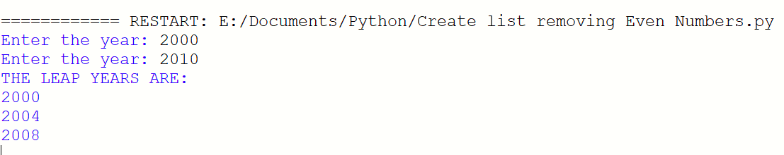

-------------------------------------------------------------------------------------

**# 3.1. Generate positive list of numbers from a given list of integers**

list1=[-465,54,-7,5,5,]

result=[number for number in list1 if number>=0]

print("3.1. The result is: ", result)

print()

**# 3.2. Square of N number**

n=int(input("3.2. Enter the limit: "))

square=[i\*\*2 for i in range(1,n+1)]

print(" The result is: ", square)

print()

**# 3.3. Form a list of vowels selected from a given word**

n=str(input("3.3. Enter the word: "))

print(" The word is: "+n)

print(" The vowel are: " ,end=" ")

for i in n:

if i in 'aeiouAEIOU':

print([i],end=" ")

print(" \n The remaining letters are: ",end=" ")

for j in n:

if j not in 'aeiouAEIOU':

print([j],end=" ")

print()

print()

**# 3.4. List ordinal value of each element of a word (Hint: use ord() to get ordinal**

**values)**

n=str(input("3.4. Enter any Letter: "))

print(" The Ordinal value of Letter " +n ,":",end=" ")

for i in n:

print(ord(i),end=" ")

**OUTPUT**

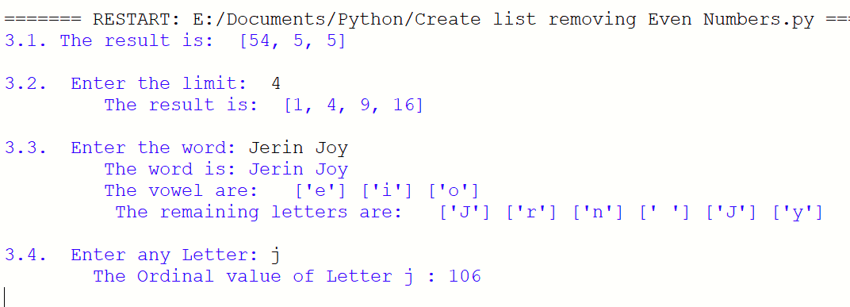

-------------------------------------------------------------------------------------

**# 4. Count the occurrences of each word in a line of text.**

str1=input("Enter any sentence: ")

wordlist=str1.split()

count= []

for i in wordlist: count.append(wordlist.count(i))

print("count of the occurrence:" + str(list(zip(wordlist, count))))

**OUTPUT**

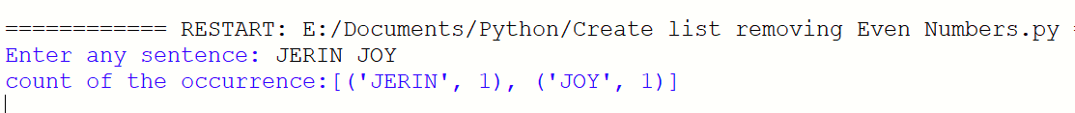

------------------------------------------------------------------------------------

**# 5. Prompt the user for a list of integers. For all values greater than 100, store**

**‘over’ instead**

n=[]

s=int(input("Enter a limit: "))

print("Enter list values")

for i in range(0,s): n.append(int(input()))

print("The list after assinging: ",end=" ")

for i in range(0,len(n)):

if n[i]<=100:

print(n[i] ,end=" ")

else:

print("over")

**OUTPUT**

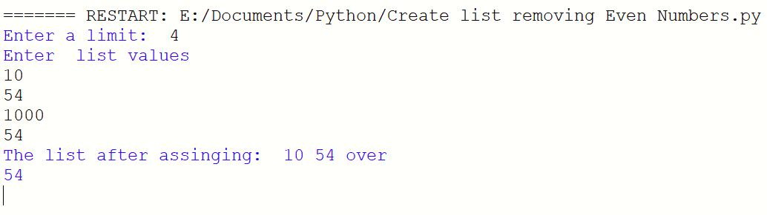

------------------------------------------------------------------------------------

**# 6. Store a list of first names. Count the occurrences of ‘a’ within the list**

list1 = ["a", "b", "c","c","b"]

occ = list1.count("a")

print("count of occurrences of a :",occ)

**OUTPUT**



-----------------------------------------------------------------------------------

**# 7. Enter 2 lists of integers. Check (a) Whether list are of same length (b) whether**

**list sums to same value (c) whether any value occur in both**

list1=[4,8,2,4,9,5,7]

list2=[2,1,7,9,8,6]

s=int(0)

c=int(0)

if len(list1)==len(list2):

print("List1 and List2 are of Same length...")

else:

print("List1 and List2 have different length....")

print()

for i in range(0,len(list1) and len(list2)):

s=s+list1[i]

c=c+list2[i]

if(s==c):

print("Sum of List1 and List2 are Equal...")

else:

print("Sum of List1 and List2 are not Equal...")

print()

print("Elements that matched between List1 and List2 are:", end=" ")

l=[]

for i in range(0,len(list1)):

for j in range(0,len(list2)):

if list1[i]==list2[j]:

l.append(list1[i] and list2[j])

else:

continue

print(l)

**OUTPUT**

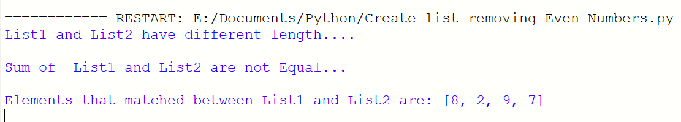

-------------------------------------------------------------------------------------

**# 8. Get a string from an input string where all occurrences of first character**

**replaced with ‘$’, except first character. [eg: onion -> oni$n]**

str1="malayalamamhm"

char = str1[0]

str1 = str1.replace(char, '$')

str1 = char + str1[1:]

print(str1)

**OUTPUT**



-------------------------------------------------------------------------------------

**# 9. Create a string from given string where first and last characters exchanged.**

**[eg: python -> nythop]**

str = input("Enter a string : ")

newstr = str[-1:] +str[1:-1] + str[:1]

print("New string : ",newstr)

**OUTPUT**



-------------------------------------------------------------------------------------

**# 10. Accept the radius from user and find area of circle.**

pi=3.14

r = float(input ("Enter the Radius of the circle : "))

result=3.14 \* r\*\*2

print ("The Area of the Circle : ", result)

**OUTPUT**



------------------------------------------------------------------------------------

**# 11. Find biggest of 3 numbers entered**

x = int(input("Enter 1st number: "))

y = int(input("Enter 2nd number: "))

z = int(input("Enter 3rd number: "))

if (x > y) and (x > z):

largest = x

elif (y > x) and (y > z):

largest = y

else:

largest = z

print("The largest number is: ",largest)

**OUTPUT**

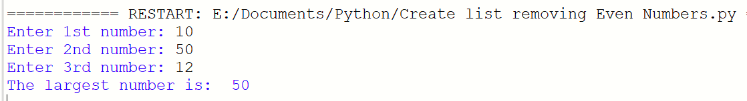

-------------------------------------------------------------------------------------

**# 12. Accept a file name from user and print extension of that**

file= input("Enter filename : ")

f=file.split(".")

print("Extension of the file is : " + f[-1])

**OUTPUT**



-------------------------------------------------------------------------------------

**# 13. Create a list of colors from comma-separated color names entered by user.**

**Display first and last colors.**

a=[]

for i in range(2):

b=input("enter the color:")

a.append(b)

print(a)

print(a[0])

print(a[1])

**OUTPUT**

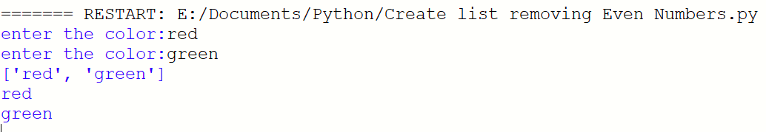

-----------------------------------------------------------------------------------

**# 14. Accept an integer n and compute n+nn+nnn**

n=int(input("Enter a number : "))

x=int("%s" % n)

y=int("%s%s" % (n,n))

z=int("%s%s%s" % (n,n,n))

print("n + nn + nnn :",x+y+z)

**OUTPUT**

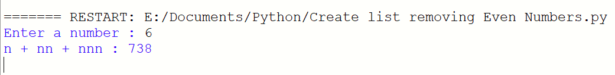

-------------------------------------------------------------------------------------

**# 15. Print out all colors from color-list1 not contained in color-list2.**

color\_list\_1 = set(["White", "pink", "Red","Blue"])

color\_list\_2 = set(["Red", "Green","pink"])

print(color\_list\_1.difference(color\_list\_2))

**OUTPUT**



-------------------------------------------------------------------------------------

**# 16. Create a single string separated with space from two strings by swapping the character at position**

a="JERIN"

b="RAHUL"

c=b[0]+a[1:len(a)]+" "+a[0]+b[1:len(b)]

print(c)

**OUTPUT**

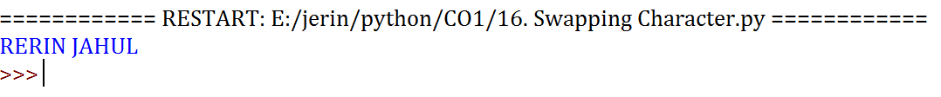

-------------------------------------------------------------------------------------

**# 17. Sort dictionary in ascending and descending order.**

import operator

d = {1: 2, 3: 4, 4: 3, 2: 1, 0: 0}

print('Original dictionary : ',d)

sortedic = sorted(d.items(), key=operator.itemgetter(1))

print(' Ascending order : ',sortedic)

sortedic = dict( sorted(d.items(), key=operator.itemgetter(1),reverse=True))

print('Descending order : ',sortedic)

**OUTPUT**

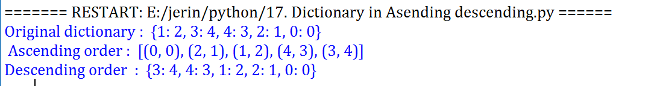

-------------------------------------------------------------------------------------

**# 18. Merge two dictionaries.**

dic1={'a':100,'b':200}

dic2={'c':200,'d':544}

print("Dictonary 1: ", dic1)

print("Dictonary 2 : ", dic2)

dic3=dic1.copy()

dic3.update(dic1)

print("Merged Dictionary: ", dic3)

**OUTPUT**

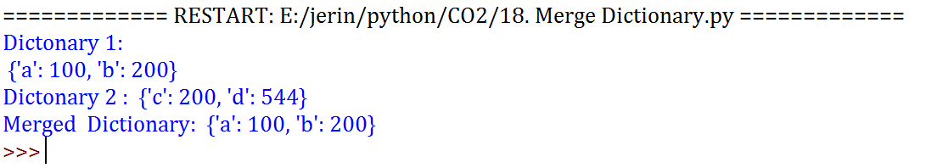

-------------------------------------------------------------------------------------

**#19. Find GCD of 2 numbers.**

x= int(input("Enter 1st number: "))

y= int(input("Enter 2nd number: "))

i = 1

while(i <= x and i <= y):

if(x % i == 0 and y% i == 0):

gcd = i

i = i + 1

print("GCD :", gcd)

**OUTPUT**

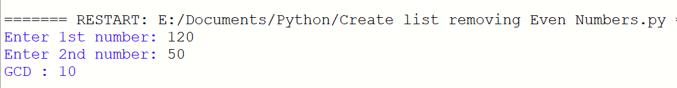

------------------------------------------------------------------------------------

**# 20.From a list of integers, create a list removing even numbers.**

number = [7,8, 130, 55, 44, 20, 27]

print( "Original list:",number)

number = [x for x in number if x%2!=0]

print("list after removing Even numbers:",number)

**OUTPUT**



------------------------------------------------------------------------------------