**CO2**

**# 1. Program to find the factorial of a number**

n=int(input("Enter a number: "))

f=1

for i in range(1,n+1): f=f*i

print ('Factorial of',n, '=',f)

**OUTPUT**

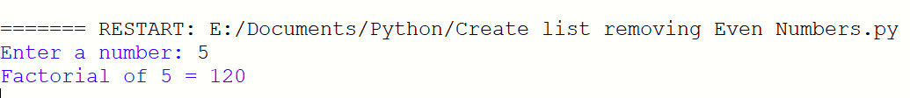

-------------------------------------------------------------------------------------

**# 2. Generate Fibonacci series of N terms**

n = int(input("Enter the limit : "))

a = 0

b = 1

sum = 0

count = 1

print("Fibonacci Series :",end= " ")

while(count <= n):

print(sum, end = " ")

count += 1

a = b

b = sum

sum = a + b

**OUTPUT**

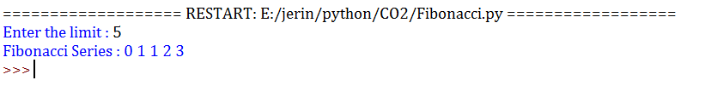

-------------------------------------------------------------------------------------

**# 3. Find the sum of all items in a list**

list1 = [20, 85, 20, 25, 56, 40]

total = sum(list1)

print("Sum of list : ",total)

**OUTPUT**

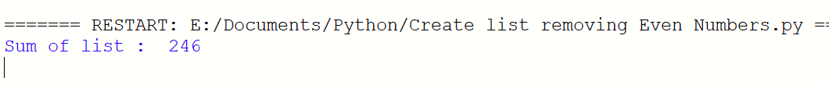

**# 4. Generate a list of four digit numbers in a given range with all their digits even and the number is a perfect square.**

from math import sqrt as s

for i in range(10,100):

if s(i)==int(s(i)) and i%2==0:

print(i,", ",end=" ")

**OUTPUT**



------------------------------------------------------------------------------------

**# 5. Display the given pyramid with step number accepted from user.**

rows = int(input("Enter the number of rows: "))

for i in range(1, rows+1):

for j in range(1,i+1):

print(i * j, end=' ')

print()

**OUTPUT**

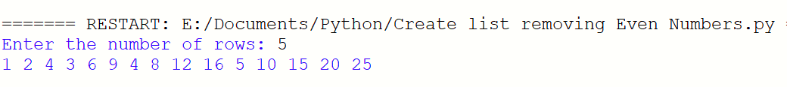

------------------------------------------------------------------------------------

**# 6. Count the number of characters (character frequency) in a string.**

test_str=str(input("Enter the string : "))

freq = {}

for i in test_str:

if i in freq:

freq[i] += 1

else:

freq[i] = 1

print ("Count of all characters : "+ str(freq))

**OUTPUT**

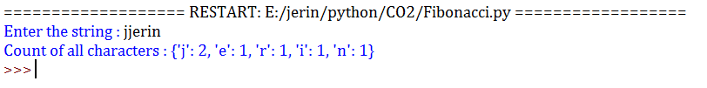

**# 7. Add ‘ing’ at the end of a given string. If it already ends with ‘ing’, then add**

**‘ly’**

str=input("Enter a string : ")

print("inputed string is : ",str)

if(str.endswith("ing")):

str=str+'ly'

else:

str=str+'ing'

print("The formated string is : ",str)

**OUTPUT**

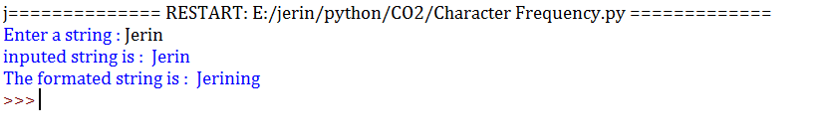

------------------------------------------------------------------------------------

**# 8. Accept a list of words and return length of longest word.**

a=[]

n= int(input("Enter the number of elements in list:"))

for x in range(0,n):

element=input("Enter element: "+str(x+1)+” “)

a.append(element)

max1=len(a[0])

temp=a[0]

for i in a:

if(len(i)>max1):

max1=len(i)

temp=i

print("Longest Word:",temp)

print("Length of longest word :",max1)

**OUTPUT**

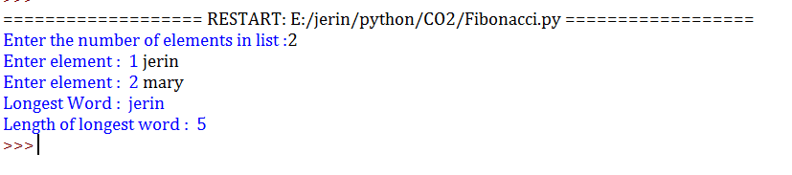

-----------------------------------------------------------------------------------

**# 9. Construct following pattern using nested loop**

n= int(input("Enter the limit:"))

for i in range(n):

for j in range(i):

print ('* ', end="")

print('')

for i in range(n,0,-1):

for j in range(i):

print('* ', end="")

print('')

**OUTPUT**

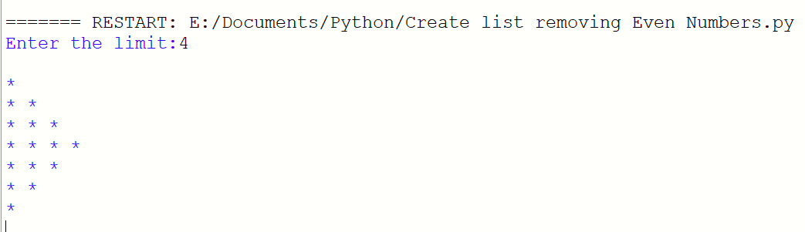

-------------------------------------------------------------------------------------

**# 10. Generate all factors of a number. def print_factors(x):**

def factors(x):

print("The factors of",x,"are:")

for i in range(1, x + 1):

if x % i == 0:

print(i)

n=int(input("Enter a number:"))

factors(n)

**OUTPUT**



