**CO3**

**1. Work with built-in packages**

**A) math module**

import math

print("The value of pi is:",math.pi)

print()

import math as m

print("The value of pi is:",m.pi)

print()

from math import pi,sqrt

print("The square root of 20 is:",math.sqrt(20))

print("The value of pi is: ",math.pi)

print()

print(math.cos(90))

print(math.sin(45))

print(math.tan(180))

print(math.cos(90))

**OUTPUT**

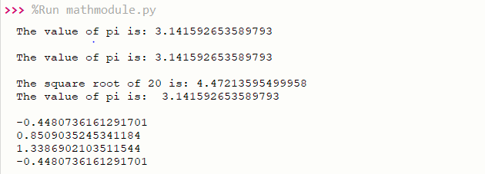

**B) time module**

import time

print("current time in sec:",time.time())

print("current time:",time.ctime())

print("current time after 30 sec:",time.ctime(time.time()+30))

print()

t=time.localtime()

print("time t:",t)

print("current year:",t.tm_year)

print("current month:",t.tm_mon)

print("current day:",t.tm_mday)

print("current hour:",t.tm_hour)

print("current minute:",t.tm_min)

print("current second:",t.tm_sec)

print("current weakday:",t.tm_wday)

**OUTPUT**

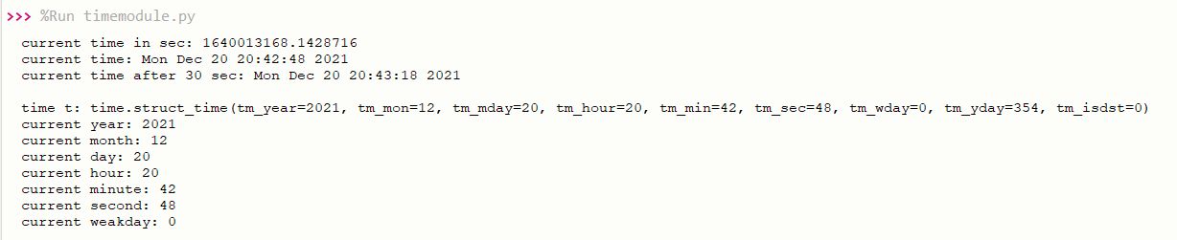

**C) calendar module**

import calendar

month=int(input("Enter month:"))

year=int(input("Enter year:"))

print()

print(calendar.month(year,month)) *#calendar of a given month*

print(calendar.calendar(2021)) *#calendar of a given year*

**OUTPUT**

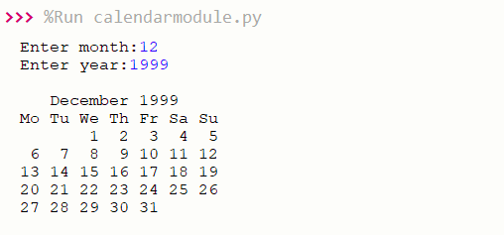

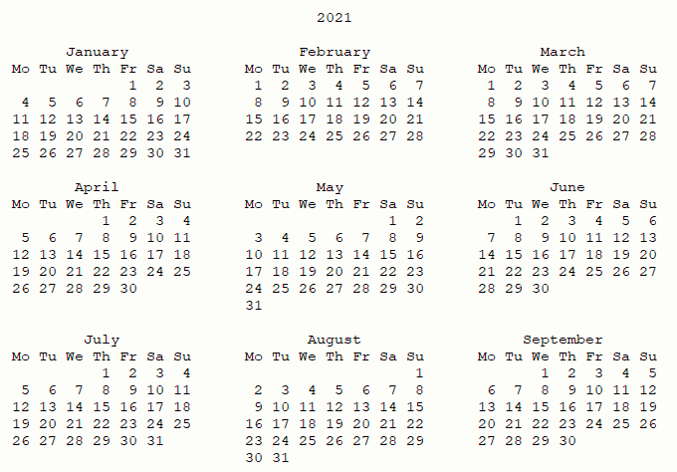

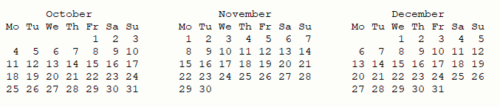

**D) random module**

import random

mylist = ["Jerin Joy", "Alwin Raju", "Jomin Joy"]

print(random.choice(mylist)) *#Returns a random element from the given sequence*

print(random.choices(mylist, k=4))

print(random.sample(mylist, k=1)) *#Return a list that contains any 2 of the items*

*from a list:*

random.shuffle(mylist)

print(mylist) *#Takes a sequence and returns the sequence in a random order*

print(random.randrange(3, 9)) *#Return a number between 3 and 9*

**OUTPUT**

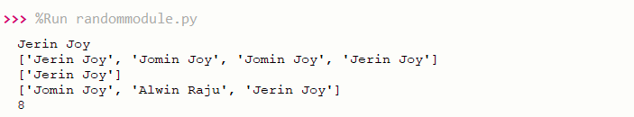

**E) Statistics module**

import statistics

list1=[1,2,3,5,5]

print("Mean: ",statistics.mean(list1))

print("Median: ",statistics.median(list1))

print("Mode: ",statistics.mode(list1))

print("Harmonic Mean: ",statistics.harmonic_mean(list1))

print("Statistics Varience: ",statistics.variance(list1))

print("Statistics Median Low: ",statistics.median_low([-12, 6.6, -3.4, 7.1, -9, 22]))

**OUTPUT**

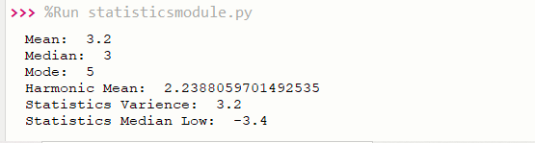

**-------------------------------------------------------------------------------------**

**# 2. Create a package graphics with modules rectangle, circle and sub-package 3D-graphics with modules cuboid and sphere. Include methods to find area and perimeter of respective figures in each module. Write programs that finds area and perimeter of figures by different importing statements. (Include selective import of modules and import * statements)**

**graphicsuse.py**

from graphics import rectangle

from graphics import circle

from graphics.ThreeD_graphics import cuboid

from graphics.ThreeD_graphics import sphere

l=int(input("Enter the length of rectangle: "))

b=int(input("Enter the breath of rectangle: "))

rectangle.area(l,b)

rectangle.perimeter(l,b)

print()

r=int(input("Enter the Radius of Circle: "))

circle.area(r)

circle.perimeter(r)

print()

l=int(input("Enter the length of Cuboid: "))

b=int(input("Enter the breadth of Cuboid: "))

h=int(input("Enter the height of Cuboid: "))

cuboid.area(l,b,h)

cuboid.perimeter(l,b,h)

print()

r=int(input("Enter the radius of Sphere: "))

sphere.area(r)

sphere.volume(r)

**----------------------------------------------**

**Package : graphics**

**circle.py**

def area(r):

print("Area of Circle: ",3.14*r*r)

def perimeter(r):

print("Perimeter of Circle: ", 2*3.14*r)

**----------------------------------------------**

**rectangle.py**

def area(l,b):

print("Area of Rectangle: ", l*b)

def perimeter(l,b):

print("Perimeter of Rectangle: ", 2*(l+b))

**----------------------------------------------**

**Sub-Package : ThreeD_graphics**

**cuboid.py**

def area(l,b,h):

print("Area of Cuboid: ",(2*l*b)+(2*l*h)+(2*h*b))

def perimeter(l,b,h):

print("Perimeter of Cuboid: ", 4*(l+b+h))

**----------------------------------------------**

**sphere.py**

def area(r):

print("Surface Area of Sphere: ",4*3.14*r*r)

def volume(r):

print("Volume of Sphere: ",(4/3)*3.14*r*r*r)

**----------------------------------------------**

**OUTPUT**



