**CO5**

**# 1. Write a program to read a file line by line and store it into a**

**list.**

file=open("pythonfile.txt","w")

file.write("1. Python was invented by Guido van Rossum.\n2. It is easy to use and Learn.\n3. It supports Object Oriented programming ")

file.close()

file=open("pythonfile.txt","r") #("filename","mode of file")(there are 6 mode)

file.seek(0,0)

ff=file.readlines()

for x in range(0,len(ff)):

print(ff[x])

print()

print(ff)

file.close()

**pythonfile.txt**

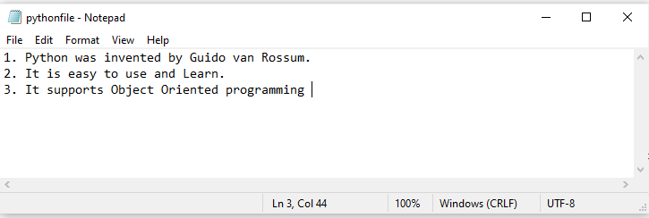

**OUTPUT**

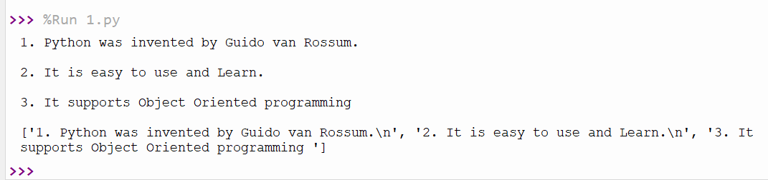

----------------------------------------------------------------------------------

**# 2. Write a program to copy odd lines of one file to other.**

file1=open("pythonfile.txt","r")

for x in file1:

print(x)

file1.seek(0,0)

print("--------------------------------------------------------------")

print()

print("Odd Line: ",end=" ")

file2=open("odd.txt","w")

ff=file1.readlines()

with open('odd.txt','w') as file2:

for x in range(0,len(ff)):

if(x%2!=0):

print(ff[x])

file2.write(ff[x])

**OUTPUT**

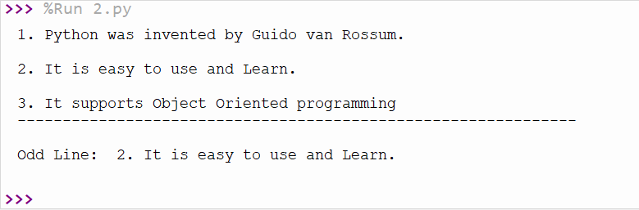

----------------------------------------------------------------------------------

**# 3. Write a Python program to read each row from a given csv file and**

**print a list of strings.**

import csv

filename = "username.csv"

fields = []

rows = []

ff=open(filename, 'r')

csvreader = csv.reader(ff)

fields = next(ff)

print(fields)

for r in csvreader:

rows.append(r)

print(rows)

print("-----------------------------------------------------------")

print('\nFirst 4 Rows are: \n')

for r in rows[:4]:

print(*r)

print("-----------------------------------------------------------")

print()

print("The File Content")

print()

for xy in rows:

for z in xy:

print(z)

print("------------------------------------------------------------")

print()

#print(z,end=" ")

print()

ff.close()

**username.csv**

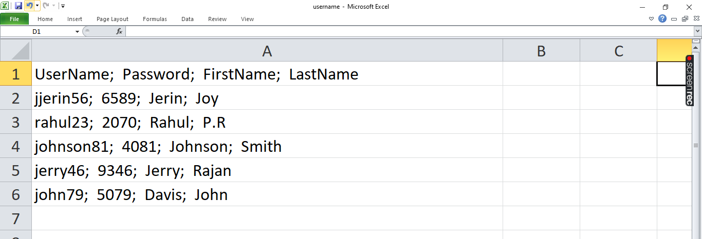

**OUTPUT**

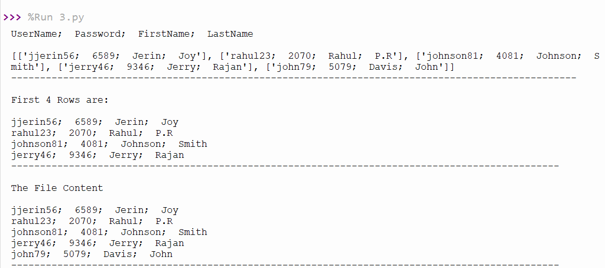

----------------------------------------------------------------------------------

**# 4. Write a Python program to read specific columns of a given CSV file**

**and print the content of the columns.**

import csv

filename = "cardetails.csv"

ff=open(filename, 'r')

#csvreader = csv.reader(ff)

data = csv.DictReader(ff)

print("No. Company Car Model")

for x in data:

print(x['No'], x['Company'], x['Car Model'])

**cardetails.csv**

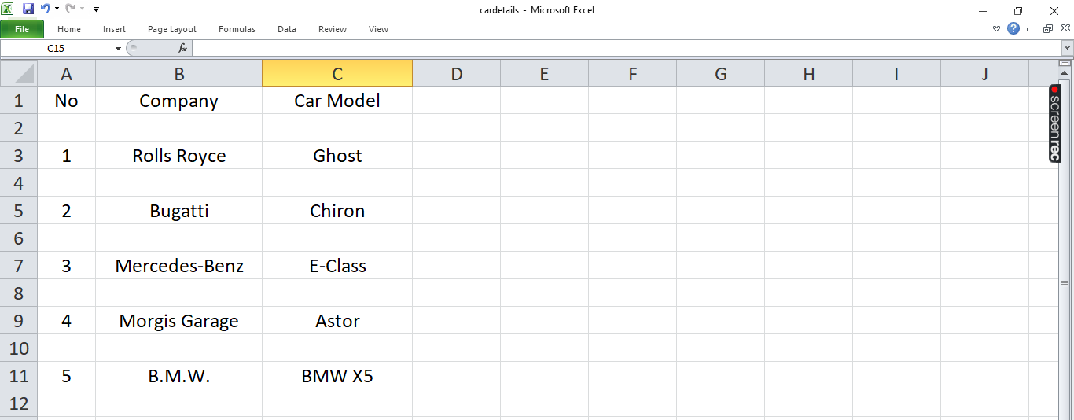

**OUTPUT**

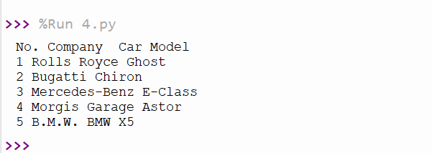

---------------------------------------------------------------------------------

**# 5. Write a Python program to write a Python dictionary to a csv file.**

**after writing the CSV file read the CSV file and display the content.**

import csv

field_names = ['No', 'Company', 'Car Model']

cars = [

{'No': 1, 'Company': 'Rolls Royce', 'Car Model': 'Ghost'},

{'No': 2, 'Company': 'Bugatti', 'Car Model': 'Chiron'},

{'No': 3, 'Company': 'Mercedes-Benz', 'Car Model': 'E-Class'},

{'No': 4, 'Company': 'Morgis Garage', 'Car Model': 'Astor'},

{'No': 5, 'Company': 'B.M.W.', 'Car Model': 'BMW X5'},

]

with open("cardetails.csv", "w") as csvfile:

writer = csv.DictWriter(csvfile, fieldnames = field_names)

writer.writeheader()

writer.writerows(cars)#print(".................")

filename = "cardetails.csv"

ff=open(filename, 'r')

rows=[]

csvreader = csv.reader(ff)

for r in csvreader:

rows.append(r)

for r in rows[:4]:

print(*r)

**OUTPUT**

