Assignment 6 jQuery
Team: BookingApp Group: SE-2513
Members: Allazhar Aldongarov, Dias Serikov, Yerkenov Abylay
Objective: Add jQuery search, animations and user feedback to our existing hotel booking website.
Website: https://aishhko.vercel.app
Repository: https://github.com/jjestar/web
For the code screenshots, keep the VS Code file tab and line numbers visible. Insert each screenshot into the matching empty box.

Task 0 jQuery setup
1. We added jQuery 4.0.0 in the head of each HTML page before our JavaScript files.
2. We used $(document).ready() to run the code after the page is ready.
3. The browser console shows "jQuery is ready!".

VS Code: index.html, lines 3-14
Show the head section and the jQuery CDN script.
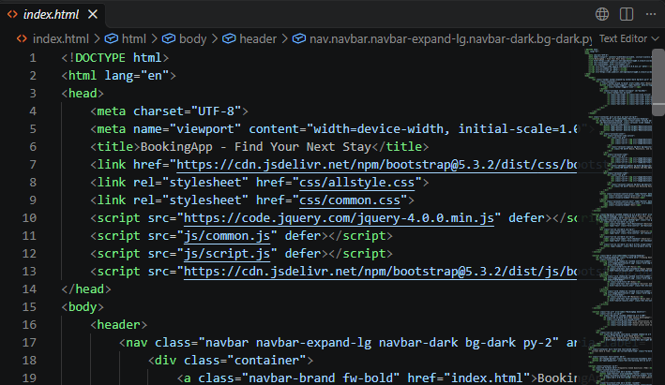

VS Code: js/script.js, lines 1-2
Show $(document).ready() and console.log().
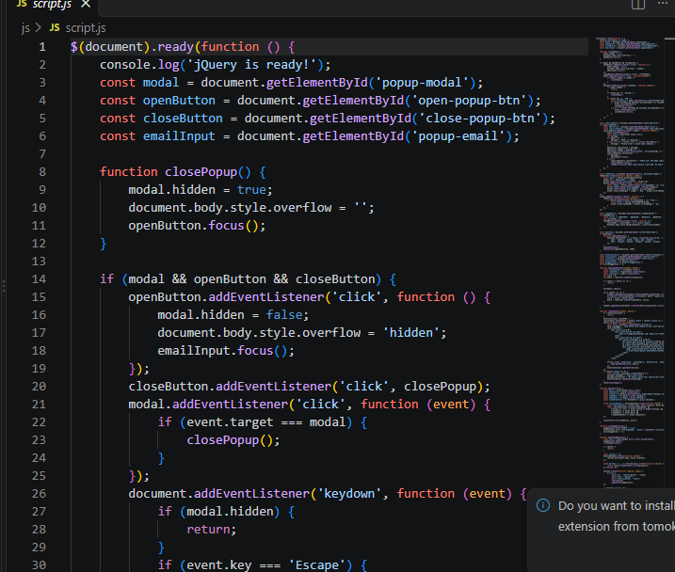

Website result
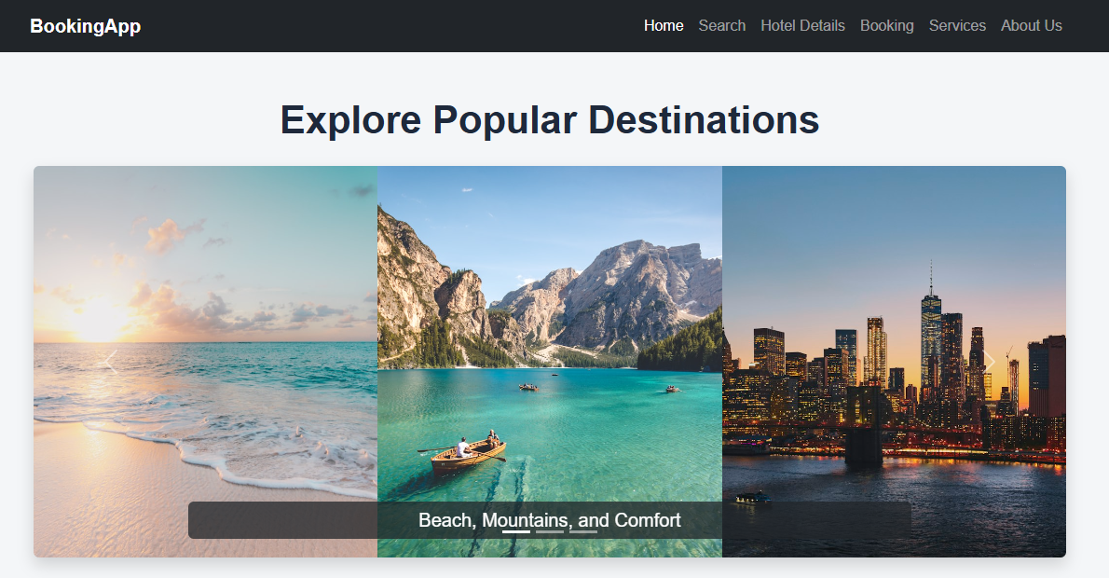
The page loads with jQuery 4.0.0.

Task 1 Live search
1. The Search page checks the input whenever the user types.
2. applyFilters() searches hotel names, cities and descriptions. Rating and amenity filters also apply.
3. The page updates the cards and result count without reloading.

VS Code: js/script.js, lines 187-205
Show applyFilters() and the hotel filtering conditions.
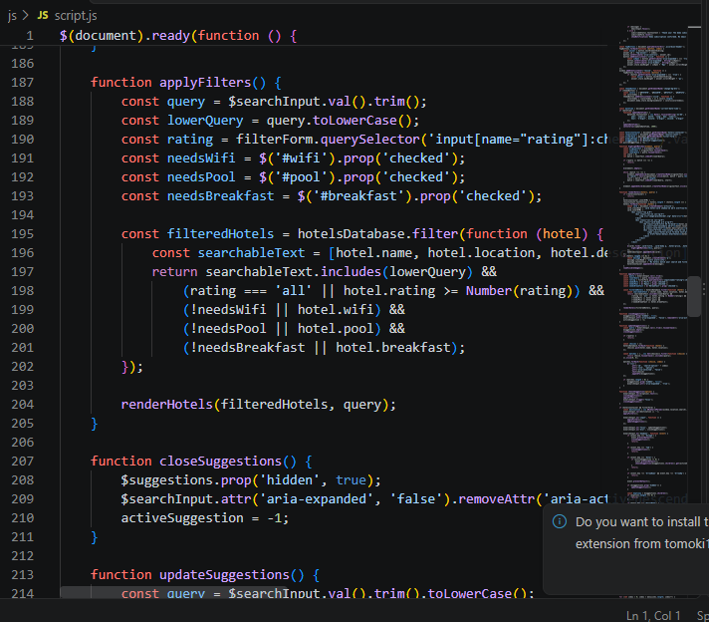

VS Code: js/script.js,
Show the input event that updates the results.
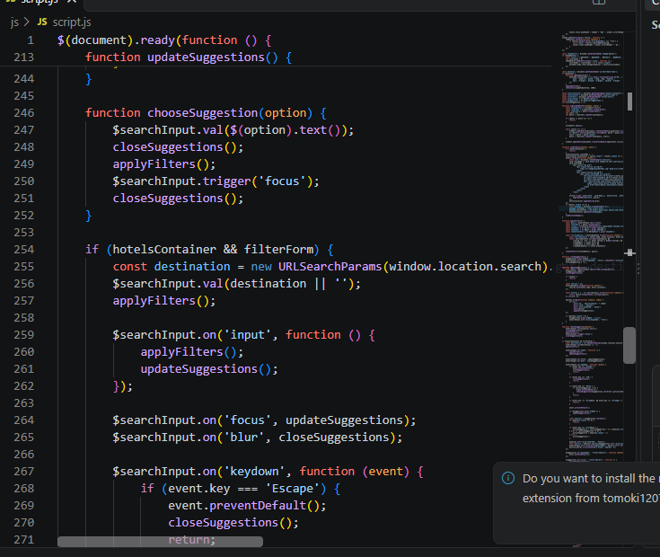

Website result
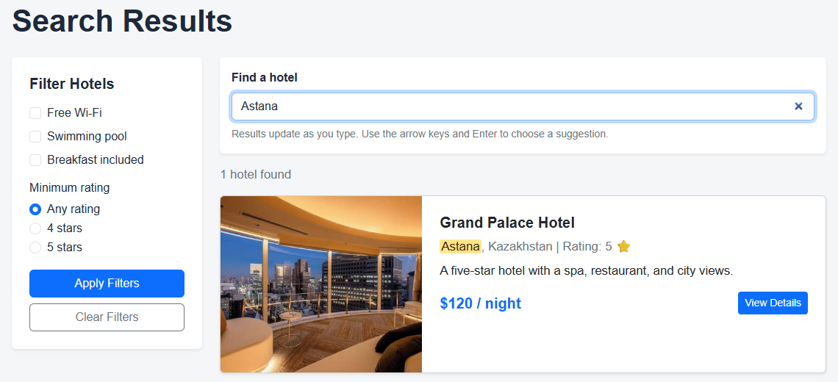
Typing Astana leaves one matching hotel.

Task 2 Autocomplete suggestions
1. We collect hotel names and locations from hotelsDatabase.
2. updateSuggestions() shows up to six matching choices below the input.
3. The user can select a suggestion with a mouse click or the arrow keys and Enter.

VS Code: js/script.js, lines 222-244
Show how updateSuggestions() builds and displays the dropdown.
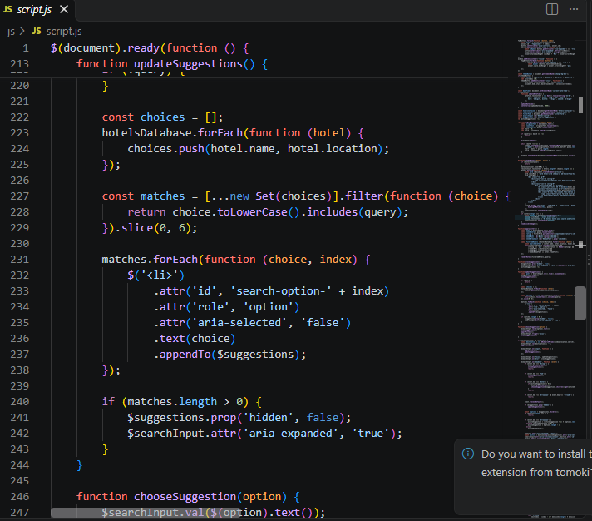

Website result
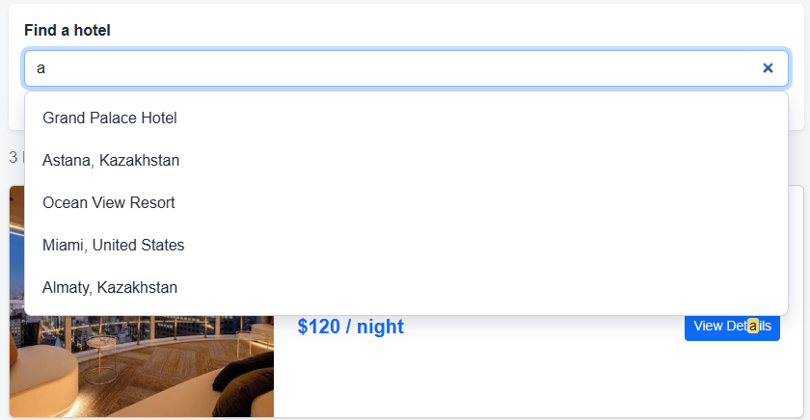
Suggestions appear as the user types.

Task 3 Search highlighting
1. highlightMatches() finds each occurrence of the search text without checking letter case.
2. Matching text is placed in a mark element. Other text stays unchanged.
3. Clearing the input removes the highlighting.

VS Code: js/script.js, lines 123-144
Show the complete highlightMatches() function.
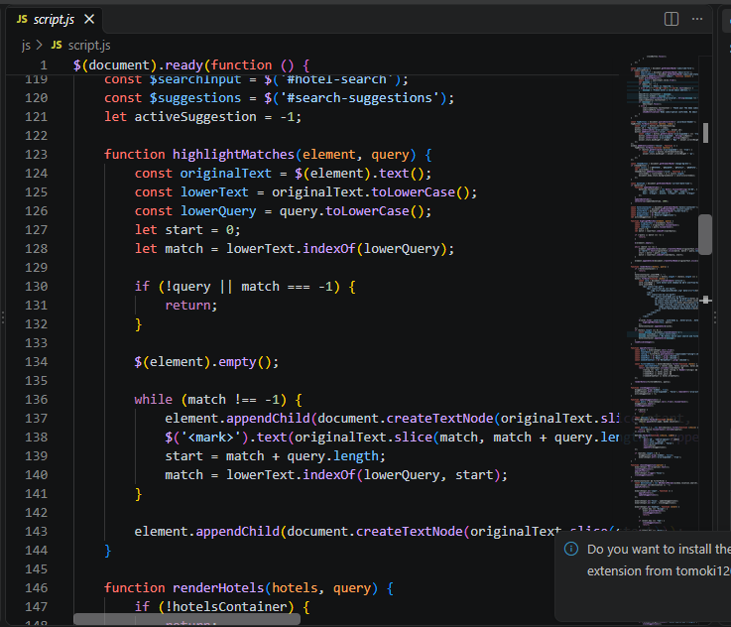

Website result
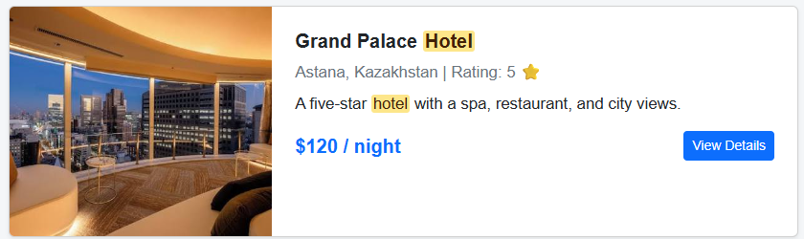
The matching words are highlighted in the hotel cards.

Task 4 Scroll progress bar
1. We added a fixed progress bar to About and Services.
2. The code divides the scroll position by the scrollable page height to find the percentage.
3. Scroll and resize events update the bar width from 0% to 100%.

VS Code: js/about-services.js, lines 226-234
Show initializeScrollProgress().
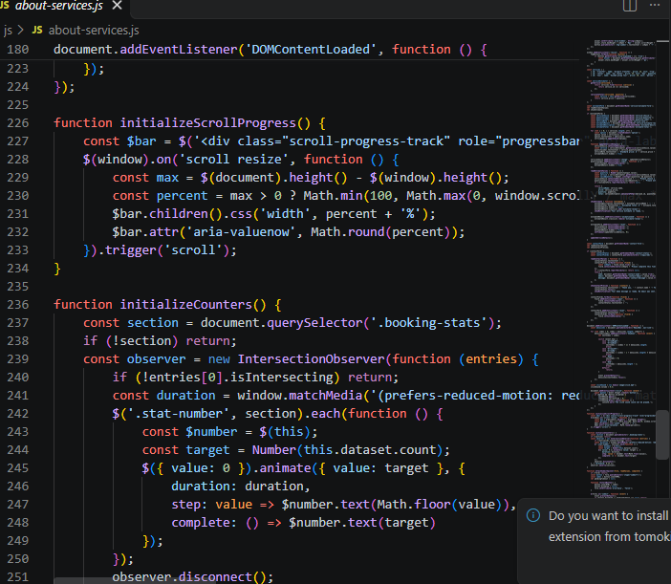

Website result
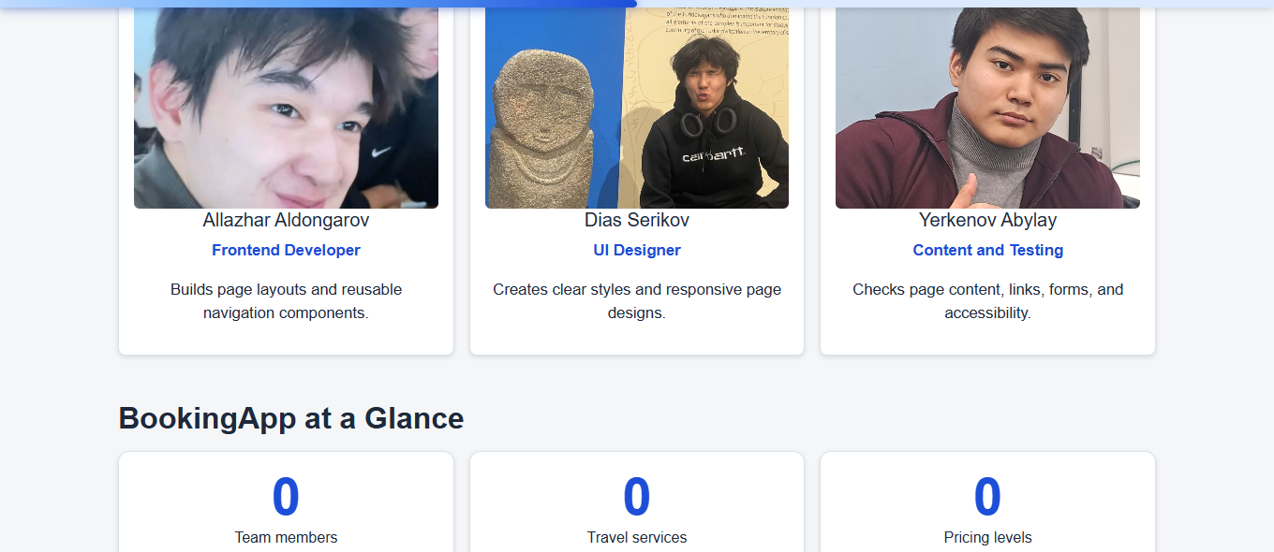
The bar at the top follows the scroll position.

Task 5 Animated number counters
1. The statistics on About start at zero. The target values are stored in data-count.
2. When the section enters the screen, jQuery animate() increases the numbers.
3. The counters stop at their targets and run only once.

VS Code: js/about-services.js, lines 236-254
Show initializeCounters() and the number animation.
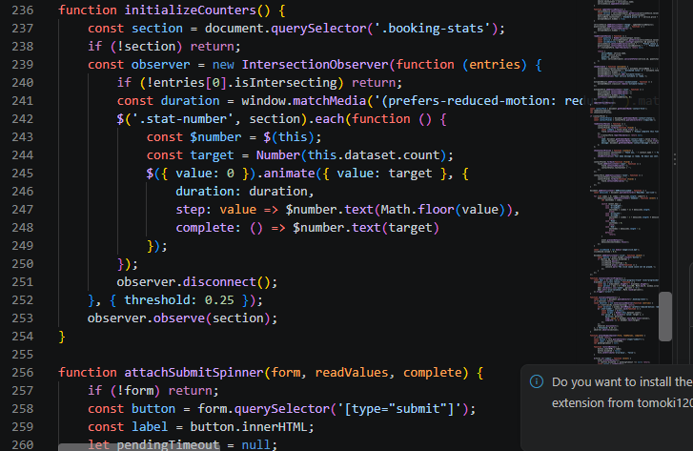

Website result
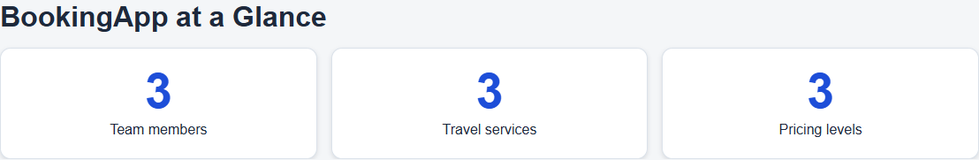
The three counters finish at 3, 3 and 3.

Task 6 Loading spinner
1. The Contact form and service calculator first validate and save the submitted values.
2. The Submit button shows a spinner and "Please wait..." and becomes disabled.
3. After 1.2 seconds, the button returns to normal and the result appears. Clear cancels the waiting action.

VS Code: js/about-services.js, lines 268-289
Show the submit handler, timeout and reset handler in attachSubmitSpinner().
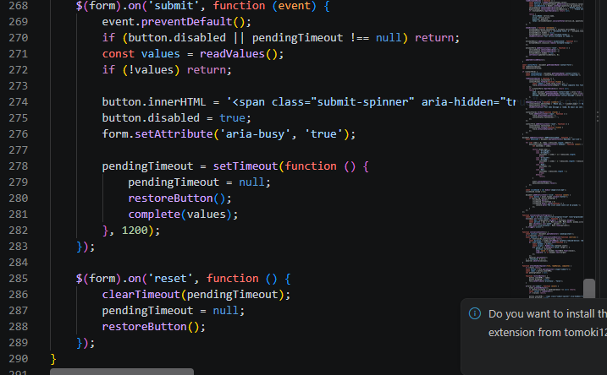

Website result
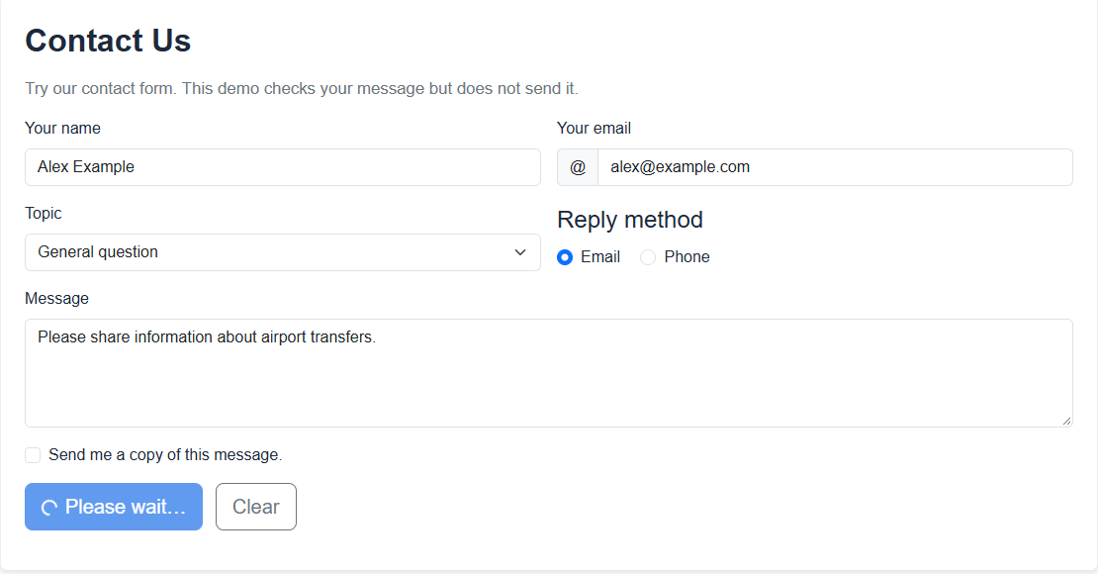
The Contact button shows the waiting state.

Task 7 Temporary notifications
1. showNotification() displays a message after a successful demo action.
2. jQuery fadeIn(), delay() and fadeOut() show the message and then hide it.
3. The same function is used for subscription, contact, service estimates and booking.

VS Code: js/common.js, lines 1-18
Show showNotification() and the fadeIn(), delay() and fadeOut() calls.
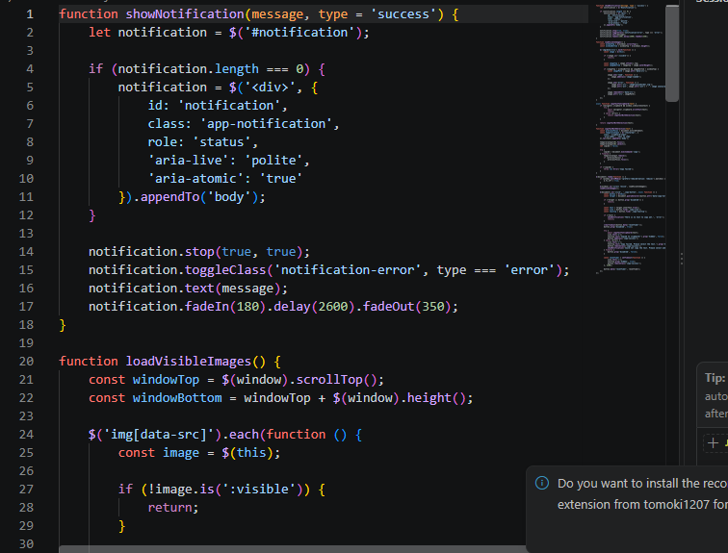

Website result
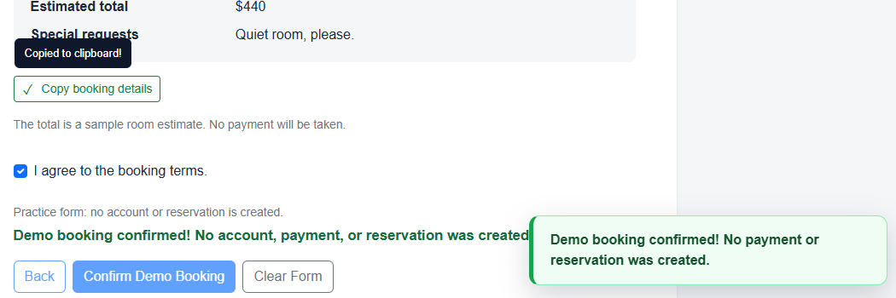
A successful action displays a temporary notification.

Task 8 Copy to clipboard
1. Copy buttons use data-copy-target to select the hotel location or booking summary.
2. copyTextToClipboard() writes the visible text to the clipboard.
3. After success, the button shows a checkmark and "Copied to clipboard!". It returns to normal after a short delay.

VS Code: js/common.js, lines 52-63
Show copyTextToClipboard().
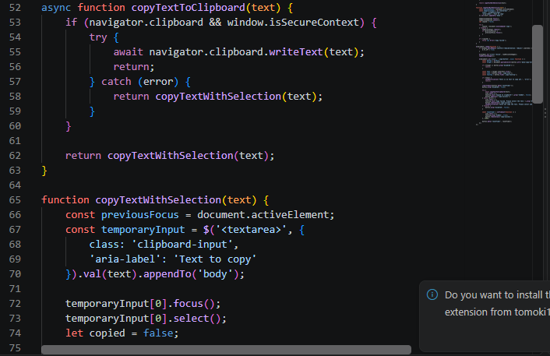

VS Code: js/common.js, lines 118-136
Show the success icon, tooltip and reset timer.
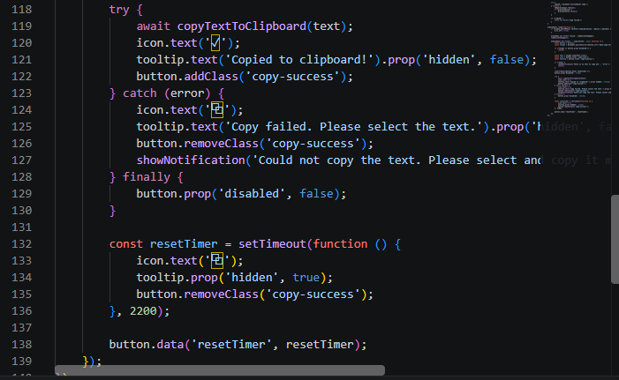

Website result
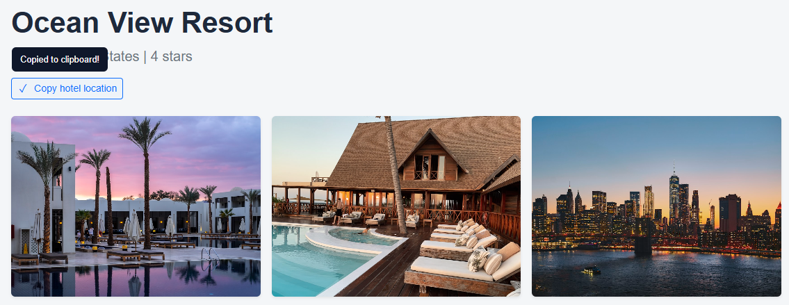
The Copy button confirms that the text was copied.

Task 9 Image lazy loading
1. Hotel cards on Search start with a placeholder. The real image path is stored in data-src.
2. loadVisibleImages() checks which images are inside the screen.
3. For a visible image, the code sets src and removes data-src. The check runs after scrolling and after new cards are shown.

VS Code: js/common.js, lines 24-48
Show the visibility check and the change from data-src to src.
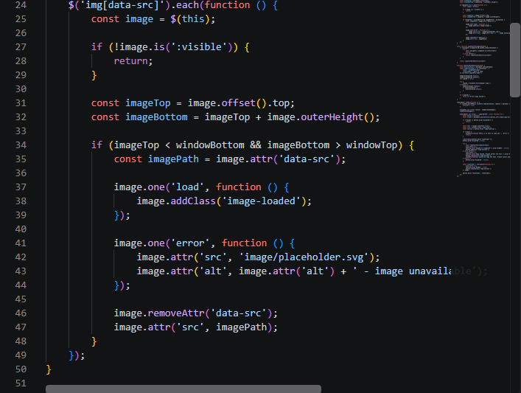

Website result
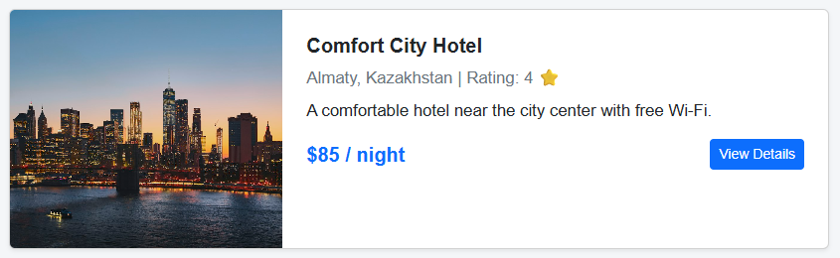
The lower hotel image loads after scrolling down.
Conclusion
The main challenge was keeping the new search and existing filters working together. We solved it with one filtering function. We also saved form values before the loading delay so that editing or clearing a form does not produce a wrong result. All tasks were tested, and the updated website is deployed on GitHub Pages.

