Meu primeiro relatório em Quarto

Este é um subtítulo

José de Jesus Filho

5/6/23

## Quarto

Quarto enables you to **weave** together/ content and executable code into a finished document. To learn more about Quarto see <https://quarto.org>.

## Running Code

| Col1 | Col2 | Col3 |
| --- | --- | --- |
| jjd | ddd |  |
|  |  |  |
|  |  |  |

When you click the **Render** *button* a document will be generated that includes both content and the output of embedded code. You can embed code like this:

hist(rnorm(1000))

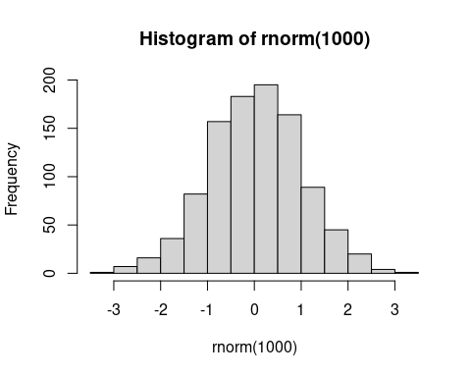

You can add options to executable code like this

[1] 4

The echo: false option disables the printing of code (only output is displayed).