Application Architecture

The NetworkProbabilityDownloader is a web app that utilizes 4 main technologies: html5, JavaScript, AJAX, and Java servlet technology. Chrome and Firefox are the supported browsers. The backend Java servlet and other java classes are packaged in a WAR file. The war file is deployed in the Apache tomcat server (version 9).
The tomcat server runs as a back-end server behind NGINX which is used as a reverse proxy. All requests are handled via SSL using the https protocol on port 443. The NGINX configuration resides in the /etc/nginx folder. NGINX is not used in the development environment on Mac. The SSL layer is all handled by NGINX using Digital Certificates obtained from letsencrypt.com. The certificates are generated using the ‘certbot’ command. The decrypted requests are then forwarded to tomcat on port 8080.
To renew the digital certificate refer to the SSL Encryption section contained later in this document.

Application Startup Configuration

The application requires a series of environment variables that must be set during start up. These variables are set in a file named tomcat_service.conf which is located in the /etc/tomcat_service folder. The Linux service unit file is called tomcat.service and is located in /etc/systemd/system. This file references the tomcat_service.conf file so that the environment variables are passed to the tomcat runtime. The environment variables and their associated values set in the tomcat_service.conf file are listed below.

MIDB_KEY=atlasver
MIDB_ADMIN=0suCK+IDA5TP7OEGqVwl56d4W2FNqZkk
MIDB_DB=cGCtzDVtdNgI3lughOWm+xt7om+38vtI
MIDB_TTP=WfhX2U4vnyok5bM+wuSeOXuKgo7fvOcp
MIDB_FTP=9SbT3Orqz6UtdhsDK7B+pTUfjwKj1mez
MIDB_TAC=R4e5lIjOOnLQlXXA1yf6ytO59doZIDQG7rOBx0h2owLnp+6AB4iUO76KYpb4PdJ/
MIDB_TAU=F//fibJI03jLMHH3QpYR/vwSwmMVugObz+yL6HP6gG1hVpibPNcb/LIGqxztWk6o
MIDB_IPLOC_AUT=6FJuC1BmV7NewMQdFwoQ3znDBepLmH4XxSqw+2+6ucQ=
MIDB_IPLOC_ACC=opytdR2wj1IgF3y/GCvw+w==
MIDB_IPINF_TAU=nypenG1fq37Z4ruxuk8X2XUfoKrtG6YU
MIDB_TBELT=jTzbjrVJJgp8/+npBbHXov99DQBfcQr9A7Qn3DldIgUDQV+HbeP6EZty9BC9z6rJg1hTcjZ8tI4t9VRa3AWB2KXkMcgwiYDwaJURaxWBg2Y=
MIDB_SMS_MODE=TWILIO

These variables represent encrypted values that the application will decrypt during application initialization. Each value is described below.

MIDB_KEY: This value is not encrypted. It is the key that is used for encryption/decryption.
MIDB_ADMIN: This is the encrypted password used to sign on to the admin console in the browser.
MIDB_DB: This is the password for the mysql user that opens jdbc database connections to mysql. The user name is midbatlas.
MIDB_TTP: This is the ‘to’ telephone number that SMS notifications are sent to by the SMSNotifier.
MIDB_FTP: This is the ‘from’ telephone number that is used to send SMS notifications. This is a virtual telephone number from twilio.com
MIDB_TAC: This is the twilio.com account SID used to send SMS notifications.
MIDB_TAU: This is the twilio authentication token used to send SMS notifications.
MIDB_TBELT: This is the SMS api key used when textbelt.com is used instead of twilio.
MIDB_IPLOC_AUT: This is the license key (used for authorization) used to access the geolite.info web service. This web service is used to get location data for client ip addresses.
MIDB_IPLOC_ACC: This is the account id for the geolite.info web service.
MIDB_TBELT: This is the key used to authenticate when using the SMS service at textbelt.com. This service is a backup for twilio.com.
MIDB_SMS_MODE: Specifies whether to use textbelt.com or twilio.com for SMS notifications. This value is not encrypted.

If you want to change the value of any of the environment variables you must first encrypt the new value unless you are replacing one of the unencrypted variables. There is an encryption tool available in the Admin Console in the application. The telephone numbers used for the twilio.com SMS notifications must be entered in the following format: +1AAABBBCCCC where AAA is the area code, BBB is the exchange and CCCC is the line number. For example: +15072501234

The above input must be encrypted before assigning the new value as an environment variable. The following screen shot shows the encryption tool in the Admin Console.

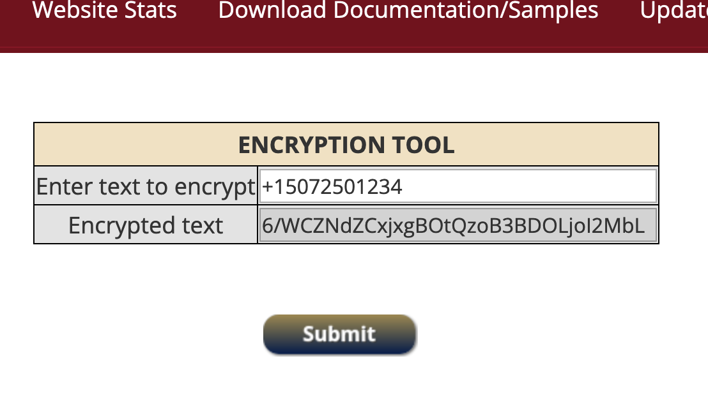

NOTE: You should not change the MIDB_KEY variable.

The main Java class on the server is NetworkProbabilityDownloader servlet. It acts as the entry point for all dynamic processing of web requests. When tomcat and the application start, the NetworkProbabilityDownloader.init() method access the environment variables listed above to initialize various components of the application. Note that when running in a development environment on Mac (Eclipse for Enterprise Java and Web Development), these variables are loaded from the /midb/settings.conf file. On Mac a logical link is setup in the /etc/synthetic.conf file since the root folder is not writable. The synthetic.conf file can be used to specify a folder that behaves as if it were in the root. That way a folder in the path /Users/some_username/midb can behave as if it were the /midb folder in the root. This allows the development environment to behave like linux where the midb folder is in the root folder.

Tomcat Startup

To start the Tomcat servlet container run the following command:
sudo systemctl start tomcat
To stop the Tomcat servlet container run the following command:
sudo systemctl stop tomcat

Install A New Version Of The Application

To install a new version of the application it must be packaged in a war file. The war file must be uploaded to the server in the /home/ubuntu directory. Once the war file is in place run the following command: sudo bash updateNPD.sh

Application Data

The image (.png) files and NIFTI (.nii) files for each study are stored under the /midb root folder. Each study has its own folder under the /midb/studies folder. Under each study folder there is a surface folder for surface data. If there is volume data then there also will be a volume folder.

There are 3 configuration (.conf) files that define the make-up of the study menu shown in the browser: menu.conf, summary.conf, and network_folder_names.conf. The contents of these files are sent to the client at startup time.

There are 4 tables in MYSQL that also hold data: web_hits, admin_access, map_urls, and file_downloads. These tables are discussed later in this document.

Application Flow

When a client browser hits the website by directing the browser to midbatlas.io, the network_probability_downloader.html is delivered to the client. This is the only html page in the application. All client views are different divs (a.k.a. layers) in the page. When the page first loads on the browser, the JavaScript function named startup() is invoked. This is triggered by the <body onload=”startup()”> tag.

This kicks off a series of AJAX calls that retrieve data from the server. The first AJAX call to the server is handled by the getmenuData() function. This is the first in a series of AJAX calls that retrieve the data required to build the menu in the ‘downloader tool’ view. Most of the data for the study menu is returned as JSON objects which are parsed by JavaScript functions. This allows the JavaScript layer to dynamically build the study menu which is depicted here.

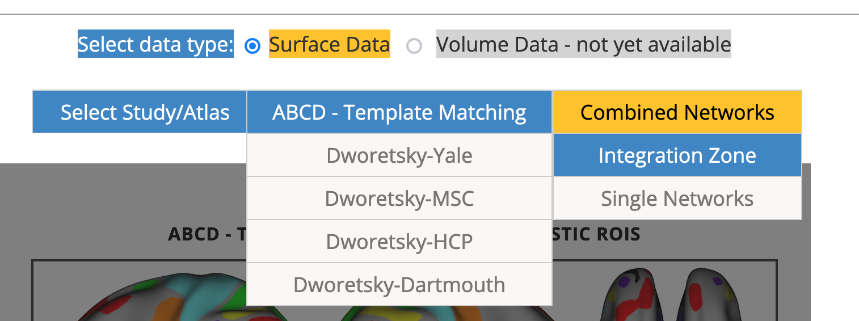

All subsequent actions that require data from the server are initiated by AJAX calls. Each AJAX call is encapsulated in a separate JavaScript function. Each one of these functions has a corresponding method on the backend server in the NetworkProbabilityDownloader Java servlet. Most requests will enter the servlet via the doGet(..) method. This method will examine a parameter named ‘action’. For example, if the action is ‘getMenuData’ then the handleGetMenuData(...) method will be invoked.

Each JavaScript function will log to the console when it is invoked and also when it exits. There is a var in np_downloader.js named ‘enableTracing’. This is set to false by default. After the startup() and continueStartup() functions complete, console tracing/logging will be toggled off when enableTracing is set to false. By changing this var to true tracing/logging will remain on. This is a good way to see the JavaScript function flow when an action is taken in the browser interface.

Error Handling And Notifications

When an unexpected error occurs the createDiagnosticEntry() method of the DiagnosticsReporter class is invoked. This method will create an entry in a file named diagnostics.txt in the /midb/diagnostics folder. The entry will have an incident id along with the error message and a stack trace as well as the session id of the user session that encountered the problem. The entry will also include the series of actions that the web user has executed leading up to the error, unless the error occurred during application startup or in an asynchronous thread. Additionally, an SMS error notification message with the incident id will be sent.

Database Access Threads

There are 3 different independent threads that handle accessing and inserting records into the database. These run as independent threads so that database inserts can happen asynchronously and not impact the performance for the web users. The database used is MYSQL and the specific database collection is named midbatlas_db. All database access is done through Java JDBC connections. Each of the 3 database access threads have their own individual jdbc connection. Each thread monitors its own connection and periodically will run a simple test query if the connection sits idle for more than 2 hours. This prevents a StaleConnectionException from occurring if the connection is left idle too long. Connection pooling is not used since there are only 3 connections maximum that are required.

The EmailTracker thread handles inserting email addresses into the email_addresses table.
The WebHitsTracker thread handles entering records in the web_hits table.
The DownloaderTracker thread handles entering records in the file_downloads table.

At tomcat server start-up, 8:00 AM, and 8:00 PM of each day, each of these threads will do a health check to validate its jdbc connection communication status. The status will be sent as an SMS text message notification. The times noted are in the CENTRAL TIME ZONE (America/Chicago). If an error is encountered during the health check then an entry will be created in the diagnostics.txt file and the incident id will be sent in an SMS text notification. If any thread cannot create a record in the database then a backup record will be created in an appropriate csv file stored in the /midb/tracking folder. The 3 csv files used are: emails.csv, hits_tracker.csv, and download_requests.csv.

NOTE: For the SMS notifications to be sent according to the CENTRAL TIME ZONE, the following variable must be set in catalina.sh which is in the following folder: opt/tomcat/apache-tomcat-9.0.41/bin :

export CATALINA_OPTS="$CATALINA_OPTS -Duser.timezone=America/Chicago"

These variables can be set immediately after the opening comments of the file along with the heap settings. Here is a snapshot of the file:

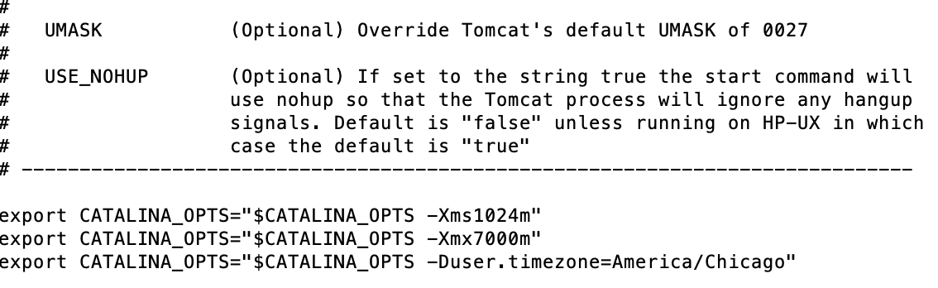

Database Table Layouts

There are 4 tables that the application uses:

Table: email_addresses:
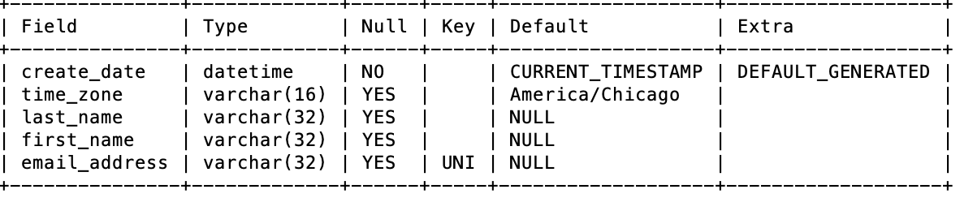

Table: file_downloads:
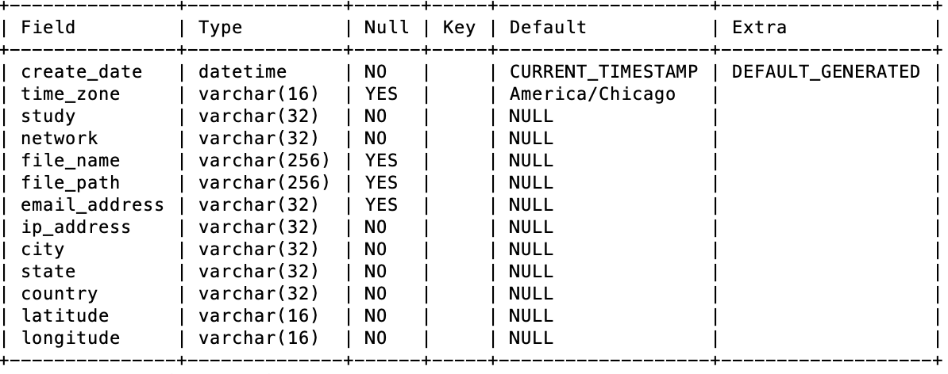

Table: web_hits:
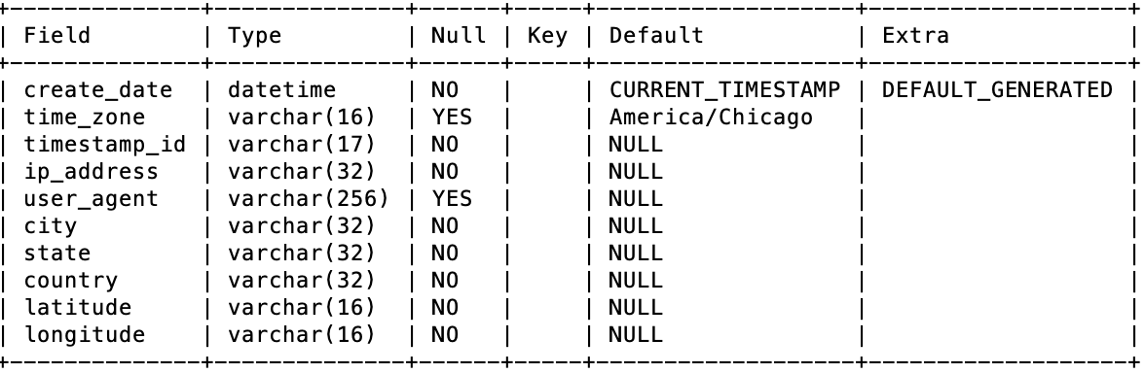

Table: map_urls: (stores the embed iframe data for the web hits and file downloads maps – refer to the application document ‘CreateNewMap.rtf’ which can be downloaded from the application Admin Console):
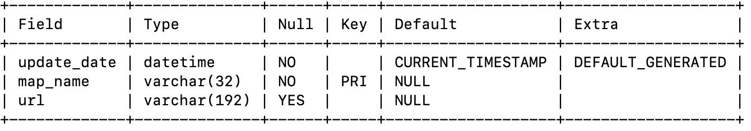

MYSQL LINUX CONFIGURATION

The following user and password must be created in MYSQL so that the JDBC Connections in the java layer are able to connect:

CREATE USER 'midbatlas'@'localhost' IDENTIFIED BY 'soggy12_TOAST='
GRANT ALL ON midbatlas_db.* TO midbatlas@localhost;

Development Environment And Source Code

The source code version control is in a github repository at:
https://github.com/jjfaircm/midb-precision-mri-atlas-downloader.git

The application is deployed under a tomcat servlet container. It is contained in a .war file named ‘NetworkProbabilityDownloader.war’. All resources required for the application are included in the war file. This includes all the Java .class files (binaries), as well as all image files, JavaScript files, html files, and .css stylesheets. Additionally, all the Java source code is also included in the war file. Eclipse is used as the IDE. On the Linux server (an AWS EC-2 instance) the war file is located at:
/opt/tomcat/apache-tomcat-9.0.41/webapps/

The development environment used is Eclipse IDE for Enterprise Java and Web Developers (Version: 2021-03 (4.19.0) for Mac OS X. The easiest way to set up the Eclipse environment, is to download the eclipse-workspace.zip file and git.zip file and unzip those folders in a folder named jjfair under the Users folder. Also a copy of the midb folder is required. This can be located anywhere on the system. However, the location of the midb folder must be set up as a ‘synthetic’ folder or link to the midb folder under the root folder so it can be referenced as the /midb folder. Refer to Mac OS X documentation for setting up the synthetic.conf file. When you start Eclipse it will prompt for the location of the workspace. Just specify the unzipped workspace under the Users/jjfair folder.

The eclipse-workspace.zip and git.zip files are stored in an account on sync.com
The user id for the sync account is jjfairmidb@gmail.com with a password of ‘boiled12toast’. The password for the email account is the same. In the account there is a folder named np_downloader where the files are stored. Both the git.zip file and the eclipse-workspace.zip file are backed up daily and are therefore current.

Server Configuration

The application is deployed on an Amazon EC2 instance which is a Linux Ubuntu server. Tomcat is used as the servlet container. NGINX is used as a web server in front of the tomcat server. All files are served by the tomcat server including static files such as image files. This makes it easy to deploy the application since everything is included in a war file. The war file is generated using the Eclipse IDE export functionality. The name of the war file is NetworkProbabilityDownloader.war. When a new version needs to be deployed on the server, the new war file is uploaded to the Linux server using the scp command via an ssh connection. The war file should be uploaded to the ubuntu home directory. Once in place, there is bash script used to install the new war file in tomcat. The script is invoked as follows: sudo bash updateNPD.sh

SSL Encryption

There is a digital certificate installed to enable ssl encryption. All encryption is handled through the nginx web server. The configuration of the nginx server specifies the location of the digital certificate. The certificate is obtained for free from letsencrypt.org.
The command to obtain a certificate is as follows (DO NOT EXECUTE THE COMMAND DESCRIBED BELOW UNTIL READING THE REMAINDER OF THIS SECTION):

sudo certbot certonly --manual --preferred-challenges=dns --email jjfaircm@gmail.com --server https://acme-v02.api.letsencrypt.org/directory --work-dir=. --config-dir=. --logs-dir=. --agree-tos -d midbatlas.io

You should substitute your own email address in the above command. The certificate must be renewed every 3 months. When the above command is run, an entry must be made in the hosted zone in AWS. The account id is: 734225062508. Simply go to
https://734225062508.signin.aws.amazon.com/console. You can specify a userid of jimfair with a password of saw12BIG!+

You can contact Damien Fair to have someone set up a new userid for yourself. It should have the same authorities as the jimfair userid.

Once you are logged in to the AWS admin console, you should go into the Route 53 dashboard. Then you must select the midbatlas.io hosted zone. You will need to update a text record in this hosted zone. The name of the record to update is:
_acme-challenge.midbatlas.io
The new value you need to put in the text record will be displayed when you run the certbot command above. Copy the new value into your clipboard. (Note: although the current value in the text record will display in single quotes, you should not put the new value in single quotes. Just erase the current value (including the single quotes) and paste the new value in (do not add single quotes around the new value). Then click the save button.

When running the certbot command on the EC2 Linux server you should create a new directory under the ubuntu home folder. You can name the folder something like ssl_0824_2022. Then you should go into that directory and now run the command. After executing the certbot command there will be a folder created named live. In the live directory there will be an midbatlas.io directory. (NOTE: To be able to cd into the live directory and subdirectories it is easiest to first execute the following command: sudo sh ). Four files with an extension of .pem will be generated in the midbatlas.io directory. The files should be copied into the /var/certs directory (note: It is safest to rename the existing pem files by appending .old to the existing file names before copying in the new files.) Then nginx should be restarted: sudo systemctl stop nginx sudo systemcltl start nginx

Once you have completed the above steps the certificate will be good for 3 months.

Admin Console

Various administrative tasks may be executed by accessing the administrative console view in the application. To login into the admin console, double-click on the DCAN image which is in the right-hand side of the splash image on the main page of the web application. Before clicking the image you should refresh your web page since there is a time-sensitive token that expires when the web page loads. This token expires after 30 seconds and to access the admin view you must have a fresh token.

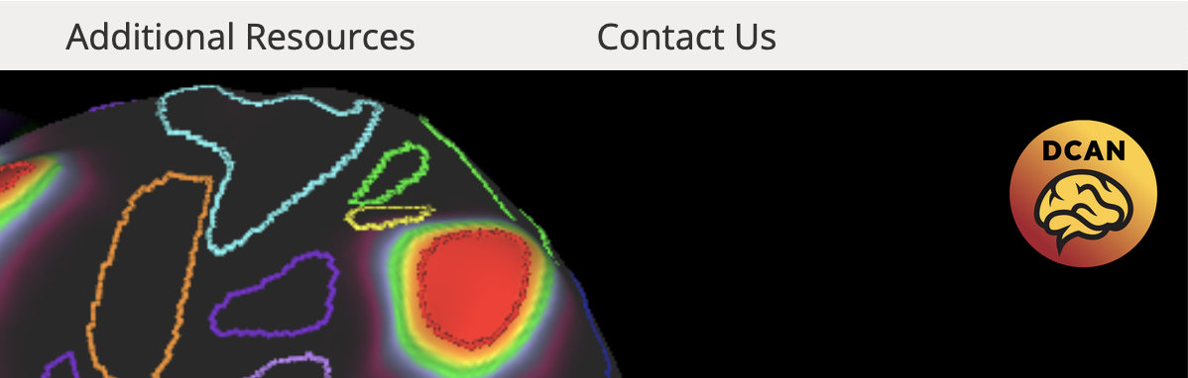

Once you double-click the DCAN image a login panel will display:

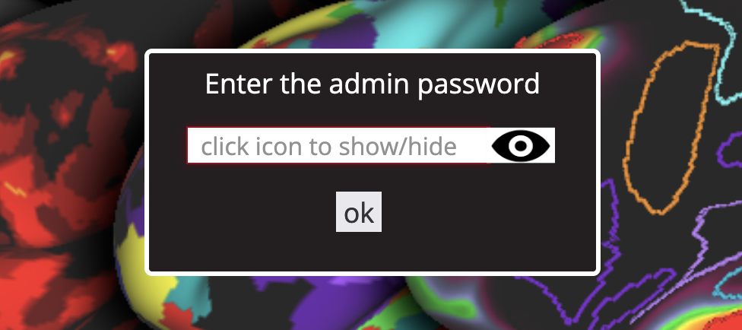

Once you login you can access the various admin tabs. There is a tab for downloading various documents pertaining to the application and how to complete different tasks.

