Adding A Study

Preparing The Data For Upload

The top level folder containing all data should be named ‘surface’ for surface data and ‘volume’ for volume data.
- Combined Clusters data should always reside in the ‘combined_clusters’ subfolder.
- Integration Zone data should always reside in the overlapping_networks subfolder.

The different types of Single Network data shall reside in folders specified in a file named folders.txt. There are common subfolder names that are recommended for the various Single Network types. The following screen image shows a sample folders.txt file using the recommended subfolder names.
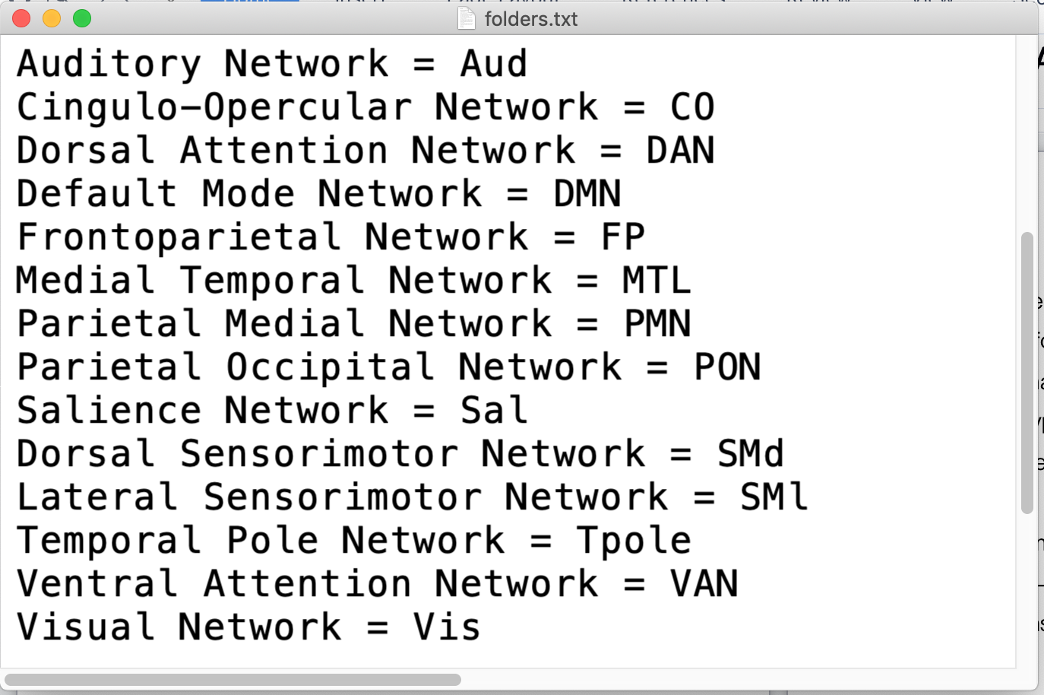

Each line in the folders.txt file specifies a Single Network name followed by the “=” character and then the subfolder that contains the data. The Single Network data type name to the left of the “=” character will be the name displayed in the dropdown selection list on the browser as shown in the following screen image.

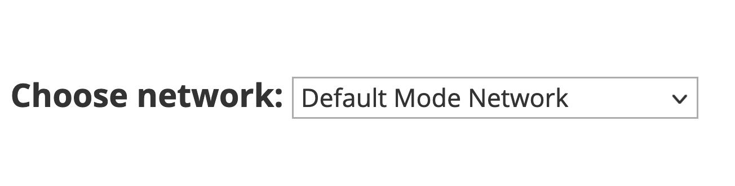
It is important to note that spaces in folder names are not allowed. Additionally, folder names are case sensitive. The subfolder name under the surface folder must be identical to the name specified in the folders.txt file. When a study has both surface and volume data, the subfolder structure under surface must match the subfolder structure under volume.

The following screen image shows the surface folder with all it’s subfolders. This image corresponds to the entries previously shown in the folders.txt file. (Keep in mind that the combined_clusters folder and the overlapping_networks folders should not be included as entries in the folders.txt file.)

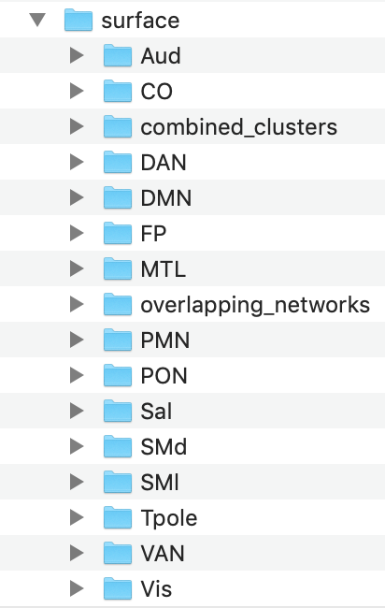

Creating The Zip Files

Once the surface folder has been created you can compress the folder into a file named surface.zip.
It is important that the top level folder in the zip file be the surface folder. The same process should be used to create the volume.zip file if volume data is available.
Make sure that you do not include summary.txt and folders.txt in the zip file. The surface.zip file should contain only the zipped surface folder. The volume.zip file should contain only the zipped volume folder.

When creating a zip file on a MAC using the built-in GUI interface, the resulting zip file will contain hidden files that are only relevant to the MAC operating system. For example it will create a __MACOSX folder, as well as other unwanted files. This will create the zip in an undesirable format. To avoid this, the zip file should be created via a command-line command in a terminal window. For the following example it is assumed the ‘surface’ folder resides in a folder named ‘study_data’ under the system root folder.

- Open a terminal command shell window
- cd to the study_data folder (cd /study_data)
- Run the following command:

zip -r surface.zip surface -x "*.DS_Store" -x "__MACOSX"

Note that there are 2 underscores before MACOSX, and 1 underscore in *.DS_Store

If the zip command is not found, you can qualify the zip command as follows: /usr/bin/zip

Creating The Atlas Summary List
There is an Atlas Summary list that appears in the browser window underneath the main image panel as shown in the following screen image.

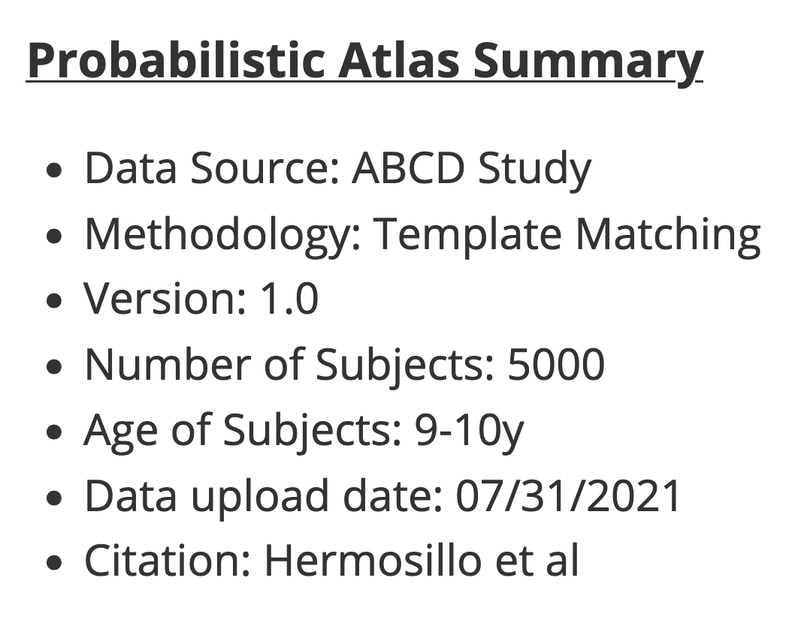
You must supply a file named summary.txt that includes the list shown in the summary. The following screen image shows sample content in the summary.txt file. Each line in the file corresponds to an item in the list displayed in the browser. The contents of each line should be brief (i.e. no more than 50 characters)

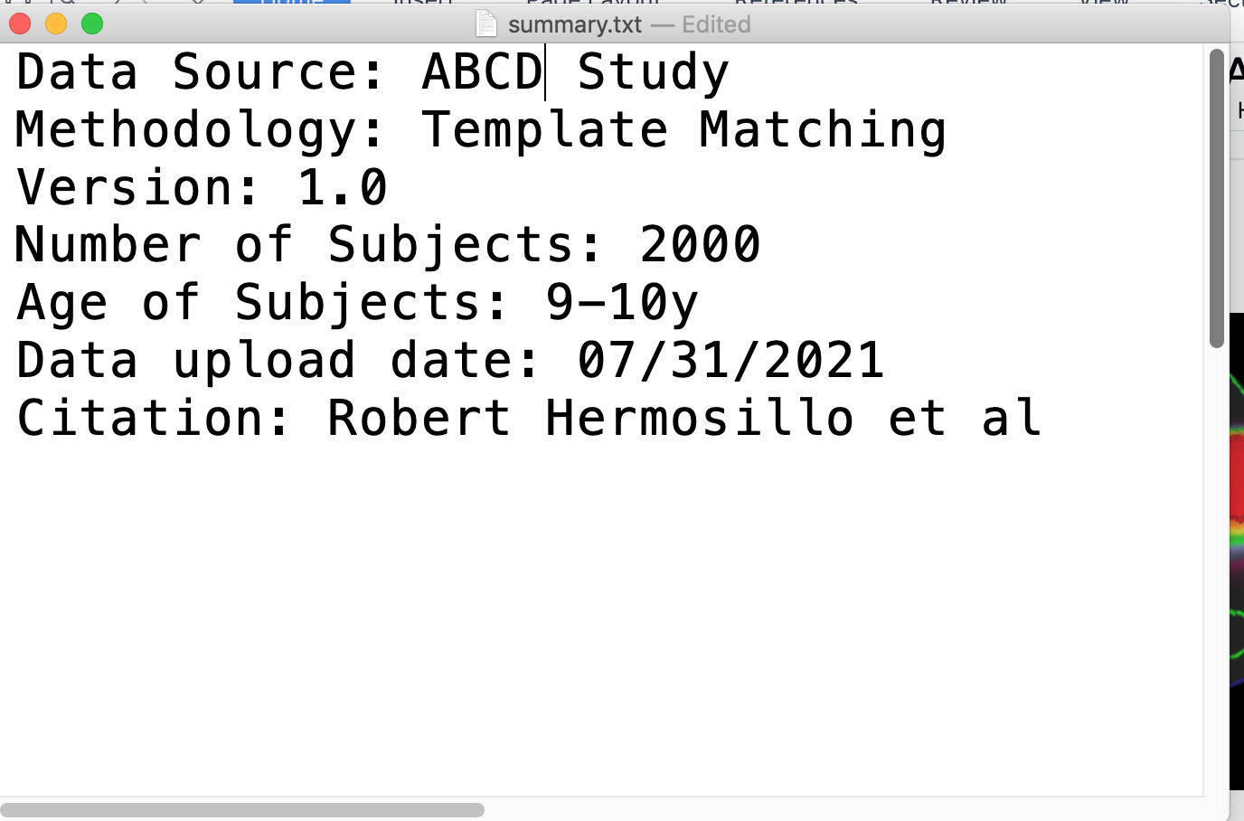

To recap briefly, you should have the following files created before beginning the upload to add a new study:
- summary.txt
- folders.txt
- surface.zip (and/or volume.zip)

Admin Page: Adding A New Study

There is a hidden menu option that will open the Admin Page. To login to the admin page, double-click on the DCAN logo in the upper-right portion of the splash screen in the browser.
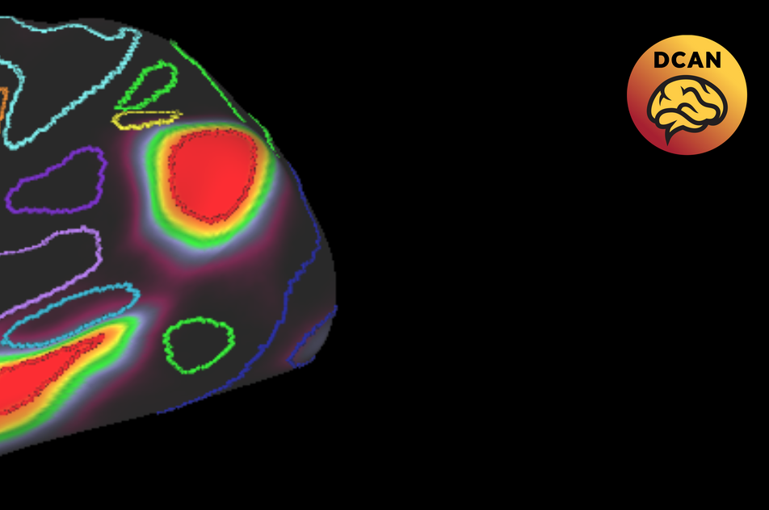

For security purposes, a single-use token is sent to the browser whenever you first access the web site or whenever you refresh the page. This token will expire after 60 seconds following a page refresh. Therefore, after refreshing the browser page, you must double-click the icon and login to the admin page quickly after a browser page refresh.

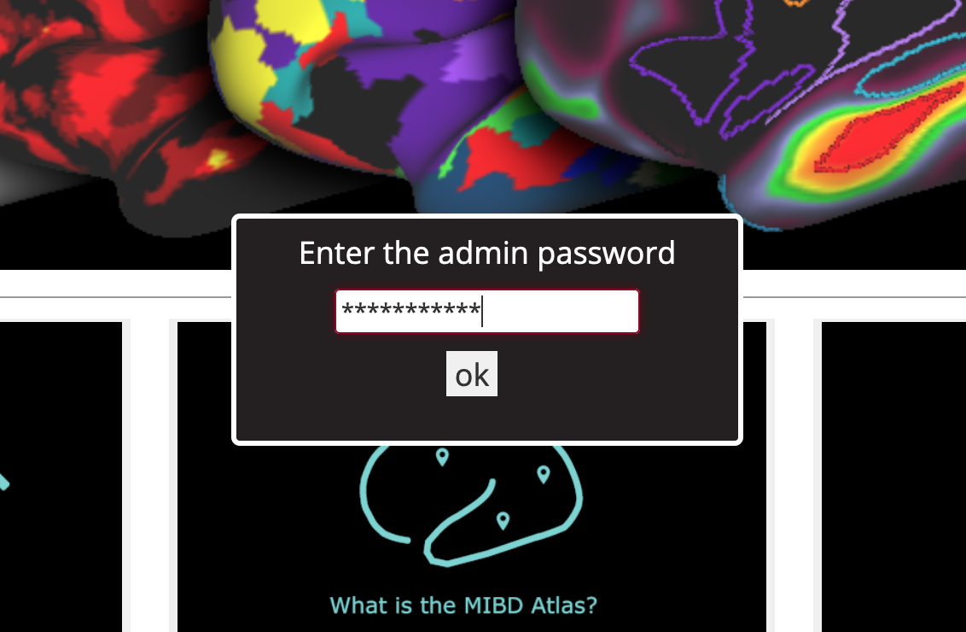

After entering the password, the following screen will appear.

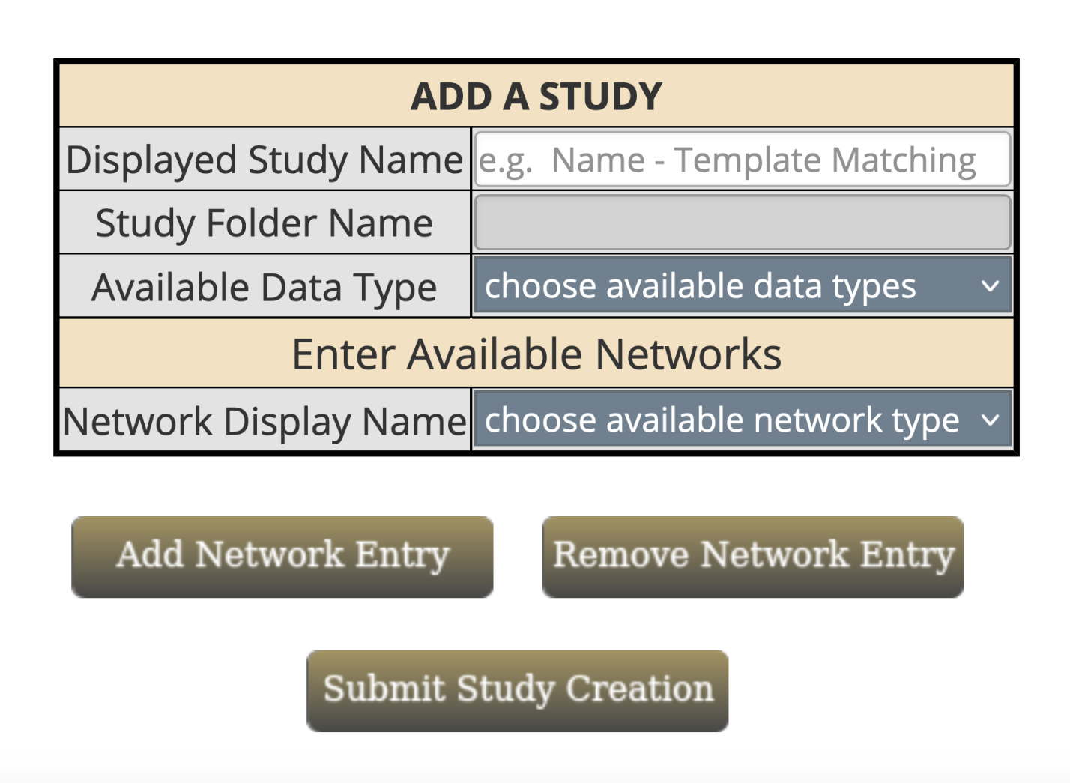

You should enter a name for the new study that will be displayed in the first level of the dropdown menu, such as ‘Sample - Template Matching’. Once the cursor leaves this input field, the application will automatically assign a folder name where the study data will be stored on the server (sample_template_matching). You can then select what type of data is available: surface, volume, or surface and volume data.

Next, you can choose what type of network data is available. For the sake of consistency the order should be: Combined Networks, Integration Zone, Single Networks (if all 3 are chosen). If just 2 are chosen then the order would be Combined Networks, Single Networks, etc. The following image shows a screen shot after a study name has been entered and other selections have been made.
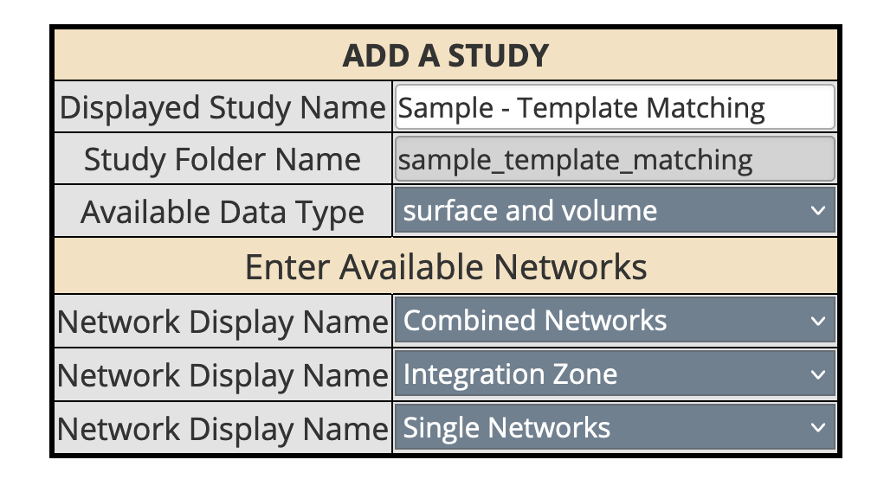

Next the files containing the network data must be dragged and dropped on to the drop zone rectangle.

You must drag and drop the following files:
- summary.txt
- folders.txt
- surface.zip (and/or volume.zip)

The table on the screen will appear as follows:
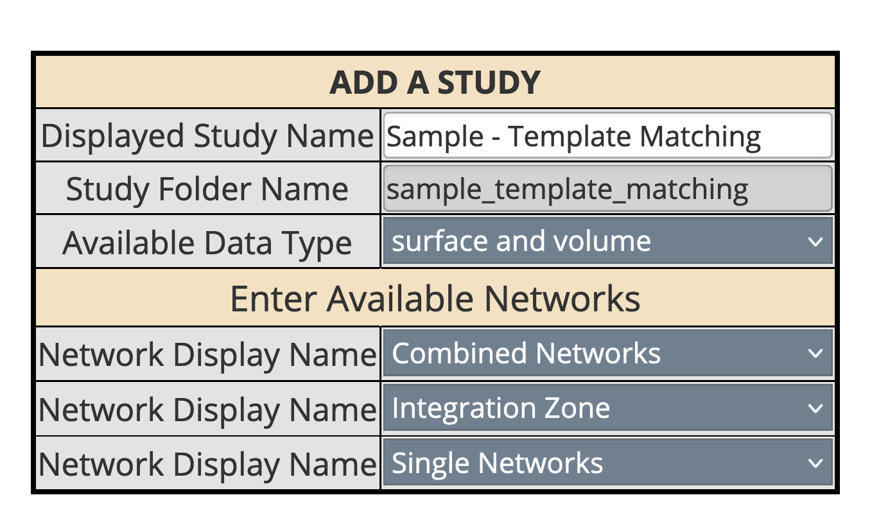

The drop zone will appear as follows:
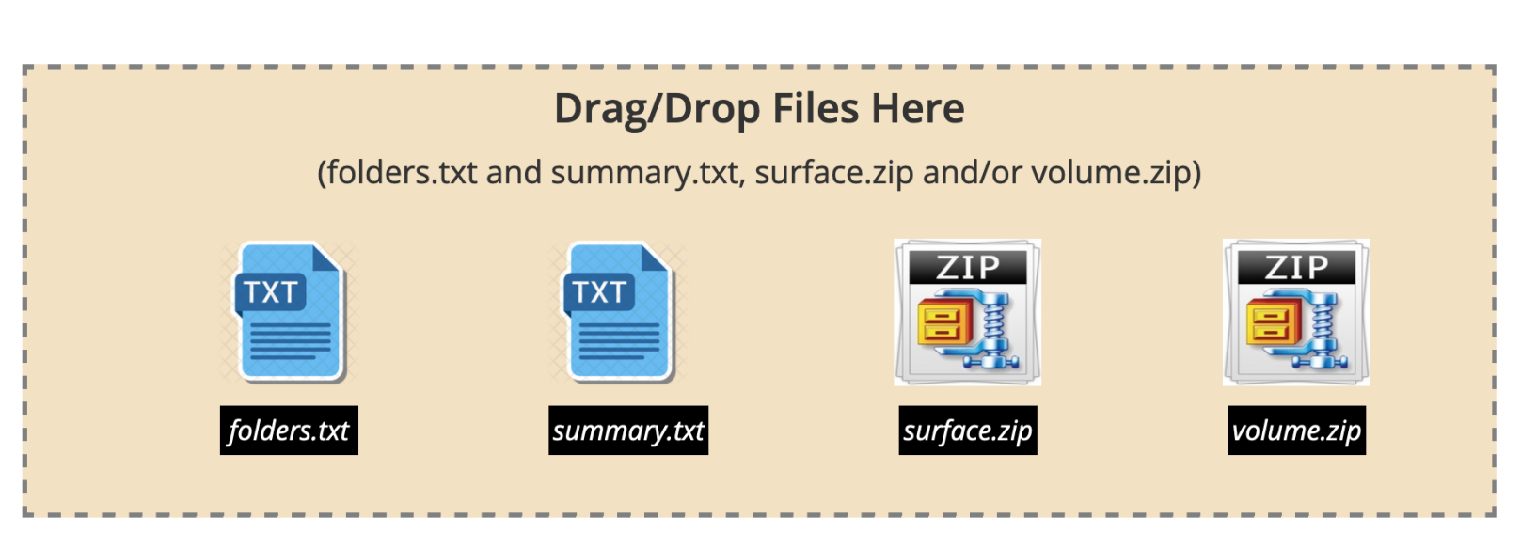

If you want to remove a file after putting it in the drag/drop zone single click on the file image.

Now you can click the Submit Study Creation button and the file upload will start. This may take several minutes or more (depending on your connection bandwidth and network congestion). There is a browser timeout of 40 minutes for the request to complete. On a 1GB internet connection it takes about 15 minutes for everything to complete when uploading the summary.txt, folders.txt, surface.zip, and volume.zip files.

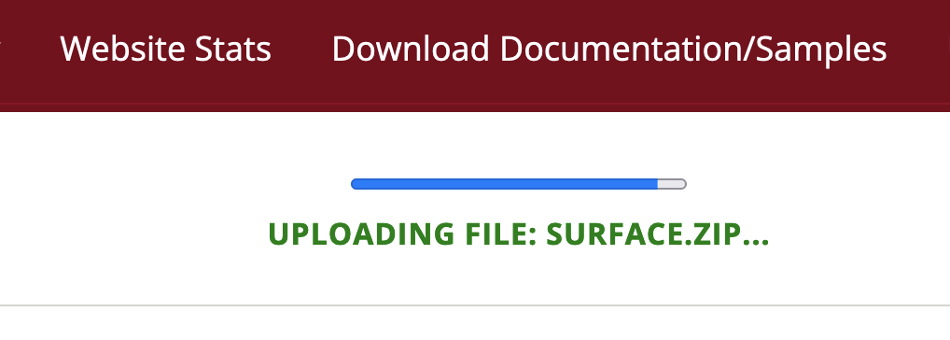

After the files have been uploaded, the zip files will be extracted on the server.

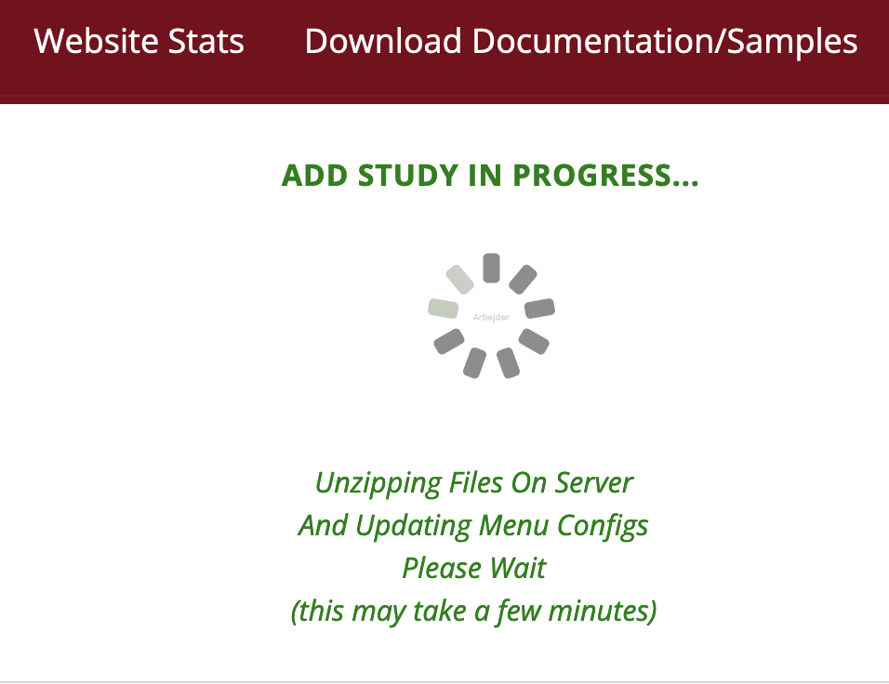

Once the zip files have been extracted and the relevant config files have been updated, you should get a completion message:

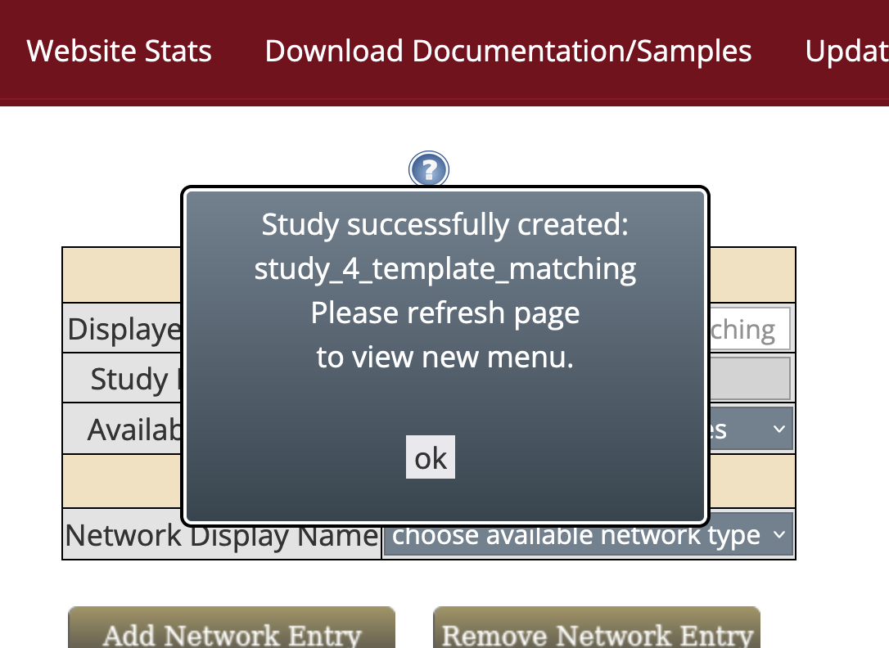

Click the ok button and refresh your browser page. You should then see the new study available in the fly-over menu on the downloader tool page.
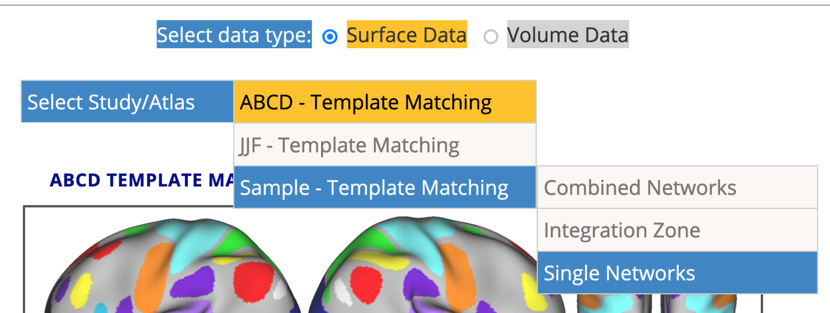

There is also a Remove Study option. Currently, the abcd_template_matching is not allowed to be removed (so it doesn’t accidentally get removed during testing). The Update Study option may be used to update the summary of an existing study or to add/update surface or volume data.

