Create New Web Hits Map

The web hits map is created using the ‘My Maps’ functionality in google maps. In order to create a map you must have a google account (which is free). If you do not have an account, you should first create an account at google.com before continuing.

To create a map you need to get a csv file with the longitude and latitude data. These are the steps you should follow:

- Open the Admin Console in the midb_atlas application
- Choose the ‘Update Maps’ tab
- Next, select ‘Download web_hits_geoloc.csv’ from the dropdown. This will download the current geo-location data for all the web hits. This file will be used later and imported into the google ‘My Map’ data.

Now you should open a browser session to https://drive.google.com. If you are not already logged in to google, you will need to login.

In the upper right side of the screen click the +New button:

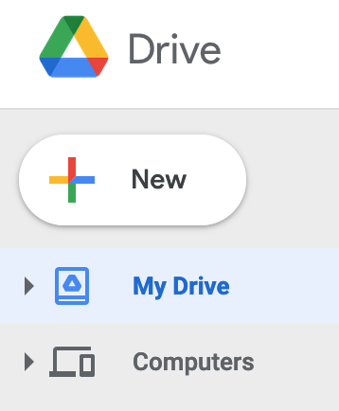

Then select: More->Google My Maps:

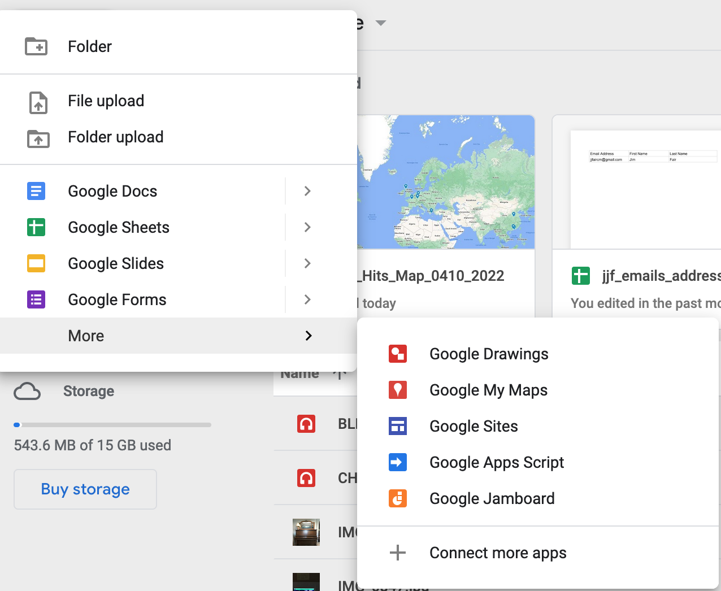

A new popup window will appear. Click on ‘create’ in the lower right of the popup window:

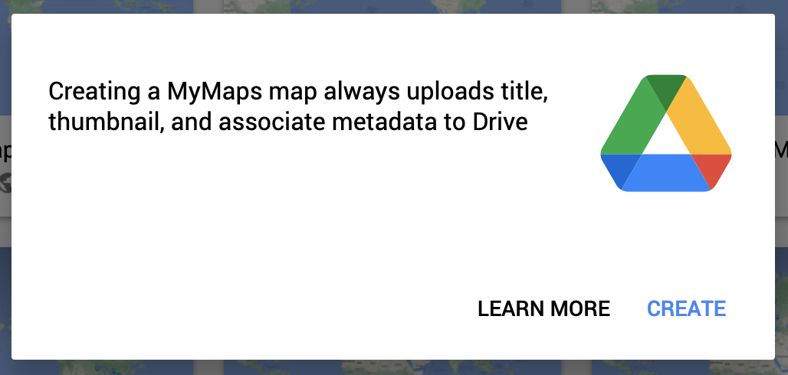
Then click on ‘import’ to upload the web_hits_geoloc.csv file that was downloaded earlier:

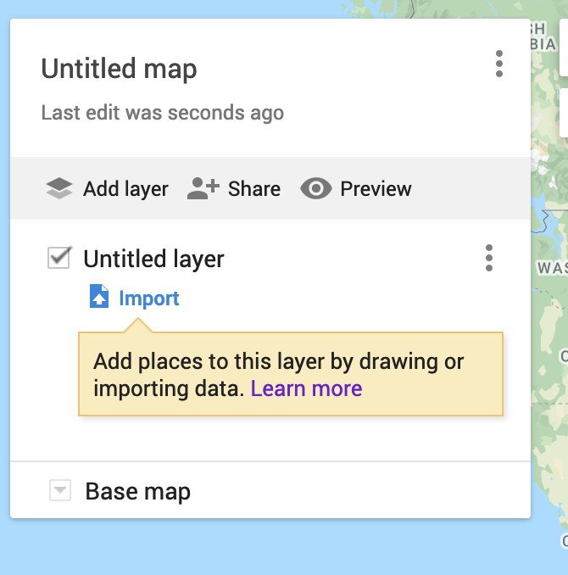

Then drag and drop the web_hits_geoloc.csv file into the drop zone:

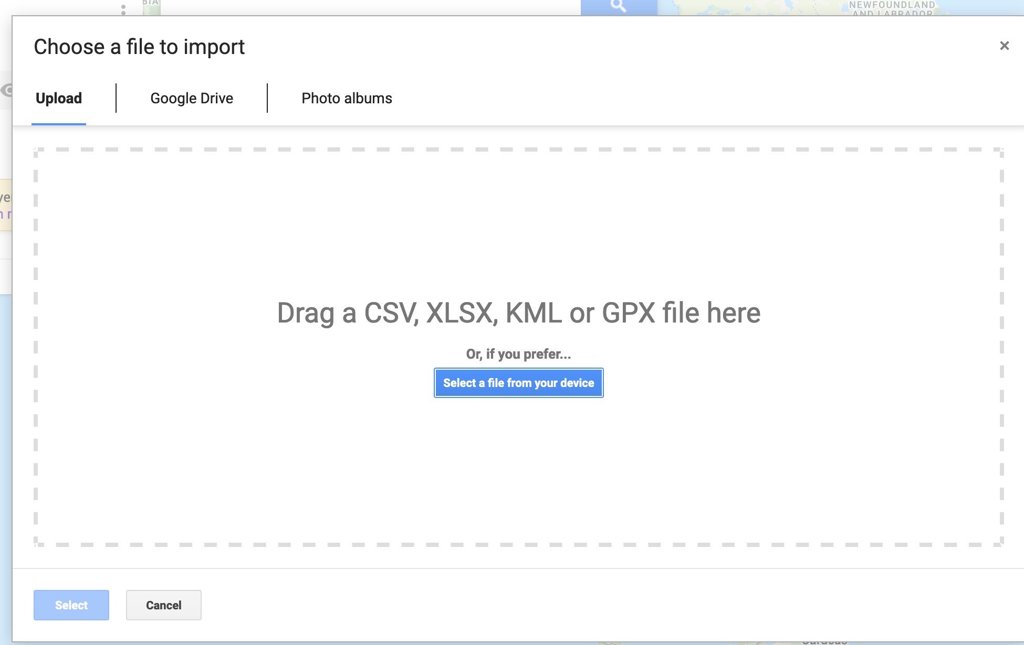

Then accept the default selections to position placemarks and click the continue button:

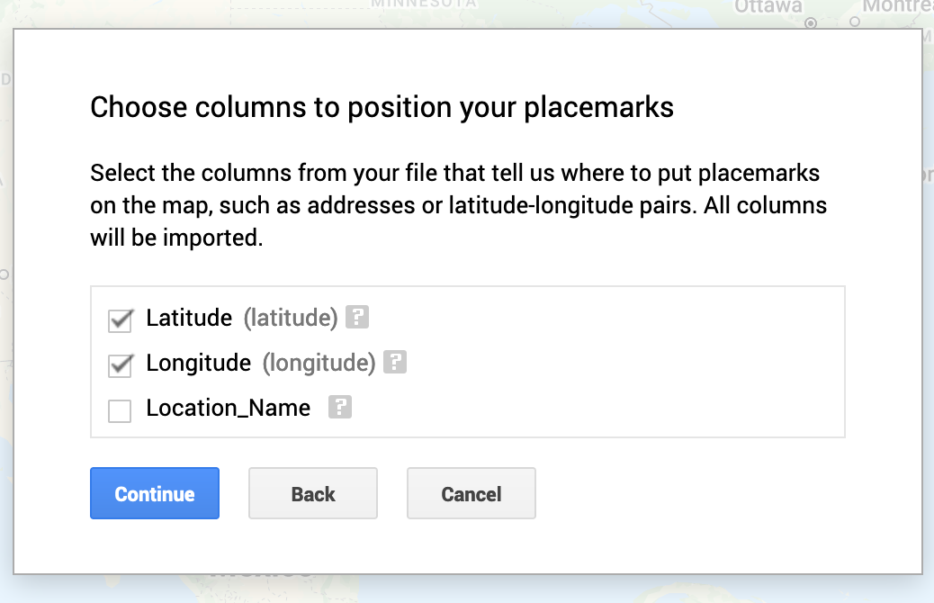

On the next screen select Location_Name as the column to title markers:

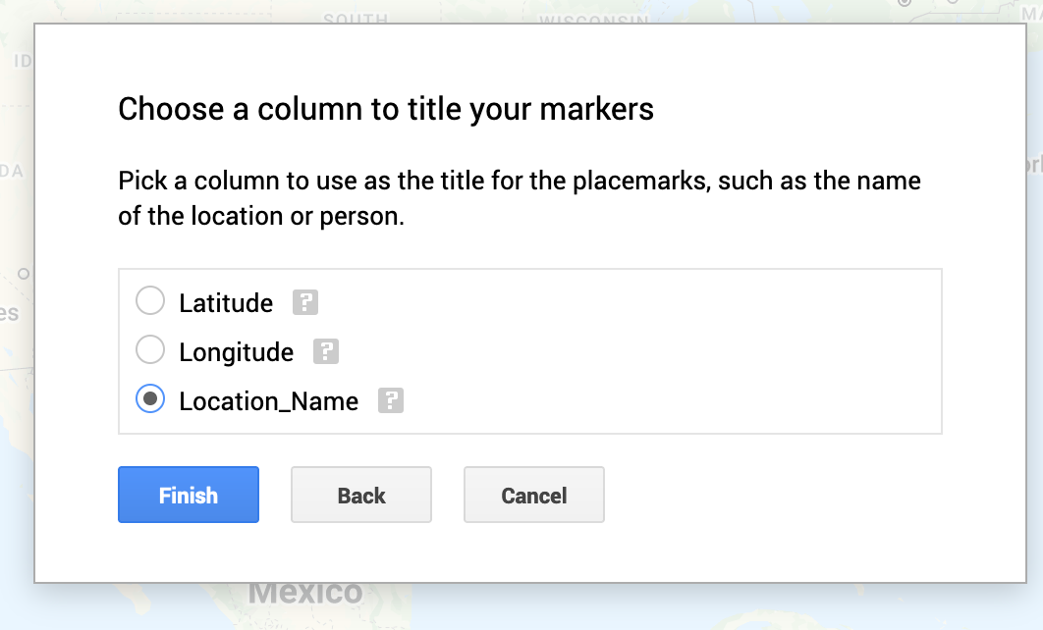

Then click the Finish button.

In the ‘Untitled Map’ pane, click Share:

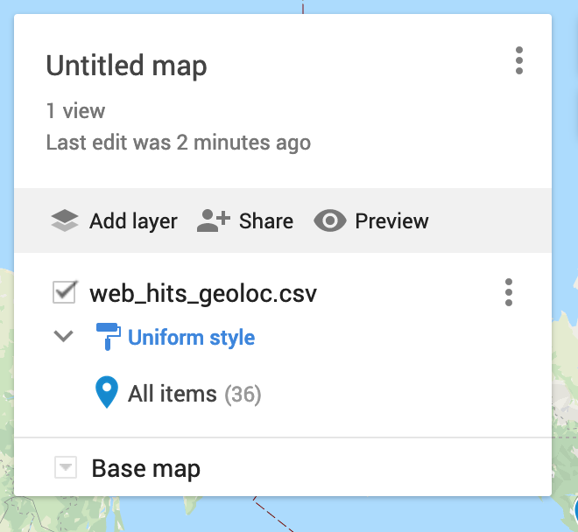

Give the map a name. It’s probably a good idea to name the map with some date information:

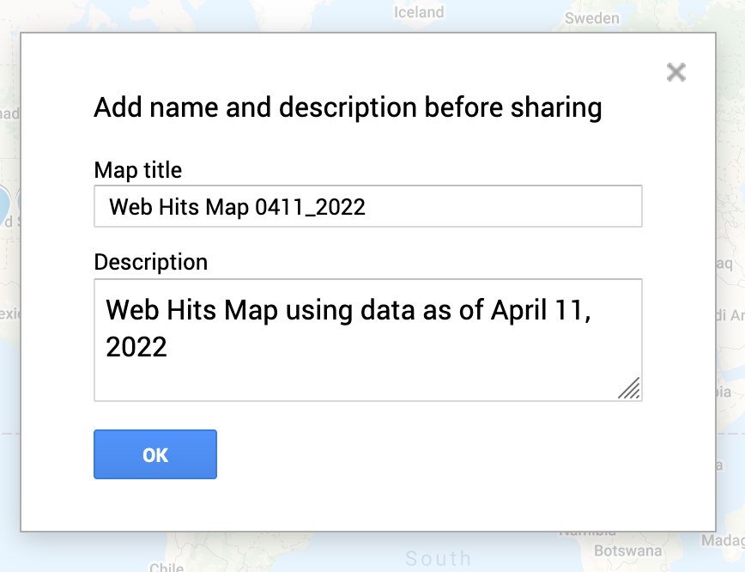

Then click the OK button.

De-select: Let others see your name.
Select: Anyone with this link can view.

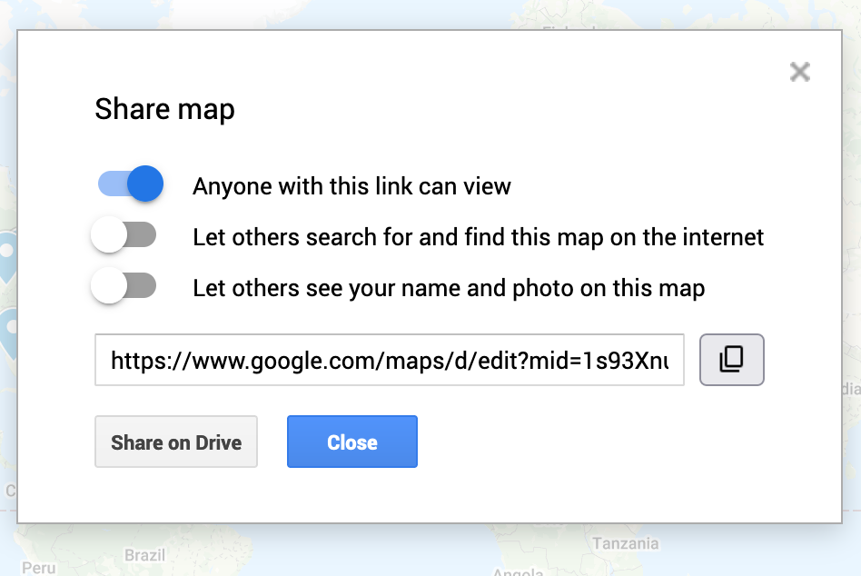

Click the Close button.

In the upper right of the screen, select the menu to the right of the map name.

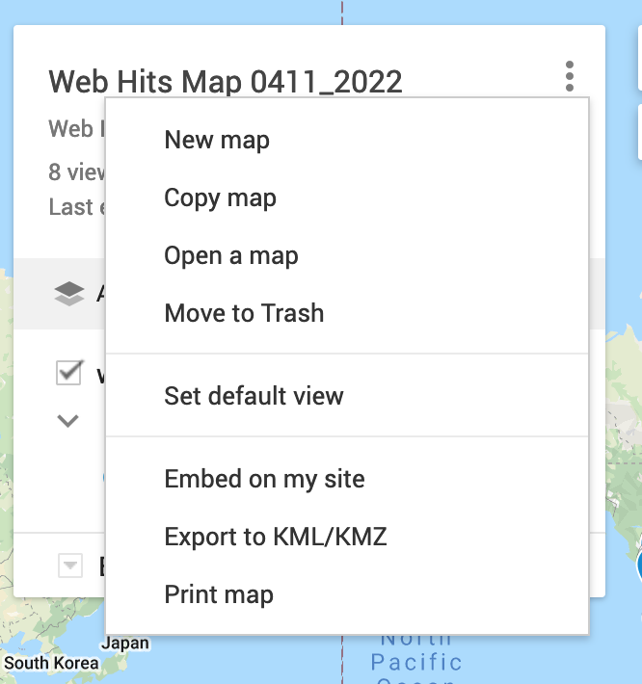

Select ‘Embed on my site’ and copy the pre-selected text into your clipboard:

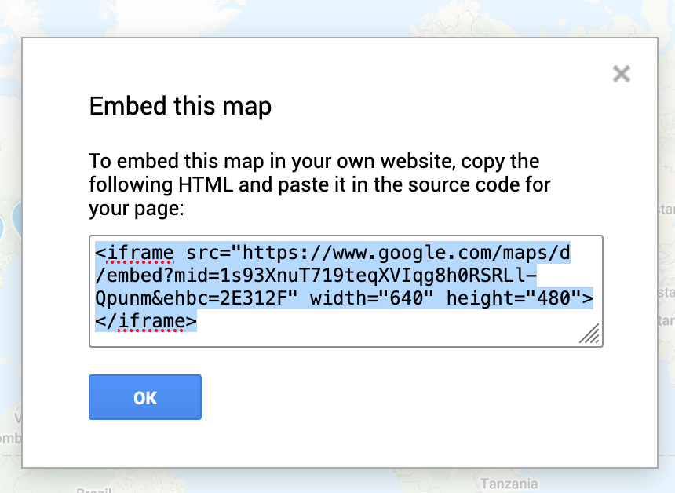

Click the OK button.

Now go back into the Admin Console of the midb_atlas application. If the session has timed out, that’s ok and you can just refresh the page and open the Admin Console again. Go into ‘Update Maps’. Then select ‘Update Web Hits Map URL’ :

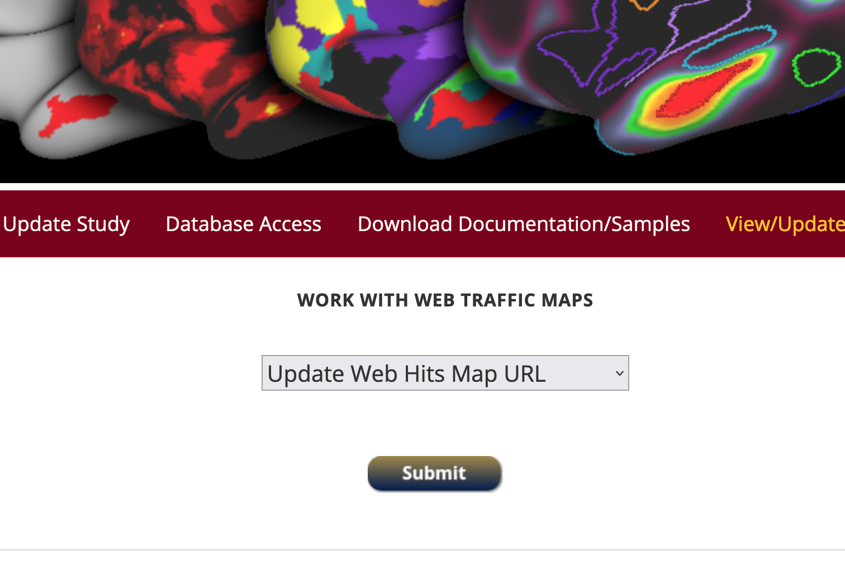

Click Submit and paste the url link into the input field. If your clipboard no longer has the url link in it you can go back into your google drive session and click on ‘Embed on my site’ again to re-copy the link.

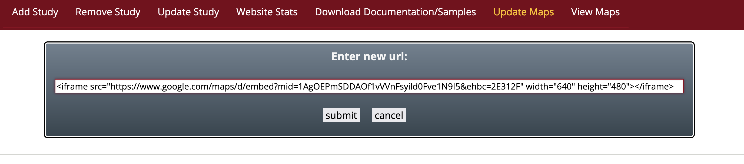

Click the submit button.

You will get a completion message and now the new map url will be used when the View Web Hits Map option is selected from the dropdown. This link is persisted in the database table named map_urls. It will always be used until this process of updating the map is executed again.

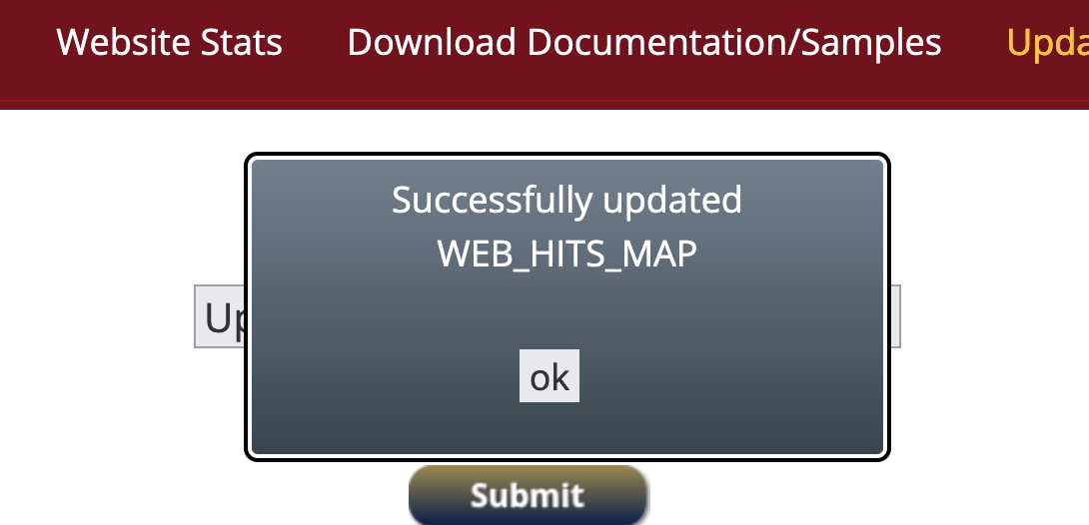

You can click ok and test the new url by selecting View Web Hits Map in admin menu bar.

Note: If the new map does not appear or if the map does not appear to format correctly, you may have to refresh your browser by closing your browser, then open a new browser window/tab and going back to midbatlas.io. Then go back into the admin console and select the ‘View Maps’ option.

Note: The process for creating a new Download Hits Map is very similar. Just choose the option to ‘Download file_downloads_geoloc.csv and use this file to create the new google map by importing this file. After creating the new map, copy the embed url into the clipboard and then in the Admin Console choose the option to ‘Update Download Hits Map URL’.

