Folder Structure:

* It’s important to note the file structure as I run from the Root folder for development
* Root
  + Client
    - Client.py
  + Server
    - Server.py

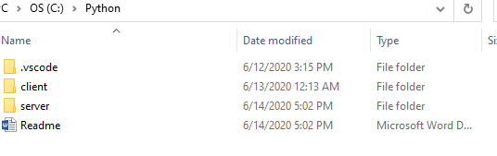

Client Script

* Running, has 2 modes API and Interface Mode, if parameters are set it goes into API, if none then there is a user interface console.
* 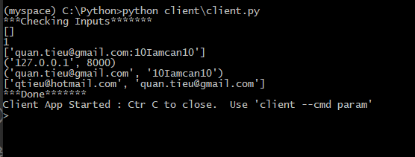
* In the App Mode there is a command prompt to enter “client –cmd param”

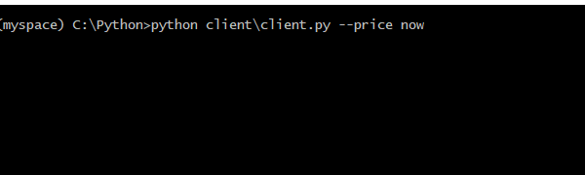

* In API mode just set the parameter outside, currently it only supports 1 parameter at a time.

Libraries:

Gmail Note:

* Gmail requires secure client, so in order to use the Gmail account, first thing to do is disable the Gmail for secure clients for Gmail settings

Note:

* usually the file path is an issue, please check the console the file path is valid for settings text file

Server Script

* Running, note tickers are comma separated in the command line

Using Historical Data (assumes there is data):

* python server\server.py --tickers IBM,AAPL --reload filename.cc --minutes 30 --port 8000

Not Using Historical Data:

* python server\server.py --tickers IBM,AAPL --minutes 30 --port 8000

Note:

* usually the file path is an issue, please check the console the file path is valid for settings and csv
* I have no idea what “reload filename.cc” is so, I’m taking a guess it means all historical files. So, I am assuming if the that there were files generated previously and those are used.

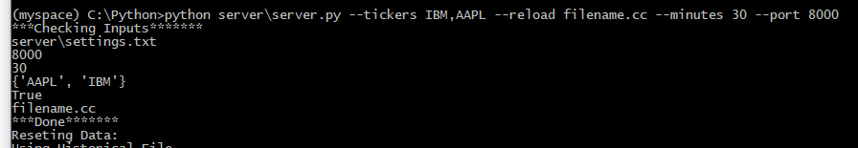

* There is a section on load of the script to check the loading
  + True, filename.cc => use historical,
  + False, ‘’ => use new data