Table of Contents
What to Design and Why 1
3D Modeling Tools 2
Minecraft 2
Create something awesome 3
Mark it 3
Export 4
Verify 8
Tinkercad 10
OpenSCAD 27
Code 29
Preview 29
Status 29
Common OpenSCAD Object Functions 34
Blender 47

A few general comments:
You mention a lot of 3D printing terms that I don’t think we’ve defined yet. What if we include a really high-level overview of the whole process in the introduction?
Agreed, perhaps in the new “anatomy of a 3d print” section we discussed in email? /JJG
Readers will find this tools overview useful, but when you move into projects, do you plan to use one tool for the rest of the book? It might make things easier if you do. At minimum, I’d suggest one tool per project.
Definately one tool per project if I refer to the tool at all (I plan to keep the projects tool-independent if possible) /JJG
Some notes about figures:
Could you embed smaller, lower resolution versions of the images in the LibreOffice files? The software tends to slow down when there are a ton of big pictures.
Will do /JJG
Throughout the chapter, I’ve also been adding figure callouts and captions, as examples. Do tweak those if I have you wrong! Could you continue adding captions for figures in future chapters? /JG
Will do /JJG
3
3D Modeling
Modeling is the process of designing a model for printing. In 3D printing, you’ll often model three-dimensional objects using digital tools alone. You could also combine multiple steps of modeling in physical mediums (paper, clay, and so on), scanning the physical model, and writing code to generate the digital model. The only fixed aspect of modeling is that the output is a file (most commonly, an STL file) that you can feed to the next step in the 3D printing chain.
Perhaps better not to mention the actual word “slicing” now, unless we’re going to discuss it in the chapter. /JG
Agreed /JJG
This book focuses on digital modeling, and in this chapter, I’ll provide an overview of several tools you’ll find useful as you get started in 3D printing. There are many 3D modeling tools out there, but since the need for these tools began in industrial and professional environments, many are designed for expert operators at big companies and come with a price-tag to match. Fortunately, things like animation and 3D printing have driven demand for these tools in the consumer market. There are now several free, open-source options as well as low-price commercial products that are more approachable for casual or novice designers.
I moved the intro to the 3D modeling section up here because I think it fits well in in the introduction.
Makes sense to me /JJG
Could you also add a high-level overview here of the tools you’re covering, perhaps in order from most to least intuitive? For example, Minecraft is pretty simple to model in—a 10 year old could do it :)—but Blender is at the opposite end of the spectrum. /JG
Good Idea:
In this chapter we'll try out four very different modeling tools. Each tool suits a different audience, from Minecraft, which can be used by anyone who's played a first-person video game to Blender which will feel most natural to people who have experience with other professional modeling tools. In-between we'll try OpenSCAD, which will make most programmers feel right at home and Tinkercad which strikes a nice balance between traditional CAD tools and an easy-to-learn web interface (and includes an extensive teaching system as well).
There's no need to learn them all, but give each a try and then pick the one that suits you the best.

But before you can model anything, you’ll need to decide what you want to make!
Do I have you right with my edits here? /JG
Yes /JJG
Finding Design Inspiration
What you design is entirely up to you! Of course, one source of design ideas is your imagination. Are there things that you've always wanted but have yet to be invented? Sometimes, however the process of acquiring (or building) a printer, setting it up, and calibrating it can consume so much time and mental effort that by the time you’re ready to design something to print, you’re at a loss. If you find yourself in this situation, explore what others have done on websites like youmagine.com or cubehero.com for inspiration.
The world around you can also be an endless source of inspiration. Take a look at the things on your desk or table (or wherever you’re sitting). When looking at real-world objects, try to imagine the basic geometric solids (cubes, spheres, pyramids, and so on) that they are composed of, and sketch out on paper how you might re-create these things.
If you look to existing objects, you’ll probably find that you need replacement parts for things around the house that have been broken or that simply have parts missing. This might include game pieces, dishwasher caps, oven knobs, drawer pulls, and anything else you can imagine. One of the earliest practical uses for 3D printing at home was creating parts that are no longer manufactured, so try modeling that missing checker piece or knob!
3D modelers often create mashups, as well. Many designs you'll find online were made by combining two or more existing models, either in-whole or along with custom-designed parts, to create hybrid objects. Some of these objects are just for fun, but others meet a genuine need for parts that don’t exist either due to low demand (too low to justify mass-production) or licensing reasons. This is one area where open-source designs shine because they can be combined, modified, and shared without fear of violating patents or copyright agreements.
Whatever you come up with, in this chapter, we’ll explore some tools that can help you turn your ideas into a model that you can bring into the physical world through 3D printing.

Minecraft
You’ve probably heard of the game called Minecraft, but I bet you never considered it a CAD tool. In fact, it may be the world’s most popular piece of CAD software, and it’s certainly the best collaborative design tool created yet. Minecraft is often described as “electronic LEGO blocks,” and like LEGO, you can build just about anything out of the cubes that make up the Minecraft world.
I don’t know of any free versions of Minecraft that are official...maybe best to just say “you need a licensed copy”? /JG
Agreed, there's a free “Raspberry Pi” edition now, but it's only avaliable for the Raspberry Pi, and I haven't tested it to see if it will work using the modeling tools here. Do you think I should dig into that or just leave it as “you'll need a licensed copy” and leave it at that? /JJG
You’ll need a licensed copy of Minecraft to use it to create models for 3D printing. Mojang (the creators of Minecraft) has demonstrated great interest in making Minecraft available to educators, so hopefully in the future there will be a version of Minecraft that can be used for modeling by up-and-coming designers at no cost (or even better, a truly Open-Source version!). For now, however, you’ll have to shell out $30 for your own copy. Once you have a copy of Minecraft, here’s what you need to do to create a printable model.
Since we have the section headers here, I think we can get away with out listing them. /JG
Create an Awesome Design
If you’re new to Minecraft you're in for a treat. In addition to Survival Mode (which works like a traditional game), there is another way to play called Creative Mode. In Creative Mode, you are free to build without fear of death or scarcity of supplies. All blocks are available to you in an infinite supply. We’ll use Creative Mode for CAD work.
My advice for creating your first printable model in Minecraft is to use blocks made of sand. This might seem constrictive, as sand blocks only work when stacked directly on top of one-another, but that's precisely the point. Models with overhang (parts that project out of the sides of the model above the first layer) are a challenge for most current 3D printers, but I haven’t been able to create a model with sand in Minecraft that actually has overhang problems. Once you get the hang of what your printer is capable of, you can move on to blocks that allow more complex designs.
I also suggest building something square and fairly large because the models that come out of this process are very low-resolution compared to what most printers can output. Designing something large mean you’ll have less scaling-up to do before printing, and the resulting print will have a smoother appearance. (Of course, keep it small if you want an 8-bit look, and scale the heck out of it later!)
Mark Your Build
Once you complete your design, you’ll need to place some markers inside the Minecraft world to tell the next step exactly what portion of the world to export as a model. These markers are stacks of a special sequence of blocks at two points that define the borders of what you want to print.
These stacks define both the “rectangle” (X and Y axis) around what should be printed and the “cube” to be printed by defining the bottom and top of the model (the Z axis). You’ll place one marker at a level that defines the bottom of the model and one high up in the air to define the top. I recommend including some of the base (the ground the model is built on) in the bottom of the model and extending the top above the top of what you want printed. Including some ground blocks with the first marker provides a solid base for the model to be printed on, making it less likely to become detached during the printing process. Keeping the second marker well above the top of the model helps you avoid accidentally cutting of the top, and any empty space above the model will simply be ignored.
Once you've selected the location for the two markers create them by building a stack containing the following blocks: diamond, gold, iron. Place the first stack at one corner of the area you want to print, and place it a few blocks below the ground the model is built on. You might have to dig a little, as in Figure 3-1.
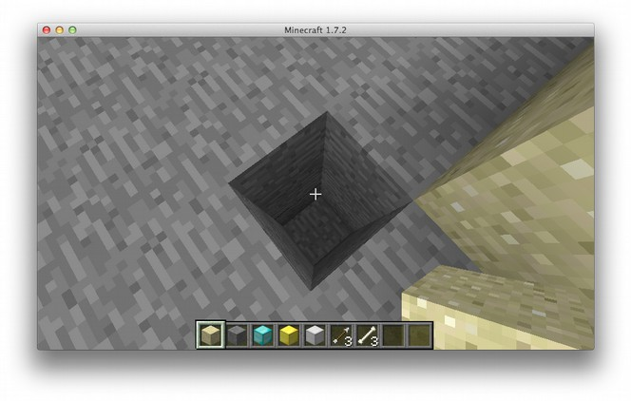
Figure 3-1: Digging to place the diamond, gold, iron marker
You’ll see throughout the chapter that I’m calling out the figures before we show them and adding descriptive captions. Could you do that for future chapters? /JG
Will do /JJG
Build a stack of blocks that aren’t diamond, gold, or iron diagonal from the first marker to define a rectangle around what you want to print. Once that stack is above your model, place the second marker stack up on top, and remove the blocks below the marker.
Do I have you right with my edits above? /JG
yes /JJG
Export the Model
This whole section moves a bit quickly, even for experienced readers. Could you slow down and explain things a bit more thoroughly? /JG
Now we need to leave the Minecraft world for a little bit and set up some tools that will allow us to export the model: Python and Git. If you don't already have these (or are unsure), refer to Appendix X and Y for instructions on verifying and, if necessary, installing these tools.
Prod: confirm Appendix references above and below
I’d suggest one “software” appendix, rather than having one for Python and one for Git. We could also try a “useful resources” appendix, and tell folks how to find these things so they can work out installation on their own. What do you think? /JG
That's probably a good idea, as installing both can vary depending on the operating system, and may change over time. I'm fine with a “useful resource” Appendix that references basic canonical sources for installation information /JJG
Once you have Python and Git working, you’ll need to download a copy of minecraft.print, the Python library that will let us turn our Minecraft build into a 3D model. Open a console (What’s a console? See Appendix Z) and issue the following command:
git clone https://github.com/codys/minecraft.print.git
This will download the latest version of the script we’ll use to export your model from Minecraft.
I think we can get away without showing the git clone command output here, since it’s a bit like a progress bar. /JG
Once Git finishes, you should be able to move to the minecraft.print directory using the cd command.
cd minecraft.print
Chances are you'll need to install some dependencies before you can run the export script. Use easy_install to get numpy and PyYaml.
Will the reader have easy_install? Is it part of Python? Also, are we assuming a Unix operating system, with sudo? /JG
A working Python install should have easy_install. Good point about sudo though. In the appendix where we explain what a console is we could point Windows users toward an “Admin” console, which would remove the need for sudo, although I'm hesitant to send novice Linux users to a root console to accomplish the same thing. /JJG
sudo easy_install numpy
sudo easy_install pyyaml
Now, you should be able to use the export script. Enter python run.py at the command line.
python run.py
>>> Try the following syntax: python run.py levelname outputname
I’m not sure what the terminal output should look like here, but I think it would make sense to show it in context. Could you tweak if it looks different? /JG
It will vary depending on the O/S, maybe we can just leave it out since the section below describes it and what actions to take? /JJG
If you’re asked to try including a levelname and outputname, then you’re all set! If you see something else, then your Python environment is still missing something, which will take additional troubleshooting. Take a look at Appendix X for some Python troubleshooting tips.
Prod: Confirm Appendix X reference above
Now we’re ready to export your awesome new model! Here's the command you'll need to run:
python run.py world model1
This will look in the default Minecraft world file for your model (as marked in previous steps) and generate an STL file named model1.stl. If all goes well, you should see the program output percentages to your console until it’s done running.
When you show terminal output, could you do so as you would command line functions instead of as a screenshot? This makes it easier to edit the output later if needed. :) I showed an example above. /JG
python run.py model_world model1.stl
Processing level: model_world
Scanning level for markers...
1.08932461874%
2.17864923747%

...

87.5%
93.75%
100%
Done!
I combined a couple of screenshots into one listing here; was that correct? Also, do you want to show the argo:minecraft.print jason$? I’ll follow your lead here. /JG
The “propt” can be left out if we're typing out the command output as above, it will be different for every machine so it's not valuable for instruction, troubleshooting, etc. /JJG
If something is wrong with the markers, or if you created the model in a different world file, and so on, you’ll receive an error. If this happens, go back into Minecraft and double-check your markers. If you created the model in a different world, you can just run the export command again, but with a different world name.
Why is it easier to use short world names? So you don’t forget or mix them up? Or does minecraft.print actually have problems with weird names? /JG
Long names and special characters are hard to type, and can require non-obvious escaping depending on the operating system. /JJG
Note: Life is easier for people who use short world names, and ones without spaces and other weird characters
Once you get the script to run without errors, you should find a file named model1.stl (or whatever you provided for outputname) in the current directory. Let’s take a look at that file and see how it turned out!
Verify the Model
Next we need to take a look at the STL file we just created and make sure it’s what we want to print. There are many tools available for viewing STL files, and most will work for previewing the model, but I'll use Meshlab for this example. You can download Meshlab from http://meshlab.sourceforge.net to install it.
Is Meshlab just for viewing STL files, or does it have other purposes? What else can it do? Will we use it later? /JG
Meshlab can do a lot (and frankly I don't know how to use everything it can do :). Do you want me to elaborate on that here? I thought about including a longer section on it but using it for anything more than preview gets pretty technical, and I'm not sure it has a lot of application in a book with this audience. /JJG
Open Meshlab, click File → Import Mesh... and select the model1.stl file we just created. If asked, leave Unify Duplicated Vertices checked and click OK. You should see your Minecraft build rendered as a 3D model, as shown in Figure 3-2.
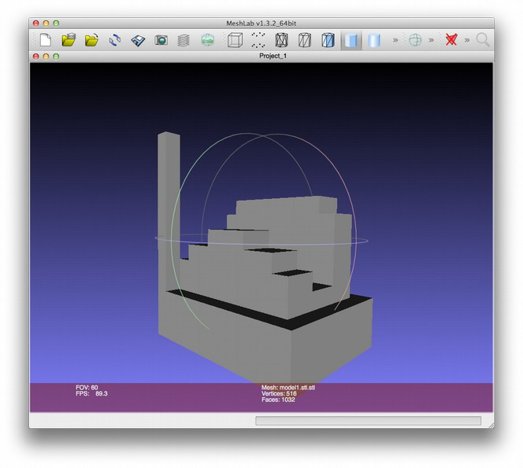
Figure 3-2: This 3D model was generated by minecraft.print.
I’m not sure what you mean by “pushing the low marker into our model.” Maybe we should just show the clean model? /JG
“...and moving the low marker so it is inside the part of the model you want printed”, does that make it more clear? Essentially, we need to make the low marker part of the area we want in the output model. /JJG
Looks like we have some extra stuff in there, so fire up Minecraft again and let's see if we can clean things up. By removing the tower under the high marker, and pushing the low marker into our model, the result is a much cleaner model, as in Figure 3-3.
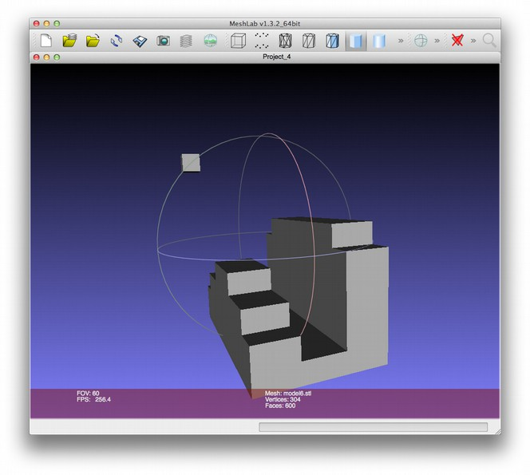
Figure 3-3: After cleaning up your build in Minecraft until you’re happy with it, just run minecrat.print again to create a new STL file.
Meshlab is an incredibly powerful tool, but all we need to do right now is review the output from minecraft.print, and it's looking pretty good. This model is ready for slicing, which we’ll cover in Chapter 4. For now, let's take a look at some more traditional design tools, beginning with a simple one called Tinkercad.
Tinkercad
Tinkercad (http://tinkercad.com) is a more conventional CAD tool, but it’s still a lot more approachable than professional CAD software. It also has the added bonus of running completely inside a web browser, which makes it compatible with almost every modern computer. The downside is that you can only use Tinkercad when an Internet connection is available.
I’m not sure what you mean by “including Minecraft” below. Do you mean the STL files we create with minecraft.print? /JG
Actually Tinker cad can import “native” Minecraft objects. I haven't experimented with this much, but there are several ways to export things from Mincraft to a Minecraft-specific format (not STL), and Tinkercad has added support for importing these files directly. It was a new feature when I was writing this chapter (added after I began it) so I don't have any experience with using it, but I thought I should mention it, but maybe not if it's just confusing? /JJG
Tinkercad is subscription-based, though there is a free subscription level with plenty of features to get you started. (In fact, as long as you use it only for personal projects, the free version might be all you ever need.) Tinkercad also has a lot of neat features geared toward casual CAD users. For example, it makes importing and exporting files of different formats easy (including Minecraft!), and it provides an excellent tutorial system that explores all of Tinkercad’s capabilities.
Getting Started
First, you’ll need to create an account. Point your browser at http://tinkercad.com and click Sign up for a free account. There are no surprises here: enter your information, and click Sign up to complete the process. (Don’t forget to read the Terms and Privacy Policy first!) Once you log in, Tinkercad provides a dashboard view that displays the models you've created. Click Create a new design to get started.
I think we can get away without showing the dashboard, since that doesn’t seem too hard to navigate. /JG
If you’ve ever used CAD or 3D design software Tinkercad's controls will seem familiar to you, but in case you’re new to CAD, I’ll go over the basics. First, let’s look at the workplane, shown in Figure 3-4.
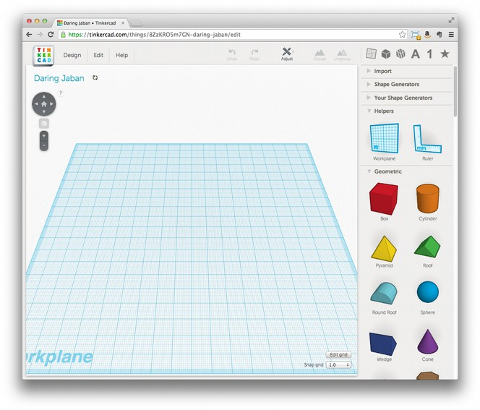
Figure 3-4: Tinkercad’s workplane
Do I have you right with my edits below? /JG
yes /JJG
I recommend using a mouse, rather than a trackpad, to navigate in Tinkercad. To tilt and pan the workplane, left-click and drag your mouse anywhere an object doesn’t exist on the plane. To slide the view, hold down the Shift key while clicking and dragging with the mouse. Use the scroll wheel on the mouse to zoom in and out.
Does the default color match the shape list on the right? /JG
It always has in my experience :) /JJG
To add a shape to the model in Tinkercad, click it once to select it from the list on the right, and then move your mouse over the workplane. The shape should follow your mouse, and when you click again, the shape will be placed on the workplane. The new shapes you create this way will start with a default size of around 20 mm wide and a default color, and once you place shape, the Inspector view (Figure 3-5) appears.
What if we show just the figure that also shows the hole attribute being toggled here? I like that it gives us a close-up and shows the Inspector at the same time. /JG
Sounds good to me /JJG
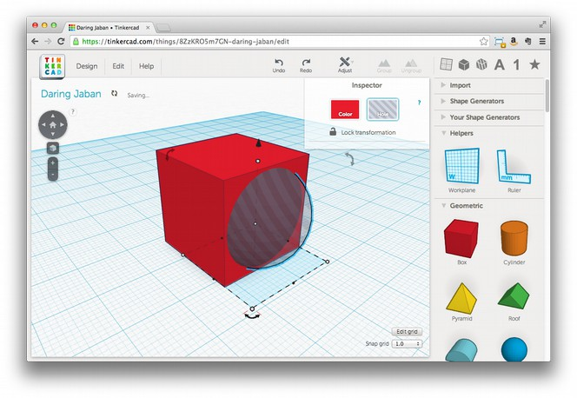
Figure 3-5: Tinkercad’s Inspector view, with hole mode activated
The Inspector view lets you select the color and toggle the Hole attribute, which makes an object have a subtractive effect on the model. For example, if you put a hole object inside of a non-hole object, and then join the two, the result will be that the solid object becomes hollow, as in Figure 3-6.
Do you think we should capitalize Hole throughout the Tinkercad section, or just when we say “Hole attribute” or “Hole property”? /JG
it's capitalized in the app, so I think we should carry-through with that, but I'm fine either way /JJG
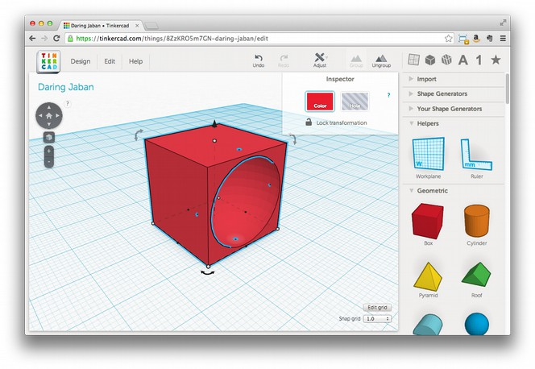
Figure 3-6: Here, we’ve joined a sphere in hole mode with a cube to carve out a rounded chunk of the cube.
Building a House
Let’s build a little house to get a feel for how Tinkercad works. Remember when I said to start thinking about the things you see in the real world as the basic solids that they are made of (cubes, spheres, and so on)? If we want to build a house, let’s think about those shapes. My house is pretty much two shapes, a cube and a pyramid, so let’s start by placing these two shapes on the workplane as in Figure 3-7.
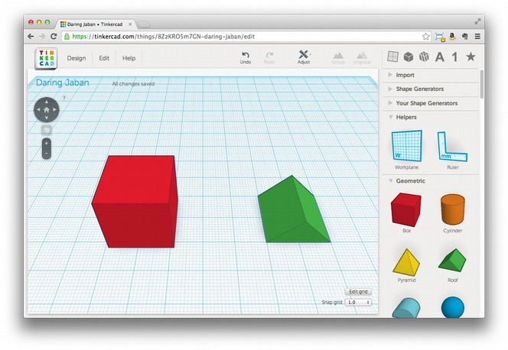
Figure 3-7: This simple house will use a pyramid for the roof and a cube as the base.
Now, let’s place the roof on the house. Left-click the roof object, and small handles should appear around the shape’s perimeter. The white handles at the corners will scale the shape on two sides at once. The black handles will scale a single side only. There is also a black cone that appears above the object; this is used to raise or lower the shape in the Z axis. Use this cone to raise the roof so it's higher than the top of the box shape (Figure 3-8).
Would you rather refer to the figures in the book with just the name in parentheses like above, or with something like “as shown in..”? /JG
Personally I prefer the shorter notation, but I'm open to suggestions based on your experience :) /JJG
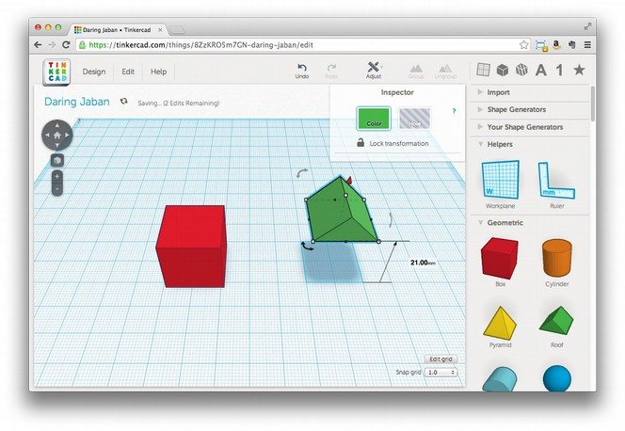
Figure 3-8: Picking up objects in Tinkercad
Notice that Tinkercad displays the distance you've moved the object as you drag it. This is very helpful, and in our case, we know the box is a 20 mm cube because we haven’t changed its size from the default. We can use this information to raise the roof to just the right height to sit on top of the cube. Now click anywhere inside the roof itself, drag it so that it is over the cube, and use the black cone again to lower it on to the top of the cube if necessary.
Note: You can also use the arrow keys to move an object in precise steps, which is sometimes easier or faster than using the mouse to line things up. The size of these steps (and all object movements) is set by the snap grid setting in the lower-right corner of the screen.
I think it should be fine not to show the close-up of the snap grid setting here, since we can still see it in the larger figures. /JG
Once the roof is on the house, we can turn these two shapes into a single object to make sure they stay together with the Group button at the top-right of the screen. Select one object, hold down the Shift key, and select the second object. With both objects selected, click the Group button. The cube and the pyramid should become one object and change to be the same color (Figure 3-9). Now, any changes to location or size will affect both the roof and the block as one.
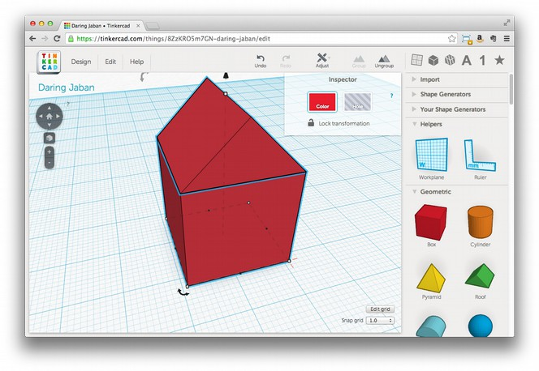
Figure 3-9: Once you group two shapes, they become a single unit that you can manipulate all at once.
When you are done with any design, you should combine all of its shapes together in this way before exporting it for printing. Some 3D printer software will complain if the shapes are not joined together, while others will guess (sometimes incorrectly) at what you want them to do with the different shapes. In either case, the results can be unpredictable, so the safest thing to do is to connect them deliberately yourself. If you decide later that you want to change them independently, you can use the Ungroup button to reverse this marriage of shapes.
Right now, our little house is a solid block of stuff, which is hard to live in. Most houses need a way to get in and an inside to get into! To fix this, we’ll use a shape with the hole property to carve out the inside as well as add an entrance to our little house. First, though, we’ll want to get the roof out of the way to make things easier, so select the house, click the Ungroup button to separate the roof from the box, and then slide the roof out of the way for now.
Add a new cube to the workplane. Using the white corner handle, reduce this cube’s width and length (X and Y size) so that it fits inside the first cube we created, but leave a few millimeters for the walls. (If you used the default 20 mm size for the first cube, 16 mm is a good size for this second cube.) Make the height a few millimeters taller than the first cube; we’ll use this extra height as a handle so the new cube doesn't get lost inside the solid box. In the Inspector view, select the Hole property, and then drag this new cube inside of the old one so that it is in the center (Figure 3-10).
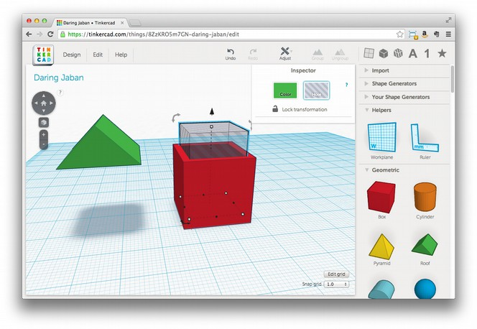
Figure 3-10: Creating the inside of the house with a smaller cube in hole mode
Using the black cone, raise the second cube so that it is 3 mm above the workplane. (This will leave a floor in the house, which any occupants would appreciate!) Finally, with the second cube still selected, shift-click the outside of the original cube and click the Group button on the top-right of the screen. This will combine the original solid box with the “hole” box and carve out the inside of our little house (Figure 3-11).
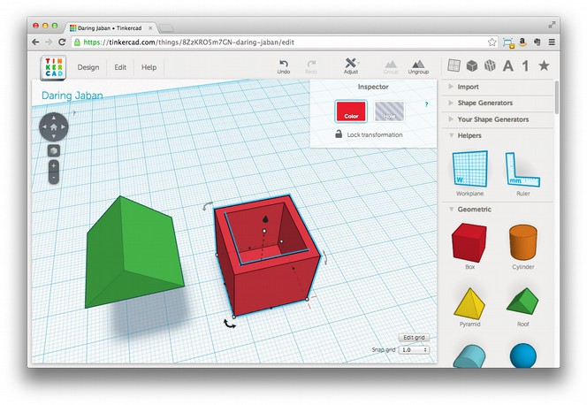
Figure 3-11: Now our house-to-be has an inside!
Now we can put the roof back on as described earlier, and since we don’t have any openings, the house should look as it did in Figure 3-9. Be sure to group the shapes when you’re done!.
Since the figure that’s here looks pretty much identical to 3-9, what if we just refer back to that? /JG
agreed /JJG
Of course we still need a way to get in, and some windows would be nice. Using what you now know about creating holes, carve out a doorway and some nice windows for our little house. Be sure to leave enough material behind to support the structure since the holes will be empty (unless you have a printer that can print glass too—that would be cool!).
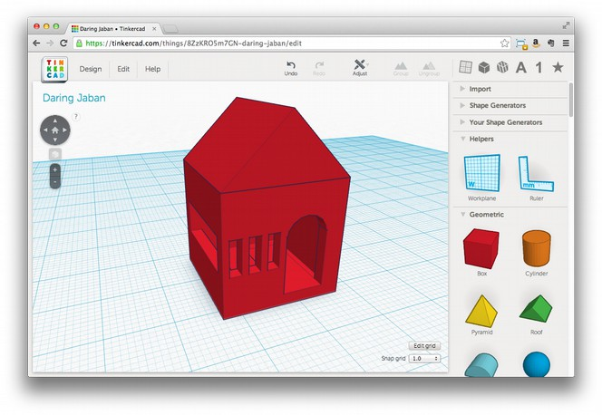
Figure 3-13: The finished house, complete with windows and a door
Exporting the House
Once you’re happy with your design, exporting it for printing from Tinkercad is simple. Click the File menu, then select Download for 3D Printing. When a dialog box asks you to select a format, click STL, and the file you need for printing should download. Tinkercad has a lot of other options for playing with your design as well. You can submit it directly from Tinkercad to a 3D printing service, or you could even export it in a format suitable for importing into Minecraft.
Note: Once you select a format, the dialog box remains open, but that doesn’t mean the download didn’t work. Check the directory where you saved the file to make sure before you try again.
Tinkercad does a lot to make 3D design easy and convenient for beginners and convenient casual users. Needing a constant Internet connection reduces that convenience sometimes, and performance can be intermittent, but Tinkercad’s ease-of-use of and its overall convenience often outweigh these disadvantages.
Do I have you right with my edits above? /JG
Looks great to me /JJG
OpenSCAD
OpenSCAD is CAD modeling software aimed at programmers or people who are more comfortable writing code to create objects than using a mouse to draw them. OpenSCAD is Open Source Software (OSS) that is available for Mac, Linux, and Windows, and you can download it for free from http://www.openscad.org/. Once you have OpenSCAD installed on your computer, open it up and we’ll design your first object. The first thing you might notice is that there’s no tool palette or similar controls that you’d find in other CAD applications. This is because everything you do in OpenSCAD by writing code. The OpenSCAD interface is split into three main sections: code, preview, and status (Figure 3-14).
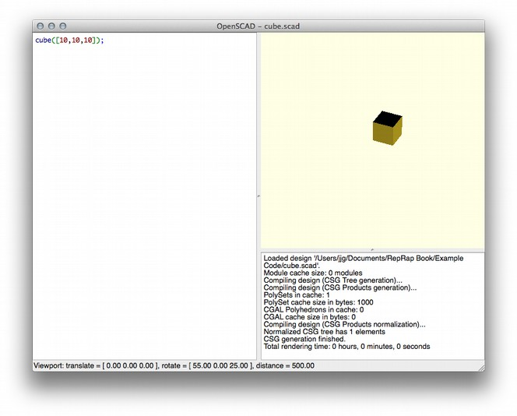
Figure 3-14: OpenSCAD’s code, preview, and status panels. The code in the left panel creates the cube on the right.
Let’s just show the OpenSCAD interface with a cube in it here at the beginning and refer back to it, rather than showing the empty panels and this figure so close together. /JG
That makes sense, my only concern would be that if it looks different from what the reader sees when they open the application it might freak them out, but I'm fine with what you describe if you don't think it will be confusing. /JJG
The code editor panel is on the left, and that’s where you’ll type in the code that tells OpenSCAD what the model looks like. The preview area on the right will display the model as you write the code for it. If there’s no code in the code view, there’s nothing to see in the preview area. The status area on the bottom-right shows messages from the OpenSCAD rendering engine as it runs your code. When you first open the application, this area displays version and copyright information.
Designing in OpenSCAD
Now that you know your way around, let’s start designing something!
If you’ve never written a program before, these first steps may seem foreign and intimidating. Fear not! If you get lost, just make sure that what you’ve typed in the code view matches what’s written in the text; we’ll walk through the details soon.
If the reader has never programmed, they probably won’t know what a compiler is later. Teaching people to code is probably out of scope here, so perhaps we should expect them to know a little programming? /JG
Good point /JJG
Enter cube([10,10,10]); in the code view, and click File4Save to save your work. Name the file cube.scad. Once you save the file, you should see a cube in the preview area, just like in Figure 3-14.
Now that there’s something in the preview area, you can use your mouse to examine it by clicking and dragging in the view.

You can also zoom in and out using the mouse wheel. If you don’t see a cube in the preview area, double-check your code and save the file again. If you still don’t see a cube, sit tight and we’ll discuss debugging next.
Debugging Errors
Let’s take a look at the status view. If your code compiled and a cube appeared, you should see a bunch of information about the model and feedback from the compiler about the status of compiling the model, the number of polygons, and so on. Let’s make a small change to the code and see how the status changes. Delete the closing square bracket (]) from the line of code you entered before.
cube([10,10,10);
Maybe we could just describe the error message here, instead of showing the whole UI? I gave it a try; seem ok? /JG
Again I'm fine with that if it made sense to you, it's hard for me to know what level of detail is necessary since I use the tool often :) /JJG
Now save the file again, and your little cube should be gone. You’ll also notice a few other differences, both in the code view and in the status view. Let’s look at the status first. All the nice messages from the compiler should be replaced with an error (specifically, “ERROR: Compilation failed!”). This is telling us that when the compiler tried to read your code, it couldn’t understand it. Well, what’s wrong with our code? Let’s take a look at that next.
You should see a big red box just after the last number 10, which is OpenSCAD’s way of helping us see what’s wrong. In this case, the problem is that we are missing a bracket, and the box shows us where it’s missing from. (In other cases, OpenSCAD might not be able to provide such precise feedback, especially in more complex models. Turn to the status view, and you’ll also see that the compiler output tells us which line the error was found in. Since our whole model is only one line, this isn’t terribly helpful, but when you’re working with a model with hundreds (or thousands) of lines, this is good information to have.
Errors like this are called compilation errors, which means that the code isn’t following the strict rules of OpenSCAD’s programming language. Compilation errors are usually easier to solve than others, and fixing them often amounts to reading the code to find a typo, a misused function name, or a forgotten character. Other error causes can be more elusive, but in most cases, you’ll still have to review the code step-by-step until you find the source of the problem. This is called debugging, and it will be very familiar to the programmers in the audience. If you’re new to debugging, welcome to the club!
Non-programmers won’t know what a function is; could you explain it sooner? /JG
OpenSCAD Syntax
Enough of this, though: let’s add the missing character back to our code to fix the error, and then we’ll discuss exactly what all these characters are for anyway:
cube([10,10,10]);
Actually, what if we move this part breaking down cube([10,10,10]); to come before the section on debugging? Then we’ve already explained what a function is. /JG
That sounds perfect, I'm not sure why I jumped into debugging, it's no fun ;) /JJG
If you save the file again, your little cube should be back, and the compiler errors should be replaced with lots of information from the compiler. Now, let’s look at the code piece-by-piece.
cube
Here, cube is a function, which is a specific instruction that tells OpenSCAD what type of shape to draw. The function name tells OpenSCAD what to draw, but it doesn’t say how to draw it, and that’s where the next piece comes in.
([10,10,10])
OK to just show the [10,10,10] inside the parens? /JG
yes /JJG
You can pass information like size, where you want an object to appear on the screen, and so on to the function using parameters, which go between the parenthesis the follow the function name.
In our code, we pass [10,10,10] to the cube function to tell it what size to draw the cube. The values 10,10, and 10 are contained between two brackets ([ and ]), which tells OpenSCAD that this is going to be an array of values. An array is just a list, and the list can have a variable number of elements. In our case, the list has three values, all the number 10. OpenSCAD knows that if a cube function is passed an array of values and the array contains three items, these three items are the X, Y, and Z measurements for the cube, so it renders a cube of 10x10x10 units.
Now you might be wondering, “How does OpenSCAD know where to put this cube?” The cube is placed with its first corner at the origin of OpenSCAD’s universe by default. If we just want to draw a cube and we know what size it should be, OpenSCAD sticks it right in the middle of the world, since we didn’t provide any more specific information about what to do with it.
We’ve just walked through one function, but OpenSCAD has a number of others for drawing basic forms, and the values you can pass vary. Most require some minimum number of values in order to work, and all accept additional optional values that further specify how OpenSCAD should draw the object. Next, we’ll explore some common object drawing functions, their required values, and some of their more interesting optional values.
Note: You can read complete documentation of all OpenSCAD functions at http://en.wikibooks.org/wiki/OpenSCAD_User_Manual/The_OpenSCAD_Language#Primitive_Solids.
Common OpenSCAD Object Functions
OpenSCAD has functions like cube(), sphere(), cylinder(), polyhedron(), and so on, which let you draw various solids for your model. Now that we know how to draw an object, how do we move it around?
Save your cube example again, and then create a new empty project by clicking File 4New. In the new project, we’ll enter some code to translate (or move) a cube around.
translate([25,0,0]){
cube([10,10,10]);
}
Save this project as translate.scad, and you should see your little 10x10x10 cube again. What has changed might not be immediately obvious, but if you click View 4Show Axis, it should become more clear (Figure 3-15).
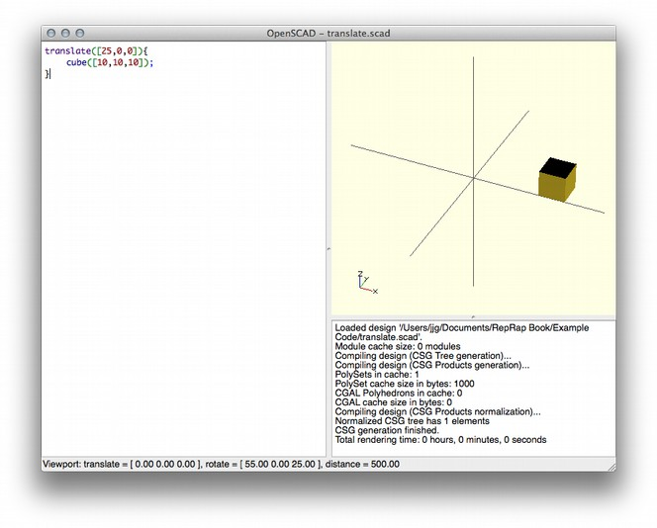
Figure 3-15: Thanks to translate(), our cube is shifted to the right along the X axis.
The translate() function’s job is to move the objects it contains based on the values passed into it. The values we passed to translate() take the same format as the values we pass into the cube() function, and the result is that translate() moves our cube 25 units along the X axis.
Maybe we can leave the image that was here as an exercise for the reader? /JG
Makes sense to me /JJG
Note: For comparison, return to the previous example (cube.scad) and turn on Show Axis. Since we haven’t used translate(), your little cube should be sitting at the origin.
In OpenSCAD, the curly braces contain objects that will be impacted by a function. In this example, the cube() function is contained within the curly braces of the translate() function, and it’s translated as a result. There are a number of functions in the OpenSCAD language that act on other objects in this way, such as scale(), rotate() and mirror(). You can even nest these functions, so that more than one function can be applied to a single object. Make sure your translate.scad file is saved, and create a new project. Now, let’s enter some code that will both translate and rotate our cube.
translate([25,0,0]){
rotate([0,50,0]){
cube([10,10,10]);
}
}
Save this project as nesting.scad, and you should see something like the cube in Figure 3-16.
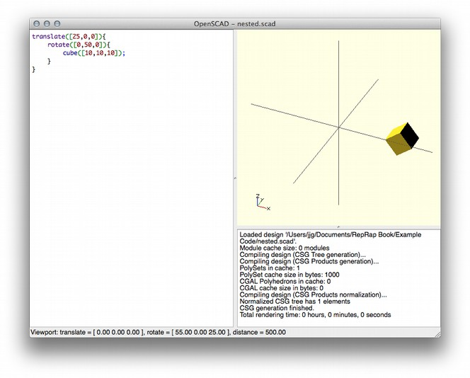
Figure 3-16: Nesting functions allows you to apply multiple actions to one object.
In this example, we’ve created a new cube within the curly braces of a rotate() function, which rotates the cube on its Y axis by 50 degrees. Finally, the rotate() function is contained within the curly braces of a translate() function, which moves everything 25 units along the Y axis.
Preparing for Printing
Finally, to use an OpenSCAD model for printing, we need to render it in a format that can be sliced and fed to a printer. The STL format is preferred, and OpenSCAD makes creating STL files simple.
But first, let’s try a more ambitious model, something more interesting to print than a cube. How about a snowman?
// union() joins everything together
union(){

// base (round things don't stick very well)
cube([20,20,2]);

// bottom
translate([10,10,10]){
sphere(10);
}

// middle
translate([10,10,25]){
sphere(8);
}

// top (head)
translate([10,10,38]){
sphere(7);

// eyes
translate([-3,-5,3]){
sphere(2);
}
translate([3,-5,3]){
sphere(2);
}

// nose
translate([0,-5,0]){
rotate([90,0,0]){
cylinder(5,2,.1);
}
}
}
}
The lines that begin with // are OpenSCAD comments, which are notes to other programmers (or yourself) that explain what’s going on inside a program. I used comments here to make it easy to tell which block of code builds each part of the model, so others will know where to make changes to a particular part of the model. (For example, if you want to make the eyes bigger, all you have to do is edit the code under the comment //eyes.) Just remember that everything after the // will be ignored by the OpenSCAD compiler, so don’t include them on a line that represents something you actually want to print. Save the new project as snowman.scad and you should see something like the screenshot in Figure 3-17.
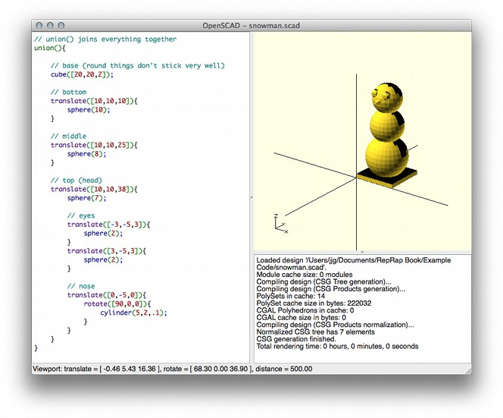
Figure 3-17: Our snowman model, complete with a face!
Now, we just need to export our frosty friend for printing! There are just two steps:
Click Design4Compile and Render to generate a detailed model of your project. This may take a few minutes.
When the model is generated, click Design 4 Export STL
Select a place to save the STL file, and name it snowman.stl. You should now have an STL file suitable for slicing and printing! If anything goes wrong, review the messages in the status area and look for clues. (The most common error is trying to Export STL before rendering.) Remember that if you make changes to the code, you’ll need to save your changes and render again before you can export a new STL file.
We can construct rich, complex models by using OpenSCAD to create basic shapes and manipulate them in space. Many 3D models published on the Internet include their OpenSCAD source code, so if you can read and understand OpenSCAD code, you can easily customize these objects and incorporate them into your own original designs.
OpenSCAD isn’t for everyone, but it can be a fast, powerful way to create very precise models. If you’re more comfortable with code than with drawing tools or if your model needs to fit in with pieces you’re not going to print (a replacement part, for example), then I recommend giving OpenSCAD a try. You can even use variables and loops to write OpenSCAD programs that generate models dynamically, which can make adapting your models for different purposes or generating custom versions easier.
Blender
Blender is a free, open-source 3D animation program for Linux, Mac and Windows. It’s a very complete 3D modeling tool, and it’s quite useful for 3D printing as well as creating animations. The learning curve for using Blender may be steep for casual users, but the reward for time spent is significant. Download Blender from http://www.blender.org, open it up, and let's take it for a spin!
By default, Blender starts out with a cube on the workplane (Figure 3-18). Right-click the cube and hit the Delete key on your keyboard (not Backspace!) to delete it. Blender is nice enough to prompt you to confirm the delete, so click confirm if you want the cube gone.
I’ve not used Blender myself; do I have you right with my edits above? /JG
so far so good! /JJG
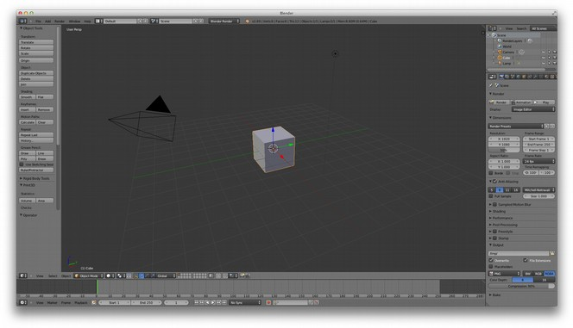
Figure 3-18: Blender’s default workplane
Blender Settings
These full-window Blender screens are going to be difficult to read in print. Where you want the reader to navigate a specific menu, we could crop to show a portion of the workspace, and then do a flyout with the menu side-by-side.
Where it makes sense, could you replace full-window screens with the cropped area you’d want to show in the chapter but still send us the full-sized screenshot, in case we need to recrop?
We can also annotate, if you note where those should go. :) /JG
I'll work on getting the cropped control views together and name them in a way to make it clear what full-sized image they belong to. /JJG
Blender wasn’t made to create printable 3D models, so before we get started, we’ll need to prepare it for designing printable objects. First, we’ll enable the 3D Print Add-On. Click File4User Preferences, and then click the Addons tab. In the search box, type “print” (you could browse through all the options, but that could take awhile), and the Mesh: 3D Print Toolbox addon should appear on the right. Check the checkbox next to the addon, click Save User Settings in the bottom-left corner, and then close the Blender User Preferences window.
I think we can get away without showing the preferences window; do my edits seem okay here? /JG
If it's clear to you it works for me :) /JJG
We'll also want to change some of the scene settings so we create something sane for 3D printing. From the menu on the right of the main Blender window, click the Scene icon, shown selected in Figure 3-19. In the scene options, select Metric units.
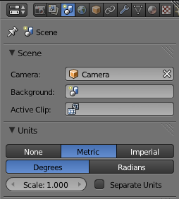
Figure 3-19: Blender’s scene options

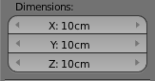
Finally, we're going to scale our dimensions so that we can produce an object that will print safely on almost any 3D printer. Select the object selected, and press the N key to view the Dimensions menu. Figure 3-20: The Dimensions menu
Prod: could we show this little screenshot off to the side?
Set the dimensions to 100mm (or 10cm) for all three dimensions.
Note: You’ll have an easier time using Blender if you get familiar with the keyboard commands, like the N shortcut you just used. These commands are available via menus, but the menus are so vast and deep that you could spend a lot of time hunting for something. Since Blender is really designed to leverage the keyboard commands heavily, I’ve adopted that behavior here as well.
Now that Blender is all set for creating printable objects, let’s make one!
Modeling a Pencil Cup
For this project, we'll create a nice little cup you can print for your pencils. (If you print it with the right materials on a very clean printer, you could also drink out of it.) Start by dropping a plain old cylinder on the workplane, Blender-style: click Add4Mesh4Cylinder, and a cylinder should appear on the workplane, as in Figure 3-21.
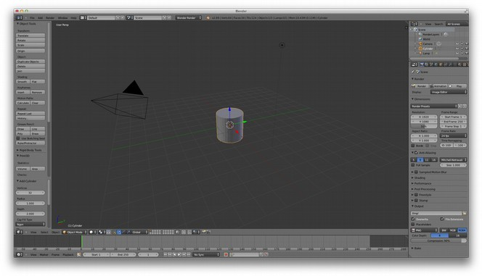
Figure 3-21: This plain cylinder will become our pencil cup.
It seems like we’re pulling up the Cap Fill Type menu now, but it’s not completely clear. Could you slow down a bit and outline the steps? /JG
Ah, Cap Fill is in the already-displayed “Add Cylinder” menu in the lower-left corner of the screen, maybe this is another area where a cropped view/call-out/etc. would make things more clear? /JJG
So far so good! Next, we'll set the fill type for the cylinder to Triangle Fan using the Cap Fill Type menu under Add Cylinder on the left of the screen. I told you there were a lot of menus!
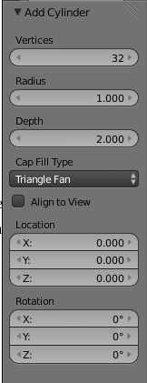Illustration 1: Add Cylinder menu
You don’t discuss fill until Ch. 4, but we should define it sooner, if the reader is seeing it here. Maybe we could explain some selected key terminology in the introduction as part of a high-level overview of the 3D printing process? /JG
Good point, in fact the term “fill” here is different from the identical term used when referring to how a model prints. Unfortunately there's a lot of term “overloading” in this space, I'm not sure the best way to manage the potential confusion there. /JJG
We need to edit the object, so click the Object Interaction Mode (Figure 3-22) menu and choose Edit Mode; your cylinder should now change color to indicate it's selected.
Just checking: is the menu the “Object Interaction Mode” menu or the “Object mode” menu? /JG
When it's not expanded (as in the image) it says “Object Mode”, but what it does is set the mode of object interaction (the mouse-over just says “mode” :) I think the documentation refers to it as the Object Interaction Mode menu. /JJG
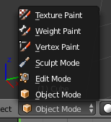
Figure 3-22: The Object Interaction Mode Menu
Could you show a bit more of the screen here, for context? /JG
Will do /JJG
We're not ready to select anything yet, so press the a key to toggle the selection. This is a handy way to get yourself out of trouble should you select part of an object on accident.)
Our pencil cup needs a hole at the top, but before we create that hole we're going to switch the object view to Wireframe. Click Viewport Shading (Figure 3-23), and select Wireframe.
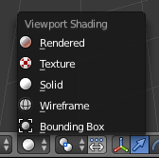
Figure 3-23: Switching to wireframe mode
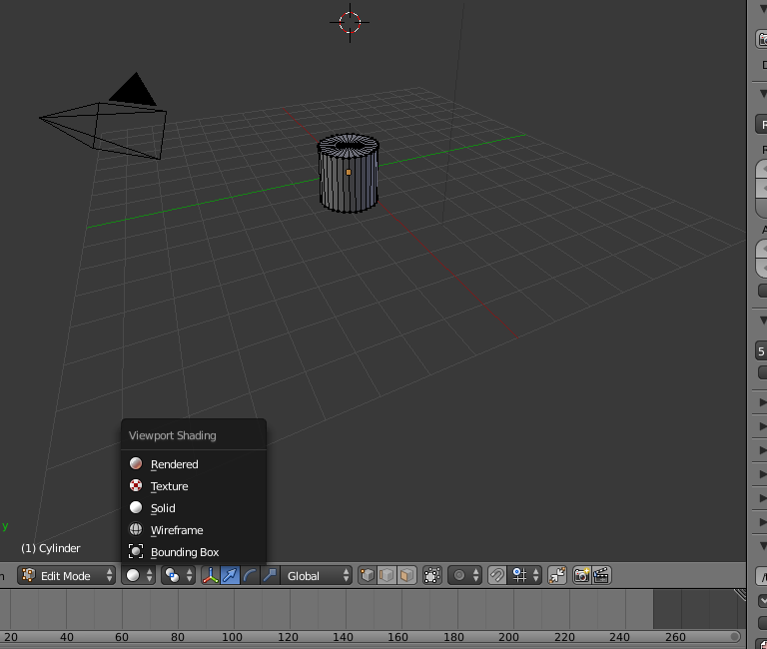
This is another where I think we should show more of the Blender screen for context. /JG
Is this better? /JJGWith the cylinder in Edit Mode and the view set to Wireframe, the workplane should look something like Figure 3-24.
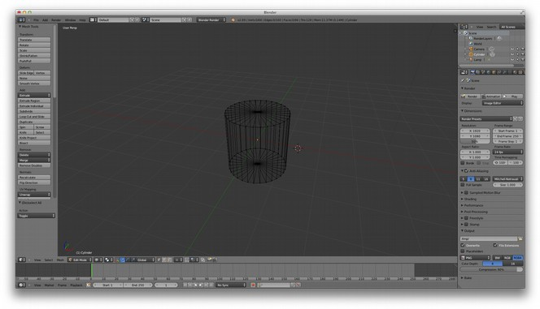
Figure 3-24: Our cylinder in Wireframe mode.
Now, we’ll remove the top of the cylinder. Right-click in the center of the top of the cylinder (where the lines come together) to select it. When it's selected properly, all of the wires on the top of the cylinder should change color. Hit the delete key, and Blender should ask what exactly you'd like to delete. In this case, select Vertices from the confirmation menu and the top of the cylinder should disappear.
I think it’s okay to not show the cylinder after deleting the top, since readers should be able to see what’s different. Seem ok? /J
Works for me /JJG
Now we're going to make some changes to how we view the cylinder to make it easier to finish the model. Click View4Front (the View menu is in the lower-left corner of the screen); this should whip the cylinder around so you're looking at the side. Next, click View4View Persp/Ortho to toggle between perspective view, which shows the object in three dimensions, and Orthogonal view, which renders the image flat. Choose orthogonal view. You’re most likely using a flat screen (unless you have a fancier setup than I do), so this view should make your life easier for the moment. At this point you should be looking at something like Figure 3-25.
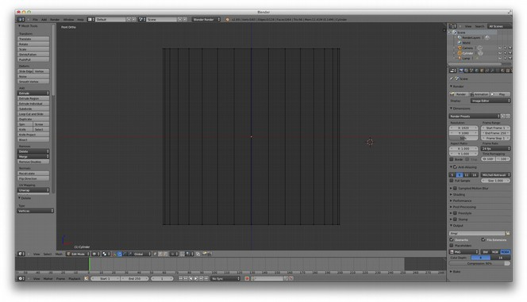
Figure 3-25: An orthogonal view of the cylinder
Use the mouse wheel to zoom in; we're focusing on the cylinder, so there’s no need for all that empty space. If your screen doesn't look like the one above, review each step we've done so far until it does, because otherwise things might get confusing. If everything looks good, let's add some shape to our vase!tr

I’m worried a lot of the wireframe images that rely on colored lines won’t convey the same meaning in grayscale, so I tried to make this next part work without most of the images. Do I have you right? /JG
That makes sense, my only concern is that there won't be visual confirmation for each step in the process, but if we can't print it then it probably won't help to show the images anyway :) /JJG
With the mouse over the cylinder, press Control-r (lowercase, not caps!); a horizontal purple line should appear. Scroll the mouse wheel slowly, and the number of lines should grow to two, then three, and so on. Scroll up until you see three purple lines, left-click to lock the number of lines, and press enter to lock them into place. This operation is called subdividing, and it's useful for taking a basic solid and manipulating sections of it, which we'll do next.
Note: If you move the mouse up or down during this process you'll move the lines as well. This isnn’t a big deal, but if you want your results to look just like my end result, move the mouse back until the initial line is in the middle of the cylinder's height.

Press the a key to deselect the cylinder if it's still selected, then press b and to turn your cursor into a crosshair. Using this crosshair cursor, drag a rectangle around the bottom of the cylinder to select the row of dots at the bottom of the cylinder.
With these selected, press s to alter the size of this section. Get creative, but keep in mind that this part must be wide enough to support the vase yet small enough to fit on the printer you want to print it out on. (100mm is a safe bet for most printers.) When you're happy with the size, left-click the mouse to set your changes in place, and press a again to make sure the selection is released. Next, repeat this process for the top row and the three rows you added earlier until you have a shape you like. You can see one possibility in Figure 3-26.
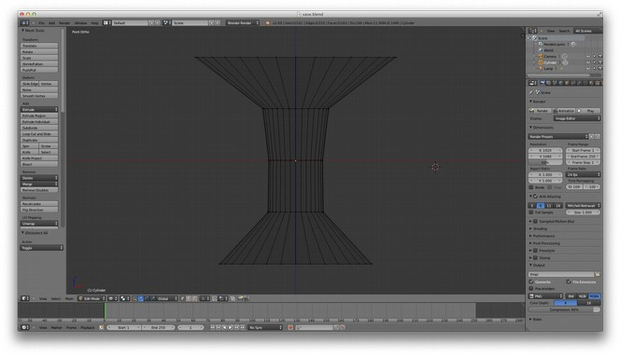
Figure 3-26: Depending on how you adjust those sizes, your cylinder might look more like a vase.
We'll be carving out the inside of the shape in order to make room for whatever we want to put inside, and so we need to leave some room between the empty inside and the outside walls of the vase for enough plastic to hold itself together.
Are we supposed to do something to leave room for the extrusion while adjusting the size? If so, could you explicitly say that? I’m just a bit confused. /JG
I think as long as the hole on the inside doesn't “touch” the outside wall we'll be safe, so I might be able to re-word the above to convey that we just don't want to “pinch” the middle section too much. Of course, this will become obvious later, so maybe we just say “you may have to come back to this step to widen the cup if you run out of room in the next step”? /JJG
Now that we have the outside shape, let's make the inside. The first step of this process is to extrude the outside wall of the shape inward so we have a lip at the top of the vase. Use the A key again to remove any existing selection, and then use B to select the row of dots at the top of the cylinder. This is where it gets weird. With the top row selected, press E (for extrude), and then press enter. Next, type S (to switch to size mode) followed by .9 on the keyboard, and press enter again. You won't see much change at this point due to the perspective, but if you tip the viewpoint a little (click and drag slowly with the middle mouse button), you'll see that we've created a thin lip around the top edge of the cylinder (Figure 3-27).
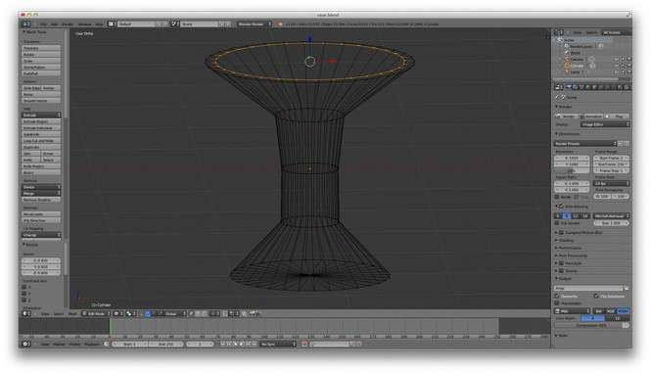
Figure 3-27: The cup, after extruding the lip inward
You started off calling this a pencil cup...do you want to call it a vase? I’ll follow your lead here, just wanted to check. /JG
It's probably safer to call it a pencil cup, only because most 3D printer output isn't “food safe”, and many may not literally hold water :) /JJG

Before continuing, use the View menu to switch things back to Front view. Now without deselecting the newly extruded lip, again press the E key to begin extruding again, and drag the mouse down to extend this edge into the body of the vase. Drag down until you meet the next row of dots from our subdivision operation, and then left-click to set it. This extrusion may go outside of the body of the vase, so to clean this up, press S and move the mouse up or down to size the extrusion until it's inside of the vase about the same amount as it is at the top.
Repeat this process until you're a few millimeters from the bottom of the vase. Now we need to form the bottom of the vase. With the extruded row still selected, press E, and then press enter. Next, click Merge under Remove: in the left-side menu, and select at center. This should bring the points we have selected together at the center of the object. (To see this effect more clearly, use the center mouse button to tilt the workspace slightly so you can see inside the vase, as in Figure 3-28.)
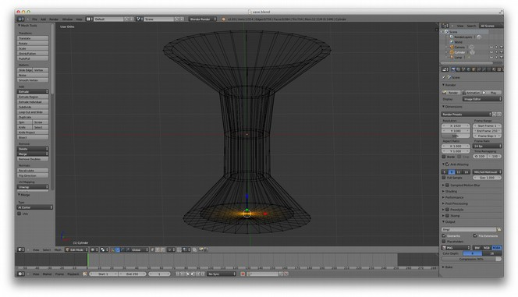
Figure 3-28: The wireframe of our vase, complete with an enclosed bottom
Now we're ready to see what this will look like when we print it. Switch the object menu from Edit mode to Object mode, and then switch the view from Wirefame to Solid, and you should see something like Figure 3-29.
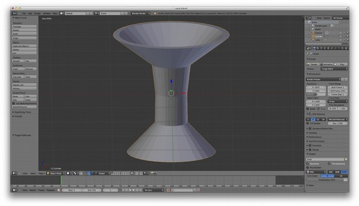
Figure 3-29: The completed vase model, shown as a solid
Let's use that 3D Print Toolbox we installed during the setup stage to check out our model and identify potential problems. Click Print3D in the Tools panel on the left to expand the Toolbox. Understanding its myriad of features is an exercise left to the reader; for now, we just want quick feedback on our model. Click the Check All button, and you'll get a summary of possible problems with the model in categories like “Non Manifold Edges,” “Zero Faces,” and “Overhangs”.
If your model has any of these problems, they should be cleaned-up before continuing. This simple model should have gotten a clean bill of health, so we'll continue on with the export.
Exporting from Blender
The final step in preparing your Blender model for printing is to export it to an STL file. Click File4Export4STL, and a dialog box will be displayed that allows you to name the file and choose a location to save it. In addition to these typical bits of information, there is one more critical thing we need to do to get a model we can feed to the slicing software.
At the lower-left corner of the dialog is a field where you can set the scale of the exported file. This must be set to 1000 in order to ensure the size (in millimeters) of the model exported matches the size of the model you created. Ignoring this will create a file that contains a model that is orders of magnitude off in size, and most slicing software will be unable to process the file. Finally, click Export STL to save the file.

In this chapter, we looked at a few applications that demonstrated a variety of ways to go about the 3D modeling process. What type of tool you choose is up to you, and may change depending on the type of modeling project you are working on. They key requirement for modeling software is that the output is an STL file that can be fed to the slicing software, which is the next step in the 3d printing process (and by no coincidence, the focus of the next chapter of this book as well).

