Table of Contents
Finding Design Inspiration 2
Tinkercad 3
Getting Started 3
Building a House 4
Exporting the House 6
Minecraft 6
Create an Awesome Design 7
Mark Your Build 7
Export the Model 8
The Terminal in Windows 9
The Terminal on a Mac 10
The Terminal in Linux 10
Prepare for Extraction 10
Create the STL File 11
Verify the Model 12
OpenSCAD 13
Designing in OpenSCAD 14
OpenSCAD Syntax 14
Common OpenSCAD Object Functions 16
Preparing for Printing 18
Blender 20
Blender Settings 21
Modeling a Pencil Cup 22
Exporting from Blender 30

3
3D Modeling Tools
this appears to be a chapter about modeling tools. The bit about finding inspiration should be somewhere in the book but not here.
In the world of 3D printing, the term modeling describes the process of designing a model to be 3D printed. You’ll often model three-dimensional objects using digital tools alone but you can also create models using physical media such as paper or clay or a scan of a physical model. Whatever method you choose, you’ll ultimately use your model to produce a file that you’ll feed up the 3D printing chain.
In this book, we’ll focus on digital rather than physical modeling, and in this chapter, I’ll walk you through several tools to get you started including several free ones as well as low-priced commercial applications appropriate for casual or novice designers. We’ll cover a wide range of 3D modeling tools from Tinkercad, which brings an easy to learn web interface to traditional CAD tools, Minecraft, OpenSCAD, to the 3D graphics program Blender. Give each a try and then pick the one that suits you the best.
I would cover Blender before OpenSCAD. Most readers will use TinkerCAD, Minecraft, or Blender.
Your list of modeling tools should match the order in which they’re presented in the chapter
One source of design ideas is, of course, your imagination. The world around you can be an endless source of inspiration. Just take a look at the stuff on your desk! When looking at real-world objects, try to visualize their component geometric shapes (cubes, spheres, pyramids, and so on), and sketch out how you might recreate these things. Look too at the objects around your house that need replacement parts, whether those are game pieces, dishwasher caps, oven knobs, or drawer pulls.
And if you get stuck, have a look at what others have done on websites like youmagine.com or cubehero.com for inspiration.
Tinkercad
Tinkercad (http://tinkercad.com) from Autodesk is an approachable CAD (computer aided design) tool that runs inside a web browser, which means you should be able to run it on almost every modern computer as long as you’re connected to the Internet.
Tinkercad is subscription-based, though its free subscription level may be all that you need for personal projects. Tinkercad has a lot of neat features geared toward the casual CAD user. It makes importing and exporting files in different formats easy (including files from Minecraft), and it provides an excellent and comprehensive tutorial system.
I don’t see this. When I log in it takes me right to a tutorial.
In order to use Tinkercad you’ll first need to create an account at http://tinkercad.com. As a new user, Tinkercad will take you to
Creating a New Design
. Click Create a New Design to get started.
You’ll create your designs in Tinkercad’s workplane as shown in Figure 3-1.
this is not the Workplane that I see. I see a list of items on the right without graphics. Show the reader what they’re likely to see. Also, we should clip off that top bar. We don’t need to see the url or your Amazon icon.
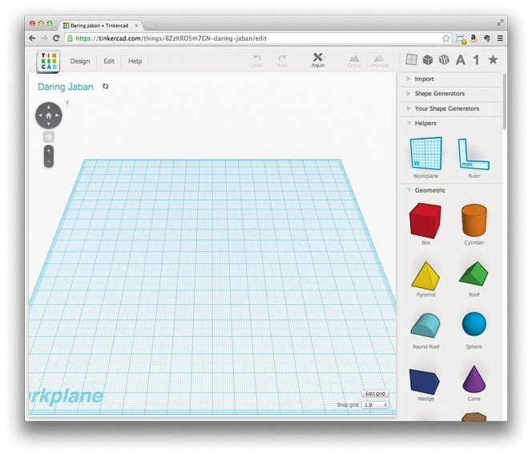Figure 3- 1: Tinkercad's workplane
Use a mouse to navigate in Tinkercad rather than a trackpad because ____. To tilt and pan the workplane, left-click and drag your mouse to any empty area of the Workplane, then release the mouse. To slide the view, hold down the Shift key while clicking and dragging with the mouse. Use the scroll wheel on the mouse to zoom in and out.
To add a shape to a model in Tinkercad expand the list of objects on the right (say Geometric) then, click to select and item from the list and drag and drop it it on the workplane. Once you place a new shape, the Inspector view should appear as shown in (Figure 3-2).
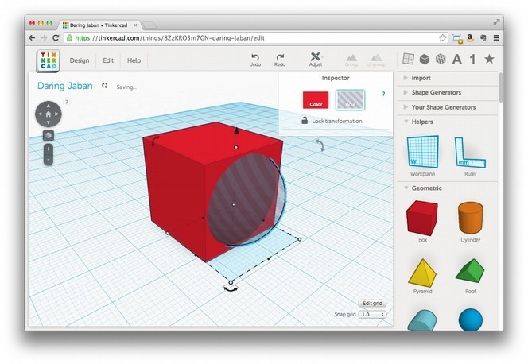Figure 3-2: Tinkercad's Inspector view, with hole mode activated.
The Inspector view lets you select the Color and toggle the Hole attribute for each object. For example, if you put a hole object inside an object, and then join the two, the result will be that the solid object becomes hollow (Figure 3-3).
I wonder whether you want to even raise this hole mode concept. Why not cover the many other concepts in Tinkercad? I’d simply offer an overview, point them to the tutorials, but then show the reader how to do something.
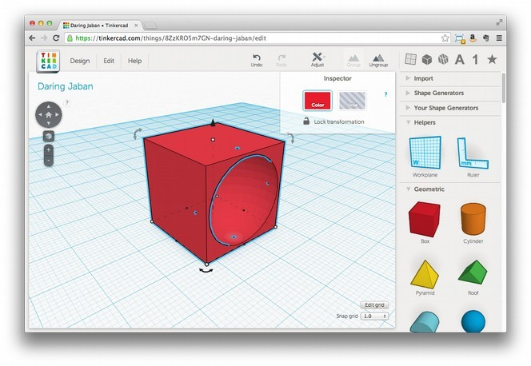Figure 3-3: Here, I’ve joined a sphere in hole mode with a cube to carve out a rounded chunk of the cube

Building a House
Let’s build a house to get a feel for how Tinkercad works. To build a house, first think about the shapes that can be used to form a simple house: a box and a pyramid if you’re building a classic Western style house. Start by placing these two shapes on the Workplane as shown in Figure 3-4.
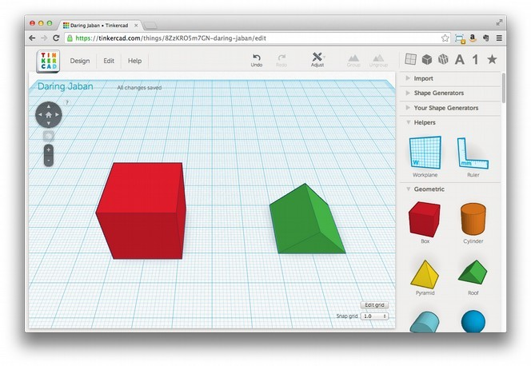Figure 3-4: This simple house will use a pyramid for the roof and a cube as the base
Now, left-click the pyramid. You should see a sort of black cone appears above the pyramid. Use this cone to raise the pyramid up higher than the top of the box as shown in Figure 3-5.
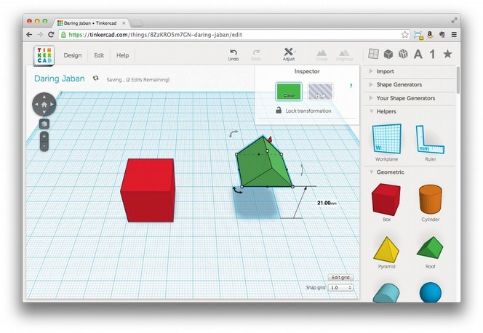Figure 3-5: Picking up objects in Tinkercad
Notice in Figure 3-5 that Tinkercad displays the distance you've moved the object as you drag it (the 21.00mm label on the right). The default height for new objects in Tinkercad is 20mm and since we haven’t changed the size of the cube we know that if we raise the roof to just the right height it will sit directly on top of the cube. Once you’ve raised the pyramid to _____mm, click inside the pyramid and drag it over the cube to create the roof. Use the black cone again to lower it on to the top of the cube if necessary.
Note: You should be able use the arrow keys on your keyboard to move objects precisely. The Snap Grid setting at the lower-right corner of the Workplane controls the degree of movement. Higher numbers move objects in larger steps.
Combining Shapes
Once the pyramid is on the cube (the roof is on your house), you can turn these two shapes into a single object with the Group button at the top-right of the Workplane. To do so,
1. Select one object, hold down the Shift key, and select the second object.
Once both objects are selected, click the Group icon at the top right ofo the Workplace.
The cube and the pyramid should become one object, all the same color as shown in Figure 3-6. Now, any changes you make to the placement or size of your house will affect both objects as one.
I would add callouts to screens to show things like the Group icon, Snap Grid, and so on. We can do that in production
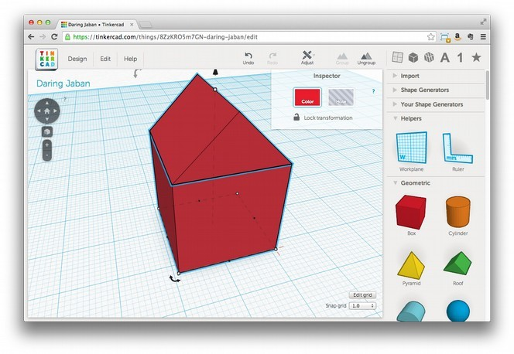Figure 3-6: When you group two shapes they become a single unit that you can manipulate all at once
Once you’re done with a design, you should combine all of its shapes before exporting it for printing or your results will be unpredictable. If you decide to change objects independently at a later stage, use the Ungroup icon.
Hollowing Out the Inside
Right now, your little house is a solid block of stuff, which is hard to live in. We need a way to get in and a place to live. To give your house an interior, we’ll use a shape with the Hole property to carve out the inside and add an entrance. But first, let’s get the roof out of the way to make those things easier. Click Ungroup to separate the roof from the box, then slide the roof out of the way for now. Now:
1. Add a new Box to the Workplane.
2. Left click the new Box and pull a white corner handle to reduce its width and length (X and Y values) to fit inside the Box that we’re using for our house, but leave a few millimeters for the walls. For example, if you used the default 20 mm size for the first box, try 16 mm for the second one.
3. Adjust the height of the new Box so that it’s a few millimeters taller than the Box that’s making up the house.
4. With the new box selected, click the Hole property in the Inspector then drag the new box into the center of the old one as showon in Figure 3-7.
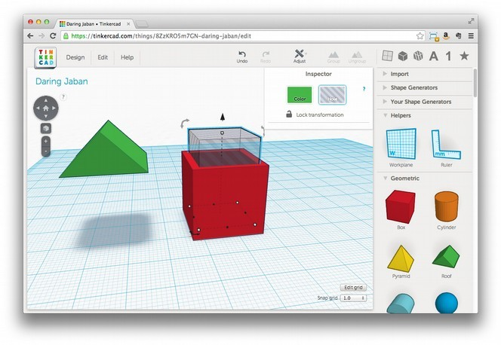Figure 3-7: Creating the inside of the house with a smaller cube in hole mode
5. Use the black cone to raise the new box so that it’s 3 mm above the workplane (the floor of the house) to create a floor.
6. Finally, with the new box still selected, shift-click the outside of the original cube and click the Group button on the top-right of the screen. This will combine the original solid box with the Hole box and carve out the inside of your house as shown in Figure 3-8.
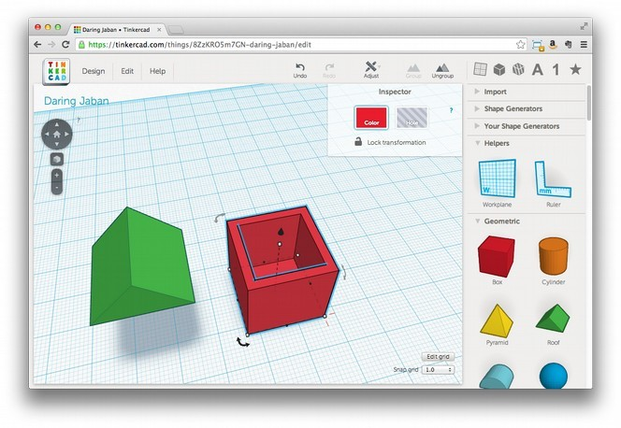Figure 3-8: Now our house has an inside!
Now can drag the roof back on. Since we haven’t added any external openings,, the house should look as it did in Figure 3-6 but it’s now hollow inside.
Adding Windows and a Door
Of course we still need a way to get into our house, and some windows would be nice. Use what you now know about creating holes to carve out a doorway and some nice windows to create a house something like the one shown in Figure 3-9. Be sure to leave enough material behind to support the structure since the holes will be empty.
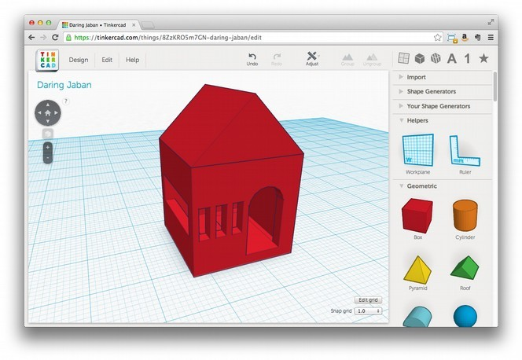Figure 3-9: The finished house, complete with windows and a door
Exporting the House Model for Printing
Once you’re happy with your design, export it for printing from Tinkercad. Click the Design menu, then select Download for 3D Printing. When a dialog box asks you to select a format, click STL from the various options and the file you need for printing should download. (Once you select a format, the dialog box remains open, but that doesn’t mean the download didn’t work. Check the directory where you saved the file to make sure before you try again.)
Tinkercad does a lot to make 3D design easy and convenient for beginners and convenient casual users. Needing a constant Internet connection reduces that convenience sometimes, and performance can be intermittent, but its ease-of-use of and overall convenience often outweigh these disadvantages.
Minecraft
You’ve probably heard of the game Minecraft, but perhaps you’ve never considered it a useful CAD tool. Minecraft is often described as “electronic LEGO blocks,” and like LEGO, you can build just about anything out of the cubes that make up the Minecraft world. In fact, Minecraft may be the world’s most popular CAD software, and it’s certainly the best collaborative design tool we’ve ever seen.
In order to use Minecraft to to create models for 3D printing you’ll need a licensed copy. Once you have Minecraft, here’s how to use it to create printable models.
Create an Awesome Design
Mincraft has two modes: Survival and Creative Mode. Most people play Minecraft in Survival Mode, but Creative Mode let’s you build without fear of death or scarcity and all blocks are available to you in an infinite supply. We’ll use Creative Mode for our CAD work.
Need to say what a Minecraft block is and confirm that there are only two modes as edited.
When creating your first printable model in Minecraft you should use sand blocks. Sand blocks only work when stacked directly on top of one-another Models with overhanging parts that project out of the sides of the model above the first layer are a challenge for most current 3D printers. Once you get the hang of what your printer is capable of, you can move on to blocks that allow more complex designs.
I also suggest building something square and fairly large because the models produced with Minecraft are very low-resolution compared to what most printers can output. Designing something large means you’ll have less scaling-up to do before printing, and the resulting print will have a smoother appearance. Of course, keep it small if you want an 8-bit look, and scale the heck out of it later!
Skipped a giant step here. How do we design our model in Minecraft?
Marking The Extent of Your Model
Once you complete your design, you’ll need to place markers inside Minecraft to tell it what portion of the world to export as a model. These markers are stacks of blocks that define both a rectangle around the X and Y axis of your model and the vertical Z axis of your model as shown in Figure xx.
Insert a figure showing the X,Y,Z axis here
When placing your markets, include some of the the ground the model is built on extend the top above the model you want printed to give your model a solid base and to make sure that your model won’t accidentally have its top cut off.
Once you've determined where to place your markers, create them by building a stack containing these blocks in order: diamond, gold, iron. Place one stack at one corner of model and a few blocks below the ground as shown in Figure 3-10. (You might have to dig a little.)
where is the stack in this figure?
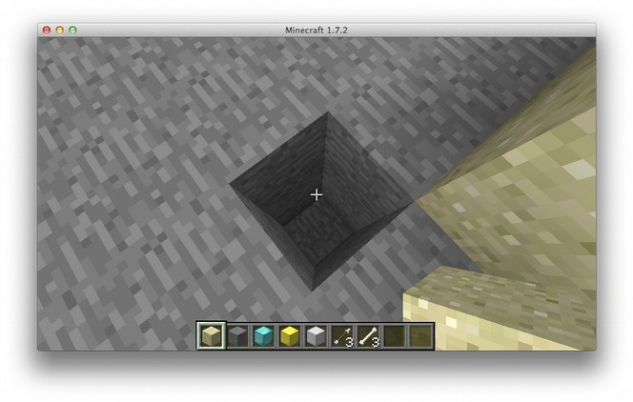Figure 3-10: Digging to place the diamond, gold, iron marker
Now build a stack of blocks diagonally across from the first marker using __ blocks to define a rectangle around your model. Once that stack is above your model, place the second marker stack up on top, and remove the blocks below the marker.
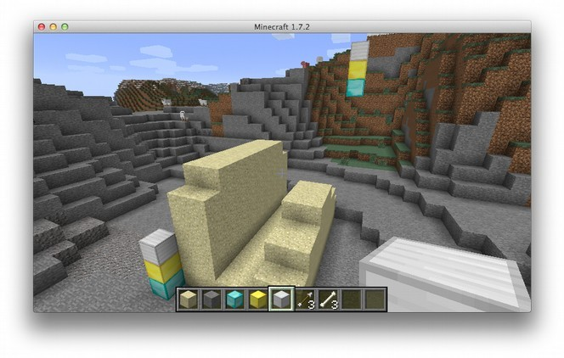Figure 3-11: A completed Minecraft model. Note the two stacks of iron, gold, and diamond as shown highlighted in the figure.
Prod: Please label the stacks per author instructions
Jason – please show us where to label the stacks
Export the Model
begin with a description of Mineways. Focus on using that for Windows and MacOS. Add a section about printing from Linux using the terminal but cut the terminal bits for Windows and MacOS. Might even be time better spent to explain how to run Mineways in Wine.
Exporting from Windows and MacOS
insert text here
Exporting from Ubuntu
Now to set up some tools that will allow us to export our model from Ubuntu. First, see if you have Python installed with this command:
$ python
Python 2.7.6 (default, Mar 22 2014, 22:59:56)
[GCC 4.8.2] on linux2
Type "help", "copyright", "credits" or "license" for more information.
>>>
If Python is not installed, try a site like http://askubuntu.com for instructions on how to install Python on your machine.
keep things as simple as possible.
Prod: confirm Appendix references above and below
I realise that minecraft.print has the benefit that it should be working on all platforms, but the amount of setup required, including having to use the console and such, makes it pretty inaccessible to non-techies. Have you considered using Mineways as an alternative? (http://www.realtimerendering.com/erich/minecraft/public/mineways/) I got this up and running pretty much straight away, and could quickly export my model using a few clicks. The downside is that it is biased towards Windows users – Mac and Linux have to jump through a few hoops sadly. /GSH
I haven't used Mineways but given the objectives of the book I'm inclined to keep this as-is, I don't want to shy away from making the reader “work” for the result, as perseverance is an important skill in working with this technology. I'm also more comfortable with providing an approach that isn't biased toward closed systems like Windows.
Maybe a “sidebar” pointing to Mineways as an alternative for Windows users who run into trouble with minecraft.print? /JJG
I agree with the TR. Use Mineways for Windows and Mac; do not bother with terminal instructions.. Keep this as simple as possible. Offer a pointer to command line directions if this doesn’t work. Simplify, simplify, simplify. If instructions don’t work people will call us. /bp

Once Python is installed download and install a copy of minecraft.print, the Python library that will let us turn our Minecraft build into a 3D model, from http://minecraftprint.com. You’ll find instructions for installation at the site.
Exporting from Linux
this is way too complicated. Focus on one distribution if anything (Ubuntu dominates) and just tell them to open a terminal on Ubuntu.
Once Python is installed, open a Terminal window and change directories to your Desktop where you saved and unzipped minecraft_print.py.
Which file are we looking for on Linux? The one I’ve changed this to above?
~/Desktop$ cd minecraft.print
Now se easy_install to get numpy and PyYaml.
What is easy_install and where do you run this from?
$ sudo easy_install numpy
$ sudo easy_install pyyaml
cut this bit about installing Python. Stick to Mineways. This opens a whole can of worms.
Prod: Confirm Appendix X reference above
With Python configured, export your model by entering:
$ python run.py world model1
I still think you should cut all of this but nevertheless I’ll continue my review. You need to tell them what to enter above. Where are we entering this? How does it know which model to pull?
I didn't get any further than this point as I got an error: “ImportError: cannot import name multiarray” - which may be specific to my setup (Cygwin on Windows Vista x64) Despite several attempts at reinstalling numpy. (Note: I continued the review on the later steps using a model I exported with the Mineways app). /GSH
@Jason: I know you don’t have a windows machine yourself, but could you perhaps borrow a computer to try out the process in Windows and see if you encounter the problem Gary describes? It’s just important to have all the steps work, at least on a system as you describe it, so that readers don’t get frustrated. /JG
Please just cut this and focus on Mineways. Anything else is a mistake. Take the simplest route. /bp
This will pull default Minecraft world file for your model that you marked earlier, and generate an STL file named model1.stl. If all goes well, you should see output like this in the Terminal as the program runs.
python run.py model_world model1.stl
Processing level: model_world
Scanning level for markers...
1.08932461874%
2.17864923747%

...

87.5%
93.75%
100%
Done!
Once the script completes, you should find a file named model1.stl (or whatever you provided for outputname) in the current directory. If you get an error, go back into Minecraft and double-check your markers. If you created the model in a different world, just run the export command again, but with a different world name.
Note: To make your life is easier, when naming a world you plan to export, use a short title without spaces or other weird characters.
Using MeshLab to View the STL File
Now to take a look at the STL file to see that it’s what we want to print. I'll use MeshLab for this purpose. You’ll find download links and instructions for installing MeshLab on Windows, MacOS, and Linux (even iOS and Android) at http://meshlab.sourceforge.net.
Once installed, open MeshLab, click File → Import Mesh and select the model1.stl file you just created. If asked, leave Unify Duplicated Vertices checked and click OK. You should see your Minecraft build rendered as a 3D model as shown in Figure 3-13.
I don’t see the value in showing them a broken model. Show them the finished model in 3-13 and add that if they model needs to be cleaned up just open up Minecraft and clean it up and resave it.
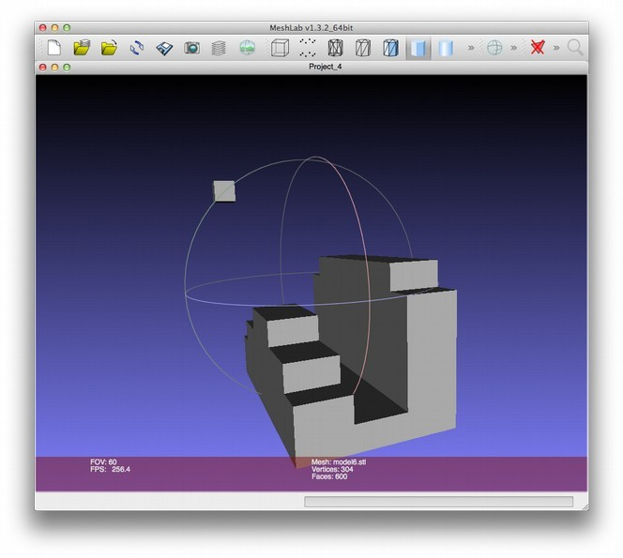Figure 3-12: The finished Minecraft model
If you’re not happy with some aspect of your model, just open Minecraft again, make any necessary adjustments, and re-export your model.
OpenSCAD
OpenSCAD is free CAD modeling software aimed at those comfortable writing code to create objects. You can download OpenSCAD for Windows, MacOS, and Linux from http://www.openscad.org/. Follow the instructions at the website to install OpenSCAD on your machine.
The OpenSCAD interface is split into three windows: code, preview, and status as shown in Figure 3-14. When you first start OpenSCAD, these fields should be blank.
Above: You’re not showing blank windows though. Please comment on thatso that this makes sense to your reader.
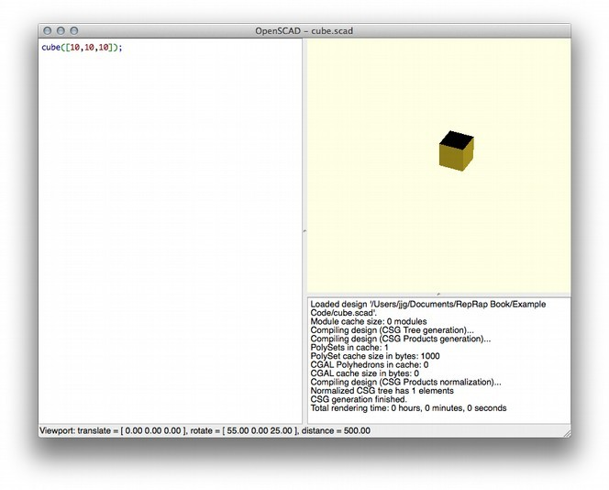Figure 3-13: OpenSCAD’s windows: code editor (left), preview (top right), and status (bottom right). The code in the left window creates the cube shown in the preview window.
The code editor panel on the left is where you’ll enter the code for your model. The preview area at the top right will display the model as you write the code for it. The status area at the bottom-right shows messages from the OpenSCAD rendering engine as it runs your code.
Designing
Now that you know your way around, let’s start designing something with OpenSCAD. This is a very basic introduction to OpenSCAD. You should be able to follow these instructions even if you’ve never written a line of code. Clearly, OpenSCAD isn’t for everyone but you may find after playing with it
First, enter
cube([10,10,10]);
in the code window, and click File4Save to save your work. Name the file cube.scad and you should see a cube in the preview area as shown in Figure 3-14. Now you can use your mouse to examine your cube by clicking and dragging in the preview window. You should be able to zoom in and out using the mouse wheel.
Please be sure that you’re using terminology consistently
NOTE: If you don’t see a cube in the preview area, double-check your code to make sure you entered it correctly, and save the file again.
Basic Syntax
You created a neat little cube in the previous section, but how does OpenSCAD know how to translate your code into a shape? You entered this in the code window.
cube([10,10,10]);
The code cube is a function that tells OpenSCAD what type of shape to draw. The code [10,10,10] gives cube the dimensions of the cube as measurements of the cube’s X, Y, and Z axis, in order. In other words, this code renders a cube of 10x10x10 units.
Simplifying here. We don’t need to go into arrays and such. What’s the point?
OpenSCAD has a number of other functions for drawing basic forms like cube(), sphere(), cylinder(), polyhedron(). You’ll find extensive documentation of all OpenSCAD functions at http://en.wikibooks.org/wiki/OpenSCAD_User_Manual/The_OpenSCAD_Language#Primitive_Solids
cut this. It’s beyond the scope of this book. The book is focused on 3D printing; not an introduction to 3D modeling using tools like OpenSCAD. You’re just opening a can of worms here.
Figure 3- 14: Thanks to translate(), our cube is shifted to the right along the X axis
Figure 3-15: Nesting functions allows you to apply multiple actions to one object.
Figure 3- 14: Thanks to translate(), our cube is shifted to the right along the X axis
Figure 3-15: Nesting functions allows you to apply multiple actions to one object.
Figure 3- 14: Thanks to translate(), our cube is shifted to the right along the X axis
Figure 3-15: Nesting functions allows you to apply multiple actions to one object.
Figure 3- 14: Thanks to translate(), our cube is shifted to the right along the X axis
Figure 3-15: Nesting functions allows you to apply multiple actions to one object.
Figure 3- 14: Thanks to translate(), our cube is shifted to the right along the X axis
Figure 3-15: Nesting functions allows you to apply multiple actions to one object.
Figure 3- 14: Thanks to translate(), our cube is shifted to the right along the X axis
Figure 3-15: Nesting functions allows you to apply multiple actions to one object.
Figure 3- 14: Thanks to translate(), our cube is shifted to the right along the X axis
Figure 3-15: Nesting functions allows you to apply multiple actions to one object.
Exporting Printing
Before you can use an OpenSCAD model for printing, you need to generate an STL file

Now, you just need to export your frosty friend for printing! There are two steps:
Click Design4Compile and Render to generate a detailed model of your project. This may take a few minutes.
When the model is generated, click Design 4 Export STL
Select a place to save the STL file, and name it snowman.stl. You should now have an STL file suitable for slicing and printing! If anything goes wrong, review the messages in the status area and look for clues. (The most common error is trying to Export STL before rendering.) Remember that if you make changes to the code, you’ll need to save your changes and render again before you can export a new STL file.
We can construct rich, complex models by using OpenSCAD to create basic shapes and manipulate them in space. Many 3D models published on the Internet include their OpenSCAD source code, so if you can read and understand OpenSCAD code, you can easily customize these objects and incorporate them into your own original designs.
OpenSCAD isn’t for everyone, but it can be a fast, powerful way to create very precise models. If you’re more comfortable with code than with drawing tools or if your model needs to fit in with pieces you’re not going to print (a replacement part, for example), then I recommend giving OpenSCAD a try. You can even use variables and loops to write OpenSCAD programs that generate models dynamically, which can make adapting your models for different purposes or generating custom versions easier.
Blender
Blender is a free, open-source 3D animation program for Linux, Mac, and Windows. It’s a very complete 3D modeling tool, and it’s quite useful for 3D printing as well as creating animations. The learning curve for using Blender may be steep for casual users, but the reward for time spent is significant. Download Blender from http://www.blender.org, open it up, and let's take it for a spin!
By default, Blender starts out with a cube on the workplane (Figure 3-18). Right-click the cube and hit the Delete key on your keyboard (not Backspace!) to delete it. Blender is nice enough to prompt you to confirm the delete, so click confirm if you want the cube gone.
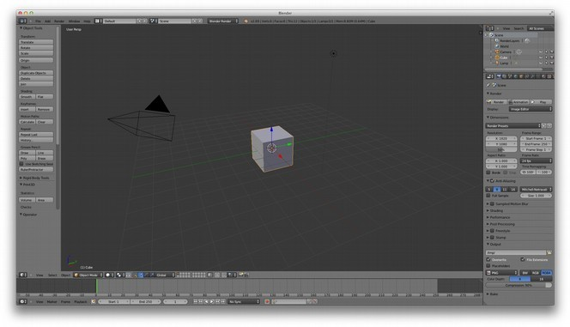Figure 3-15: Blender’s default workplane
Blender Settings
Prod: Where reasonable, let’s use flyouts in the Blender section, show the small menus to the side of the workspace screens. AU working on getting cropped control views and naming them to correspond to full-sized images.
Blender wasn’t made to create printable 3D models, so before you get started, you’ll need to prepare it for designing printable objects. First, enable the 3D Print Add-On. Click File4User Preferences, and then click the Addons tab. In the search box, type print (you could also browse through all the options, but that could take awhile), and the Mesh: 3D Print Toolbox addon should appear on the right. Check the checkbox next to the addon, click Save User Settings in the bottom-left corner, and then close the Blender User Preferences window.
You'll also want to change some of the scene settings so you create something sane for 3D printing. From the menu on the right of the main Blender window, click the Scene icon (Figure 3-19). In the scene options, select Metric units.
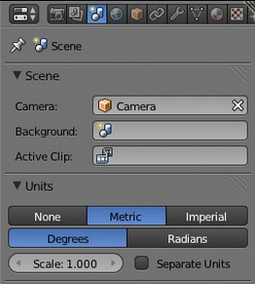
Figure 3-19: Blender’s scene options
Finally, scale your dimensions so that you can produce an object that will print safely on almost any 3D printer. Select the object, and press the N key to view the Dimensions menu (Figure 3-20).
The above says “Select the object” but we haven't yet created something.
By default (at the time of writing) Blender starts with a single cube on the workplane (shown above). Perhaps the text needs to be more descriptive, i.e.: “Select the default object (cube) that Blender placed on the workplane...”? /JJG
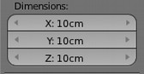
Figure 3-20: The Dimensions menu
Prod: could we show this little screenshot off to the side of the paragraph describing it?
Set the dimensions to 100mm (or 10cm) for all three dimensions.
Note: You’ll have an easier time using Blender if you get familiar with the keyboard commands, like the N shortcut you just used. These commands are available via menus, but the menus are so vast and deep that you could spend a lot of time hunting for something. Since Blender is really designed to leverage the keyboard commands heavily, I’ve adopted that behavior here as well.
Now that Blender is all set for creating printable objects, let’s make one!
Modeling a Pencil Cup
For this project, you'll create a nice little cup you can print for your pencils. (If you print it with the right materials on a very clean printer, you could also drink out of it.) Start by dropping a plain old cylinder on the workplane, Blender-style: click Add4Mesh4Cylinder, and a cylinder should appear on the workplane, as in Figure 3-21.
Was not immediately obvious where the “Add” Menu Option was. The later style of describing where to find the menu would help here. /GSH
@Jason: Could you clarify in response to Gary’s comment? I do agree that if he had some trouble finding the menu, the reader may, as well. /JGFigure 3-21: This plain cylinder will become our pencil cup.
Prod: Perhaps we could have Figure 3-22 be a flyout from Figure 3-21?
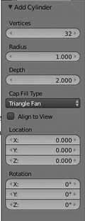
Figure 3-22: Add Cylinder menu
Next, we'll set the fill type for the cylinder to Triangle Fan using the Cap Fill Type menu under Add Cylinder on the left of the screen. We need to edit the object, so click the Object Interaction Mode (Figure 3-23) menu and choose Edit Mode; your cylinder should now change color to indicate it's selected.
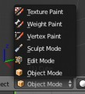
Figure 3-23: The Object Interaction Mode Menu
You're not ready to select anything yet, so press the a key to toggle the selection. This is a handy way to get yourself out of trouble should you select part of an object on accident.
The pencil cup needs a hole at the top, but before you create that hole, switch the object view to Wireframe. Click Viewport Shading (Figure 3-24), and select Wireframe.
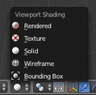
Figure 3-24: Switching to wireframe mode
Prod: Both of these images should be part of Figure 3-24; zoomed in shot should be a flyout
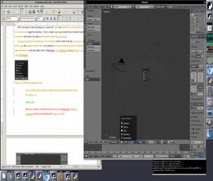

With the cylinder in Edit Mode and the view set to Wireframe, the workplane should look something like Figure 3-19.
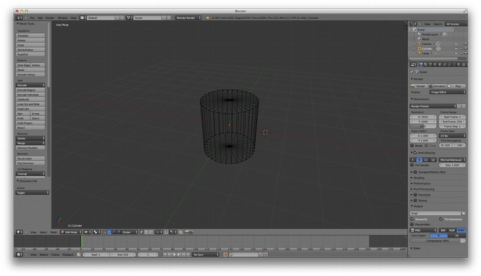Figure 3-16: Our cylinder in Wireframe mode
Now, remove the top of the cylinder. Right-click in the center of the top of the cylinder (where the lines come together) to select it. When it's selected properly, all of the wires on the top of the cylinder should change color. Hit the delete key, and Blender should ask what exactly you'd like to delete. In this case, select Vertices from the confirmation menu and the top of the cylinder should disappear.
Changing how you view the cylinder makes it easier to finish the model. Click View4Front (the View menu is in the lower-left corner of the screen); this should whip the cylinder around so you're looking at the side. Next, click View4View Persp/Ortho to toggle between perspective view, which shows the object in three dimensions, and Orthogonal view, which renders the image flat. Choose orthogonal view. Assuming you’re using a flat screen (unless you have a fancier setup than I do), this view should make your life easier for the moment. At this point you should be looking at something like Figure 3-20.
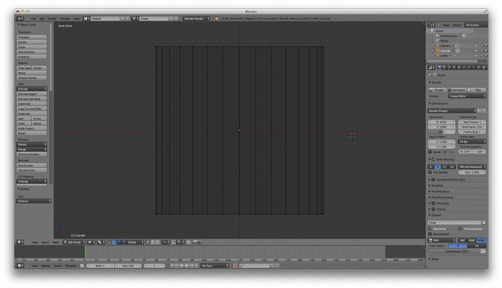Figure 3-17: An orthogonal view of the cylinder
Use the mouse wheel to zoom in; you're focusing on the cylinder, so there’s no need for all that empty space. If your screen doesn't look like the one above, review each step so far until it does so you can follow along from here. If everything looks good, let's add some shape to our pencil cup!
With the mouse over the cylinder, press ctrl-r (lowercase, not caps!); a horizontal purple line should appear. Scroll the mouse wheel slowly, and the number of lines should grow to two, then three, and so on. Scroll up until you see three purple lines, left-click to lock the number of lines, and press enter to lock them into place. This operation is called subdividing, and it's useful for taking a basic solid and manipulating sections of it, which you'll do next.
Note: If you move the mouse up or down during this process you'll move the lines as well. This isn’t a big deal, but if you want your results to look just like my end result, move the mouse back until the initial line is in the middle of the cylinder's height.
Press the a key to deselect the cylinder if it's still selected, then press b to turn your cursor into a crosshair. Using this crosshair cursor, drag a rectangle around the bottom of the cylinder to select the row of dots at the bottom of the cylinder.
With these selected, press s to alter the size of this section. Get creative, but keep in mind that this part must be wide enough to support the pencil cup yet small enough to fit on the printer you want to print it out on. (100mm is a safe bet for most printers.) When you're happy with the size, left-click the mouse to set your changes in place, and press a again to make sure the selection is released. Next, repeat this process for the top row and the three rows you added earlier until you have a shape you like. You can see one possibility in Figure 3-21
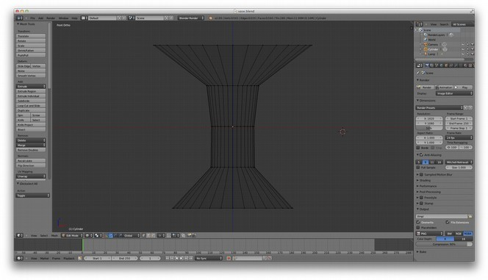Figure 3-18: Depending on how you adjust those sizes, your cylinder might look more like a vase
You'll be carving out the inside of the shape in order to make room for whatever you want to put inside, but you need to leave some room between the empty inside and the outside walls so the cup has enough plastic to hold itself together.
Note: As long as the hole on the inside doesn't touch the outside wall, you'll be safe, so just don't pinch the middle section too much. If you run out of room in the next step, come back to this step to widen the cup.
Now that you have the outside shape, let's make the inside. The first step of this process is to extrude the outside wall of the shape inward so you have a lip at the top of the vase. Use the A key again to remove any existing selection, and then use B to select the row of dots at the top of the cylinder. This is where it gets weird. With the top row selected, press E (for extrude), and then press enter. Next, type S to switch to size mode, type .9 on the keyboard, and press enter again. You won't see much change at this point due to the perspective, but if you click and drag slowly with the middle mouse button to tip the viewpoint a little, you should see that you've created a thin lip around the top edge of the cylinder (Figure 3-22)
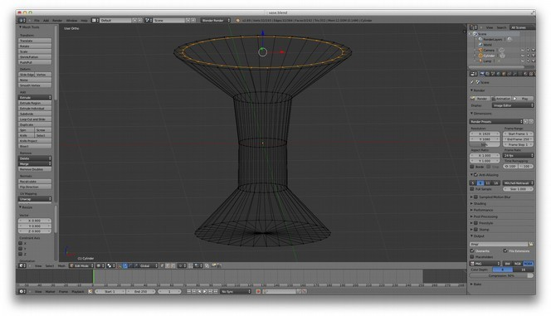Figure 3-19: The cup, after extruding the lip inward
Before continuing, use the View menu to switch back to Front view. Now without deselecting the newly extruded lip, again press the E key to begin extruding again, and drag the mouse down to extend this edge into the body of the pencil cup. Drag down until you meet the next row of dots from your subdivision operation, and then left-click to set it. This extrusion may go outside of the body of the vase, so to clean this up, press S and move the mouse up or down to size the extrusion until it's inside of the vase about the same amount as it is at the top.
Repeat this process until you're a few millimeters from the bottom of the vase. Now you need to form the bottom of the vase. With the extruded row still selected, press E, and then press enter. Next, click Merge under Remove: in the left-side menu, and select at center. This should bring the points we have selected together at the center of the object. To see this effect more clearly, use the center mouse button to tilt the workspace slightly so you can see inside the vase, as in Figure 3-23.
Above it should be clarified that the Merge option is under the Tools panel./GSH
@Jason: Could you clarify the steps above, as Gary described? /JG

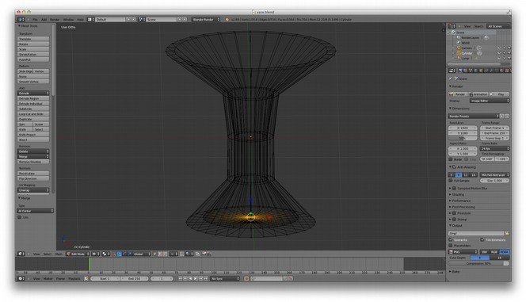Figure 3-20: The wireframe of our vase, complete with an enclosed bottom
It’s time to see what this will look like when you print it! Switch the object menu from Edit mode to Object mode, and then switch the view from Wirefame to Solid, and you should see something like Figure 3-24
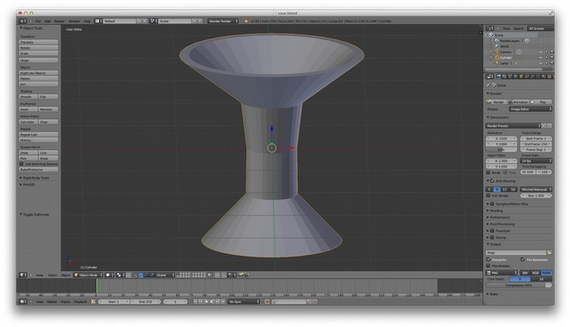Figure 3-21: The completed vase model, shown as a solid
Use that 3D Print Toolbox we installed during the setup stage to check out your model and identify potential problems. Click Print3D in the Tools panel on the left to expand the Toolbox. Understanding its myriad of features is an exercise I leave to you; for now, let’s just get some quick feedback on your model. Click the Check All button, and you'll get a summary of possible problems with the model in categories like “Non Manifold Edges,” “Zero Faces,” and “Overhangs”.
In Blender v2.72 the 3D Printing options are now in a tab called “3D Printing”./GSH
@Jason: If you want to stick with an older version of Blender, that can work (as long as it’s still available to download), but could you explain to readers why you chose to use something older at the beginning of the section? It’s just helpful to be up front about decisions like that.
Otherwise, if you think readers will be using the most recent version of Blender, could you update accordingly? /JG
If your model has any of these problems, clean them up before continuing. This simple model should have gotten a clean bill of health, though, so I'll continue on with the export.
Exporting from Blender
The final step in preparing your Blender model for printing is to export it to an STL file. Click File4Export4STL, and a dialog box should appear that allows you to name the file and choose a location to save it. In addition to these typical bits of information, there is one more critical thing you need to do to get a model we can feed to the slicing software.
At the lower-left corner of the dialog is a field where you can set the scale of the exported file. This must be set to 1000 in order to ensure the size (in millimeters) of the model exported matches the size of the model you created. Ignoring this will create a file that contains a model that is orders of magnitude off in size, and most slicing software will be unable to process the file. Finally, click Export STL to save the file.

In this chapter, we looked at a few applications that demonstrated a variety of ways to go about the 3D modeling process. What type of tool you choose is up to you, and may change depending on the type of modeling project you are working on. They key requirement for modeling software is that the output is an STL file that can be fed to the slicing software, which is the next step in the 3D printing process—and by no coincidence, the focus of the next chapter of this book as well.

