Table of Contents
Cleaning Up the Model 1
Avoid Overhang 1
Make Watertight Connections 6
Shells, Infill and Wall Thickness 8
Slicing Software and Terminology 12
Choose Your Slicing Software 13
Layer Height 15
Shells 16
Infill 17
Speed 19
Skirt & Brim 20
Support Material 21
Additional Settings 21
Let's slice it already! 22
4
Now that you’ve designed something awesome, let’s print it! But wait; none of the modeling programs we just learned about actually have a Print button. What’s up with that?
Well, it turns out we have a little more work to do before we can feed the model to the printer. In this chapter, I’ll walk you through the necessary steps to prepare your model for the actual printing process.
Cleaning Up the Model
The first question to ask is this: “Will it print?” And the answer isn’t always yes.
It’s certainly possible to design your model in ways that will throw the printer for a loop. Software can help with some of these problems, but it probably won’t catch every error you make. There are, however, a few things you can do when preparing to print that can save you some headaches and valuable printer time later.
Avoid Overhang
The first thing to consider is how the printer deposits material to create the model. Current RepRap designs still favor a deposition model, in which a print head deposits material on a build surface layer-by-layer until the model is complete as shown in Figure 4-1. Each new layer is laid down on top of the previous one, so a RepRap printer can’t properly print models with overhangs or projections out of the sides of the model, above the first layer.
What is the alternative to the deposition model? Have you discussed different models of 3D printers in an earlier chapter? If not, seems to me this should be discussed earlier, not hidden here.
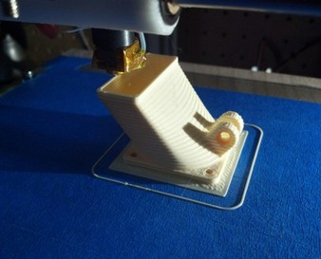
Figure 4-1: The print head creates a model by placing layer upon layer of plastic, where each new layer is supported by the one below.
You can, however, bend that rule to a certain extent. Most RepRaps can perform some level of bridging, or printing “in thin air” by rapidly cooling the liquid filament as it emerges from the nozzle. Just how far you can push this varies from printer to printer, and the best way to determine that limit is by experimenting. In general, a good rule of thumb is to keep the angle of any overhangs under 45 degrees as shown in Figure 4-2.
insert < 04_deposition.jpg
Prod: Please make the next three images all part of one Figure 4-2, and number them
Begin Figure 4-2
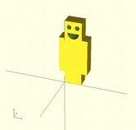
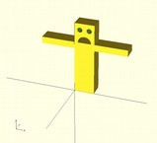
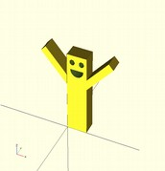
End Figure 4-2
Figure 4-2: You can get away with overhangs, but don’t make them greater than 45 degrees.
As you can see, the arms of the first model in Figure 4-2 u extend only a few millimeters from the body at a 90 degree angle; most printers can handle this. The second model v, however, has long arms that extend far from any previous layers, so there's nothing to support the plastic being laid down and the resulting model would be unstable. The third model w has arms that stick out, but at a 45 degree angle which most printers can safely handle.
Often the problem of overhangs can be addressed simply by rotating your model such that its larger parts are at the bottom of the print, resting safely on the print bed as shown in Figure 4-3.
Prod: please make the next two images part of Figure 4-3 with annotations
Begin Figure 4-3
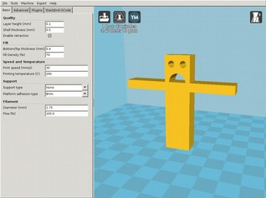
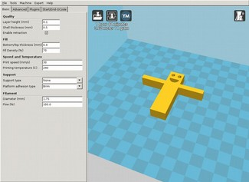
insert < 04_good_bed.jpg 04_bed_bad.jpg>
End figure 4-3
production: please do noto use wingdings for these images. Use letters, or regular numbers, but not wingdings. Those are reserved for code. /bp
Figure 4-3: Design your print so that the largest part will rest on the print bed.
In the first position u, the model’s arms will be unsupported when printed, which is likely to leave drooping plastic under the arms. By laying the model flat on its back v, all parts are supported which makes it much easier to print. (Sometimes overhang problems will solve themselves. On more than one occasion, I've overlooked an obvious overhang problem, sent the model to the printer, and found that the model printed acceptably.)
where does the below figure fit in? Please refer to it in text.
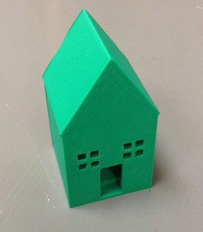
Shells, Infill, and Wall Thickness
Objects printed by a deposition-style printer are usually constructed from a combination of two types of print objects called shells and infill. Shells are solid walls of plastic laid-down in an outline of the model’s shape; infill is the material that goes between those walls. For example, when printing a ring, the printer first lays down one circle of plastic for the outside of the ring, then another circle for the inside of the ring, and finally it infills the space between these two shells with plastic as shown in Figure 4-7.
insert <3dprintingwithreprap04_07.jpg>
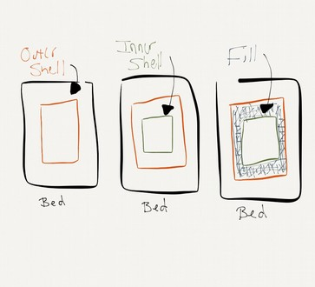
Figure 4-7: Shells and infill in a simple square ring.
Prod: please redraw this graphic
In a real world reprap setup, the shell and infill might look something like Figure 4-8.
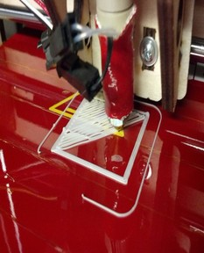
insert <04_shell_and_infill.jpg>
Figure 4-8: In this photo the outer and inner shell for the first layer have been laid down and the printer is in the process of adding infill.
Every RepRap printer has minimum sizes for the width of any output. The minimum width of a shell is limited by the size of the printer's nozzle. Technically, minimum infill size has the same limit, but practically speaking, infill that is thinner than three shell widths (as in Figure 4-9) is impractical.
Insert <04_no_infill.jpg>
In most cases, it usually makes more sense to use multiple shells rather than infill, as shown in the four pieces in Figure .
not sure what you’re saying above. Where are the multiple shells? Why not use infill? Please explain in your text.
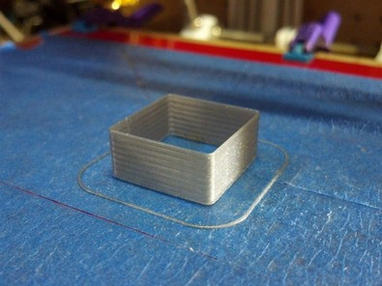
insert <04_infill.jpg>
Figure 4-9: This print is all shell, with no infill between walls or inside the model. It won't be very strong, but it prints fast and uses very little plastic.
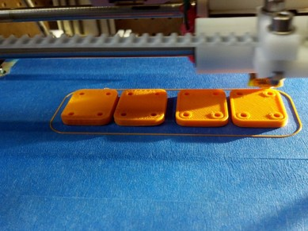
Figure 4-10: These parts have two shells and a lot of infill for strength. The outside of each part has a shell as do the interior holes).
But what does the infill amount have to do with the model itself? Can’t software solve that problem? Perhaps, but no software knows as much as you do about how your part will be used. Choosing the correct infill amount is a balancing act between the strength of the part and the amount of plastic used, which affects the cost, weight, and the time it takes to print a part.
When determining how much infill to use, look carefully at any thin walls or other thin structures in your model to determine whether they require additional strength. If so, consider making them thick enough to leave room for some infill. Conversely, if they don't need the extra strength, consider making them thinner to match the shell thickness, so that the printer won't waste time and material depositing small amounts of unnecessary infill.
In cases where infill isn't necessary (in a vase for example), you can disable it altogether as you’ll learn in the next section. You can also use additional shells to provide more strength, which can dramatically reduce print time.
don’t introduced the term “slicing” above until you’ve defined it
Slicing Software and Terminology
Once you've addressed all of the potential issues with your model, it's time to slice it! Slicing is the process of taking the solid CAD model (usually in STL format) and turning it into Gcode, a programming language your printer understands. Once converted to Gcode the file changes from something that describes what your model will look like into a series of motions that the printer must make in order to create your model. This process is called slicing because it takes the solid object and cuts it into the individual layers that the printer will lay down one at a time.
start box
Common Gcode Commands
Gcode derives from the earliest programmable machines, which were weaving looms. You don’t need to know how to read or write gcode to use a 3D printer, but knowing a little can come in handy if you need to make a change to the printer on-the-fly without regenerating the entire gcode file (like moving the nozzle to a different starting point or changing the hot-end temperature slightly for a different type of plastic).Table 4-1 lists a few useful gcode commands.
Table 4-1: Common Gcodes
Code | Action
G1 | Moves the tool head (the extruder) to the specified coordinate (x,y,z)
G28 | Home all axis
M104 | Set hot-end temperature
M84 | Disable the motors
M106 | Set the fan speed
Some printers interpret the Gcodes differently (especially the “M” codes) according to the printer’s software or firmware. The examples in Table 4-1 are for the Marlin firmware, which is popular on Reprap printers. You’ll find a complete reference to standard Gcodes here: http://reprap.org/wiki/G-code
end box
Choose Your Slicing Software
As of this writing, several open-source software packages are capable of slicing a model in STL format into Gcode. Table 4-2 lists some of the most widely used ones. For the examples that follow I’ve chosen to use Cura because it’s the simplest one for beginners, but explore the rest and pick the one that works for you.
Table 4-2: Popular Reprap Slicing Software
alphabetized below
Software | Website
Cura | http://wiki.ultimaker.com/Cura
KISSlicer | http://kisslicer.com
Repsnapper | https://github.com/timschmidt/repsnapper
Slic3r | http://slic3r.org/
Download and install the current version of Cura for your operating system from http://ultimaker.com/en/products/software now. When you open it, you should see something like Figure 4-11, but without the friendly model.
Assuming this is not a final screenshot
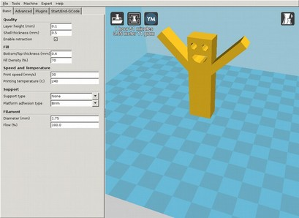
Figure 4-11: The interface for the Cura software for slicing models and controlling 3D printers.
insert <04_slicing.png>
Let's explore some of the slicing parameters in Cura.
You don’t seem to be going through the options one by one so you shouldn’t suggest that you are.
Layer Height
Cura’s Layer Height field determines how thinly the layers of your model will be sliced. Printer manufacturers sometimes refer to this as resolution. Layer height is usually expressed in fractions of a millimeter or microns (0.001mm). The lower the number of the layer height, the smoother the print will be, but beyond a certain point, reducing the layer height will actually result in loss of detail or other irregularities. Exactly where this limit is varies from printer to printer, though most well-calibrated RepRaps can produce good prints down to a layer height of 0.01mm.
The lower the layer height, the higher the number of layers and the longer the model will take to print. You may choose to print above the minimum layer height to save time. For example, if a model takes an hour and a half to print with .25mm high layers, it may take up to two and a half hours with 0.1mm layers. Take it down to 0.01mm (100 microns) and you’re looking at 15 hours!
Time is important because your first print attempt is rarely your last, especially with new designs where multiple iterations are often necessary to get things right. In these cases, shorter print times can make a big difference.
The other issue with long print times is that they increase the odds of equipment failure, so you actually run the risk of losing your work with slower prints. I don't have to tell you how fun it is to have a 15 hour print go wrong at hour 14.
I typically use a 0.1mm layer height on my RepRap Mendel by default. I’ll go up to 0.25mm if I’m in a hurry, and down to 0.01mm when I need a smooth finish, but only once the model is exactly what I want and I've checked that it prints correctly at lower resolutions.
Shell Thickness
speak about this option in Cura specifically. That’s what you said you were going to do at the start of these sections.
Cura’s Shell Thickness field ___.
Slicing software varies a bit when it comes to specifying shell parameters. Some applications allow you to specify the number of shells, but not the size. Others allow you to specify shell thickness and will calculate the number of shells for you based on your printer's nozzle size. If you have to specify the number of shells, it's good to start with two or three which is adequate for most models that require infill, while three should be used for models that rely just on their shells for structure.
In Cura, you simply specify the shell thickness in millimeters and the software handles the rest. Our model is just for fun, so our only requirement is that the shell thickness isn't smaller than our nozzle size. Cura will let us know if we get too close to the nozzle’s limits by turning the Shell thickness field yellow or red if we make it too small. It will give you a warning, as shown in Figure 4-12.
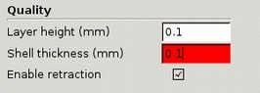
insert <cura_shell_warning.png>
Figure 4-12: Cura warns you if it thinks you're using invalid configuration parameters.
You skipped one option. The next major section is listed as Fill. We’re deviating from the Cura menu so this is not making sense. If you want to speak about these options in general that’s fine but don’t have the reader think you’re working through the Cura options because you’re not really. Please rewrite accordingly.
Infill
Infill is discussed in terms of density (in percentages) and pattern. The stronger a model needs to be, the more infill you should use. 3D printed models are surprisingly strong, and fill percentages above 20 percent are rarely necessary. Too, higher fill rates use more filament, and can increase print times significantly.
Infill pattern is another interesting topic. When I started building my first RepRap, the most common fill pattern was rectilinear (that is, criss-cross); however, the honeycomb pattern is another a popular default. The pros and cons of various patterns is a rich area of discussion, and you may well find that one pattern is superior to another for your application.
A discussion of when to use each fill pattern may be out of the scope of the book, but an image visually comparing the different fill types might be useful enough to answer most readers' questions about them. /EG
I agree with Enrique here; could you either describe (perhaps in a table, or even a box?) or offer a figure for comparison? I think that's a major concept someone new to 3D printing would hope to learn in this book. /JG
The Slic3r documentation (http://manual.slic3r.org/expert-mode/infill) has a great detailed breakdown on this subject, I'm not sure if it makes more sense to get permission to include that information in the book or simply direct readers to the website for more information since it is somewhat software-specific? /JJG
No. I would just offer a couple of examples. Show examples of the two patterns that you mention then point them to the Slic3r documentation for more information. /bp
The one certainty about infill is that the more complex it is, the longer it will take to print. A honeycomb infill like the one shown in Figure 4-13 will take about twice as long to print as a rectilinear one, and other designs can be even slower. Consider the value of using a particular pattern in relation to its print time and decide what best suits your needs. I use honeycomb by default and rectilinear for solid layers (like tops and bottoms).
Be sure to show the rectilinear pattern
Insert <3dprintingwithreprap04_09.jpg>
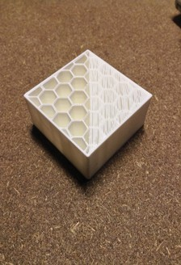
Figure 4-13: A square shell with hexagonal infill
The slicing software you choose will dictate the fill patterns you can use. The version of Cura current as of this writing offers only a rectilinear option, so we only need to decide on the fill percentage. Since our little guy just needs to be strong enough to support his own weight, we'll choose 20 percent by entering 20 in the Fill Density (%) field.
You should provide readers with your model so that they can work through these steps if that’s the intention. If that’s not the intention please rewrite accordingly because this is confusing.
NOTE: The fill density should not affect the look of your model as the fill is hidden inside the model when complete. Its only affect is on the strength of your model, the amount of material used, and its weight and printing time.
Speed and Temperature
You can use your slicing software to set the speed at which your printer moves its print head. We'd like the printer to run as fast as it safely can of course, but that speed will vary greatly from machine to machine. If you are using a ready-made printer, the manufacturer will likely have a recommended speed that you should use as a starting point. If you're using a custom built one, you'll have to experiment to find the highest safe speed for it, but 30mm/s is a good place to start.
Some slicing applications may allow you to specify the printing speed in more detail. For example you may be able to use different speeds for shells and infills, or use a lower speed for the first layer when making the plastic stick to the bed is critical. Experimentation is the best way to discover the right settings, but it’s usually a good idea to start with the same speed for everything.
Regardless of your machine’s limitations, some designs will simply come out better if printed below maximum speed. The time a layer has to cool before the next layer is placed on top of it can cause distortions such as curling as shown in Figure 4-14.
at this point you’re kind of deviating from Cura so I wonder why bother to speak about one particularly slicing tool. Maybe just recommend it but continue sticking to this general discussion? You’re also not really stepping your reader through anything.
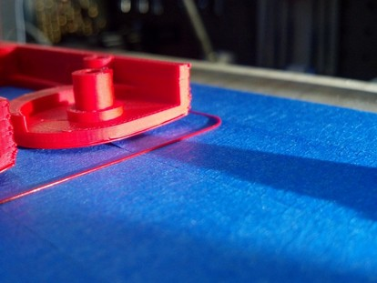
Figure 4-14: Curling is causing this part to lift off of the printbed, resulting in a bent bottom.
Insert <04_curling.jpg>
Most slicing software will automatically vary the print speed, or provide multiple speed settings for various operations in order to try and prevent these errors. If you are getting poor output from your printer (like complete failures, or prints coming loose from the bed, and so on) without any obvious explanation for the problem, try slowing the print speed.
Skirt and Brim Settings
I don’t see this on the Cura Basic tab. As noted earlier, I’d just make this a general discussion of slicing settings.
The Skirt (shown in Figure 4-15) is a bit of material laid down before the printer starts working on the actual model to ensure that the plastic is flowing well and that any gunk left over from previous prints is expelled before printing the new model. The size of the skirt is usually specified in terms of distance from the model, and the number of loops you want the print head to make before starting work on the model.
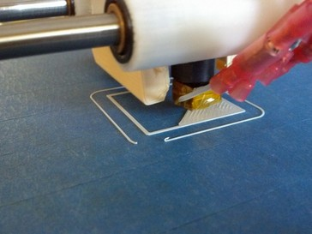
Figure 4-15: The ring of plastic around the model is the skirt. This example uses a single loop.
Insert <04_skirt.jpg>
There are two things to consider when adjusting the skirt settings: how much extra room the print bed has outside of the model, and that the skirt won’t go outside the printer’s boundaries. Typically one loop is enough, but when printing very small models, it’s sometimes worth printing two loops just to make sure everything is flowing well before laying down material for the actual print.
I still don’t know what a loop is
should brim have it’s own section?
Like the skirt, brim is throw-away layer of plastic printed outside the actual model in order to combat curling of the first layer of the print. Figure 4-16 shows an example.
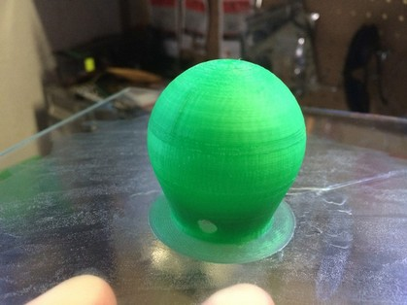
Figure 4-16: Use of a brim can be seen here as the thin layer of plastic laid down around the base of the model. This should be removed before the print is used.
Insert <04_brim.jpg>
Brim helps a print stay flat against the bed to prevent the base of the model from curling or coming completely loose. It's also useful when printing models that don't have a lot of contact with the bed, like a model of the Eiffel Tower that has just four small feet.
Support Material
Support material is extra plastic that is added by the slicing software to support parts of the model that would otherwise be unprintable, like excessive overhangs or parts that are simply floating in mid air. On a single-material printer, you’ll have to cut away support material once the print is finished, so it's best to avoid using support material if possible.
On multi-material printers, it's possible to load an extruder with special support material that is easy to remove (typically water soluble). On these machines, it should be fine to let the slicer generate support material because you can easily remove it from the finished print.
Additional Settings
All slicing programs have many more settings than just the ones described here. Many of these are specific to the printer you’re using and will only need to be changed when generating Gcode for a different printer. Others may be specialized settings for specific materials (such as temperature settings, filament diameter, and so on) or simply options that are unique to your software.
Whichever slicing software you choose, review its documentation and experiment to see what works best for your model, material, and printer.
Let’s Slice It Already!
Once you’ve selected the settings for your print, it's time to slice it! Load your model in the slicing program and then select whichever option is necessary to save it to Gcode. Figure 4-17 shows our example saved to Gcode in Cura.
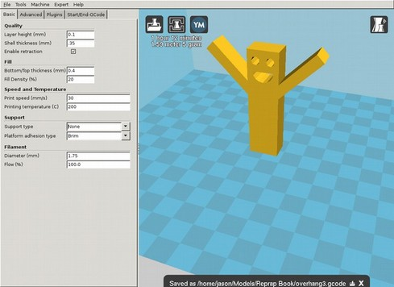
Figure 4-17: Model loaded, sliced, and saved to an overhang3.gcode file.
Insert < 04_slicing.png>
Slicing may take a while, as the software works hard to find the best combination of printer moves to translate your model into lines of plastic on the print bed. (Writing slicing software is a black art bordering on alchemy, so be patient and grab a beverage while your software does the work for you.)
Once slicing has finished, you should have a Gcode file that is ready for consumption by the printer of your choice. Feeding this file to the printer is the job of another piece of software called the host, which we’ll discuss in Chapter 5.
NOTE: Gcode files are generally compatible, but there may be printer-specific parameters like the size of the bed or maximum speeds that could make a gcode file incompatible (or at least unsafe) for one printer or another. Generally you'll generate a Gcode file for a specific printer by specifying the printer's details to the slicing software.
Jason: As is often the case with many authors, your responses to questions are often useful notes. Not sure where this one should go – probably earlier – but be aware that when answering our questions it may be best to just add additional explanation to the text.
You preview your gcode before feeding it to your printer with a number of applications, but one of the easiest is the website GCode Viewer at http://gcode.ws/. Figure 4-18 shows what the Gcode for our model looks like when fed to the Gcode Viewer.
Insert <04_gcode_view.png>
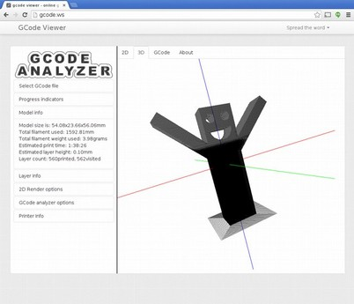
Figure 4-18: The GCode Viewer site can read and display your model’s GCode both as a complete model and layer-by-layer.
When previewing your model, check for any problems that may have been introduced during the slicing step. If what you see on GCode Viewer doesn't look like the model you just sliced, double-check the slicer settings; you should correct your file before sending it to your printer. If everything looks good, you're ready to move on to the next step: printing!

