Table of Contents
Cleaning Up the Model 1
Avoid Overhang 1
Make Watertight Connections 6
Shells, Infill and Wall Thickness 8
Slicing Software and Terminology 12
Choose Your Slicing Software 13
Layer Height 15
Shells 16
Infill 17
Speed 19
Skirt & Brim 20
Support Material 21
Additional Settings 21
Let's slice it already! 22

@Jason: Could you update the “Insert <filename>” directives throughout this chapter? With all the new screenshots, I was unsure which ones were correct.
I tried adding/updating the directives appropriately, if there are any questions let me know. /JJG
Could you also insert all images in the chapter with the same structure I used for Figure 4-1 through 4-7, and call out all images before they appear? Hopefully, leaving out the boxes will simplify things, and the callouts will help readers follow the discussion. /JG
I tried to make the requested changes to the images but I'm not enough of an expert in OpenOffice to be able to convince it to format things the way you want them. /JJG
4
Now that you've designed something awesome, let’s print it! But wait; none of the modeling programs we just learned about actually have a “Print” button. What’s up with that?
Well, it turns out we have a little more work to do before we can feed the model to the printer. In this chapter, I will walk you through the necessary steps to prepare your model for the actual printing process.
Cleaning Up the Model
“Will it print?”
That’s a legitimate question. It’s certainly possible to design your model in ways that will throw the printer for a loop. Software can help with some of these problems, but it probably won’t catch every error you make. There are, however, a few things you can do when preparing to print that can save you some headaches (and valuable printer time) later.
Avoid Overhang
The first thing we need to consider is how the printer goes about putting material down to create the model. Current RepRap designs still favor a deposition model, in which a print head deposits material on a build surface layer-by-layer until the model is complete. Each new layer has to be laid down on top of the previous layer, so a RepRap printer can’t properly print models with overhangs projecting out of their sides above the first layer.
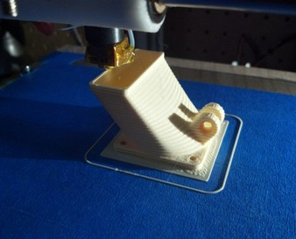
Figure 4-1: The print head creates a model by placing layer upon layer of plastic, where each new layer is supported by the one below.
You can, however, bend that rule to a certain extent. Most RepRaps can perform some level of bridging, which is the process of printing “in thin air” by rapidly cooling the liquid filament as it emerges from the nozzle. Just how far you can push this varies from printer to printer, and the best way to determine that limit is by experimenting. In general, a good rule is to keep the angle of these overhangs under 45 degrees (Figure 4-2).
insert < 04_deposition.jpg
@Jason: I really like what you’ve done with the 3D models here; the smiley faces are even more effective as good/bad indicators, and they make your points much more clearly. /JG
Prod: Possible to make the next three images all part of Figure 4-2, and perhaps label them with u, v, and w?
I’ve taken the three renders you made and tried incorporating them all into one figure, with the more descriptive captions as part of the body text. Does this seem okay? /JG
The body text below looks good to me (I don't see the consolodated image here but I can imagine what it might look like). /JJG
Begin Figure 4-2

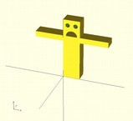
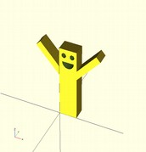
End Figure 4-2
Figure 4-2: You can get away with overhangs, but don’t make them bigger than 45 degrees.
The arms on the first model in Figure 4-2 u only extend a few millimeters from the body at a 90 degree angle; most printers can handle this. The second model v, however, has long arms extended far away from any previous layers, so there's nothing to support the plastic being laid down. The third model w has arms that stick out, but they are at a 45 degree angle which most printers can safely handle..
@Jason: I found myself a bit lost in the highlight above. Could you clarify what you mean by “go upward”? /JG
Could probably be phrased as “so there will be enough overlap for the lower layers to support the upper layers as they're printed.” / EG
Reworded. /JJG
Often the problem of overhangs can be addressed simply by rotating the object such that the larger parts are at the bottom of the print, resting safely on the print bed (Figure 4-3).
Prod: Possible to make the next two images part of Figure 4-3, with annotations?
Begin Figure 4-3
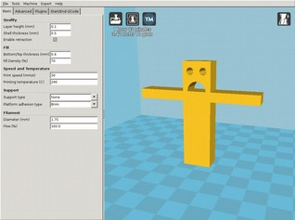
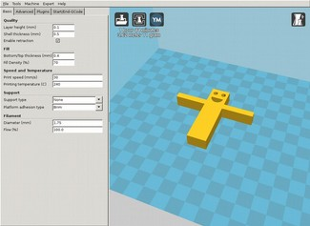
insert < 04_good_bed.jpg 04_bed_bad.jpg>
End figure 4-3
Figure 4-3: Design your print so that the largest part will rest on the print bed.
In the first position u, the model’s arms will be unsupported when printed, which is likely to leave drooping plastic under the arms. By laying the model flat on its back v, all parts are supported which makes it much easier to print.
Sometimes overhang problems will just “solve” themselves, though you can’t rely on that to happen every time. On more than one occasion, I've overlooked an obvious overhang problem with a design, sent it to the printer, and returned to find that the model printed acceptably.

I do wonder about presenting this example to the reader...they can’t expect it to happen all the time, right? If nothing else, might be good to close out the section by reiterating the “right” way to avoid issues. /JG
Good point, let's drop this entire example, I think the new images do a better job of explaining /JJG
@Jason: Just to confirm—do you want to remove the entire house example, or just the story about how overhang corrected itself? Either way, could you make the change? /JG
The whole thing, now removed. /JJG
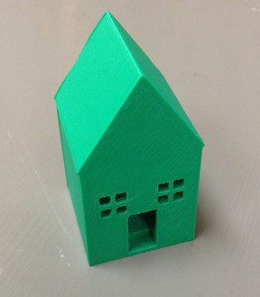

The more I think about it, I do a poor job of explaining what “watertight” means here. Partially because it's actually a difficult concept and partially because the tools I'm using avoid creating the problem in the first place. I'm considering re-working this section, but I'm also considering cutting it, since it's not as common of a problem as it used to be, and there are automated ways to fix most watertight problems now. What do you think? /JJG
I'd favor reworking over cutting, because it's still a potential problem. Perhaps we could box it, as an aside, if you think it's less relevant? /JG
Re-reading this in 2015 I don't think it's a topic for a book like this. Using current modeling tools it's not as easy as it used to be to create models with watertight problems, and none of the examples will produce them, it's really something that was a problem back when I started the book but doesn't come up much anymore, and would be difficult to explain to a useful degree without going way above the average readers head. /JJG

Shells, Infill and Wall Thickness
Objects printed by a deposition-style printer are usually constructed from a combination of two types of print objects called shells and infill. Shells are solid walls of plastic laid-down in an outline of the model’s shape; infill is the material that goes between those walls.
Imagine printing a ring. The printer first lays down one circle of plastic for the outside of the ring, then it lays down another circle of plastic for the inside of the ring, and finally it infills the space between these two shells with plastic (Figure 4-7).
insert <3dprintingwithreprap04_07.jpg>
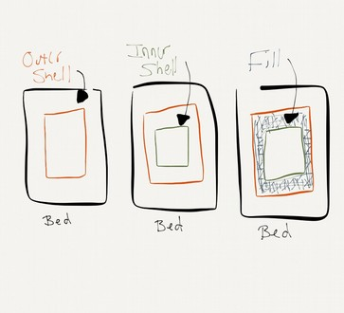
Figure 4-7: Shells and infill in a simple square ring.
Prod: Could you try redrawing this one as a vector graphic, with the labels?
In a real world reprap setup, the shell and infill might look something like Figure 4-8.
We could just use a bit here to connect the drawing and the photo; would my sentence above make sense? Also, as you’re changing the figure captions, could you tweak that callout so it has the correct number? /JG
Your wording looks great. /JJG
insert <04_shell_and_infill.jpg>
Figure 4-8: In this photo the outer and inner shell for the first layer have been laid down and the printer is in the process of adding infill.
Illustration 2
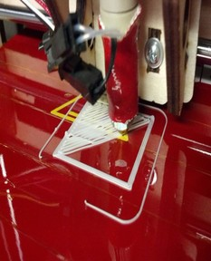Figure 1
The trick is that on any RepRap printer, there are minimum sizes for the width of these types of output. The minimum width of a shell is limited to the size of the printer's nozzle. Technically, minimum infill size has the same limit, but practically speaking, infill that is thinner than three shell widths, as in Figure 4-9, is impractical.
Insert <04_no_infill.jpg>
Does the figure callout above refer to the image of the silver object that’s all shell? If so, could you move that image to here, immediately after the callout? /JG
I think the image is immediately after the callout already (below these comments)? /JJG
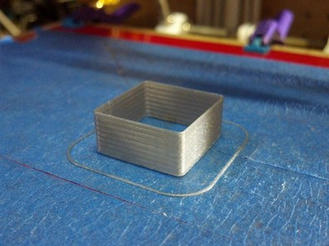Figure 4-9: This print is all shell, with no infill between walls or inside the model. It won't be very strong, but it prints fast and uses very little plastic.
In most cases, it usually makes more sense to use multiple shells, as I've done in the four pieces in Figure 4-11.
insert <04_infill.jpg>
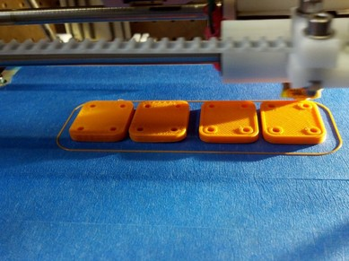Figure 4-10:: These parts have two shells and a lot of infill for strength (notice how both the outside of each part has a shell as well as the interior holes).
I was a bit confused about the first sentence below, and what it referred to; do I have you right with my tweaks? /JG
I took another run at that sentence to try and make it more clear. /JJG
But what does the infill amount have to do with the model itself? Can’t software solve that problem? Perhaps, but no software knows as much as you do about how your part will be used. Choosing the correct infill amount is a trade-off between the strength of the part vs. the amount of plastic used, which affects the cost, weight and printing time of the part..

Look carefully at any thin walls or other thin structures in your model, and if they require strength, consider making them thick enough to leave room for some infill between them. Conversely, if they don't need the extra strength, consider making them thinner to match the shell thickness, so that the printer won't waste time and material doing small amounts of unnecessary infill.
In cases where infill isn't necessary (in a vase for example), you can disable it altogether when slicing the model, which you’ll learn about in the next section. You can also use additional shells to provide more strength, which can dramatically reduce print time.
Compared to strengthening with infill? /EG
Correct. /JJG
Slicing Software and Terminology
Once you've addressed all of the potential issues with the model, it's time to slice it! Slicing is the process of taking the solid CAD model (usually in STL format) and turning it into Gcode, a programming language used extensively in the manufacturing industry, which the printer understands. At this point, the file changes from something that describes what your model will look like into a series of motions that the printer must go though. This process is called slicing because it takes the solid object and cuts it into the individual layers that the printer will lay down one at a time.
start box
Common Gcode Commands
Gcode is used for all sorts of machines, and it derives from the earliest programmable machines (weaving looms). You don’t need to know how to read or write gcode to use a 3D printer, but knowing a little can come in handy if you need to make a change to the printer on-the-fly without regenerating the entire gcode file (moving the nozzle to a different starting point to avoid a portion of the bed, or changing the hot-end temperature slightly for a different type of plastic, for example). In Table 4-1, you’ll find a few common gcode commands you might want to remember.
Under what circumstances will remembering these codes come in handy for the reader? They aren't being referenced anywhere else in the chapter, so it's a bit confusing to be asked to learn them at this point without explanation. /EG
@Jason: Pointing readers to a section or chapter in the book where they'll need Gcode might be enough; could you add that look ahead? I might also just suggest boxing this, since it doesn't seem to be a primary focus of the section. /JG
I added a little more above to provide some examples. /JJG
Table 4-1: Common Gcodes
Code | Action
G1 | Moves the tool head (in our case, the extruder) to the specified coordinate (x,y,z)
G28 | Home all axis
M104 | Set hot-end temperature
M84 | Disable motors
M106 | Set fan speed

Note that not all codes mean the same thing on all printers (especially the “M” codes). Exactly what happens when the printer receives a Gcode is up to the printer’s firmware. The examples in Table 4-1 are for the Marlin firmware, which is popular on Reprap printers, but other printers may treat these commands differently. A complete reference of standard Gcodes can be found here: http://reprap.org/wiki/G-code
end box
Before you can start slicing, you'll need to get some software to do the work for you.
Choose Your Slicing Software
At the time of publication, there are a number of open-source software packages capable of slicing a model in STL format into Gcode. Some of the most widely used slicing packages are listed in Table 4-2; explore them, and pick the one that you like best.
Table 4-2: Popular Reprap Slicing Software
Software | Website
Slic3r | http://slic3r.org/
Cura | http://wiki.ultimaker.com/Cura
KISSlicer | http://kisslicer.com
Repsnapper | https://github.com/timschmidt/repsnapper

Skeinforge seems to not have been updated since 2012, is it still used widely enough to justify including it here? /EG
Agreed, replaced with KISSlicer. /JJG
Let's discuss some common slicing parameters that you'll need to understand in order to slice your model correctly.
Could you explain to the reader why you're demonstrating with Cura? It seems a bit limited, based on the “Infill” section. /JG
Cura is (at this time) the easiest of the packages to get running. Given the potential complexity of the other slicing software across platforms Cura is the safest bet for beginners. /JJG
I'll use Cura to demonstrate these parameters in action, so download the most recent version of Cura for your operating system (Windows, Mac, and Ubuntu Linux are supported) from http://ultimaker.com/en/products/software now. To install it...
Should readers have downloaded and installed Cura yet? I'd suggest doing a clean install of Cura here, on all three systems, to look for potential hangups.
If the reader won't have to adjust any settings, select particular options, add certain files, etc., it should be fine to just advise them to accept all defaults and carry on. Otherwise, could you walk them through the install, on each system? /JG
Downloading and installing Cura is pretty straightforward on all platforms. /JJG
Once you've installed Cura, open it up, and you should see something like Figure 4-11, but without the friendly model.
Would my placeholder above be accurate to introduce the next image? If not, could you try another transition? /JG
Works for me. /JJG
insert <04_slicing.png>
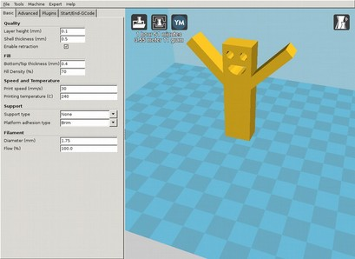Figure 4-11: The interface for Cura, easy-to-use software for slicing models and controlling 3D printers.
Now, let's explore those slicing parameters, in the order listed in Cura's Basic tab, at left.
Layer Height
Layer height u is how thin the layers of your model will be sliced; printer manufacturers sometimes refer to this as resolution. Layer height is usually expressed in fractions of a millimeter or microns (0.001mm).
The lower the layer height, the smoother the print will be, up to a limit. Beyond a certain point, reducing the layer height will stop improving print quality, and result in loss of detail or other irregularities. Exactly where this limit is varies from printer to printer, though most well-calibrated RepRaps are capable of producing good prints down to a layer height of 0.01mm.
You may choose to print above the minimum layer height to save time. The lower the layer height, the higher the number of layers and the longer the model will take to print. If a model takes an hour and a half to print with .25mm high layers, it may take up to two and a half hours with 0.1mm layers. Take it down to 0.01mm (100 microns) and you're looking at 15 hours!
Time is important because your first print attempt is rarely your last, especially with new designs where multiple iterations are often necessary to get things right. In these cases, shorter print times can make a big difference.
The other issue with long print times is that they increase the odds of equipment failure, so you actually run the risk of losing your work with slower prints. I don't have to tell you how fun it is to have a 15 hour print go wrong at hour 14.
Personally, I use a 0.1mm layer height on my RepRap Mendel by default. I’ll go up to 0.25mm if I'm in a hurry, and down to 0.01mm when I need a smooth finish, but only once the model is exactly what I want and I've checked that it prints correctly at lower resolutions.
Shells
I wasn't 100% sure of the subject of “This” in the first sentence below; do I have you right with my tweaks? /JG
Looks good. /JJG
Slicing software varies a bit when it comes to specifying shell parameters. Some applications allow you to specify the number of shells, but not the size. Others allow you to specify the shell thickness and calculate the number of shells for you based on your printer's nozzle size. If you have to specify the number of shells, it's good to start with two or three. Two shells is adequate for models that require infill, while three should be used for models that rely just on their shells for structure.
I found myself lost in this section. It seems like we're walking through slicing a model here, but that's not explicitly stated.
What if we provide the smiley guy as a file to practice on (or perhaps include a project at the end of Ch. 3, that has the reader model him?), tell the reader to open it in Cura, and give specific directions for fiddling with parameters?
Slight tweaks to the existing material (“We'll choose...” versus “Choose...”) would do the trick. I'd tell them to adjust shell thickness, for example, to see the error in action.
If you like the idea, could you make these changes as you revise? /JG
I'm not sure how to tackle this. I do like the idea of re-writing it as more of an exercise, but I'm not sure how to make it more clear. /JJG
In Cura, you only need to specify the shell thickness in millimeters and the software handles the rest. Our model is just for fun, so our only requirement is that the shell thickness isn't smaller than our nozzle size. Luckily, Cura lets us know if we get too close to the nozzle's limits by turning the Shell thickness field yellow or red if we make it too small. It will give you a warning, as shown in Figure 4-12.
insert <cura_shell_warning.png>
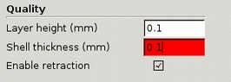Figure 4-12: Cura warns you if it thinks you're using invalid configuration parameters.
Infill
Infill is discussed in terms of density (in percentages) and pattern. The stronger the model needs to be, the more infill you should use. Printed models with are surprisingly strong, and fill percentages above 20% are rarely necessary. The downside to higher fill rates is that it takes more filament to print the model, and it can also increase print times significantly.
Is there going to be a comparison of different plastic/filament types anywhere that readers will be able to reference easily? Just anticipating something that readers will probably be thinking about at this point. /EG
Agreed. However this is an area experiencing a lot of change right now so it's something I'd like to discuss in detail in the final chapter (since I plan to complete that as close to the publishing date as possible so it's somewhat current when the book comes out). For now I re-worded the above to avoid going down that road at this point. /JJG
Choosing a good infill pattern is another interesting topic. When I started building my first RepRap, the most common fill pattern was rectilinear (that is, criss-cross); however, the honeycomb pattern is another a popular default. The pros and cons of various patterns is certainly a rich area of discussion and debate, and one pattern may be superior to another depending on the application.
A discussion of when to use each fill pattern may be out of the scope of the book, but an image visually comparing the different fill types might be useful enough to answer most readers' questions about them. /EG
I agree with Enrique here; could you either describe (perhaps in a table, or even a box?) or offer a figure for comparison? I think that's a major concept someone new to 3D printing would hope to learn in this book. /JG
The Slic3r documentation (http://manual.slic3r.org/expert-mode/infill) has a great detailed breakdown on this subject, I'm not sure if it makes more sense to get permission to include that information in the book or simply direct readers to the website for more information since it is somewhat software-specific? /JJG
The one certainty about infill is that the more complex it is, the longer it'll take to print. A honeycomb infill takes about twice as long as a rectilinear one, and other designs can be even slower. You'll need to consider the value of a pattern in relation to its print time and decide what best suits your needs for each case. Personally, I use honeycomb by default (see Figure 4-13) and rectilinear for solid layers (like tops and bottoms).
Insert <3dprintingwithreprap04_09.jpg>
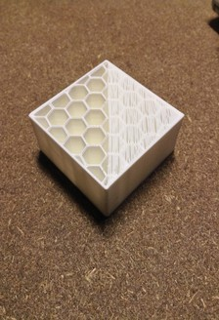
Figure 4-13: A square shell with hexagonal infill
In Figure 4-13, you can clearly see the vertical shells around the outside of the model, the honeycomb fill, and the beginnings of a horizontal shell (seen here covering half of the top surface).
How would the reader choose 20%? I'd suggest directing them to “click Button X to choose 20% now” or similar. /JG
Updated explanation below. /JJG
The slicing software you choose will dictate what fill patterns you can use. In the current version of Cura, the only option is rectilinear, so the only decision to make is the fill percentage. In the case of our example, our little guy just needs to be strong enough to support his own weight, so we'll choose 20% by typing “20” in the “Fill Density (%) field.
An image showing a completed rectilinear fill at 20% may be good to include here (since it seems to be implied that it isn't terribly strong). Or perhaps an image comparing different fill densities (if their differences are even visually noticeable)? Because at this point, the reader might not have a very good idea of how these fills and densities might affect the look of their model, just that they affect the strength of it. /EG
The fill density shouldn't have any effect on the look of the model as it's hidden inside the model when complete (so long as the printer is working correctly :), only the strength, amount of material used, weight and printing time. /JJG
Speed
You can also use your slicing software to set the speed at which your printer moves its print head. We'd like the printer to run as fast as it (safely) can of course, but that speed will vary greatly from machine to machine. If you are using a ready-made printer, the manufacturer will likely have a recommended speed that you should use as a starting point. If you're using a custom built printer, then you'll have to experiment to find the highest safe speed for it, but 30mm/s is a good place to start.
Some slicing applications may allow you to specify the printing speed in more detail, for example using different speeds for shells and infills, or using a lower speed for the first layer (when making the plastic stick to the bed is critical). Experimentation is the best way to discover the right settings, but starting with the same speed for everything is a good place to start.
Regardless of the machine's limitations, some designs will simply come out better if printed below maximum speed. The time a layer has to cool before the next layer is placed on top of it can cause distortions such as curling (demonstrated in Figure 4-14) to occur.
Insert <04_curling.jpg>
Most slicing software will automatically vary the print speed, or provide multiple speed settings for various operations (usually expressed as percentages of the base speed), to try and prevent these errors.
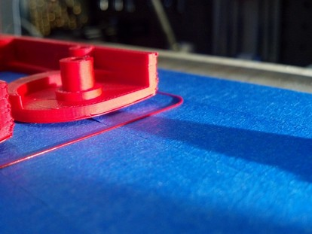Figure 4-14: Curling is causing this part to lift off of the printbed, resulting in a bent bottom.
If you are getting poor output from your printer (like complete failures, or prints coming loose from the bed, and so on) without any obvious explanation for the problem, slowing down can make a big difference.
Our model is fairly simple, but we don't want to take any chances, so we'll choose a printing speed of 30mm/s to be on the safe side.
Skirt & Brim
Skirt is a bit of material laid down before the printer starts working on the actual model. This ensures that the plastic is flowing well and that any “gunk” left over from previous prints is expelled before printing the new model. Skirt, which I show in Figure 4-15, is usually specified in terms of distance from the model, and the number of loops you want the print head to make before starting work on the model.
Insert <04_skirt.jpg>
There are really only two things to consider when adjusting settings for the skirt: how much extra room the print bed has outside of the model, and that the skirt won’t go outside the printer’s boundaries. Typically one loop is enough, but for very small models, it might be worth doing two just to make sure everything is flowing well before laying down material for the actual print.
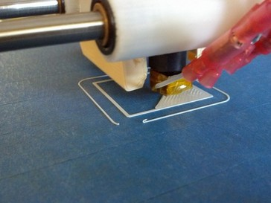Figure 4-15: The ring of plastic around the model is the skirt. This example uses a single loop.
Brim is a technique used to combat curling of the first layer of the print. The brim is a throw-away layer of plastic that is printed around the outside of the actual model (similar to a skirt, but attached). See Figure 4-16 for an example.
Insert <04_brim.jpg>
This helps the print stay flat against the bed to prevent the base of the model curling or coming completely loose. It's also useful when printing models that don't have a lot of contact with the bed, like a model of the Eiffel Tower that has just four small feet.
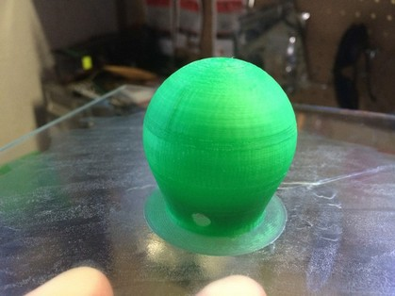Figure 4-16: Use of a brim can be seen here as the thin layer of plastic laid down around the base of the model. This should be removed before the print is used.
Support Material
Support material is extra plastic that is added by the slicer to support parts of the model that would otherwise be unprintable, like excessive overhangs or parts that are simply floating in mid air. On a single-material printer, you’ll have to cut away support material after the print is done, so it's best to avoid using it if possible.
On multi-material printers, it's possible to have one of the extruders loaded with special support material that is easy to remove (typically water soluble). On these machines, it should be fine to let the slicer generate support material because you can easily remove it from the finished print.
Additional Settings
All slicing programs have many more settings than just the ones described here. Many of these parameters are specific to the printer you’re using and would only need to be changed when generating Gcode for a different printer. Others may be specialized settings for specific materials (such as temperature settings, filament diameter, and so on). or just options that are unique to that software you're using.
If there are settings in your slicing software that I didn’t describe, you should review the software's documentation and experiment with them to see what works best for your model, material, and printer.
Let's slice it already!
Once your settings are in order, it's time to generate some Gcode! First, load your model up in the slicing program. In some slicers you can simply click File4Open to load your model by itself, while others support loading multiple models simultaneously. See Figure 4-17 for an example in Cura.
Insert < 04_slicing.png>
Cura makes things easy and automatically slices the file whenever you make a change to the settings, so all you have to do is click File4Save Gcode and we're all set.
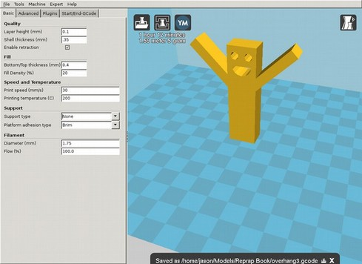Figure 4-17: Model loaded, sliced, and saved to an overhang3.gcode file.
Slicing may take a while, as the software works hard to find the best combination of printer moves to translate your model into lines of plastic on the print bed. Writing slicing software is a black art bordering on alchemy, so be patient and grab a beverage while your software does the work for you.
Once it's done, you should have a Gcode file that is ready for consumption by the printer of your choice. Feeding this file to the printer is the job of another piece of software called the Host, which is the first thing we'll talk about in the following chapter.
Is the Gcode generated not overly specific to the printer you specified in the slicer software? Not sure if it's clear under what circumstances Gcode would be compatible with other printers. /EG
Gcode files are generally compatible, but there may be printer-specific parameters like the size of the bed or maximum speeds that could make a gcode file incompatible (or at least unsafe) for one printer vs. another. Generally speaking you'll generate a Gcode file for a specific printer by specifying the printer's details to the slicing software, but I'm not sure how to get that across here? /JJG
You can also test out gcode before feeding it to your printer with a number of applications that can “preview” the code, but one of the easiest is a website called http://gcode.ws/.
Insert <04_gcode_view.png>
Could you slow down a bit here and explain to the reader, step-by-step, how they'd use gcode.ws to analyze the Gcode? /JG
I broke the process down a bit and added some details about how you can use the feedback from the website. /JJG
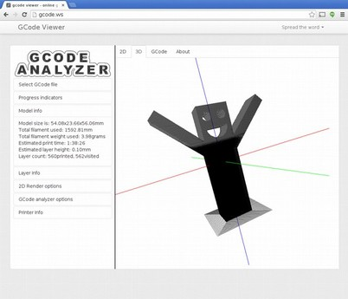Figure 4-18: gcode.ws can read and display your models GCode both as a complete model and layer-by-layer.
To preview your model's Gcode open http://gcode.ws in a browser and click the “Choose File” button to select your gcode file. Gcode.ws will then display a 3D render based on the contents of the gcode file that you can check for any problems that were introduced during the slicing step.

If what you see on Gcode.ws doesn't look like the model you just sliced, double-check the slicer settings. What you see on Gcode.ws is drawn from the same instructions that will be sent to your printer, so if they are drawing the wrong thing you'll want to correct that before sending these instructions to your printer.

Gcode.ws's analyzer can display your model layer-by-layer, and as a complete 3D visualization, which is a quick way to find any errors that may have crept in during the slicing process.
I found myself wondering how I'd troubleshoot errors here. Any advice you'd offer? Could you also describe how the reader will actually know there are errors? Does gcode.ws tell them? /JG
I added some additional steps to indicate how the results of using gcode.ws can be used to “pre-flight” check the gcode. /JJG
If everything still looks good, you're ready to move on to the next step: printing!

