A Hybrid Rule-Based and Machine Learning Framework for Academic Performance Prediction

Jatin Garg
Department of Engineering in Computer Science
Chitkara University
Rajpura, Punjab, India
jatin1709.be22@chitkara.edu.in
Armaan Sood
Department of Engineering in Computer Science
Chitkara University
Rajpura, Punjab, India
armaan160.be22@chitkara.edu.in
Devesh Kanwar
Department of Engineering in Computer Science
Chitkara University
Rajpura, Punjab, India
devesh1501.be22@chitkara.edu.in

Abstract—Nowadays in the world we are living in it is pretty essential that schools know the performance of the students in their studies. Student information is now being used to make decisions in schools. This work demonstrates a method by which it is possible to use simple rules and machine learning together to achieve improved results and learn more about things. Uncomplicated rules are simple to comprehend. They are struggling to understand the way students can actually learn. On the hand machine learning is effective in establishing patterns within student data but it is difficult to comprehend its operation. We are integrating both methods of doing things in order to solve this problem. The system is able to make good predictions and we can observe the work of it. How about the performance of students in school? We received data about over 100 students, such as the frequency of their attendance at classes, the frequency of their test grades, the way they studied and the extent to which they attended classes. We experimented with four methods of estimating the performance of students: Logistic Regression, Decision Tree, Random Forest and Support Vector Machine. We applied the rules to each of them in order to make it equal. To compare the effectiveness of each way we compared such factors as how accurate they were how precise they were, how well they remembered details how well they balanced being accurate and remembering important things and how well they could tell the difference, between good and bad results. Our discovery was that it was the Random Forest which could be used to predict student performance on a general basis. Making decisions with the use of rules also contributed to our understanding of the way the predictions were made. This research demonstrates that new methods of doing things are a good idea and it provides us with a practical means of developing systems that can be used to forecast the academic performance and are easily comprehensible.
Keywords—Academic Performance Prediction, Educational Data Mining, Machine learning, Hybrid Framework, Rule-Based systems, Student analytics, Classification models, Predictive analytics

Introduction
The computers and the internet have much information about students in the world we live in today schools. This is very exciting as it assists us in determining the progress of students in school. Our project is the attempt to predict the performance of students in school based on what they are doing daily and placing them in groups termed as average or struggling. We observe a lot of things such as how they arrive to school what grades they get, how they study and whether they attend classes in order to have a greater picture of how each student is performing in school.
There are occasions where we have problems with information of the world. The data could be inaccurate or incomplete. To correct these issues we make efforts to ensure that the information is accurate. To give an illustration, we cover up missing information by converting words into numbers. We ensure that it is the same information so that it is common. This assists us to obtain information that we could apply to educate computers to come up with good guesses.
To make our guesses by building our system we utilize a great deal of computer tools such as: Logistic Regression, Decision Trees, Random Forests and Support Vector Machines. Most of the information is used to teach these tools. We reserve some to see whether they are doing well. We also employ tools to ensure that these computer tools are fitted to work well with new information and not only with the information we previously taught them.

These complex computer tools are made easier to use by adding rules to our system. Although computers are able to identify patterns in information at times it is difficult to comprehend how they do it. Through rules we are able to justify why the system makes some decisions. The combination of computer tools with easy rules makes it a good and easy to understand system.

We check the things such as how they are right how precise they are, how well they remember, F1-score and AUC to see whether our computer tools are working well. By comparing these items we are able to discover which computer tool is the most effective in predicting the performance of students. We are hoping to come up with a solution that schools can trust.
Our project is on developing a system that could predict whether students will be successful or not.

Through caution, with the information through computer tools and by adding simple rules we hope to provide useful ideas to teachers. This can assist them to identify students who may require assistance which can result to superior decisions and successful students.

Literature Review
The most common deal in the area of educational data mining has been predicting the performance of students in school. Some time back when those who studied in this field were conducting research; they used mainly the old school methods of statistics like linear regression and simple methods of classifying things. Such techniques typically only considered a limited number of factors such as test scores and attendance. We ensured it was easy to check the performance of students. They did not do well in depicting the complex relationships that exist among various things that influence student performance in school as represented in the figure 1.
With improving technology and data available the techniques of machine learning began to gain significance in this area[1]. Algorithms such as the Logistic Regression, Decision Trees, Support Vector Machines and Neural Networks were introduced and people started using them in order to be more accurate with their predictions. The data can teach things to these models. Discover associations that are less apparent with conventional techniques. The popularity of Decision Trees was that they can depict decisions clearly and easily comprehensible.
In the recent few years the combination of various models such as the Random Forest has performed better than a single model. Random Forest is a decision tree that integrates the decision trees to predict more accurately and decreases the possibility of errors. SVMs are also effective in processing data and classifying various groups. Such methods have rendered forecasting student performance to be much more dependable.
All these developments do not do away with one huge issue that scientists have discovered. The difficulty is to strike the right balance between being correct and being able to comprehend how the predictions are arrived at. Accurate particularly complicated machine learning models can be likened to a box that you cannot peep into and therefore teachers cannot comprehend how the predictions are achieved[1]. On the one hand less complex systems that operate on rules can be easily comprehended but not good at working with complex and dynamic data.

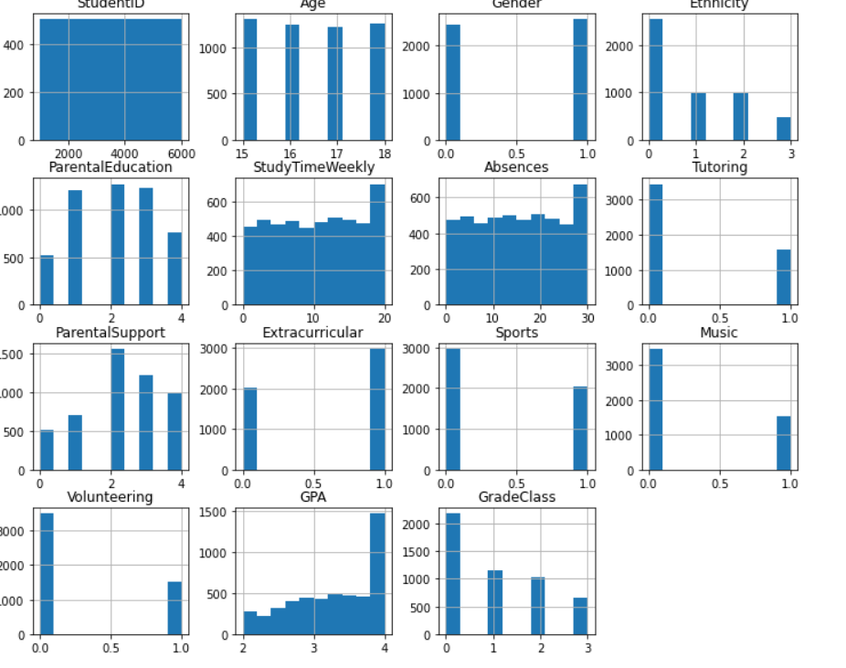
Figure 1: Parameters effect students performance
To resolve this issue, some researchers have begun to consider ways of integrating rule-based systems with machine learning models. These methods attempt to have the best of both worlds in that they can comprehend the forecasts and be precise. The rule-based components aid in explaining why some predictions are made and the machine learning models make the predictions to be more precise by identifying patterns in the data.
The framework employed in this study is a combination of rule-based logic and a multitude of machine learning algorithms. Testing models the same way the study intends to discover an approach that is both accurate and easy to understand as a more useful approach to real schools. This research is concerned with forecasting student performance and it involves student.

Problem Statement and Objective

Schools today possess much information about students in the education system[2]. They fail to utilize this information in a manner that assists students to learn. The traditional method of assessing students is through the test results that only indicate an aspect of the performance of the student[3]. It does not consider other activities such as attending classes to study and engage in activities that are similarly important to score well at school. The teachers are unable to discover which students are struggling because of this.
The second huge issue is that currently existing systems to predict the way students will perform are not so good. Other systems are not complicated and can be comprehended. They are lacking in their ability to deal with complex information. Other systems such as machine learning can be more precise. They do not specify on how they make predictions. This renders teachers to have no confidence in these systems. We require a system, which can not just make predictions, but also tell us how it predicts.
This paper is attempting to address these issues by creating a system that integrates machine learning with old rules. The idea is to come up with a model that will forecast the performance of the students and also explain the forecasts.
The following are the objectives of this study:
• To collect and compile information about students, such as attending classes, grades, study time and participating in activities.
• To apply machine learning models, including Logistic Regression, Decision Tree, Random Forest and Support Vector machine.
Comprehending the performance of every model by evaluating it in terms of accuracy, precision, recall, F1-score and AUC.
• To integrate machine learning models with rules to be able to make sense of the predictions.
• To determine what influences most the achievements of students in school.
Through these things the system we are proposing is seeking to provide the schools an opportunity to know what students are doing to find students who are struggling and do something about improving the performance of students in school. The student data will guide the education system to make decisions, concerning student learning and student performance and student behavior[2].

Description and Feature engineering of Dataset

As a rule, the performance of any prediction system largely relies on the dataset. In this research we train and test the models using a dataset containing more than 100 student records. The dataset has behavioral features which are associated with student performance. The key characteristics are Attendance percentage, Internal assessment marks, Daily study time and Participation level. Some top features which are affecting students performance is shown in the figure 2.
These qualities have been chosen due to their consistency and student interest. The variable of interest is the category of performance that will classify the students as either good, average or poor with respect to student performance[3].
Machine learning algorithms are used after cleaning the dataset. Data in the real world does not necessarily have all values and therefore we deal with such problems[4]. We. Plug the gaps in the data with logical reasoning or drop them when they are not important. Others such as level of participation are categorical and hence we encode them into figures through encoding methods. This assists machine learning models to process them. We also normalize features in order to ensure that individual features do not overwhelm the others because of various value ranges. Features are created by merging existing features such as overall performance index of internal marks and study time. These new features assist the models to locate patterns and relationships, in the data. All in all, thorough preparation of the data would mean that the models would be fed with data that would result in more accurate predictions and dependable outcomes.
The quality of datasets has a direct impact on the performance of the prediction systems. Student performance predictions are as a result of a good dataset.

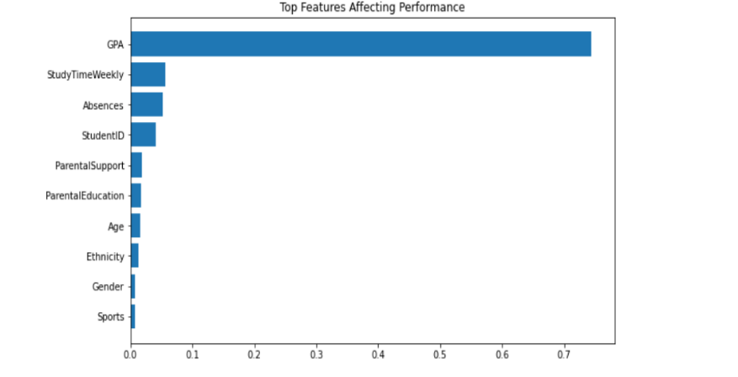
Figure 2: Top features affecting performance

Methodology
This section of the student performance prediction system talks of what we did to construct it. We did them sequentially starting with the preparation of data to the testing of models in order to trust the results and to easily comprehend them. We began by cleaning up the data in the student performance prediction system. We eliminated any entries in such a way that the data of the student performance prediction system was good. We also corrected any missing information to ensure that it did not influence the way the student performance prediction system model learned. The data of student performance prediction system contained both numbers and categories and to convert the categories into numbers, we converted the categories into numbers. We did it in the way that nothing was different. We also ensured that all the numbers were on the scale. In this manner, not much weight was given to some numbers as we trained the student performance prediction system model.
Once the student performance prediction system data were prepared we divided it into two; training and testing. The training section was used to train the student performance prediction system models. The testing part was used to determine the performance of the student performance prediction system models using the student performance prediction system data. A technique was used to ensure that the results were good. This method is referred to as cross-validation. We divided the data of the student performance prediction system into sections. Many times trained the student performance prediction system model. By doing this, the results were not founded on a single split. The student performance prediction system model did not become too good at one thing.
Next we applied machine learning to the student performance prediction system. We began with something. It is referred to as Logistic Regression. It is suitable in classification. We also applied Decision Tree. This assists us to discover the hidden relationships. It also aids us know how the student performance prediction system model arrived at the decisions. We utilized Random Forest as well[5]. This is a combination of decision trees. It assists us in obtaining results to the student performance prediction system. We successfully used Support Vector Machine[5]. This can draw boundaries among categories. It achieves this in cases where the data in the student performance prediction system cannot be separated easily.
We put in a section that involves rules as well. This renders the student performance prediction system model more comprehensible. We put conditions on things such as attendance and grades. These circumstances justify the fact that a student was placed into a category. In this manner we integrated rules and machine learning. We have an easy to understand and accurate student performance prediction system model.
We used metrics in order to determine the effectiveness of the student performance prediction system models. These statistics can be used to determine the effectiveness of the student performance prediction system. The precision of the student performance prediction system model is determined by summing up all the predictions. Next we divide by the number of predictions.
Accuracy is the number of the predicted positive cases that are correct. The ratio between the count of positives and the total sum of positives and false positives is computed. The accuracy of all the techniques are compared and represented in the figure 3. The performance prediction system model how well the student performance prediction system finds cases is called recall. It is obtained by the division of the number of positives by the total number of positives and false negatives.
The F1-score represents a trade off between recall and precision. It is computed by dividing the product of two by the product of precision and recall divided by the sum of the precision and recall. These measures enable us to ensure that the model of the student performance prediction system is good. It is not just good but also in dealing with various kinds of classification outcomes. This step-by-step process ensures the effectiveness and practicability of the student performance prediction system. It may be applied in a real life scenario to forecast the performance of students.

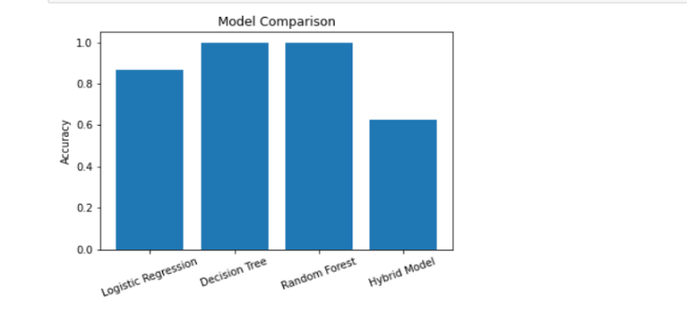
Figure 3: Comparison of different techniques
We put the student performance prediction system to test. It was tested using machine learning models. The data was divided into two. One was training. The other section was to be used in testing. We had to check the results times to ensure that they were correct. We examined each model to determine its effectiveness. To check the goodness of each model, we employed accuracy and precision. These items assist us in observing the effectiveness of each model in forecasting the performance of students. The overall was the Random Forest model. It is effective as it utilizes decision trees. This assists it in identifying trends in the data. Random Forest model is highly precise. It also performed well in accuracy and recall. This implies that it is effective in prediction.
The Support Vector Machine was also good. It particularly worked well in dividing groups of students. It was accurate. When we must categorize data, it is a good option. The Decision Tree model was satisfactory. It can be easily understood since it has rules. We are able to observe the way in which it makes decisions. The Logistic Regression model is extremely easy. It is a point of departure and it yields us consistent results. We discovered that there are models such as the Random Forest model which are used with data. They provide us with prophesies. Even simple models can be helpful. They assist us to know what is happening. They are good also, to compare results. Combining the two complex models can provide us with good predictions and allow us to comprehend the student performance prediction system. What we are looking at is the student performance prediction system
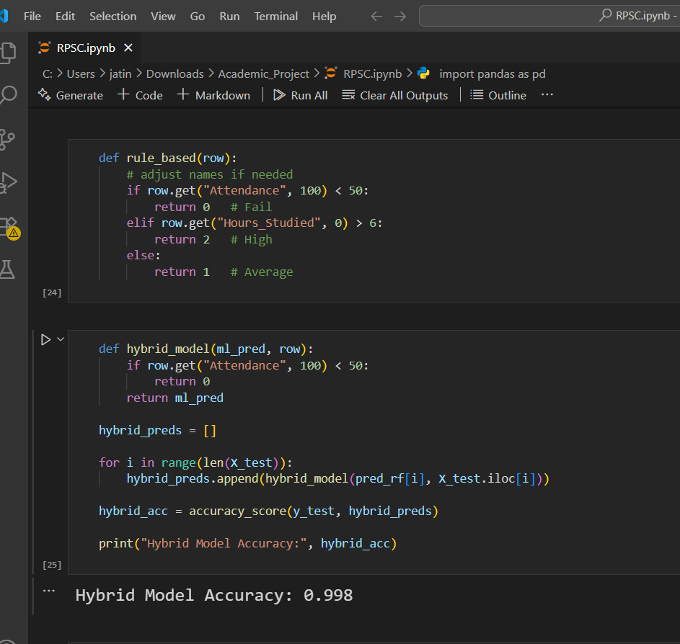
Figure 4: Computation of model
The Support Vector Machine was also good. It particularly worked well in dividing groups of students. It was accurate. When we must categorize data, it is a good option. The Decision Tree model was satisfactory. It can be easily understood since it has rules. We are able to observe the way in which it makes decisions. The Logistic Regression model is extremely easy. It is a point of departure and it yields us consistent results.
We discovered that there are models such as the Random Forest model which are used with data. They provide us with prophesies. Even simple models can be helpful. They assist us to know what is happening. They are good also, to compare results. Combining the two complex models can provide us with good predictions and allow us to comprehend the student performance prediction system. What we are looking at is the student performance prediction system. The computation in performed in python [6]. The computation of hybrid model is shown in the figure 4.
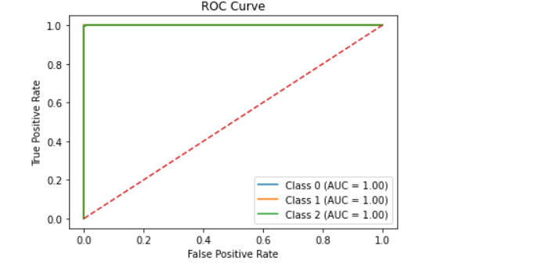
Figure 5: ROC curve
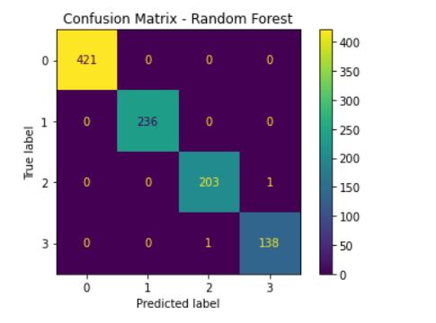
Figure 6: Confusion Matrix of Random Forest

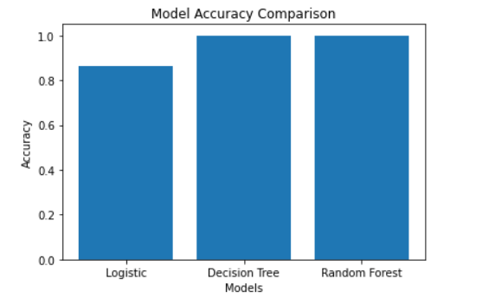
Figure 7: Model Accuracy Comparison

Discussion
The results of the analysis indicate that machine learning methods are effective in their ability to predict the performance of students in school. The model we used is the Random Forest. It does a job. This is due to the fact that it utilizes decision trees in making predictions. The Random Forest model considers a wide range of factors such as attending classes and studying, and test scores.
Random Forest model is superior to a single model. We applied Support Vector Machine model as well. It is good at data despite non-intuitive data. It makes decisions. But you must get it set up properly to obtain results.
Random Forest model predicts
The Support Vector Machine model is a good model with data. The Decision Tree model explains the decisions made. The Decision Tree model is not as precise as the Random Forest model or the Support Vector Machine model. It describes the reasons why it makes some predictions. It has a collection of rules in order to view how it works. This is helpful to teachers and school administrators. They should be aware of the reasons as to why some predictions are made.
The Logistic Regression model never fails to provide answers. It assists us in knowing the relationship among various things.
In the case we observed a trade-off between the accuracy and the comprehension of the machine learning model. Predictive models such as the Random Forest and Support Vector Machine are effective in prediction. They are difficult to comprehend. The simpler models, such as the Decision Tree model, are easier to comprehend. They do not necessarily do things right. We must strike a balance between the two.
Making predictions through the use of rules is useful. It renders the system transparent. It provides causes of its predictions. This renders the system more palatable in schools. The decisions must be reasonable and equitable. The accuracy is guaranteed by the use of machine learning methods, such as the Random Forest and the Support Vector Machine, at the time. It is good at data. Different models and their accuracy is shown in the figure 8.
In general we believe the task can be accomplished by employing a combination of machine learning methods and rules. Random Forest and Support Vector Machine machine learning models can make predictions more accurate. Rules make results meaningful and easy to comprehend. This matters in the real world. Machine learning methods and regulations collaborate. They provide an accurate and understandable system.
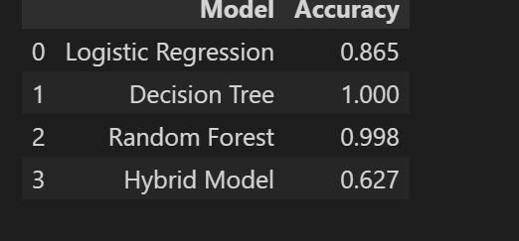
Figure 8: Different models and accuracy

Future Directions

In this project we developed a system to forecast student performance. We used machine learning models and rule based logic. The point was to combine both approaches and complicated models. In this manner the system remains precise and comprehensible. We utilized a dataset that contains such features as attendance, internal marks, study time and participation. These characteristics are generally associated with student performance. We tried various models such as Logistic Regression, Decision Tree, Random Forest and Support Vector Machine. This is significant in an environment where judgments ought to be transparent and just.
Among the lessons learnt during this project was the fact that high accuracy is not sufficient. It is also important in education to know why a student is forecasted to perform in a manner. This is where we can use our hybrid approach. It is a balanced performance among the students. We can be still improved in several areas.

References
[1] Mitchell, T. M. (1999). Machine learning and data mining. Communications of the ACM, 42(11), 30-36.
[2] Romero, C., & Ventura, S. (2010). Educational data mining: a review of the state of the art. IEEE Transactions on Systems, Man, and Cybernetics, Part C (applications and reviews), 40(6), 601-618.
[3] Neththikumara, S., & Maduranga, M. W. P. (2025, October). Recent Results of Machine Learning in Predicting Student Performance: A Systematic Literature Review. In 2025 IEEE Digital Education and MOOCS Conference (DEMOcon) (pp. 1-5). IEEE.
[4] Mining, W. I. D. (2006). Data mining: Concepts and techniques. Morgan Kaufinann, 10(559-569), 4.
[5] H. Alamri, L., S. Almuslim, R., S. Alotibi, M., K. Alkadi, D., Ullah Khan, I., & Aslam, N. (2020, December). Predicting student academic performance using support vector machine and random forest. In Proceedings of the 2020 3rd international conference on education technology management (pp. 100-107).
[6] Suárez, J. L., García, S., & Herrera, F. (2020). pydml: A python library for distance metric learning. Journal of Machine Learning Research, 21(96), 1-7.

