PROJECT REPORT
ON
A Hybrid Rule-Based and Machine Learning Framework for Academic Performance Prediction
submitted in partial fulfilment of the requirements for the award of degree of
BACHELOR OF ENGINEERING
In
COMPUTER SCIENCE AND ENGINEERING
Submitted by: Supervised By:
Jatin Garg , 2210991709 Dr. Shyam Bhari Goyal
Armaan Sood, 2210990160 Professor & Dean
Devesh Kanwar, 2210991501 Chitkara University


DEPARTMENT OF COMPUTER SCIENCE AND ENGINEERING
CHITKARA UNIVERSITY
CHANDIGARH-PATIALA NATIONAL HIGHWAY, RAJPURA, PUNJAB, INDIA

Table of Contents
 | Page No.
Abstract | 3
Introduction | 4
Objectives | 4
Dataset Description | 5
Data Preprocessing | 5
Methodology | 5
Model Evaluation Metrics | 6
Results and Findings | 6
Feature Importance Analysis | 7
Actual Code Snippet and Result | 7
Prediction Outcome | 10
Conclusion | 10
Future Scope | 11
References | 11

Abstract
In recent years, educational institutions have started using data to better understand and improve student performance. This report presents a system that predicts student academic outcomes by analyzing key factors such as attendance, internal marks, study time, and participation. The problem is approached as a classification task, where students are grouped into categories like good, average, or poor based on their overall performance.
To build this system, the dataset is first preprocessed by handling missing values, converting categorical data into numerical form, and normalizing the features. Multiple machine learning models, including Logistic Regression, Decision Tree, Random Forest, and Support Vector Machine, are then trained and tested using an 80–20 data split along with cross-validation. The models are evaluated using standard metrics such as accuracy, precision, recall, F1-score, and AUC.
The results show that Random Forest performs the best among all models due to its ability to capture complex patterns in the data. At the same time, simpler models like Decision Tree help in understanding how predictions are made. To improve interpretability, basic rule-based logic is also considered, making the system easier to understand for real-world use.

Introduction
With the growing use of digital systems in education, a large amount of student-related data is now available in structured form. This data includes not only academic records such as marks and attendance but also behavioral factors like study habits and participation. Using this data effectively can help institutions understand student performance better and take early action when needed.
Traditional methods of evaluating students mainly depend on exam results. While these methods are useful, they do not give a complete picture of a student’s overall learning behavior. Important factors such as consistency, engagement, and effort are often ignored. As a result, it becomes difficult to identify students who may be at risk before it is too late.
To overcome these limitations, this project focuses on predicting student academic performance using a data-driven approach. The problem is treated as a classification task, where students are categorized into performance levels such as good, average, or poor based on various input features. The dataset used in this work includes attributes like attendance, internal marks, study time, and participation, which are closely related to academic outcomes.
Before applying machine learning techniques, the data is carefully preprocessed. This includes handling missing values, converting categorical data into numerical form, and normalizing the features so that all variables contribute equally during training. These steps are important to ensure that the models learn effectively from the data.
Multiple machine learning algorithms are implemented in this project, including Logistic Regression, Decision Tree, Random Forest, and Support Vector Machine. Each model is trained using an 80–20 train-test split and evaluated using metrics such as accuracy, precision, recall, F1-score, and AUC. This allows a fair comparison of all models under the same conditions.

Objectives
- To preprocess student data for accurate analysis.
- To implement multiple machine learning models for prediction.
- To evaluate model performance using standard metrics.
- To combine rule-based logic with machine learning for better interpretability.
- To identify key factors affecting student academic performance.

Dataset Description
The dataset used in this project is obtained from Kaggle and contains student-related attributes such as attendance, internal marks, study time, and participation for performance prediction.
Key Features Include:
- Attendance Percentage
- Internal Marks
- Study Time
- Participation Level
- Past Academic Performance

Data Preprocessing
The dataset used in this project is first prepared to ensure it is suitable for machine learning models. Since real-world data may contain missing, inconsistent, or unstructured values, several preprocessing steps are applied.
Initially, the dataset is cleaned by removing duplicate entries and handling missing values. Depending on the situation, missing data is either filled with appropriate values or removed to maintain data quality. Next, categorical features such as participation level are converted into numerical form using encoding techniques so that they can be used by machine learning algorithms.
After encoding, all numerical features such as attendance and internal marks are scaled using normalization. This ensures that all features are within a similar range and prevents any single feature from dominating the model during training.
The dataset is then divided into input features and the target variable. The input features include attendance, internal marks, study time, and participation, while the target variable represents the student performance category. Finally, the data is split into training and testing sets using an 80–20 ratio, which allows the models to be trained and then evaluated on unseen data.

Methodology
The proposed system follows a structured approach to predict student academic performance using machine learning techniques. The process begins with data collection and preprocessing, where the dataset is cleaned, missing values are handled, categorical features are encoded, and numerical features are normalized to ensure consistency.
After preprocessing, the dataset is divided into input features and the target variable. The input features include attendance, internal marks, study time, and participation, while the target represents the student performance category. The data is then split into training and testing sets using an 80–20 ratio to evaluate the model on unseen data.
Multiple machine learning algorithms are implemented, including Logistic Regression, Decision Tree, Random Forest, and Support Vector Machine. Each model is trained on the training dataset and tested on the testing dataset to compare their performance. Cross-validation is also applied to improve reliability and reduce the chances of overfitting.
To evaluate the models, performance metrics such as accuracy, precision, recall, F1-score, and AUC are used. These metrics provide a detailed understanding of how well each model performs in predicting student outcomes.

Model Evaluation Metrics
To measure the performance of the implemented machine learning models, several evaluation metrics are used. These metrics help in understanding how accurately and effectively the models predict student performance.
Accuracy is used to measure the overall correctness of the model by comparing the number of correct predictions to the total number of predictions made.
Precision indicates how many of the predicted positive cases are actually correct. It helps in understanding the reliability of positive predictions made by the model.
Recall measures how well the model is able to identify actual positive cases. It is useful in determining whether the model is missing important instances.
F1-Score provides a balance between precision and recall by combining both into a single metric. It is especially useful when the dataset is not perfectly balanced.
AUC (Area Under the Curve) is used along with the ROC curve to evaluate the model’s ability to distinguish between different classes. A higher AUC value indicates better model performance.
These evaluation metrics provide a complete analysis of model performance and help in selecting the most suitable model for predicting student academic outcomes.

Results and Findings
The student performance prediction system was successfully implemented using multiple machine learning models, including Logistic Regression, Decision Tree, Random Forest, and Support Vector Machine. All models were trained and tested using the same dataset with an 80–20 split to ensure a fair comparison.
From the results, it is observed that the Random Forest model performs the best among all the models. It achieves the highest accuracy and shows strong performance across precision, recall, and F1-score. This is mainly because Random Forest combines multiple decision trees, which helps in capturing complex patterns in the dataset and reduces overfitting.
The Support Vector Machine (SVM) also performs well and provides good classification results. It is particularly effective in separating different performance categories, although its performance is slightly lower than Random Forest.
The Decision Tree model gives moderate accuracy but is easy to understand. Its rule-based structure makes it useful for explaining how predictions are made, even though it may not be as accurate as ensemble methods.
The Logistic Regression model serves as a baseline and provides stable but comparatively lower performance. It works well for simple relationships but struggles to capture complex patterns in the data.
Overall, the results clearly show that ensemble methods like Random Forest are more effective for this type of prediction task. At the same time, simpler models help improve interpretability. This supports the use of a hybrid approach, where both machine learning and rule-based logic are combined to achieve better accuracy and understanding.
These findings highlight that factors such as attendance, internal marks, study time, and participation play a significant role in determining student performance, and using them together improves prediction reliability.

Actual Code Snippet and Result
The following visual outputs were generated:
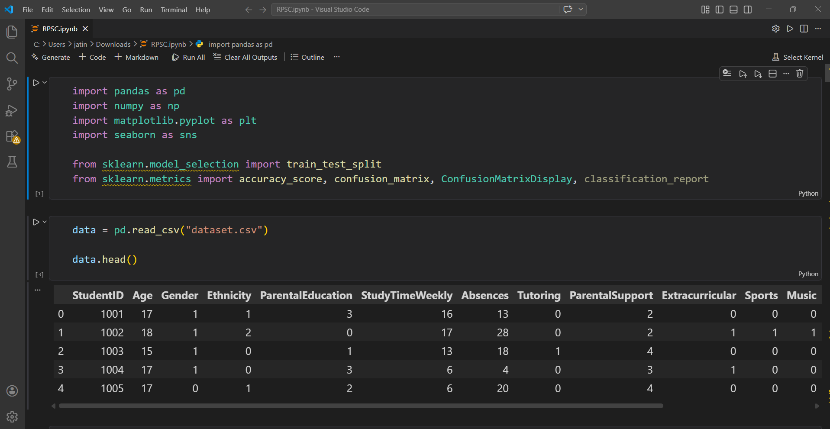

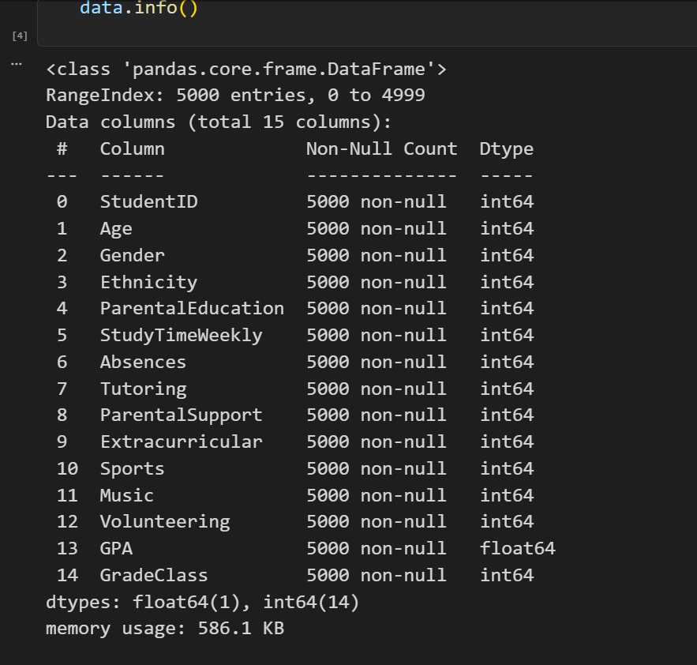
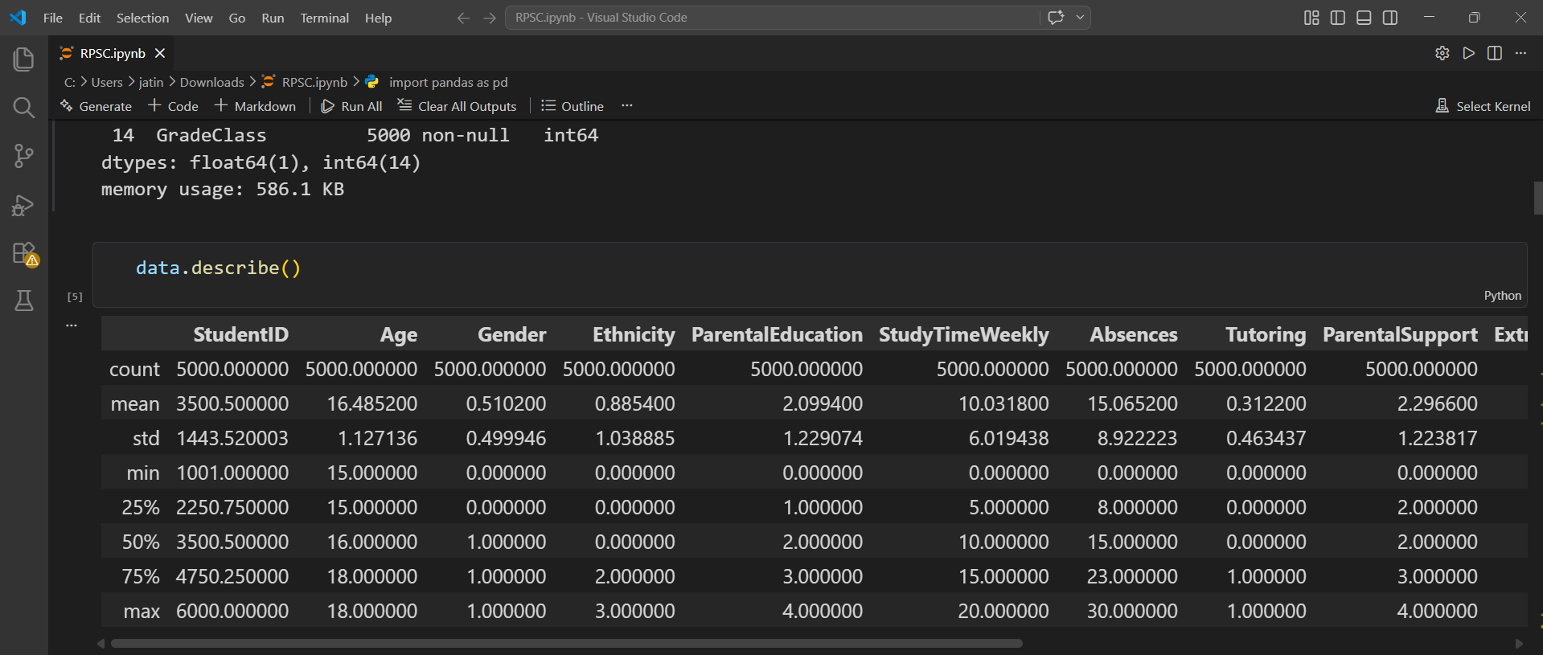
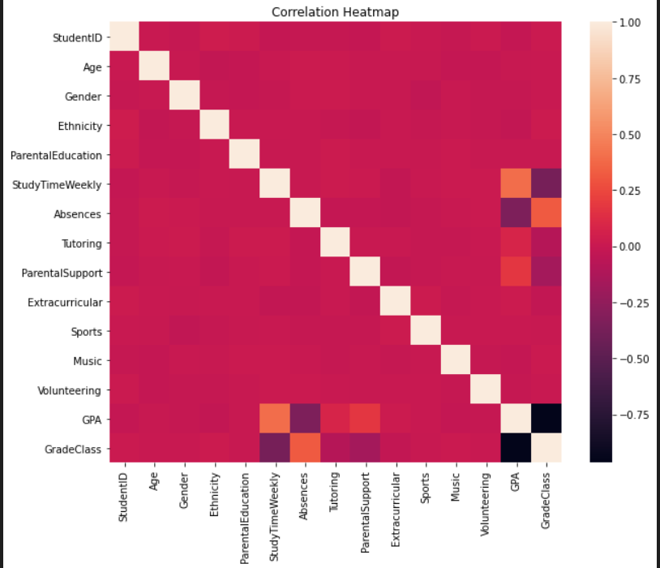

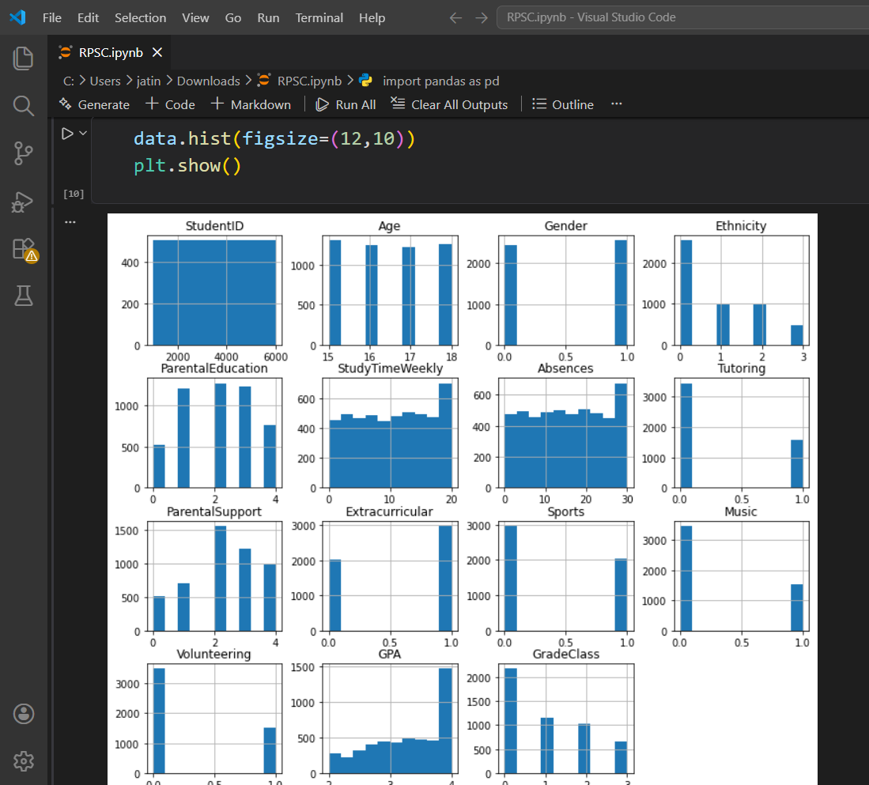

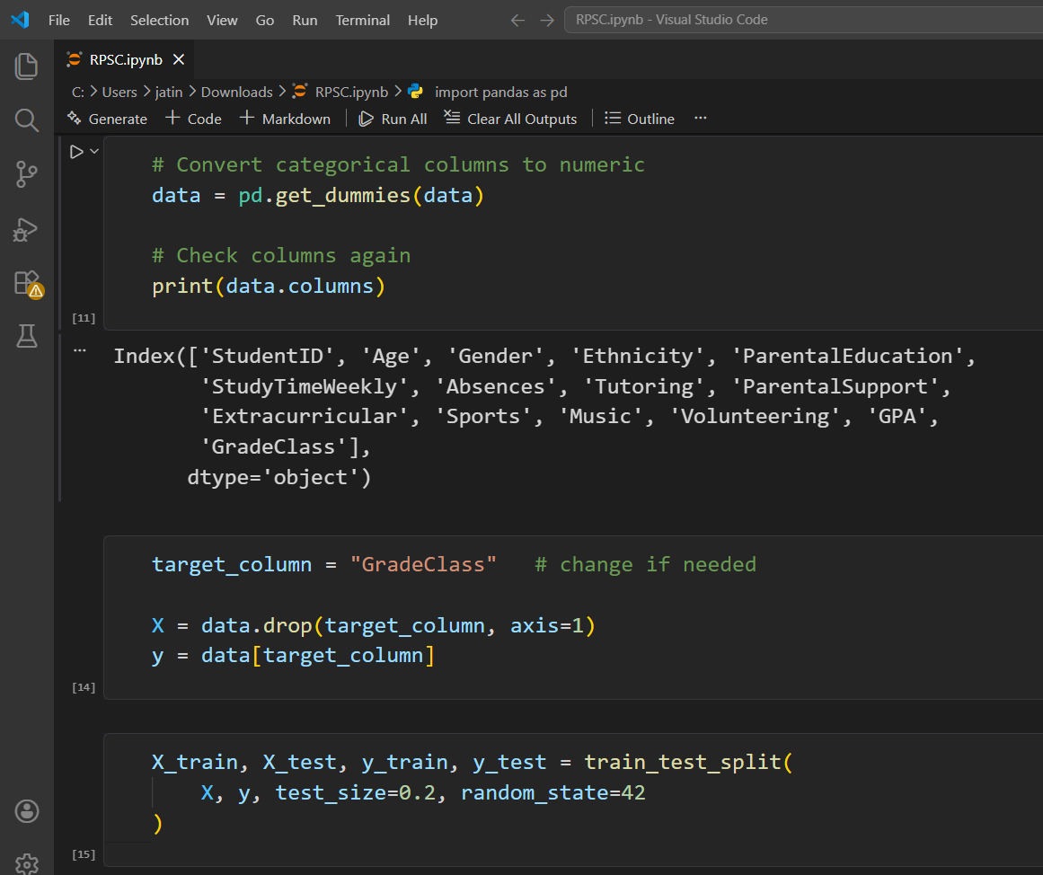

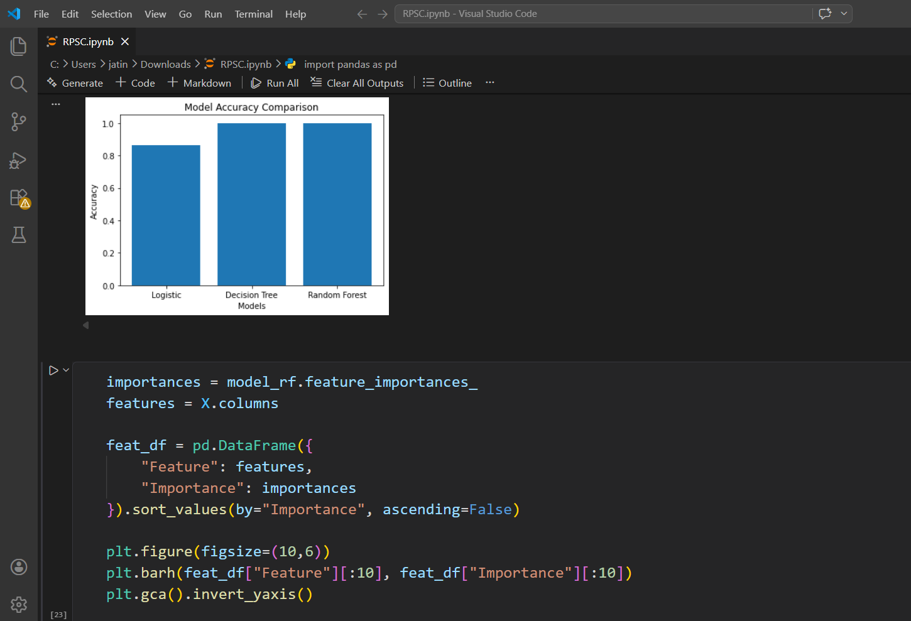

Prediction Outcome
The final model predicts the academic performance category of a student based on input features such as attendance, internal marks, study time, and participation.
This prediction can be used as:
• An early identification system for at-risk students
• A decision-support tool for teachers and institutions
• A performance monitoring mechanism to improve student outcomes

Conclusion
This project presents a system to predict student academic performance using machine learning models. Among all models, Random Forest performs the best, while simpler models help in understanding predictions. The system shows that factors like attendance, marks, and study time play an important role. Overall, it provides a useful way for institutions to identify and support students effectively.
- To use a larger and more diverse dataset for better accuracy.
- To include additional features like online activity and assignment submission patterns.
- To apply advanced models such as deep learning for improved prediction.
- To develop a real-time dashboard for monitoring student performance.
- To deploy the system as a web or mobile application for practical use.

References
- Mitchell, T. M. (1997). Machine Learning. McGraw-Hill.
- Romero, C., & Ventura, S. (2010). Educational Data Mining: A Review. IEEE Transactions.
- Kotsiantis, S., Pierrakeas, C., & Pintelas, P. (2004). Predicting Student Performance Using Machine Learning. Applied Artificial Intelligence.
- Han, J., Kamber, M., & Pei, J. (2011). Data Mining: Concepts and Techniques. Morgan Kaufmann.
- Breiman, L. (2001). Random Forests. Machine Learning Journal.
- Cortes, C., & Vapnik, V. (1995). Support Vector Machines. Machine Learning Journal.
- Pedregosa, F. et al. (2011). Scikit-learn: Machine Learning in Python. Journal of Machine Learning Research.

12

