Final Landing, Login, and Enrollment Pages Development
Jessica Jennings
CST499: Capstone for Computer Software Technology
Charmelia Butler
September 28, 2026

Landing, Login, and Enrollment Pages Development

Implementation Environment and Running PHP in XAMPP
The implementation phase translates the requirements and design of the online course enrollment system into working software. For this project, XAMPP was used as the local development environment because it provides the Apache web server, PHP, MySQL/MariaDB, and phpMyAdmin tools needed to develop and test a database-driven website. Tsui et al. (2018) explain that implementation involves converting software design into executable components while following coding practices that support later testing and maintenance. To run a PHP file in XAMPP, the project files were placed in the C:\xampp\htdocs\course_enrollment directory. Apache and MySQL were then started from the XAMPP Control Panel. The PHP pages were accessed through a web browser by entering a localhost address, such as http://localhost/course_enrollment/index.php. Accessing the file through localhost allows Apache to send the PHP source code to the PHP interpreter before the resulting HTML is returned to the browser.

Development of the Landing, Login, and Registration Pages
The initial user interface consists of a landing page, login page, and registration page. The landing page serves as the entry point to the application and provides navigation to the login and account-registration functions. The login page contains fields for a user ID and password. The registration page contains fields for the user ID, full name, phone number, email address, password, and password confirmation. Bootstrap components were incorporated into the pages to provide consistent form controls, spacing, buttons, and responsive page layouts (Bootstrap, n.d.). The registration form uses the POST method so that the submitted values can be processed by PHP on the server rather than being placed in the browser address bar.

MySQL Database and Users Table
The database for the application was created in phpMyAdmin and named course_enrollment. A users table was then created to store the account and profile information submitted through the registration page. The table contains the fields id, user_id, full_name, phone, email, password_hash, and created_at. The id field is an auto-incrementing primary key, while user_id and email use UNIQUE constraints. These constraints support the project requirement that users have unique account identifiers and prevent duplicate values from being stored. The CREATE TABLE statement defines the columns, data types, indexes, and constraints that determine how the table stores data (Oracle, 2026). The database can later be expanded with tables for courses, semesters, enrollments, and waiting lists as the remaining enrollment requirements are implemented.

Database Connection Custom Class
A custom Database class was created in Database.php to manage the connection between PHP and the course_enrollment database. The class stores the local host name, database username, database password, and database name. Its connect() method creates a mysqli object and checks whether the connection was successful. The utf8mb4 character set is also assigned to the connection. Centralizing the connection code in a class prevents the same configuration information from being repeated throughout multiple pages and makes future changes easier to maintain. The registration code calls the class when it needs database access. Prepared statements are used for the database queries so that user-entered values are bound separately from the SQL command. The PHP manual describes prepared statements as parameterized SQL statements in which values are bound before execution (PHP Documentation Group, n.d.).

Registration Processing and Saving User Information
The registration process begins when the user completes the form and selects the Register button. PHP reads the submitted values and validates that the required fields are present. The email address is checked for a valid format, and the password and confirmation password must match. The application then connects to MySQL and checks whether the submitted user ID or email address already exists in the users table. If either value already exists, the user receives a message indicating that the user ID or email is already registered. If the information passes validation, PHP uses password_hash() to create a one-way password hash. The application then prepares an INSERT statement, binds the user ID, name, phone number, email address, and password hash, and executes the statement. A successful execution produces a registration-success message and creates a new record in the users table. The plaintext password is not stored in the database.

Testing and Verification
The implementation was verified at both the web-interface and database levels. Apache and MySQL were first confirmed as running in the XAMPP Control Panel. The landing, login, and registration pages were then loaded through localhost to verify that PHP files were being served correctly. The registration page was tested with a sample account, and phpMyAdmin was used to confirm that the submitted user information appeared in the users table. The stored password value appeared as a hash rather than the password entered into the form. Additional testing can include blank fields, invalid email addresses, mismatched passwords, and duplicate user IDs. Testing during implementation provides immediate feedback about component behavior and helps identify defects before additional functionality is added (Tsui et al., 2018).
Final Project Revision Status. The verified Week 3 implementation is retained as the final baseline for the landing, login, and registration portion of the capstone project. The final artifact documents the XAMPP execution environment, browser-based interface, MySQL users table, centralized PHP database connection, input validation, duplicate-user checking, prepared statements, password hashing, successful registration, and database-level verification. Because instructor feedback identified the database organization, front-end/backend integration, registration workflow, validation, data processing, and user feedback as successful, the final revision preserves those working components and their implementation evidence rather than redesigning them.

Conclusion
The first implementation stage established the foundation of the online course enrollment system. XAMPP provides the local web and database services, PHP performs server-side processing, Bootstrap supports the page layouts, and MySQL provides persistent storage for registered users. The landing, login, and registration pages provide the initial user interface, while the Database class connects the application to the course_enrollment database. The users table, validation logic, prepared statements, unique constraints, and password hashing provide a structured approach for storing account information. This foundation can be extended during the next development stage to support authentication, course listings, semester selection, enrollment limits, and waiting-list functionality.

References
Bootstrap. (n.d.). Forms. https://getbootstrap.com/docs/5.3/forms/overview/
Oracle. (2026). CREATE TABLE statement. In MySQL 8.4 reference manual. https://dev.mysql.com/doc/refman/8.4/en/create-table.html
PHP Documentation Group. (n.d.). mysqli::prepare. PHP manual. https://www.php.net/manual/en/mysqli.prepare.php
Tsui, F., Karam, O., & Bernal, B. (2018). Essentials of software engineering (4th ed.). Jones & Bartlett Learning.

Appendix A
Implementation Screenshots
Figure 1
XAMPP Apache and MySQL Services Running
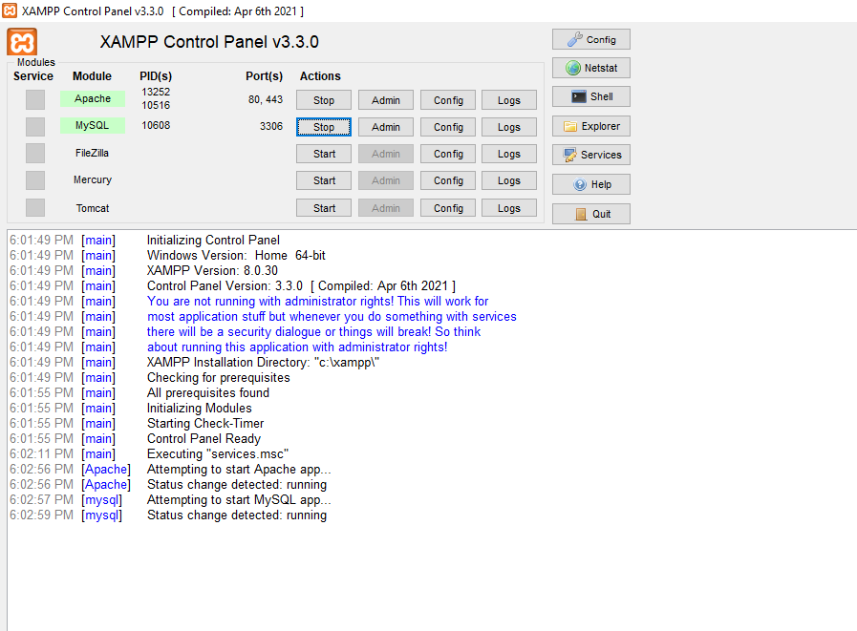
screenshot showing Apache and MySQL running in the XAMPP Control Panel.

Figure 2
Course Enrollment Database in phpMyAdmin
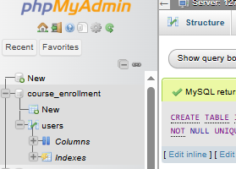
Show the course enrollment database in the phpMyAdmin left navigation panel.

Figure 3
Users Table Structure
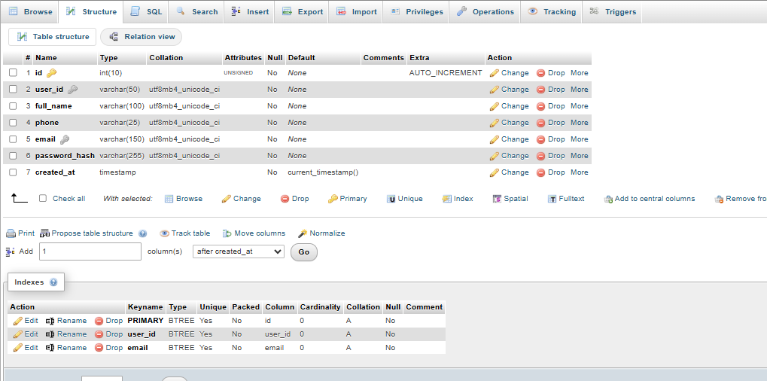
Show the id, user_id, full_name, phone, email, password_hash, and created_at fields.

Figure 4
Database Connection Class Source Code
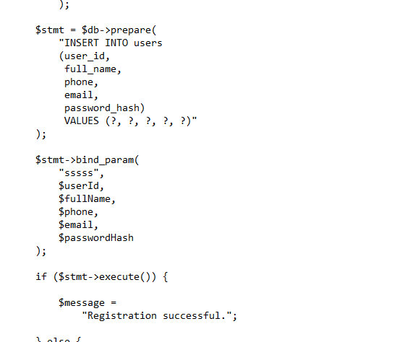
Database.php source-code screenshot.

Figure 5
Course Enrollment Landing Page

Show the landing page running through localhost in the browser.

Figure 6
Student Login Page
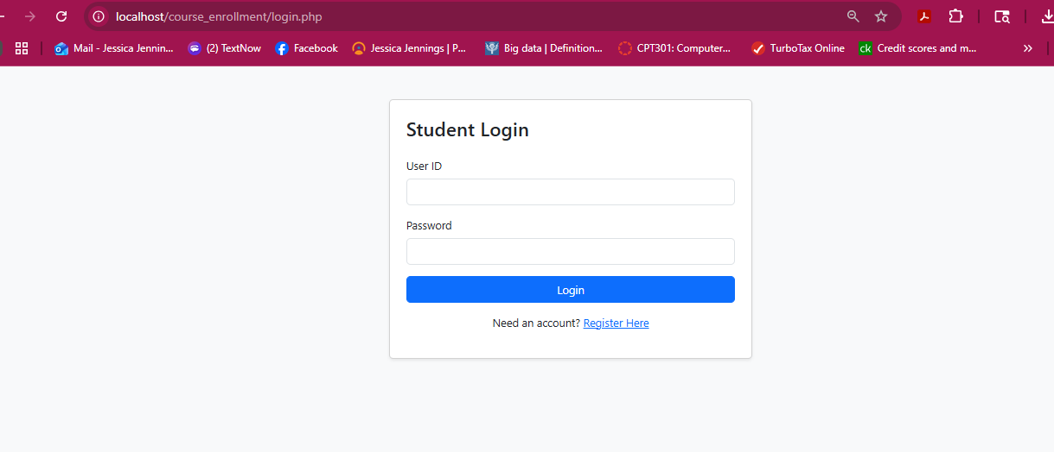
Show login.php running through localhost.

Figure 7
Registration PHP Source Code
register.php source-code screenshot. Use a second figure if the code requires two screenshots.

Figure 8
Student Registration Page Layout
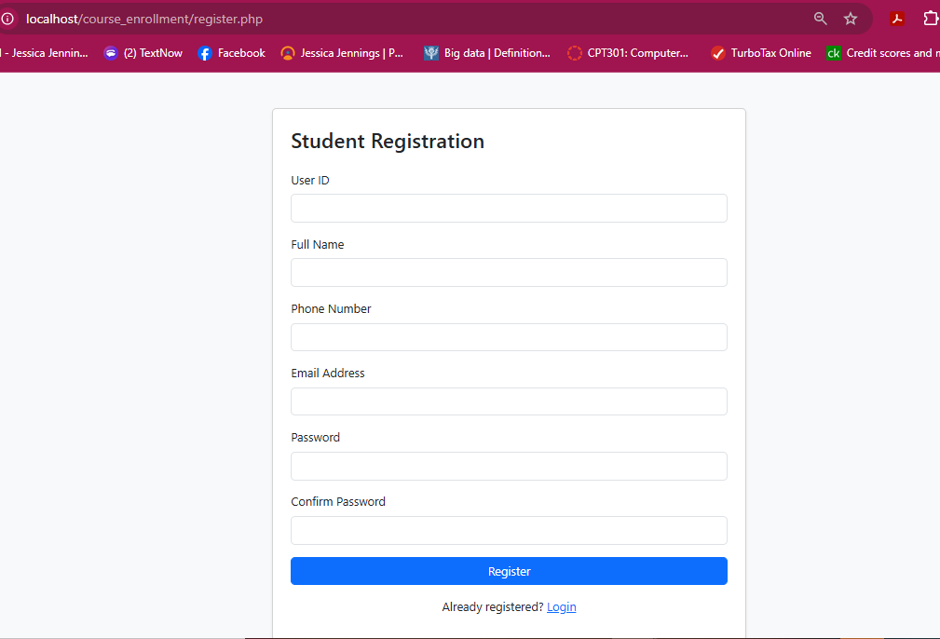
complete registration form before entering test information.

Figure 9
Successful User Registration
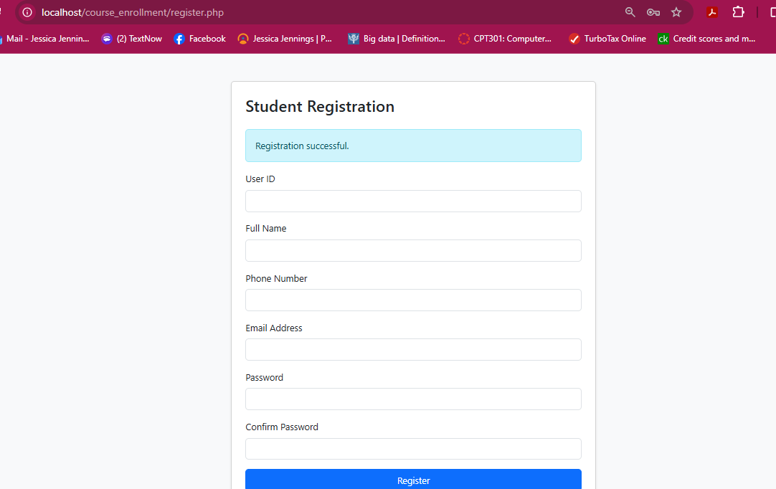
registration-success message after submitting a test account.

Figure 10
Registered User Record in MySQL
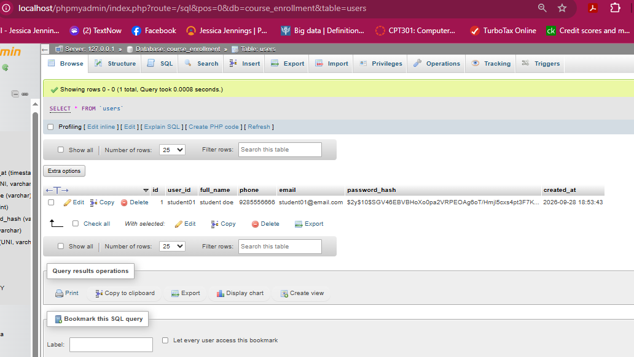
test account in the users table.
Figure 11
Duplicate User Protection
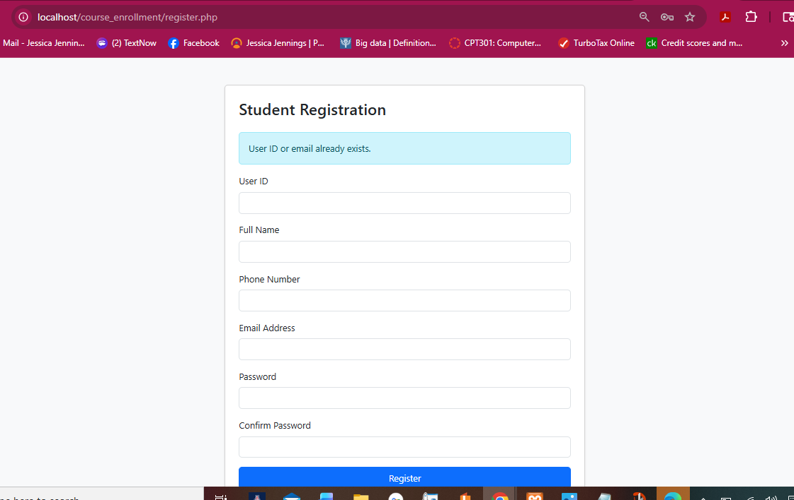
Screenshot showing duplicate user protection

