NOTE: This template is shareware downloaded from www.processimpact.com. All shareware payments are donated to the Norm Kerth Benefit Fund to help a consultant who is disabled with a brain injury. Please visit http://www.processimpact.com/norm_kerth.html to make a shareware payment ($10 suggested). Thank you!
Software Requirements Specification
for
Online Course Enrollment System
Version 1.0 approved
Prepared by Jessica Jennings
University of Arizona Global Campus
September 23, 2026
Table of Contents
Table of Contents ii
Revision History ii
1. Introduction 1
1.1 Purpose 1
1.2 Document Conventions 1
1.3 Intended Audience and Reading Suggestions 1
1.4 Project Scope 1
1.5 References 1
2. Overall Description 2
2.1 Product Perspective 2
2.2 Product Features 2
2.3 User Classes and Characteristics 2
2.4 Operating Environment 2
2.5 Design and Implementation Constraints 2
2.6 User Documentation 2
2.7 Assumptions and Dependencies 3
3. System Features 3
3.1 System Feature 1 3
3.2 System Feature 2 (and so on) 4
4. External Interface Requirements 4
4.1 User Interfaces 4
4.2 Hardware Interfaces 4
4.3 Software Interfaces 4
4.4 Communications Interfaces 4
5. Other Nonfunctional Requirements 5
5.1 Performance Requirements 5
5.2 Safety Requirements 5
5.3 Security Requirements 5
5.4 Software Quality Attributes 5
6. Other Requirements 5
Appendix A: Glossary 5
Appendix B: Analysis Models 6
Appendix C: Issues List 6

Revision History
Name | Date | Reason For Changes | Version
Jessica Jennings | September 23, 2026 | Initial SRS submission using required template | 1.0
Jessica Jennings | October 7, 2026 | Final revision based on instructor feedback: increased requirement precision, measurability, and testability. | 1.1

Introduction

Purpose
This document specifies Version 1.0 of the Online Course Enrollment System. The SRS covers student account registration, profile creation, authentication, semester course browsing, course enrollment, waiting-list management, enrollment cancellation, and seat-availability notification. It defines the requirements that will guide design, implementation, and testing of the course project (Tsui et al., 2018).

Document Conventions
Requirements are written using the word shall for mandatory behavior and are assigned unique identifiers such as REG-01 and ENR-01. Priorities are stated as High, Medium, or Low. Functional requirements are grouped by system feature so they can be traced to later design and testing artifacts. The document follows the organization of the provided Software Requirements Specification template.

Intended Audience and Reading Suggestions
The intended audience includes the instructor, student developer, testers, reviewers, and future maintainers of the project. Readers should begin with Sections 1 and 2 for the system purpose and context, continue to Section 3 for detailed functional requirements, and use Sections 4 through 6 for interfaces, quality requirements, and data constraints.

Project Scope
The project will provide a web-based system that allows students to create accounts, maintain required profile information, authenticate, view online courses by spring, summer, or fall semester, enroll when seats are available, join a waiting list when a course is full, and cancel an enrollment. When a cancellation creates an opening, the system will notify the first student on the waiting list. The objective is to provide a consistent self-service enrollment workflow while enforcing unique user IDs, course capacity, and waiting-list order.

References
Tsui, F., Karam, O., & Bernal, B. (2018). Essentials of software engineering (4th ed.). Jones & Bartlett Learning.
ISO/IEC/IEEE. (2018). ISO/IEC/IEEE 29148:2018 systems and software engineering—Life cycle processes—Requirements engineering. IEEE. https://doi.org/10.1109/IEEESTD.2018.8559686
Temoshok, D., Choong, Y.-Y., Regenscheid, A., Galluzzo, R., Fenton, J. L., Richer, J., & Lefkovitz, N. (2025). Digital identity guidelines: Authentication and authenticator management (NIST Special Publication 800-63B-4). National Institute of Standards and Technology. https://doi.org/10.6028/NIST.SP.800-63B-4

Overall Description

Product Perspective
The Online Course Enrollment System is a new, self-contained web application developed as part of a larger software development life-cycle project. It will maintain student account and profile data and connect those records to semester course offerings, enrollment records, and waiting-list records. The system is intended to provide the requirements baseline for subsequent UML design, implementation, and testing activities.

Product Features
Major product features include new-user registration and profile creation; unique user-ID validation; login authentication; course listing by spring, summer, and fall semesters; enrollment with course-capacity enforcement; first-in, first-out waiting lists for full courses; enrollment cancellation; notification of the first waiting-list student when a seat becomes available; and administrative maintenance of course offerings and capacity values.

User Classes and Characteristics
Student users are the primary user class. Students register, sign in, view semester offerings, enroll, join waiting lists, and cancel enrollments. Administrative users maintain course offerings, academic terms, and maximum enrollment values. The student interface should require only ordinary web-browser skills. Administrative functions require authorized access because they can change course and capacity data.

Operating Environment
The application will operate as a browser-based system on modern desktop or mobile devices with Internet access. The design should support current mainstream web browsers and a server-side application connected to a persistent relational database. No specialized client hardware is required.

Design and Implementation Constraints
The system must support exactly three academic semester categories—spring, summer, and fall—for the assignment scope. User IDs must be unique. Each course offering must have a defined maximum enrollment, and the application must not permit active enrollment beyond that capacity. Waiting-list processing must preserve first-in, first-out order. Authentication and student data must be protected using appropriate security controls; NIST guidance emphasizes secure authenticator management for digital identity systems (Temoshok et al., 2025).

User Documentation
User documentation will include a concise README in the public GitHub project repository and in-application labels or help text for registration, login, course enrollment, waitlisting, and cancellation. Additional end-user documentation may be added as the application is implemented.

Assumptions and Dependencies
The system assumes students have Internet access, a supported web browser, and a valid email address for notifications. It assumes course offerings and capacity values are entered accurately by an authorized administrator. The notification feature depends on an available email or equivalent messaging service. Payment, financial aid, grading, and learning-management functions are outside the current scope.

System Features
Functional requirements are organized below by major services, consistent with the provided template's feature-based organization. Each requirement is uniquely identified and written so that it can be verified during testing.

System Feature 1
Student Registration and Authentication
3.1.1 Description and Priority
High priority. This feature establishes the student's account, profile, and authenticated access. It is required before protected enrollment functions can be used.
3.1.2 Stimulus/Response Sequences
1. A new student selects registration, enters account and profile data, and submits the form; the system validates the data and creates the account when valid.
2. If the requested user ID already exists, the system rejects the registration and requests a different ID.
3. A registered student enters a user ID and password; the system authenticates valid credentials and grants access, or displays an error for invalid credentials.
3.1.3 Functional Requirements
REG-01: The system shall create a student account only after all required account and profile fields pass validation, and shall display a registration-success confirmation after the account record is stored.

Each functional requirement in this SRS has a unique identifier so it can be traced to design elements and test cases. ISO/IEC/IEEE 29148 emphasizes clear, verifiable requirements information throughout the requirements-engineering process (ISO/IEC/IEEE, 2018).

REG-01 through AUTH-01: See Section 3.1.3.
Status: Defined for Version 1.0.

Course Discovery, Enrollment, Waitlisting, and Cancellation

3.2.1 Description and Priority
High priority. This feature provides the core enrollment workflow and enforces semester availability, capacity limits, waiting-list order, and cancellation behavior.

3.2.2 Stimulus/Response Sequences
1. The student selects a semester; the system displays courses offered in that semester.
2. The student selects an offered course; if a seat is available, the system enrolls the student and confirms the enrollment.
3. If the course is full, the system offers the student a waiting-list option and records the student's ordered position when accepted.
4. The student cancels an enrollment; the system removes the enrollment, updates capacity, and, if a waiting list exists, notifies the first student on that list.

3.2.3 Functional Requirements
CRS-01: The system shall allow an authenticated student to select spring, summer, or fall and shall display only course offerings assigned to the selected semester.

External Interface Requirements

User Interfaces
The system will provide browser-based screens for registration, login, profile information, semester selection, course listings, enrollment status, waiting-list status, and cancellation. Required fields will be clearly indicated, and validation or error messages will explain what the user must correct. Navigation and terminology should remain consistent across pages.

Hardware Interfaces
No specialized hardware interface is required. Users interact through standard desktop or mobile input devices and displays. Server and database hardware are implementation details and must support the performance and reliability requirements in Section 5.

Software Interfaces
The application will interface with a persistent relational database containing user accounts, student profiles, courses, course offerings, enrollments, and waiting-list entries. A notification service will be used to alert the first waiting-list student when a seat becomes available. Specific database and notification products are TBD until implementation technology is selected.

Communications Interfaces
Client/server communication will use standard web protocols over encrypted HTTPS. The notification component will use email or an equivalent messaging interface. Authentication credentials and personally identifiable student information shall not be transmitted in plaintext.

Other Nonfunctional Requirements

Performance Requirements
PERF-01: Under normal operating load in the supported environment, login, semester course listing, enrollment confirmation, and cancellation confirmation shall complete within 3 seconds for at least 95% of test transactions, excluding external notification-service delays.

Safety Requirements
No physical safety-critical functions are included in this software. The primary harm to prevent is incorrect academic enrollment data. Enrollment and cancellation operations shall therefore preserve database consistency and shall not leave partial transactions if processing fails.

Security Requirements
SEC-01: The system shall require authentication for protected student and administrative functions.
SEC-02: Passwords shall be stored using an approved one-way password hashing mechanism rather than plaintext.
SEC-03: The system shall protect credentials and personally identifiable information during transmission.
SEC-04: Administrative functions shall be restricted to authorized administrative users.
SEC-05: The application shall collect and expose only student information needed for account and enrollment functions. Current NIST authentication guidance should inform implementation decisions (Temoshok et al., 2025).

Software Quality Attributes
QUAL-01 Reliability: Enrollment, cancellation, and waiting-list changes shall be processed transactionally so related records remain consistent.
QUAL-02 Usability: The interface shall use consistent navigation, descriptive labels, and actionable error messages.
QUAL-03 Maintainability: Requirements, source code, and testing artifacts shall use version control and traceable identifiers.
QUAL-04 Testability: Each functional requirement shall be written so that an observable test can confirm whether the requirement is satisfied.
QUAL-05 Availability: The application should be available during published enrollment periods except for scheduled maintenance or unavoidable outages.

Other Requirements
DATA-01: User IDs shall be unique.
DATA-02: A CourseOffering shall identify a course, semester, and maximum enrollment.
DATA-03: The number of active enrollments shall not exceed the maximum enrollment for a course offering.
DATA-04: A student shall not have duplicate active enrollment or duplicate waiting-list entries for the same course offering.
DATA-05: Waiting-list order shall be preserved by join time or an equivalent ordered position.
DATA-06: The system shall retain sufficient transaction data to display the student's current enrollment and waiting-list status accurately.

Part 1: GitHub Account Evidence

Figure 1. Active GitHub account dashboard screenshot provided by the student.
Appendix A: Glossary
SRS — Software Requirements Specification.
User ID — A unique identifier used by a student to access the system.
Course Offering — A specific course made available during a spring, summer, or fall semester.
Maximum Enrollment — The greatest number of active students permitted in a course offering.
Waiting List — An ordered list of students requesting enrollment after a course reaches capacity.
FIFO — First in, first out; the ordering rule used for the waiting list.
Appendix B: Analysis Models
Relevant analysis models, including use-case, class, sequence, activity, and state diagrams, will be developed in the design phase of the course project. These models will trace back to the requirements defined in this SRS.
Appendix C: Issues List
ISSUE-01: The specific implementation technology, database product, and notification service are TBD for the implementation phase.
ISSUE-02: The amount of time a notified waiting-list student has to claim an available seat is not specified in the assignment and remains TBD.
ISSUE-03: Password complexity and account-recovery rules are not specified in the problem statement and remain TBD pending design decisions.

Figure 1: GitHub Account Screenshot

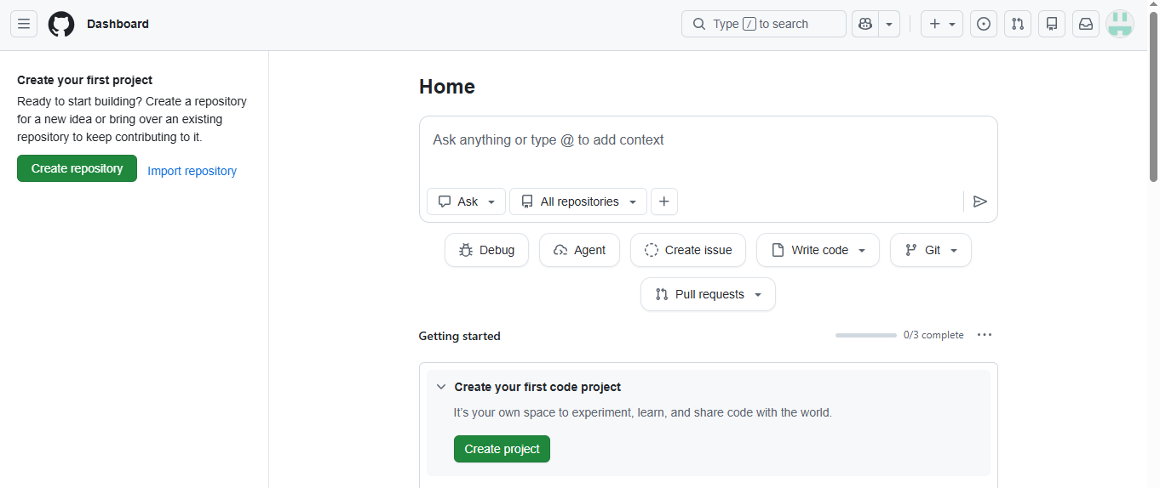

Figure 1. Active GitHub account dashboard screenshot

