UML Design Modeling for an Online Course Enrollment System
Jessica Jennings
University of Arizona Global Campus
Essentials of Software Engineering
Charmelia Butler
September 19, 2026

UML Design Modeling for an Online Course Enrollment System
Software design converts approved requirements into an implementable structure that developers and testers can evaluate before construction. The Week 1 Software Requirements Specification (SRS) defines an online course enrollment system that supports secure account creation, authentication, student profile maintenance, semester-based course discovery, enrollment, first-in-first-out (FIFO) waiting lists, cancellation, and notification when a seat becomes available. Unified Modeling Language (UML) is appropriate for this work because complementary diagrams can represent both the static structure of the system and its dynamic behavior. Tsui, Karam, and Bernal (2018) explain that design artifacts provide the bridge between requirements and implementation by refining responsibilities, interfaces, and interactions. This paper presents use case, class, sequence, activity, and state models for the enrollment system and explains how component, integration, system, and acceptance testing verify the resulting design.

UML Design Models
The UML models were selected to provide complementary views rather than duplicate the same information. The use case diagram establishes the system boundary and shows how students and administrative users interact with the system. The class diagram captures the principal domain objects and their relationships. The sequence and activity diagrams describe the ordering and flow of enrollment behavior, while the state diagram emphasizes how an enrollment changes over time. This combination supports traceability from the SRS into design and gives developers and testers multiple perspectives on the same requirements (Object Management Group [OMG], 2017).
Relationship Among the UML Models. The five UML diagrams support one another by carrying the same requirements through progressively different design perspectives. The use case diagram begins with the SRS and identifies the functions performed by the Student and Administrator actors, including account creation, sign-in, course viewing, enrollment, wait-list participation, cancellation, and administrative maintenance. Those use cases help identify the responsibilities represented in the class diagram, including Student, StudentProfile, Course, CourseOffering, Enrollment, and WaitListPosition. The sequence diagram then uses these responsibilities to show the time-ordered messages exchanged when a student requests enrollment and when a full course causes the wait-list path to be used. The activity diagram complements the sequence model by emphasizing the overall workflow and the decision point at which seat availability determines whether the student is enrolled or wait-listed. Finally, the state diagram shows how the resulting enrollment relationship changes over time among available, enrolled, wait-listed, promoted, cancelled, and closed conditions. Together, these models provide traceability from requirements to static structure, interactions, workflow, and lifecycle behavior, giving developers and testers consistent views of the same system.
Figure 1
Use Case Diagram
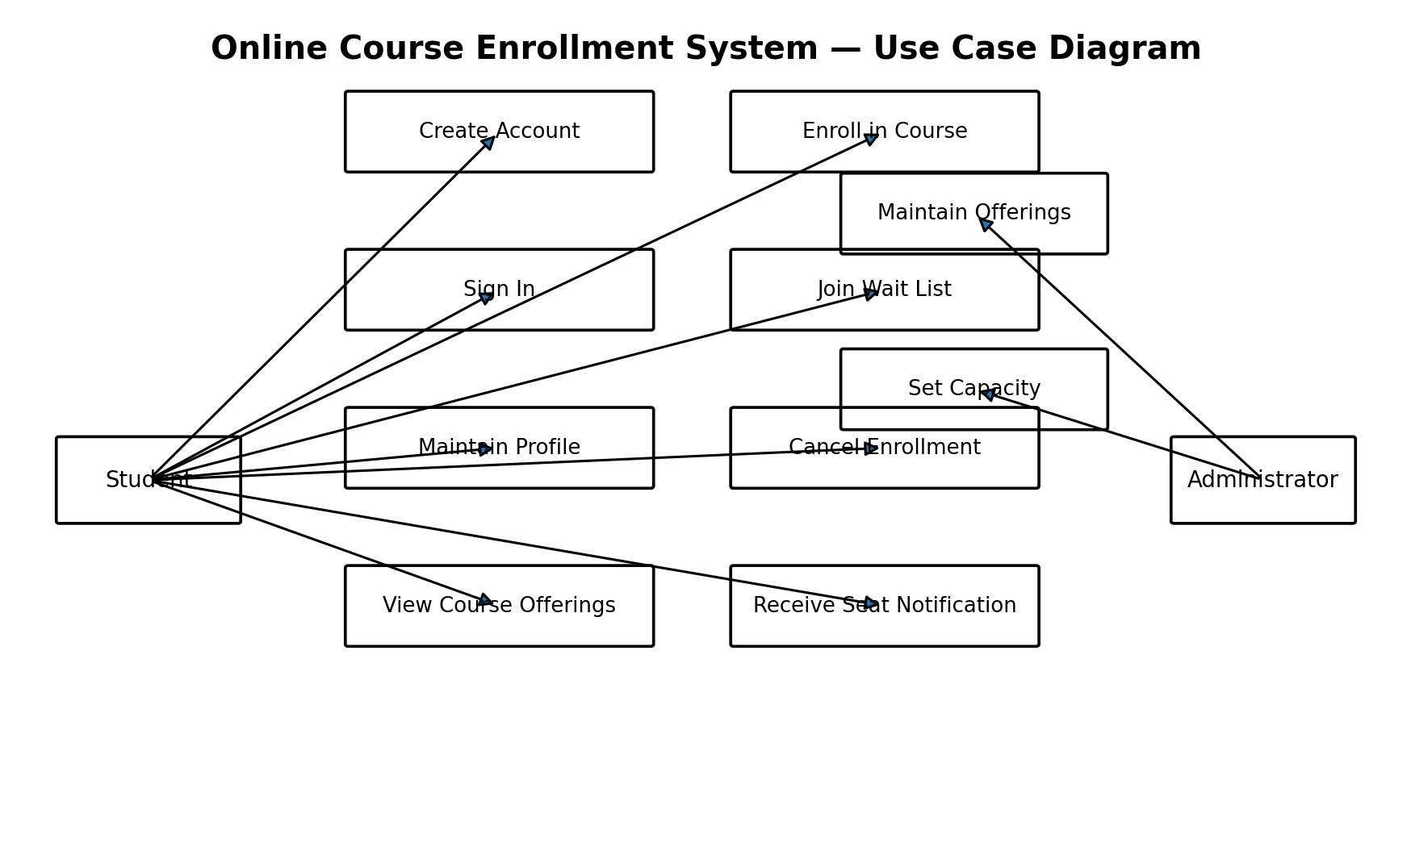
Note. The student performs account, authentication, profile, course, enrollment, wait-list, cancellation, and notification use cases. The administrator maintains offerings and capacity.
Figure 2
Class Diagram
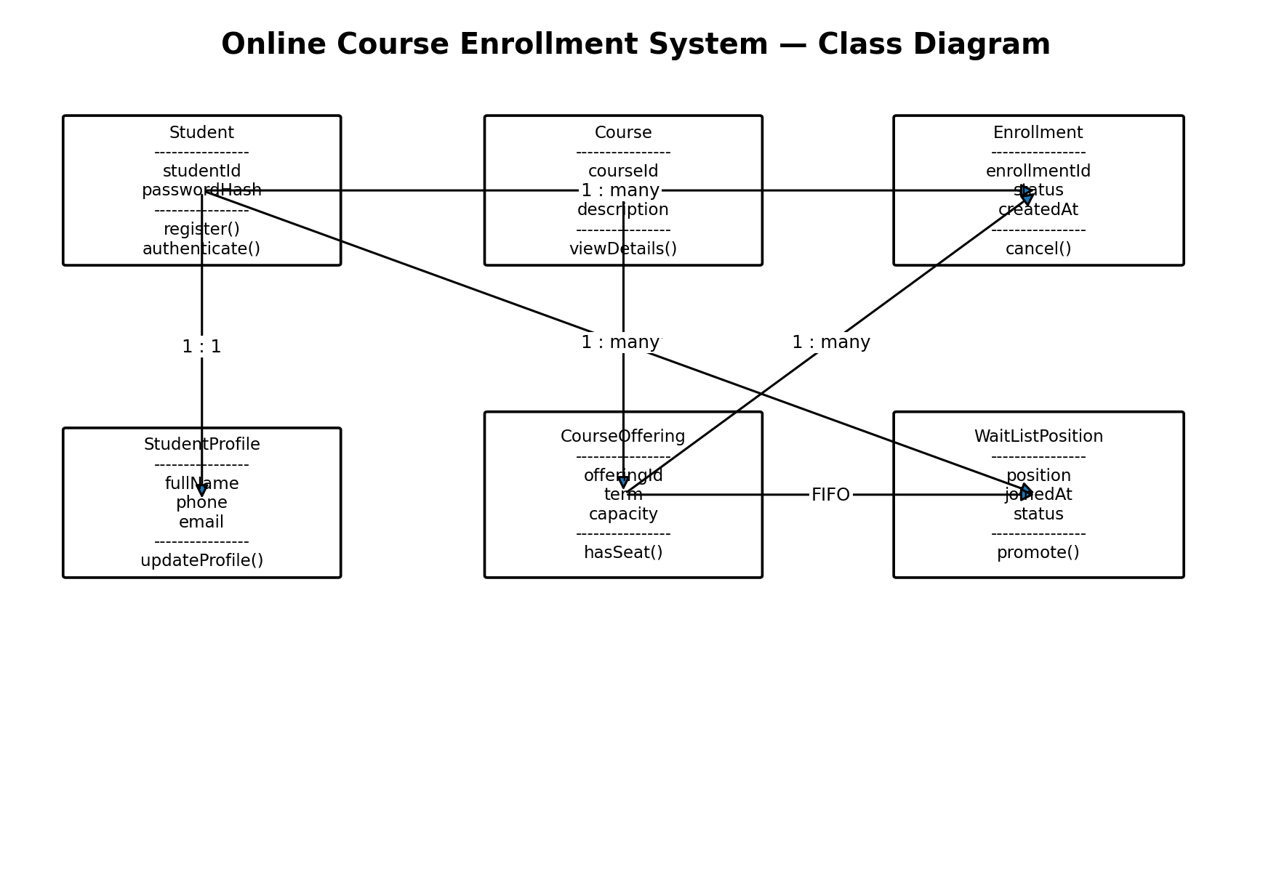
Note. Core classes derived from the SRS include Student, StudentProfile, Course, CourseOffering, Enrollment, and WaitListPosition.

The class model separates a general course definition from a semester-specific course offering. This distinction is important because capacity, term, enrollment, and waiting-list information belong to a particular offering rather than to the permanent course record. StudentProfile stores the required name, telephone number, and email information, while the Student class represents authentication identity. Enrollment and WaitListPosition act as transactional classes that connect a student to a specific offering. These relationships support the SRS rules that enrollment cannot exceed capacity and that a full offering places students into a FIFO waiting list.
Figure 3
Enrollment and Wait-List Sequence Diagram
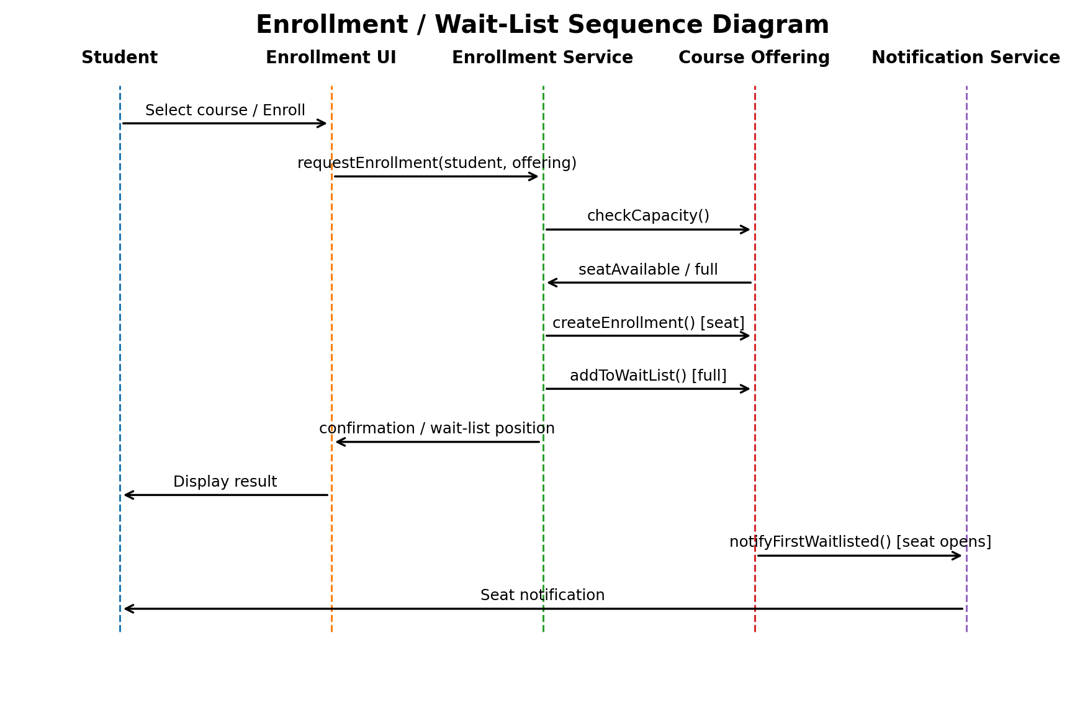
Note. The sequence shows the messages exchanged when a student requests enrollment and the alternative path used when an offering is full.
Figure 4
Course Enrollment Activity Diagram
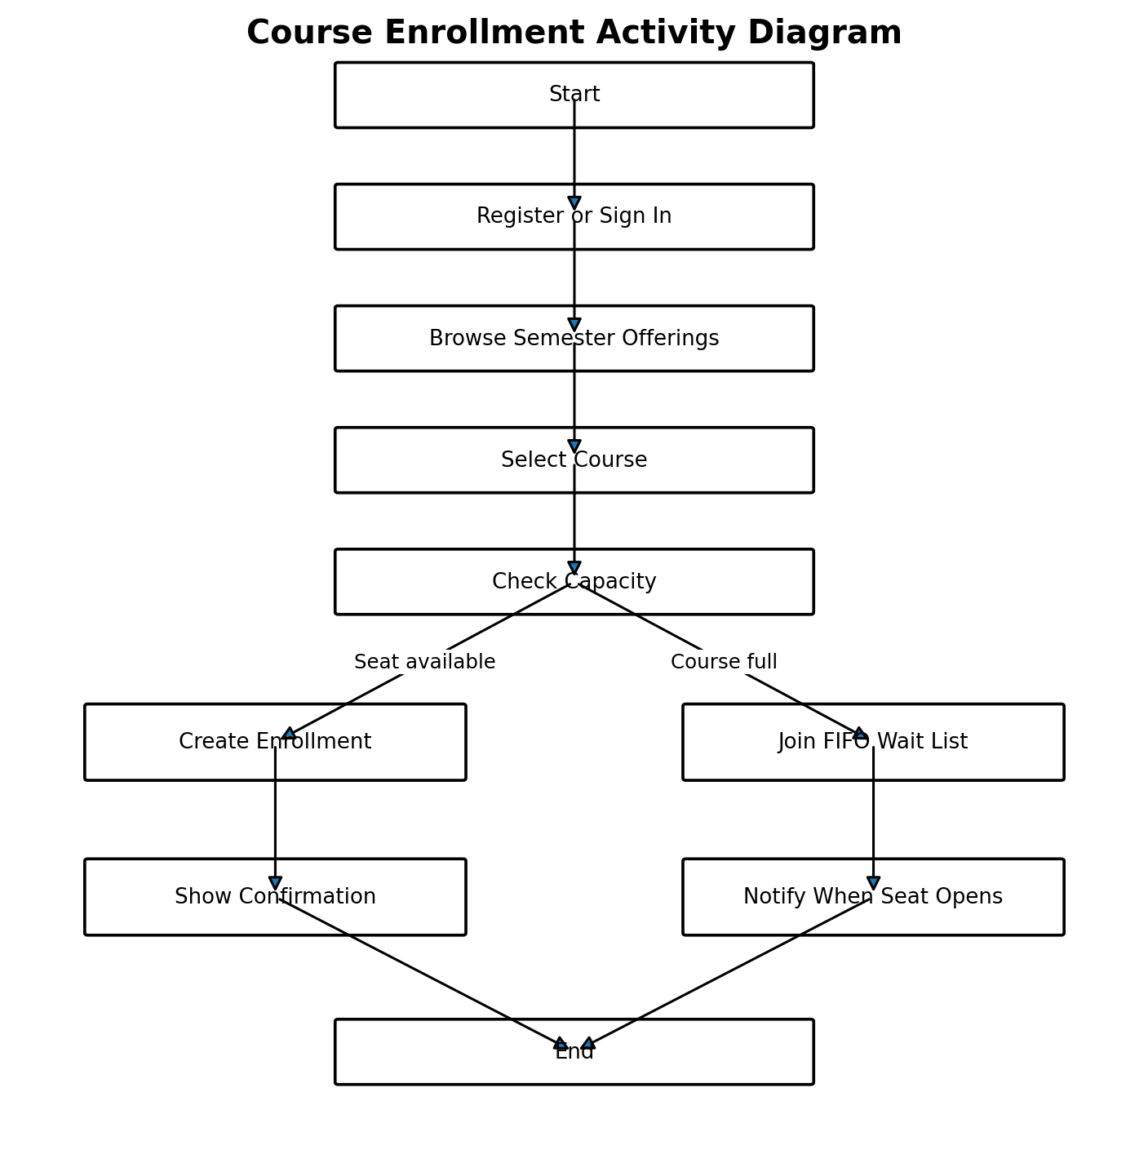
Note. The activity flow branches according to seat availability and ends with either enrollment confirmation or wait-list notification.
Figure 5
Enrollment State Diagram
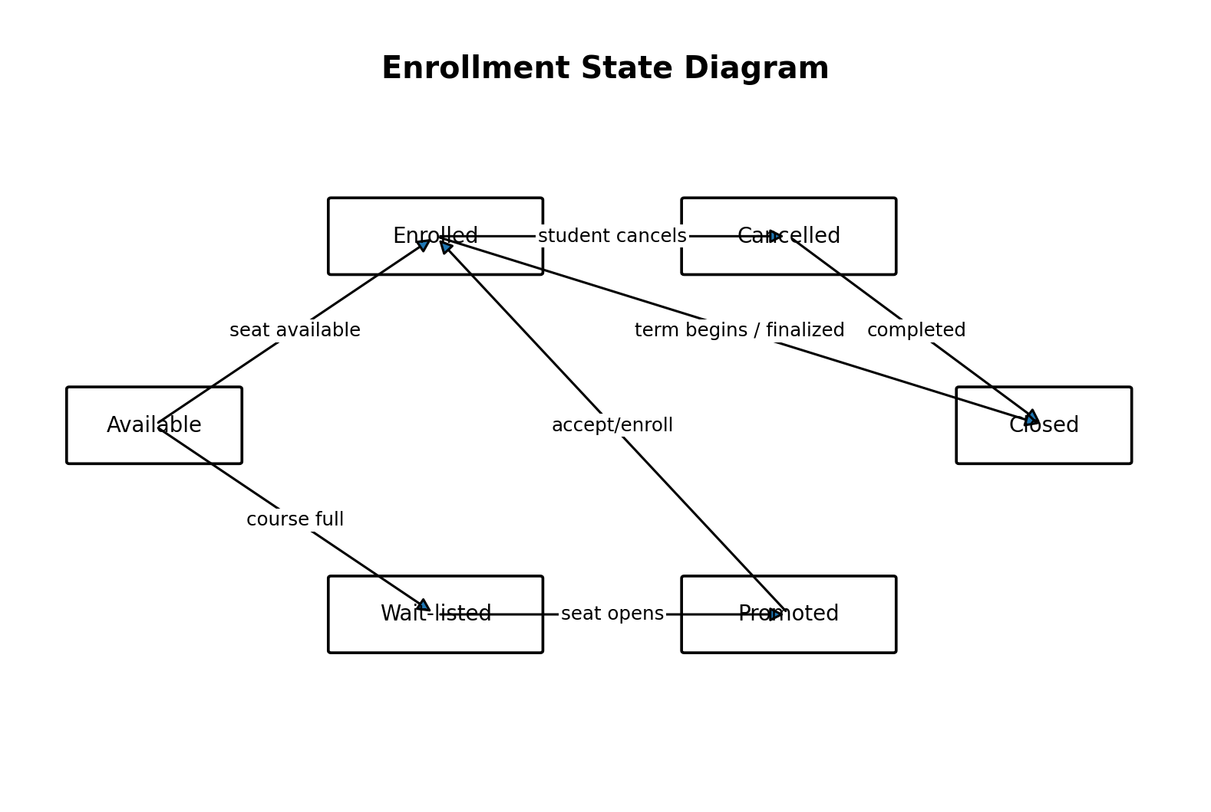
Note. The state model shows how a student's relationship to an offering can move among available, enrolled, wait-listed, promoted, cancelled, and closed conditions.
Design Traceability to Testing. The relationships among the diagrams also support test planning. Use cases identify user-visible behaviors that become acceptance and system test scenarios. Class responsibilities identify components that can be tested independently. Sequence messages identify integration points among the interface, enrollment service, course offering, and notification service. Activity branches identify alternate test paths for available and full courses, while state transitions identify conditions that must be verified when an enrollment is created, wait-listed, promoted, cancelled, or closed. This cross-model traceability helps ensure that the design remains aligned with the SRS and that important behaviors are represented in later testing.

Component Testing
Component testing verifies the smallest independently testable software units before they are combined. For this system, component tests should target authentication validation, duplicate user-ID detection, profile validation, capacity calculations, enrollment creation, cancellation, FIFO wait-list ordering, and notification selection. Tests should include normal, boundary, and invalid conditions. For example, the capacity component should return an available-seat result when enrollment is below capacity and a full result when the maximum is reached. Likewise, the wait-list component should always identify the earliest eligible waiting student when a seat opens. Pressman and Maxim (2020) emphasize that unit-level verification isolates defects close to their source, reducing the cost and complexity of later correction.

Integration Testing
Integration testing evaluates whether components exchange data and invoke services correctly after individual units have passed component tests. The most important integrations are between authentication and student profiles, course offerings and enrollment, enrollment cancellation and capacity management, and the wait list and notification service. A critical scenario begins when an enrolled student cancels a course: the system must update enrollment status, release capacity, select the first student in the FIFO wait list, update that student's status, and trigger the appropriate notification. Interface defects, incorrect data formats, transaction-order problems, and missing error handling are more likely to emerge at this level than during isolated component testing (Tsui et al., 2018).

System Testing
System testing evaluates the complete application against the functional and nonfunctional requirements in the SRS. End-to-end scenarios should begin with account registration and sign-in, continue through browsing spring, summer, or fall offerings, and then exercise enrollment, wait-list, cancellation, and notification workflows. Security testing should confirm that passwords are not stored in plain text and that unauthorized users cannot access protected functions. Performance testing should evaluate response behavior under realistic enrollment demand, while usability testing should confirm that students can identify course status and understand whether they are enrolled or wait-listed. System testing therefore validates not only individual functions but also the quality attributes of the completed product.

Acceptance Testing
Acceptance testing determines whether the completed system satisfies stakeholder needs and is ready for operational use. Representative students and administrative users should execute business-oriented scenarios based directly on the SRS acceptance criteria. Examples include creating a unique account, rejecting a duplicate user ID, locating offerings for a selected term, enrolling when capacity exists, joining a wait list when a course is full, cancelling an enrollment, and confirming that the first wait-listed student is notified after a seat becomes available. Acceptance testing differs from system testing because its focus is business suitability and stakeholder approval rather than exhaustive technical defect detection. Clear pass/fail criteria also provide evidence that the implemented design fulfills the original requirements.

Conclusion
The UML design translates the Week 1 SRS into a coherent representation of the online course enrollment system. Use case and class diagrams define actors, responsibilities, data, and structural relationships, while sequence, activity, and state diagrams model the behavior of enrollment, waiting, cancellation, and notification processes. The four testing levels provide a corresponding verification strategy: component testing isolates individual functions, integration testing validates interfaces, system testing evaluates the complete application, and acceptance testing confirms stakeholder requirements. Together, these design and testing artifacts strengthen traceability, reduce ambiguity, and provide a disciplined foundation for implementing the course enrollment system.

References
Object Management Group. (2017). OMG Unified Modeling Language (OMG UML), version 2.5.1. https://www.omg.org/spec/UML/2.5.1
Pressman, R. S., & Maxim, B. R. (2020). Software engineering: A practitioner’s approach (9th ed.). McGraw-Hill Education.
Tsui, F., Karam, O., & Bernal, B. (2018). Essentials of software engineering (4th ed.). Jones & Bartlett Learning.

