Proton-coupled electron transfer drives long-range proton translocation in bioinspired systems

Emmanuel Odella,§‡ , Brian L. Wadsworth,§‡ S. Jimena Mora,§‡ Joshua J. Goings,†‡ Mioy T. Huynh,† Miguel Gervaldo,# Leónides E. Sereno,# Devens Gust,§ Thomas A. Moore,§ Gary F. Moore,§* Sharon Hammes-Schiffer,†* and Ana L. Moore.§*

§ School of Molecular Sciences, Arizona State University, Tempe, Arizona 85287-1604, United States.
† Department of Chemistry, Yale University, New Haven, Connecticut 06520-8107, United States.
# Departamento de Química, Facultad de Ciencias Exactas, Físico-Químicas y Naturales, Universidad Nacional de Río Cuarto, Agencia Postal No 3, 5800 Río Cuarto, Córdoba, Argentina.

One-sentence summary

Inspired by nature, engineered molecules employ oxidation-reduction processes to reversibly move protons up to ~16 Å across a hydrogen-bonded network.

Abstract

Proton-coupled electron transfer is an essential link between electron and proton transfer reactions in bioenergetics and catalysis. In artificial photosynthetic constructs, proton translocation over ~7 Å has been predicted and observed in concert with the oxidation of a phenol-based model of Tyr_{z} in oxygenic photosynthesis. In the present work, two, three, and four proton transfers take place through a Grotthuss-type mechanism in hydrogen bond networks composed of benzimidazole moieties linking the phenol to the final proton acceptor, a cyclohexylimine. Following electrochemical oxidation at the phenol, the appearance of an infrared band at ~1650 wavenumbers signals proton arrival at the terminal basic site ~16 Å from the phenol. Reversing the electrode potential to reducing conditions reverses the proton translocation and resets the structure to the neutral initial species.

Electrons and protons move in specific ways under gradients of chemical potential to perform the most fundamental processes of all living cells. These processes include the generation of proton-motive force (PMF, the difference in electrochemical potential of protons across a membrane) whereby the energetic demands of maintaining the living system in a steady state far from equilibrium are met (1, 2). One of the fundamental mechanisms nature uses to couple a spontaneous redox process to the anti-spontaneous generation of PMF is proton-coupled electron transfer (PCET). In other words, PCET provides a mechanism for translating the energy available from a redox process into PMF. Often in bioenergetic processes, the coupling between redox and PMF is fully reversible so that protons flowing down a PMF gradient across a membrane can drive a redox process in the anti-spontaneous direction.
In other biological processes, PCET can provide the lowest-energy reaction pathway and thereby choreograph the movement of electrons and protons as they are directed by enzymes to break and make new chemical bonds in myriad biochemical reactions (3-9).
In addition to mimicking the iconic PCET process used by the Tyr_{z}-His190 pair in photosystem II to transfer electrons from the water oxidizing catalyst to the oxidized P680 complex (10-13), this work specifically addresses the length scale over which PCET processes may occur. By coupling the coordinated movement of up to four protons to a single electron transfer event, proton translocation by a Grotthuss-type process (14) over distances of up to ~16 Å is demonstrated. The thermodynamic findings from this synthetic “proton wire” have implications for understanding and designing proton channels and pumps in artificial and reengineered photosynthesis (15, 16), and for management of proton activity around catalytic sites including those for water oxidation and reduction(17).
Fig. 1 presents a progression of four constructs in which electrochemical oxidation of the phenol initiates transfer of the phenolic proton as indicated. In each case, the phenol serves as a model for Tyr_{z} and the benzimidazole as a model for His190; additionally, in 1 the amide serves as a model for Asp298 (12). Proton transfer to the attached imidazole has been extensively characterized (11, 18-21). As is likely the case in the natural system, Asp298 H-bonded to the His190 cannot accept a proton from the benzimidazolium ion due to the unfavorable pK_{a}; similarly, the attached amide in 1 cannot accept a proton, and the benzimidazolium ion, 1’, is the final PCET product (22). In 2, 3 and 4, protons translocate across benzimidazole moieties all the way to the terminal cyclohexylimine (vide infra). In 1, the one-electron one-proton transfer process is known as an E1PT process. In 2, a cyclohexylimine H-bonded to the distal NH of the benzimidazole provides a network for proton translocation to the imine site. Because a one-electron oxidation event drives two proton transfers, this is known as a one-electron two-proton transfer (E2PT) process yielding 2’. By inserting a second benzimidazole, construct 3 was synthesized, allowing an E3PT process to take place with 3’ as the product. Similarly, 4 was formed by inserting a third benzimidazole to provide a platform for an E4PT process and the formation of 4’, corresponding to proton translocation across ~16 Å.

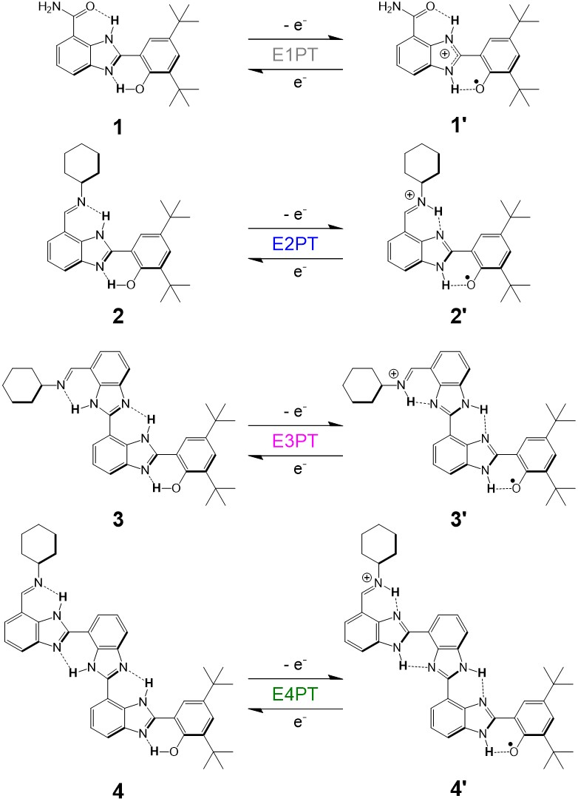
Fig.1. Molecular structures of benzimidazole-phenol (BIP) derivatives and their oxidation products.
On the left: compounds 1, 2, 3, and 4 designed to explore E1PT, E2PT, E3PT and E4PT (generically EnPT) processes, respectively. On the right: products of the electrochemical oxidation of the phenol coupled with one (1’), two (2’), three (3’), and four (4’) proton transfers. The hydrogen atoms involved in the PCET reactions are labeled in red.

As indicated in Fig.1, compounds 1–4 exhibit internal hydrogen bonds providing well-defined structural frameworks required for transport of protons by PCET processes. In 1–4, the presence of a strong H-bond between the phenolic proton and the nitrogen lone pair of the adjacent benzimidazole has been well established in related compounds (11, 18, 22, 23). In 2–4, the formation of an intramolecular H-bond between the benzimidazole NH and the terminal imine nitrogen, as well as the H-bonds connecting the benzimidazole moieties (for 3 and 4), is supported by their ¹H NMR chemical shifts at low fields and IR absorption features (see SI).
Depending on the solvent, compounds 1 and 2 may exist as mixtures of isomers due to both the 1,3-tautomerism of imidazole and rotation around the bond connecting the benzimidazole and the phenolic moieties. In the case of 2, in a non-polar solvent such as CDCl₃, only one of these isomers, the closed cis enol (24), acquires the H-bond network necessary for intramolecular proton transfers to take place upon phenol oxidation. As the number of benzimidazole units increases from 2 to 4 (see Fig. 1), the number of possible isomers in solution increases as well. For compounds analogous to 4 (with a para-substituted phenyl group instead of the cyclohexyl group attached to the imine nitrogen, see structures in the SI), the presence of isomers can be clearly detected by inspection of the ¹HNMR spectra in the low field region (Fig,xx SI). The data confirm that at least three isomers are present in CDCl₃. Some of these isomers lack the H-bond network requisite for the intramolecular proton translocation all the way to the imine. However, the ¹HNMR spectrum drastically changes when the cyclohexylimine moiety is used as the final proton acceptor (see 4 and SI Fig x). The number of signals in the low-field region indicates the existence of essentially one isomer in CDCl₃ solution. Presumably, the stronger basicity of the imine nitrogen in 4, compared with that of the analogous phenylimine derivatives, strengthens the terminal H-bond, resulting in the conformation where the H-bond network extends across the molecule as shown in Fig.1. DFT calculations provide quantitative support for the structures shown in 1–4 (Fig.1, SIXX).
Fig. 2. Cyclic voltammograms and experimental and calculated redox potentials.
(A) Cyclic voltammograms of 1 (grey), 2 (blue), 3 (magenta) and 4 (green) in dry CH₂Cl₂. (B) Color coded experimental and calculated E_{1/2} potentials for the redox couples indicated in Fig 1. For each compound, the calculated distance from the phenol oxygen to the final proton acceptor (Å) compound is included (blue wedge). Agreement between calculated and experimental values for 3 are by construction because this species was used as the reference for all calculations (see SI).

Fig. 2A shows the cyclic voltammograms of compounds 1–4 (a detailed electrochemical characterization is provided in the SI). We observe a 60 mV drop in the E_{1/2} for each benzimidazole unit added to the system, indicating that the phenol becomes easier to oxidize with the sequential addition of benzimidazole groups. DFT calculations of the redox potentials with all protons transferred for each species agree with the experimental redox potentials (Fig. 2B, colored lines), supporting the products in Fig. 1. These computed redox potentials indicate a decrease of 100 mV/imidazole across the series, which is consistent within the accuracy of DFT calculations with the 60 mV observed (see SI). Furthermore, theory quantifies the contributions of individual proton transfer reactions to the overall thermodynamics (Fig. 2B, uncolored lines). In this model, all proton transfers are individually thermodynamically favorable upon oxidation of the phenol, even those between two benzimidazole units (which are the least thermodynamically favorable). The first proton transfer from the phenoxyl radical cation to the proximal benzimidazole is the most favorable in each case (–––– to – • – ) and is quantified only by DFT, because E_{1/2} for oxidation of phenols without appended bases are typically irreversible and therefore poorly defined.(ref Richards) The difference between the theoretical E_{1/2} for the phenoxyl radical cation/phenol couple (E0PT) and the E_{1/2} value for the 1’/1 couple (E1PT) is attributed to the thermodynamically downhill proton transfer; it qualitatively agrees with estimates of ΔpK_{a} between the phenoxyl radical cation and the benzimidazolium ion in CH₂Cl₂. The final proton transfer yielding the protonated imine is less thermodynamically favorable, as expected by the lower ΔpK_{a} for this step compared to that of the first step. This analysis of the elementary processes within a thermodynamic cycle is not intended to suggest a stepwise mechanism for the EnPT process but rather provides insight into the relative contribution of each proton transfer to the overall redox potential.
Infrared spectroelectrochemical (IRSEC) measurements were carried out to examine the changes in the IR spectra of compounds 1–4, which can clearly distinguish the site of protonation upon oxidation of the phenol. In the case of 1, the appearance of the band at 1556 cm⁻¹ indicates the formation of the benzimidazolium ion (1’, Fig. 1), signaling the occurrence of an E1PT process (22). The band at 1670 cm⁻¹, corresponding to the stretching mode of the amide carbonyl, shifts to 1678 cm⁻¹ upon oxidation. The appearance of the band at 1660 cm⁻¹ in 2–4 provides definitive evidence for proton translocation from the phenol to the imine, assigned to E2PT, E3PT, and E4PT in 2, 3, and 4, respectively. This band is attributed to the coupling between the C=N stretching and the C=N-H bending modes (25) and has been found in the IRSEC of compounds related to 2 (23). The absence of the band at ~1556 cm⁻¹ in 2–4 indicates that the benzimidazolium ion is not detectable in these experiments (11, 22) and further corroborates the long-distance translocation of protons upon oxidation of the phenol.
Fig. 3. Infrared spectroelectrochemical spectra (IRSEC) of compounds 1–4.
(A), (B), (C) and (D) IRSEC of compounds 1, 2, 3, and 4, respectively. Colored lines correspond to the oxidized species (color coded as in Fig. 2) following polarization in 50 mV increments to generate increasing amounts of the oxidized species. Black lines correspond to the neutral species, and the dotted line in D corresponds to the spectra obtained upon polarizing the solution to reducing potentials after polarizing for 2 min at a potential required to deplete 4 within the path of the optical probe. The arrows show the appearance of the characteristic band for either the benzimidazolium ion (1) or the protonated imine (2–4).

In the high-frequency region (3500–3200 cm⁻¹, see SI) of 2–4, the bands at ~ 3370 cm⁻¹ correspond to the imidazole NH stretching and are sensitive to hydrogen bonding. The similarity of the spectra before and after oxidation of the phenol indicates that the hydrogen bond network persists, a precondition for the reversibility of the process. In 1, the strong broad band with maximum at 3316 cm⁻¹ corresponds to the formation of the benzimidazolium ion; the analogous band is absent in the IRSEC of 2–4.
The reversible electrochemical oxidation of 4 is depicted in Fig. 3 D. It is remarkable that upon reduction of the phenoxyl radical a reversal of the four proton translocation takes place and, within experimental error, perfect recovery of the initial neutral species of 4 is observed. No less certain reversibility is observed for compounds 1–3 (Fig.xx SI). The chemical reversibility of the phenoxyl/phenol couple is attributed to the ability of the proton to shuttle between acidic and basic sites comprising the H-bond network via intramolecular processes.
In summary, a series of four bioinspired, redox-driven, proton-translocating compounds have been designed and studied theoretically and experimentally. The results of the IRSEC experiments are definitive – the one-electron oxidation of the phenol moiety of 1–4 results in reversible, ΔpK_{a} driven, proton rearrangements extending over ~2, ~7, ~11 and ~16 Å to the terminal proton acceptor in 1, 2, 3, and 4, respectively. DFT calculations of redox potentials predicated on concerted or nearly concerted PCET processes with all protons transferring correctly account for the experimental observations (7, 22). Combining theoretical guidance, experimental measurements, and new synthetic designs, we should be able to tweak the relative pK_{a}’s of intervening proton transfers so that the cost in redox potential of long-distance proton transfer can be better defined and controlled. Having in hand the parameters controlling proton transfer over an extended H-bond network, fully reversible processes such as those described herein foretell the development of artificial bioinspired energy coupling membranes capable of the full range of reversible bioenergetic processes observed in nature.
‡ These authors contributed equally.
ACKNOWLEDGMENT
This research was supported by the U.S. Department of Energy, Office of Science, Office of Basic Energy Sciences, under Award DE-FG02-03ER15393. The theoretical portion of this research was supported by the Center for Molecular Electrocatalysis, which is an Energy Frontier Research Center funded by the U.S. Department of Energy, Office of Science, Office of Basic Energy Sciences.

REFERENCES
1. R. E. Blankenship, Molecular mechanisms of photosynthesis (Wiley Blackwell, Oxford, UK, NJ, USA, ed. Second Edition, 2014).
2. P. Mitchell, Coupling of Phosphorylation to Electron and Hydrogen Transfer by a Chemi-Osmotic type of Mechanism. Nature 191, 144-148 (1961).
3. A. Migliore, N. F. Polizzi, M. J. Therien, D. N. Beratan, Biochemistry and theory of proton-coupled electron transfer. Chem Rev 114, 3381-3465 (2014).
4. S. Y. Reece, D. G. Nocera, Proton-coupled electron transfer in biology: results from synergistic studies in natural and model systems. Annu Rev Biochem. 78, 673–699 (2009).
5. J. Stubbe, D. G. Nocera, C. S. Yee, M. C. Y. Chang, Radical Initiation in the Class I Ribonucleotide Reductase: Long-Range Proton-Coupled Electron Transfer? Chemical Reviews 103, 2167-2202 (2003).
6. J. L. Dempsey, J. R. Winkler, H. B. Gray, Proton-Coupled Electron Flow in Protein Redox Machines. Chemical Reviews 110, 7024-7039 (2010).
7. S. Hammes-Schiffer, A. A. Stuchebrukhov, Theory of coupled electron and proton transfer reactions. Chem. Rev. 110, 6939–6960 (2010).
8. D. Zhong, Electron Transfer Mechanisms of DNA Repair by Photolyase. Annu. Rev. Phys. Chem. 66, 691-715 (2015).
9. T. Mathes, I. H. van Stokkum, M. Stierl, J. T. Kennis, Redox modulation of flavin and tyrosine determines photoinduced proton-coupled electron transfer and photoactivation of BLUF photoreceptors. J. Biol. Chem. 287, 31725-31738 (2012).
10. C. Tommos, G. T. Babcock, Proton and hydrogen currents in photosynthetic water oxidation. Biochimica et Biophysica Acta 1458, 199–219 (2000).
11. S. J. Mora et al., Proton-Coupled Electron Transfer in Artificial Photosynthetic Systems. Acc. Chem. Res. 51, 445-453 (2018).
12. Y. Umena, K. Kawakami, J.-R. Shen, N. Kamiya, Crystal structure of oxygen-evolving photosystem II at a resolution of 1.9 Å. Nature 473, 55–60 (2011).
13. Z. Guo, J. He, B. A. Barry, Calcium, conformational selection, and redox-active tyrosine YZ in the photosynthetic oxygen-evolving cluster. 115, 5658-5663 (2018).
14. N. Agmon, The Grötthuss mechanism. Chem. Phys. Lett. 244, 456–462 (1995).
15. D. R. Ort et al., Redesigning photosynthesis to sustainably meet global food and bioenergy demand Proc. Natl. Acad. Sci. USA 112, 8529–8536 (2015).
16. L. Hammarström, Artificial photosynthesis: closing remarks. Faraday Discussions 198, 549-560 (2017).
17. T. Liu et al., Accelerating proton-coupled electron transfer of metal hydrides in catalyst model reactions. Nature Chemistry 10, 881-887 (2018).
18. T. F. Markle, I. J. Rhile, A. G. DiPasquale, J. M. Mayer, Probing concerted proton-electron transfer in phenol-imidazoles. Proc. Natl. Acad. Sci. USA 105, 8185–8190 (2008).
19. L. Benisvy et al., Phenoxyl radicals hydrogen-bonded to imidazolium: analogues of tyrosyl D of photosystem II: high-field EPR and DFT studies. . Angew. Chem. Int. Ed. 44, 5314–5317 (2005).
20. G. Chararalambidis et al., Water Molecules Gating a Photoinduced One-Electron Two-Protons Transfer in a Tyrosine/Histidine (Tyr/His) Model of Photosystem II. Angew Chem Int Ed Engl 57, 9013-9017 (2018).
21. J. D. Megiatto Jr. et al., A bioinspired redox relay that mimics radical interactions of the Tyr–His pairs of photosystem II. Nature Chem. 6, 423–428 (2014).
22. M. T. Huynh et al., Concerted one-electron two-proton transfer processes in models inspired by the Tyr-His couple of photosystem II. ACS Cent. Sci. 3, 372−380 (2017).
23. E. Odella et al., Controlling Proton-Coupled Electron Transfer in Bioinspired Artificial Photosynthetic Relays. J. Am. Chem. Soc. 140, 15450-15460 (2018).
24. M. Forés, M. Duran, M. Solà, M. Orozco, F. J. Luque, Theoretical Evaluation of Solvent Effects on the Conformational and Tautomeric Equilibria of 2-(2‘-Hydroxyphenyl)benzimidazole and on Its Absorption and Fluorescence Spectra. The Journal of Physical Chemistry A 103, 4525-4532 (1999).
25. J. J. Lopez-Garriga, G. T. Babcock, J. F. Harrison, Factors influencing the C:N stretching frequency in neutral and protonated Schiff's bases. J. Am. Chem. Soc. 108, 7241-7251 (1986).

