**Perception travel system diagram**

jhanacek. net

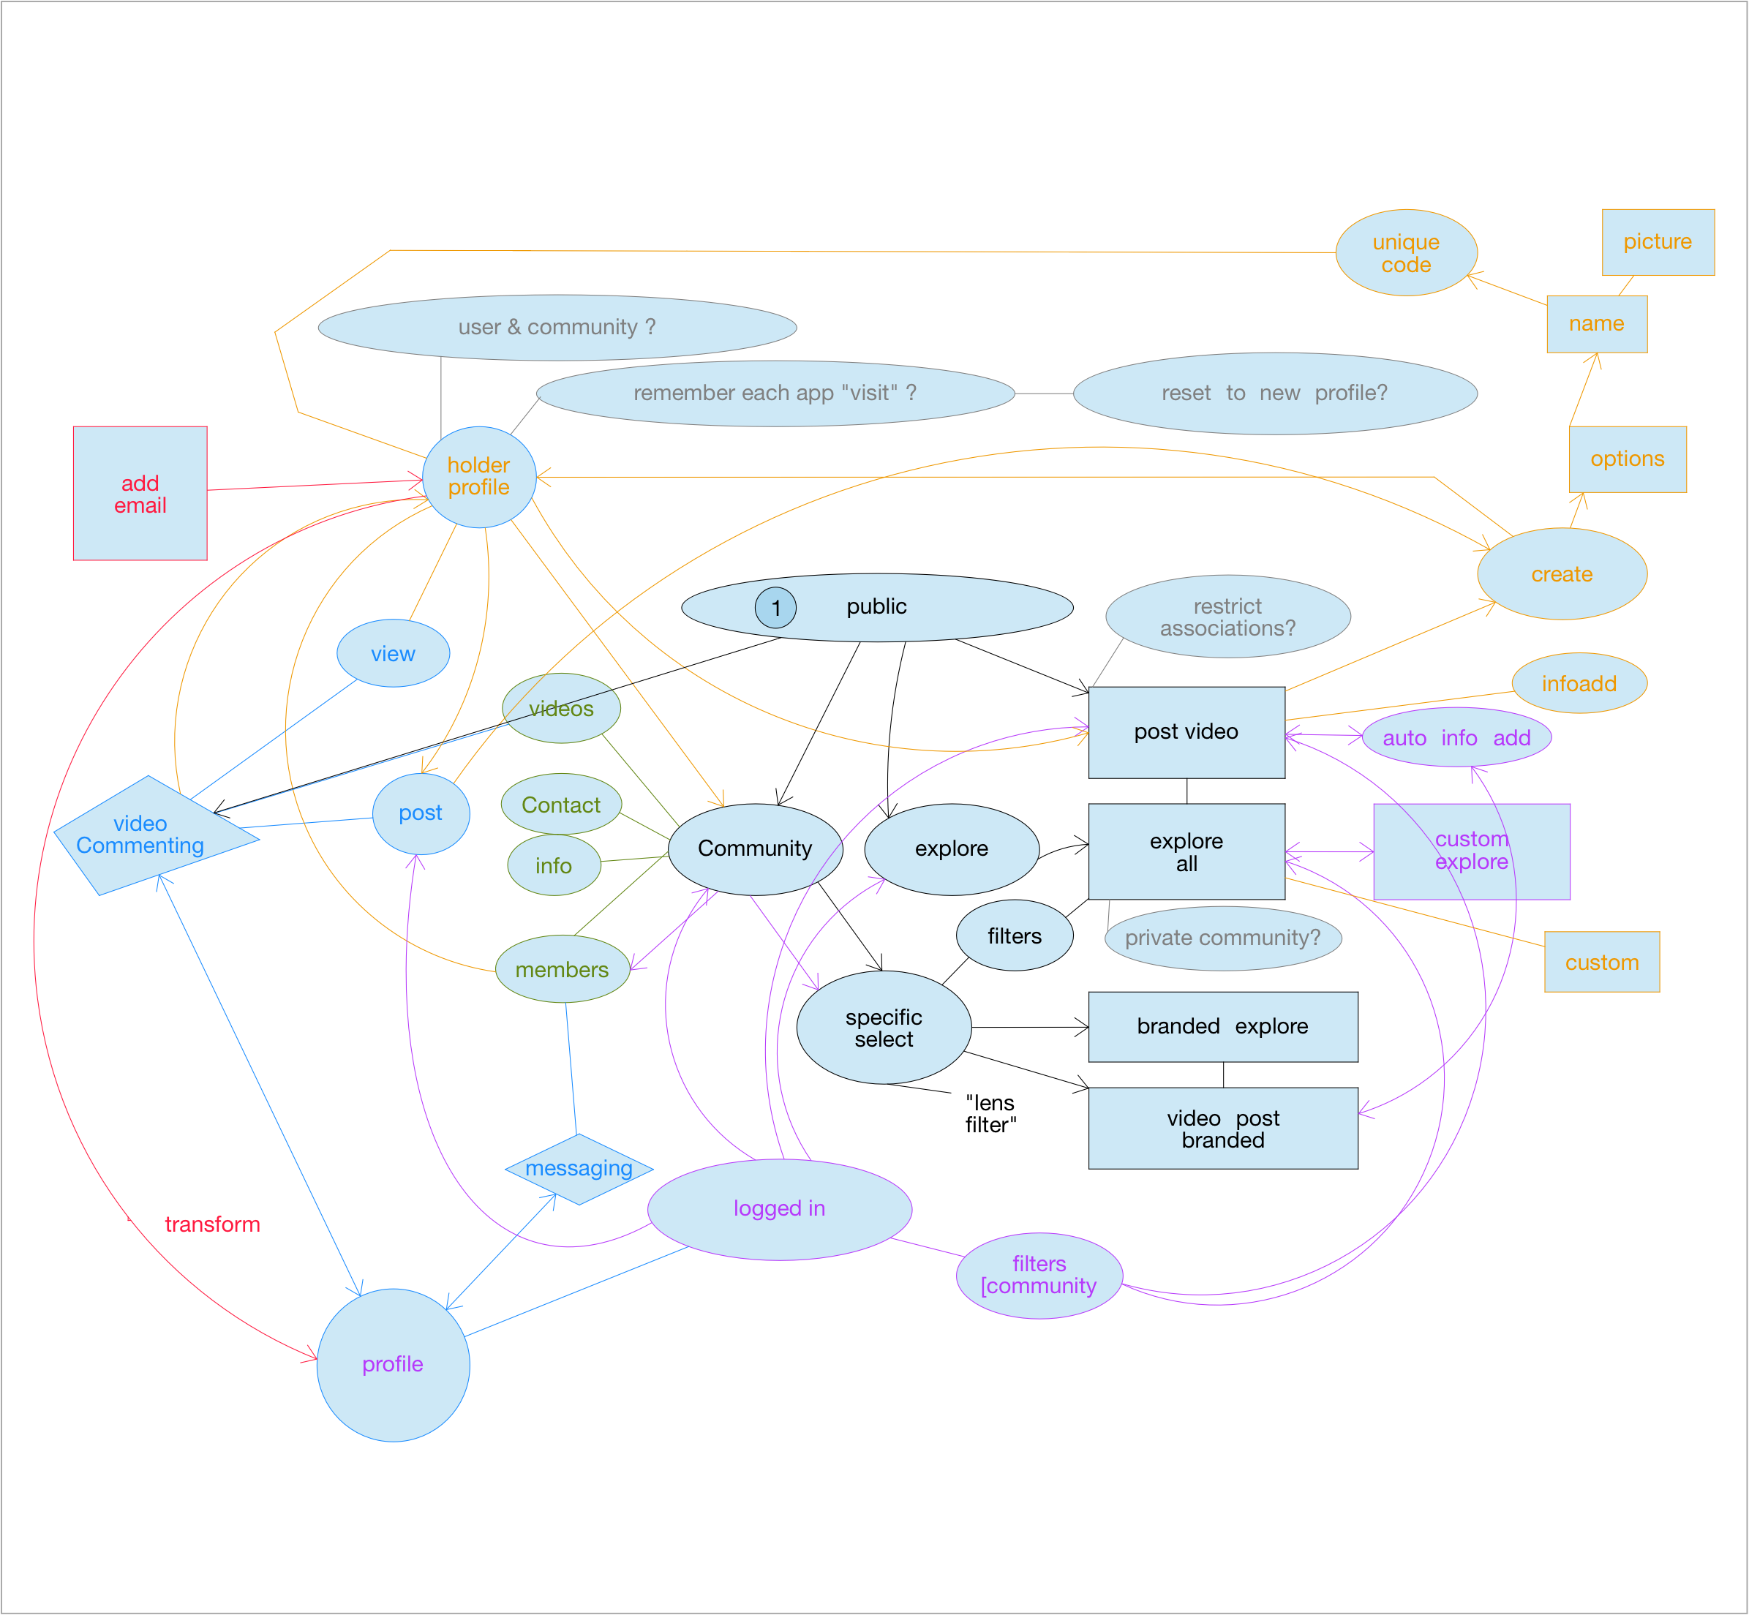

Decentraland - temple

mid october site launch

content delivery network

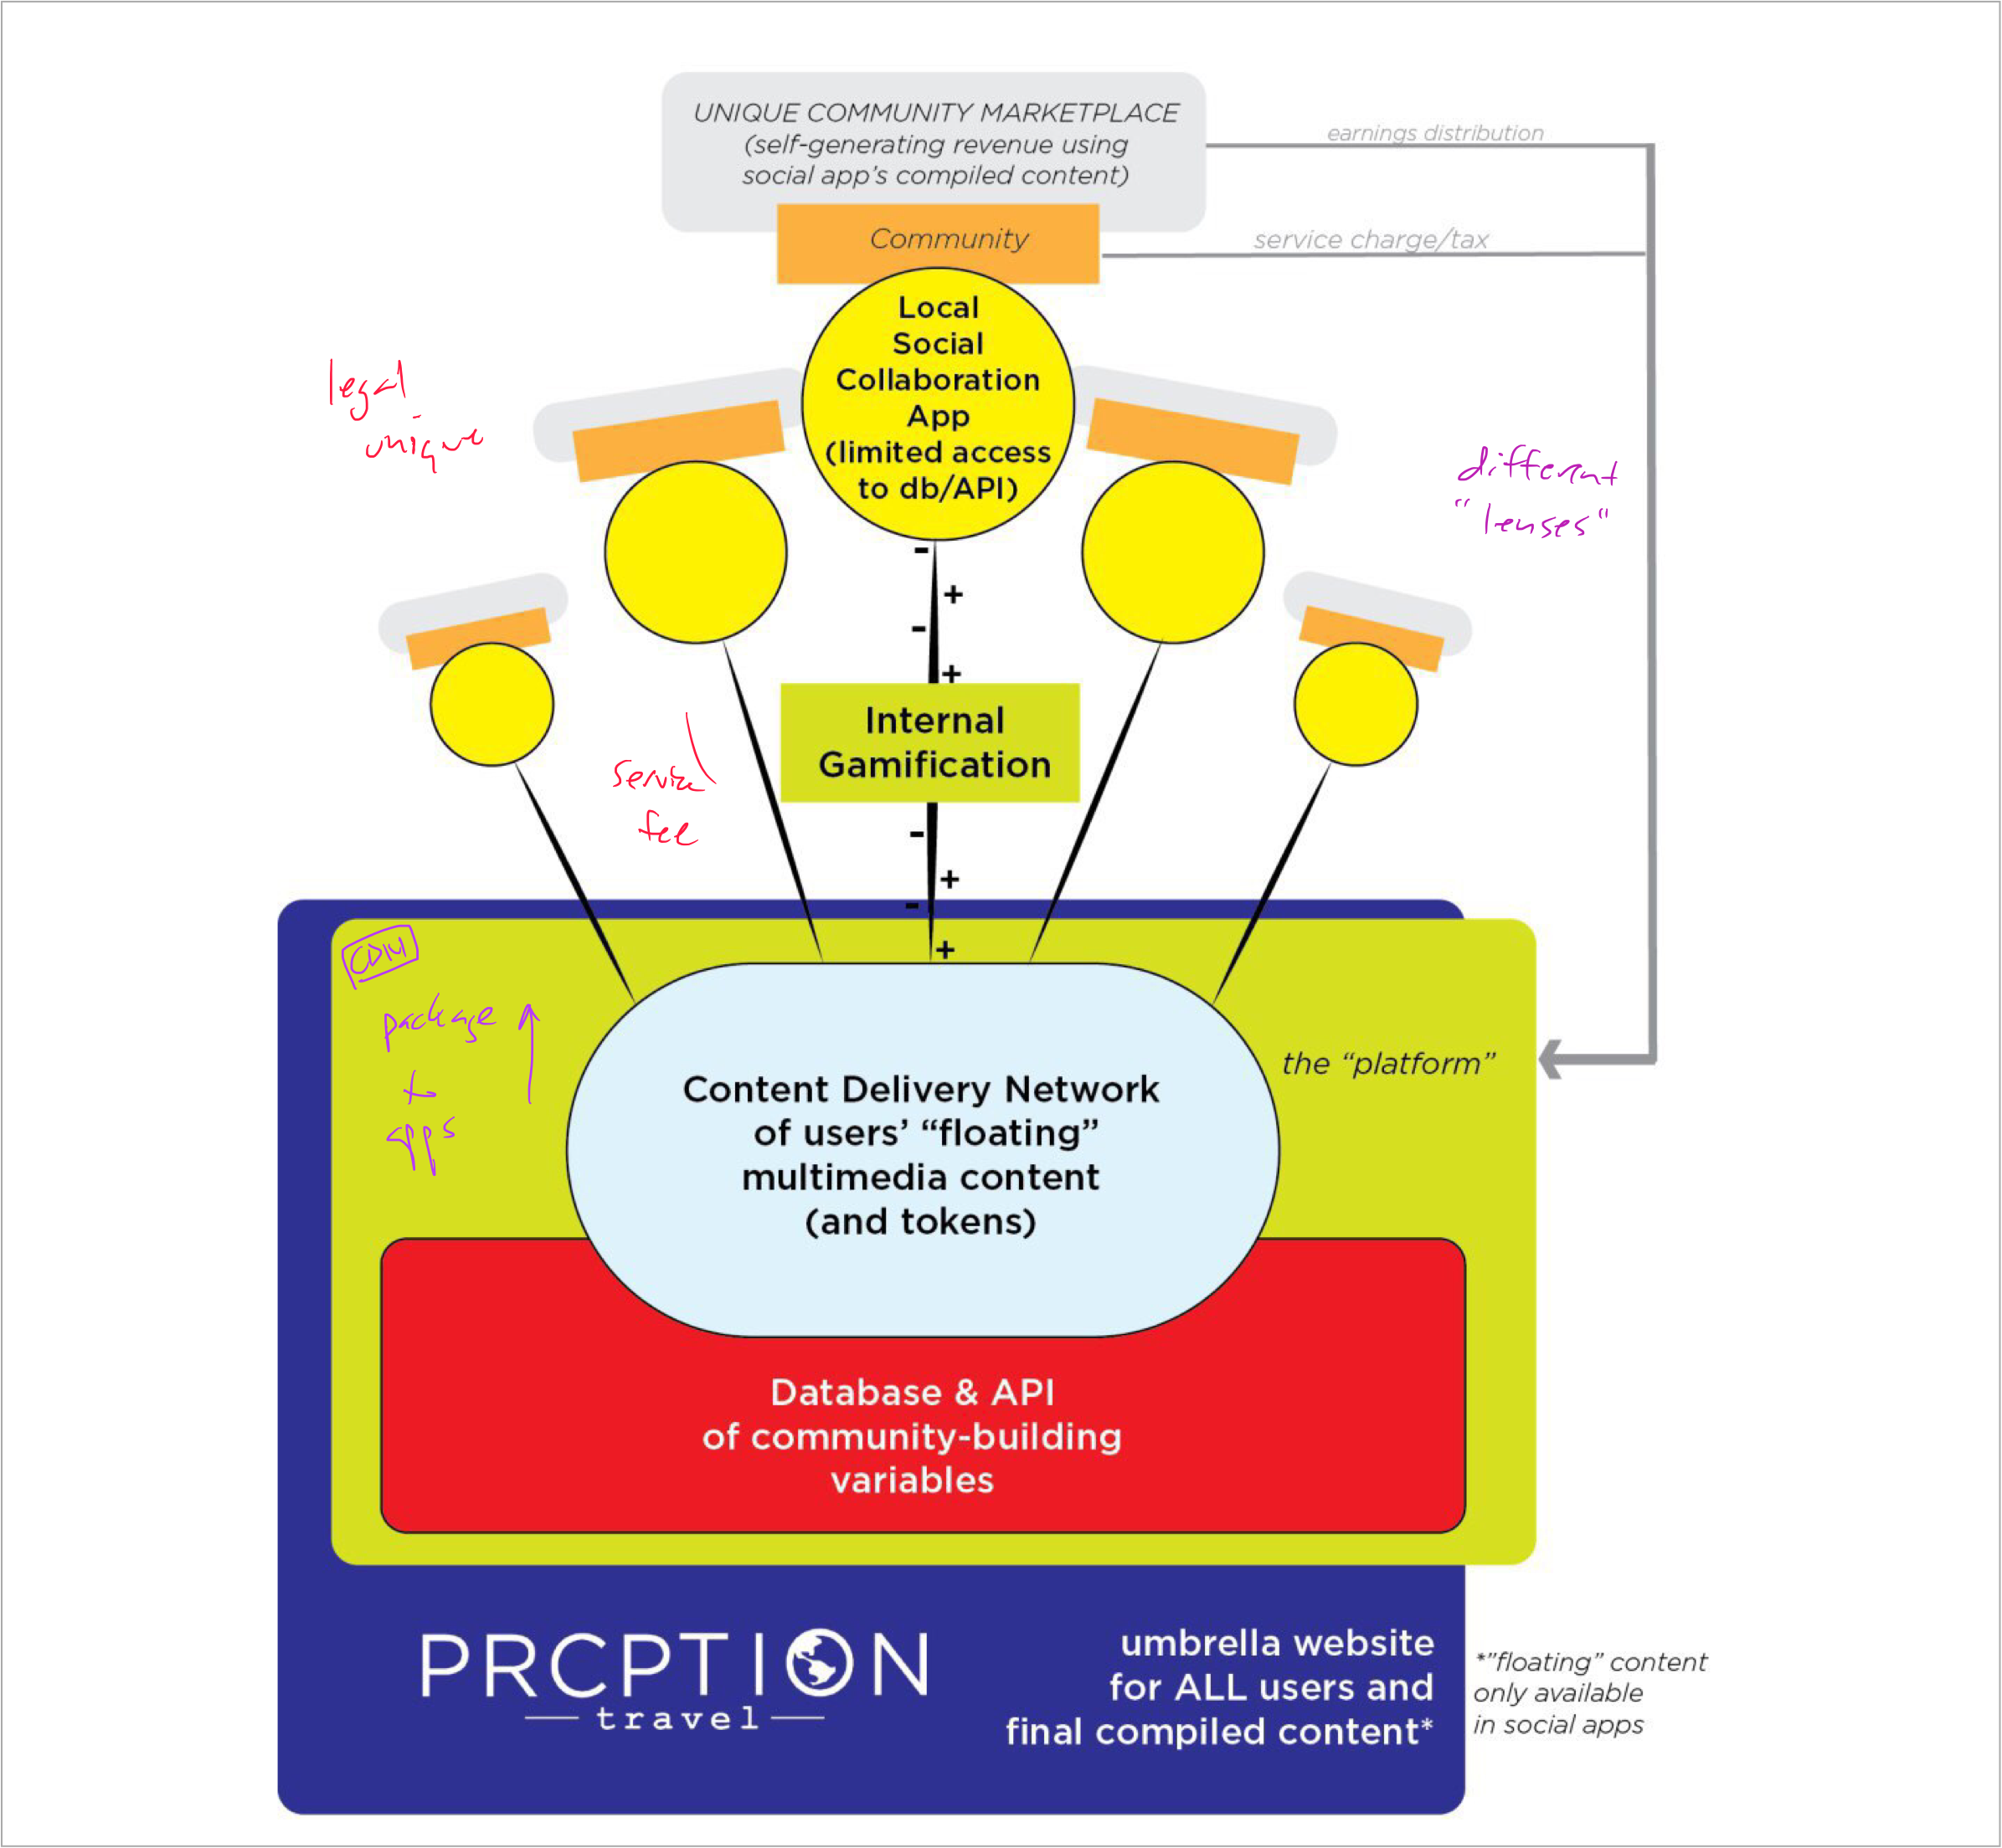

* art
* travel
* music

plus and play frontend

quick app for art

view + submit new voice → new art "remix"

swipe neighborhood

microslog app

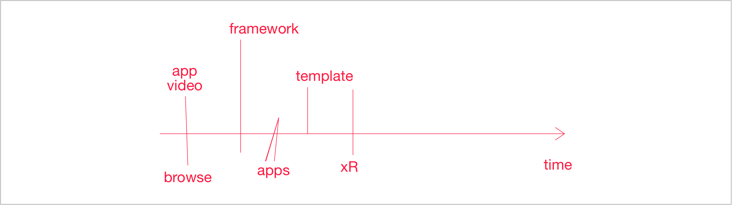

video submit page unique fields

* 2 video submission

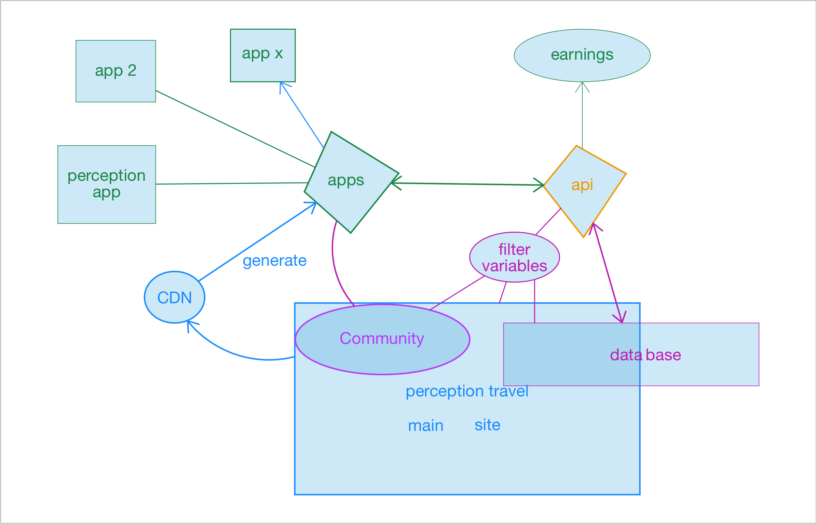

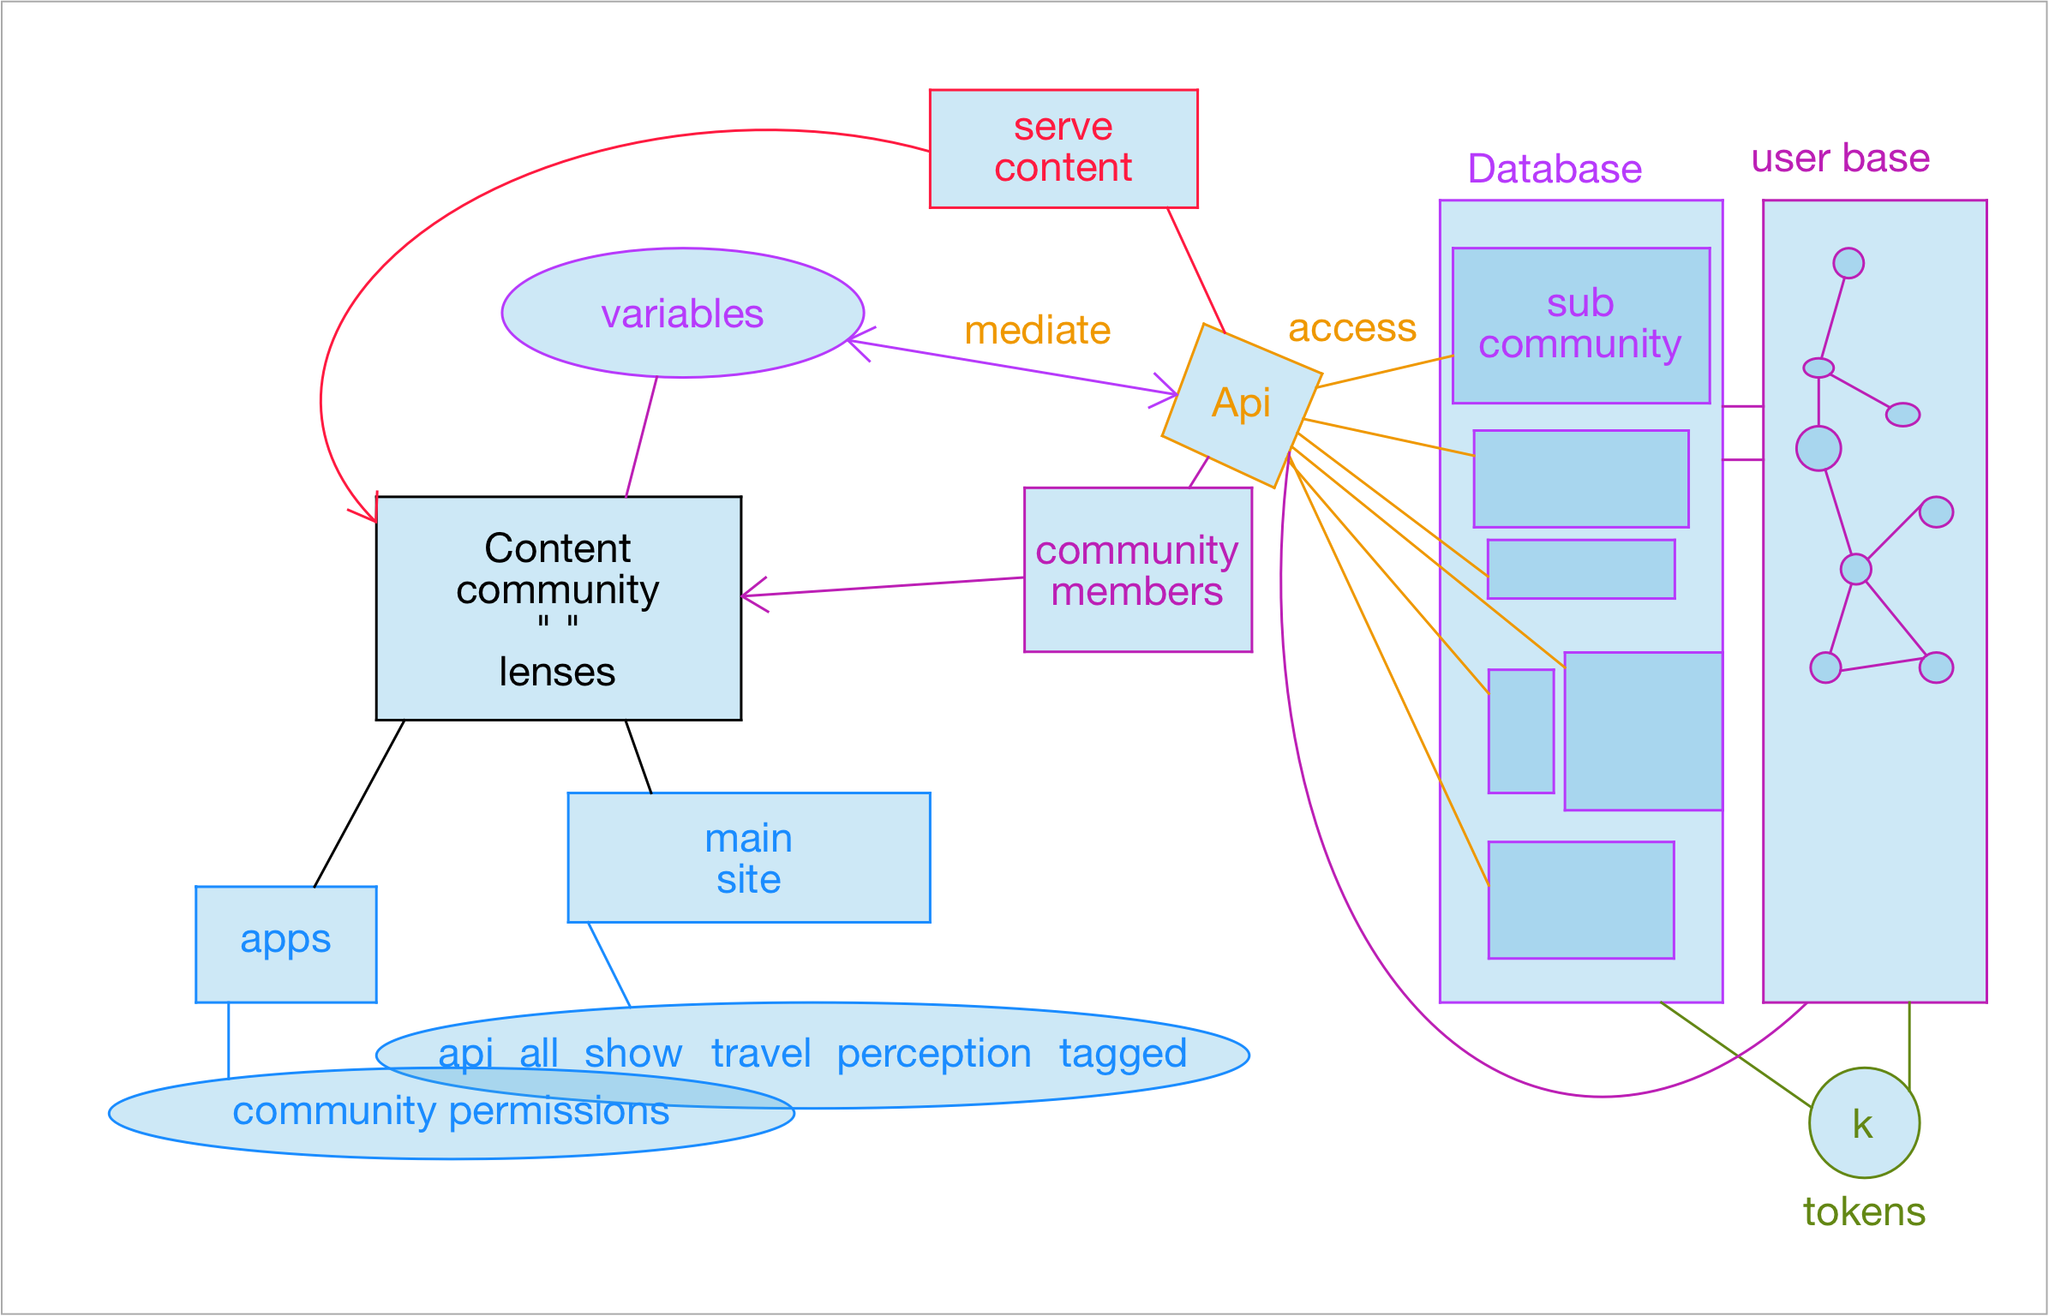

Database and user database  
connected by user permissions thru" lenses"

