CSCI 3308

Professor Boese

Project Part 3

Who:

Kevin Flynn

Jason Hill

Andrew Callahan

Soham Shah

Title:

Stock Insights

Vision:

A service to inform millennials about an investing strategy by interpreting and visualizing market data.

Part 1: Automated Testing

We wrote python scripts to automate the testing for the momentum algorithm we are applying. Here’s the link to the code: <https://github.com/jjh68069/3308_Project/blob/master/momentum_test.py>

Here’s what output running the program gives us:

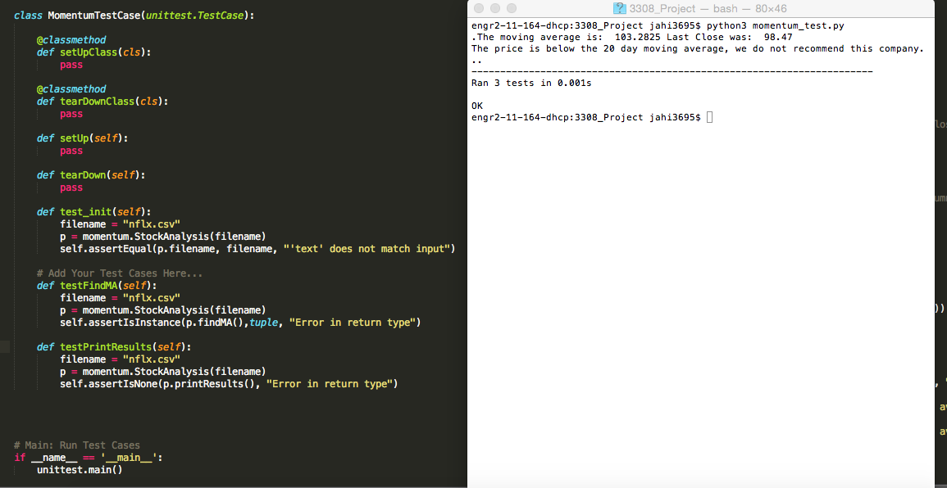

Link to unittest documentation: https://docs.python.org/2/library/unittest.html

Part 2: User Acceptance Tests

|  |  |  |  |  |  |  |
| --- | --- | --- | --- | --- | --- | --- |
| Project name: Stock Insights | | | | | | |
| Test Case Template | | | | | | |
| Test case ID: US-01 | | | Test designed by: Soham Shah | | | |
| Test priority (low, med, high): Med | | | Test designed date: 11/11/15 | | | |
| Module name: Access top company stocks | | | Test executed by: | | | |
| Test title: Stock listings | | | Test execution date: | | | |
| Preconditions: User can access website and knows top stocks | | | | | | |
| Dependencies: The website has to be running and connected to the database. | | | | | | |
|  | | | | | | |
| Step | Test Steps | Test data | Expected Results | Actual Results | Status (pass/fail) | Notes |
| 1 | Access website | Webpage displays | User can see the webpage |  |  |  |
| 2 | Select function tab | Click the tab | Webpage redirects to function page |  |  |  |
| 3 | Type in a stock ticker | Enter “aapl” | Look at apple stock |  |  |  |
| 4 | Select go | Click the go button | Server gets user entry |  |  |  |
| 5 | Look at the data | NA | Data on stock is displayed |  |  |  |
| Post Conditions:  Test is validated by visually looking at the data presented and cross-referencing it with the apple csv on another computer to make sure the data is displayed accurately. Also, User evaluates ease of use. | | | | | | |

|  |  |  |  |  |  |  |
| --- | --- | --- | --- | --- | --- | --- |
| Project Name: Stock Insights | | | | | | |
| Test Case Template | | | | | | |
| Test Case ID: US-02 | | | Test designed by: Andrew Callahan | | | |
| Test Priority (low, med, high): Med | | | Test designed date: 11/11/15 | | | |
| Module Name: Check invalid company name | | | Test executed by: | | | |
| Test Title: Invalid company search | | | Test execution date: | | | |
| Preconditions: user can access website and search for company | | | | | | |
| Dependencies: Website online and connected to database | | | | | | |
| Step | Test Steps | Test data | Expected Results | Actual Results | Status(pass/fail) | Notes |
| 1 | Access the website | Webpage displays | User can see the webpage |  |  |  |
| 2 | Select function tab | Click on function tab | Website redirects to function tab |  |  |  |
| 3 | Type in a false company name | Type in “test” into field | Server does not find company, displays invalid message |  |  |  |
| Post Conditions: Test is validated when the user see an invalid entry response from the website after it is not able to find that company stock in the database. | | | | | | |

|  |  |  |  |  |  |  |
| --- | --- | --- | --- | --- | --- | --- |
| Project Name: Stock Insights | | | | | | |
| Test Case | | | | | | |
| Test Case ID: US-03 | | | Test designed by: Kevin Flynn | | | |
| Test Priority (low, med, high): High | | | Test designed date: 11/11/15 | | | |
| Module Name: Webpage loads and displays properly | | | Test executed by: | | | |
| Test Title: Viewable Webpage | | | Test execution date: | | | |
| Preconditions: User knows how to access the webpage | | | | | | |
| Dependencies: Website online and connected Django Server | | | | | | |
| Step | Test Steps | Test data | Expected Results | Actual Results | Status(pass/fail) | Notes |
| 1 | Access the website | Enter in webpage name | Webpage loads |  |  |  |
| 2 | Overview what is displayed | NA | Everything loads properly and is formatted correctly |  |  |  |
| 3 | Access function tab | Click to access function | Function tab loads properly and is formatted correctly |  |  |  |
| Post Conditions: Validated when the user is properly able access the site without, there are no formatting problems and all tabs are working. | | | | | | |

VCS:

<https://github.com/jjh68069/3308_Project>