CSCI 3308

Professor Boese

Project Part 6: Final Submission

# Title:

Stock Insights

Who:

Kevin Flynn

Jason Hill

Andrew Callahan

Soham Shah

# Project Tracker Trello:

<https://trello.com/b/Lyux3Cda/3308-project>

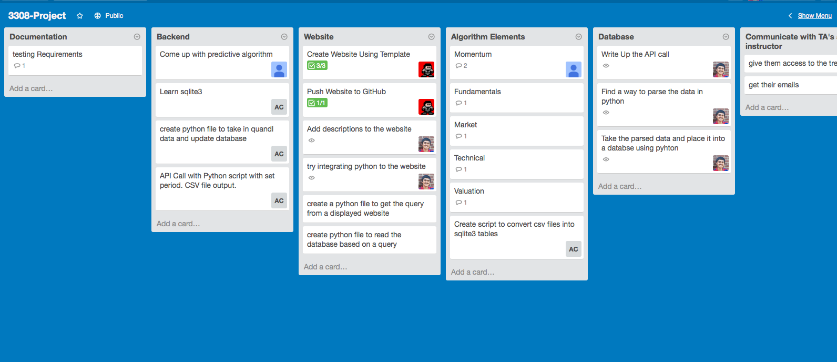

# Video:

<https://github.com/jjh68069/3308_Project/blob/master/Documentation/ProjectPart6/ProjectPart6.avi>

# VCS:

<https://github.com/jjh68069/3308_Project>

# Screenshot:

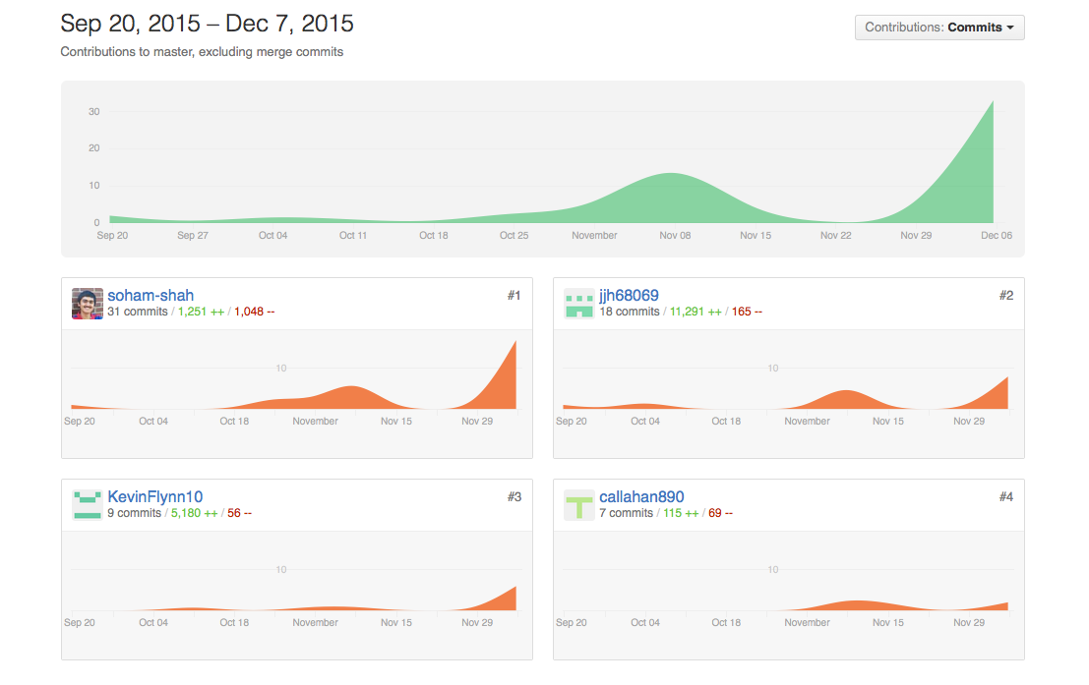

# Deployment:

<http://soham-shah.github.io/index.html>

Simply go to the following website to see the stocks. At the moment the only stock that will display is “aapl.” This is for testing purposes.

You can also run the website locally. Download the github repository to your desktop. Then in terminal, navigate to the HTML folder. Type “Python –m CGIHTTPServer” without quotes. Open the default webbrowser and in the addressbar type in localhost:8000 and the website should be displayed.

# Auto-Doc:

<https://github.com/jjh68069/3308_Project/tree/master/Documentation/html>

