Crime Concentration at the Block Level
What It Means for Targeting Resources
New York City, 2006–2024

The Basic Finding
Crime does not spread evenly across a city. A small share of blocks produces a large share of crime. This is true in every city that has been studied, and it is true in New York.
The simplest way to measure this is the 50-X metric: if you rank every block in the city by how much crime it has and start counting from the top, how far down the list do you get before you’ve accounted for half of all crime? That percentage is the 50-X.
Here is what the numbers look like for New York City’s 89,292 physical blocks:
Crime Type | Period | Total Incidents | 50-X
Shootings | 2006–2024 | 23,300 | 2.2%
Murder | 2006–2024 | 7,729 | < 0.1%
Outdoor robbery | 2006–2024 | 214,568 | 6.0%
Outdoor felony assault | 2006–2024 | 167,058 | 4.8%
Gun violence* | 2017–2024 | 26,199 | 2.4%
*Gun violence = shootings + shots fired (reports of gunfire where no one was hit). Shots fired data begins in 2017.
Read the table this way: 2.2% of New York City’s blocks account for half of all shootings over nearly two decades. For murder, the number is even smaller — fewer than 1 in 1,000 blocks. For outdoor robbery and outdoor felony assault, 5–6% of blocks carry the burden.
The 50-X is the simplest way to communicate concentration. It translates directly into an operational question: how much of the city do you need to cover to reach half the problem?

But the Number Overstates the Case
When a crime is rare — like shootings or murders — even a completely random scattering across the city would look “concentrated.” Think of it this way: New York has about 89,000 blocks and roughly 300 murders a year. Even if murders happened at random locations with no pattern at all, the vast majority of blocks would have zero murders. The resulting distribution would appear highly concentrated — not because of hot spots, but because of arithmetic.
The 50-X metric captures this mathematical inevitability alongside the genuine spatial signal. It mixes two things together:
- The mechanical effect of rare events spread across many locations
- The real tendency of crime to cluster at specific places
This does not mean concentration is fake. It means the standard number needs context. For common crimes like outdoor robbery, the 50-X is mostly a real signal. For rare crimes like murder, most of the apparent concentration is mathematical, and only a portion reflects genuine spatial clustering.

Separating the Signal from the Noise
We can calculate what concentration would look like if crime were scattered at random — no hot spots, no patterns, just chance. The difference between what we actually observe and that random baseline is the real concentration signal. Researchers call this marginal crime concentration (MCC).
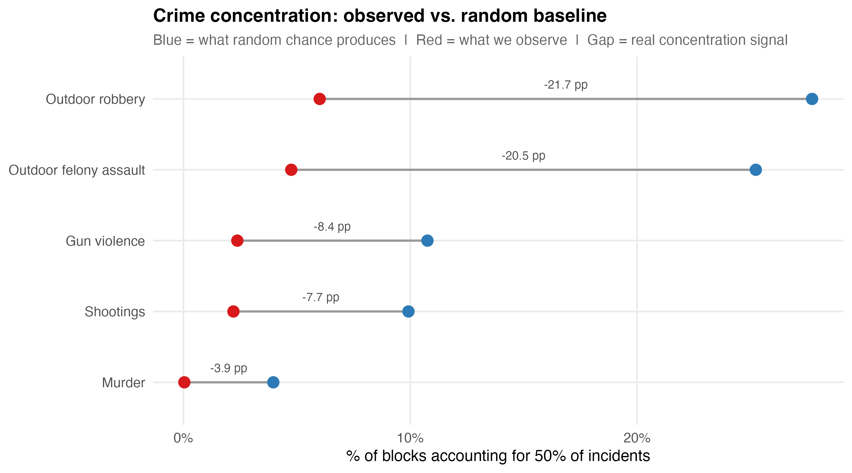
Figure 1. Crime concentration: observed (red) vs. random baseline (blue). The gap between the dots is the real spatial signal.
In the figure above, each crime type has two dots. The blue dot shows what random chance alone would produce. The red dot shows what we actually observe. The gap between them is the real concentration signal — the part that reflects genuine hot spots rather than sparse-data math.
Key finding: For outdoor robbery and outdoor felony assault, observed concentration far exceeds random chance — the red dot is 20+ percentage points more concentrated than the blue dot. Crime genuinely clusters at specific blocks. For shootings and murder, the observed numbers look dramatic, but the real signal above chance is smaller. The math of rare events does much of the work.
This does not mean shooting hot spots are not real. It means you should interpret the raw 50-X number differently for rare versus common crimes. Use 50-X to communicate the scale of the problem. Use MCC to evaluate how much of it is a targetable spatial pattern.

Shooting Concentration Over Time
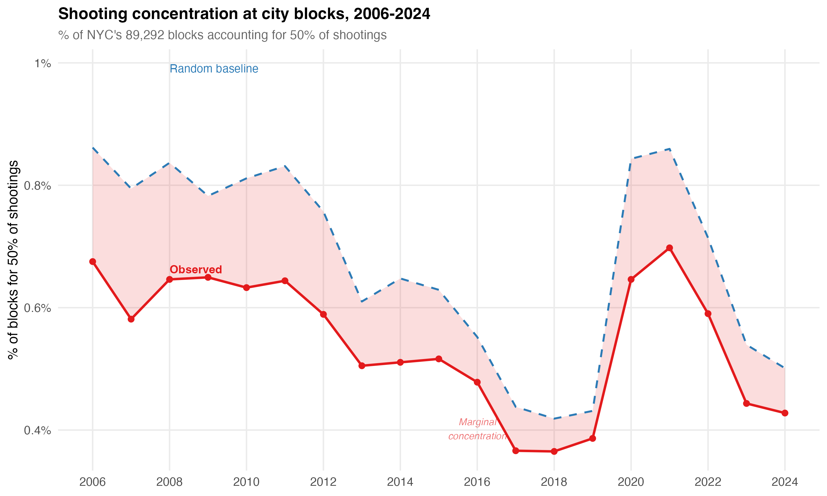
Figure 2. Shooting concentration (50-X) by year. Red = observed. Dashed blue = random baseline. Shaded area = the real concentration signal (MCC).
The red line shows shooting concentration each year from 2006 to 2024. In any given year, roughly 0.4% to 0.7% of blocks account for half of all shootings. The dashed blue line shows what random chance would produce given that year’s shooting volume.
Three things stand out:
- Shooting concentration is remarkably stable. The same small fraction of blocks carries the burden year after year.
- The random baseline moves with shooting volume. When shootings increase, more blocks get hit, pushing the baseline up. When shootings decline, fewer blocks are involved, and the baseline drops.
- Even during the 2020–2021 shooting surge, the concentration pattern held. More shootings meant more blocks were affected, but the spatial structure did not fundamentally change.
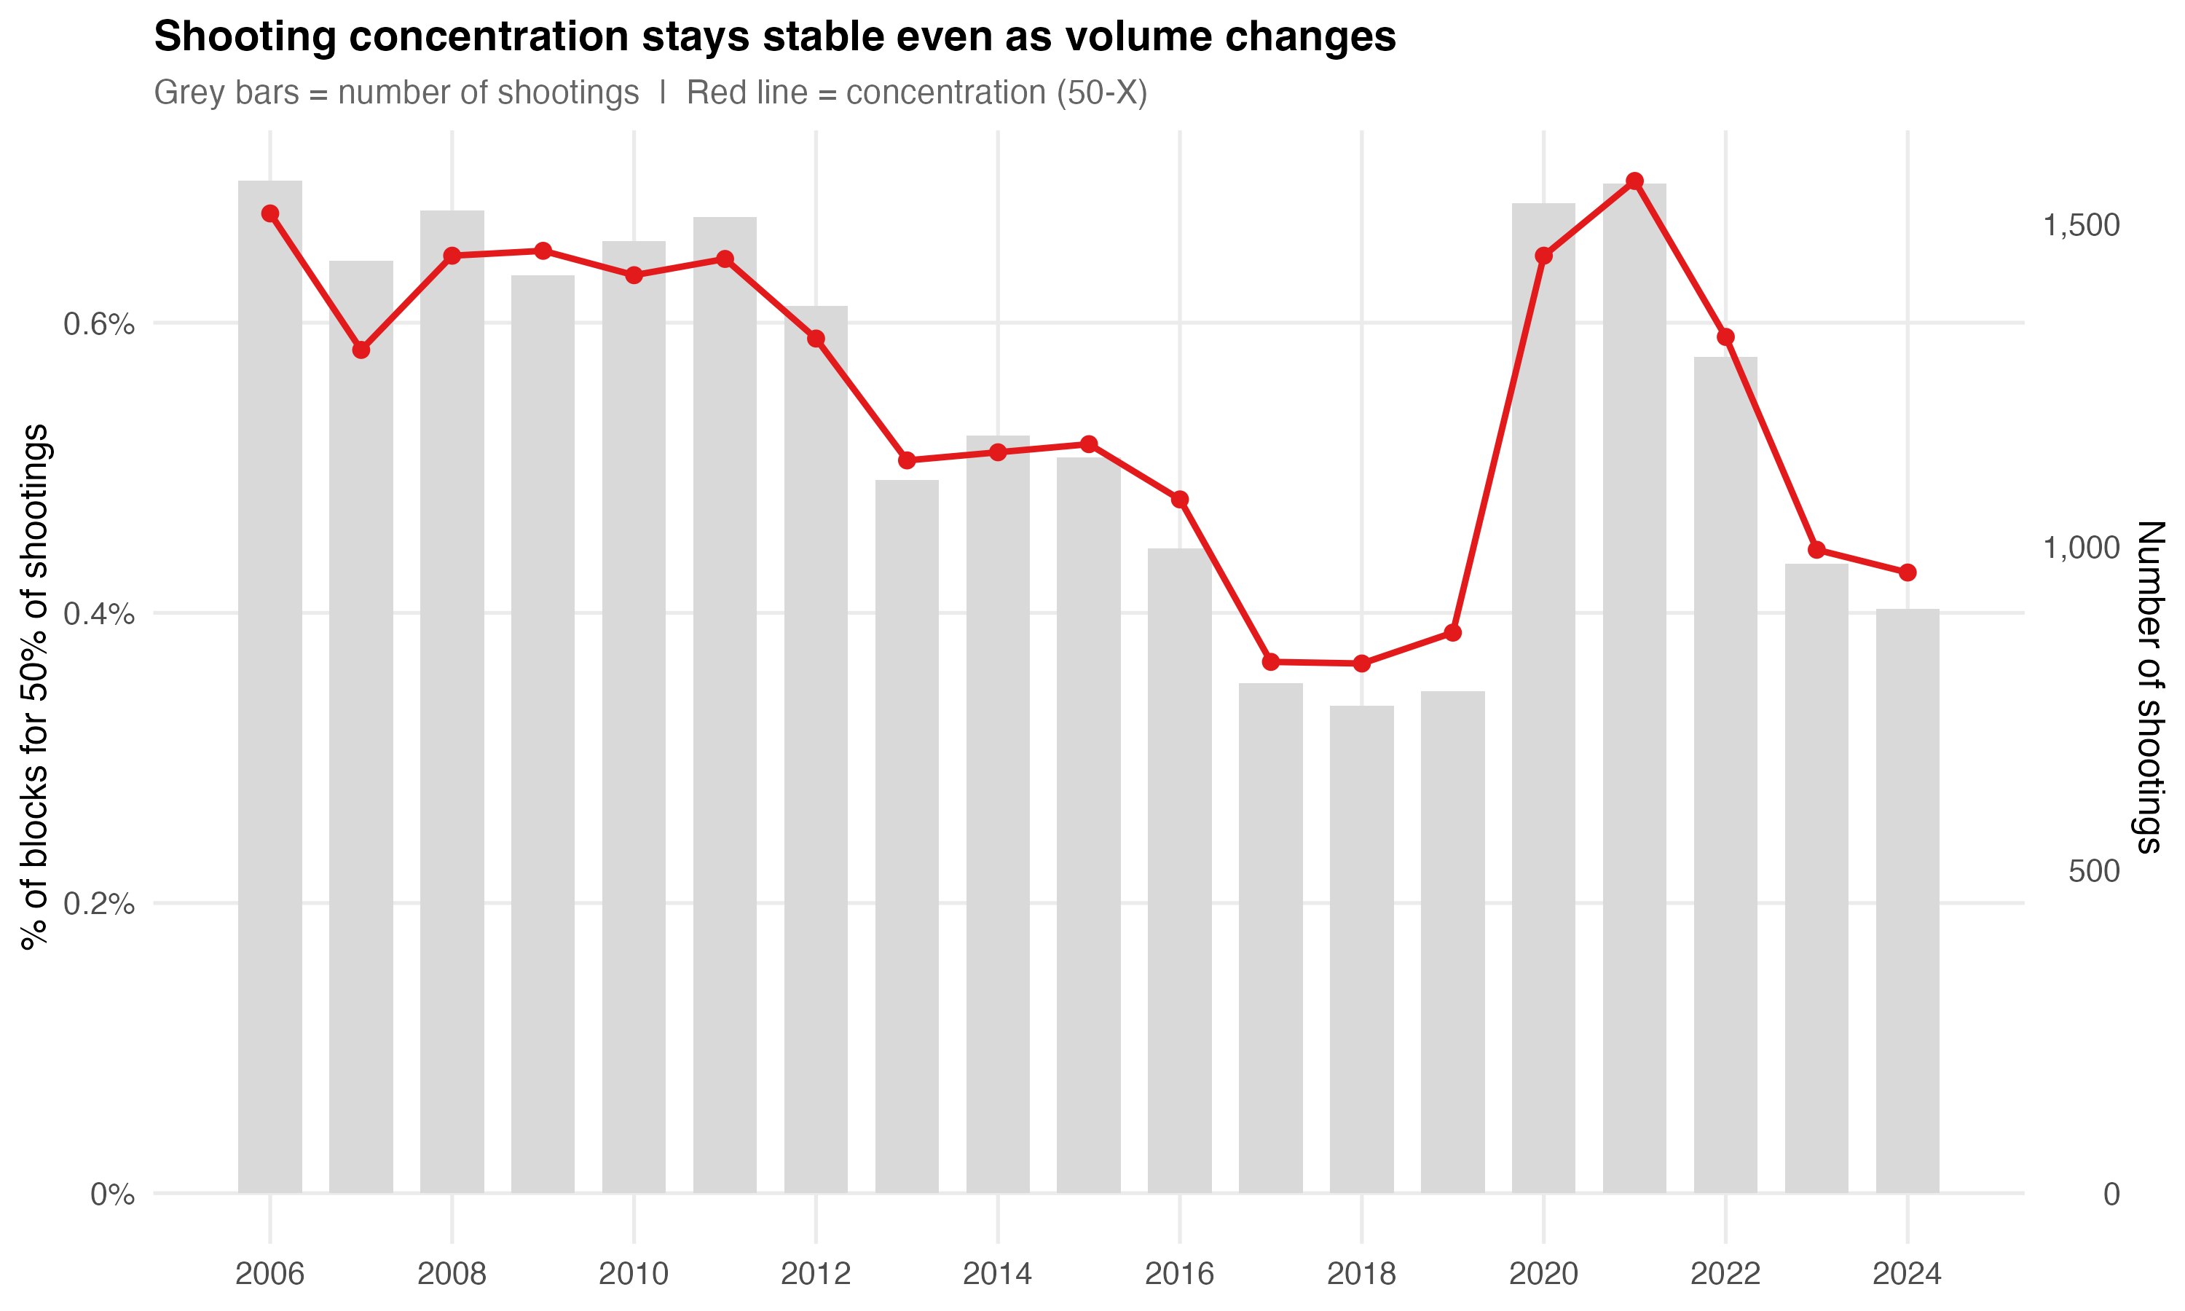
Figure 3. Shooting volume (grey bars) vs. concentration (red line). Concentration tracks volume because more shootings mechanically spread across more blocks.
This figure makes the relationship between volume and concentration visible. When shootings rise (as in 2020–2021), the 50-X metric rises too — not because concentration weakened, but because more events mechanically spread across more blocks. When shootings fall, concentration tightens. The MCC analysis confirms that the real spatial signal — the part above random chance — remains stable through these volume swings.

Gun Violence Concentration, 2017–2024
Gun violence here includes both shootings (where someone was hit) and shots fired (reports of gunfire where no one was hit). The shots fired data begins in 2017, so this series covers 2017–2024.
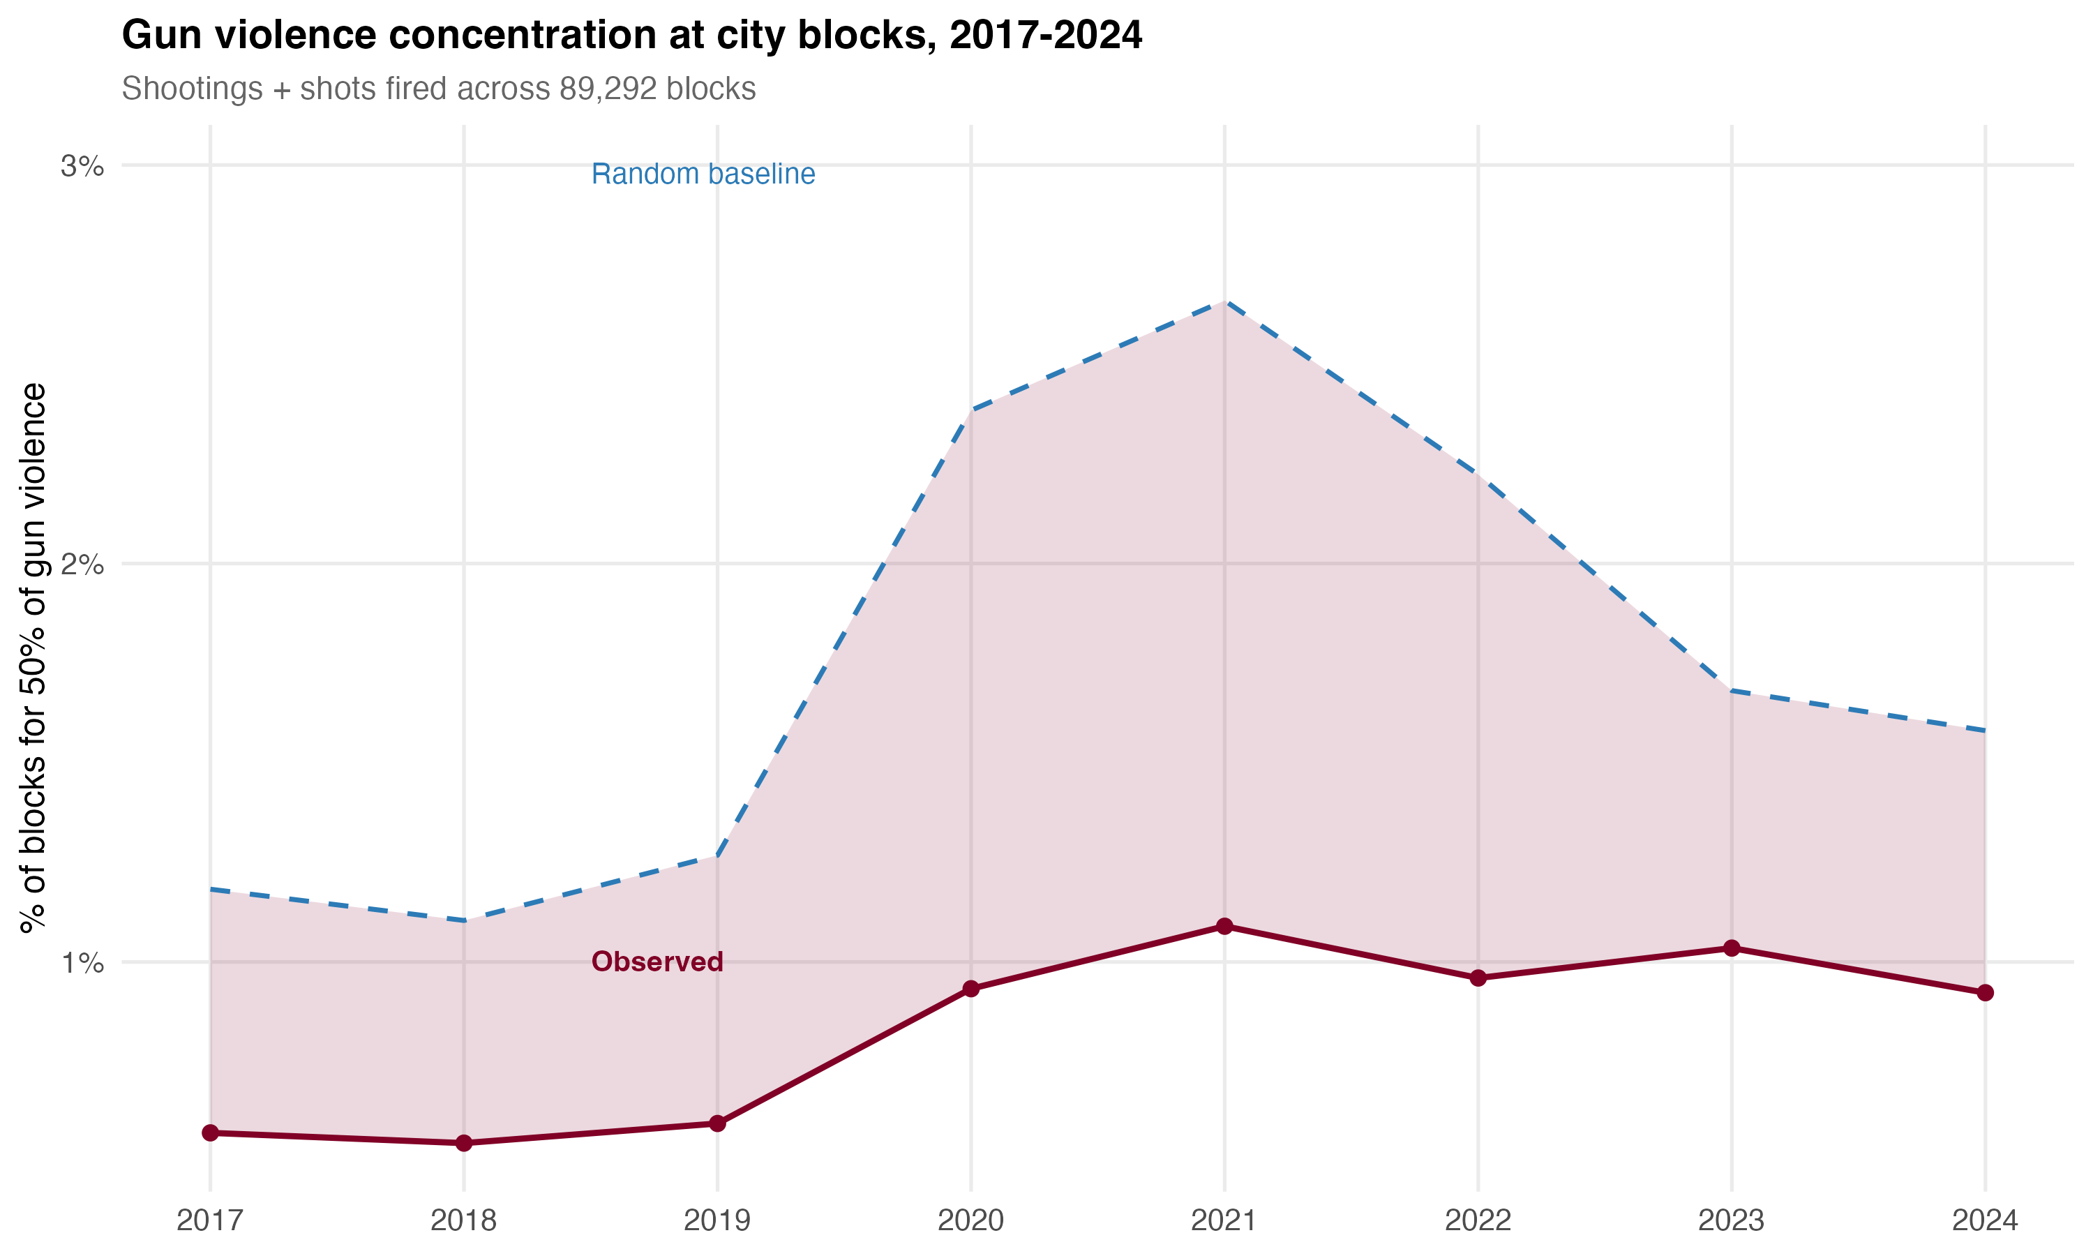
Figure 4. Gun violence concentration by year. Less than 1% of blocks account for half of all gun violence incidents in every year.
Less than 1% of blocks consistently account for half of all gun violence. The pattern is stable across years, including through the 2020–2021 surge and subsequent decline. The shaded area between the observed and random baseline represents the real spatial signal, which remains consistent.

Comparing Crime Types
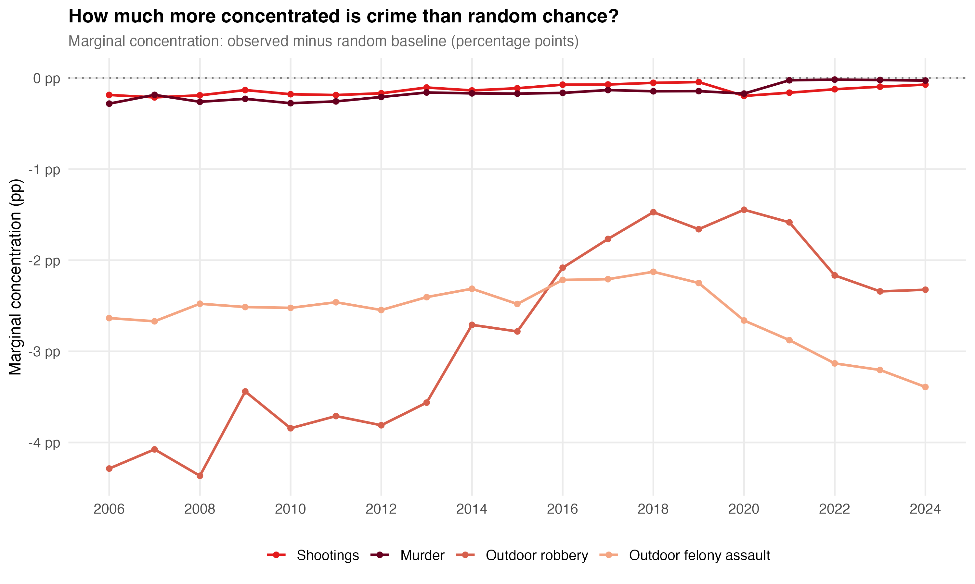
Figure 5. Marginal concentration (real signal above random chance) by crime type and year. More negative = more concentrated beyond what chance predicts.
This figure shows the marginal concentration — the real signal above random chance — for each crime type over time.
- Outdoor robbery and outdoor felony assault have the largest real concentration signals, consistently 2–4 percentage points more concentrated than chance.
- Shootings and murder have real but smaller marginal signals. With so few events spread across 89,000 blocks, random chance alone produces extreme apparent concentration.
- All four types show stable concentration over time. The spatial pattern persists year after year. This is not a snapshot — it is a structural feature of the city.

What This Means for Targeting Resources
- Crime concentrates at a small number of blocks. This is a genuine, stable pattern — not a statistical fluke. It has been confirmed in every city where it has been tested.
- The 50-X metric is the easiest way to communicate this. Less than 1% of blocks account for half of all gun violence. About 5–6% account for half of outdoor violent crime. These numbers are real and they are stable.
- But 50-X overstates the case for rare crimes. The MCC measure separates the real spatial signal from the mathematical artifact of sparse data. Use 50-X to communicate; use MCC to evaluate whether concentration reflects targetable patterns or arithmetic.
- Concentration is stable over time. The same blocks carry the burden year after year, even as crime rises and falls. Targeted interventions have a stable foundation — you are not chasing a moving target.
- Concentration varies by crime type. A block that concentrates shootings may not be the same block that concentrates robbery. Intervention strategies should be crime-specific, not one-size-fits-all.

Data: NYPD Complaint Data, NYPD Shooting Incidents, NYPD Shots Fired Reports. Analysis unit: 89,292 physical blocks (EPSG:2263).

