Crime Concentration at Micro-Places: What We Know, What We Measure, and What It Means

I. A Place to Stand
“Our more precise geographic concept of place can be defined as a fixed physical environment that can be seen completely and simultaneously, at least on its surface, by one’s naked eyes.” — Sherman, Gartin, & Buerger (1989)
A small share of places accounts for a large share of crime. In Minneapolis in 1986, 3% of addresses generated 50% of police calls — and crime was six times more concentrated by place than by individual offender (Sherman et al., 1989). In Seattle over 14 years, 4–5% of street segments produced roughly half of all crime incidents, year after year, even as the citywide total dropped by 24% (Weisburd et al., 2004). A systematic review of 47 studies reported a median of 4.5% of street segments for 50% of crime, with an interquartile range of 3.2–5.7% (Weisburd et al., 2024). The finding replicates across Vancouver, The Hague, Tel Aviv, Chicago, Boston, St. Louis, and a dozen more cities. It is one of the most cited empirical regularities in modern criminology.
It is also one of the most imprecisely understood. The concentration finding is real. The question is what it tells us — and what it does not.
For the Every Block Counts trial to work, three things must be true, and they come in order. First, crime must be persistent: a block that is dangerous this year must still be dangerous next year, or sending resources there is chasing yesterday’s pattern. Second, crime should be concentrated: a small number of blocks should carry a large share of harm. But concentration only matters if it lasts — a snapshot is not sufficient. Crime clustered at a few blocks in one period and scattered across different blocks in the next does not constitute a targetable pattern. What the intervention needs is persistent concentration — the same blocks, carrying the same burden, period after period. Third, crime must yield to the interventions employed. Persistence tells you where to go. Concentration tells you it is feasible. Amenability tells you it is worth going. If the mechanisms producing harm at a block do not respond to what officers and partners actually do there, the first two conditions identify a problem without providing a solution.
This chapter examines the first two conditions. It traces the history of the concentration idea, interrogates what standard metrics actually measure, presents null-adjusted concentration estimates for 18 crime types across NYC’s 89,292 physical blocks, and argues that the field’s most popular statistic — the 50-X metric — communicates an important point about the spatial distribution of crime but does not, on its own, measure concentration in any analytically useful sense. The chapter then shows that concentration is not a single phenomenon but a family of crime-type-specific patterns with distinct generating processes, and that aggregating them obscures more than it reveals. It closes by connecting these findings to the harm-weighted framework that Every Block Counts requires.

II. History of an Idea

The Prehistory: Frightful Regularity
The spatial study of crime is old. Adolphe Quetelet’s 1842 Treatise on Man is frequently cited as the origin of empirical criminology. Alongside André-Michel Guerry, Quetelet published some of the first maps of personal and property crime in France, showing that crime rates varied systematically across regions and were linked to ecological and social characteristics. His observation of “une régularité effrayante” — frightful regularity — captures the discovery that crime is not random but patterned, persistent, and predictable:
“There is a budget which we pay with frightful regularity — it is that of prisons, dungeons, and scaffolds. We might even predict annually how many individuals will stain their hands with the blood of their fellow men, how many will be forgers, how many will deal in poison.”
This was a radical claim. In an era when crime was understood principally as moral failing, Quetelet argued that it was regular enough to model statistically — determinism entering what had been the domain of sin and free will. His work established the intellectual foundation for everything that follows.
For the next century and a half, the unit of analysis remained coarse. Mayhew (1862) mapped London’s rookeries. Shaw and McKay (1942) demonstrated that delinquency rates in Chicago neighborhoods remained stable even as ethnic composition turned over entirely — social disorganization was a property of places, not people. But the “place” in question was still the neighborhood: hundreds or thousands of addresses treated as a single unit.

The Opportunity Turn
Three theoretical currents shifted attention from offender motivation to situational opportunity. Jane Jacobs (1961) argued in The Death and Life of Great American Cities that the physical design of streets and buildings shapes informal social control at a granularity far below the neighborhood. Busy sidewalks with mixed uses generate “eyes on the street” — natural surveillance that deters crime without formal enforcement. This was the first influential argument that micro-level physical features of places matter for crime, independent of who lives there.
Cohen and Felson (1979) proposed routine activities theory: crime requires the convergence in space and time of a motivated offender, a suitable target, and the absence of a capable guardian. The theory was originally macrosociological, but its spatial logic was immediately applicable to micro-places. If crime requires convergence, then the places where these elements reliably intersect should concentrate crime.
Brantingham and Brantingham (1993) introduced crime pattern theory — nodes, paths, and edges — explaining geometrically why crime clusters at predictable locations: transit hubs, commercial corridors, the boundaries between land uses. Clarke (1995) gave the framework practical substance with situational crime prevention, demonstrating that modifying the immediate environment could reduce offending at specific locations with minimal displacement.
These streams converged on a common departure from the neighbourhood tradition. A single neighbourhood could contain blocks with dozens of annual incidents alongside blocks with none. The insight that drove the micro-place turn was that the neighbourhood average conceals this heterogeneity, and that the heterogeneity itself is where the explanatory action lies.

The Empirical Breakthrough
Sherman, Gartin, and Buerger (1989) delivered the empirical demonstration. Analysing 323,000 calls for service in Minneapolis, they showed that crime was not merely concentrated — it was more concentrated by place than by person. Sherman proposed that places have “criminal careers” with onset, persistence, and desistance, and that place-focused interventions are more tractable than offender-level strategies because places are stationary and experimentally manipulable.
Sherman also did something that the field would largely overlook for the next quarter century. He included a Poisson model benchmark — a comparison of the observed concentration of 911 calls against their expected distribution under randomness. He recognised that when the number of places vastly exceeds the number of crimes, high apparent concentration is “mathematically inevitable.” The caution was prescient, and it went substantially unheeded.

Formalisation as a “Law”
Weisburd, Bushway, Lum, and Yang (2004) conducted the foundational longitudinal study: 29,849 street segments in Seattle over 14 years. The central result was stability — 84% of segments maintained consistent crime levels, and the citywide crime drop was driven by a small group of declining micro-places rather than a generalised reduction. Weisburd (2015), in his Sutherland Address, formalised the finding as the “law of crime concentration at places”: for a defined measure of crime at a specific micro-geographic unit, the concentration of crime will fall within a narrow bandwidth of percentages.
The word “law” was deliberately chosen. Weisburd meant to signal an empirical regularity robust enough to guide both theory and policy. The subsequent replication wave — Vancouver (Curman et al., 2015), Albany (Wheeler et al., 2016), six U.S. cities (Walter et al., 2023), eight cities on common metrics (Spencer & Schnell, 2022), 47 studies in systematic review (Weisburd et al., 2024) — confirmed the core pattern. It also raised complications that the law’s parsimonious framing did not fully anticipate.

III. What the Standard Metric Actually Measures

The 50-X Metric
The most common formulation of crime concentration is the 50-X: what percentage of places accounts for 50% of crime? Weisburd (2015) used it to define the law — 4–6% of street segments. Weisburd et al. (2024) used it in their systematic review (median 4.5%, IQR 3.2–5.7%). It has become the field’s common currency.
The 50-X has genuine virtues. It is simple, intuitive, and translates directly into a policy-relevant statement: this is how much of the city you need to target to reach half the crime. It conveys a real and important point about urban life — crime is sparse. On the vast majority of blocks in any city, serious crime does not occur in any given year. Whether the distribution is random or structured, the metric communicates that most places are safe most of the time.
What the 50-X does not do, however, is distinguish between genuine spatial concentration and the mechanical concentration that arises from sparse data. The metric’s rhetorical power and its analytical limitations are not in tension — they are simply different properties.

The Sparse-Data Problem
The fundamental issue is arithmetic. When the number of spatial units far exceeds the number of crime events — the default condition for every serious crime type — standard concentration metrics mechanically produce concentrated distributions. NYC has 89,292 physical blocks and roughly 300 annual homicides. Even under a perfectly random allocation of murders to blocks, the vast majority of blocks will have zero murders, a handful will have one, and the resulting distribution will appear concentrated. This apparent concentration is a mathematical consequence of the places-to-crimes ratio, not evidence of a spatial process.
Sherman recognised this in 1989. The formal methodological response came considerably later.
Chalfin, Kaplan, and Cuellar (2021) proposed a randomisation-based counterfactual — the concentration that would be expected if crimes were distributed uniformly at random — and defined marginal crime concentration as the difference between the observed value and this null. The marginal captures the genuine spatial signal after removing the sparse-data artifact. For common crimes, the correction is modest and observed concentration is largely substantive. For rare crimes, the correction is substantial.
Bernasco and Steenbeek (2017) arrived at a convergent conclusion through a different route: standard Gini coefficients are biased upward when places outnumber events. Mohler et al. (2019) demonstrated the bias parametrically using Poisson-Gamma estimation. The common finding across these approaches is that the field’s signature metric overstates concentration for rare crime types by an amount that depends on the ratio of places to incidents.

What Our Data Show
We computed the analytical Poisson null concentration for NYC’s 89,292 physical blocks across the full range of possible crime volumes. The result is a curve that maps, for any given number of incidents, how concentrated a purely random distribution would appear.
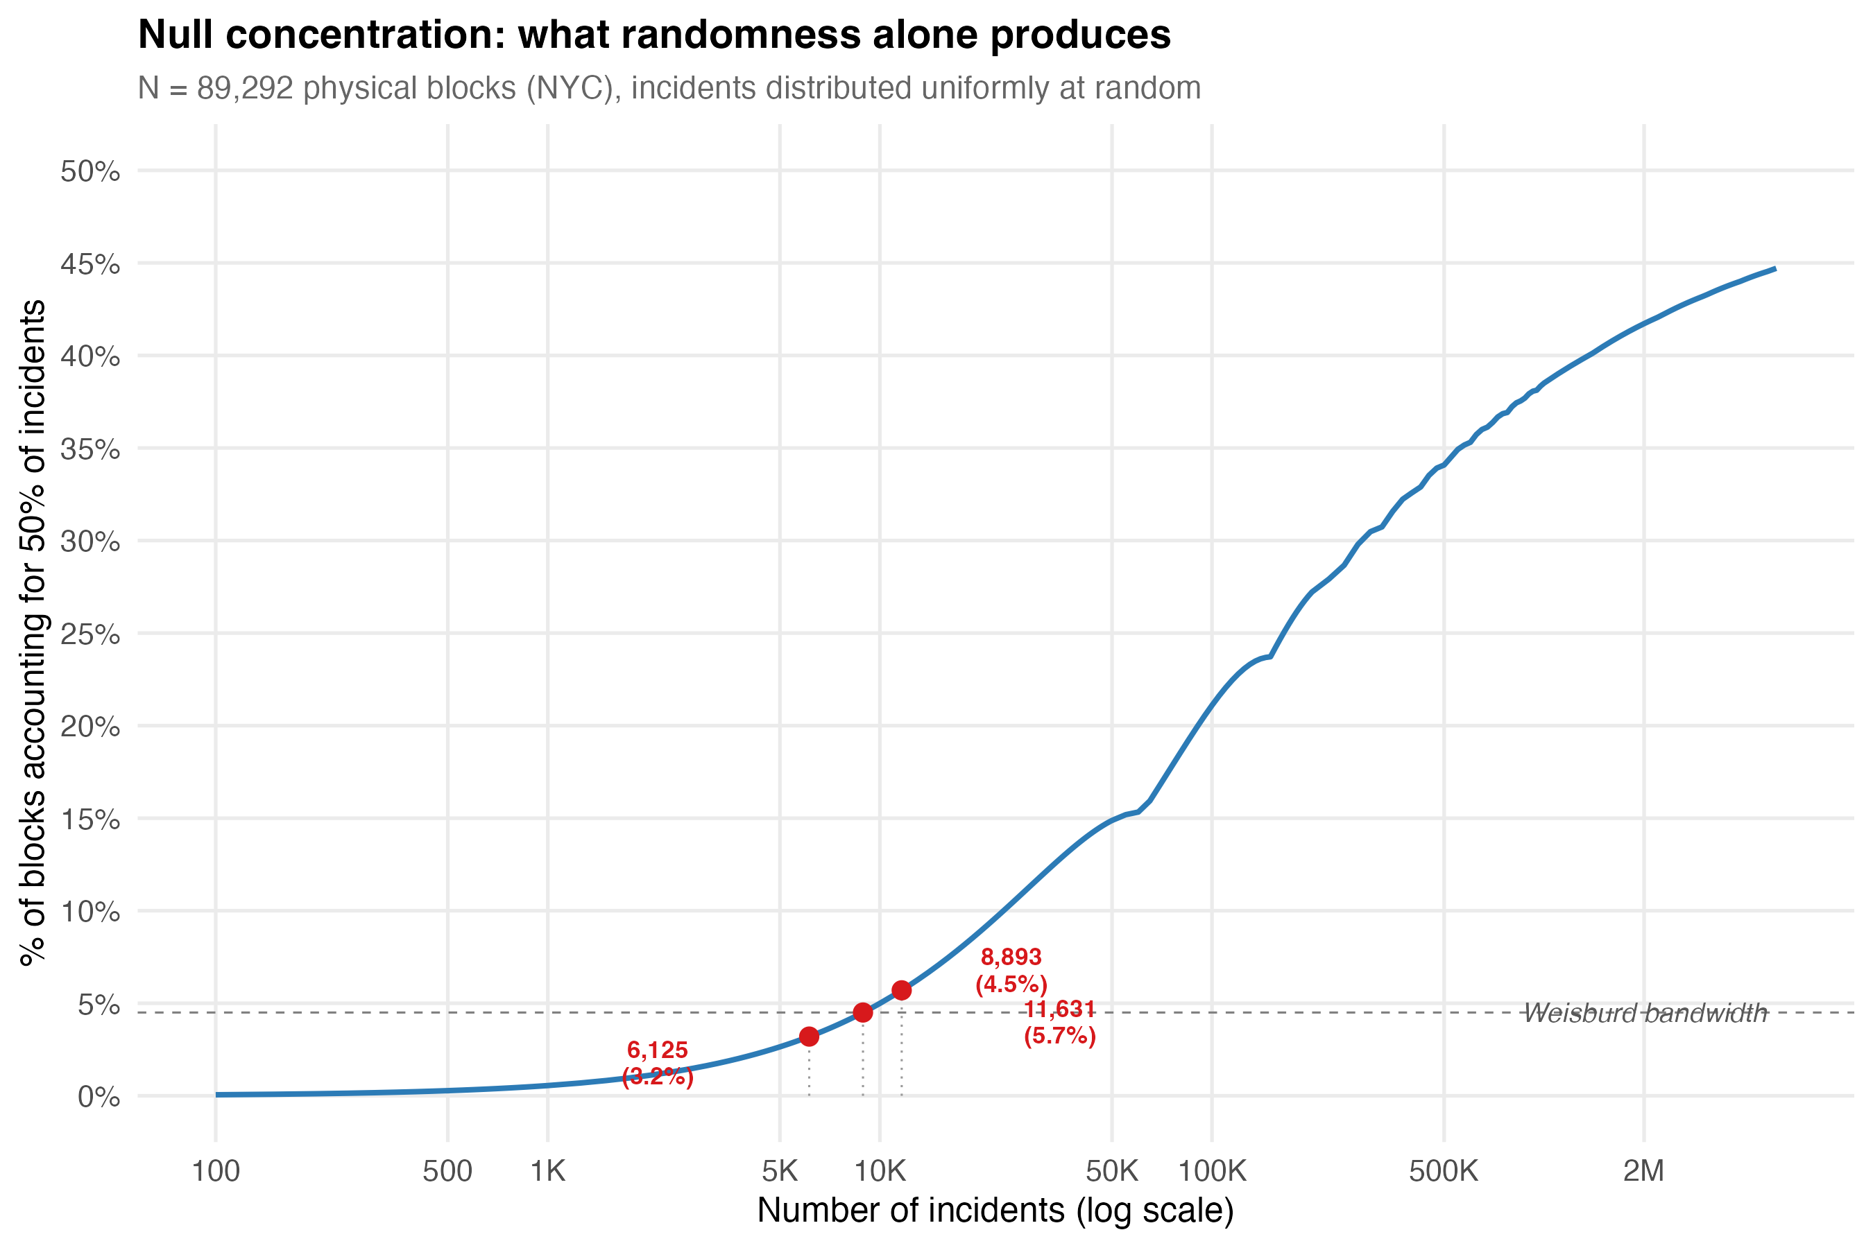
Null concentration curve for NYC’s 89,292 physical blocks with Weisburd bandwidth shading.
The curve establishes a threshold: any crime type producing fewer than approximately 6,000–12,000 incidents citywide will fall within the Weisburd bandwidth (3.2–5.7%) under pure randomness. For homicides (~8,200 incidents over 20 years, ~400/year), transit pickpocketing (~6,200), and several other categories, the conventional 50-X conveys little information about genuine spatial processes. The number lands inside the “law” range even under a uniformly random allocation.
We applied the Chalfin framework to 18 specific crime types, spanning the full volume spectrum from grand larceny (880,000 incidents) to transit pickpocketing (6,200):
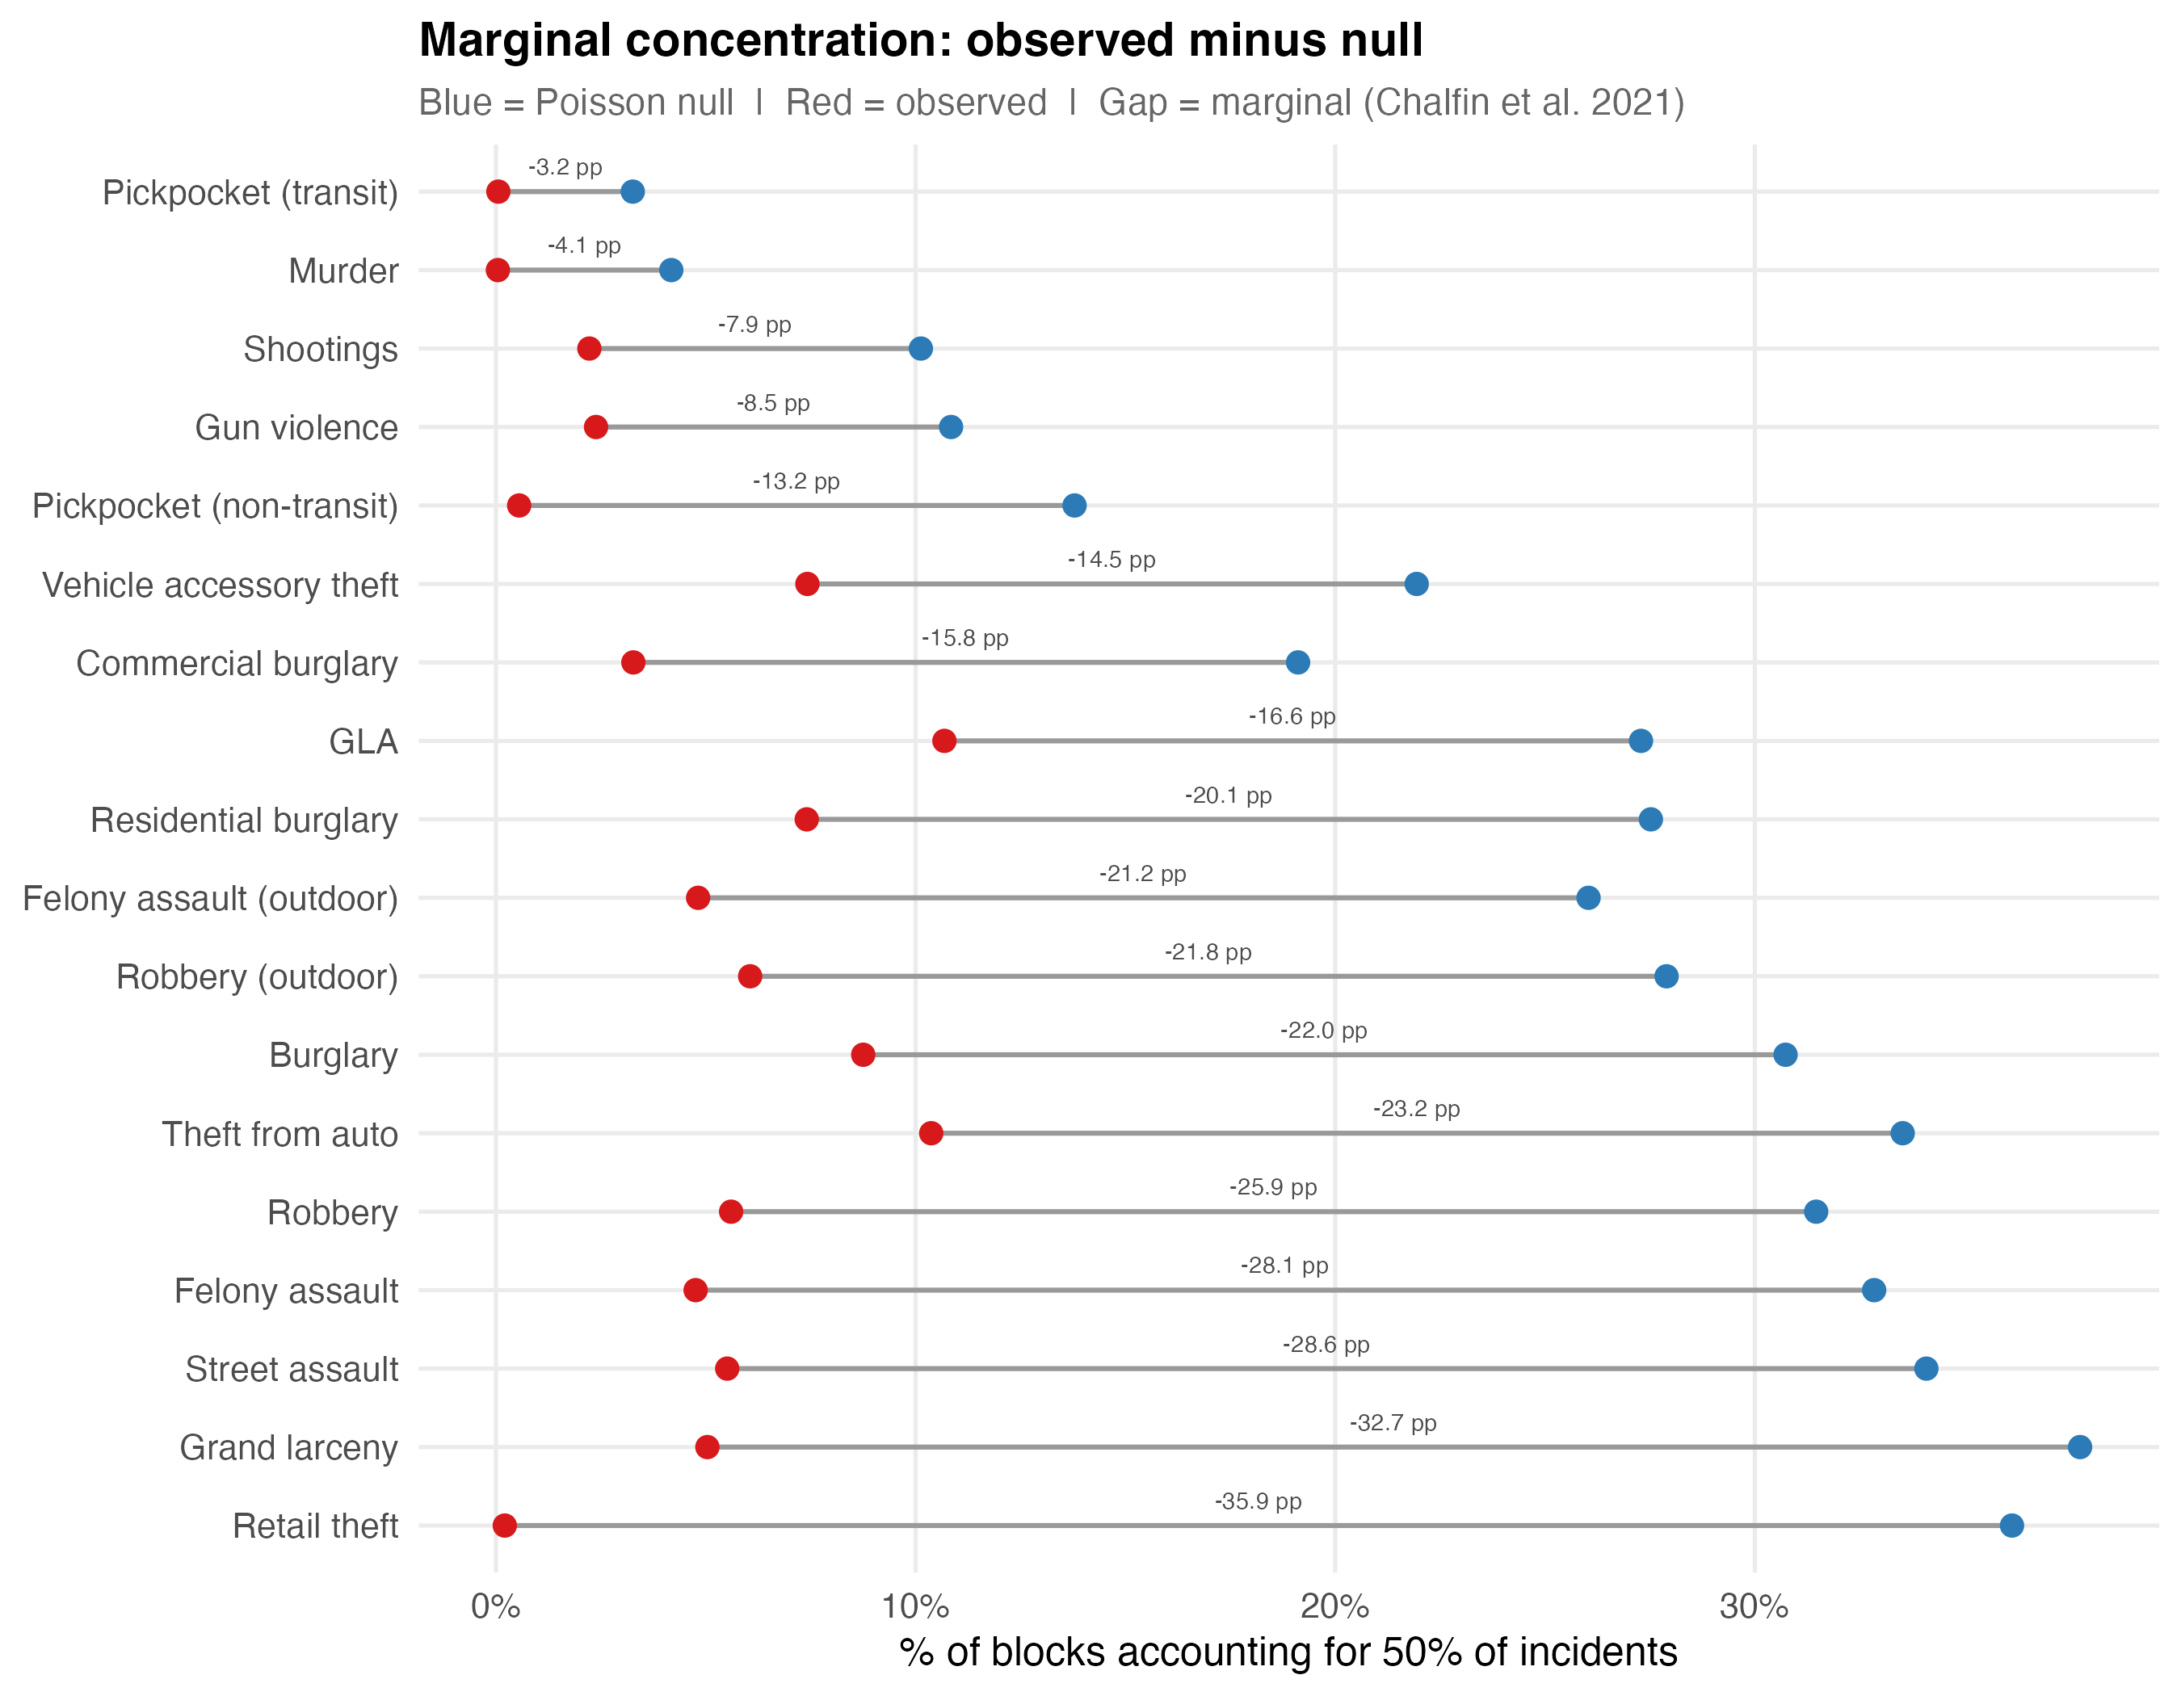
Marginal concentration dotplot for 18 crime types on NYC’s 89,292 physical blocks.
The hierarchy that emerges differs from the one the conventional metric produces. Under the standard 50-X, murder appears to be the most concentrated crime type (0.05% of blocks). Under the marginal framework, murder has the weakest genuine concentration — a marginal of only -4.13 percentage points — because nearly all its apparent concentration is artifact. Retail theft, by contrast, shows the strongest genuine concentration: a marginal of -35.92 pp, meaning that observed concentration exceeds the random baseline by 36 percentage points. The marginal framework does not merely adjust the values. It reorders the ranking.
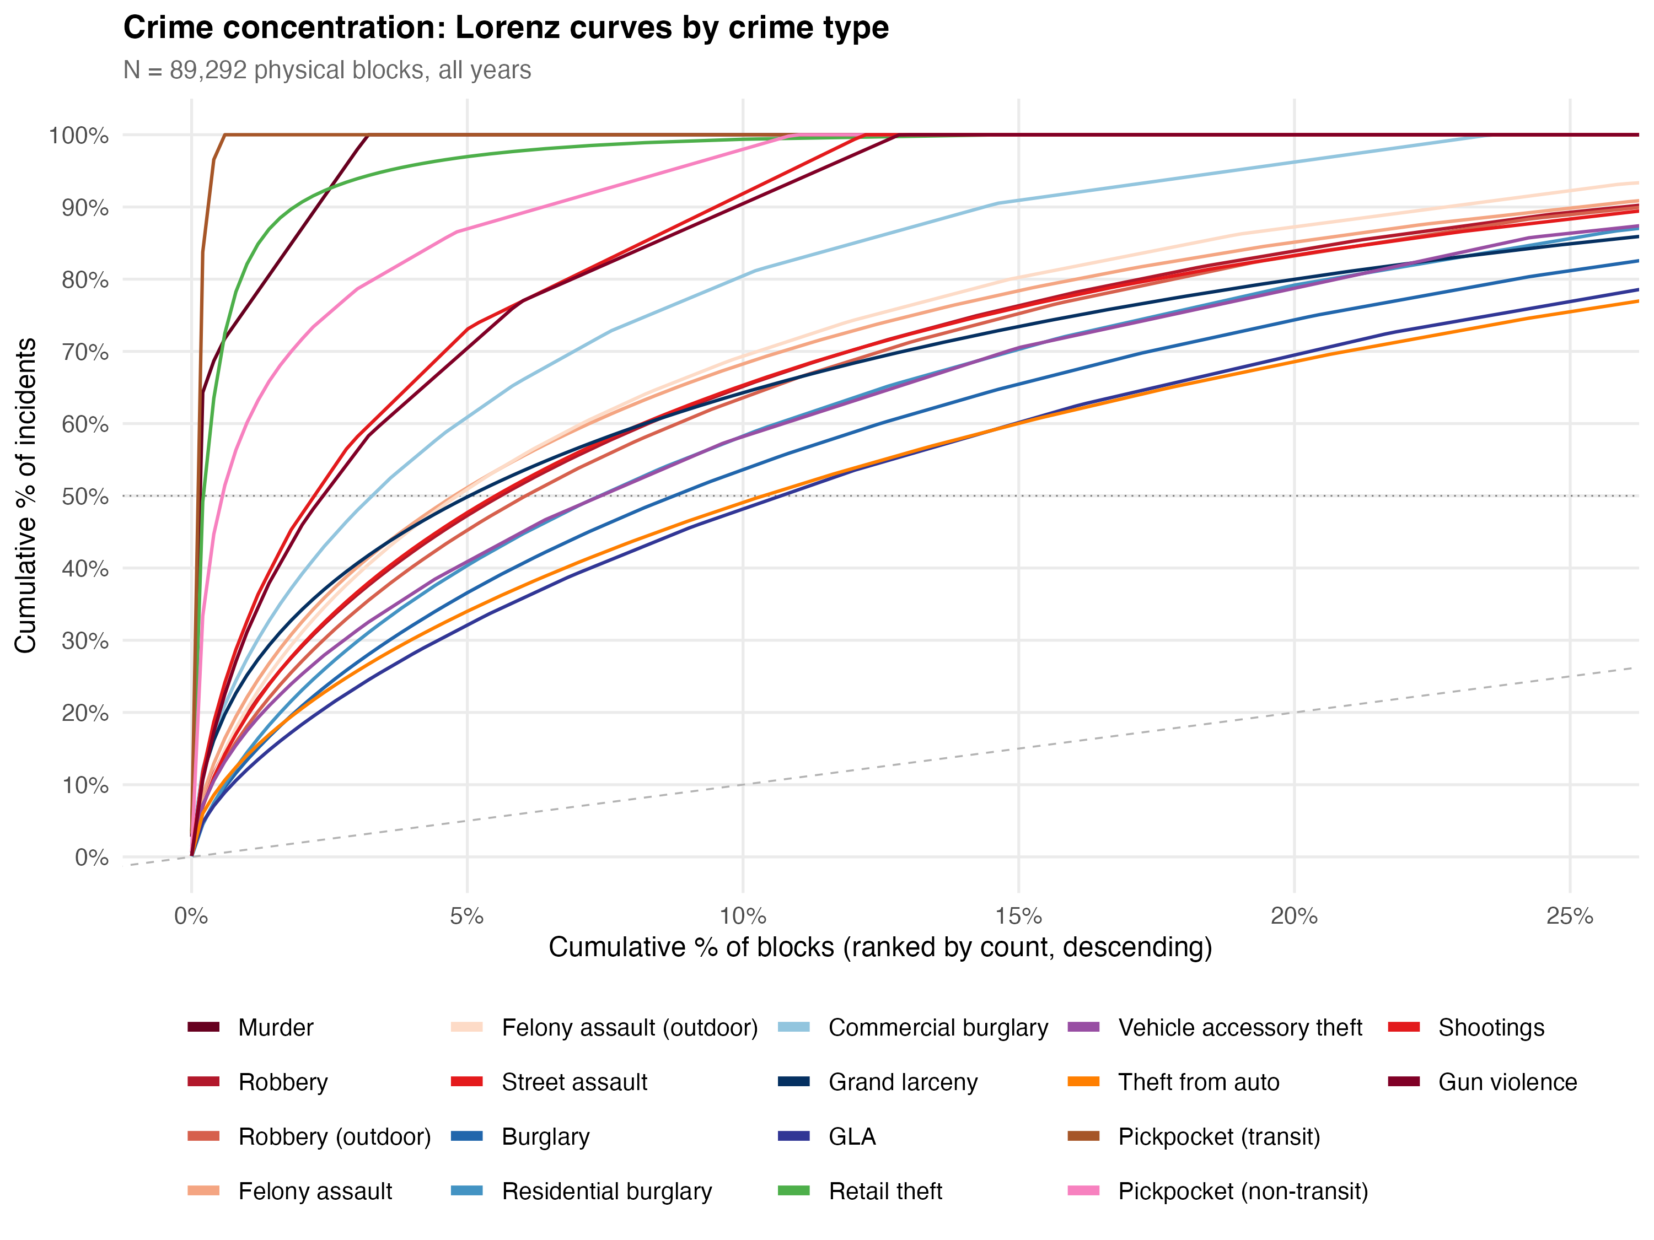
Lorenz curves for selected crime types against the Poisson null.
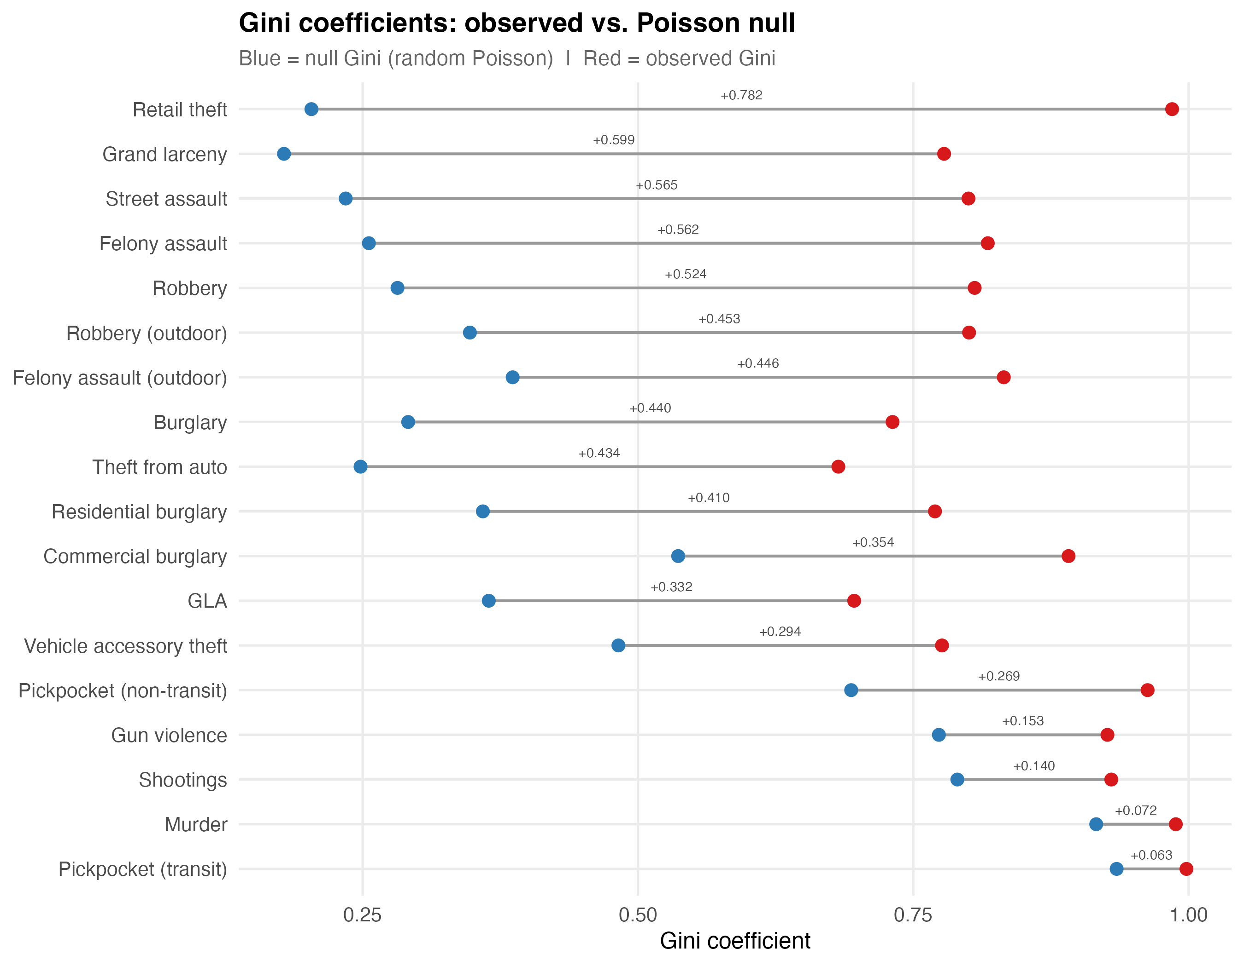
Gini coefficient comparison: observed vs. null across crime types.
The Gini comparison illustrates the point. Observed Gini coefficients exceed 0.95 for nearly every crime type — they all appear concentrated. But the null Gini is also extremely high for sparse types. The marginal Gini — the gap between observed and null — ranges from +0.781 (retail theft) to +0.072 (murder). That is a ten-fold range in genuine concentration, invisible under standard metrics.

The Bandwidth Is Not Narrow
Considerable attention has been devoted to establishing a narrow bandwidth for crime concentration. The Weisburd systematic review reports an IQR of 3.2–5.7%. But this tightness is partly a product of several forces that compress the number:
Sparse data. For rare crimes, the 50-X falls inside the bandwidth regardless of the spatial distribution, because randomness alone produces those values. Including rare crime types in cross-study comparisons tightens the bandwidth mechanically.
Aggregation. Most studies use aggregate crime indices — total Part 1 offenses, “all crime,” broad categories like “violent crime.” Aggregating crime types with imperfectly correlated spatial distributions compresses concentration metrics toward a narrow range through portfolio diversification, volume dominance, and zero-inflation reduction. A place that is a hotspot for robbery but not burglary will appear less concentrated in a combined index than in either type alone.
Metric choice. Andresen and Weisburd (2025) showed that some of the apparent disagreement about the bandwidth is attributable to metric selection. The inverted 5-X metric (Hipp & Kim, 2017) produces wider bandwidths; converting all estimates to the 50-X form restores narrower ranges. But this is a statement about the metric, not about the phenomenon.
Our NYC data demonstrate that within a single city, the 50-X for specific crime types ranges from 0.05% (murder) to 10.4% (felony assault) — a 200-fold range. The tightness of the canonical bandwidth reflects the way the calculation is set up — the aggregation, the metric, the inclusion of sparse types — more than it reflects a stable property of how crime distributes in cities.

IV. Why Concentration Is Overdetermined
Even after correcting for sparse data, the genuine spatial signal in crime concentration may be less distinctively about crime than the field has generally assumed.

The Eck Challenge
Eck, Lee, O, and Martinez (2017) posed the most consequential question in the concentration literature: compared to what? They showed that crime concentrates at roughly the same level as hospital visits, traffic accidents, code violations, and many other spatial phenomena. The J-curve distribution that characterises crime concentration is common across spatial data generally. If concentration is a generic property of spatially distributed count variables, then the policy implications require re-examination. The argument for hot spots policing rests partly on the claim that crime is unusually concentrated — that a small investment in targeted patrol captures a disproportionate share of the problem. If many urban phenomena concentrate similarly, the distinctiveness of the criminological finding is less clear.

Network Topology
Space syntax research (Hillier et al., 1993; Hillier & Sahbaz, 2008) demonstrates that the configuration of the urban grid is itself a primary generator of pedestrian flow patterns. Some streets are topologically more integrated — requiring fewer direction changes to reach all other streets — and these streets attract disproportionate movement purely as a function of network structure. Davies and Johnson (2015) showed that betweenness centrality is a significant predictor of burglary risk at the street-segment level, controlling for socio-demographic factors. Summers and Johnson (2017) found comparable results for outdoor serious violence in London.
For NYC’s physical blocks, this is directly relevant. The grid varies considerably in integration values — from through-blocks in Midtown Manhattan to dead-end residential streets in eastern Queens. That topological variation alone would produce concentration of any activity correlated with pedestrian flow.

Urban Scaling Laws
Bettencourt et al. (2007) showed that social outputs — wages, patents, GDP, and explicitly crime — scale superlinearly with city population (exponent ~1.15). Bettencourt (2013) derived this theoretically: cities function as social reactors where interaction density increases faster than population. The prediction is that all social outputs concentrate at high-density, high-connectivity places. Crime concentration becomes a corollary of a general scaling relationship between social interaction and spatial density.
Oliveira (2021) extended the analysis across 12 countries, showing that theft scales superlinearly with population while burglary scales roughly linearly — crime-type-specific scaling that parallels the crime-type-specific concentration patterns in our micro-place data.

Multiplicative Processes
Clauset, Shalizi, and Newman (2009) showed that power-law distributions appear across an enormous range of phenomena. Mitzenmacher (2004) demonstrated that multiplicative processes — where a quantity grows by random proportional increments — produce lognormal distributions nearly indistinguishable from power laws in empirical data. Crime accumulation at a block is plausibly multiplicative: each additional commercial establishment or transit connection multiplies opportunity rather than adding to it linearly. The resulting distribution would appear concentrated regardless of any spatial clustering mechanism.
Phillips (2022) formalised the implication as equifinality: the same distributional outcome can be produced by multiple distinct generative processes. A power-law concentration pattern is consistent with routine activities, social disorganisation, network centrality, and pure stochastic accumulation simultaneously. The distribution alone cannot identify the mechanism.

Synthesis
Crime concentration at micro-places is overdetermined. It would emerge from:
- The occupancy problem — when crimes are rare relative to places, standard metrics mechanically inflate concentration.
- Network topology — streets with higher integration attract disproportionate flow, and therefore crime, as a property of the street graph.
- Superlinear scaling — all social outputs concentrate at high-density places as a mathematical consequence of urban interaction dynamics.
- Multiplicative accumulation — any quantity that grows proportionally produces heavy-tailed distributions.
- Economic agglomeration — commercial activity self-reinforces at specific locations, and crime opportunity follows.
The marginal concentration framework strips away (1). But (2) through (5) remain as non-criminological explanations that the field has not systematically engaged with. The concentration finding carries considerable theoretical and policy weight. Whether it tells us something specific about crime, or something general about the spatial distribution of human activity in cities, is a question the existing literature has not resolved.

V. Crime Types Are Not the Same Phenomenon

The Aggregation Problem
The most consequential measurement issue after sparse data is that “crime” is not a natural kind. It is an administrative and legal category that bundles together behaviours with nothing in common except that the state has decided to prohibit them. Robbery is driven by economic desperation and opportunity structure. Domestic assault is driven by relationship dynamics and substance use. Auto theft is driven by resale markets and anti-theft technology. A “crime rate” that sums them is a number that no single intervention can move coherently.
This has immediate analytical consequences. A policy might reduce one component and leave others untouched; the aggregate barely moves. Two countervailing shifts can cancel out, and the index reads “stable” while the underlying reality has changed in opposite directions. The revision dynamics in NYC’s monthly crime statistics illustrate the problem: transit crime revisions run at ~11% while the overall revision rate looks modest, because the aggregate smooths over the one category where reporting is least settled.
The formal treatment comes from econometrics. Theil (1954) showed that when you aggregate structural equations with different functional forms and different explanatory variables, the aggregate coefficients are not averages of the micro-coefficients — they can be unrelated to any of them. Arrow’s (1951) impossibility theorem demonstrates an analogous principle for preference aggregation: coherent individual rankings do not necessarily produce a coherent collective ranking. In epidemiology, the point is sufficiently well understood that the field does not attempt to model “total disease” as though cancer, influenza, and diabetes were a single phenomenon. Criminology, by contrast, routinely treats “total crime” or “index crime” as a meaningful dependent variable and attempts to explain it with a single model.

What Our Data Show About Type-Specific Concentration
The 18 crime types in our NYC analysis produce substantially different concentration profiles:
Crime Type | Incidents | Observed 50-X | Null 50-X | Marginal (pp) | Marginal Gini
Retail theft | 675,073 | 0.21% | 36.13% | -35.92 | +0.781
Grand larceny | 880,025 | 5.04% | 37.75% | -32.71 | +0.626
Felony assault | 399,783 | 4.76% | 33.22% | -28.46 | +0.570
Robbery | 229,614 | 5.60% | 29.51% | -23.91 | +0.489
Outdoor robbery | 150,854 | 3.41% | 26.09% | -22.68 | +0.468
Shootings | 17,393 | 1.32% | 8.37% | -7.05 | +0.153
Murder | 8,192 | 0.05% | 4.18% | -4.13 | +0.072
Transit pickpocket | 6,251 | 0.06% | 3.20% | -3.14 | +0.057
The range is considerable. Retail theft is 9 times more genuinely concentrated than shootings and 10 times more than murder. Under the conventional metric, murder appears the most concentrated crime type (0.05% of blocks). Under the marginal framework, it is among the least concentrated. The marginal framework does not simply adjust the values; it inverts the ranking.
The Lorenz curves make the mechanism clear. For high-volume types like retail theft, the observed curve separates substantially from the null — a wide gap representing genuine spatial process. For murder, the observed and null curves nearly overlap. The gap is real but narrow: most of what appears as concentration reflects the occupancy problem.

Overlapping Opportunity Structures
Environmental criminologists (Brantingham & Brantingham, 1993; Andresen et al., 2017) have long argued that different crimes require different opportunity structures. Commercial burglaries cluster in retail corridors. Aggravated assaults cluster around entertainment districts. Auto thefts cluster near commuter parking lots. When these are combined into “total crime,” the geographic centre of a city — which naturally contains retail, entertainment, and parking — appears as a single massive hot spot. The impression is of a universal “criminogenic” quality attaching to those street segments. In practice, the map is overlaying entirely separate micro-environments.
Andresen et al. (2017) tested this directly in Vancouver, finding that while crime is always concentrated regardless of type, the types do not cluster in the same places. Our cross-type concordance analysis for NYC confirms partial but imperfect overlap:
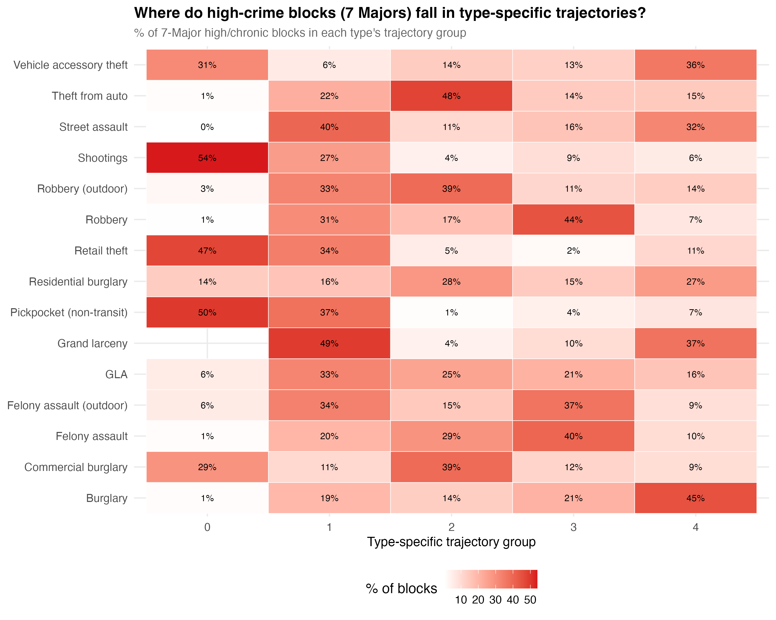
Cross-type concordance heatmap showing where blocks classified as high-crime for 7 Major Felonies fall in type-specific trajectory groups.
Of the 1,125 blocks in the chronic-high trajectory for 7 Major Felonies, 53% were also in the highest robbery group and 64% in the highest larceny group. But the correspondence is not one-to-one. The chronic hot spots are driven by a mix of crime types, and the mix varies from block to block.

The Portfolio Effect
When multiple crime types with imperfectly correlated spatial distributions are summed, concentration metrics compress toward a narrow bandwidth through several mechanisms:
Portfolio diversification. Combining spatially uncorrelated crime types reduces “concentration risk,” much as diversifying a financial portfolio reduces variance. A block that is a hotspot for robbery but not burglary will appear less concentrated in a combined index than in either type alone.
Volume dominance. High-count crime types dominate rare types in the aggregate. In NYC, grand larceny’s 880,000 incidents swamp homicide’s 8,200 in any aggregate that includes both. The aggregate concentration tracks the most common offence regardless of how other types distribute.
Zero-inflation reduction. Individual crime types have many zero-crime blocks. Summing types fills in zeros, pushing the distribution toward a less extreme shape.
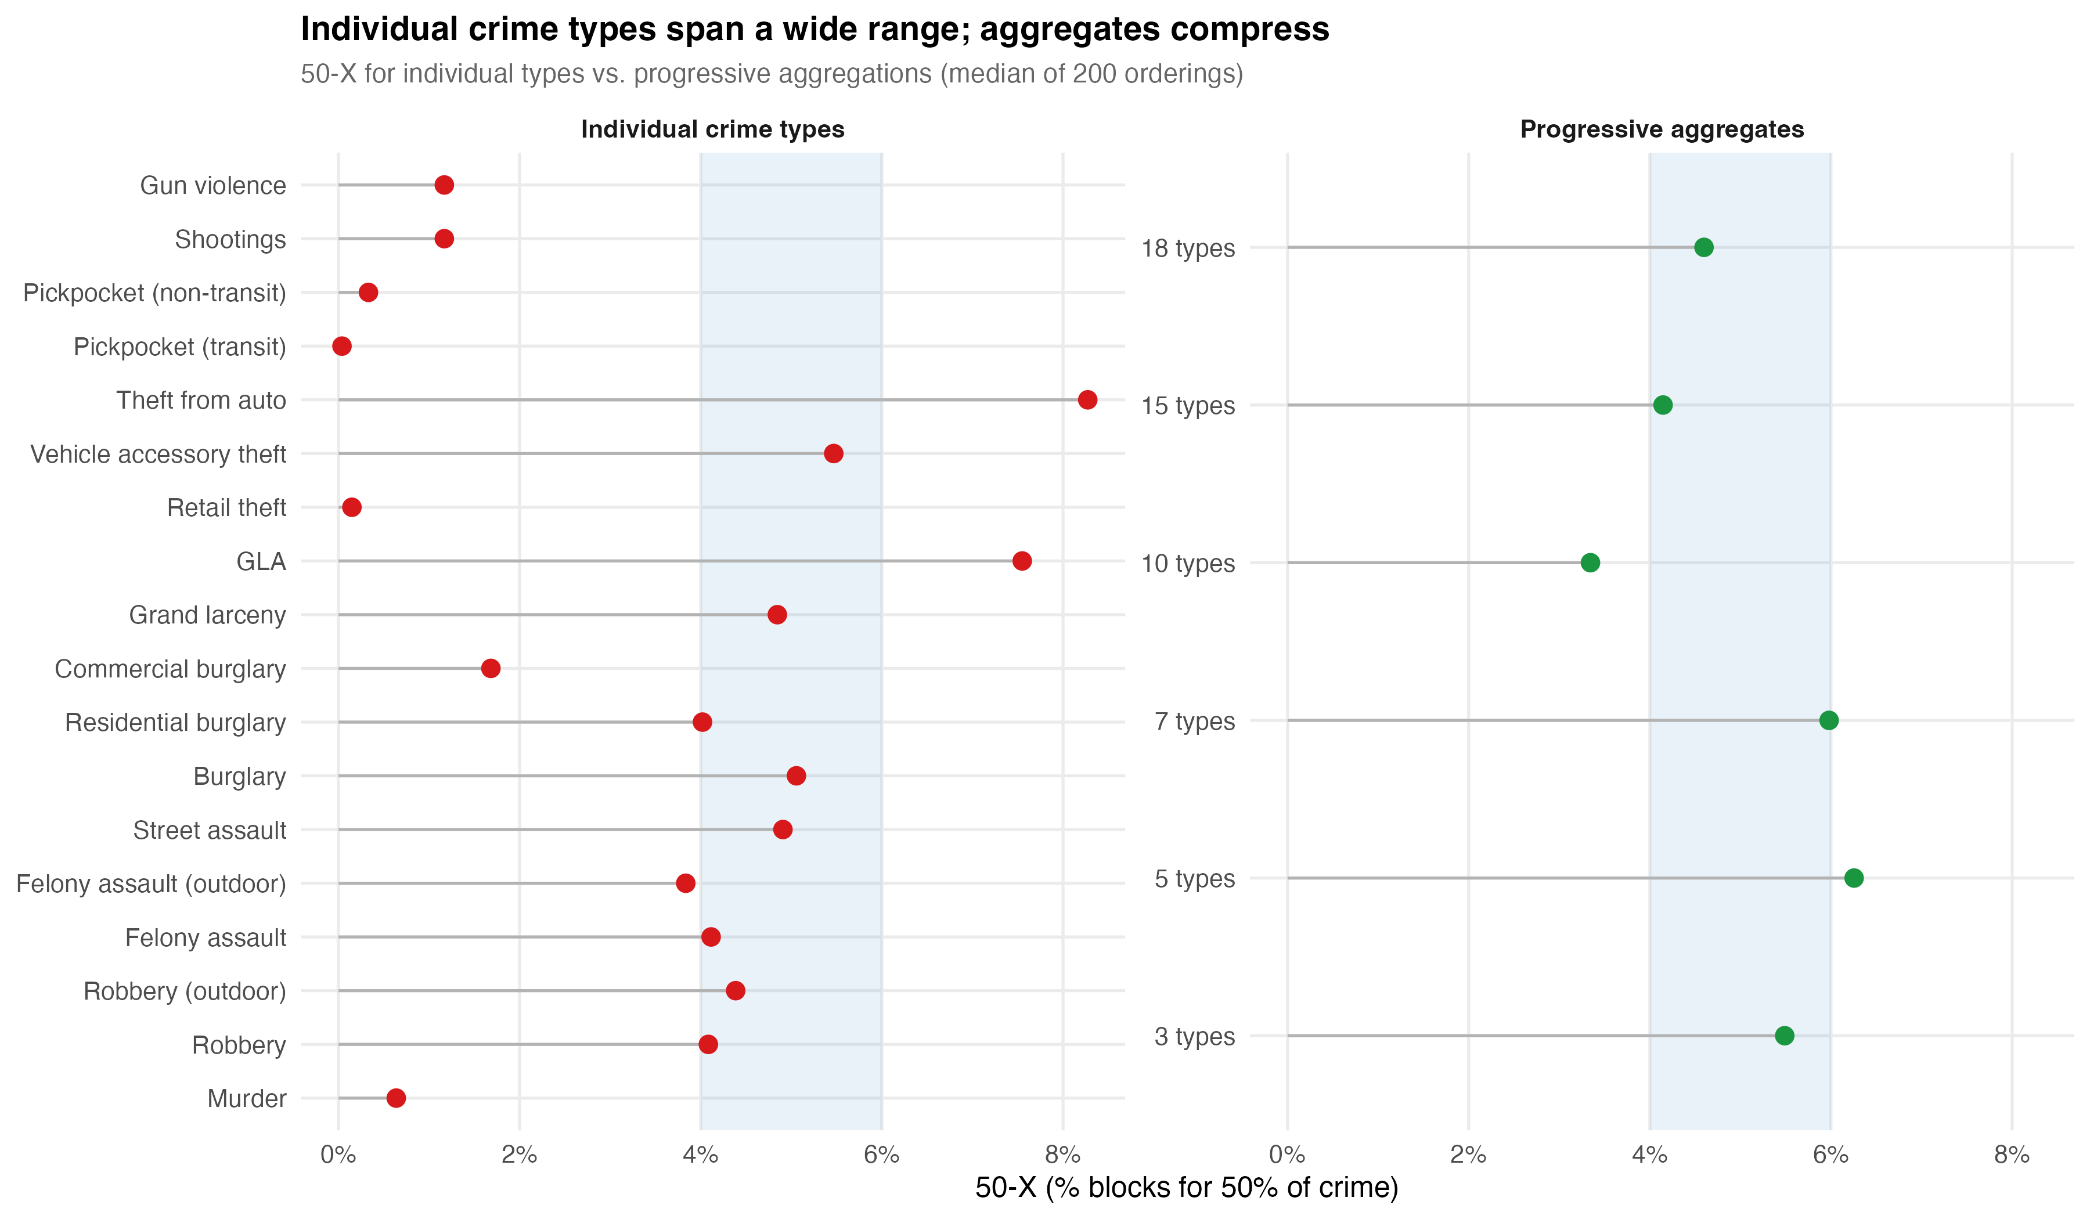
Individual vs. aggregate concentration: how combining crime types mechanically compresses the 50-X.
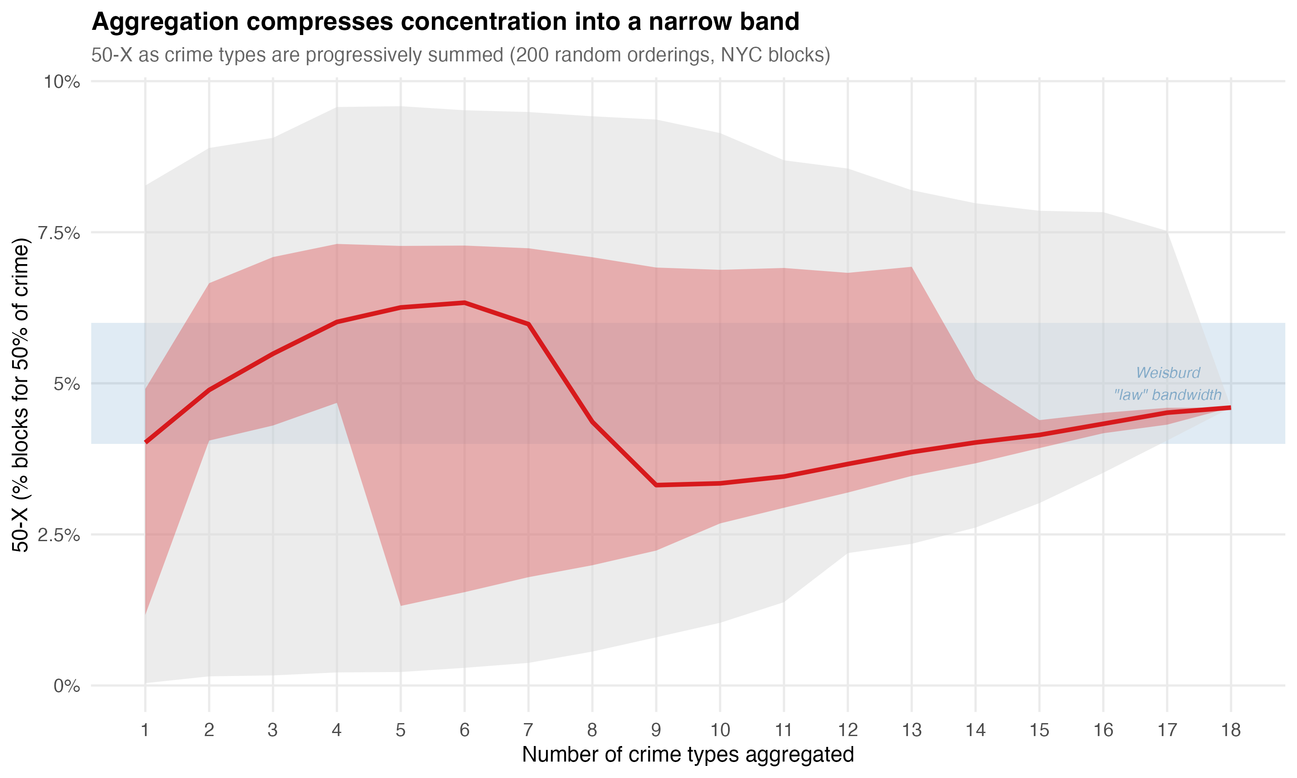
Convergence ribbon: how adding crime types converges the 50-X toward a narrow range.
The tight 4–6% bandwidth may be partly a property of aggregation — a mathematical attractor as much as a substantive spatial regularity. The bandwidth is tightest precisely when it aggregates the most.

Aggregation for Explanation vs. Aggregation for Allocation
The critique of aggregation requires a distinction. Aggregation is incoherent for explanation: you cannot build a causal model of “total crime” because there is no single generating process. But aggregation is practically necessary for allocation: a city budget must make tradeoffs between robbery prevention and domestic violence intervention, and some common metric — however imperfect — is preferable to treating every line item as incomparable.
Scott (1998) provides the relevant framework. In Seeing Like a State, he argues that the state must render complex social reality legible in order to act on it, and aggregation is one of the primary tools of legibility. The simplification is simultaneously necessary and dangerous — necessary because you cannot govern what you cannot summarise, dangerous because the summary can be mistaken for the reality. The position advanced here is not to reject legibility but to practise what might be called transparent legibility — aggregates that do not conceal what they are collapsing.
The practical implication is straightforward: the policy conversation should begin with “crime is up” but immediately ask which crimes, where, driven by what. The problem is not that a police department tracks total index crime. The problem arises when the aggregate becomes the endpoint of analysis rather than its starting point.
Epidemiology provides an instructive parallel. The DALY (disability-adjusted life year) aggregates across conditions — malaria, depression, road injuries — that have completely different aetiologies. No one treats “total DALYs” as representing a single phenomenon. But the framework is useful for resource allocation precisely because a health ministry must distribute a finite budget across incommensurable problems (Murray & Lopez, 1996). The aggregation is decisional, not scientific: it answers “where should attention go” rather than “what causes this.” The Cambridge Crime Harm Index (Sherman et al., 2016) operates on the same logic. The claim is not that weighted crime is a natural kind; the claim is that it provides a rational basis for prioritisation.

VI. Concentration Over Time and Space

Temporal Stability and Its Limits
The trajectory literature established that the majority of places maintain stable crime levels over time. In our analysis of 89,292 NYC physical blocks over 19 years (2006–2024):
- 68% of blocks followed stable trajectories — crime-free, low-stable, moderate-stable, or high-stable
- 22.4% of blocks (20,006) recorded zero 7 Major Felony incidents across the entire period
- 1.3% of blocks (1,125) were chronic-high, averaging over 20 felonies per year for nearly two decades and accounting for 20.7% of all major felony crime
- Combined, 13.9% of blocks produced 65.8% of all major felony crime over 19 years
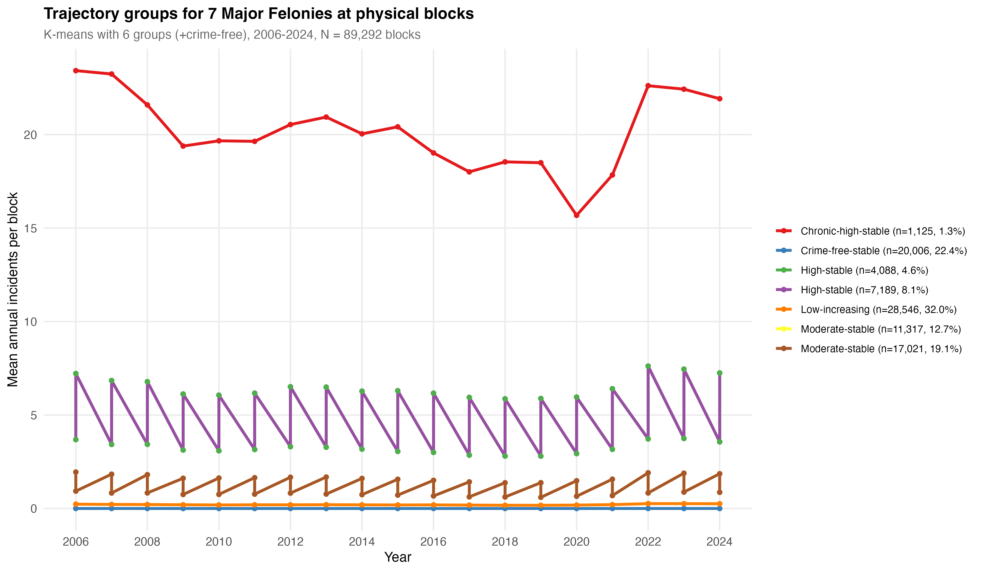
Trajectory groups for 7 Major Felonies, 2006-2024.
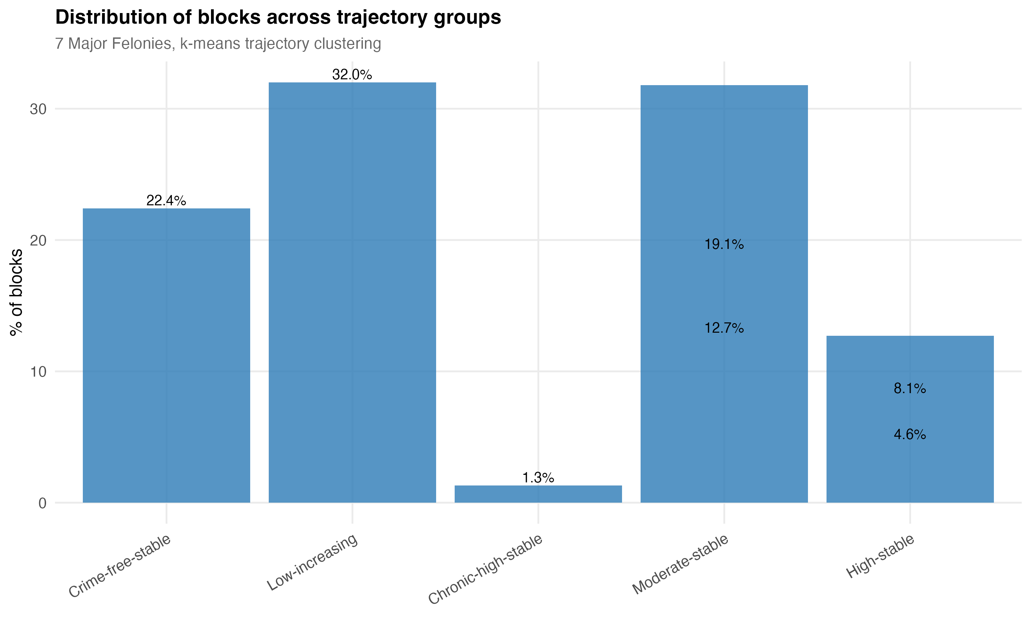
Distribution of blocks across trajectory groups.
These findings replicate the core results from Seattle (Weisburd et al., 2004), Vancouver (Curman et al., 2015), and Albany (Wheeler et al., 2016), though with a somewhat lower stability rate (68% vs. 70–84% in prior studies). The difference may reflect NYC’s larger scale and greater heterogeneity, or the longer observation window capturing more temporal variation.

Concentration Is Not Static
When we track marginal concentration over time for specific crime types, a more dynamic picture emerges:
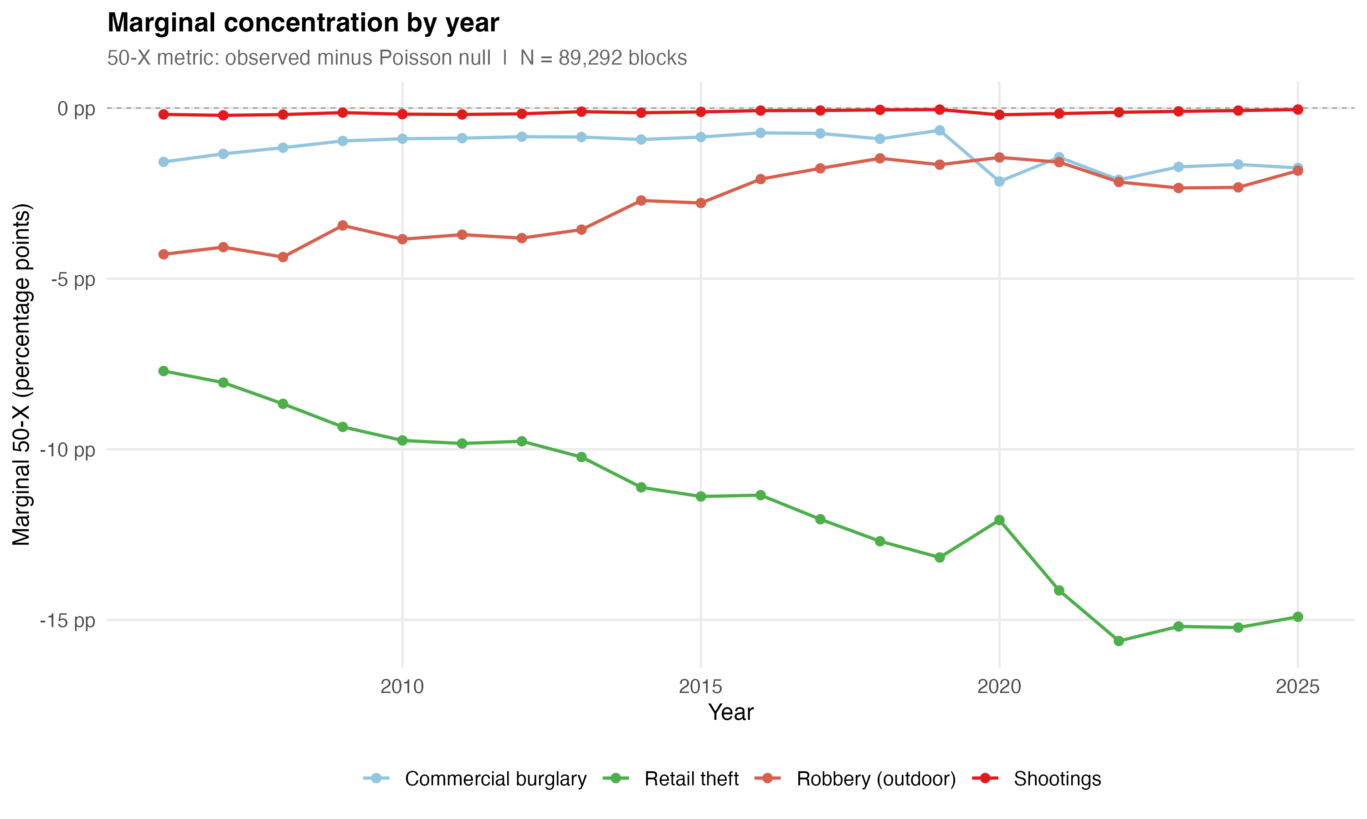
Marginal 50-X by year for selected crime types, 2006-2025.
Retail theft concentration has been increasing steadily: the marginal 50-X roughly doubled from -7.7 pp (2006) to -14.9 pp (2025), with the sharpest increase during 2020–2022 when volume surged from 32,000 to 64,000 incidents concentrating at the same commercial blocks. Robbery shows a different trajectory — stable but declining concentration (-4.3 pp in 2006 to -1.8 pp in 2025). Shootings show negligible marginal concentration in any single year, never exceeding -0.2 pp.
The bandwidth is not consistent across time or geography within a city. It moves with the data-generating process. This variation is not a failure of the concentration framework; it is informative. Concentration that is increasing for retail theft and declining for robbery reflects shifting opportunity structures. The law’s emphasis on a stable bandwidth treats this variation as noise when it is, in fact, signal.

Borough Heterogeneity
Citywide metrics average over geographically heterogeneous sub-areas. When we decompose marginal concentration by borough:
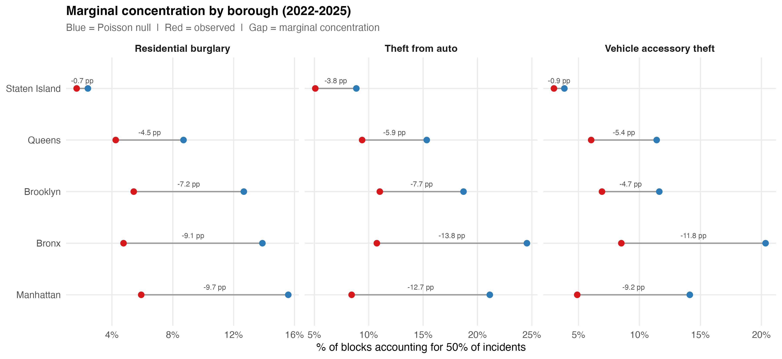
Marginal concentration by borough, 2022-2025.
Manhattan leads for retail theft (-39.47 pp marginal, driven by lambda=15.4 — the largest single value in the entire analysis). The Bronx leads for shootings (-3.33 pp). Queens and Staten Island show near-zero shooting marginals — their apparent concentration is almost entirely sparsity artifact. Transit pickpocketing is essentially a Manhattan phenomenon.
The citywide 50-X is a potentially misleading summary of these heterogeneous patterns. O’Brien et al. (2022) demonstrated an analogous result in Boston: two neighbourhoods with identical crime rates can have very different concentration profiles. Concentration is not a property of the city as a whole. It is a property of specific places within specific parts of the city, for specific crime types.

Spatial Heterogeneity Within Neighbourhoods
The micro-place thesis holds that crime varies dramatically within neighbourhoods — that blocks with very different crime profiles sit adjacent to one another. Our data confirm this:
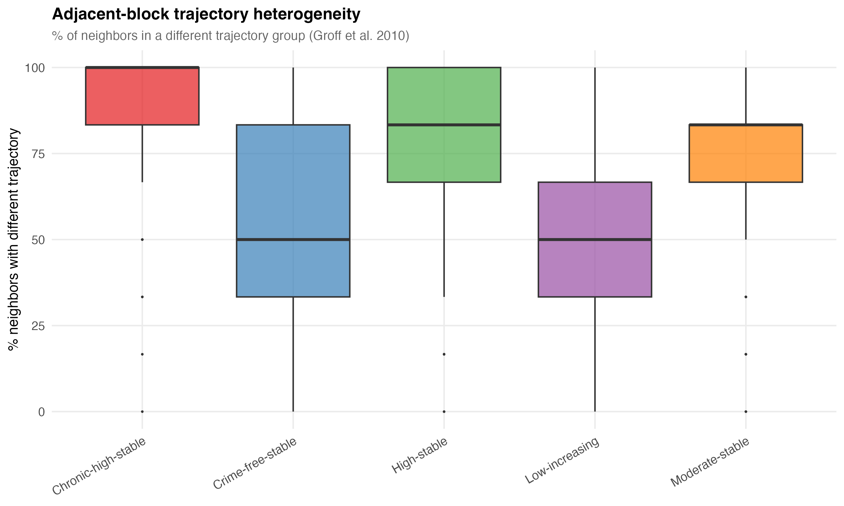
Neighbor trajectory heterogeneity by group.
On average, 62.7% of a block’s six nearest neighbours were in a different trajectory group. For blocks in the chronic-high group, 77.7% of neighbours followed a different trajectory. Even the most consistently high-crime blocks in the city are typically surrounded by blocks with substantially different crime profiles.
Local Moran’s I analysis found only 15,524 blocks (17.4%) in statistically significant spatial clusters. The remaining 82.6% are not spatially clustered with like-trajectory neighbours. At this spatial scale, heterogeneity dominates over homogeneity.

VII. The Social Construction of the Measured Phenomenon
A deeper issue sits beneath the measurement debates. Crime concentration measures the concentration of recorded criminal incidents — a phenomenon that is socially constructed at every stage.
What counts as a crime is a legislative choice. What gets reported depends on victim behaviour, cultural norms, and technological access. What gets recorded depends on police discretion, organisational incentives, and data infrastructure. What gets geocoded accurately depends on address-matching algorithms and the physical layout of locations. Taylor et al. (2024) showed that 311 calls — increasingly used as disorder proxies — lack discriminant validity: theoretically unrelated categories (information requests) predicted physical conditions just as well as relevant categories (litter complaints). The pattern reflects a general propensity to call, shaped by technology acceptance and demographics, rather than specific on-the-ground conditions.
The concentration finding is, strictly speaking, a finding about the spatial distribution of recorded incidents, not about crime per se. This does not make it analytically useless — administrative data captures something real, and it is what we have. But it means that concentration patterns reflect the interaction of crime and reporting and recording and geocoding, and disentangling these components is rarely attempted.
Robinson (1950) demonstrated that correlations computed at the aggregate level can differ substantially from individual-level correlations — the ecological fallacy. For crime concentration, the implication is that area-level patterns cannot be straightforwardly interpreted as individual-level behavioural processes. The concentration of crime at a street segment does not mean the people on that segment are more criminal. It may mean the segment has properties — network centrality, commercial density, transit access — that attract crime from elsewhere.

VIII. What Concentration Tells Us About Harm

From Counts to Consequences
Concentration metrics typically count incidents. A pickpocketing and a homicide each count once. This is inadequate for resource allocation, and the Cambridge Crime Harm Index (Sherman et al., 2016) was developed to address it, weighting crimes by sentencing severity to produce a metric that reflects the harm a community actually experiences.
The harm-weighted framework changes the concentration picture. Homicide is rare and weakly concentrated in the marginal sense, but its harm per incident is orders of magnitude greater than theft. A block with one murder imposes more harm than a block with 50 larcenies. When the question shifts from “where does crime happen most” to “where does harm concentrate most,” the answer may differ — and the answer matters more for intervention design.
For Every Block Counts, the relevant question is not “what percentage of blocks account for 50% of incidents” but “what percentage of blocks account for 50% of harm.” The distinction determines which blocks receive resources, what interventions are deployed, and how success is measured.

From Crime to Crime Types
The heterogeneity findings from Section V have direct implications for harm-weighted concentration. If retail theft is the most genuinely concentrated crime type but carries relatively low harm per incident, and shootings are weakly concentrated but carry high harm, then count-based and harm-based concentration profiles will diverge substantially. A block that appears unremarkable in the count-based framework may be a harm outlier because of a single homicide or a cluster of shootings. Conversely, a block that dominates the count-based rankings may contribute little to the harm profile if its volume consists of low-severity theft.
The policy implication is that “hot spots” identified by incident counts and “harm spots” identified by severity-weighted counts may not overlap. Interventions designed for the former (high-volume, low-severity) differ from interventions designed for the latter (low-volume, high-severity). Environmental design and situational prevention may suit one; violence interruption, social services, and investigative capacity may suit the other.

IX. What This Means for Every Block Counts
Return to the three conditions.
Persistence. Our trajectory analysis confirms it. The majority of NYC blocks maintain stable crime levels over 19 years, and the chronic-high group has been persistently elevated throughout. The 22.4% of blocks with zero major felonies across the entire period are persistently safe. The pattern is stable enough to target.
Concentration. It is real but requires careful interpretation. The marginal framework shows that genuine spatial concentration is predominantly a property-crime phenomenon. For shootings and homicides — the crimes that carry the most harm and that Every Block Counts most needs to affect — the marginal concentration is modest. This does not mean place-based intervention is futile for violence. It means that the efficiency gain is smaller than the conventional 50-X metric suggests, and that the target set is less stable year-to-year. The trial design must account for this: the matched-pair cluster RCT needs sufficient harm at treated blocks to detect an effect, and diffuse harm can render a sound strategy invisible to the evaluation.
The type-specificity problem. If the intervention treats “crime” as a single phenomenon, it will allocate resources based on an aggregate that obscures the distinct generating processes at each block. A block with high retail theft calls for situational prevention and environmental design. A block with shootings calls for violence interruption and social service coordination. A block with both needs both — but the aggregate count does not distinguish between them. The trial should be designed to measure type-specific effects, not only total-crime effects, because the aggregate can mask success on one dimension while a different dimension holds steady.
Transparent legibility. The concentration finding provides the warrant for place-based intervention. The measurement critique does not undermine that warrant; it refines it. Crime concentrates at micro-places, but the concentration varies by type, by time, and by geography. The narrow bandwidth reflects aggregation and sparse data more than it reflects a law of nature. The genuine signal is strongest for property crime and weakest for the violent crime that matters most for public safety. The policy response should match the precision of the measurement: disaggregated, harm-weighted, and temporally dynamic.

References
Andresen, M. A. (2006). Crime measures and the spatial analysis of criminal activity. British Journal of Criminology, 46(2), 258–285.
Andresen, M. A., Curman, A. S., & Linning, S. J. (2017). The trajectories of crime at places. Journal of Quantitative Criminology, 33(3), 427–449.
Andresen, M. A. & Weisburd, D. (2025). Ockham’s razor and the measurement of crime concentrations. Journal of Quantitative Criminology, 41, 1–25.
Arrow, K. (1951). Social Choice and Individual Values. Wiley.
Bernasco, W. & Steenbeek, W. (2017). More places than crimes. Journal of Quantitative Criminology, 33(3), 451–467.
Bettencourt, L. M. A. (2013). The origins of scaling in cities. Science, 340(6139), 1438–1441.
Bettencourt, L. M. A., Lobo, J., Helbing, D., Kuhnert, C., & West, G. B. (2007). Growth, innovation, scaling, and the pace of life in cities. PNAS, 104(17), 7301–7306.
Brantingham, P. J. & Brantingham, P. L. (1993). Environment, routine, and situation. In R. V. Clarke & M. Felson (Eds.), Routine Activity and Rational Choice. Transaction Publishers.
Chalfin, A., Kaplan, J., & Cuellar, M. (2021). Measuring marginal crime concentration. Journal of Research in Crime and Delinquency, 58(4), 467–504.
Clarke, R. V. (1995). Situational crime prevention. Crime and Justice, 19, 91–150.
Clauset, A., Shalizi, C. R., & Newman, M. E. J. (2009). Power-law distributions in empirical data. SIAM Review, 51(4), 661–703.
Cohen, L. E. & Felson, M. (1979). Social change and crime rate trends. American Sociological Review, 44(4), 588–608.
Curman, A. S. N., Andresen, M. A., & Brantingham, P. J. (2015). Crime and place: A longitudinal examination of street segment patterns in Vancouver, BC. Journal of Quantitative Criminology, 31(1), 127–147.
Davies, T. & Johnson, S. D. (2015). Examining the relationship between road structure and burglary risk. Journal of Quantitative Criminology, 31, 481–507.
Diaz, R. et al. (2025). Street markets, eyes on the street, and crime. Journal of Quantitative Criminology [forthcoming].
Eck, J. E., Lee, Y., O, S., & Martinez, N. N. (2017). Compared to what? Crime Science, 6, 8.
Espeland, W. N. & Stevens, M. L. (1998). Commensuration as a social process. Annual Review of Sociology, 24, 313–343.
Hacking, I. (1999). The Social Construction of What? Harvard University Press.
Hillier, B., Penn, A., Hanson, J., Grajewski, T., & Xu, J. (1993). Natural movement. Environment and Planning B, 20(1), 29–66.
Hillier, B. & Sahbaz, O. (2008). An evidence based approach to crime and urban design. Working paper, UCL.
Hipp, J. R. & Kim, Y.-A. (2017). Measuring crime concentration across cities of varying sizes. Journal of Quantitative Criminology, 33(3), 595–632.
Levin, A., Rosenfeld, R., & Deckard, M. (2017). The law of crime concentration in St. Louis. Journal of Quantitative Criminology, 33(3), 635–648.
Mitzenmacher, M. (2004). A brief history of generative models for power law and lognormal distributions. Internet Mathematics, 1(2), 226–251.
Mohler, G., Brantingham, P. J., Carter, J., & Short, M. B. (2019). Reducing bias in estimates for the law of crime concentration. Journal of Quantitative Criminology, 35, 747–765.
Murray, C. J. L. & Lopez, A. D. (1996). The Global Burden of Disease. Harvard School of Public Health/WHO/World Bank.
O’Brien, D. T., Ciomek, A., & Tucker, R. (2022). Crime concentration variation across neighborhoods. Journal of Quantitative Criminology, 38, 975–1000.
Oliveira, M. (2021). More crime in cities? Crime Science, 10, 27.
Phillips, J. D. (2022). The law of scale independence. Annals of GIS, 28(1), 15–29.
Quetelet, A. (1842). A Treatise on Man and the Development of His Faculties. Edinburgh: Chambers.
Robinson, W. S. (1950). Ecological correlations and the behavior of individuals. American Sociological Review, 15(3), 351–357.
Scott, J. C. (1998). Seeing Like a State. Yale University Press.
Shaw, C. R. & McKay, H. D. (1942). Juvenile Delinquency and Urban Areas. University of Chicago Press.
Sherman, L. W., Gartin, P. R., & Buerger, M. E. (1989). Hot spots of predatory crime. Criminology, 27(1), 27–56.
Sherman, L. W. (1995). Hot spots of crime and criminal careers of places. In J. E. Eck & D. Weisburd (Eds.), Crime and Place. Criminal Justice Press.
Sherman, L. W., Neyroud, P. W., & Neyroud, E. (2016). The Cambridge Crime Harm Index. Policing, 10(3), 171–183.
Spencer, M. D. & Schnell, C. (2022). Reinvestigating cities and the spatial distribution of robbery. Journal of Criminal Justice, 82, 101988.
Steenbeek, W. & Weisburd, D. (2016). Where the action is in crime? Criminology, 54(1), 96–130.
Summers, L. & Johnson, S. D. (2017). Does the configuration of the street network influence where outdoor serious violence takes place? Journal of Quantitative Criminology, 33, 397–420.
Taylor, R. B., Lockwood, B., & Wyant, B. R. (2024). Can streetblock 311 physical incivility call count shifts predict later changing on-site conditions? Journal of Crime and Justice, 47(1), 1–22.
Theil, H. (1954). Linear Aggregation of Economic Relations. North-Holland.
Walter, R. J., Tillyer, M. S., & Acolin, A. (2023). Spatiotemporal crime patterns across six U.S. cities. Journal of Quantitative Criminology, 39, 983–1011.
Weisburd, D. (2015). The law of crime concentration and the criminology of place. Criminology, 53(2), 133–157.
Weisburd, D., Bushway, S., Lum, C., & Yang, S. (2004). Trajectories of crime at places. Criminology, 42(2), 283–322.
Weisburd, D., Zastrowa, T., Kuen, K., & Andresen, M. A. (2024). Crime concentrations at micro places: A review of the evidence. Aggression and Violent Behavior, 78, 101936.
Wheeler, A. P., Worden, R. E., & McLean, S. J. (2016). Replicating group-based trajectory models of crime at micro-places in Albany, NY. Journal of Quantitative Criminology, 32(4), 589–612.

