NYC Crime Harm Index
Scoring, Deduplication, and Aggregation
Technical Reference
February 2026
Every Block Counts (EBC) Project

1. Overview
The Crime Harm Index (CHI) scores crime events by severity using the midpoint of statutory sentencing ranges under the New York State Penal Law. A single assault 3rd (A misdemeanor, 0–364 days) scores 182 days. A murder 2nd (A-I felony, 15–25 years to life) scores 7,300 days. The index converts crime counts into harm-weighted totals so that a block with one murder registers more harm than a block with forty petit larcenies.
Three data streams feed the index. Each stream has its own scoring logic. The streams must be deduplicated before aggregation because a single real-world event (a fatal shooting) can generate records in more than one stream.

1.1 Data Streams
Stream | Source | CHI Method | Aggregation
Complaints | NYPD Complaint Data (Historic + YTD) | Lookup: ofns_desc × pd_desc → chi_weight via chi_pd_key | Additive (except matched records, which are removed)
Shooting victims | NYPD Shooting Incident + Victim files | Fixed: fatal = 7,300; non-fatal = 5,475 | Substitution: replaces the matched complaint
Shots fired | NYPD shots fired complaint extracts | Fixed: 3,376 (CPW 2nd floor) | Purely additive, no overlap

2. CHI Weight Derivation
Every weight in the index traces to a specific section of the NYS Penal Law. The sentencing statute determines the regime (PL 70.00 for non-violent indeterminate, 70.02 for violent determinate, 70.80 for sex offenses, 70.15 for misdemeanors). Within each regime, the statutory minimum and maximum define a range. The CHI weight is the true midpoint of that range, converted to days.

2.1 Sentencing Ranges
Class | Range | Midpoint | CHI (days)
A-I (Murder 2nd) | 15–25 yrs to life | 20 yrs | 7,300
A-I (Murder 1st) | 20–40 yrs to life | 1.5× Murder 2nd | 10,950
B Violent | 5–25 yrs | 15 yrs | 5,475
C Violent | 3.5–15 yrs | 9.25 yrs | 3,376
D Violent | 2–7 yrs | 4.5 yrs | 1,643
E Violent | 1.5–4 yrs | 2.75 yrs | 1,004
B Non-Violent | 1–8.33 yrs | 4.67 yrs | 1,703
C Non-Violent | 1–5 yrs | 3 yrs | 1,095
D Non-Violent | 1–2.33 yrs | 1.67 yrs | 608
E Non-Violent | 1–1.33 yrs | 1.17 yrs | 426
A Misdemeanor | 0–364 days | 182 days | 182
B Misdemeanor | 0–90 days | 45 days | 45

Non-violent felony ranges are derived from PL 70.00(3): minimum period floor = 1 year, ceiling = class cap / 3. Article 130 sex offenses use PL 70.80 determinate ranges, which are identical to 70.02 violent ranges. Attempts reduce one class per PL 110.05 with exceptions for Murder 1st and A-II offenses.

2.2 The PD-Level Key (chi_pd_key)
The arrest data (scripts 00–02) empirically maps each offense_description1 × pd_description combination to its constituent law codes and their CHI weights. The key stores the weighted mean CHI for each combination. This is the lookup table that scores complaints. It has three columns: offense_description1, pd_description, chi_weight.
The key was built from arrest charge distributions because arrests carry specific penal law codes. Complaints do not carry law codes—they carry ofns_desc and pd_desc, which are categorical labels. The key bridges the two.

2.3 Gun Violence Weights
Fatal shooting victims score at Murder 2nd (7,300 days). This reflects the criminal justice outcome: a shooting that kills someone is a homicide regardless of how the initial complaint was classified.
Non-fatal shooting victims score at Attempted Murder 2nd (5,475 days, B Violent). This is higher than the typical felony assault complaint score (~1,600–2,000) because the conduct—firing a gun at a person—is more severe than what the complaint classification captures.
Shots fired (no victim hit) score at 3,376 days (C Violent, the CPW 2nd floor). This is the minimum harm for any gun discharge. All pd_desc categories collapse to this floor.

3. The Deduplication Problem
A single fatal shooting produces two records in two data streams: a murder complaint in the complaint data, and a fatal shooting victim in the shooting data. If both are scored and aggregated to the same block, the harm is double-counted.
Non-fatal shootings have the same issue: each generates a felony assault complaint and a shooting victim record.
Shots fired have no overlap. They produce complaint records with pd_desc values like "ASSAULT 2,1,UNCLASSIFIED" or "RECKLESS ENDANGERMENT 1", but these are distinct from the shooting victim records and are scored independently.

3.1 Why Not Just Drop All Murder/FA Complaints?
Not all murder complaints come from shootings. Stabbings, beatings, strangulations, and vehicular homicides all generate murder complaints with no corresponding shooting record. Dropping all murder complaints would erase non-gun homicide harm. The same applies to felony assaults—most are not shootings.
The solution is to match shooting victims to their specific corresponding complaints and remove only those complaints. Everything else stays.

4. Matching Logic
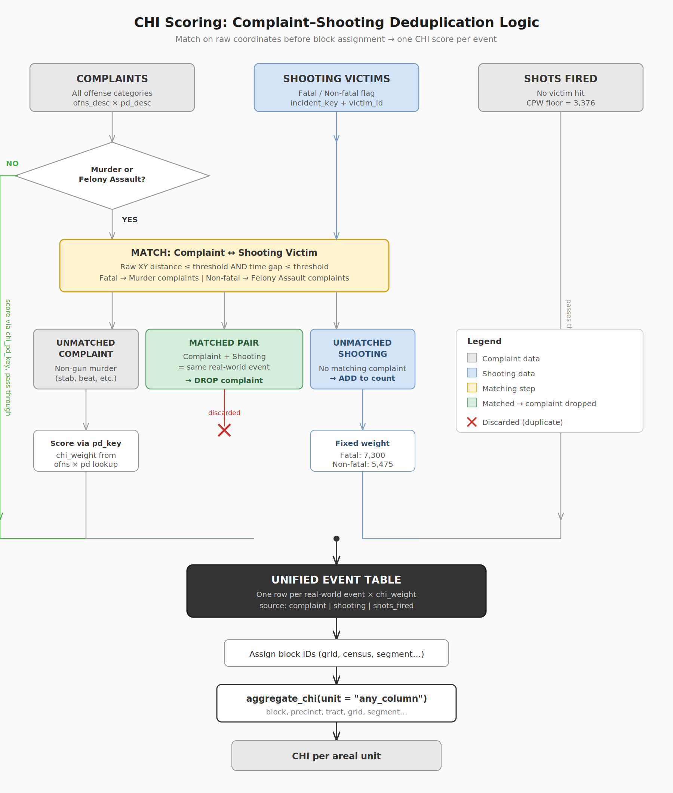

4.1 Spatiotemporal Match
The match operates on raw State Plane coordinates (feet), not on block IDs. This eliminates boundary artifacts where a shooting and its corresponding complaint fall on opposite sides of a grid cell or block boundary.
For each shooting victim, the algorithm finds the nearest complaint of the correct type (fatal → murder, non-fatal → felony assault) that satisfies both:
Distance constraint: Euclidean distance between the shooting XY and the complaint XY must be ≤ the distance threshold (default 500 feet).
Time constraint: Absolute time gap between the shooting datetime and the complaint datetime must be ≤ the time threshold (default 12 hours).
Ties are broken by nearest in space, then nearest in time. Each complaint can be claimed by at most one shooting. Each shooting matches at most one complaint.

4.2 Match Outcomes
Matched pair: The complaint is dropped. The shooting victim record carries the harm into the unified table at the shooting weight (7,300 or 5,475).
Unmatched complaint: A murder or felony assault complaint with no nearby shooting. This is a non-gun crime (stabbing, beating, etc.). It stays in the data and is scored via the pd_key like any other complaint.
Unmatched shooting: A shooting victim with no corresponding complaint on the same block and date. Added to the unified table at the shooting weight. No complaint is removed.

4.3 Order of Operations
The sequence matters. Block assignment must come after deduplication, not before:
- Deduplicate on raw coordinates — match shooting victims to complaints using spatiotemporal proximity. Remove matched complaints. Stack all surviving records into a unified event table.
- Score complaints — join chi_pd_key on offense_description1 × pd_description. Shooting and shots fired rows already have chi_weight.
- Assign block IDs — snap to grid, census block, LION segment, or whatever spatial unit you need. This step comes after deduplication so boundary artifacts cannot cause false non-matches.
- Aggregate — group by any column(s) in the data and sum chi_weight. The function does not care what the spatial unit is.

5. Using the Functions
The file 06_assign_chi.R contains three functions. Source it and call them in order.

5.1 deduplicate_gun_violence()
unified <- deduplicate_gun_violence(complaints, shootings, shots_fired,
dist_ft = 500, hours = 12)
Takes the three raw data streams. Returns a single stacked tibble with a source column ("complaint", "shooting", "shots_fired") and chi_weight pre-filled for shooting and shots fired rows. The match log is stored as attr(unified, "match_log") for audit. Reports match rates to console.

Parameters
Parameter | Default | Description
complaints | (required) | NYPD complaint data with x_coord_cd, y_coord_cd, cmplnt_fr_dt, cmplnt_fr_tm
shootings | (required) | Shooting victim data with coordinates, occur_date, occur_time, is_fatal
shots_fired | NULL | Shots fired data. Passed through unchanged. Optional.
dist_ft | 500 | Max Euclidean distance (State Plane feet) for a match
hours | 12 | Max time gap (hours) for a match
chi_fatal | 7300 | CHI for fatal victims (Murder 2nd)
chi_nonfatal | 5475 | CHI for non-fatal victims (Att. Murder 2nd)
chi_sf | 3376 | CHI for shots fired (CPW 2nd floor)

5.2 assign_chi()
scored <- assign_chi(unified, chi_pd_key)
Joins the pd_key lookup to fill chi_weight for complaint rows. Rows that already have chi_weight (shooting, shots_fired) are untouched. Reports match rate for complaints. Unmatched complaints get chi_weight = NA.

5.3 aggregate_chi()
block_harm <- aggregate_chi(scored, unit = "block_id")
precinct_harm <- aggregate_chi(scored, unit = "precinct")
panel <- aggregate_chi(scored, unit = c("block_id", "year"))
Groups by whatever column(s) you pass and returns n_crimes, chi_total, chi_mean. The unit parameter is a character vector of column names. It does not care what they represent—block, precinct, census tract, grid cell, or anything else already in your data.

6. Required Files
File | Purpose
06_assign_chi.R | The three functions. Source this file.
chi_pd_key.csv (or .rds) | Lookup table: offense_description1 × pd_description → chi_weight. Built by scripts 00–02/05. This is the only NYC-specific file.
CHI_Lookup_Table_Complete.md | Reference documentation showing every penal law code, sentencing range, and CHI value. For review/audit, not read by code.

To port to another project, copy 06_assign_chi.R and chi_pd_key.csv. No other files are needed. To adapt for a non-NYC jurisdiction, rebuild the key with local offense categories, sentencing statutes, and midpoints. The functions themselves are jurisdiction-agnostic.

7. Worked Example
library(tidyverse)
source("06_assign_chi.R")

# Load data
chi_pd_key <- read_csv("chi_pd_key.csv")
complaints <- read_csv("NYPD_Complaints.csv") |> janitor::clean_names()
shootings <- readRDS("shootings_chi.rds")
shots_fired <- readRDS("shots_fired_chi.rds")

# Step 1: Deduplicate
unified <- deduplicate_gun_violence(complaints, shootings, shots_fired,
dist_ft = 500, hours = 12)

# Step 2: Score
scored <- assign_chi(unified, chi_pd_key)

# Step 3: Assign spatial unit (your choice)
scored <- scored |>
mutate(block_id = paste(
round(x_coord_cd / 150) * 150,
round(y_coord_cd / 150) * 150, sep = "_"))

# Step 4: Aggregate
block_harm <- aggregate_chi(scored, unit = "block_id")

# Inspect match log
match_log <- attr(unified, "match_log")
summary(match_log$dist_ft)
summary(match_log$time_gap_hrs)

8. Block-Level CHI Formula
After deduplication and scoring, the harm for any areal unit is simply the sum of chi_weight for all events in that unit:
CHI_{block} = Σ chi_weight_{i} for all events i on block
There is no subtraction step. The deduplication already removed the duplicate complaints. What remains is a clean event table where each real-world event appears exactly once at its correct harm weight.

9. Key Design Decisions

Match on raw coordinates, not blocks
If block IDs are assigned before matching, a shooting at x=999 and its complaint at x=1001 can land on opposite sides of a grid boundary. The match fails and both records survive, double-counting the harm. Matching on continuous coordinates eliminates this artifact entirely.

Nearest in space, tie-break by time
A shooting and its complaint occur at nearly the same location and time. Distance is the stronger discriminator because geocoding accuracy is within a block face (~150 feet), while complaint filing times can drift by hours. Spatial proximity is primary; temporal proximity breaks ties.

Each record claimed at most once
A single shooting cannot displace multiple complaints, and a single complaint cannot absorb multiple shootings. This prevents cascade errors in blocks with multiple shootings.

Unmatched records are kept, not discarded
Unmatched murder complaints are non-gun homicides. Unmatched shooting victims are events without a corresponding complaint at that location. Both represent real harm and are added to the total.

2020 data retained despite geocoding artifacts
NYPD murder complaint geocoding in 2020 shows ~38% of records falling on precinct stationhouse coordinates. Shooting coordinates are accurate. The deduplication handles this correctly: when no complaint exists near the shooting location, the shooting is added as an unmatched event. Harm accrues to the block where it actually occurred.

