Every Block Counts
Targeting Analysis

Comparing Block Targeting Algorithms for a
Place-Based Violence Intervention in New York City

John Hall
March 2026

Overview
Every Block Counts (EBC) is a planned matched-pair cluster randomized controlled trial of non-police interventions at violent micro-places in New York City (2026–2030). This analysis compares nine targeting models to determine which blocks should be eligible for the trial.
The central question: which algorithm best identifies the blocks where intervention can prevent the most serious harm?
We tested three families of models across a five-year baseline period (October 2020 – September 2025), using over 424,000 violent crime complaints, nearly 20,000 shooting victims, and 1,600 shots-fired events allocated to approximately 88,000 city blocks. Blocks containing precinct station houses, hospitals, or large NYCHA housing developments were excluded from the eligible pool, leaving roughly 88,000 blocks available for targeting.

The Nine Models
We compared three approaches to ranking blocks:
- Count-based models rank blocks by raw crime volume (gun violence, violent crime, felony violent, and outdoor-only variants).
- Crime Harm Index (CHI) models rank blocks by total harm, weighting each crime by its statutory seriousness using 151 distinct pd-description-level weights from NYS Penal Law.
- Outdoor variants restrict to street-level crime only, excluding indoor incidents.
Model | What It Counts | Type
Gun Violence | Shootings + shots fired only | Count
Violent Crime | Murder + robbery + felony assault + misd assault | Count
Violent Crime Outdoor | Same, outdoor locations only | Count
Felony Violent | Murder + robbery + felony assault (no misd) | Count
Felony Violent Outdoor | Same, outdoor only | Count
CHI Full | All violent, weighted by statutory harm | CHI
CHI Outdoor | Outdoor violent, harm-weighted | CHI
CHI Felony | Felony violent, harm-weighted | CHI
CHI Felony Outdoor | Outdoor felony, harm-weighted | CHI

All models use the same spatial allocation logic: crimes near intersections are split equally across adjacent blocks; other crimes go to the nearest block.

What Each Model Captures
The table below shows how much of citywide crime each model captures when selecting the top 200 or 400 blocks. No single model dominates every dimension.

Top 200 Blocks
Model | Gun  Violence | Shootings | Felony  Violent | All  Violent | Outdoor  F.V.
Gun Violence | 12.1% | 13.3% | 3.6% | 3.3% | 3.0%
Violent Crime | 4.9% | 5.2% | 7.5% | 7.3% | 5.2%
Felony Violent | 5.1% | 5.9% | 7.7% | 7.0% | 5.5%
CHI Full | 7.2% | 8.8% | 7.5% | 6.8% | 5.6%
CHI Outdoor | 8.4% | 11.0% | 6.1% | 5.5% | 6.1%
CHI Felony Outdoor | 9.3% | 12.0% | 5.9% | 5.4% | 6.3%

Top 400 Blocks
Model | Gun  Violence | Shootings | Felony  Violent | All  Violent | Outdoor  F.V.
Gun Violence | 19.6% | 22.3% | 6.0% | 5.6% | 5.3%
Violent Crime | 8.6% | 9.6% | 11.6% | 11.5% | 8.5%
Felony Violent | 9.1% | 10.9% | 12.1% | 11.1% | 9.1%
CHI Full | 12.3% | 15.2% | 11.8% | 10.8% | 9.0%
CHI Outdoor | 14.4% | 18.8% | 9.6% | 8.8% | 9.8%
CHI Felony Outdoor | 15.7% | 20.1% | 9.5% | 8.6% | 10.2%

The Gun Violence model captures the most gun violence (12–20%) but misses most broader violent crime. The Violent Crime and Felony Violent models capture more overall violence (7–12%) but are dilute on gun violence. The CHI models split the difference—CHI Outdoor captures 8–14% of gun violence while still picking up 6–10% of felony violent crime.
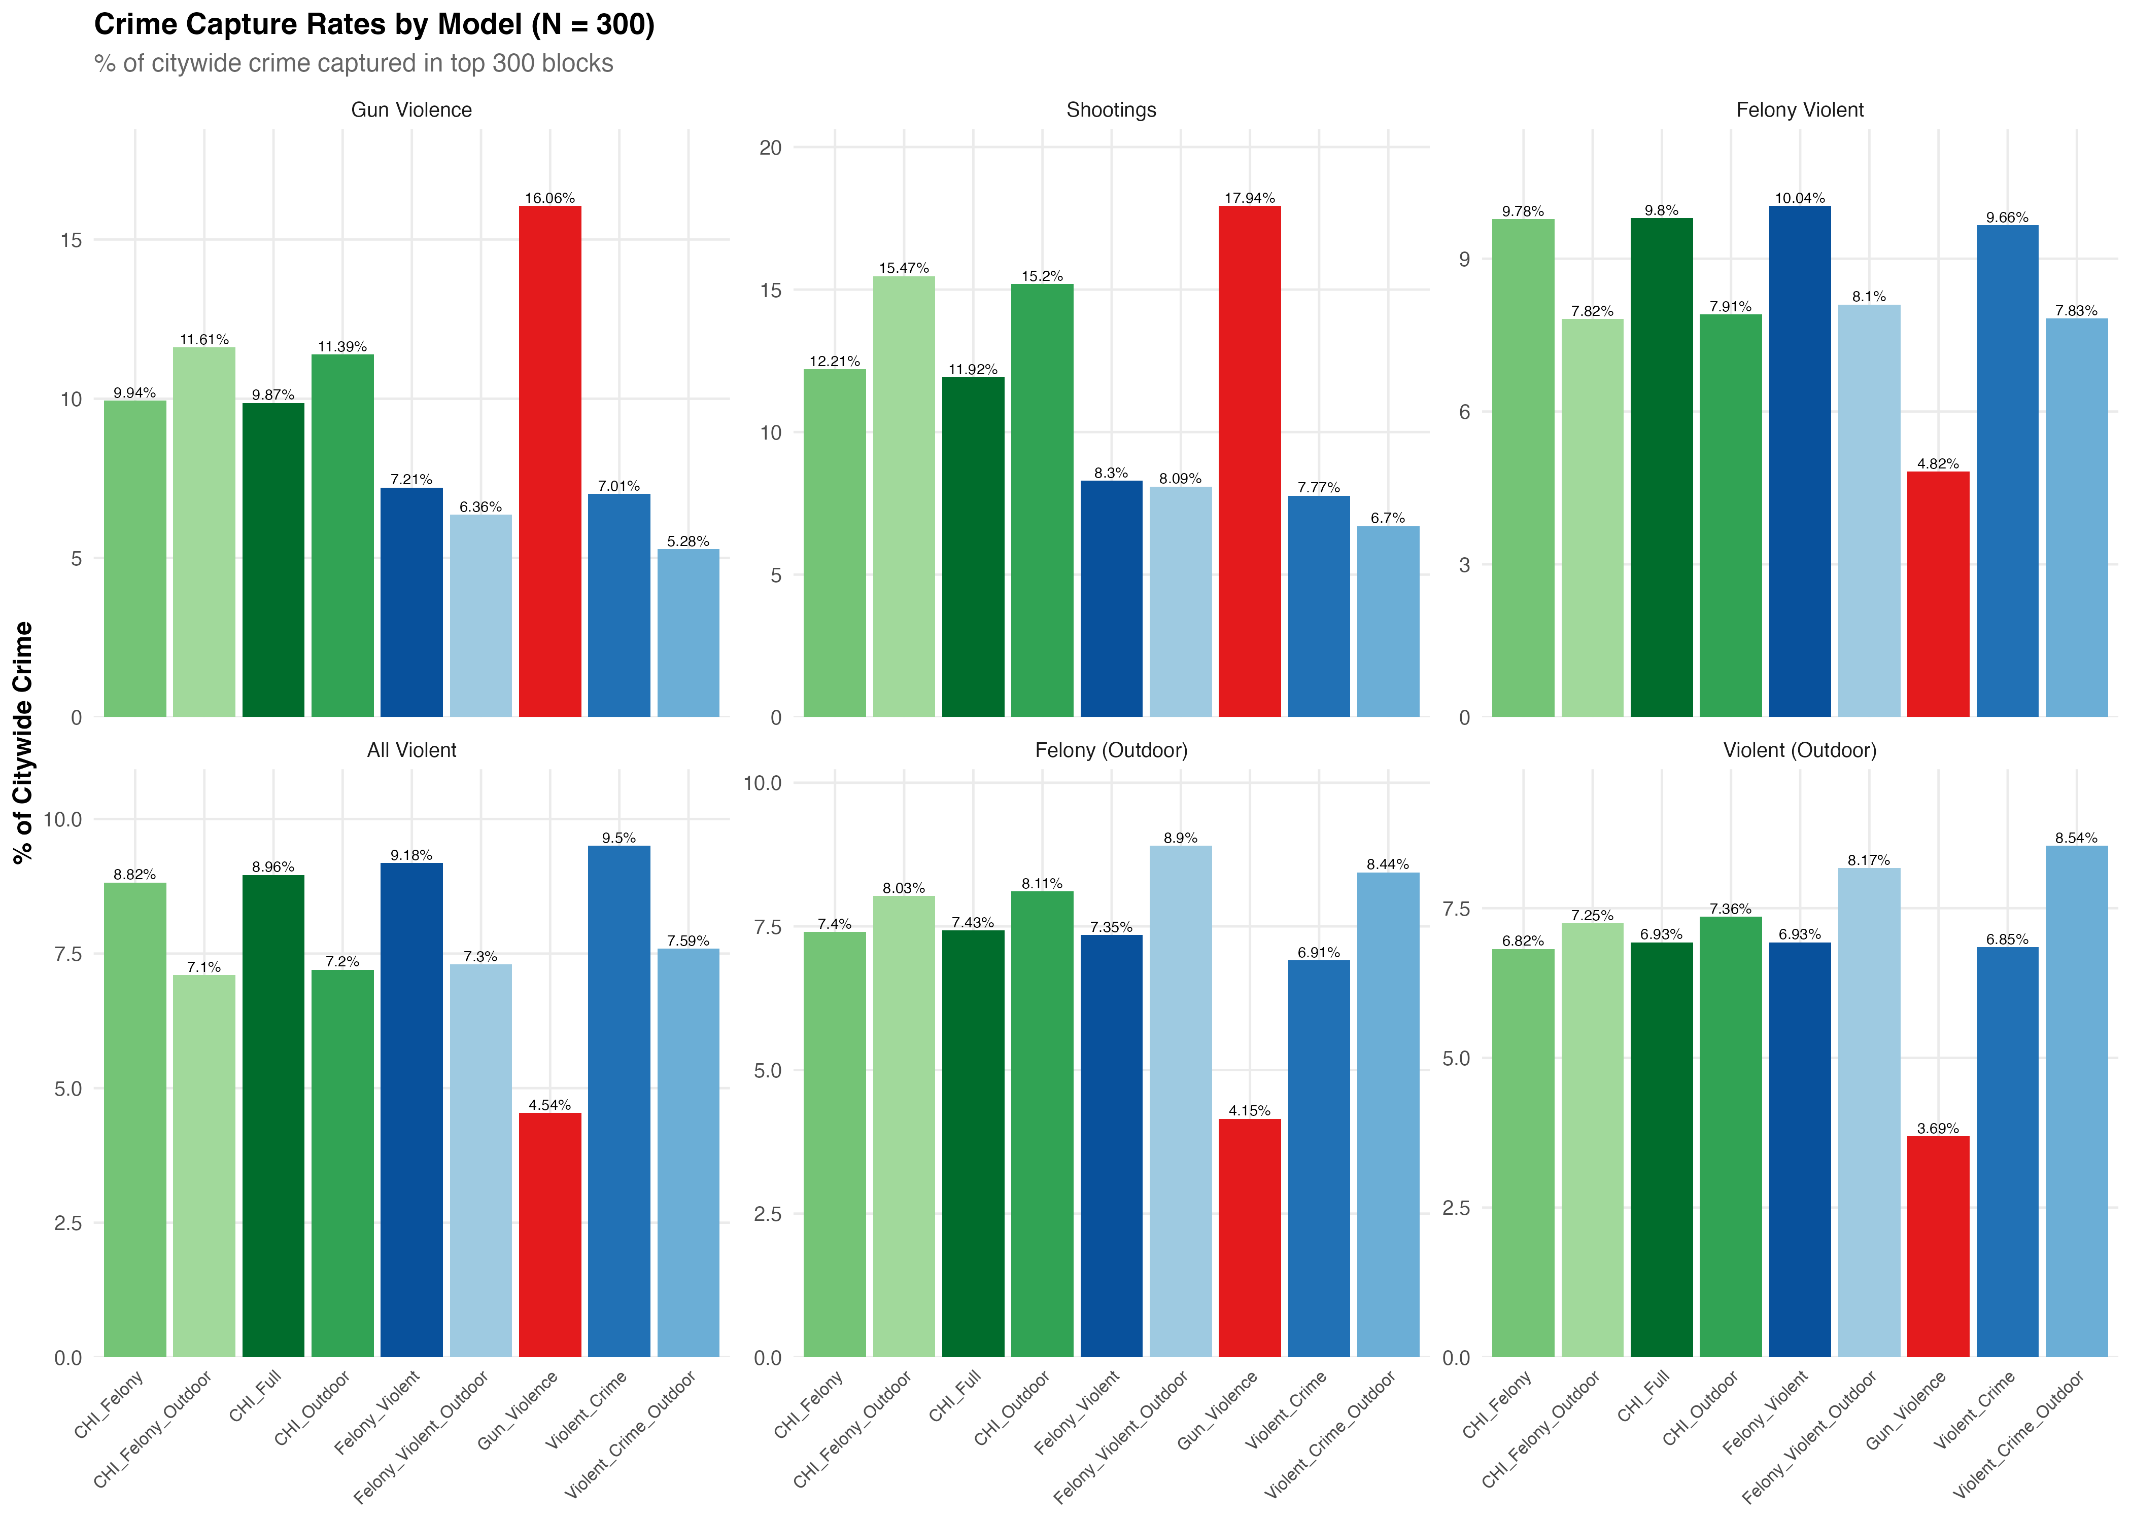
Figure 1. Capture rates across all models and sample sizes.

Covering the Hottest Blocks
A critical test: does the model capture New York City’s most dangerous blocks? We checked how many of the top 20 and top 50 gun violence blocks each model selects.
Model | Top 20  (N=200) | Top 20  (N=400) | Top 50  (N=200) | Top 50  (N=400)
Gun Violence | 20/20 | 20/20 | 50/50 | 50/50
CHI Outdoor | 19/20 | 20/20 | 45/50 | 47/50
CHI Felony Outdoor | 19/20 | 20/20 | 45/50 | 48/50
CHI Full | 19/20 | 19/20 | 36/50 | 43/50
Felony Violent | 14/20 | 16/20 | 25/50 | 32/50
Violent Crime | 13/20 | 16/20 | 19/50 | 26/50

Only the Gun Violence model guarantees 100% coverage of the top 20 and top 50 most violent blocks at every sample size. CHI Outdoor comes close (90–95% of the top 50). Count-based violent crime models miss a substantial share—selecting only 38–52% of the top 50 gun violence blocks at N=200.
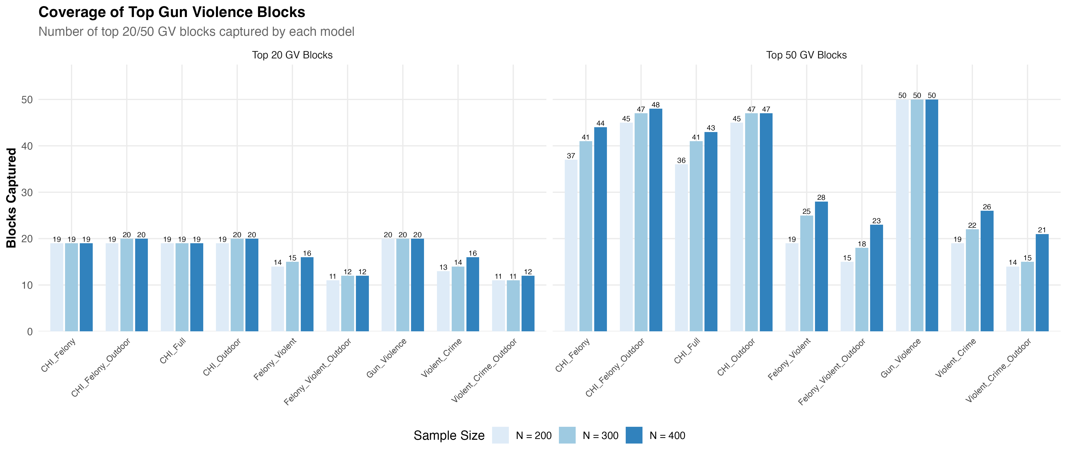
Figure 2. Coverage of NYC’s top gun violence blocks by model.

How Much Do Models Agree?
We compared every pair of models to see how many of their top 200 blocks overlap. Key findings:
- CHI variants are highly similar: CHI Felony and CHI Full share 97% of their blocks (194/200).
- Gun Violence stands apart: only 18–44% overlap with other models—it selects a fundamentally different set of blocks.
- Violent Crime and CHI Full are close cousins: 72% overlap (143/200 blocks shared).
- Only 18 blocks appear in all nine models—a core consensus set that every approach identifies as high-priority.
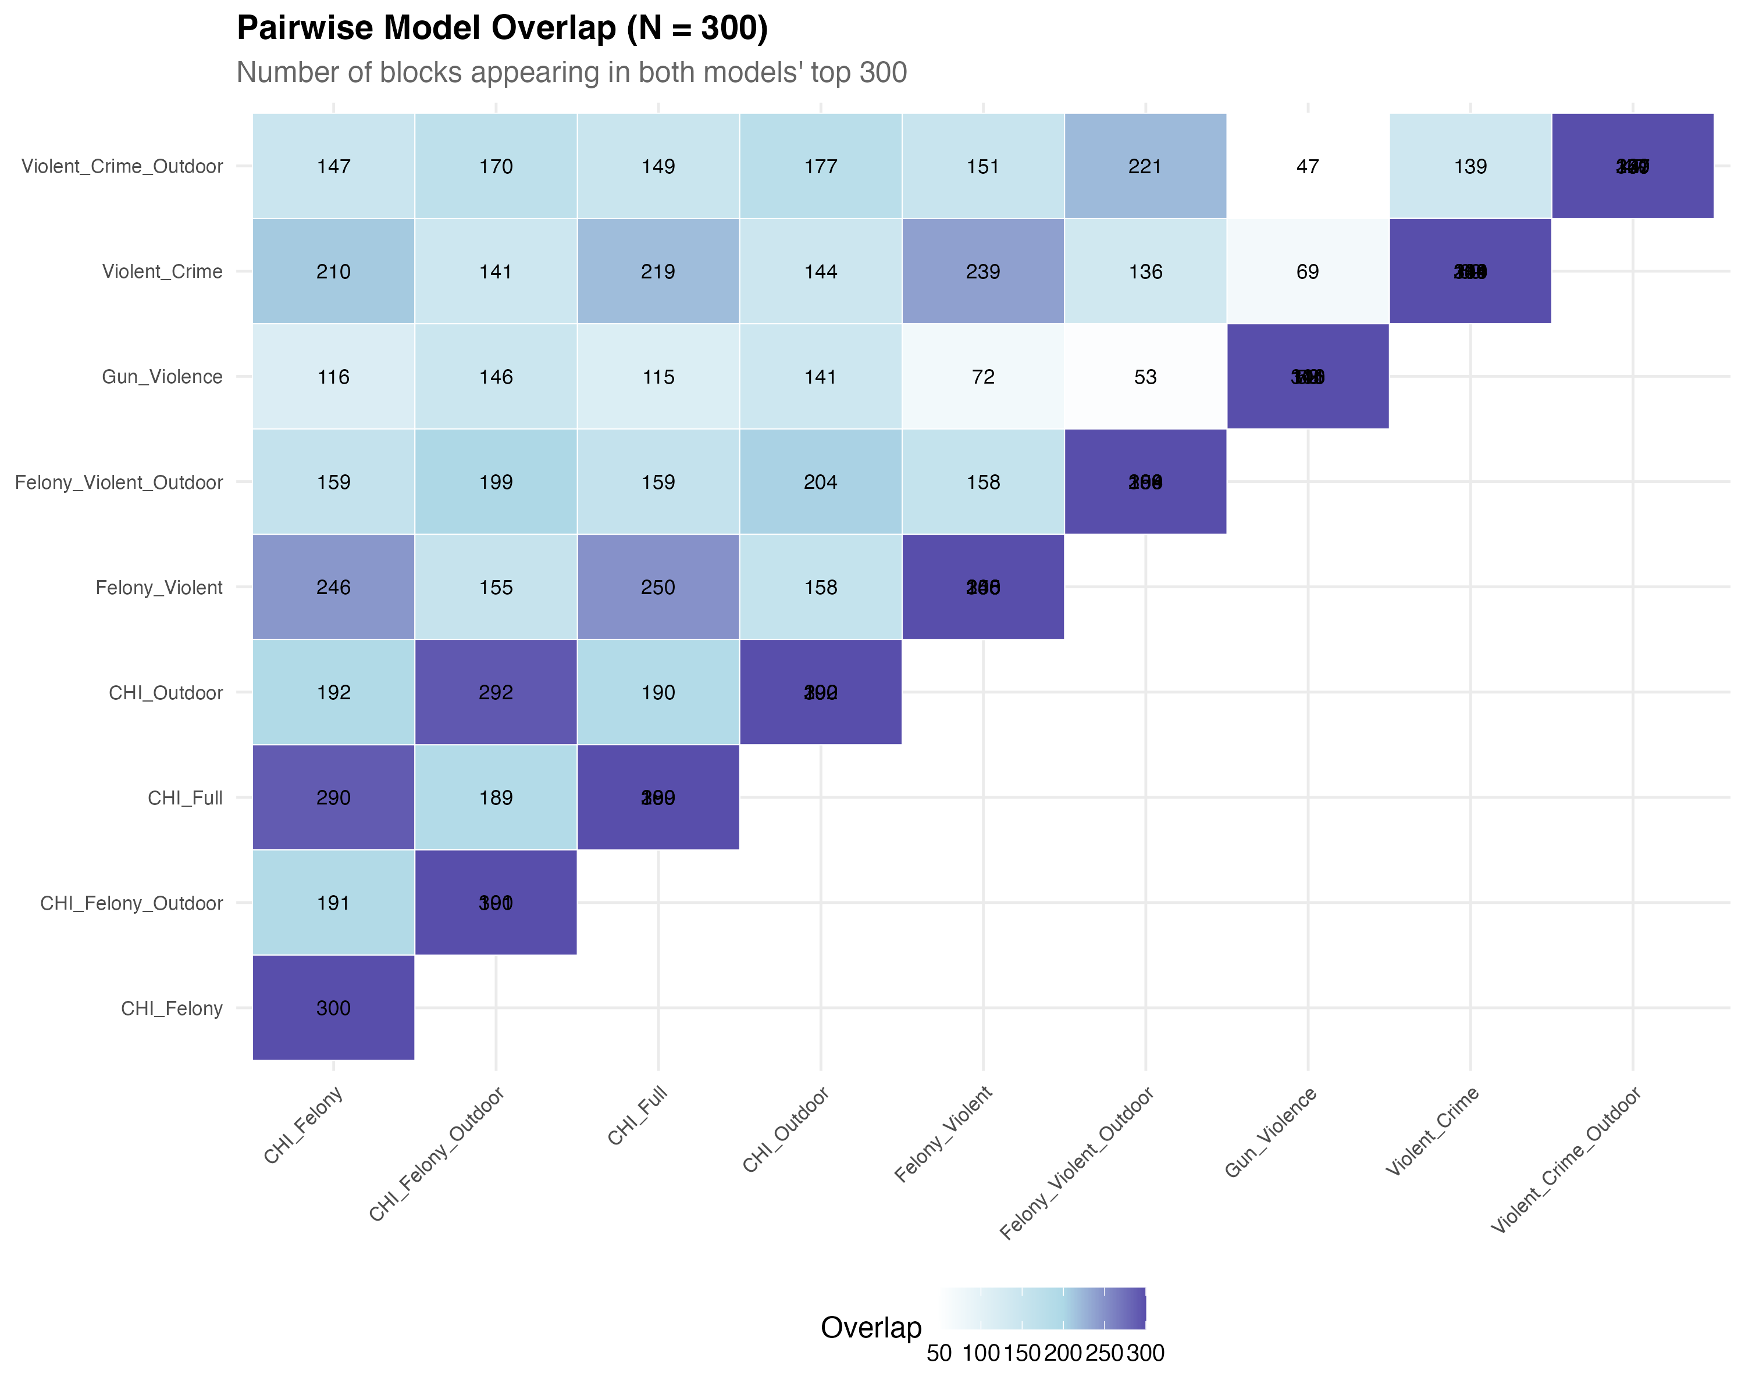
Figure 3. Pairwise block overlap between models (N=200). Darker = more blocks in common.

What Selected Blocks Look Like
Different models select blocks with very different crime profiles. The table below shows the average annual incidents per block for each model’s top 200 selections.
Incidents / Block / Year | Gun  Violence | Violent  Crime | CHI  Full | CHI  Outdoor
Shootings | 0.95 | 0.37 | 0.63 | 0.79
Gun Violence (all) | 2.38 | 0.96 | 1.41 | 1.65
Felony Violent | 7.34 | 15.38 | 15.56 | 12.50
All Violent Crime | 14.14 | 30.87 | 28.70 | 23.47

Gun Violence blocks average nearly 1 shooting per year but only 14 total violent incidents. Violent Crime blocks average 31 violent incidents but only 0.37 shootings—a much more diffuse profile. CHI models fall between these extremes, balancing gun violence concentration with broader harm coverage.
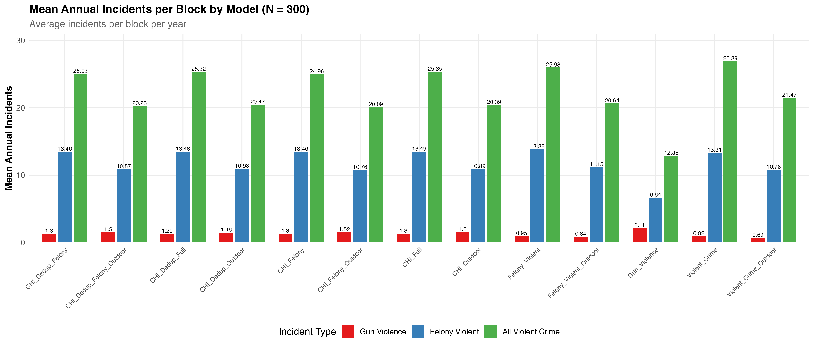
Figure 4. Mean annual incidents per block by model and sample size.
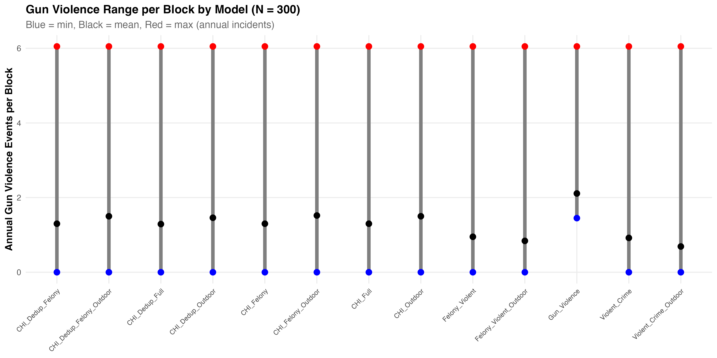
Figure 5. Range of gun violence per block across models.

Geographic Concentration
Gun violence is heavily concentrated in Brooklyn and the Bronx, which together account for two-thirds of citywide gun violence despite containing only 37% of the city’s blocks.
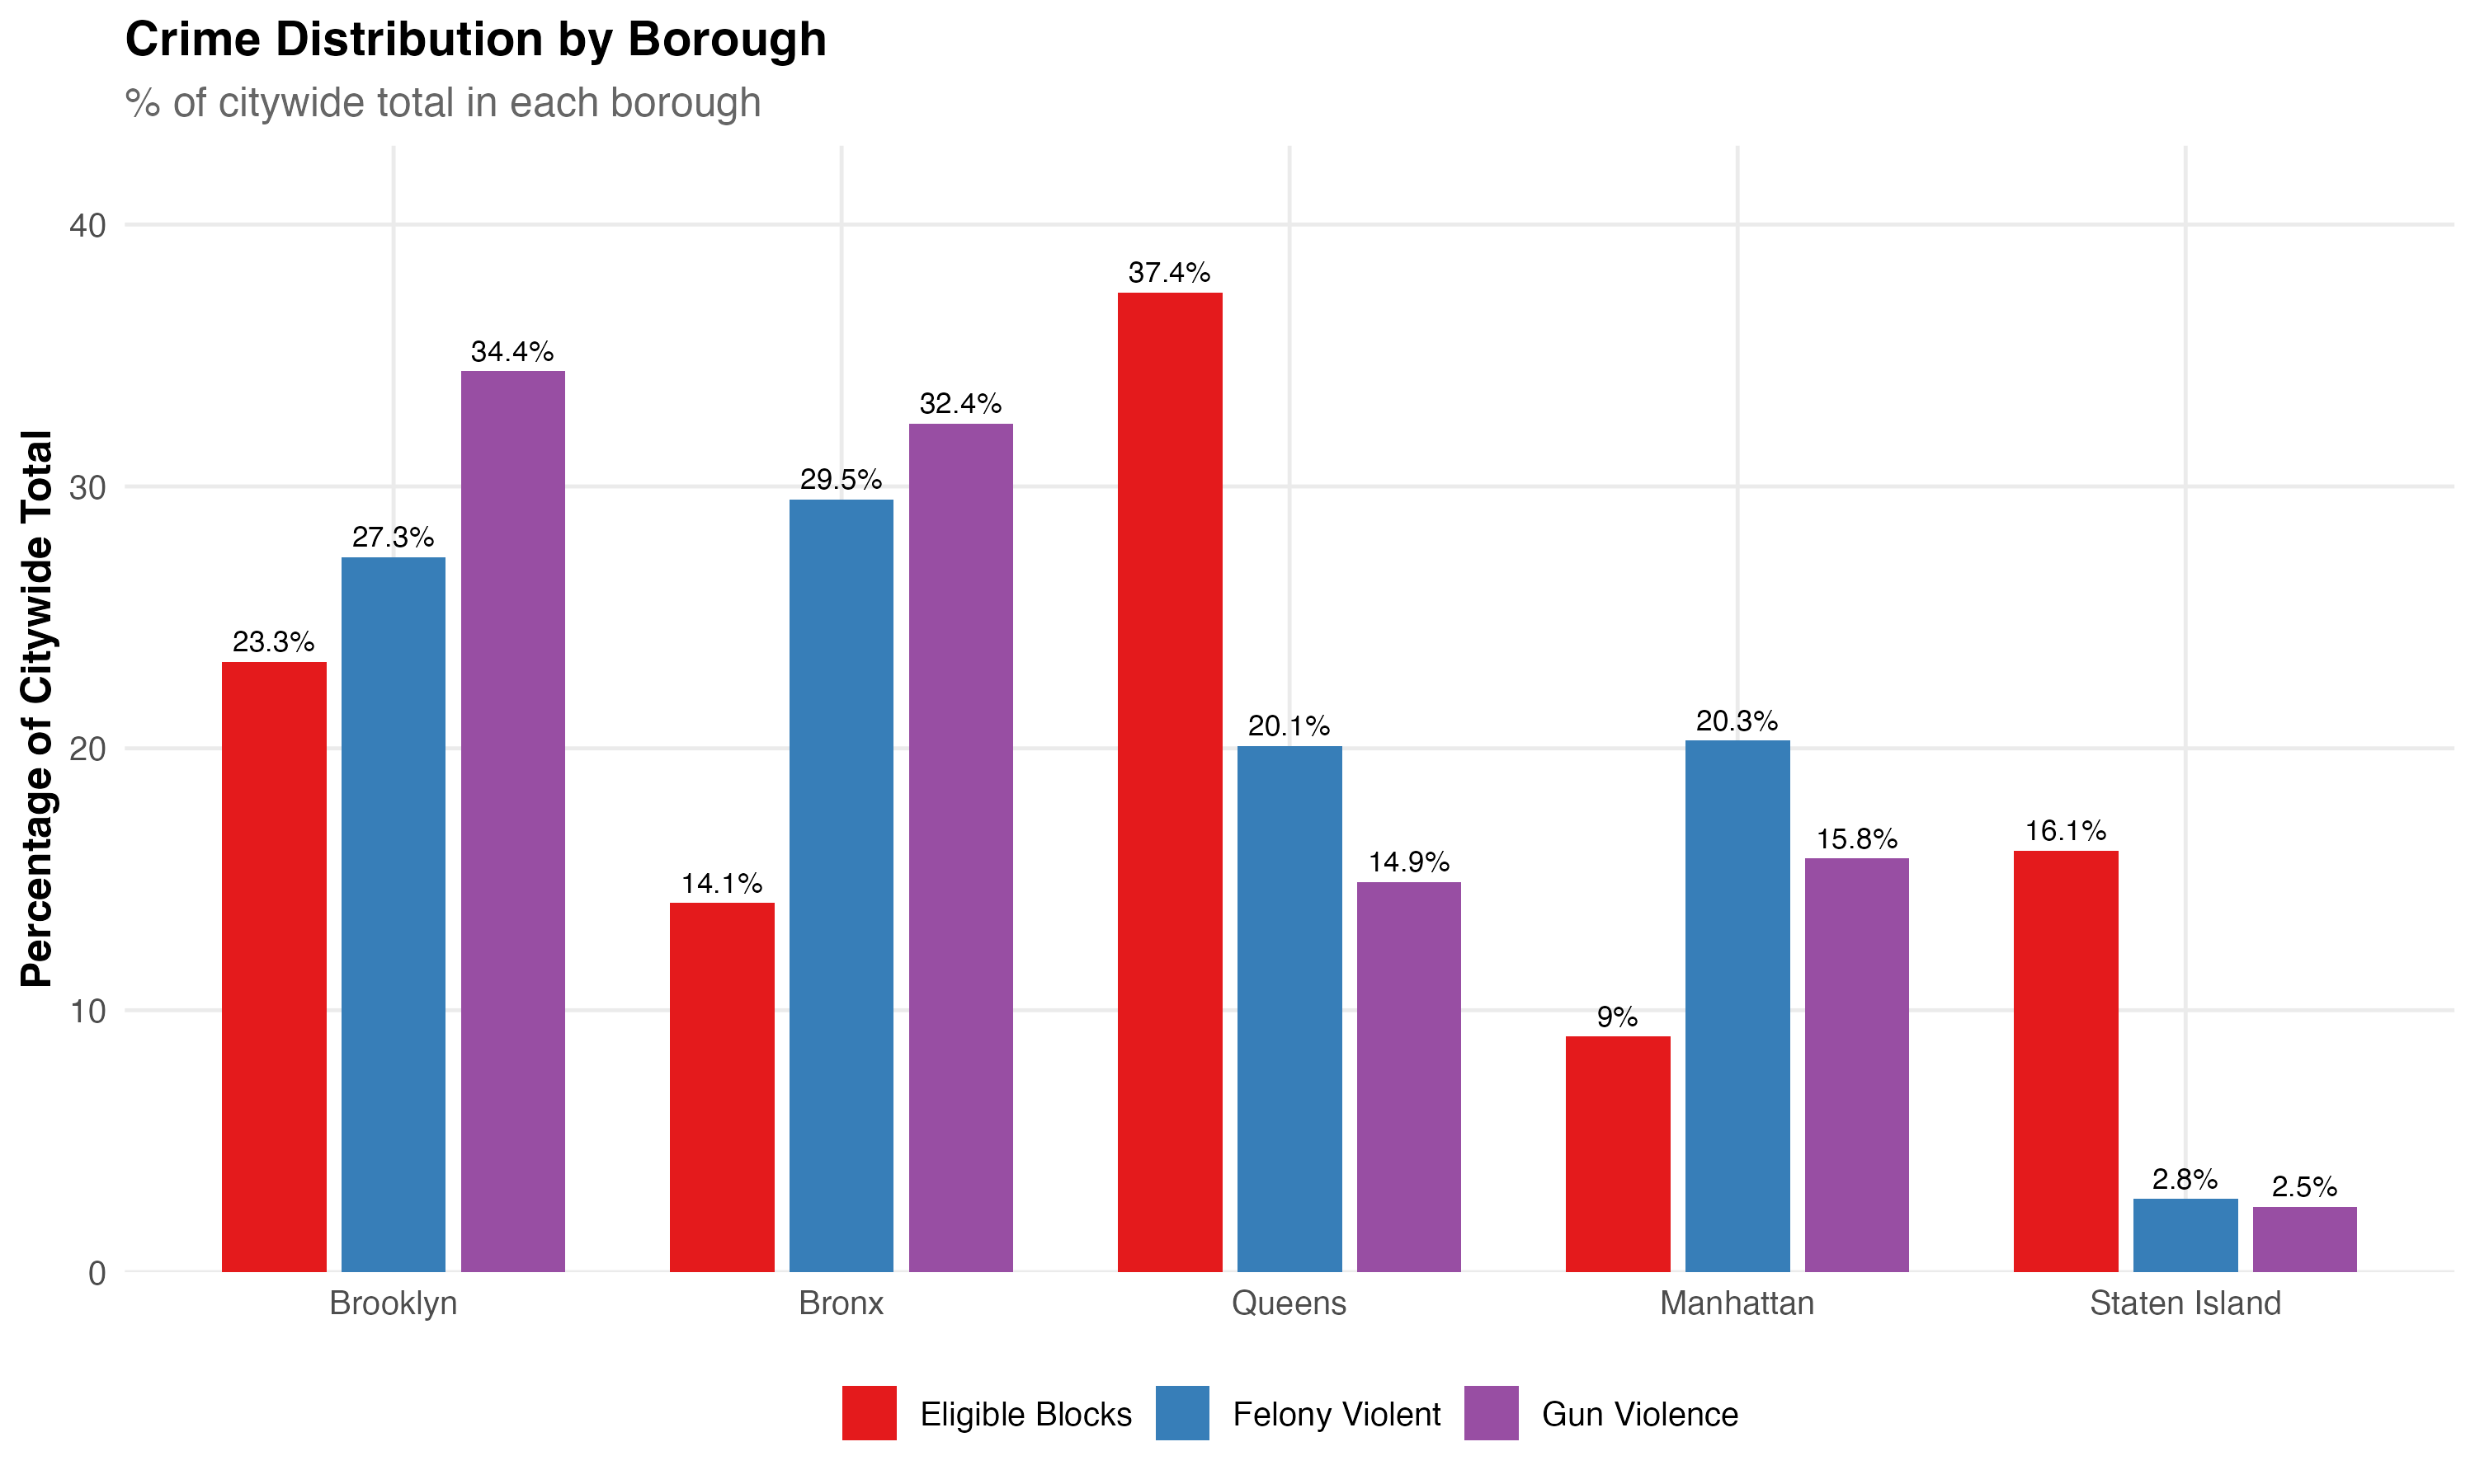
Figure 6. Gun violence and felony violent crime by borough.
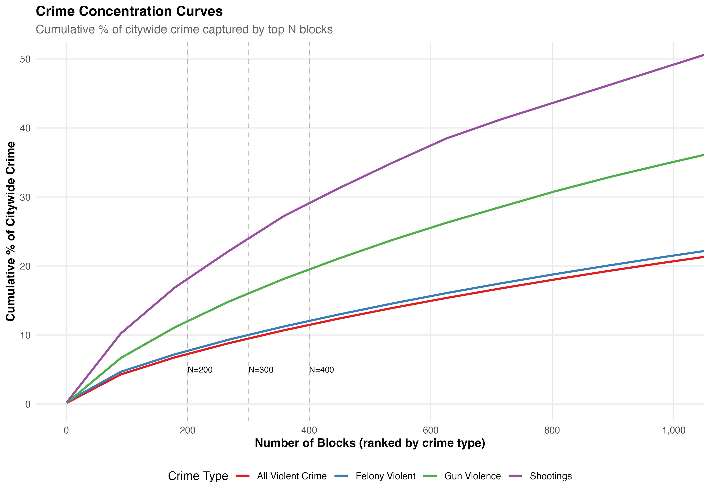
Figure 7. Concentration curves: cumulative crime captured as more blocks are selected.
The concentration curves confirm the pattern: selecting the top 200 blocks (out of 88,000) captures 12% of gun violence but only 3–7% of broader violent crime, depending on the model. Crime counts are distributed more evenly across the city than gun violence.

Outdoor vs. Indoor Crime
Since EBC targets street-level interventions, the share of outdoor crime matters. Citywide, about 44% of violent crime occurs outdoors. Murder (66%) and robbery (60%) are primarily outdoor; assaults are more evenly split.
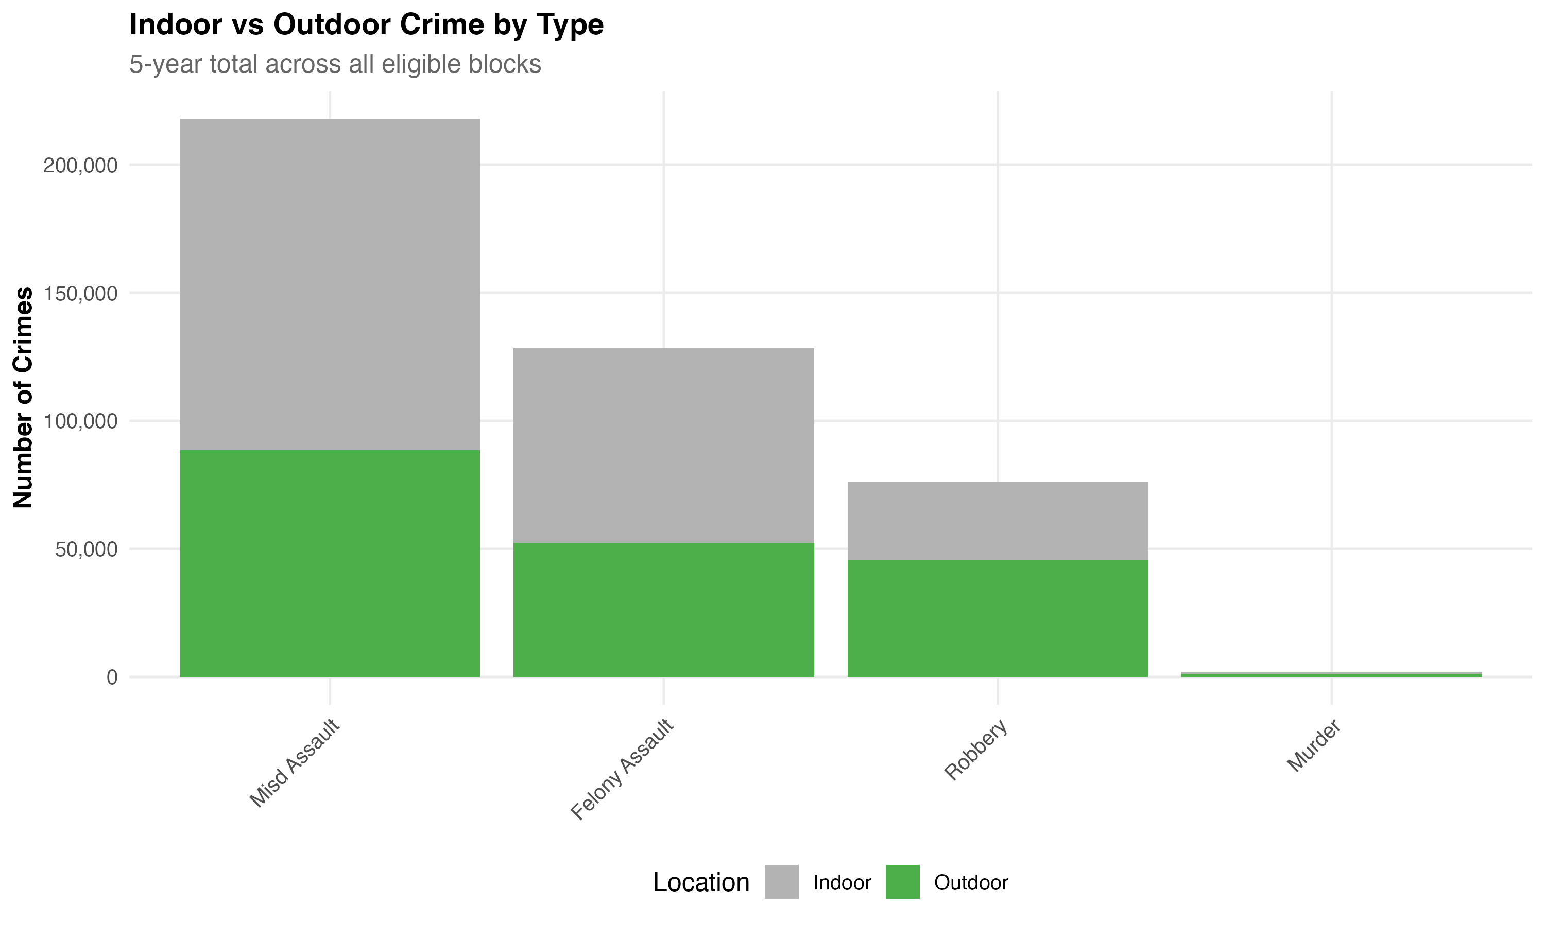
Figure 8. Outdoor vs. indoor breakdown by crime type.
Outdoor-targeted models (Violent Crime Outdoor, CHI Outdoor) successfully concentrate on blocks with higher outdoor percentages (45–50%), while full models include more indoor-heavy locations (~34%). This distinction matters if the intervention is designed primarily for public spaces.

The Core Trade-Off
No single model dominates all dimensions. The choice depends on the intervention’s theory of change:
- If the intervention targets gun violence specifically: Gun Violence model is the clear winner—100% coverage of the hottest blocks, highest gun violence capture rate.
- If the intervention aims to reduce broader violence through environmental or community change: Violent Crime or Felony Violent models capture the most overall violence, but miss many of the highest-harm gun violence blocks.
- If the goal is to balance both: CHI Outdoor offers the strongest compromise—95% of the top 20 gun violence blocks, while capturing meaningful violent crime volume and weighting by seriousness.
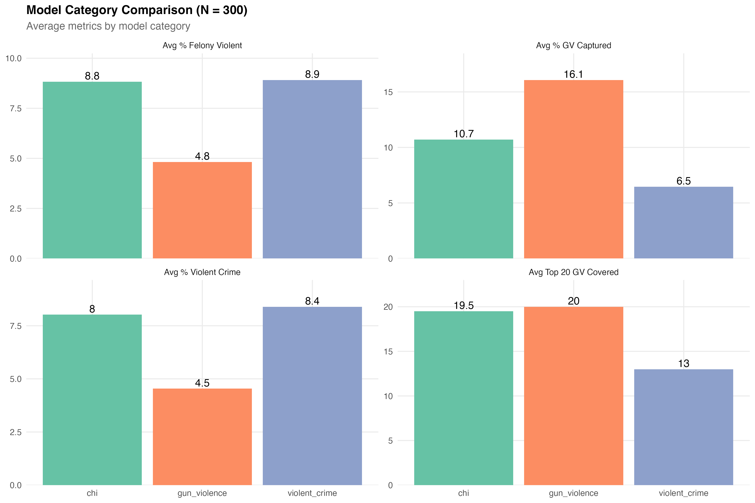
Figure 9. Side-by-side comparison of model families.
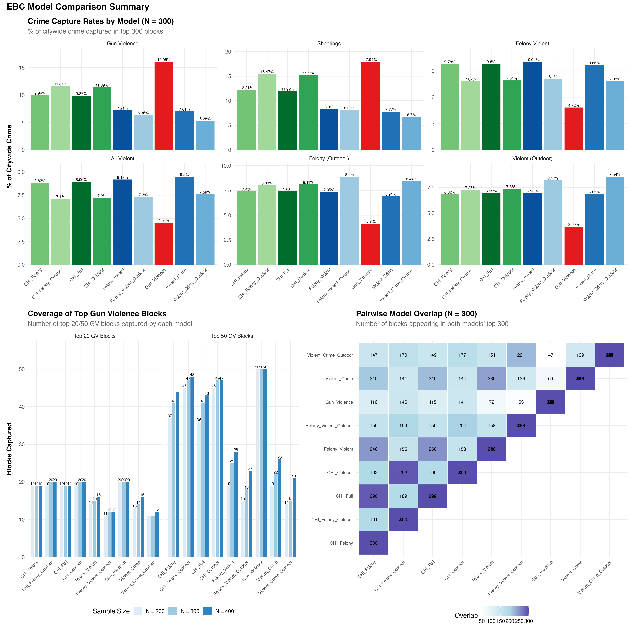
Figure 10. Comprehensive model comparison across all key metrics.

Summary
 | Gun Violence  Model | CHI Outdoor  Model | Violent Crime  Model
Gun violence capture (N=200) | 12.1% | 8.4% | 4.9%
Top 20 GV block coverage | 100% | 95% | 65%
Top 50 GV block coverage | 100% | 90% | 38%
Felony violent capture | 3.6% | 6.1% | 7.5%
All violent capture | 3.3% | 5.5% | 7.3%
Shootings per block / year | 0.95 | 0.79 | 0.37
Violent crimes per block / year | 14.1 | 23.5 | 30.9
Overlap with Gun Violence | — | 44% | 25%

The targeting algorithm selected will shape which blocks are eligible for randomization. This analysis provides the empirical basis for that decision.

