NYC Crime Harm Index

How Weighting Crimes by Seriousness Can Improve
Public Safety Decision-Making in New York City

March 2026

The Problem: Not All Crimes Are Equal
Every year, New York City tracks hundreds of thousands of reported crimes. But the standard approach, simply counting each crime as one event,treats a grand larceny the same as a murder. A neighborhood that sees 50 fewer thefts but 5 more homicides would look safer on paper, even though the real-world harm to residents has increased dramatically.
This is not a new observation. Researchers and police leaders have recognized for decades that counting crimes equally can mislead decision-making. The question has always been: what’s the alternative?
The answer is a Crime Harm Index (CHI)—a tool that weights each crime by how serious it is, producing a single number that reflects the total harm experienced in a neighborhood, precinct, or city block.

A Brief History of Crime Harm Measurement
The idea of weighting crimes by seriousness dates back to the 1960s, but it remained a theoretical exercise for decades. The breakthrough came in 2007, when criminologist Lawrence Sherman published research showing that across every city studied, a tiny share of places and people produced the vast majority of serious harm.
This meant that treating all crimes equally was not just inaccurate—it was actively misdirecting police resources away from where intervention could prevent the most serious harm.

Key Milestones
- 2007: Sherman introduces the “Power Few” concept—a small number of places, offenders, and victims drive most harm.
- 2009: Canada launches the Crime Severity Index (CSI), the first national harm-weighted crime measure, published annually ever since.
- 2016: Cambridge University formalizes the Cambridge Crime Harm Index (CCHI) using UK sentencing guidelines. Key finding: while crime counts dropped 37% over a decade, harm only dropped 21%—crime statistics had overstated safety gains by 76%.
- 2017–2023: Denmark, New Zealand, Australia, Sweden, and several US cities build their own versions.
- 2024: Lewis and colleagues raise equity concerns about using actual court sentences (which can reflect racial disparities) as weights—strengthening the case for using statutory law instead.
Today, at least 13 countries use some form of crime harm weighting for policing decisions.

How New York City’s Index Works

The Core Idea
Our Crime Harm Index assigns each reported crime a weight based on New York State law. Specifically, we use the midpoint of the sentencing range that state law prescribes for each offense class. A Class B violent felony (like armed robbery) carries a sentencing range of 5 to 25 years; the midpoint is 15 years, which translates to 5,475 days. That becomes the weight.
This approach has three important advantages:
- It’s grounded in law, not opinion. The weights come directly from what New York’s elected legislators have decided each crime deserves. No panel of experts, no survey—just the law as written.
- It avoids baking in person-level bias. Some researchers have used actual court sentences as weights, but sentences can reflect disparities in how different communities are treated by the justice system. Using statutory ranges sidesteps this problem entirely.
- It’s transparent and reproducible. Anyone can look up New York’s Penal Law and verify every weight in the index.
The NYC CHI uses statutory midpoints specifically to avoid the equity concerns raised in recent research. The weights are drawn from NYS Penal Law §70.00 and §70.02.

The Sentencing Framework
Here is the complete set of weights used in the index, expressed in days of incarceration:
Offense Class | Type | Sentencing Range | Midpoint | CHI (Days)
A-I Felony | Murder 1st | 20–40 yrs to life | 30 years | 10,950
A-I Felony | Murder 2nd | 15–25 yrs to life | 20 years | 7,300
B Felony | Violent | 5–25 years | 15 years | 5,475
C Felony | Violent | 3.5–15 years | 9.25 years | 3,380
D Felony | Violent | 2–7 years | 4.5 years | 1,643
E Felony | Violent | 1.5–4 years | 2.75 years | 1,004
B Felony | Non-Violent | 1–9 years | 5 years | 1,825
C Felony | Non-Violent | 1–5.5 years | 3.25 years | 1,186
D Felony | Non-Violent | 0–2.5 years | 1.25 years | 456
E Felony | Non-Violent | 0–1.5 years | 0.75 years | 274
A Misdemeanor | — | Up to 1 year | 6 months | 183
B Misdemeanor | — | Up to 3 months | 45 days | 45

In plain terms: a murder carries a weight of 7,300 days while a misdemeanor assault carries 183 days—making a single murder count as roughly 40 misdemeanor assaults in the index. This reflects the reality that these crimes are not remotely equivalent in the harm they cause. While there are valid arguments about incommensurability across these crime types, this is a step-forward, as the current state makes them functionally equivalent.

What We Analyzed
We analyzed over five years of NYPD complaint data (2018–2022)—more than a million victim-reported crimes—across ten offense categories that together capture the vast majority of serious crime in New York City:
Offense Category | Offense Category
Murder & Manslaughter | Grand Larceny
Rape | Grand Larceny of Motor Vehicle
Robbery | Misdemeanor Assault
Felony Assault | Petit Larceny
Burglary | Sex Crimes

These include the seven standard FBI Part I crime categories plus three additional categories (misdemeanor assault, petit larceny, and sex crimes) that are important to New York City’s public safety picture.

Going Beyond Broad Categories
Most crime harm indices assign a single weight to each broad category—for example, one number for all robberies. But robberies vary enormously: a forcible purse snatching and an armed carjacking are both “robbery,” but they carry very different charges under state law.
We built a finer-grained index that looks within each category at the specific police description of the incident. This means “Robbery — home invasion” gets a different (and higher) weight than “Robbery — personal electronic device.” The weights reflect the actual mix of charges that NYPD records for each specific type of incident.
This level of detail is finer than any published crime harm index in the United States.

Stability Over Time
A good index should produce consistent weights year to year. We tested this by comparing our weights across each of the five years individually. The result: the weights are highly stable. The figure below shows how the average harm per crime, by offense category, holds steady from 2018 through 2022.
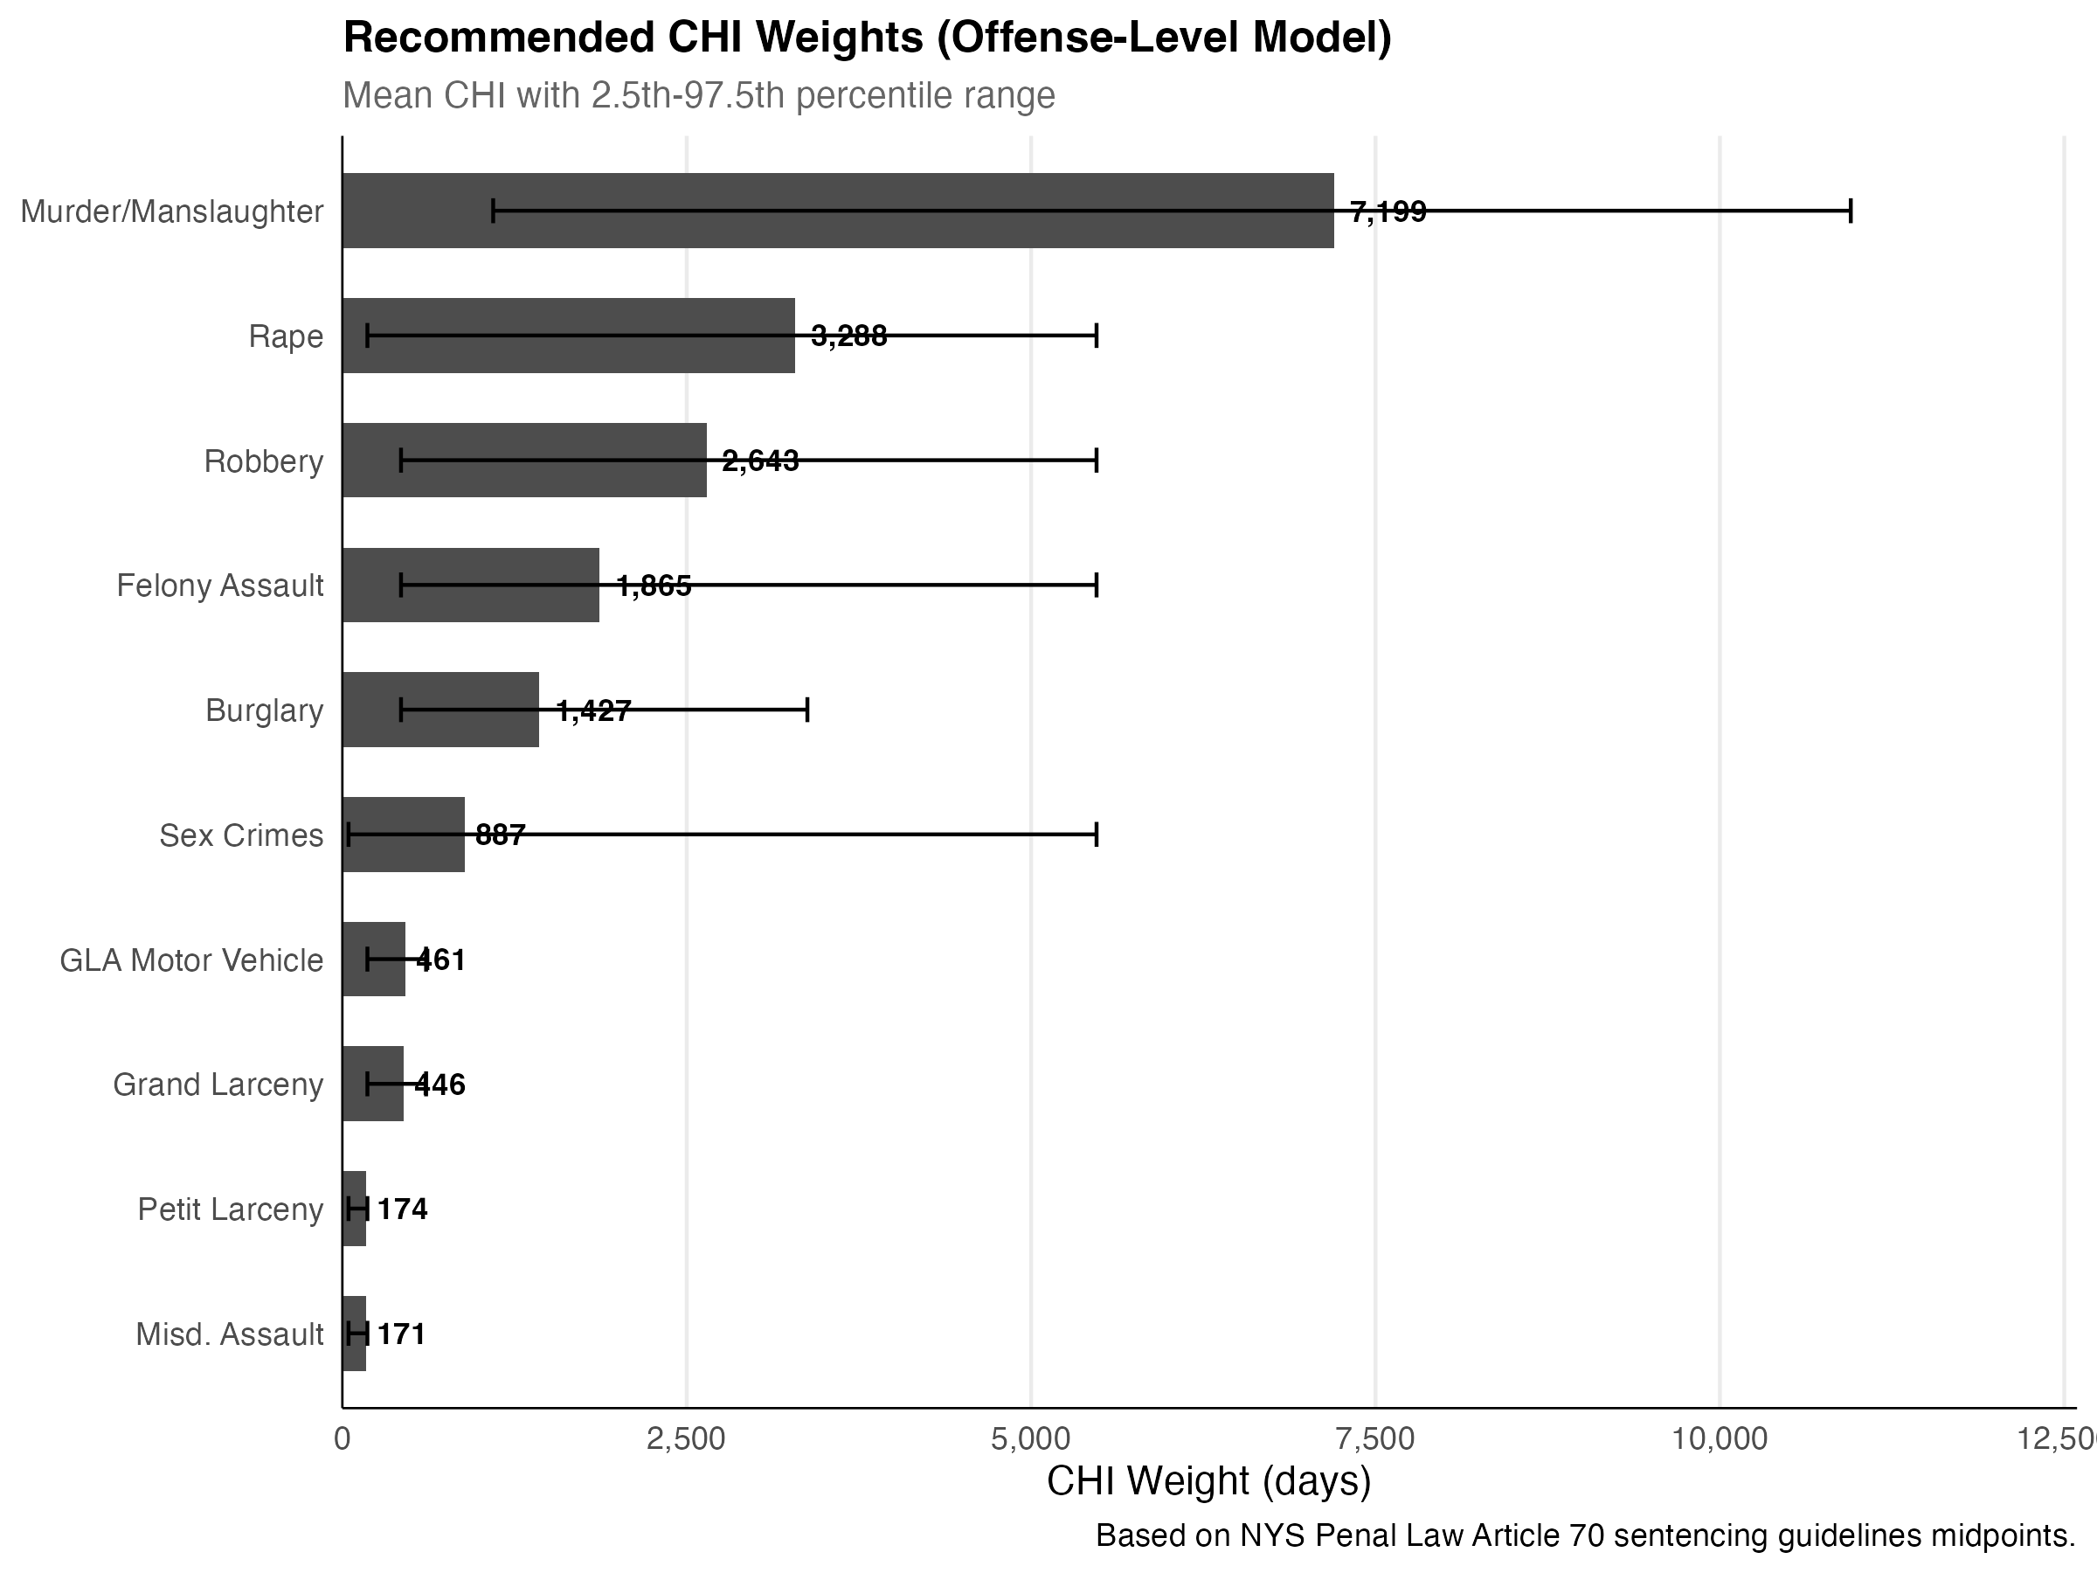
Figure 1. Recommended CHI weights by offense category, showing the harm each crime type contributes (in days).
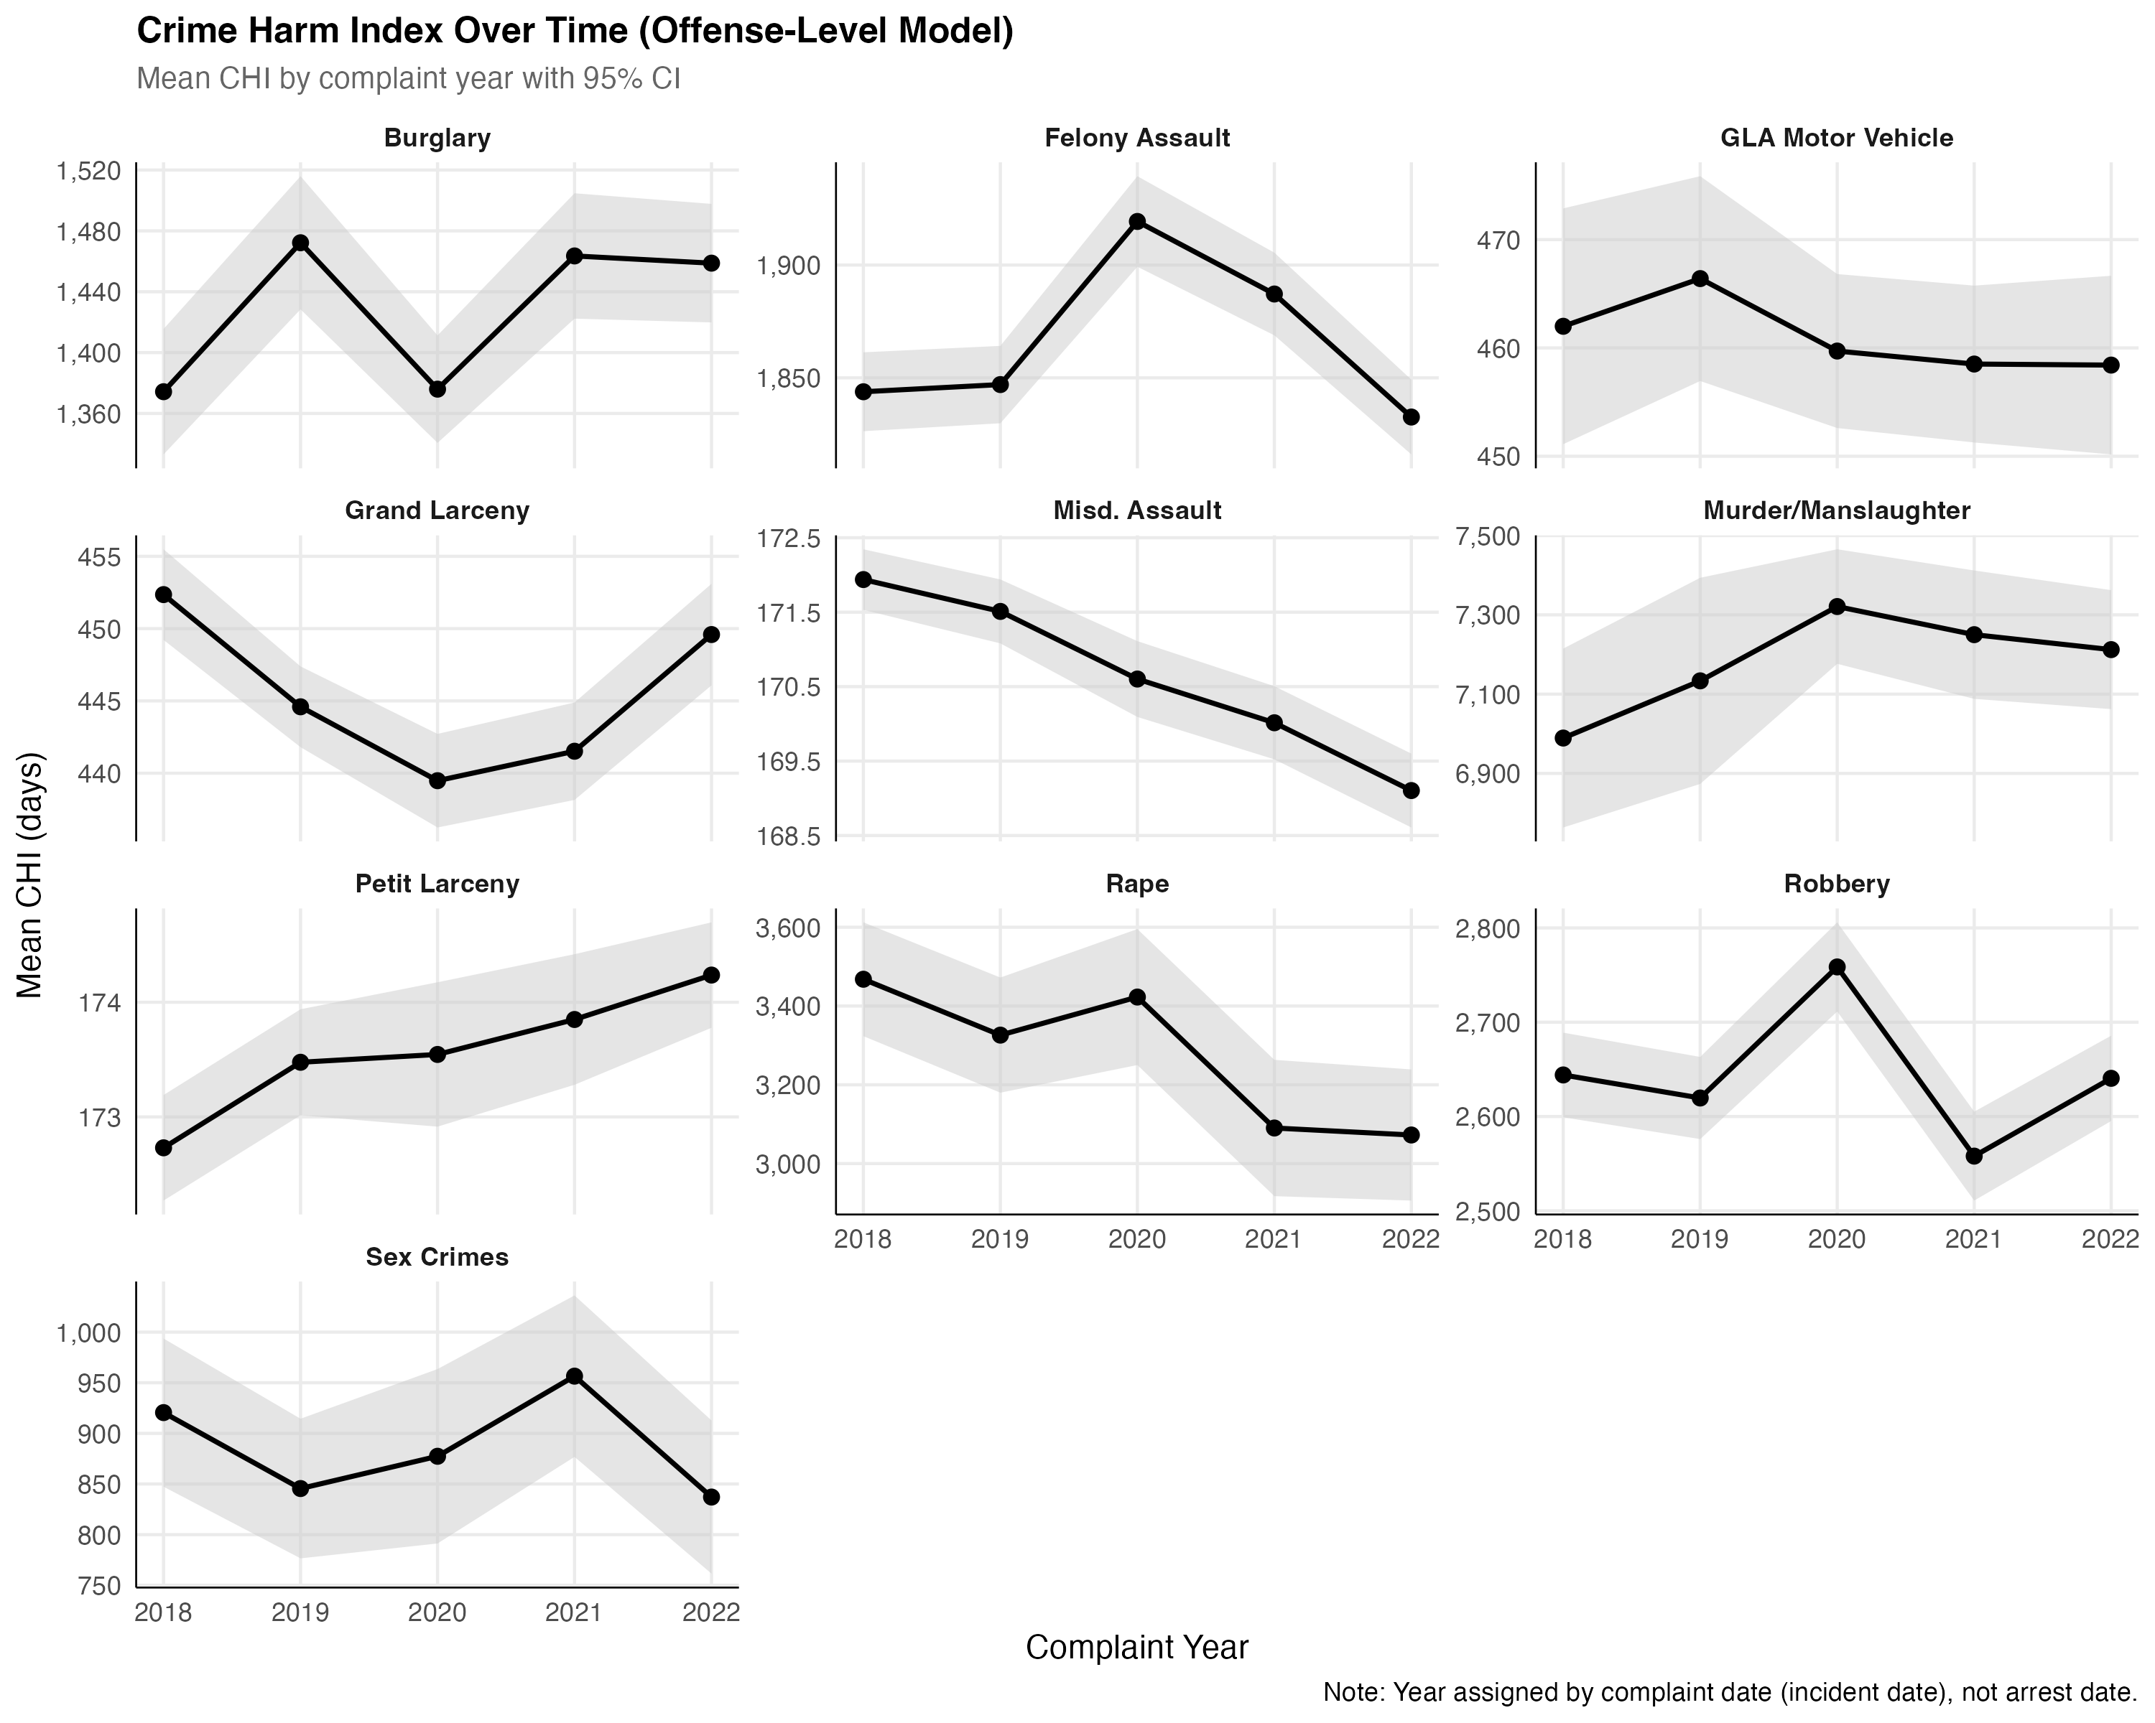
Figure 2. CHI weights remain stable across five years (2018–2022), confirming the index is reliable over time.

Accounting for Gun Violence
Standard crime reports have a blind spot when it comes to gun violence. Shootings often generate a complaint record (for assault or murder) and a separate shooting record. If we simply added both, we’d be double-counting the same event.
We solve this through substiution: when a shooting matches a complaint record for the same incident (same place, same time), the shooting’s harm score replaces the complaint’s score rather than stacking on top of it.

How Shootings Are Scored
Event Type | CHI Weight | Legal Basis
Fatal shooting (per victim) | 7,300 days | Murder in the 2nd Degree (PL 125.25)
Non-fatal shooting (per victim) | 5,475 days | Attempted Murder 2nd (PL 110/125.25)
Shots fired (no victim hit) | 3,376 days | Data-driven mix; CPW 2nd Degree floor

Shots-fired events—where a gun is discharged but no one is struck—are scored separately, because they typically don’t generate a complaint for assault or murder. These events are added to the index rather than substituted.

The Current Index: Selected Weights
The table below shows a selection of weights from the current NYC Crime Harm Index. Each row represents a specific type of crime as recorded by the NYPD, along with the harm weight in days. Higher numbers mean more serious crimes.
Crime Category | Specific Type | CHI (Days)
Murder | Murder/manslaughter | 7,300
Murder | Negligent homicide (vehicle) | 7,182
Rape | Rape 1st degree | 5,475
Rape | Sexual abuse | 1,253
Felony Assault | Assault 1st degree | 4,067
Felony Assault | Assault 2nd degree, unclassified | 1,519
Felony Assault | Strangulation 1st degree | 3,380
Robbery | Carjacking / hijacking | 4,426
Robbery | Street robbery, open area | 2,771
Robbery | Personal electronic device | 2,459
Robbery | Bank / commercial | 1,534
Burglary | Residence, nighttime | 1,835
Burglary | Commercial, daytime | 1,176
Grand Larceny | From person (pickpocket) | 638
Grand Larceny | From building / residence | 508
Motor Vehicle Theft | Auto theft | 456
Assault 3 (Misd.) | Assault 3rd degree | 174
Assault 3 (Misd.) | Menacing | 45
Petit Larceny | Shoplifting | 182
Petit Larceny | From person / open area | 156
Sex Crimes | Forcible touching | 183

The full index contains 151 unique crime types with individual weights. This level of detail allows for better targeting of public safety resources.

What This Means for Policy

Smarter Resource Allocation
With a harm-weighted index, decision-makers can identify not just where the most crime happens, but where the most harm happens. These are often different places. A block with dozens of petit larcenies produces far less total harm than a block with a handful of shootings and robberies.
The index is designed for block-level targeting—the smallest practical unit for place-based interventions like focused deterrence, community outreach, or environmental design improvements.

What the Index Is and Isn’t
The Crime Harm Index is a targeting tool, not an accountability metric. It is designed to help direct limited resources to where they can prevent the most serious harm. It is not designed to rank neighborhoods against each other or to evaluate police performance.
This distinction matters. When indices become performance metrics, there is a risk that the numbers themselves become the target rather than the underlying reality they measure. The CHI should inform resource allocationdecisions, not become a scorecard.

Built for New York City
Because the weights come from New York State law and the data comes from NYPD records, this index reflects the legal and operational context of New York City specifically. The methodology, however, is designed to be portable: any jurisdiction with statutory sentencing ranges and incident-level crime data could build an equivalent index.

Key Findings from Our Analysis
The index is stable over time—weights computed separately for each year from 2018 to 2022 are highly consistent, meaning the index is not sensitive to year-to-year fluctuations.
- Fine-grained weights matter. Within robbery alone, harm weights range from roughly 1,500 days (bank robbery) to over 4,400 days (carjacking). A single weight for “robbery” would miss this variation.
- Gun violence scoring avoids double-counting. The substitution approach ensures that a shooting event is counted exactly once—at the appropriate severity level—regardless of how many data systems record it.
- Harm is far more concentrated than crime counts suggest. The blocks driving the most harm are identifiable and persistent—making them viable targets for sustained intervention.

Sherman, L.W. (2007). The Power Few: Experimental Criminology and the Reduction of Harm.
Sherman, L.W., Neyroud, P.W., & Neyroud, E. (2016). The Cambridge Crime Harm Index: Measuring Total Harm from Crime Based on Sentencing Guidelines.
Lewis, J., Pina-Sánchez, J., & Sheridan-Sherwin, E. (2024). Equity concerns with sentence-based harm indices.
CHI weights are calculated using the midpoint of the minimum and maximum sentences prescribed by the New York State Penal Law for each offense class.
PD-level weights are the empirical mean of all law-code-level CHI values observed within each police description category, using 2018–2022 NYPD complaint data.

