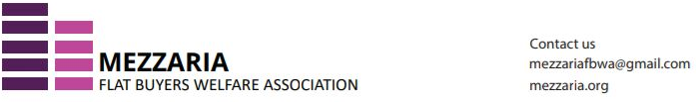
e-Mail: mezzariafbwa@gmail.com Web Site: www.mezzaria.org
────────────────────────────────────────────────────────────────────────────────
MINUTES OF MEETING
Executive Committee (EC) Meeting
Held on 13th June 2025
Attendees:
1. Rahoul Mundra
2. Suneal Singhal
3. Meenakshi Jhamb
4. Jayant Jhamb
5. Narendra Kumar (on phone)
6. Gp Capt HK Srivastava
Mom awaited.
Points discussed on 13th June 2025:
1. Acceptance of resignation by Sinha sahab.
2. Proposal of making Jayant Jhamb President.
3. Proposal to choose another person as treasurer as I can't be anymore.
4. Association to pursue delinking of electricity meter from maintenance.
5. Meanwhile KYC will be done in a day or two, so payments will be carried out as requisitioned.

